Supplementary Data
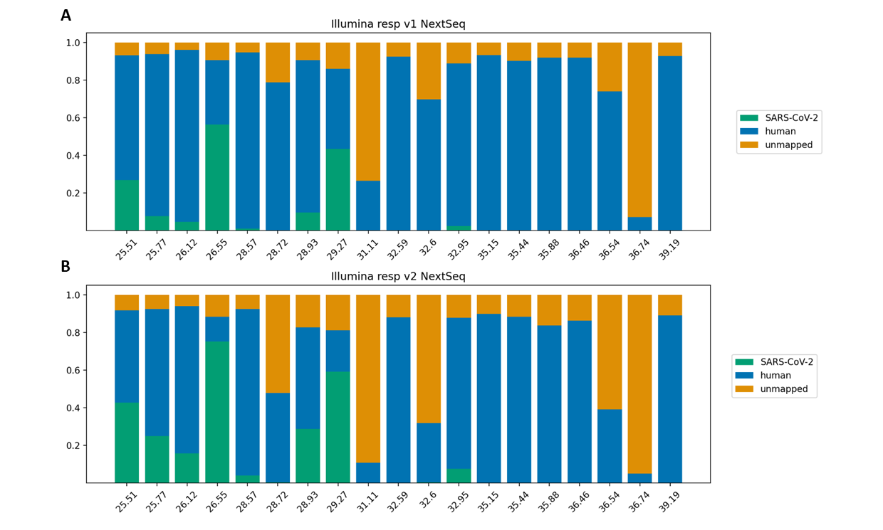
Figure S1. . Comparison between the fraction of on-target reads for Illumina’s Resv 1 panel ( A) and Illumina’s Resv 2 panel (B).
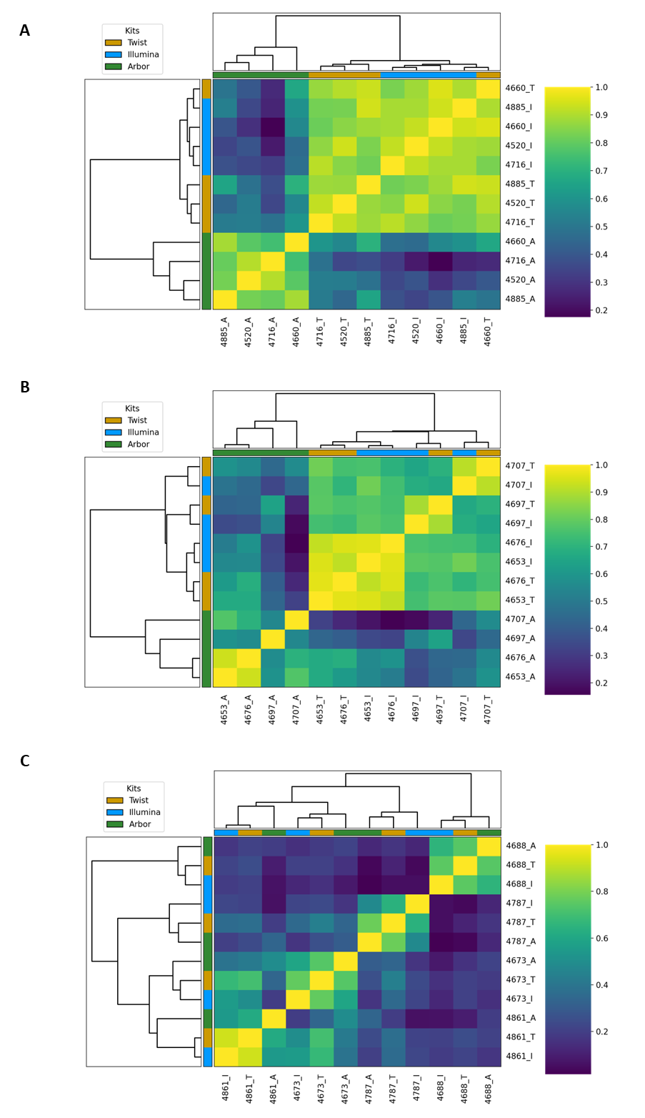
Figure S2. Correlation between reads from groups A-C samples (A-C), captured with the Twist SARS-CoV-2 in orange, Illumina Resv2 in blue and Arbor Biosciences SARS-CoV-2 in green.
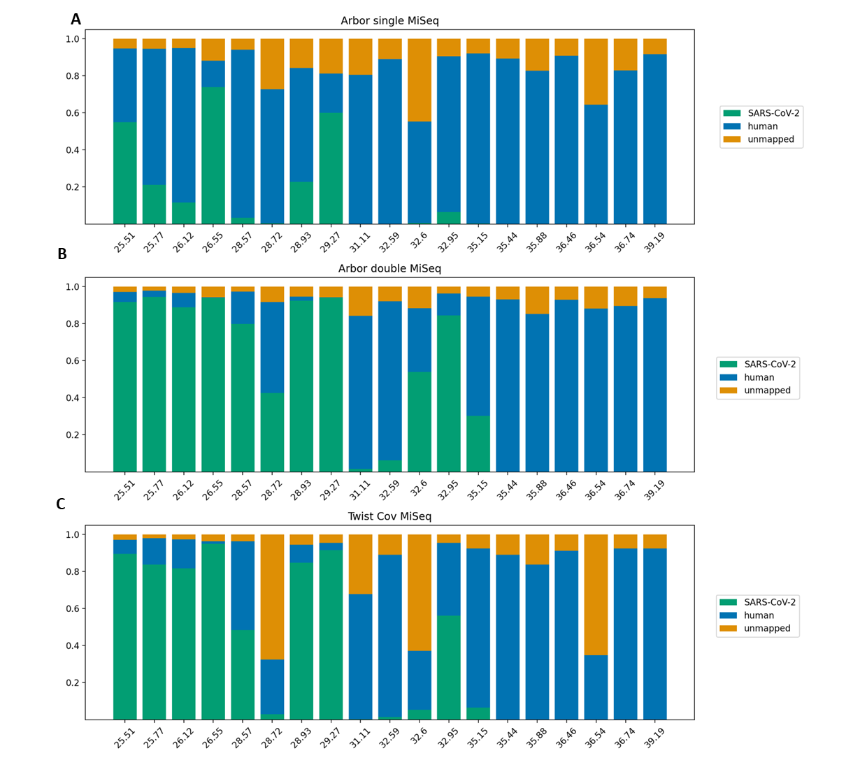
Figure S3. Comparison between the fraction of on-target reads for SARS-CoV-2-only panels in single or double capture. (A) Arbor single capture. (B) Arbor double capture. (C) Twist SARS-CoV-2.

 |  | Arbor SARS-CoV-2 Panel (1x capture) |  |  |  | Arbor SARS-CoV-2 Panel (2x capture) |  |  |  | Twist SARS CoV-2 Panel
Sample | Group | Reads (M) | Map (%) | BOC | DOC | Reads (M) | Map (%) | BOC | DOC | Reads (M) | Map (%) | BOC | DOC
4885 | A | 1.5M | 12 | 100 | 742 | 0.4M | 89 | 100 | 2E+03 | 0.5M | 82 | 100 | 2E+03
4716 | A | 1.6M | 21 | 100 | 2E+03 | 0.8M | 94 | 100 | 4E+03 | 0.7% | 84 | 100 | 2E+03
4660 | A | 2.0M | 74 | 100 | 6E+03 | 3.5M | 94 | 100 | 1E+04 | 2.6M | 95 | 100 | 9E+03
4520 | A | 2.2M | 55 | 100 | 5E+03 | 2.5M | 92 | 100 | 1E+04 | 2.2M | 90 | 100 | 8E+03
4707 | B | 3.0M | 3.4 | 100 | 448 | 0.8M | 80 | 100 | 3E+03 | 0.5M | 48 | 100 | 932
4697 | B | 1.3M | 0.4 | 97 | 24 | 0.1M | 43 | 98 | 139 | 0.5M | 3.0 | 98 | 70
4676 | B | 1.8M | 23 | 100 | 2E+03 | 2.1M | 92 | 100 | 9E+03 | 1.4M | 85 | 100 | 4E+03
4653 | B | 2.3M | 60 | 100 | 6E+03 | 5.8M | 94 | 100 | 2E+04 | 5.5M | 92 | 100 | 2E+04
4861 | C | 2.7M | 6.6 | 100 | 751 | 7.7M | 84 | 100 | 3E+04 | 3.6M | 56 | 100 | 8E+03
4787 | C | 2.6M | 0.0 | 50 | 5.4 | 0.5M | 6.3 | 55 | 138 | 1.0M | 1.4 | 56 | 55
4688 | C | 3.0M | 0.0 | 25 | 1.6 | 0.6M | 1.6 | 27 | 45 | 1.7M | 0.3 | 28 | 18
4673 | C | 1.1M | 0.6 | 92 | 26 | 0.5M | 54 | 95 | 1E+03 | 1.5M | 5.4 | 94 | 315
4777 | D | 2.7M | 0.0 | 4.8 | 0.0 | 2.2M | 0.0 | 0.0 | 0.0 | 2.1M | 0.0 | 0.3 | 0.0
4668 | D | 2.3M | 0.0 | 1.1 | 0.0 | 1.8M | 0.0 | 1.5 | 0.0 | 1.2M | 0.0 | 1.2 | 0.0
4510 | D | - | - | - | - | - | - | - | - | - | - | - | -
4489 | D | 3.0M | 0.2 | 94 | 32 | 3.7M | 30 | 95 | 5E+03 | 1.7M | 6.6 | 94 | 468
4798 | E | 2.4M | 0.0 | 2.9 | 0.0 | 1.9M | 0.0 | 1.2 | 0 | 1.1M | 0.0 | 1.6 | 0.0
4797 | E | 2.9M | 0.0 | 1.7 | 0.0 | 3.9M | 0.0 | 3.6 | 0 | 1.4M | 0.0 | 0.9 | 0.0
4656 | E | 1.6M | 0.0 | 1.0 | 0.0 | 1.1M | 0.0 | 0.0 | 0 | 2.5M | 0.0 | 0.0 | 0.0
4544 | E | 0.9M | 0.0 | 7.4 | 0.1 | 0.4M | 0.0 | 0.0 | 0 | 2.7M | 0.0 | 2.7 | 0.0

Table S1. Mapping results for all samples captured by the Arbor SARS-CoV-2 Panel in single and double capture, and the Twist SARS-CoV-2 Panel. All data were mapped to the Wuhan SARS-CoV-2 sequence (accession MN908947.3).

