Supplementary Materials for

Digital virus manipulation chip with a large array of all-dielectric nanocavities
Yuzhi Shi¹, Yongfeng Wu², Lip Ket Chin¹*, Mu Ku Chen², Shubo Wang³, Yi Zhang⁴,
Zhenyu Li¹, Patricia Yang Liu¹, Xiaohong Zhou⁵, Hong Cai⁶, Yefeng Yu⁷, Peng Huat Yap⁸,
Wee Ser¹, Thi Thanh Binh Nguyen¹, Jiayan Liao⁹, Fan Wang⁹,
Che Ting Chan¹⁰*, Yuri Kivshar^{2,11}*, Din Ping Tsai²*, and Ai Qun Liu¹*
¹School of Electrical and Electronic Engineering, Nanyang Technological University, Singapore 639798, Singapore
²Department of Electronic and Information Engineering, The Hong Kong Polytechnic University, Hong Kong, China
³Department of Physics, City University of Hong Kong, Hong Kong, China
⁴School of Mechanical and Aerospace Engineering, Nanyang Technological University, Singapore 639798, Singapore
⁵State Key Joint Laboratory of ESPC, School of Environment, Tsinghua University, Beijing 100084, China
⁶Institute of Microelectronics, A*STAR (Agency for Science, Technology and Research), Singapore 138634, Singapore
⁷School of Electronic and Optical Engineering, Nanjing University of Science and Technology, Jiangsu 210094, China
⁸Lee Kong Chian School of Medicine, Nanyang Technological University, Singapore 308232, Singapore
⁹Institute for Biomedical Materials & Devices (IBMD), Faculty of Science, University of Technology Sydney, Sydney, NSW 2007, Australia
¹⁰Department of Physics, The Hong Kong University of Science and Technology, Hong Kong, China
¹¹Nonlinear Physics Centre, Research School of Physics, Australian National University, Canberra ACT 2601, Australia

*e-mail: lkchin@ntu.edu.sg; phchan@ust.hk; ysk@internode.on.net; dinping.tsai@polyu.edu.hk; eaqliu@ntu.edu.sg

- Characterizations of the upconversion nanoparticles:
The morphology characterization of the upconversion nanoparticles was performed by transmission electron microscopes (TEM) of JEOL TEM-1400 at an acceleration voltage of 120 kv. The UCNPs dispersed in cyclohexane were dropped onto carbon-coated copper grids for imaging.
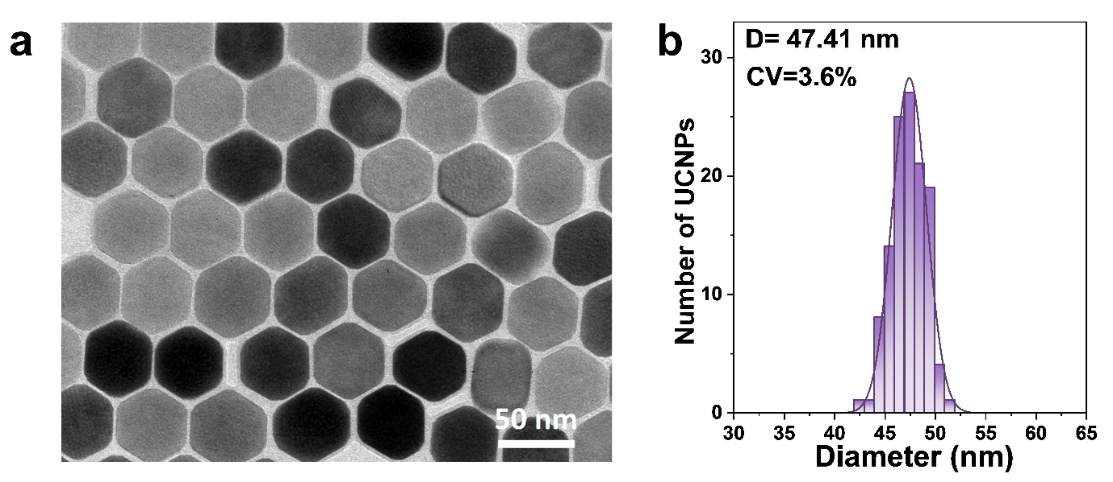
Fig. S1 | TEM image (a) and size histograms (b) of the NaYF₄: 20%Yb³⁺, 4%Tm³⁺ upconversion nanoparticles. The average diameter of nanoparticles is around 47 nm and the coefficients of variation (CV) is 3.6% of over 100 single nanoparticles. Scale bars equals 50 nm.
- Calculation of the band structures for TE and TM modes with different designs.
The band structure and quality factor of silicon nitride nanowell plate are calculated using three-dimensional finite element method (COMSOL). The refractive indices of the medium, the silicon nitride and silicon oxide are set to be 1.3337+1.4992×10⁻⁹i, 2.056+0i and 1.4607+0i, respectively. Period boundary conditions are applied to the x- and y-directions and perfectly matched layers (PML) is constructed along the z-direction are constructed. The band structure is calculated using eigen frequency solver with gradual change of the incident angle. Figure S2A shows the calculated quality factor (Q factor) for the four-transverse electric (TE) modes, which shows that the modes 3 and 4 have Q factors > 10⁹ at point 0, manifesting the BIC modes. The mode 1 has a Q factor < 1000 at that point, which can be considered as the quasi-BIC mode. The H_{z} distributions in the x-y plane for the four modes at point 0 are shown in Fig. S2B.
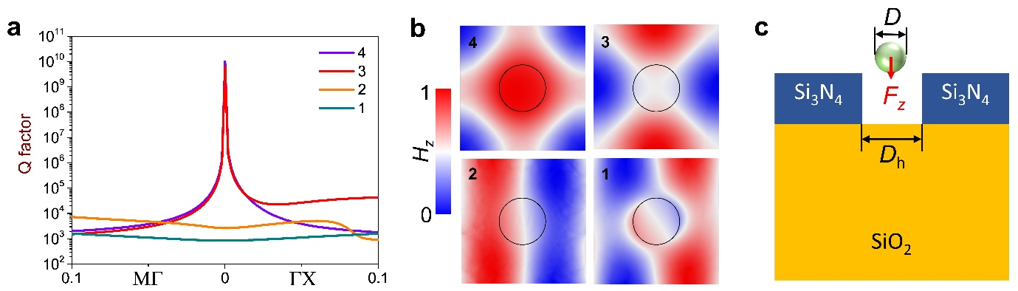
Fig. S2 | Analysis of TE modes when R_{h} = 55 nm. (a) Calculated Q factors of four resonances. (b) H_{z} distributions in the x-y plane (z = -120 nm) in the four resonances in Figs. 1c,d. (c) Illustration of the optical force in the z-direction F_{z}. The nanoparticle (green; diameter D = 100 nm; refractive index RI = 1.58) is placed right above the hole.
A nanoparticle is placed near the hole with the particle centre at z = R, R is the radius of the particle. The calculation of the optical forces (Fig. 2d) in the z-direction F_{z} shows that mode 1 has the largest optical forces comparing to modes 2, 3 and 4. This is because that the BIC modes trap light perfectly inside the nanostructure without radiation, the optical force caused by the energy leaking will be suppressed. The particle itself will also change the resonance of the nanostructure, making some energy leaking to the medium. However, for the mode 1, the light is also nicely trapped inside the hole, and some light is transmitted into the medium above the hole, generating a very large optical forces similar to those from the evanescence wave. The mode 2 has the similar band structure and quality factors as mode 1, but it has smallest optical force at point 0 because light is travelling surround the hole rather than being trapped inside the hole, which results in a weak optical force.

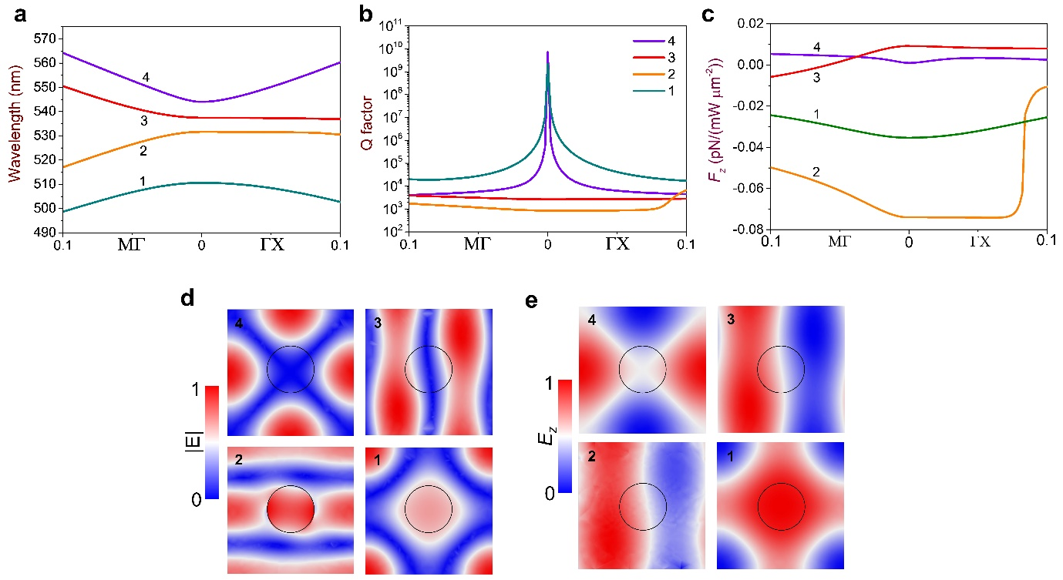
Fig. S3 | Analysis of TM modes when R_{h} = 55 nm. (a) Dispersion relation around 532 nm for laser resonances in both ΓΧ and ΓΜ directions. (b) Calculated Q factors of four resonances with TE modes. Insets show the normalized electric fields. (c) Calculated optical forces in the z-direction of four resonances with TM modes. (d) |E| and E_{z} distributions in the x-y plane (z = -120 nm) in the four resonances with TM modes.
The mode and force analysis for the four-transverse magnetic (TM) modes are shown in Fig. S3. Similar to the TE modes, modes 1 and 4 have Q factors > 10⁹ and can be considered as the BIC mode. The calculation of the optical force shows the mode 2 has the largest F_{z}, which can also be indicated from the normalized electric field in Fig. S3d. It shows that the mode 2 has strong energy trapped inside the hole, while light propagates inside the solid silicon nitride in modes 3 and 4. Mode 1 has a moderate optical force as there is also some energy trapped inside the hole which can also exert an optical gradient force.

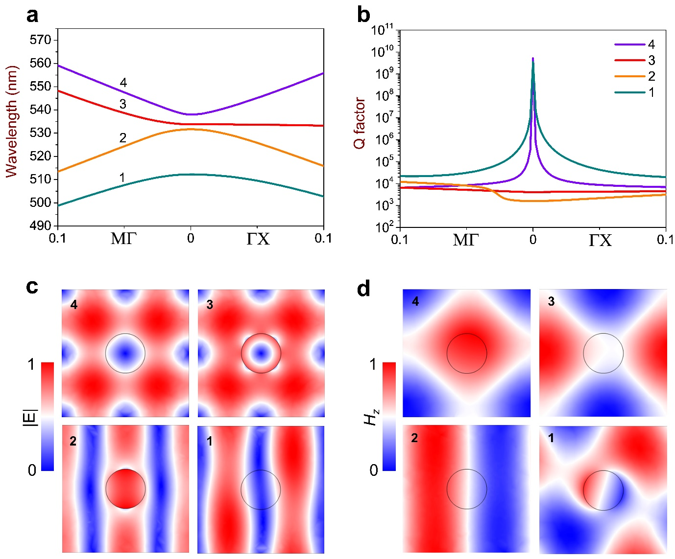
Fig. S4. Analysis of TE modes when R_{h} = 45 nm. (a) Dispersion relation around 532 nm for laser resonances in both ΓΧ and ΓΜ directions. (b) Calculated Q factors of four resonances with TE modes. (c) Normalized electric field distributions in the four resonances in (a) and (b). (d) Simulation of H_{z} distributions in the x-y plane (z = -120 nm) in the four resonances in (a) and (b).
The calculation of the four TE modes when R_{h} = 45 nm is shown in Fig. S4. Similar to those modes when R_{h} = 55 nm, two modes 3 and 4 are the BIC modes, while the other two modes 1 and 2 are the quasi-BIC modes. Meanwhile, only mode 1 has the light confined the nanohole, which could be used for the optical trapping. As radius of the hole (45 nm) is smaller than 55 nm, light is confined to a smaller space which will result in bigger optical forces comparting to the 55-nm hole. Comparison of the optical forces near different holes will be calculated in the latter text.

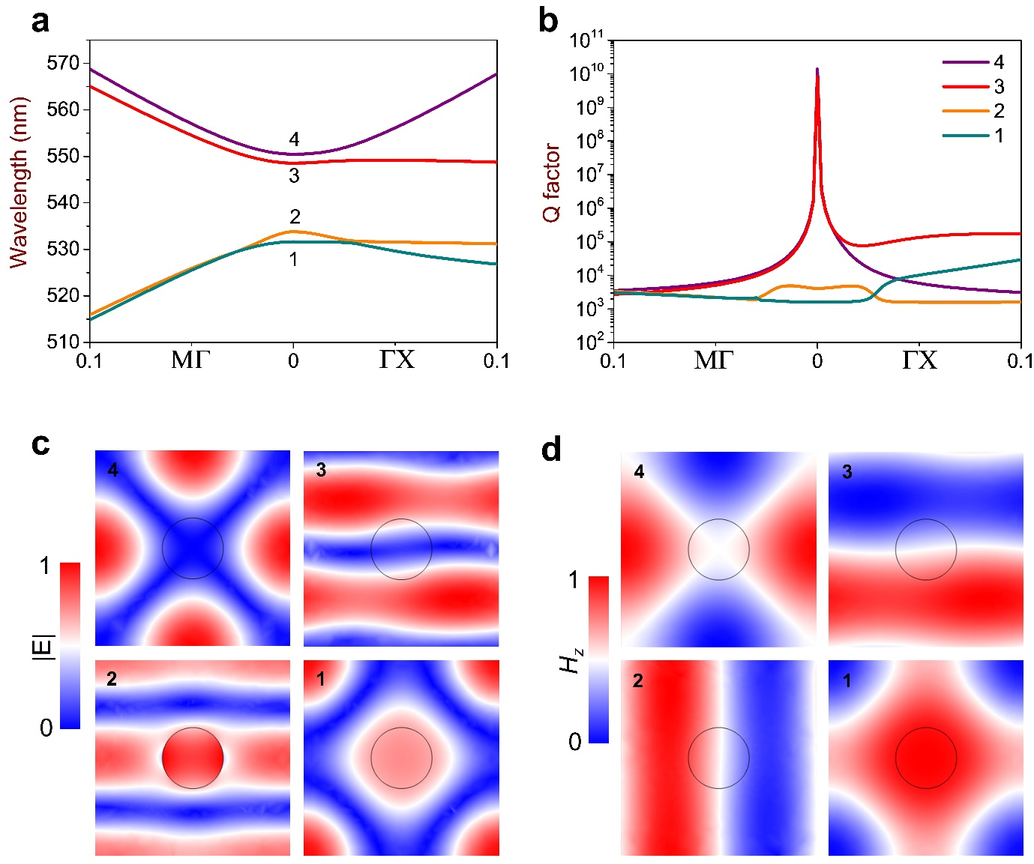
Fig. S5 | Analysis of TM modes when R_{h} = 45 nm. (a) Dispersion relation around 532 nm for laser resonances in both ΓΧ and ΓΜ directions. (b) Calculated Q factors of four resonances with TM modes. (c) Normalized electric field distributions in the four resonances in (a) and (b). (d) Simulation of H_{z} distributions in the x-y plane (z = -120 nm) in the four resonances in (a) and (b).
For the TM modes when R_{h} = 45 nm (Fig. S5), modes 1 and 4 are the BIC modes as seen from the Q factors in Fig. S5b. The mode 2 in TM mode is similar to the mode 1 in TE mode, which could be used for the trapping. The mode 1 here is similar to the mode 1 when R_{h} = 55 nm, we could also expect a moderate optical force.
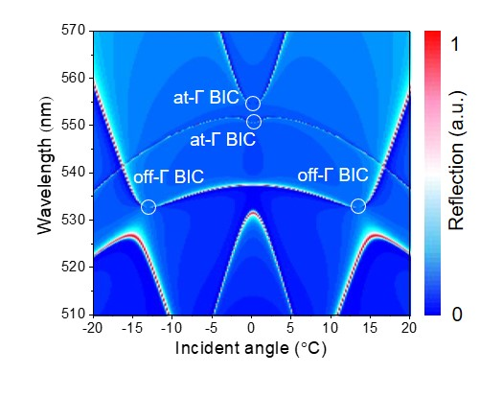
Fig. S6 | Reflection spectrum as a function of incident angle and wavelength.

- Simulation of the temperature in the VDC.
The temperature can be increased to a substantial value for plasmonic tweezers, which is the most serious issue to cause the vibration of the nearby flow stream and damage the trapped biosamples. Our VDC uses the dielectric (Si₃N₄) which does not absorb the manipulation laser (532-nm). Therefore, it does not generate much heat as shown in Fig. 2g, showing that the temperature increment is less than 0.01 °C for the maximum experimental input laser power (1 mW/µm²). Here, we simulate the temperature increment procedure using a laser intensity 100 times higher than the maximum intensity used in the experiment as shown in Fig. S7. The Fig. S7a shows that the temperature reaches a stable status in 1 µs. The temperature increments are approximately 0.45 °C and 0.35 °C for the interval g = 291.5 nm and 295.1 nm, respectively.

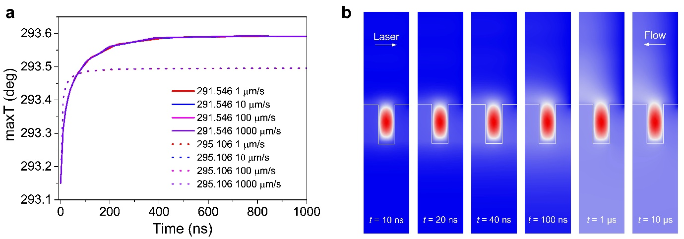
Fig. S7 | Simulation of the temperature in the virus-digital chip. (a) Temperature increment with time under different flow velocities. (b) Temperature distribution in the x-z plane at different time. The temperature stabilizes after 1 µs. The laser power used in (b) is 100 times of that in the experiment.
It is noted that the flow stream does not affect the maximum temperature in the VDC as shown in Fig. S7a. However, it does affect the temperature distributions near the nanohole as shown in Fig. S7b. The heated flow is flushed to the left by the flow stream, causing the heating distribution becoming inhomogeneous. The distribution because steady in approximately 1 µs. The temperature is the highest inside the nanohole because of the highest light intensity inside. The heating comes from the absorption of the 532-nm wavelength by water rather than from the solid silicon nitride. If the medium (water here) does not have any absorption of light, the dielectric chip will not generate any heating effect, serving as a perfect paradigm for the manipulation of tiny bioparticles, such as viruses and exsomes.
- Comparison of optical forces in the conventional photonic crystal and the VDC.
To facilitate the experimental demonstration of the trapping of single viruses, we investigate the reflection spectrum and maximum light intensities inside the nanohole by sweeping the interval g and radius R as shown in Figs. 2a and 2b. The comparison of the conventional photonic crystal made by silicon and the quasi-BIC cavity is shown in Fig. S8. It is found that the reflection and transmission spectra have resonances when the wavelength is 835 nm as shown in Fig. 8b. The radius and thickness of the hole are set to 150 and 240 nm, respectively. The resonance wavelength is then used for the calculation of the optical force on the nanoparticles in the z-direction. The absolute value of the optical forces is approximately several femto newton. The trapping positions for nanoparticles with different size and refractive indices are near z = -30 nm.
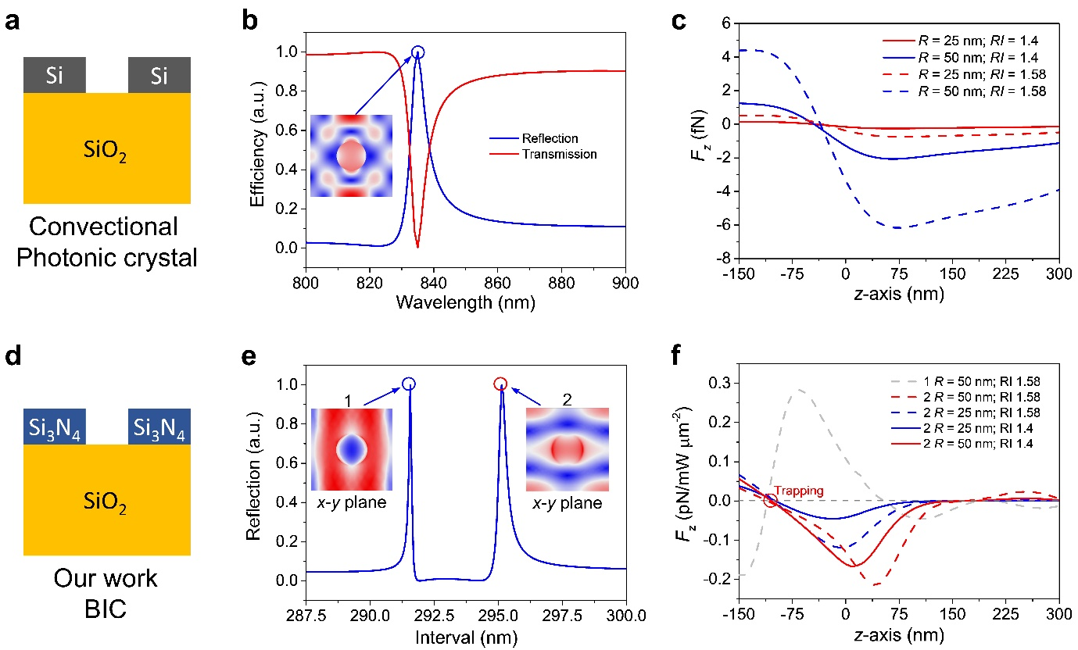
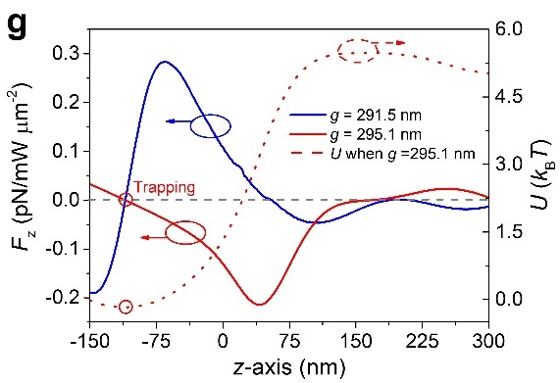
Fig. S8 | Comparison of the mode and forces in the conventional photonic crystal and quasi-BIC. (a) Schematic of a conventional photonic crystal made by silicon on insulator (SOI). (b) Reflection and transmission spectrum with the wavelength. (c) Optical forces in the z-direction on nanoparticles with different radii and refractive indices. (d) Schematic of a BIC cavity made by silicon nitride. (e) Reflection spectrum with different interval g when R = 55 nm. (f) Optical forces in the z-direction on the nanoparticles with different radii and refractive indices in modes 1 and 2. (f) Optical force for the Trapping mode (g = 295.1 nm) and Futile mode (g = 291.5 nm), and the potential well profile for the Trapping mode.
The BIC chip has two resonances at g = 291.5 (mode 1) and 295.1 (mode 2) nm, representing two modes as shown in Fig. S8e. Light propagates surround the nanohole when g = 291.5 nm, which is unsuitable for the optical trapping. Light is trapped inside the nanohole at g = 295.1 nm, which is capable to trap nanoparticles inside. The calculation of optical force in the z-direction also shows that there is no stable trapping position for mode 1. The optical force for mode 2 can reach 200 fN, which is over 20 times larger than that in Fig. S8c. The potential well depth for the Trapping mode is a few k_{B}T, strong enough for the hopping of the nanoparticle. Meanwhile, once the nanoparticle goes inside the nanohole, it will be physically confined inside even when the laser is turned off. In the experiment, the nanoparticle or virus is stably trapped inside even when the flow stream is set to very high (e.g., 1 mm/s).
From Figs. 2a and 2b, we can see that each interval has a resonance with appropriate hole size. Therefore, the optical forces also have the resonances under certain hole sizes as shown in Fig. S8, which shows that the optical force resonances at R_{h} = 35, 45 and 55 nm when g = 286.3, 290.6 and 295.1 nm, respectively.
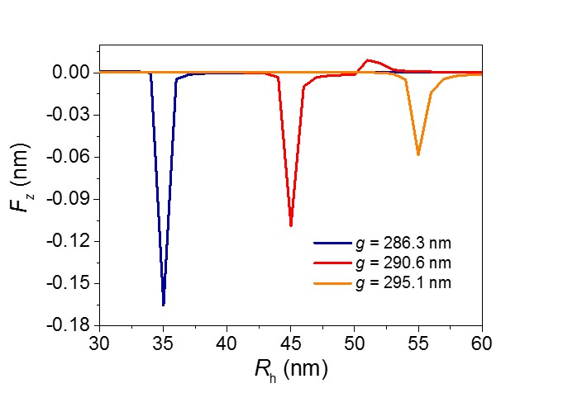
Fig. S9 | Optical forces with the hole size when the interval changes.

- Trapping limit of VDC.
To explore the trapping capability of the VDC, we consider two configurations as shown in Fig. S10a. One is that the hole diameter D_{h} is fixed to 110 nm, another is that the hole diameter is changed with particle diameter D as D_{h} = D + 10 nm. The hole changing scenario is supposed to have larger optical force as the intensity gradient near the hole is larger. However, it is not the case when the size is from 50-90 nm. This may result from disturbance of the light field in the hole when the size of nanoparticle is similar to the hole. This can also be indicated from the dashed curves in which the hole size is fixed to 110 nm. When D ≤ 70 nm, the optical force increases with D. It decreases with D when D > 70 nm as D is becoming closer to D_{h}.
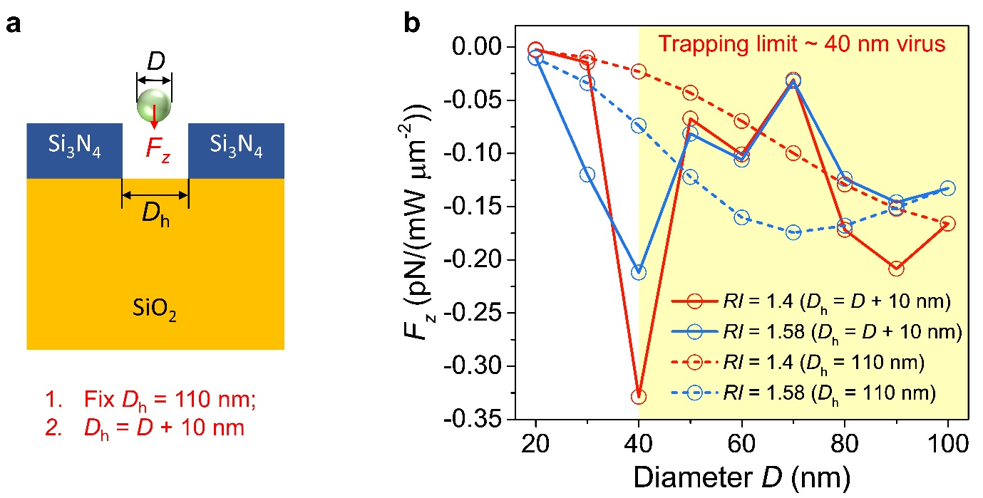
Fig. S10 | Investigation of the trapping limit of the Trapping modes. (a) Schematic of nanoparticles with a diameter of D placed above the hole. The bottom of the nanoparticle is in the same plane of the top surface of the hole. Two schemes are employed to calculate the optical force F_{z}. One is that the diameter of the hole D_{h} is fixe to 110 nm; The other is that D_{h} = D + 10 nm. (b) Calculated F_{z} with particle diameter D in the two schemes. The particle with refractive index 1.4 has a much larger optical forces when D ≥ 40 nm, showing a trapping limit of BIC cavity to be 40 nm.

- Particle kinetics and hydrodynamics in VDC.
Since the hole diameter is very small (≤ 110 nm) and the hole is deep (240 nm), the flow stream will not go inside the nanohole in a long distance as shown in Fig. S11a. The less than 10-nm flow penetration will cause nanoparticles to move above the hole rather than go inside the hole (Fig. S11b). This manifests that the flow dynamics is incapable to locate the nanoparticle inside the holes.
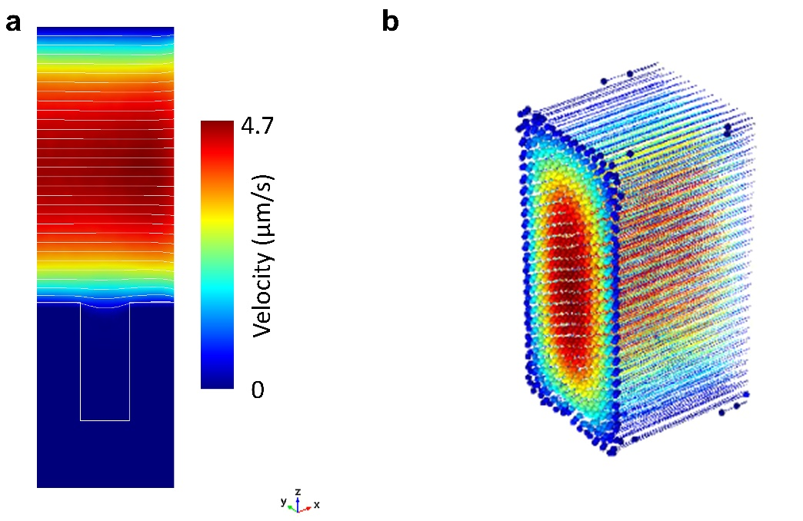
Fig. S11 | Flow and particle dynamics in the optofluidic chip without laser illumination. (a) Flow stream distribution near the nano-hole. (b) Particle moving in the microchannel without going inside the hole.

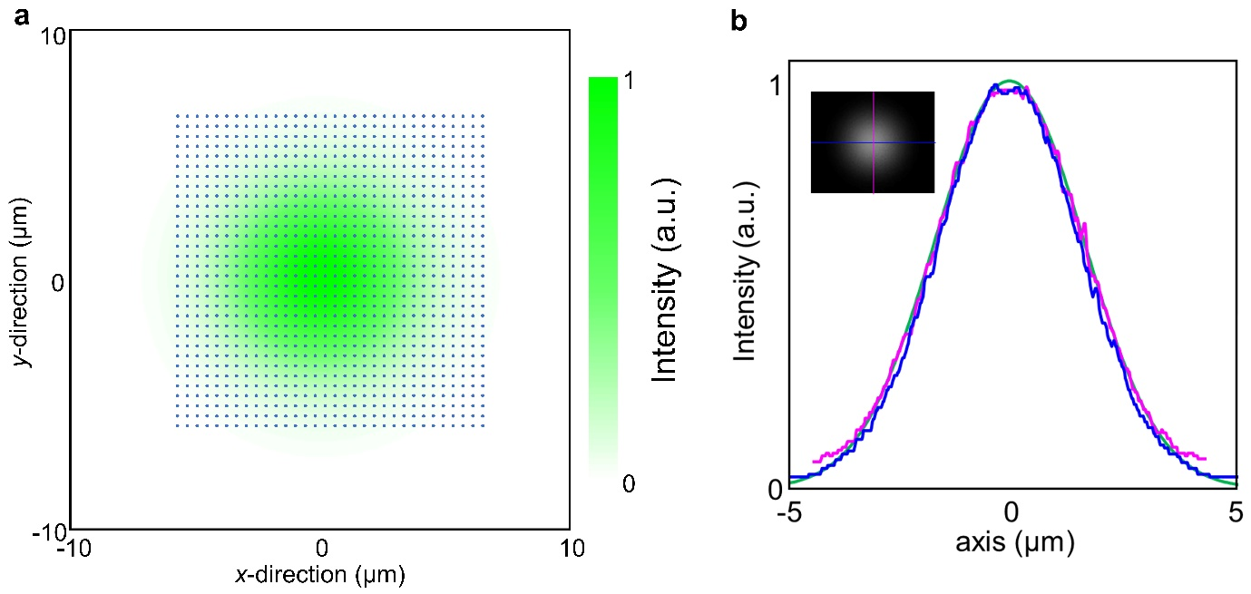
Fig. S12 | Laser spot characterization. (a) Illustration of a 10-µm spot size illuminating on the virus-digital chip. (b) Simulated and measured profile of the input Gaussian beam.

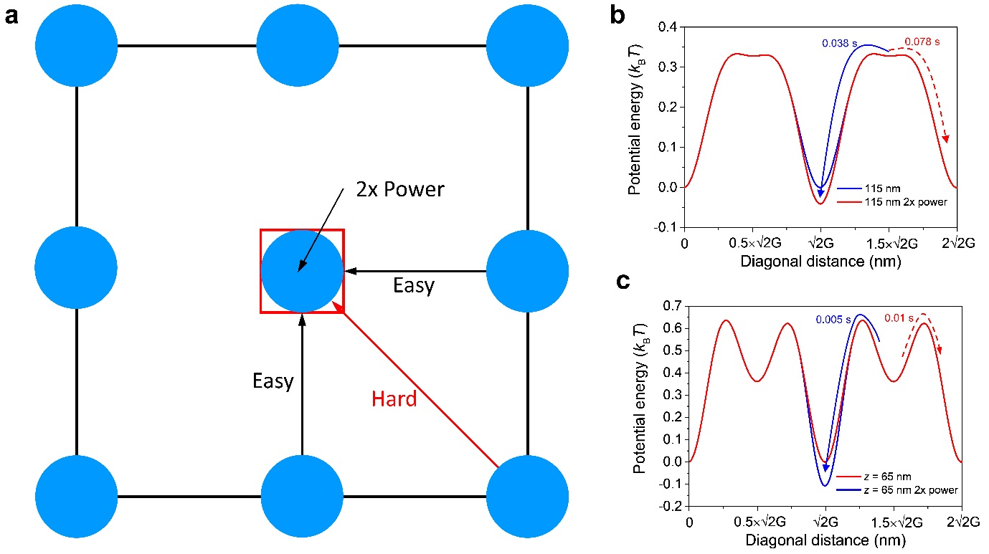
Fig. S13 | Particle hopping in the potential well landscape with gradient laser energy. (a) Laser around each hole can be regarded as a plane wave. The laser power in the region covering the middle hole is set to 2 times of the surrounding holes. Simulation of potential well and particle hopping in the orthogonal when z = (b) 115 nm and (c) 65 nm.

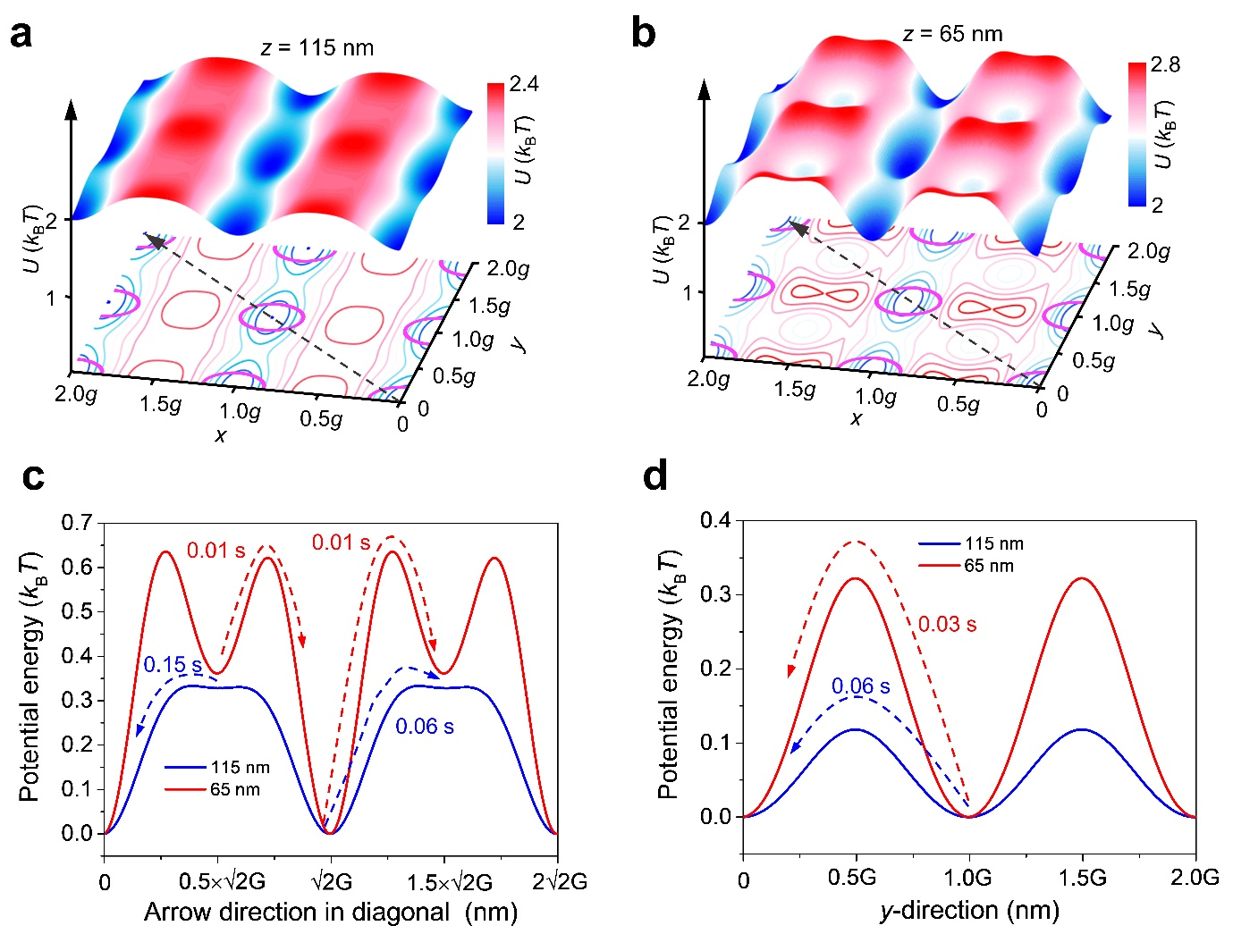
Fig. S14 | Particle hopping in the potential well landscape with homogenous laser energy. Simulated optical trapping potential well landscapes of a 100-nm nanoparticle at (a) z = 115 (particle centre) and (b) z = 65 nm. Dashed arrow indicates one scenario that the particle hopping to the adjacent hole in the diagonal direction. Particle hopping time in the (c) orthogonal and (d) vertical directions.

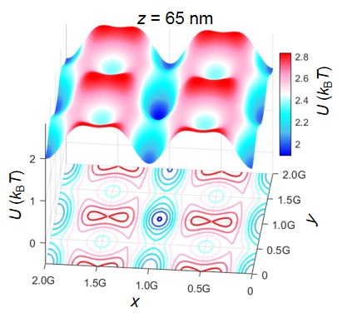
Fig. S15 | Simulated optical trapping potential well landscapes of a 100-nm nanoparticle at z = 65 nm. The power in the middle hole is set to 2 times of that in the adjacent holes.

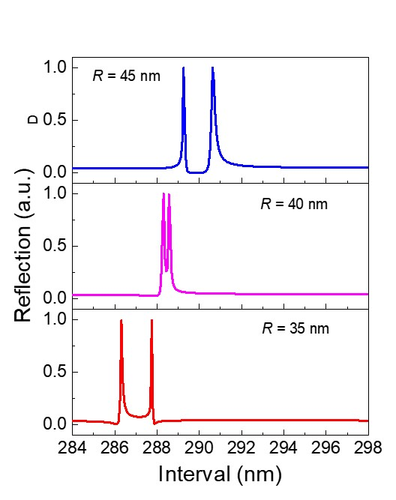
Fig. S16 | Fano resonance with different hole radii and intervals.

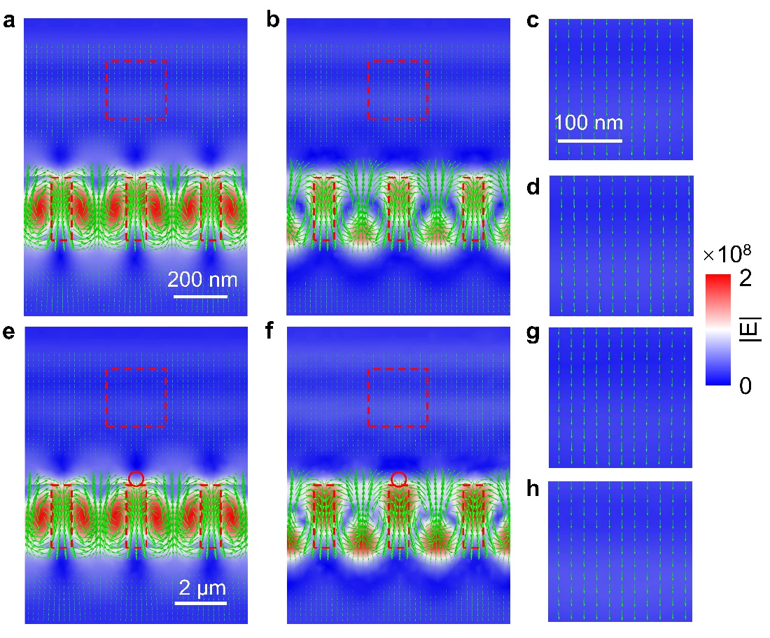
Fig. S17 | Poynting vector distribution in the system. Poynting vector distribution in the (a) y-z and (b) x-z planes without the particle. (c) and (d) plot the enlarged view of Poynting vectors in the squares in (a) and (b), respectively. Poynting vector distribution in the (d) y-z and (e) x-z planes with a 70-nm polystyrene particle marked by the circle. (g) and (h) plot the enlarged view of Poynting vectors in the squares in (e) and (f), respectively.

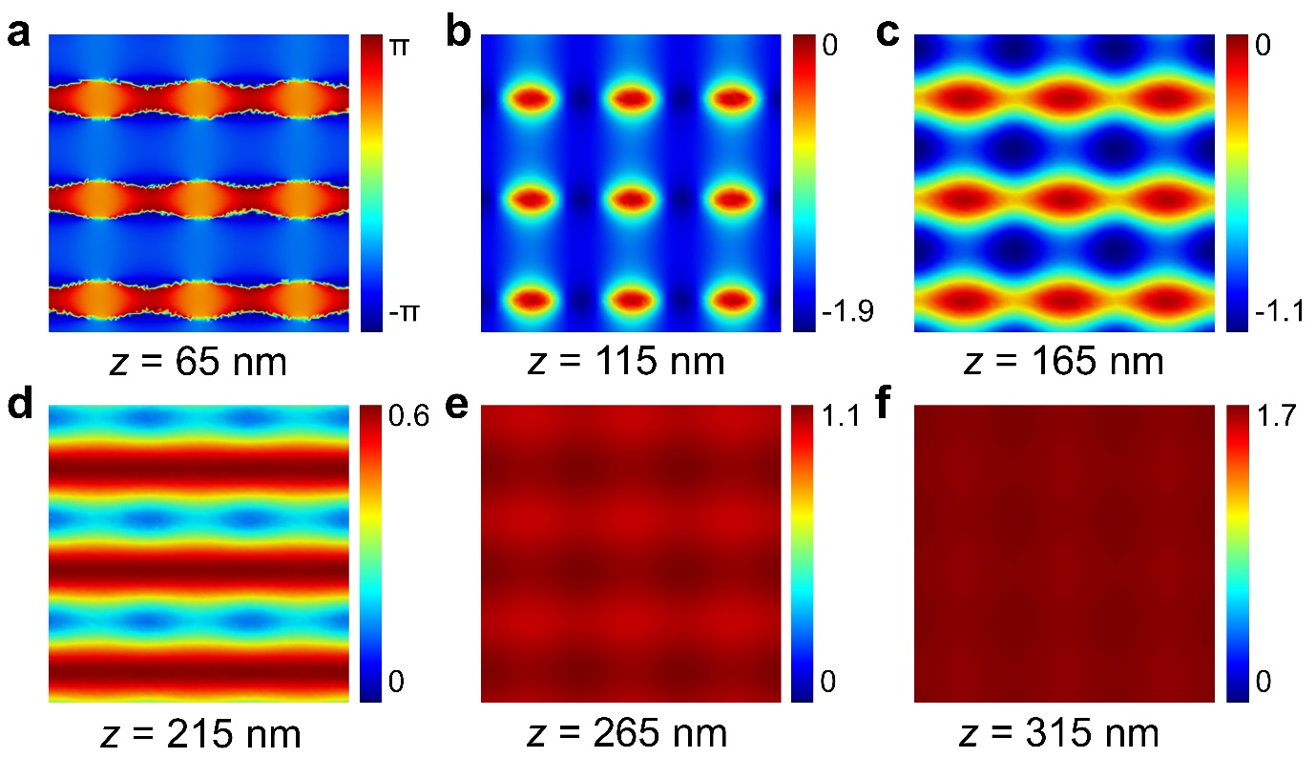
Fig. S18 | Electric field phase distribution in different planes when R_{h} = 55 nm. (a) z = 65 nm; (b) z = 115 nm; (c) z = 165 nm; (d) z = 215 nm; (e) z = 265 nm; (f) z = 315 nm.

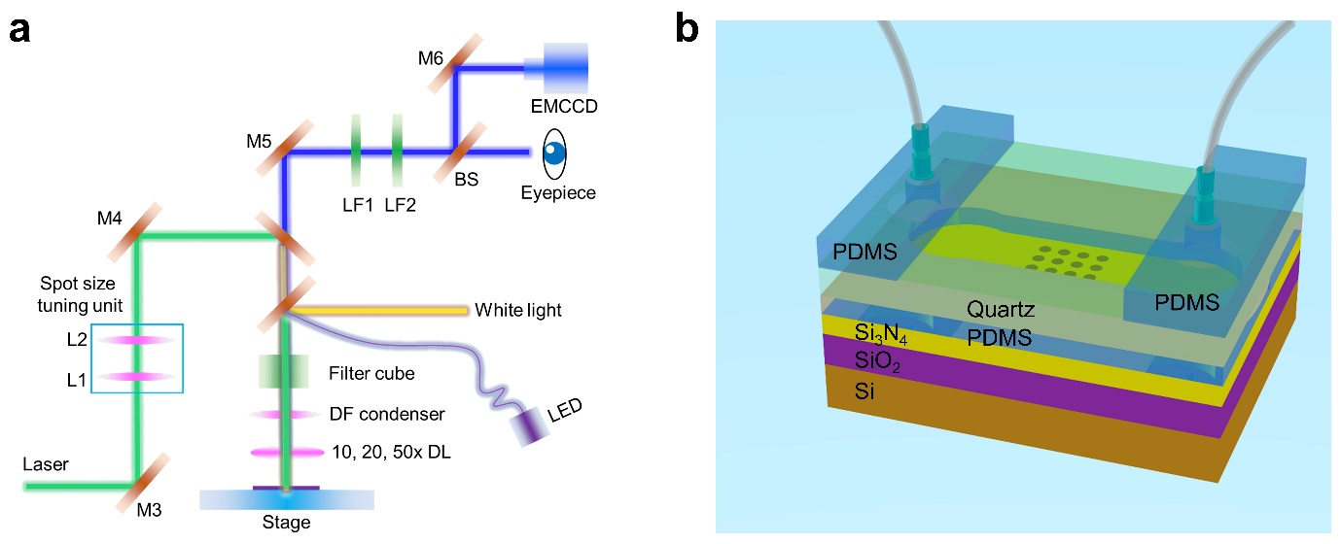
Fig. S19 | Experimental setup and optofluidic chip. (a) L: lens; M: mirror; DF: dark field condenser; LF: 600-nm long pass filter; BS: beam slitter; DL: dark field lens. The spot size tuning unit is used to tune the size of the laser spot. (b) Packaged optofluidic chip.
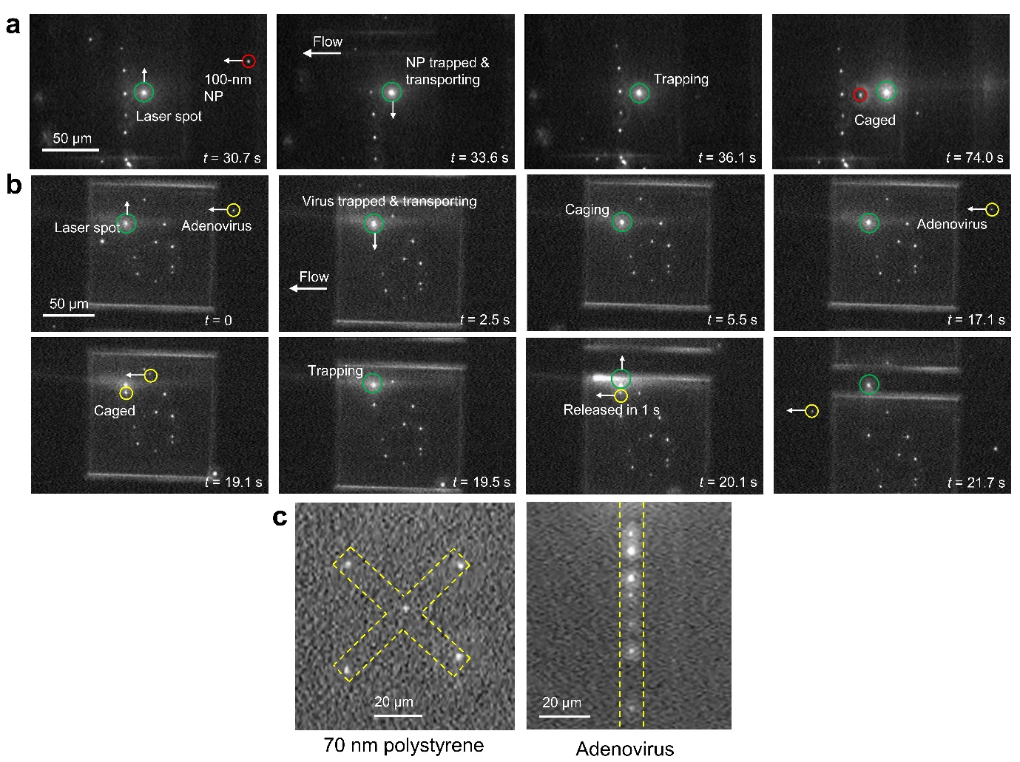
Fig. S20 | Positioning and patterning process of the nanoparticles and adenoviruses in the VDC. Patterning of (a) 100-nm polystyrene nanoparticles and (b) Adenoviruses in the VDC. (c) Patterned 70-nm polystyrene nanoparticles and adenoviruses.

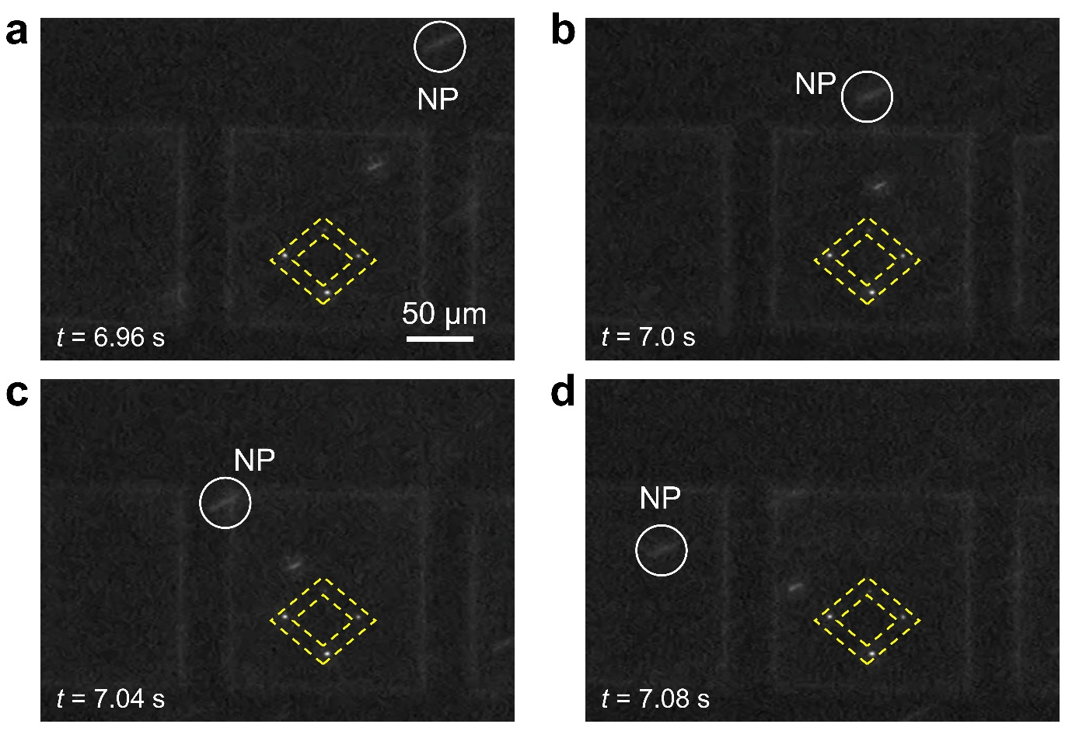
Fig. S21 | Demonstration of stable caging of the 50-nm upconversion nanoparticles in a fast flow velocity (also see Supplementary Movie S4). The flow velocity was approximately 2.5 mm/s. Four 50-nm upconversion nanoparticles are stably caged inside the holes. No non-specific adhesion of nanoparticles to the surface occur, manifesting a good surface treatment protocol (see Methods). Nanoparticles will be flushed away by the fast flow stream if they are not physically caged inside the holes.
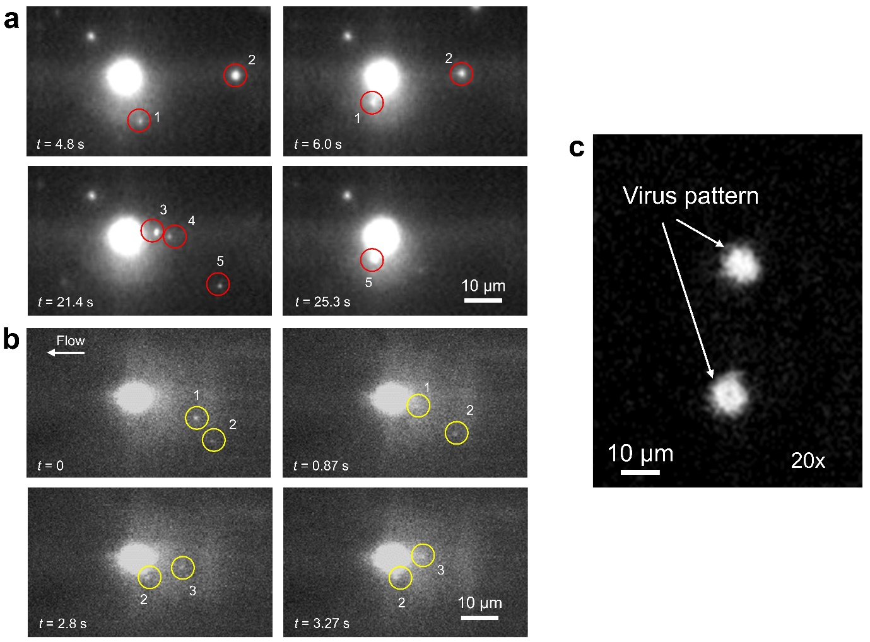
Fig. S22 | Demonstration of trapping multiple (a) 70-nm polystyrene nanoparticles and (b) adenoviruses.

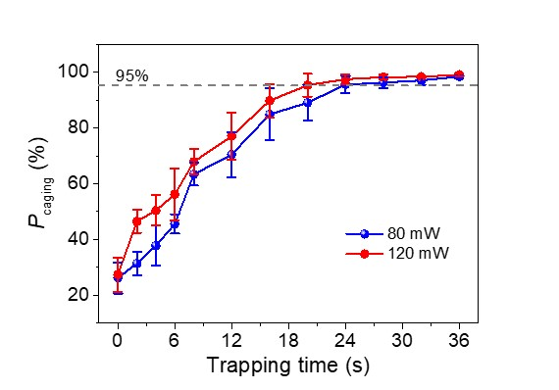
Fig. S23 | Caging probability of 100-nm polystyrene nanoparticles as a function of trapping time and laser power.

