Supplementary Information

Theoretical study of metal-free catalytic for catalyzing CO-oxidation with a synergistic effect on P and N co-doped graphene

Sarinya Hadsadee ¹, Siriporn Jungsuttiwong ^{2*}, Rui-Qin Zhang ³, Thanyada Rungrotmongkol ^{1,4*}

¹Center of Excellence in Biocatalyst and Sustainable Biotechnology, Department of Biochemistry, Faculty of Science, Chulalongkorn University, Bangkok 10330, Thailand.
²Department of Chemistry and Center of Excellence for Innovation in Chemistry, Ubon Ratchathani University, Ubon Ratchathani 34190, Thailand E-mail: siriporn.j@ubu.ac.th
³Department of Physics and Materials science and Centre for Functional Photonics (CFP), City University of Hong Kong, Hong Kong, China.
⁴Program in Bioinformatics and Computational Biology, Graduate School, Chulalongkorn University, Bangkok 10330, Thailand. E-mail: thanyada.r@chula.ac.th

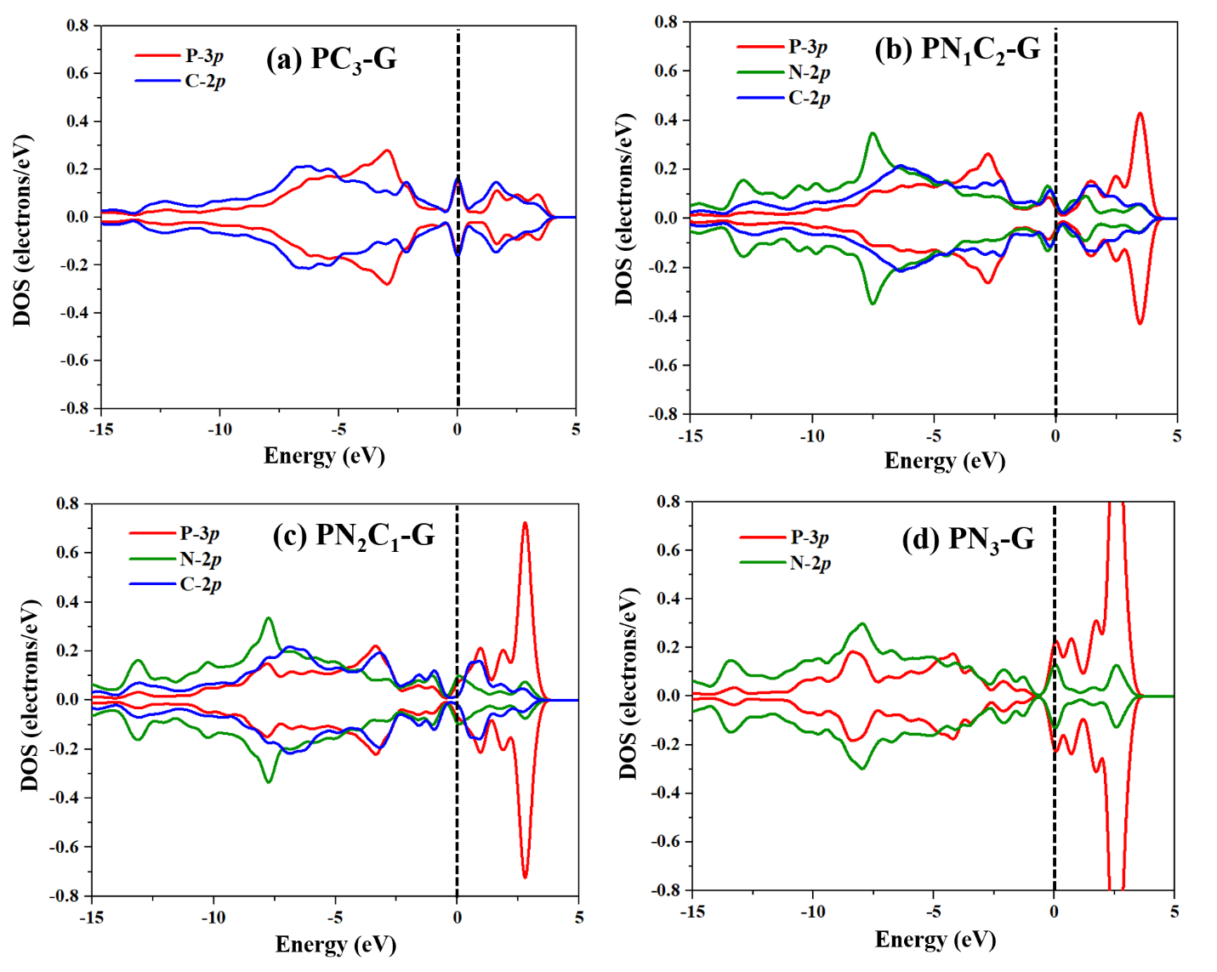
Figure 1. PDOS plots for (a) single vacancy P-embedded graphene, (b) N-doped single vacancy P-embedded graphene, (c) two N-doped single vacancy P-embedded graphene, (d) three N-doped single vacancy P-embedded graphene. The Fermi level is set to zero.
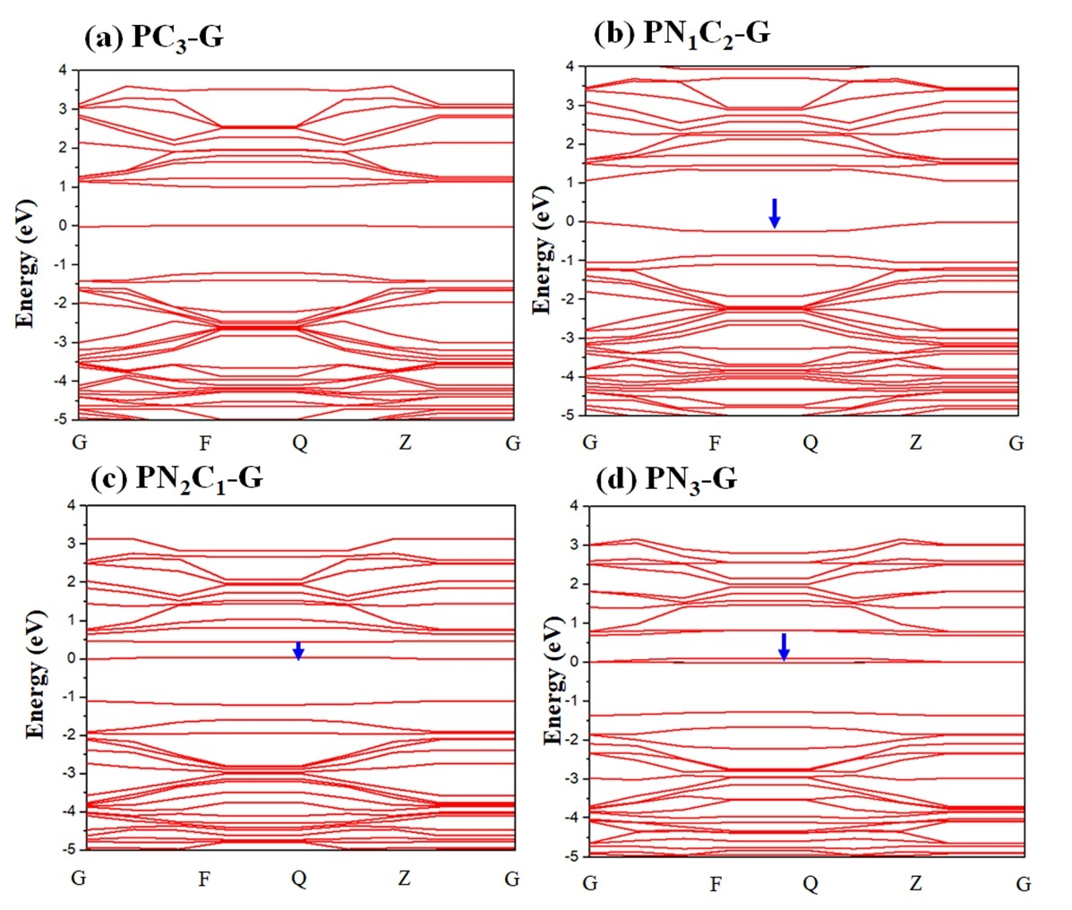

Figure 2. The band structures of (a) PC₃-G, (b) PN₁C₂-G, (c) PN₂C₁-G, and (d) PN₃-G monolayers, which show unpaired spins.
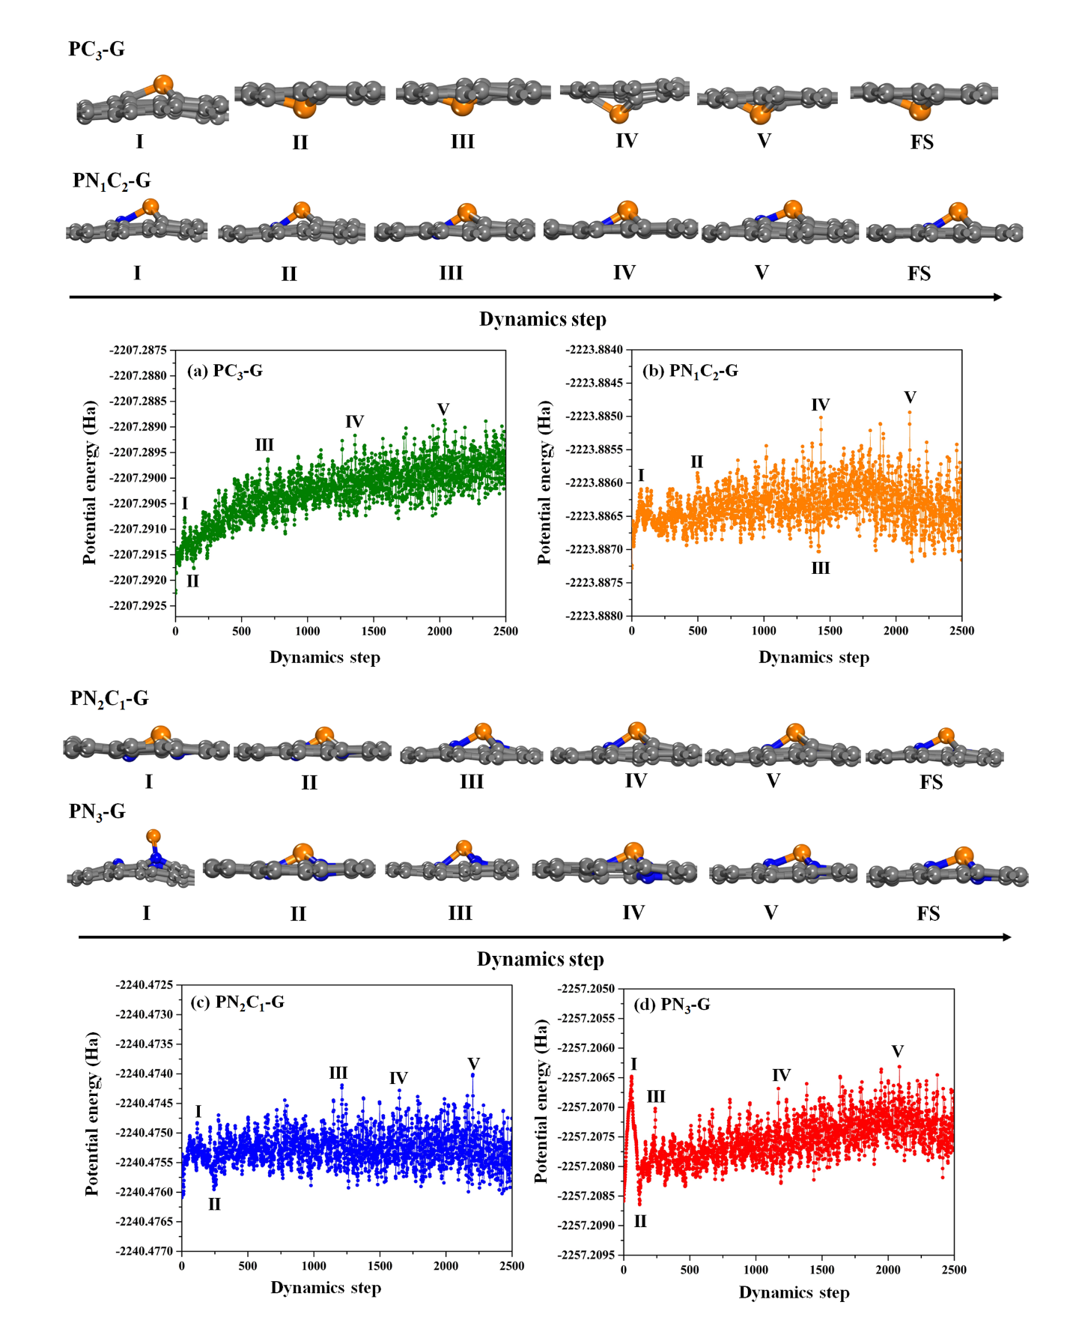
Figure 3. The potential energy as a function of time, obtained from molecular dynamics simulations (MD).

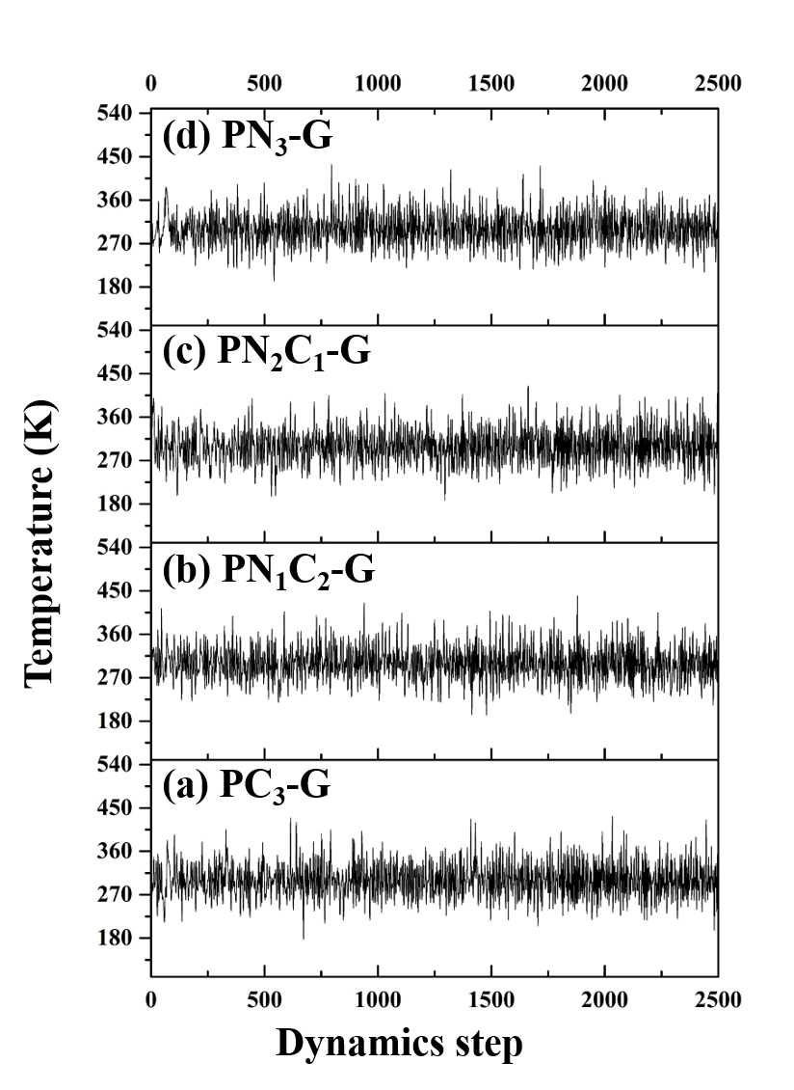
Figure 4. The temperature as the function of time obtained from molecular dynamic simulations (MD).
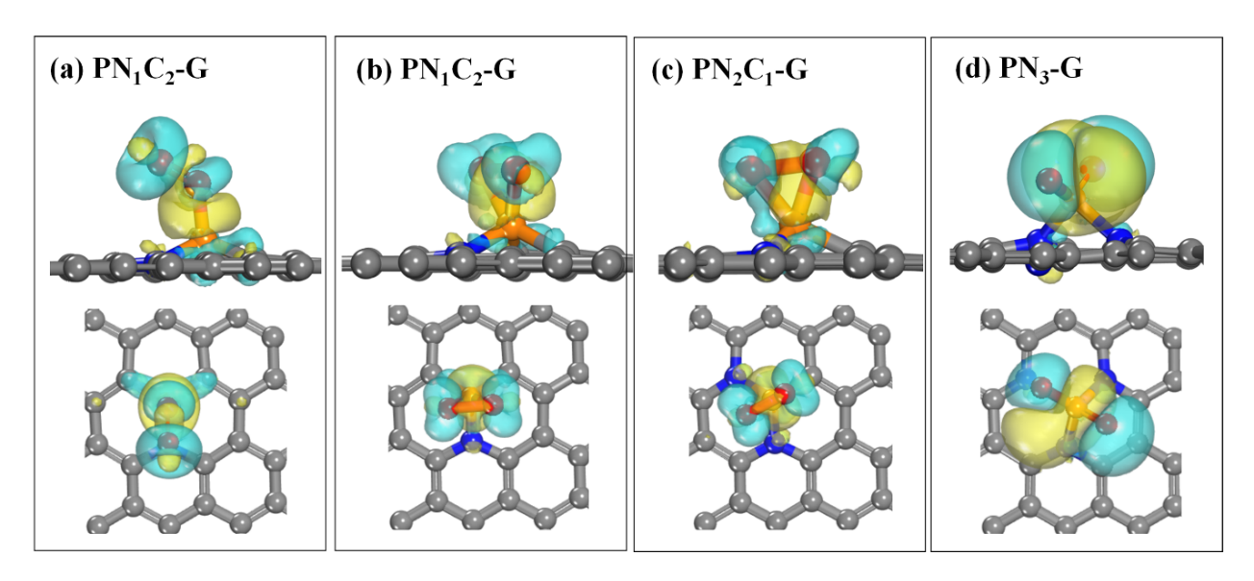
Figure 5. Electron density difference maps of O₂ adsorption on (a) PN₁C₂-G-(End-on), (b) PN₁C₂-G-(Side-on), (c) PN₂C₁-G, and (d) PN₃-G. (the isovalue is ±0.02)

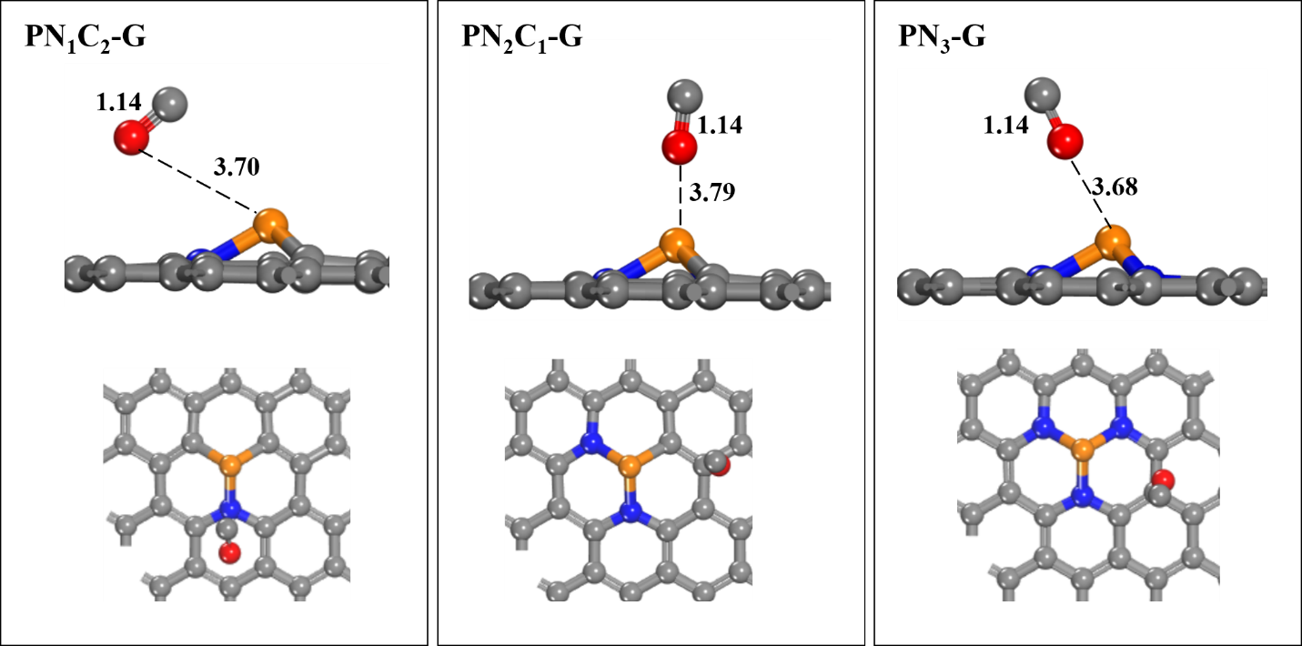
Figure 6. Optimized geometries CO molecule on PNC-G surfaces.
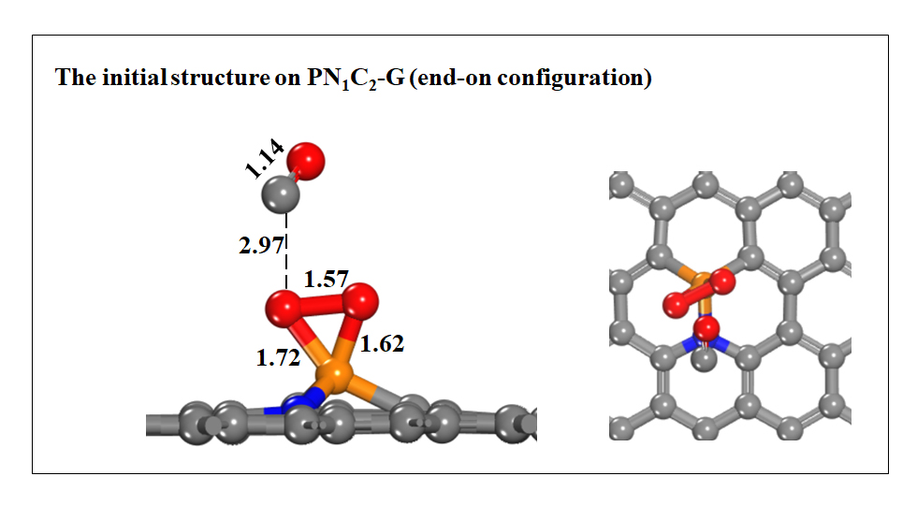
Figure 7. Optimized initial structure of O₂ and CO molecules for end-on configuration of O₂ on PN₁C₂-G
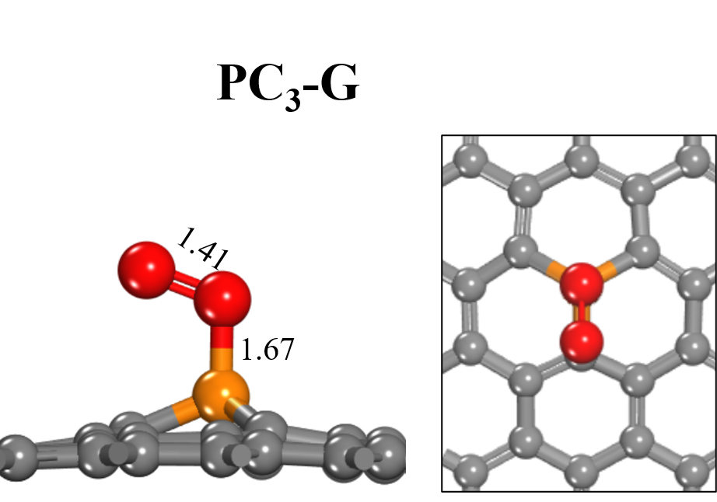
Figure 8. Optimized geometries O₂ molecule on PC₃-G.

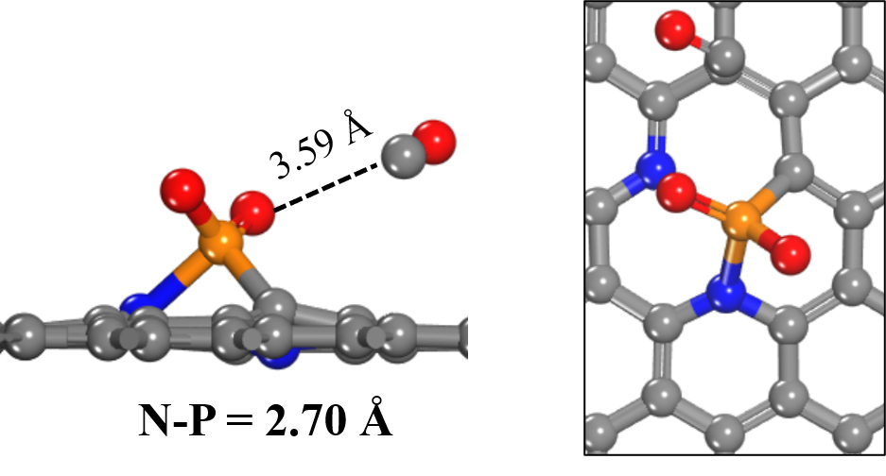
Figure 9. The co-adsorption of O₂ and CO molecules on PN₂C₁-G.
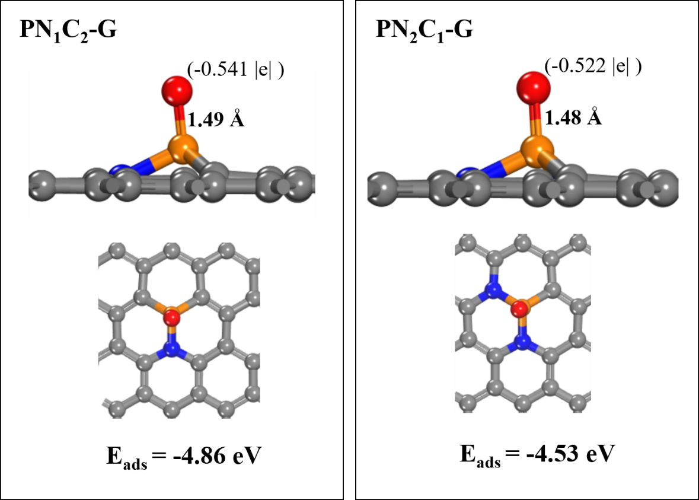
Figure 10. Optimized geometries for the adsorption of O on PN₁C₂-G and PN₂C₁-G

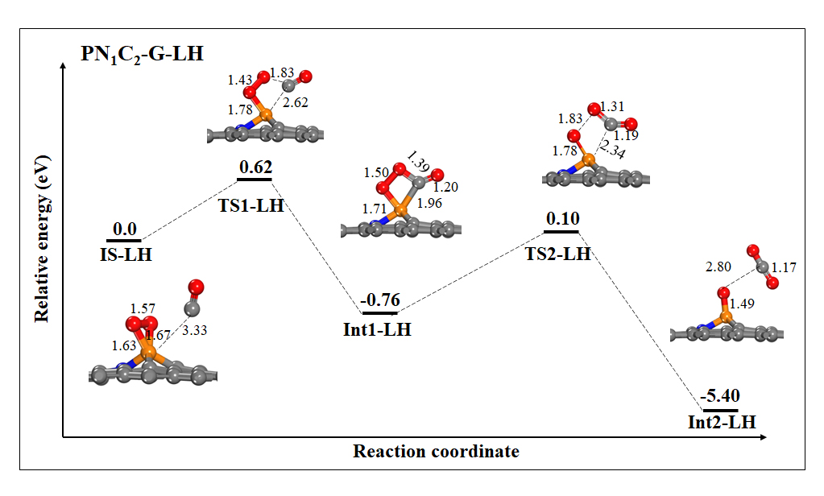
Figure 11 The potential energy surface diagram of CO oxidation shows the LH mechanism for PN₁C₂-G. All bond distances are in Å.
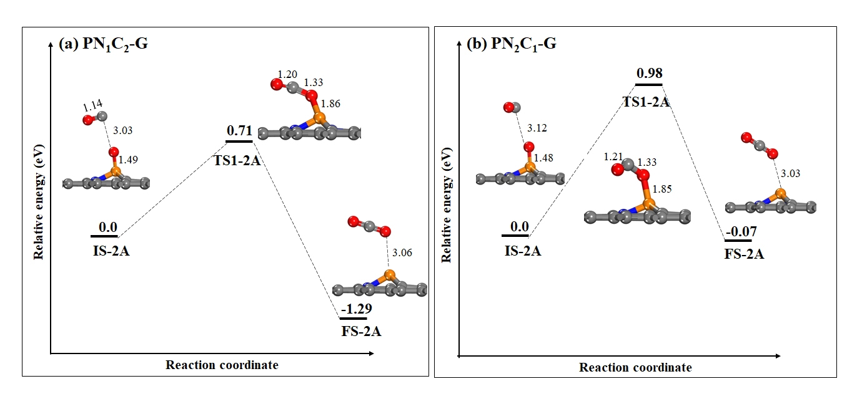
Figure 12. The potential energy surface diagram of CO oxidation via the second step in pathway A. (a) PN₁C₂-G and (b) PN₂C₁-G. All bond distances are in Å.
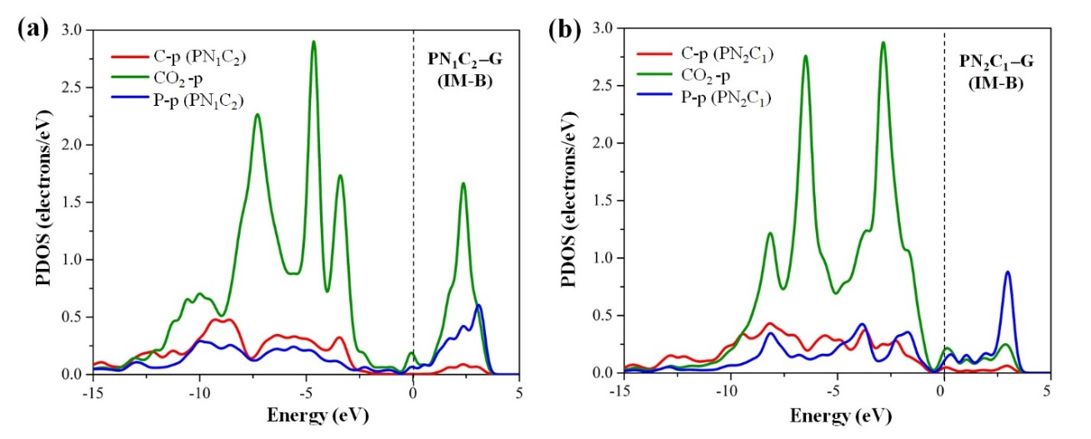

Figure 13. The corresponding PDOS plots for the intermediate (IM-B) of OCO on (a) PN₁C₂-G and (b) PN₂C₁-G in pathway B.
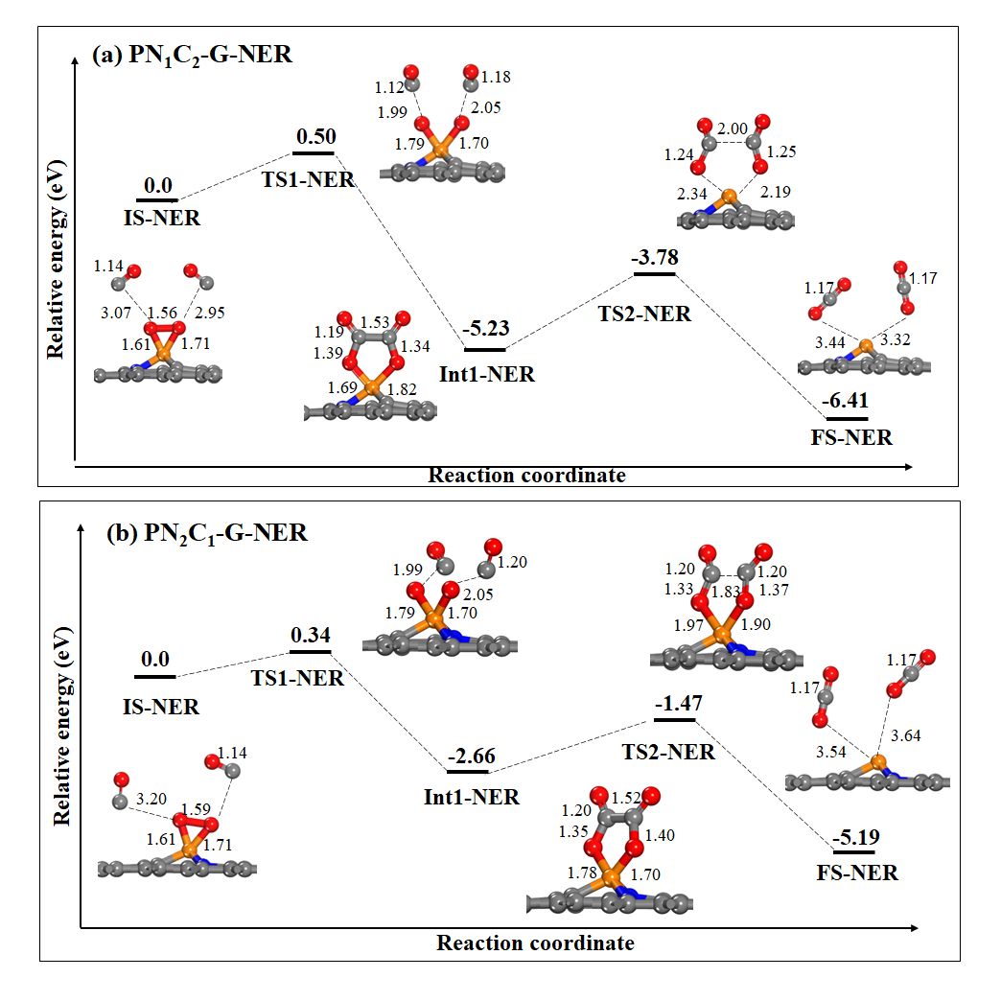
Figure 14. The potential energy surface diagram for CO oxidation via a NER mechanism (a) PN₁C₂-G and (b) PN₂C₁-G. All bond distances are in Å.
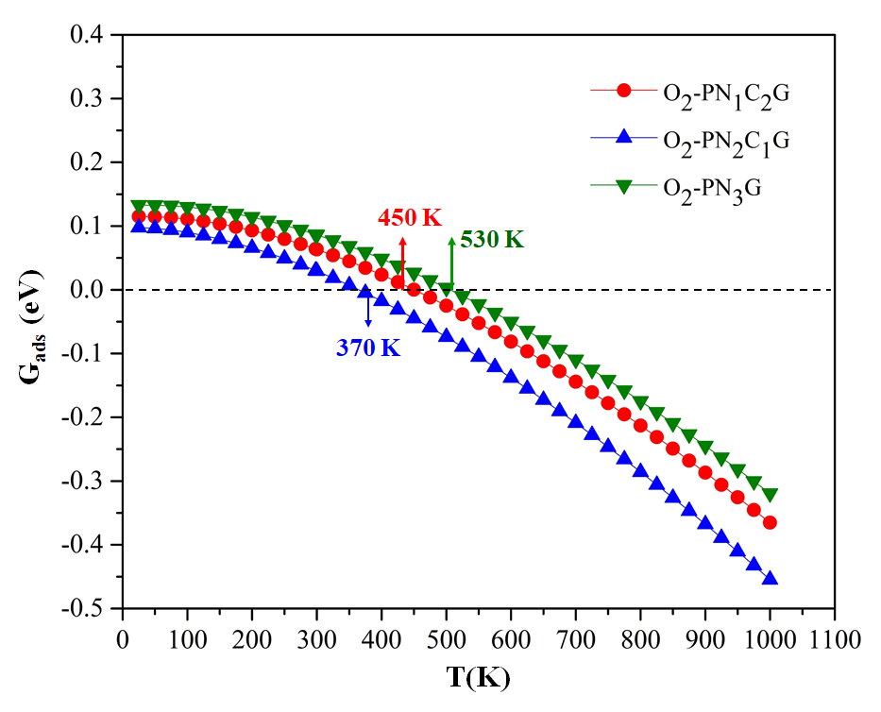
Figure 15. Gibbs free energy dependent on the temperature obtained from DFT calculations.

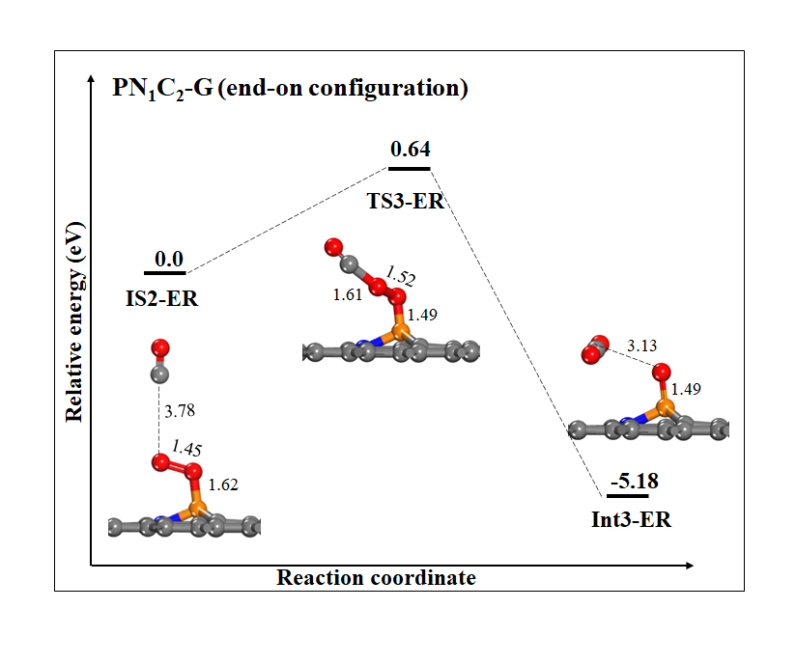
Fig. S16. The potential energy surface diagram of CO oxidation via an ER mechanism the first step of PN₁C₂-G for end-on configuration of O₂. All bond distances are in Å.

Table 1 Calculated atomic charges on the P atom (q_{P}, |e|) and formation energies (E_{form}, eV) of PN_{x}C_{y}-G graphitic monolayers.

Surface | q_{P} | E_{form}
PC₃-G | 0.638 | -1.76
PN₁C₂-G | 0.692 | -1.90
PN₂C₁-G | 0.810 | -1.06
PN₃-G | 0.903 | -0.74

Table 2 The O₂ and CO adsorption energies (E_{ads}, eV) on P-N_{x}C_{y}-G, their corresponding Mulliken charge (q, |e|) of O₂/CO.
Surfaces | Adsorbate | E_{ads} | q(P) | q(N) | q(C) | q(gas)
PC₃-G | Bare | - | 0.638 | - | -0.334 | -
 | O₂ (End-on) | -1.50 | 1.103 | - | -0.365 | -0.565
PN₁C₂-G | Bare | - | 0.692 | -0.595 | -0.349 | -
 | O₂ (End-on) | -0.54 | 1.382 | -0.642 | -0.406 | -0.614
 | O₂ (Side-on) | -1.76 | 1.401 | -0.652 | -0.388 | -0.685
 | CO | 0.48 | 0.716 | -0.573 | -0.339 | 0.001
 | O* | -4.83 | 1.196 | -0.722 | -0.362 | -0.541
PN₂C₁-G | Bare | - | 0.810 | -0.601 | -0.371 | -
 | O₂ (Side-on) | -2.83 | 1.532 | -0.653 | -0.403 | -0.674
 | CO | -0.20 | 0.817 | -0.605 | -0.351 | 0.007
 | O* | -4.53 | 1.332 | -0.737 | -0.376 | -0.522
PN₃-G | Bare | - | 0.903 | -0.612 | - | -
 | O₂ (Side-on) | -4.58 | 1.348 | -0.645 | - | -0.592/-0.582
 | CO | -0.23 | 0.909 | -0.617 | - | 0.008

Table 3. Activation energies of the rate-determining step for CO oxidation on some metal-free catalysts.
Catalyst | Rate determining step (eV)
Si-C₃N nanosheet [1] | 0.38 (LH)
B-N₃ graphene [2] | 0.39 (ER)
N-doped / P-doped graphene [3] | 0.67 (LH)/ 0.54 (LH)
B-doped/B-N doped penta-graphene [4] | 0.34 (ER)/ 0.39 (ER)
P/FeP₄/ CoP₄/ NP₄- doped graphene[5] | 1.19/0.87/0.81/0.79 (LH)
PN₁C₂-G /PN₂C₁-G | 0.60/0.26 (ER) (the present study)
PN₁C₂-G | 0.86 (LH) (the present study)
PN₁C₂-G /PN₂C₁-G | 1.46 /1.19 (NER)  (the present study)

References
1 Esrafili, M. D. & Heydari, S. An effective approach for tuning catalytic activity of C3N nanosheets: Chemical-doping with the Si atom. Journal of Molecular Graphics and Modelling 92, 320-328, doi:https://doi.org/10.1016/j.jmgm.2019.08.011 (2019).
2 Esrafili, M. D. & Mousavian, P. Boosting graphene reactivity with co-doping of boron and nitrogen atoms: CO oxidation by O2 molecule. Applied Surface Science 455, 808-814, doi:https://doi.org/10.1016/j.apsusc.2018.06.053 (2018).
3 Esrafili, M. D., Mohammad-Valipour, R., Mousavi-Khoshdel, S. M. & Nematollahi, P. A Comparative Study of CO Oxidation on Nitrogen- and Phosphorus-Doped Graphene. 16, 3719-3727, doi:https://doi.org/10.1002/cphc.201500488 (2015).
4 Krishnan, R., Wu, S.-Y. & Chen, H.-T. Catalytic CO oxidation on B-doped and BN co-doped penta-graphene: a computational study. Physical Chemistry Chemical Physics 20, 26414-26421, doi:10.1039/C8CP04745F (2018).
5 Xu, X.-Y., Lin, S., Xu, H., Guo, H. & Zhao, C. Mechanistic insights into the CO oxidation reaction catalyzed by P-coordinated metal-doped graphene: The roles of phosphorus and metal atom. Applied Surface Science 556, 149776, doi:https://doi.org/10.1016/j.apsusc.2021.149776 (2021).

