Supporting Information

Fully inkjet-printed flexible organic voltage inverters as a basic component in digital NOT gates

Adam Luczak, Kalyan Y. Mitra, Reinhard R. Baumann, Ralf Zichner, Beata Luszczynska, and Jaroslaw Jung*

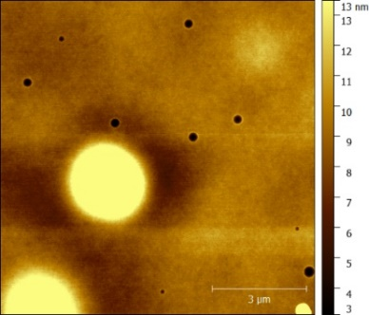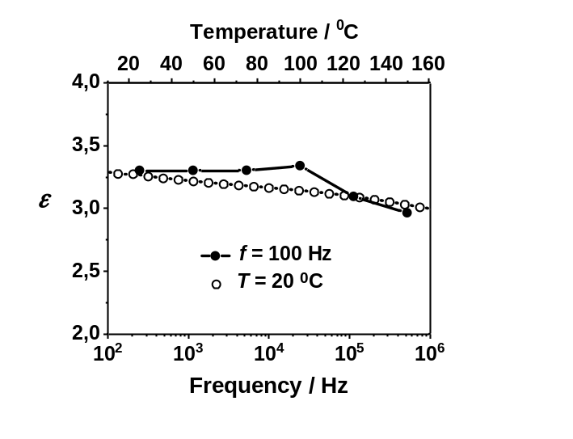
a) b)
Figure S1. AFM images of the surface of a printed PVPh dielectric film a). Yellow round areas are agglomerations of undissolved PVPh, and black dots are the holes in the film. Dielectric permittivity as a function of frequency (white circles) and of temperature (black circles) measured for the printed dielectric film b).
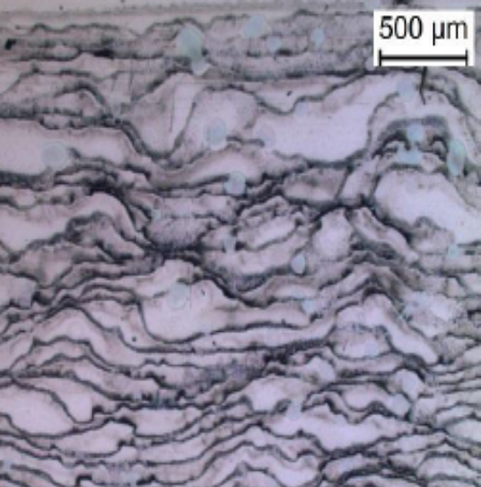
Figure S2. Microscopic image of the surface structure of a DPPDTT layer printed using toluene based ink. The coffee-stain effect is visible on the dry edges of the ink drops.

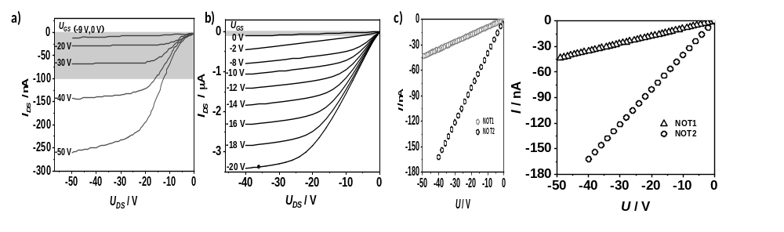
Figure S3. Electrical current-voltage output characteristic of transistors with a DPPDTT layer. The transistors were components in INV1 a) and INV b) electrical circuits. The current-voltage operating ranges of the inverters are marked by gray rectangles. Current-voltage characteristics of the resistors with a P3HT layer for INV1 and INV2 electrical circuits c).

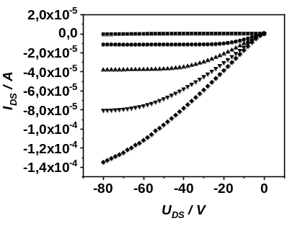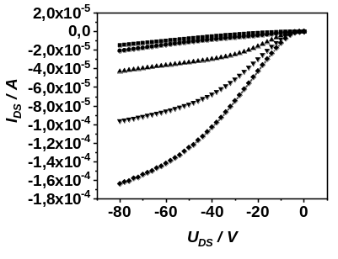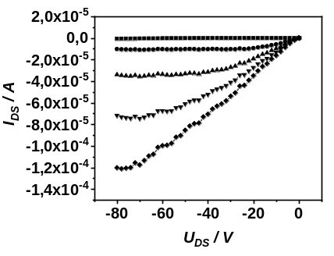
Annealed three-year device
Three-year device
Just after printing
-80V

-60V

-40V

-20V

U_{GS}

b) d) f)

a) c) e)

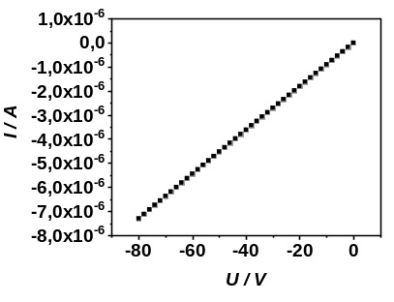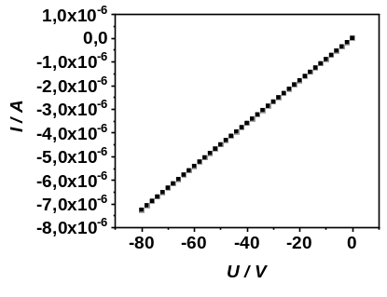
Annealed three-year device
Three-year device
Just after printing
Figure S4. Electrical current-voltage characteristics of the transistor and resistors measured: just after printing a) and b); three years after printing c) and d); after annealing of three-year old devices e) and f).

