Supporting Information

TD-DFT Investigation on Supramolecular Anion Recognition Mechanism of Anthraldehyde based Fluorescent Thiosemicarbazone Derivatives
Sabeel M. Basheerª*, Rohini Gandhaveeti^{b}

Contents
- The low-lying absorption energies for ATSC
- The low-lying absorption energies for ATSC-F complex
- NBO hybridisation orbital analysis
- The calculated potential energy curves for ATSC-F in ground state and excited state
- The calculated potential energy curves for APTSC-F in ground state and excited state
- The ground state and excited state XYZ coordinates (Å) and SCF energies (a.u.) for APTSC, APTSC-F, ATSC and ATSC-F

* Corresponding Author
ª Department of Chemistry, School of Advanced Sciences, VIT-AP University, Andhra Pradesh, India - 522 237
^{b} Department of Chemistry, National Institute of Technology-Tiruchirappalli, Tiruchirappalli-620015, Tamil Nadu, India
E-mail: sabeel.basheer@vitap.ac.in; Tel: +91 8632 3705 84

S1 The low-lying absorption energies for ATSC

Energy  (eV) | Wavelength (nm) | Oscillation frequency  f | Percentage  % | Composition
ATSC |  | -1179.20988183
3.0136 | 411.42 | 0.1453 | 86.24 | H → L
3.1808 | 389.79 | 0.0004 | 100.00 | H-1 → L
3.2891 | 376.95 | 0.0120 | 86.65 | H-2 → L
3.8048 | 325.86 | 0.0056 | 46.00 | H-2 → L+1
3.9405 | 314.64 | 0.0123 | 41.54 | H-1 → L+1
3.9889 | 310.82 | 0.0243 | 43.57 | H-1 → L+2

S2 The low-lying absorption energies for ATSC-F complex

Energy  (eV) | Wavelength (nm) | Oscillation frequency  f | Percentage  % | Composition
ATSC−F |  | -1278.63540680
3.2841 | 377.53 | 0.2463 | 73.35 | H – L
3.7492 | 330.69 | 0.0109 | 44.08 | H-2 – L
3.9857 | 311.07 | 0.0012 | 34.12 | H-2 – L+1
4.0068 | 309.43 | 0.0014 | 27.18 | H-1 – L
4.2651 | 290.69 | 0.0012 | 38.61 | H-2 – L
4.5329 | 273.52 | 0.0007 | 31.08 | H-1 – L+1

S3. NBO hybridisation orbital analysis

Occupancy | Bond orbital | Coefficients | Hybrids
APTSC-F
1.98212 | BD N25-H41 | 77.29% | 0.8791*N25 | s( 33.67%)p 1.97( 66.31%)
 |  | 22.71% | 0.4766*H41 | s( 99.71%)
 | TOTAL |  |  | 0.8791sp²N+0.4766 s H
1.96906 | BD N27-H42 | 77.88% | 0.8825*N27 | s( 26.88%)p 2.72( 73.10%)
 |  | 22.12% | 0.4703*H42 | s( 99.70%)
 | TOTAL |  |  | 0.8825 sp^{2.7} N + 0.4703 s H
1.99999 | CR F44 | --- | --- | s(100.00%)
 | TOTAL |  |  | 1s F
APTSC-F*
1.97729 | BD N27-H42 | 73.02% | 0.8545*N27 | s( 25.30%)p 2.95( 74.67%)
 |  | 26.98% | 0.5194*H42 | s( 99.76%)
 | TOTAL |  |  | 0.8545 sp^{2.9} N + 0.5194 s H
1.99565 | LP F44 | --- | --- | s( 27.65%)p 2.62( 72.34%)
 | TOTAL |  |  | sp^{2.62} F

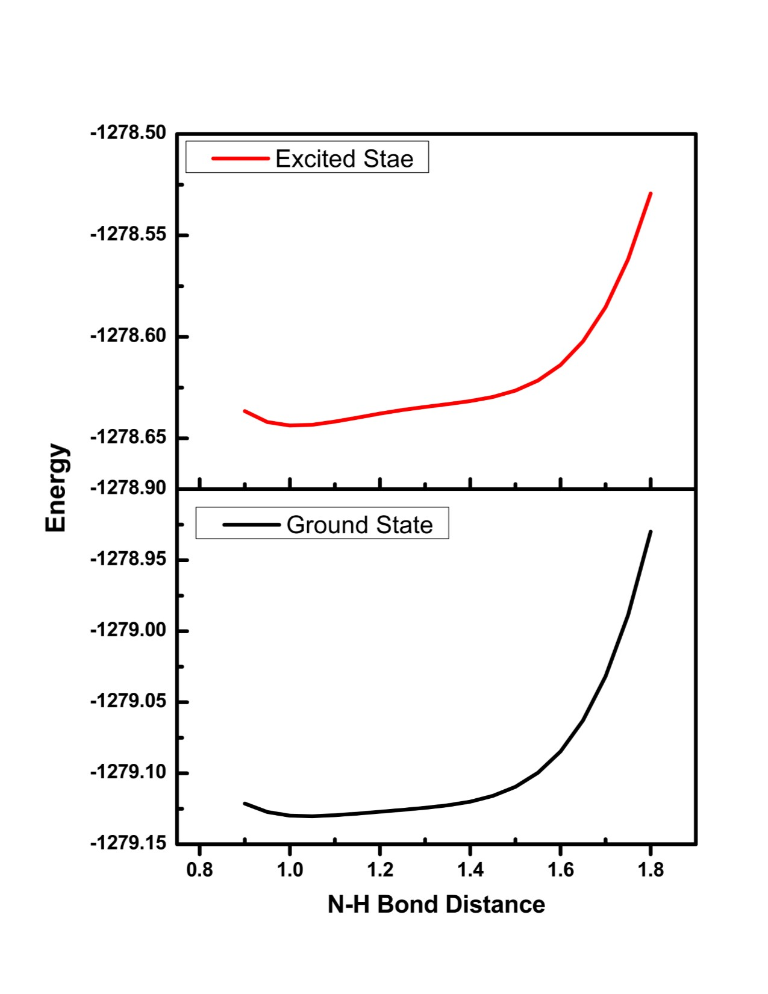
S4. The calculated potential energy curves for ATSC-F in ground state and excited state. The energies of ground state were calculated under the geometries of the corresponding excited state.

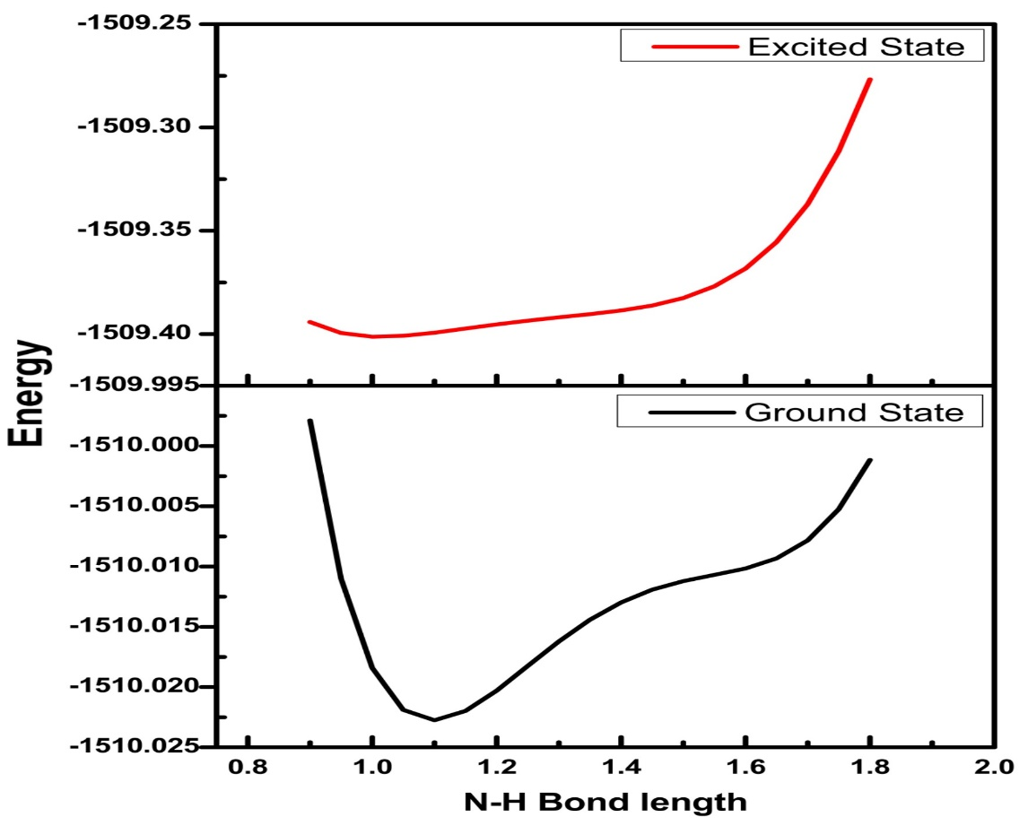
S5. The calculated potential energy curves for APTSC-F in ground state and excited state. The energies of ground state were calculated under the geometries of the corresponding excited state.

S6(a) APTSC in ground state
Energy: -884909.2104483
C 2.22393 -0.28192 -0.74806
C 3.78598 1.21353 1.08311
C 2.89219 1.88708 0.23977
C 2.09776 1.13188 -0.70661
C 4.20883 -2.98840 0.93077
C 4.99488 -2.22624 1.84478
C 4.85856 -0.86143 1.89621
C 3.93773 -0.17941 1.03626
C 3.14209 -0.94829 0.10443
C 3.31009 -2.37227 0.09320
C 2.75574 3.31312 0.28508
C 1.22822 1.86283 -1.58401
H 4.32129 -4.07501 0.90196
H 5.70128 -2.73555 2.50463
H 5.45155 -0.26836 2.59734
C 1.89756 3.96906 -0.56081
C 1.13055 3.23121 -1.51080
H 1.80292 5.05666 -0.51780
H 0.46219 3.76388 -2.19178
H 4.38347 1.79049 1.79428
H 3.35752 3.86876 1.00896
H 0.64256 1.31936 -2.32732
C 1.44017 -1.08767 -1.72798
N 0.16641 -1.26136 -1.77522
N -0.60418 -0.68738 -0.83139
C -1.97937 -0.81443 -0.82336
N -2.52798 -0.11277 0.21382
H 2.70723 -2.97566 -0.58802
S -2.82331 -1.69008 -1.97282
C -3.86961 0.00616 0.64407
C -4.24564 1.22379 1.24007
C -5.53819 1.39993 1.73622
C -6.47709 0.36753 1.64012
C -6.10095 -0.84569 1.05447
C -4.80712 -1.03705 0.56204
H -3.51752 2.03652 1.31108
H -5.81160 2.35342 2.19489
H -7.49123 0.50582 2.02225
H -6.82116 -1.66505 0.98484
H -4.52180 -1.98636 0.11421
H -0.14860 -0.19723 -0.05732
H -1.89918 0.52592 0.69509
H 1.99642 -1.62587 -2.50646

S6(b). Excited state of APTSC*
Energy: -884540.5188976

C 2.21841 -0.45623 -0.53186
C 3.72395 1.63059 0.67325
C 2.56876 1.96612 -0.06166
C 1.81973 0.92934 -0.72074
C 5.12659 -2.34000 1.01653
C 5.86205 -1.30131 1.57000
C 5.39539 0.01045 1.45405
C 4.20404 0.30631 0.76500
C 3.45477 -0.76282 0.16374
C 3.92857 -2.06999 0.33512
C 2.16839 3.30907 -0.21385
C 0.78998 1.32106 -1.58696
H 5.46498 -3.37274 1.11659
H 6.79125 -1.50382 2.10575
H 5.95606 0.83116 1.90723
C 1.09899 3.65813 -1.03958
C 0.42447 2.66736 -1.74203
H 0.81001 4.70559 -1.14397
H -0.39274 2.92610 -2.41752
H 4.29428 2.43092 1.15152
H 2.72774 4.08452 0.31435
H 0.25902 0.56719 -2.16789
C 1.47869 -1.55191 -1.11556
N 0.19823 -1.78444 -1.15951
N -0.60676 -1.01989 -0.41665
C -1.97458 -1.09536 -0.48285
N -2.56083 -0.26890 0.42662
H 3.35932 -2.91206 -0.05778
S -2.76936 -2.05844 -1.58756
C -3.92740 -0.02847 0.68731
C -4.29272 1.27474 1.04514
C -5.61174 1.57256 1.36918
C -6.58509 0.57635 1.33226
C -6.21987 -0.72152 0.98135
C -4.90008 -1.03308 0.66609
H -3.53324 2.05990 1.06492
H -5.87925 2.59440 1.64616
H -7.62240 0.80942 1.58029
H -6.97185 -1.51338 0.96066
H -4.62074 -2.04994 0.40135
H -0.18218 -0.40385 0.28002
H -1.94013 0.37188 0.91333
H 2.06723 -2.34608 -1.59079

S6(c). The Ground state of APTSC-F
Energy: -947605.2560303

C 2.23301 -0.42951 -0.71685
C 3.78873 1.46832 0.70921
C 2.79016 1.91880 -0.16481
C 2.00026 0.95777 -0.90355
C 4.53177 -2.65771 1.24628
C 5.31596 -1.69553 1.94885
C 5.07526 -0.35533 1.77515
C 4.04742 0.10222 0.88762
C 3.25559 -0.86926 0.16473
C 3.53430 -2.25858 0.38892
C 2.54854 3.31883 -0.35682
C 1.02460 1.46396 -1.82450
H 4.72462 -3.72280 1.39780
H 6.10320 -2.03172 2.62815
H 5.66541 0.39048 2.31458
C 1.59499 3.75727 -1.24032
C 0.83128 2.81341 -1.98980
H 1.42176 4.82712 -1.38081
H 0.08458 3.17219 -2.70281
H 4.38428 2.20066 1.26156
H 3.14910 4.03205 0.21423
H 0.43575 0.75881 -2.41179
C 1.46668 -1.44802 -1.48811
N 0.19698 -1.67780 -1.49445
N -0.60213 -0.96918 -0.68532
C -1.97733 -1.10713 -0.72862
N -2.53126 -0.28780 0.20501
H 2.93391 -3.01060 -0.12605
S -2.77061 -2.14276 -1.80805
C -3.84357 -0.03067 0.60170
C -3.98434 0.85662 1.69684
C -5.24218 1.20174 2.18501
C -6.40064 0.67295 1.60012
C -6.26955 -0.20450 0.51990
C -5.01318 -0.55987 0.01742
H -3.08047 1.26659 2.15535
H -5.31823 1.88927 3.03196
H -7.38840 0.94171 1.98251
H -7.16307 -0.62644 0.05052
H -4.91895 -1.24350 -0.82367
H -0.25406 -0.27983 0.06869
H -1.76788 0.26794 0.73281
H 2.04702 -2.11504 -2.13956
F -0.44671 0.73515 1.16982

S6(d). The excited state of APTSC-F
Energy: -947211.5759293

C 2.25377 -0.67110 -0.33551
C 3.36694 1.91643 0.04588
C 2.11660 1.80591 -0.57462
C 1.56392 0.50583 -0.84235
C 5.78068 -1.45766 0.84231
C 6.28235 -0.16354 1.07675
C 5.48480 0.92906 0.82789
C 4.15992 0.78604 0.32764
C 3.63952 -0.53151 0.10395
C 4.48909 -1.62695 0.37767
C 1.39740 2.96171 -1.00702
C 0.41545 0.43794 -1.66653
H 6.40743 -2.33188 1.03051
H 7.29875 -0.02915 1.45393
H 5.86188 1.93929 1.00684
C 0.25043 2.85016 -1.75417
C -0.22999 1.57496 -2.11864
H -0.27629 3.74793 -2.08720
H -1.11357 1.48067 -2.75335
H 3.77797 2.91069 0.23937
H 1.80246 3.94538 -0.75614
H 0.03330 -0.53552 -1.97123
C 1.63130 -1.93408 -0.21875
N 0.33059 -2.20913 -0.20038
N -0.50404 -1.35777 0.31333
C -1.81623 -1.38612 -0.08650
N -2.51193 -0.42476 0.59635
H 4.13561 -2.64491 0.21407
S -2.41097 -2.43021 -1.26392
C -3.84283 -0.01155 0.60150
C -4.14676 1.07106 1.45044
C -5.44070 1.56022 1.54548
C -6.46996 0.98527 0.79803
C -6.17422 -0.08433 -0.04186
C -4.87891 -0.58688 -0.14939
H -3.34689 1.52628 2.04010
H -5.64752 2.40061 2.21188
H -7.48927 1.36915 0.87136
H -6.96767 -0.54619 -0.63440
H -4.65644 -1.41932 -0.81121
H -0.14400 -0.28646 1.32632
H -1.91232 0.11956 1.22105
H 2.26135 -2.82479 -0.13896
F -0.18300 0.49095 1.95352

S6(e) The ground state of ATSC
Energy: -740034.8620422
C -0.60537 0.19633 0.76665
C -2.58604 -1.22258 -0.67935
C -2.76880 0.14597 -0.43630
C -1.76026 0.87609 0.29978
C 0.79002 -3.29269 0.79185
C -0.19648 -3.98736 0.03074
C -1.28905 -3.31325 -0.45297
C -1.45674 -1.90990 -0.21472
C -0.44463 -1.19526 0.53493
C 0.67038 -1.94638 1.03749
C -3.92991 0.84098 -0.90674
C -1.96994 2.27806 0.51570
H 1.64784 -3.84172 1.18788
H -0.08018 -5.05755 -0.15600
H -2.05822 -3.83719 -1.02635
C -4.09569 2.18236 -0.66766
C -3.10073 2.90723 0.05253
H -4.98573 2.70200 -1.03038
H -3.23945 3.97621 0.23213
H -3.34713 -1.76963 -1.24256
H -4.68299 0.27694 -1.46324
H -1.21337 2.85512 1.05069
C 0.40169 0.95769 1.55671
N 1.62681 1.20038 1.24854
N 2.12550 0.76349 0.07235
C 3.42946 1.01498 -0.27738
N 4.16153 1.66701 0.63309
H 1.43001 -1.43772 1.63314
S 4.00683 0.50053 -1.77510
H 0.08219 1.39362 2.51184
H 3.73771 1.95612 1.51009
H 1.54828 0.28121 -0.61788
H 5.12742 1.88443 0.42695

S6(f) The excited state of ATSC (ATSC*)
Energy: -739750.6464124
C -0.68028 0.41853 0.55282
C -2.40234 -1.54603 -0.56611
C -2.89655 -0.23650 -0.37799
C -2.04320 0.77135 0.18958
C 1.30877 -2.78741 1.00461
C 0.51427 -3.69928 0.32030
C -0.69564 -3.27933 -0.23207
C -1.12227 -1.93899 -0.12897
C -0.25804 -0.97215 0.49422
C 0.91682 -1.44293 1.09546
C -4.20937 0.10364 -0.75694
C -2.55564 2.07041 0.30262
H 2.24089 -3.10689 1.47367
H 0.82146 -4.74293 0.23029
H -1.34435 -3.99726 -0.73893
C -4.70083 1.40008 -0.59396
C -3.87253 2.38283 -0.06900
H -5.72387 1.63741 -0.89144
H -4.23292 3.40645 0.04707
H -3.05759 -2.29507 -1.01786
H -4.84591 -0.67073 -1.19105
H -1.92708 2.87533 0.68198
C 0.18349 1.46293 1.03955
N 1.45193 1.68762 0.83291
N 2.11369 0.97228 -0.08189
C 3.45099 1.15720 -0.28810
N 4.03624 2.05874 0.49913
H 1.54627 -0.75443 1.65881
S 4.23811 0.25602 -1.46709
H -0.27610 2.23311 1.66908
H 3.47543 2.56418 1.17823
H 1.65149 0.29213 -0.68504
H 5.02362 2.24588 0.39142

S6(g) The ground state of ATSC-F
Energy: -802573.6671110
C 0.64155 -0.26996 -0.72413
C 2.90931 1.03495 0.38880
C 1.79887 1.79772 0.00141
C 0.64382 1.14022 -0.57107
C 2.94228 -3.16697 -0.07928
C 4.07873 -2.50212 0.46978
C 4.06823 -1.13801 0.62309
C 2.93099 -0.35787 0.23244
C 1.77854 -1.02589 -0.33351
C 1.83169 -2.45400 -0.46314
C 1.79051 3.22433 0.14582
C -0.45393 1.96239 -0.98922
H 2.95589 -4.25445 -0.18849
H 4.95264 -3.08491 0.77166
H 4.93152 -0.61978 1.04958
C 0.71398 3.97049 -0.26263
C -0.41984 3.32762 -0.84422
H 0.72102 5.05769 -0.15039
H -1.26852 3.93205 -1.17487
H 3.78028 1.53845 0.81792
H 2.66792 3.70673 0.58536
H -1.32771 1.48320 -1.43096
C -0.49776 -0.97746 -1.37756
N -1.73050 -1.07701 -1.00700
N -2.11935 -0.50976 0.15203
C -3.43280 -0.60742 0.47825
N -3.71719 -0.01952 1.66993
H 0.96431 -2.98005 -0.86583
S -4.69317 -1.34923 -0.41444
H -0.25863 -1.51672 -2.30535
H -2.95748 0.40157 2.20458
H -1.35131 0.10710 1.15815
H -4.66445 -0.04749 2.01802
F -1.00341 0.59557 2.02978

S6(h) The excited state of ATSC-F (ATSC-F*)
Energy: -802413.4000944
C 0.76921 -0.60437 -0.46260
C 2.31435 1.66411 0.26290
C 0.97832 1.85271 -0.10972
C 0.19603 0.72920 -0.55164
C 4.26749 -2.06033 -0.16318
C 4.99577 -0.92821 0.24432
C 4.34971 0.27862 0.39217
C 2.95819 0.41572 0.13211
C 2.20972 -0.73952 -0.27138
C 2.90775 -1.96071 -0.40238
C 0.38226 3.15049 -0.11843
C -1.06774 0.99513 -1.13025
H 4.77000 -3.02210 -0.28598
H 6.06679 -1.00735 0.44474
H 4.90403 1.16438 0.71332
C -0.87635 3.35447 -0.63147
C -1.59911 2.27315 -1.17549
H -1.30733 4.35889 -0.64056
H -2.57922 2.43764 -1.62803
H 2.90124 2.52713 0.58840
H 0.96744 3.99024 0.26511
H -1.63788 0.17590 -1.56678
C -0.02198 -1.77832 -0.51110
N -1.31740 -1.89187 -0.25632
N -1.88533 -1.07152 0.57980
C -3.22830 -0.82152 0.46397
N -3.65793 0.04012 1.40916
H 2.37579 -2.86222 -0.70677
S -4.25282 -1.46930 -0.70548
H 0.45256 -2.72563 -0.78426
H -2.97373 0.46638 2.03225
H -1.20866 -0.25966 1.68895
H -4.61688 0.35748 1.39281
F -1.02849 0.38299 2.42656

