Supplementary information 1-1. Boosting model ROC curve graph (Xgboost)
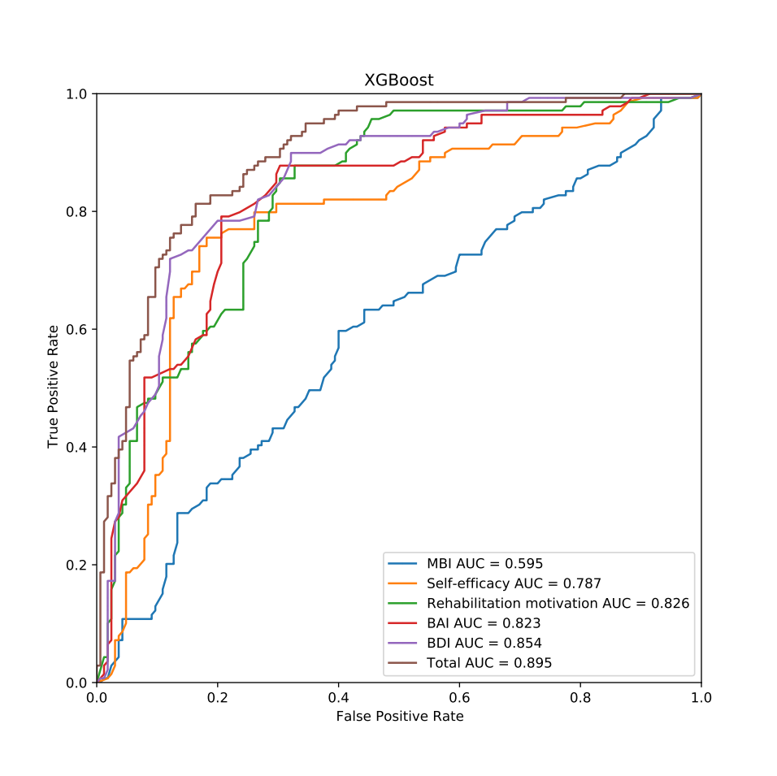

Supplementary information 1-2. Boosting model ROC curve graph (CatBoost)
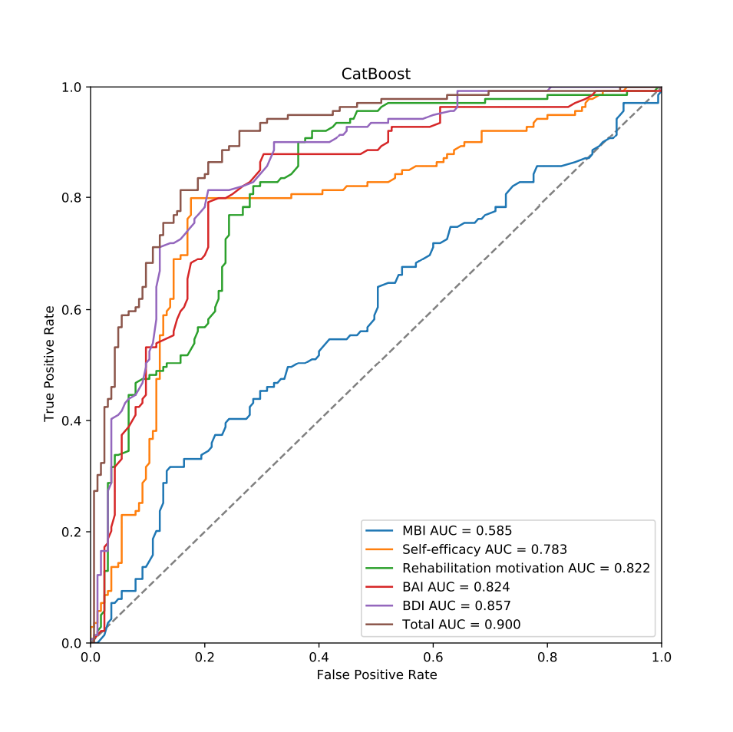

Supplementary information 1-3. Boosting model ROC curve graph (Light GBM)
