Supplementary materials

Table S1. GRADE of each comparison
Table S2. Search strategy

Fig. S1. Risk of bias of included studies
Fig. S2. Network map
Fig. S3. Forest plot of each comparison
Fig. S4. The inconsistency test at the global and local levels.
Fig. S5. Funnel plot of included studies

Table S1. GRADE of each comparison
Multiple doses compared to Placebo for Reintubation
Bibliography:
Certainty assessment |  |  |  |  |  |  | Summary of findings
Participants  (studies)  Follow up | Risk of bias | Inconsistency | Indirectness | Imprecision | Publication bias | Overall certainty of evidence | Study event rates (%) |  | Relative effect  (95% CI) | Anticipated absolute effects
 |  |  |  |  |  |  | With Placebo | With Multiple doses | Relative effect  (95% CI) | Risk with Placebo | Risk difference with Multiple doses
Reintubation_ Multiple doses vs Placebo
1191  (6 RCTs) | not serious | not serious | not serious | not serious | none | ⨁⨁⨁⨁  HIGH | 49/568 (8.6%) | 23/623 (3.7%) | OR 0.43  (0.25 to 0.72) | 86 per 1,000 | 47 fewer per 1,000  (from 63 fewer to 23 fewer)
Reintubation_ Single dose vs Placebo
1003  (5 RCTs) | not serious | not serious | not serious | not serious | none | ⨁⨁⨁⨁  HIGH | 26/504 (5.2%) | 9/499 (1.8%) | OR 0.31  (0.14 to 0.69) | 52 per 1,000 | 35 fewer per 1,000  (from 44 fewer to 15 fewer)
Reintubation_ Multiple doses vs Single dose
194  (2 RCTs) | not serious | not serious | not serious | serious | none | ⨁⨁⨁◯  MODERATE | 4/95 (4.2%) | 5/99 (5.1%) | OR 1.22  (0.32 to 4.74) | 42 per 1,000 | 9 more per 1,000  (from 28 fewer to 130 more)
Table S2. Search strategy
Database | Search | Studies
Medline | #1. Intubation [MeSH Terms] OR Intubation, Intratracheal [MeSH Terms] OR intubation.ti,ab,kw (74,313)  #2. Airway Extubation [MeSH Terms] OR extubation.ti,ab,kw (9,774)  #3. Airway Obstruction [MeSH Terms] OR airway obstruction (32,349)  #4. stridor*.ti,ab,kw (3,778)  #5. (laryn*.ti,ab,kw AND edema*.ti,ab,kw) OR laryngeal edema.ti,ab,kw (1,777)  #6. or/1-5 (112,118)  #7. Adrenal Cortex Hormones [MeSH Terms] OR Steroids [MeSH Terms] Glucocorticoids [MeSH Terms] OR steroid*.ti,ab,kw OR corticosteroid*.ti,ab,kw OR glucocorticoid*.ti,ab,kw (1,060,038)  #8. Prednisone [MeSH Terms] OR prednisone*.ti,ab,kw (51,185)  #9. Prednisolone [MeSH Terms] OR prednisolone*.ti,ab,kw (60,562)  #10. Methylprednisolone [MeSH Terms] OR methylprednisolone*.ti,ab,kw (25,032)  #11. Dexamethasone [MeSH Terms] OR dexamethasone*.ti,ab,kw (68,065)  #12. Cortisone [MeSH Terms] OR cortisone*.ti,ab,kw (23,124)  #13. Hydrocortisone [MeSH Terms] OR hydrocortisone*.ti,ab,kw (75,757)  #14. Budesonide [MeSH Terms] OR budesonide*.ti,ab,kw (5,839)  #15. Fluticasone [MeSH Terms] OR fluticasone*.ti,ab,kw (4,299)  #16. ciclesonide*.ti,ab,kw (336)  #17. Triamcinolone [MeSH Terms] OR triamcinolone*.ti,ab,kw (11,165)  #18. Beclomethasone {MeSH Terms} OR beclomethasone*.ti,ab,kw (3,743)  #19. flunisolide*ti,ab,kw (309)  #20. momethasone*.ti,ab,kw (10)  #21. or/7-20 (1,095,201)  #22. Randomized controlled trial.pt OR controlled clinical trial.pt OR randomized.ti,ab OR placebo.ti,ab OR drug therapy.sh OR randomly.ti,ab OR trial.ti,ab OR groups.ti,ab (2,797,200)  #23. 6 AND 21 AND 22 (1,914) | 1,914
Embase | #1. Endotracheal Intubation [E] OR Intubation [E] OR intubation.ti,ab,kw (100,387)  #2. Extubation [E] OR extubation.ti,ab,kw (21,364)  #3. Airway Obstruction [E] OR airway obstruction (42,647)  #4. Stridor [E] OR stridor.ti,ab,kw (8,768)  #5. (laryn*.ti,ab,kw AND edema*.ti,ab,kw) OR laryngeal edema.ti,ab,kw (2,750)  #6. or/1-5 (158,209)  #7. Corticosteroid [E] OR Steroid [E] OR Glucocorticoid [E] OR steroid*.ti,ab,kw OR corticosteroid*.ti,ab,kw OR glucocorticoid*.ti,ab,kw (1,485,027)  #8. Prednisone [E] OR prednisone*.ti,ab,kw (164,062)  #9. Prednisolone [E] OR prednisolone*.ti,ab,kw (122,080)  #10. Methylprednisolone [E] OR methylprednisolone*.ti,ab,kw (90,720)  #11. Dexamethasone [E] OR dexamethasone*.ti,ab,kw (148.354)  #12. Cortisone [E] OR cortisone*.ti,ab,kw (15,302)  #13. Hydrocortisone [E] OR hydrocortisone*.ti,ab,kw (119,640)  #14. Budesonide [E] OR budesonide*.ti,ab,kw (20,529)  #15. Fluticasone [E] OR fluticasone*.ti,ab,kw (11,754)  #16. Ciclesonide [E] OR ciclesonide*.ti,ab,kw (1,484)  #17. Triamcinolone [E] OR triamcinolone*.ti,ab,kw (18,778)  #18. Beclomethasone [E] OR beclomethasone*.ti,ab,kw (9,534)  #19. Flunisolide [E] OR flunisolide*ti,ab,kw (2,411)  #20. Momethaone Furoate [E] OR momethasone*.ti,ab,kw (4,552)  #21. or/7-20 (589,724)  #22. randomized.ti,ab OR placebo.ti,ab OR drug therapy.sh OR randomly.ti,ab OR trial.ti,ab OR groups.ti,ab (4,051,545)  #23. 6 AND 21 AND 22 (1,844) | 1,844
Cochrane library | #1. Intubation [MeSH] OR Intubation,Intratracheal [MeSH] OR intubation OR Airway Extubation [MeSH] OR extubation OR Airway Obstruction [MeSH] OR airway obastruction OR stridor OR laryngeal edema (18,732)  #2. Adrenal Cortex Hormones [MeSH] OR Steroids [MeSH] OR Glucocorticoids [MeSH] OR steroid OR corticosteroid OR glucocorticoid OR prednisone OR prednisolone OR methylprednisolone OR dexamethasone OR cortisone OR hydrocortisone OR budesonide OR fluticasone OR ciclesonide OR triamcinolone OR beclomethasone OR flunisolide OR mometasone (88,274)  #3. 1 AND 2 (1,871) | 1,871
Total |  | 5,629

Fig. S1. Risk of bias of included studies
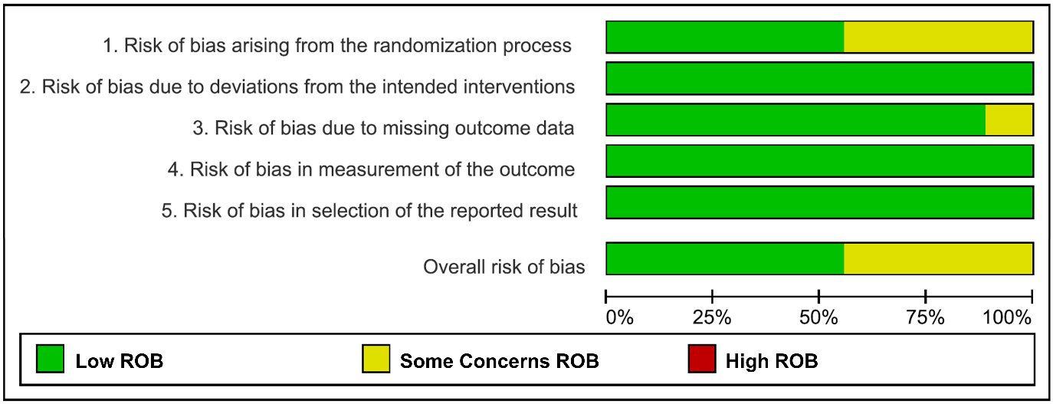

Fig. S2. Network map
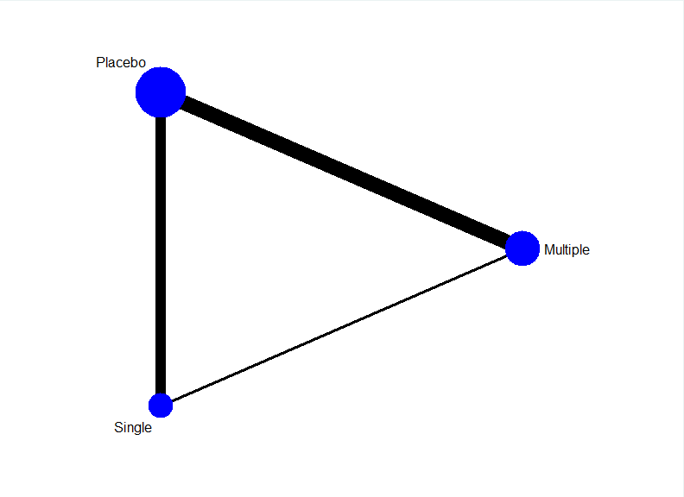

Fig. S3. Forest plot of each comparison
1. Multiple doses vs Placebo
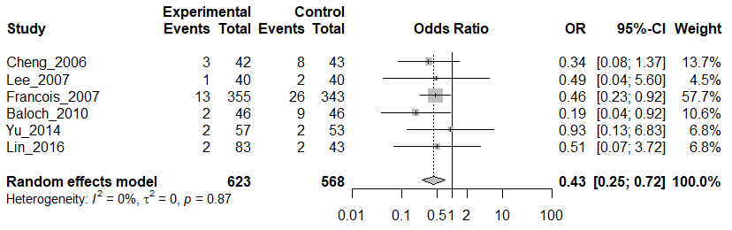

2. Single dose vs Placebo
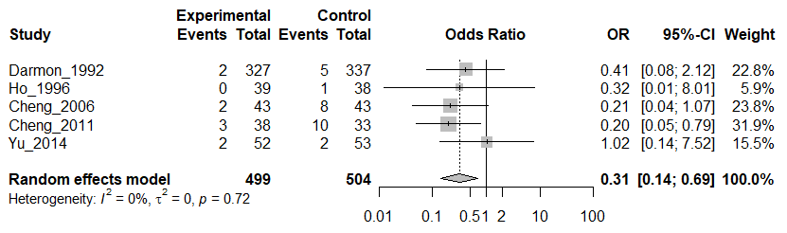

3. Multiple doses vs Single dose
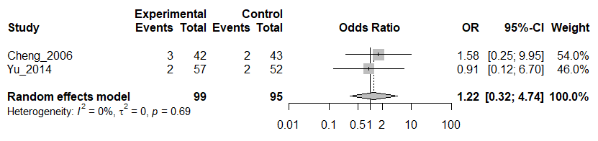

Fig. S4. The inconsistency test at the global and local levels.
1. Global approach
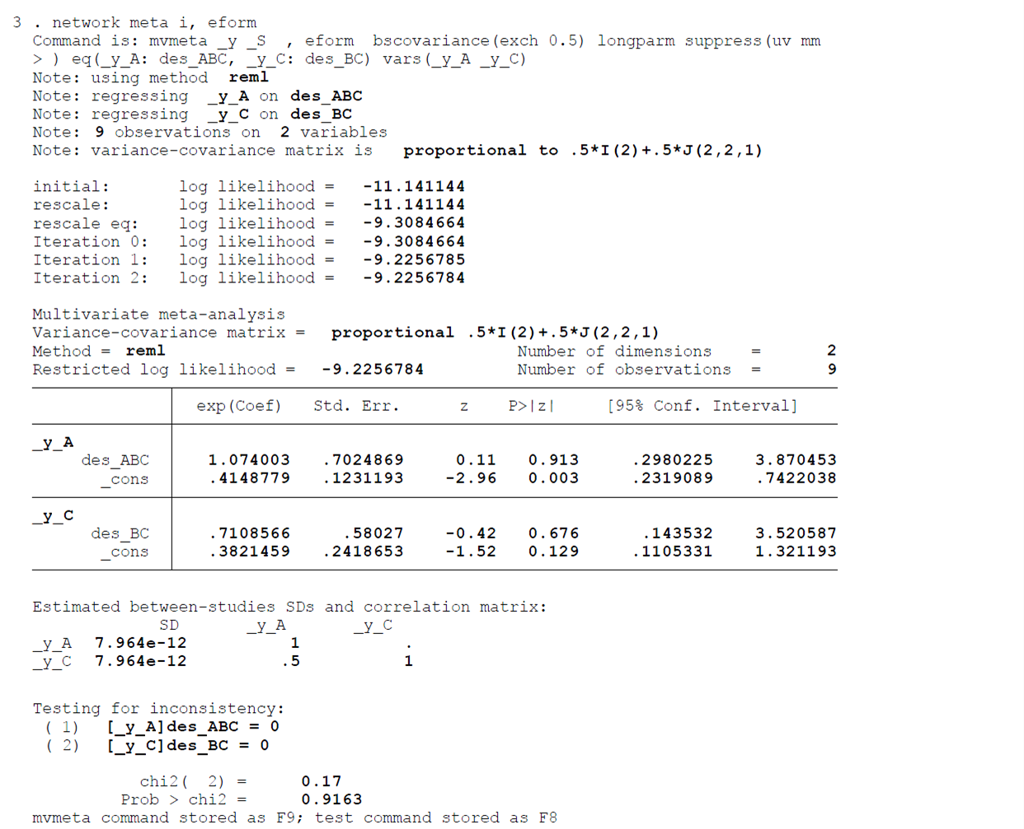
2. Local approach
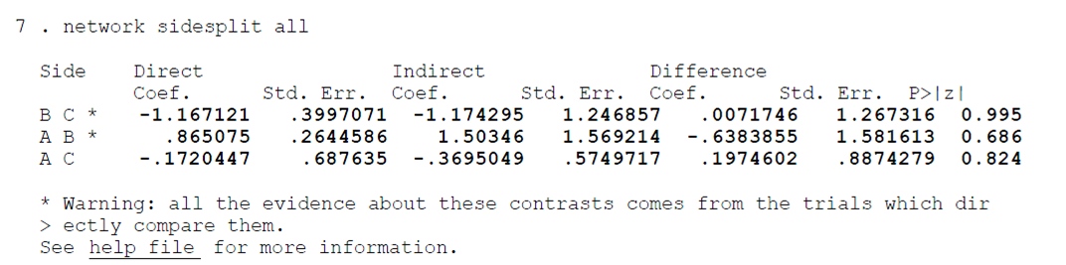

Fig. S5. Funnel plot of included studies
