Supplementary Appendices

Appendix A. Bronchoalveolar Lavage Fluid Findings in Right and Left Lung (Severely and Less Severely)

BALF Findings | Right Lung (n = 40) | Left Lung (n = 40) | p Value
sTREM-1 (ng/mg protein) | 2,09 (0,85 – 2,92) | 2,04 (0,81 – 2,54) | 0,670
% (Macrophage cells/CD45+, HLA-DR+, CD11b+) | 10,25 (2,8-10,7) | 7,81 (2,8-10,2) | 0,950
Foxp3+ CD25+ / CD4 (%) | 21,40 (11,43-28,59) | 19,65 (10,21-22,17) | 0,300
Caspase 3 (ng/mg protein) | 1,70 (0,41 – 1,66) | 1,65 (0,37 – 1,46) | 0,530
SP-A (ng/mg protein) | 11,89 (5,44 – 18,51) | 10,53 (5,95 – 13,48) | 0,070
p Value < 0,05 (statistically significant)
sTREM-1 denotes soluble triggering receptor expressed on myeloid cells-1, SP-A surfactant protein - A

Appendix B. Bronchoalveolar Lavage Fluid Findings in Severely Affected Lung Based on Extubation Status

Laboratory Findings | Total (n = 40) | Extubation Success & Survived (n = 8) | Extubation Failure & Death (n = 32) | p Value
Peripheral Blood
Interleukin-17 (pg/mL) | 11,74 (11,22 – 12,42) | 11,82 (10,99 – 12,58) | 11,59 (11,22 – 12,27) | 1
BALF
sTREM-1 (ng/mg protein) | 1,17 (0,76 – 2,88) | 1,26 (0,69 – 3,420 | 1,17 (0,76 – 2,79) | 0,892
% (Macrophage cells/CD45+, HLA-DR+, CD11b+) | 7,23 (±0,78) | 7,81 (±6,96) | 7,08 (±4,47) | 0,716
IL-17(pg/mg protein) | 6,43 (3,91 – 14,31) | 7,80 (4,46 – 21,77) | 6,42 (3,91 – 14,31) | 0,499
Foxp3+ CD25+ / CD4 (%) | 16,34 (11,54 – 27,28) | 18,95 (14,61 – 27,28) | 15,99 (11,31 – 25,64) | 0,612
Caspase 3 (ng/mg protein) | 0,83 (0,55 – 1,76) | 1,40 (0,65 – 3,42) | 0,82 (0,44 – 1,50) | 0,199
SP-A (ng/mg protein) | 11,54 (±1,05) | 11,46 (±5,01) | 11,57 (±7,07) | 0,967
p Value < 0,05 (statistically significant)
sTREM-1 denotes soluble triggering receptor expressed on myeloid cells-1, SP-A surfactant protein - A

Appendix C. Microbial Pattern and PCR SARS-CoV-2 Findings of the Study Population

Microbiology and RT-PCR | n (%) (n = 31)
Sterile BAL culture, negative PCR SARS-CoV-2 (n = 3) | 3 (100)
Pneumonia COVID-19 (n = 28)
Positive PCR SARS-CoV-2 (COVID-19) | 18 (63,3)
COVID-19 + α-hemolytic Streptococcus | 2 (7,1)
COVID-19 + Staphylococcus aureus | 2 (7,1)
COVID-19 + Staphylococcus saprophyticus | 2 (7,1)
COVID-19 + Acinetobacter sp. | 2 (7,1)
COVID-19 + Staphylococcus epidermidis | 2 (7.1)

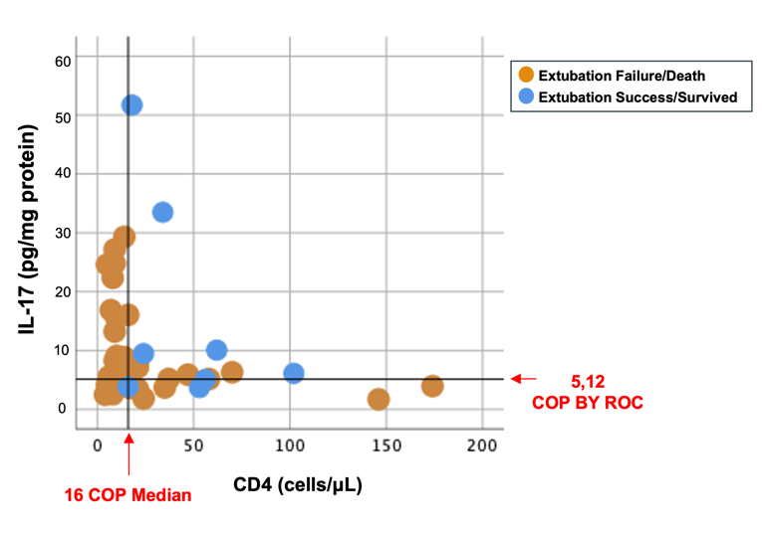 | 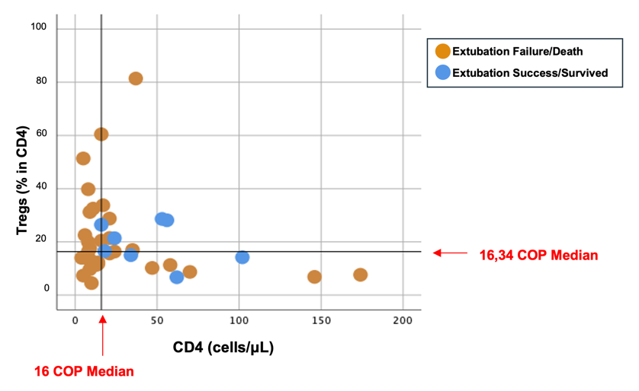
(a) | (b)
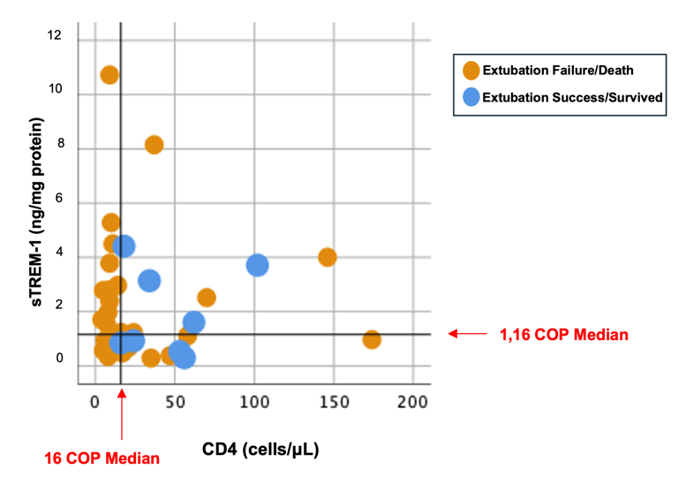 | 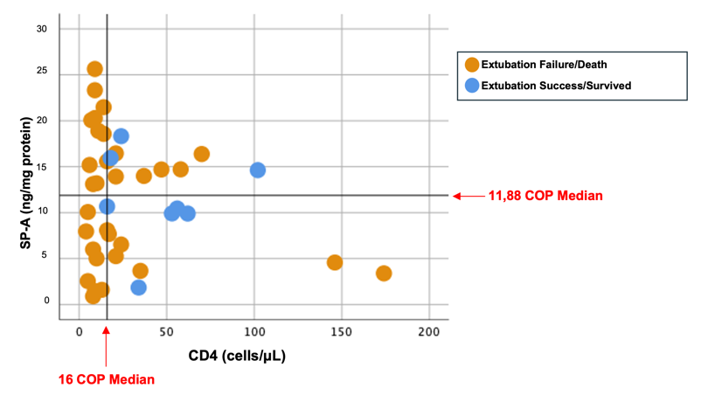
(c) | (d)

Appendix D. Biomarker Interactions

- CD4 – IL-17
Among all the patients with extubation success within 19 days, 5 patients (62,5%) displayed the tendency of low CD4 levels (cutoff points median 16 cells/μL) with low expression of IL-17 (cutoff points by ROC 5,12 pg/mg protein), conversely, among all the patients with extubation failure (32 patients), 25 patients (78,1%) (Relative Risk: 2,083, 95% Confidence Interval = 0.836 – 5,192, p = 0,039).

- CD4 – sTREM-1
Among all the patients with extubation success within 19 days, 4 patients (50%) displayed the tendency of low CD4 levels (cutoff points median 16 cells/μL) with low expression of sTREM-1(cutoff points median 1,16 pg/mg protein), conversely, among all the patients with extubation failure (32 patients), 23 patients (71,9%) did not show this tendency (p = 0,400).

- CD4 – Tregs
Among all the patients with extubation success within 19 days, 5 patients (62,5%) displayed the tendency of low CD4 levels (cutoff points median 16 cells/μL) with low expression of Tregs (cutoff points median 16,34 % in CD4), conversely, among all the patients with extubation failure (32 patients), 24 patients (75%) (p = 0,086).

- CD4 – SP-A
Among all the patients with extubation success within 19 days, 3 patients (37,5%) displayed the tendency of low CD4 levels (cutoff points median 16 cells/μL) with low expression of SP-A (cutoff points median 11.88 pg/mg protein), conversely, among all the patients with extubation failure (32 patients), 25 patients (78,1%) (p = 0,388).

