Support information: A facilitated gas transport strategy: 3D porous hyper-crosslinked polymers incorporating 6FDA-based polyimide matrix for the design and fabrication of mixed matrix membranes with high permeability
Zan Chen^{1,2}, Longfei Peng¹, Yinhui Li^{1*}, Weixin Li¹, Cuijia Duan², Biao Yuan²,
Shuo Yan²
¹ School of Chemical Engineering and Technology, Hebei University of Technology, Tianjin 300130, PR China
² Key Laboratory of Membrane and Membrane Process, China National Offshore Oil Corporation Tianjin Chemical Research & Design Institute, Tianjin 300131, PR China

1. Characterization of hyper cross-linked polymers (HCPs)
XRD shows that the as-prepared hyper cross-linked polymers are amorphous in Figure S1a, which is attributed to the free polymerization and disorder cross-linking reaction of α,α´-dichloro-p-xylene and 2-phenylimidazole, resulting in non-directional distortion and growth of the spatial structure. FT-IR spectrum shows that HCPs had four characteristic peaks at 3402 cm⁻¹, 2923 cm⁻¹, 1603 cm⁻¹, and 1437 cm⁻¹, respectively. The four characteristic peaks are attributed to N-H in the imidazole, C-H in -CH₂-, C=C of the benzene ring, and the C-N in benzylamine, respectively, indicating that the 2-phenylimidazole type hyper crosslinked polymers were successfully synthesized. The BET adsorption and desorption curve is type II, and the adsorption and desorption curves do not overlap due to the existence of a large number of pore structures. Specific surface area of HCPs is 721.37 m²/g, and the pore size distribution of HCPs calculated by BJH is approximately 5-10 Å, which proves that pore size of HCPs is mainly microporous. The particle size distribution shows that the particle size of HCPs is about 102.02 nm.

Fig. S1 (a)XRD pattern, (b)FT-IR spectrum, (c)N₂ adsorption and BJH and (d) SEM image of HCPs

2. Preparation of polyimide (PI)
Pretreatment of imide monomer
6FDA was dried in a blast drying oven at 170℃ for 2 d, and then the dried temperature was gradually reduced to 50℃. The dried 6FDA was immediately transferred to a vacuum desiccator to prevent 6FDA from causing serious hydrolysis after absorbing moisture in the air atmosphere.
Synthesis of 6FDA-based PI
In a typical experiment, 0.015moL of DAPI and 0.015moL of 6FDA was added into 46.25mL of DMAc solution in a three-neck flask and fully dissolved under mechanical stirring, the polymerization system was performed at 0°C for 24 h. Then, 0.045 mol of acetic anhydride as dehydrating agent and 0.015 mol of TEA as catalyst were doped into the reactive system, and the reactive temperature was raised to 30°C. The polymerization continued polymerizing for another 24 h. The resulting product was precipitated with anhydrous methanol. Finally, it was dried in a vacuum oven at 170°C for 24 h. The white powder was obtained and named as 6FDA-based PI. The polymerization process is shown in Scheme S1.

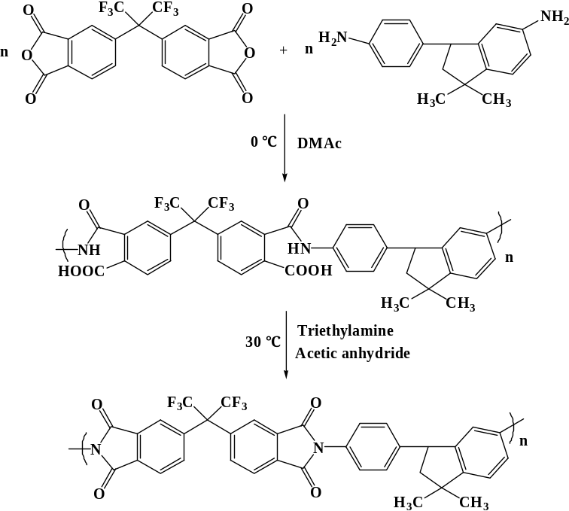
Scheme S1. Synthesis process of 6FDA-based PI

Fig. S2 molecular dynamics simulations of (a) HCPs-0.02/PI MMMs, (b) HCPs-0.06/PI MMMs and (c) HCPs-0.08/PI MMMs
Table S1Density, occupied volume, d-spacing and FFV of pure PI film和HCPs/PI MMMs
HCP/PI MMMs | Density/g/cm³ | Occupied volume /Å³ | d-spacing/Å | FFV_{sim}
0.00 wt.%HCPs | 1.5358 | 399765 | 5.576 | 0.1892
0.02 wt.% HCPs | 1.4853 | 409900 | 5.597 | 0.1994
0.04 wt.% HCPs | 1.4204 | 403126 | 5.690 | 0.2498
0.06 wt.% HCPs | 1.3808 | 427388 | 5.705 | 0.2299
0.08 wt.% HCPs | 1.3553 | 442792 | 5.460 | 0.2200

