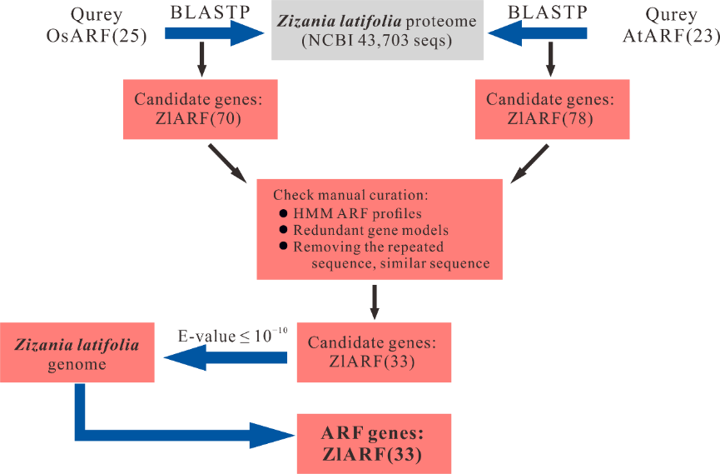
Supplementary Figure S1. Workflow showing the patterns of ARF gene identification in Z. latifolia. Oryza sativa and Arabidopsis all ARF proteins were used as query to search for orthologs using BLASTP program in the Z. latifolia genome-wild. The output was further examined by artificial selection for remove redundant and invalid genes from candidate sequences. We identified 33 ARF protein sequences.

Supplementary Figure S2. Sequence logos of conserved amino acid residues in ARF gene family.

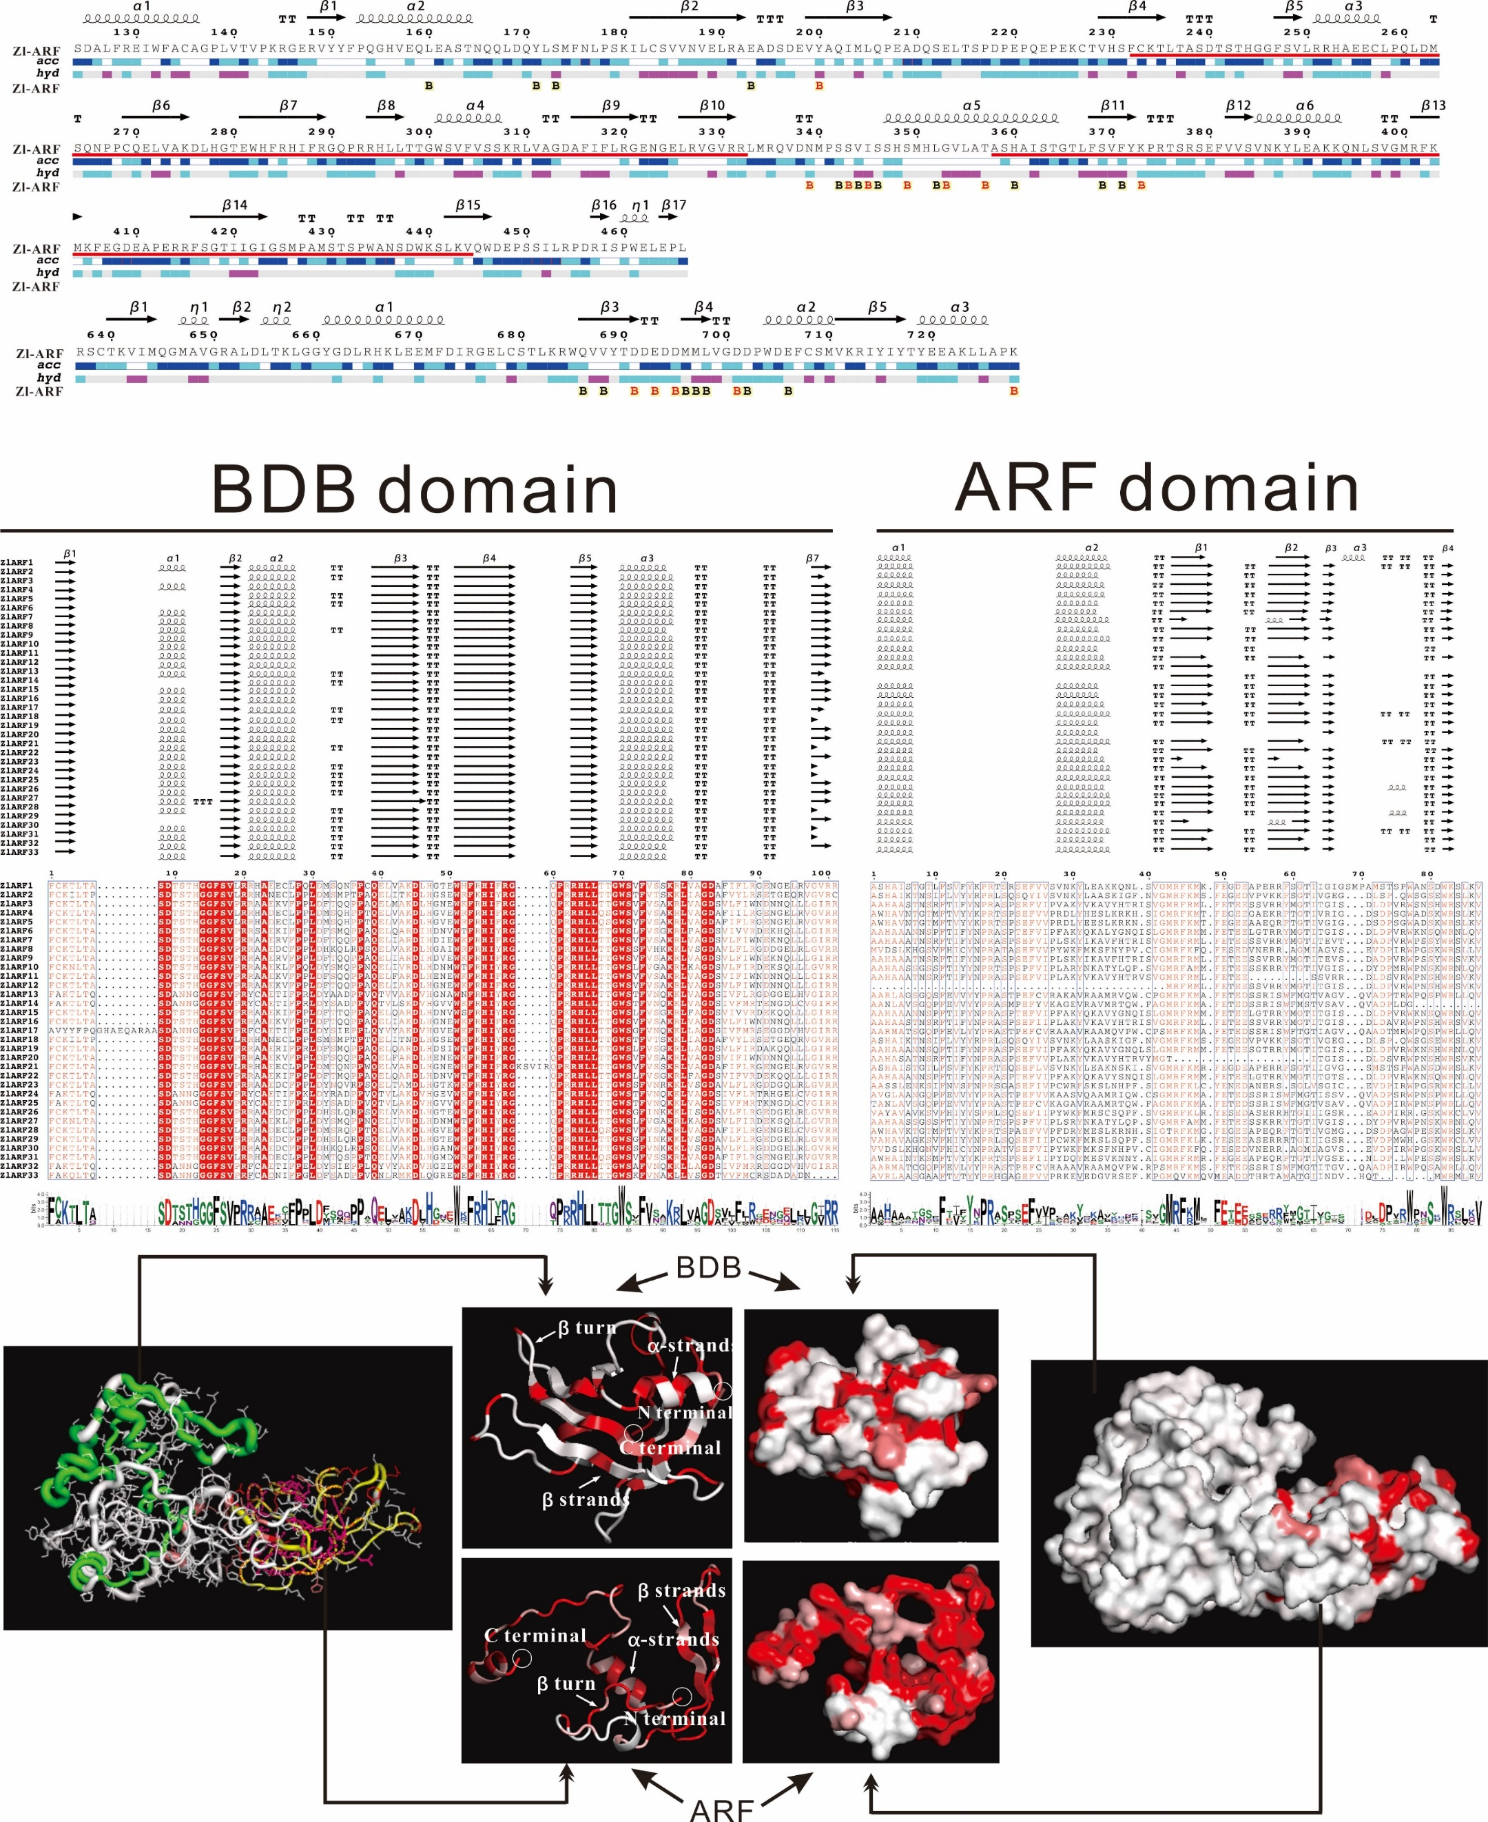
BDB domain
ARF domain
Supplementary Figure S3. Comparisons of the DBD and MR domain. Excerpt from the second ENDscript flat diagram, sequence comparison analysis of the BDB domain and MR domain in ZlARF proteins. It is showing the multiple sequence alignment (MSA). The bottom line is the sequence logo analysis.

