Supporting Information

Capacitive Humidity Sensing Properties of Freestanding Bendable Porous SiO₂/Si Thin Films

Soobin Park¹, Jinmyeong Seo¹, Jungjoon Park¹, Inseong Hwang¹, Han-Seung Lee ², Hyunsung Jung^{3*}, and Bongyoung Yoo^{1*}
¹ Department of Materials Science and chemical Engineering, Hanyang University, Ansan 15588, Republic of Korea
² Department of Architectural Engineering, Hanyang University, Ansan 15588, Republic of Korea
³ Electronic Convergence Materials Division, Korea Institute of Ceramic Engineering & Technology, 101 Soho-ro, Jinju, 52851, Republic of Korea

*Co-corresponding authors: hyunsungjung@gmail.com; byyoo@hanyang.ac.kr

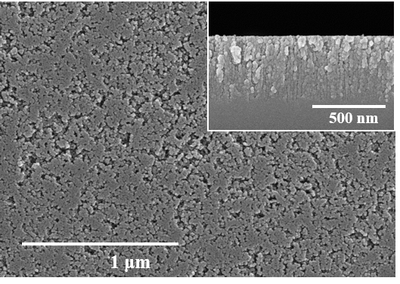
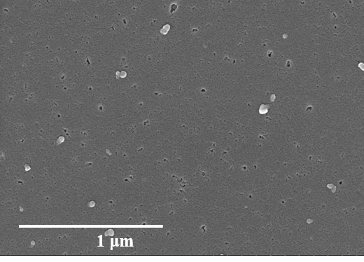
(a) (b)

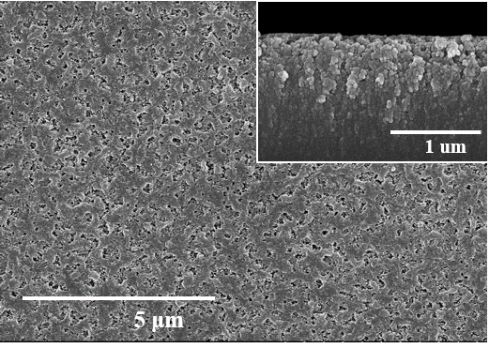
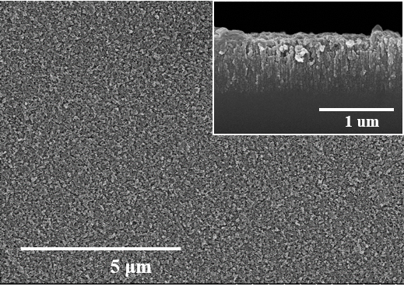
(c) (d)

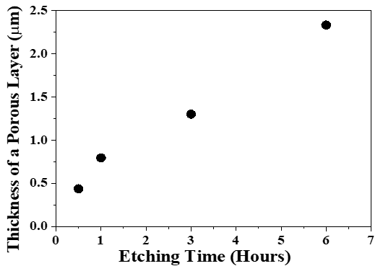
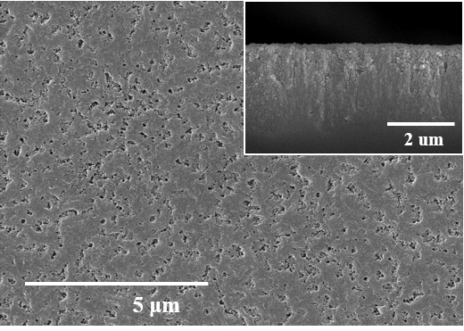
(e) (f)

Figure S1. The morphologies of porous Si layers depending on the metal-assisted chemical etching times (insets: cross-sectional views of porous Si layers): (a) 10 min, (b) 30 min, (c) 1 hour, (d) 3 hours, (e) 6 hours, and (f) the thickness of porous Si layers as a function of the etching times

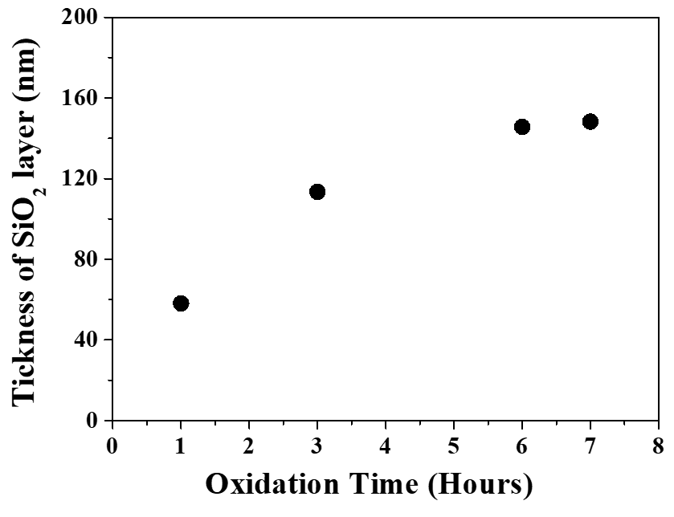
Figure S2. The thickness of SiO₂ layers formed on Si wafers as a function of oxidation time at 1000 ℃ in the air.

Figure S3. The sensing properties of a SiO₂ layer formed on a bare Si wafer as a function of RH level.

