Supporting information

Biochars prepared from biogas residues: Temperature is a crucial factor that determines their physicochemical properties

Ping Cong ¹ • Shuhui Song ² • Wenjing Song ¹ • Jianxin Dong ¹ • Jinguang Yang ¹ • Xuebo Zheng ^{1*}

¹ Key Laboratory of Tobacco Biology and Processing, Ministry of Agriculture and Rural Affairs, Tobacco Research Institute of Chinese Academy of Agricultural Sciences, Qingdao, China
² South Subtropical Crops Research Institute, Chinese Academy of Tropical Agricultural Sciences, Ministry of Agriculture and Rural Affairs, Zhanjiang, China

Xuebo Zheng
zhengxuebo@caas.cn

Ping Cong and Shuhui Song contributed equally to this paper.

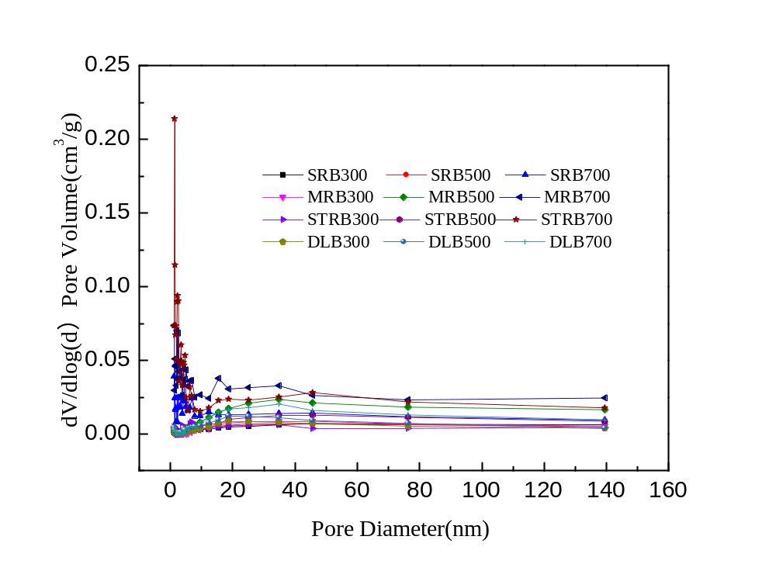
Fig. S1. Pore size distribution of different biogas residues biochar at three pyrolysis temperatures. SR: sludge residue; MR: mushroom biogas residue; STR: straw residue; DL: distillery lees; B300: the pyrolysis temperature of biochar is 300℃; B500: the pyrolysis temperature of biochar is 500℃; B700: the pyrolysis temperature of biochar is 700℃.

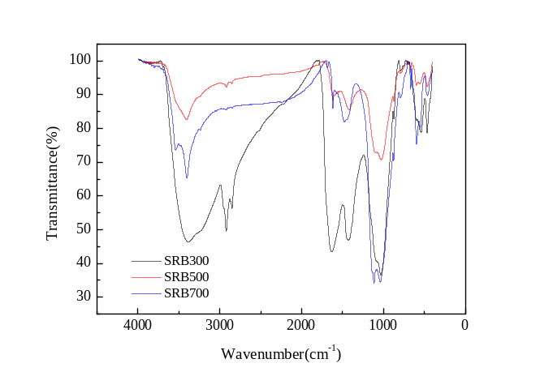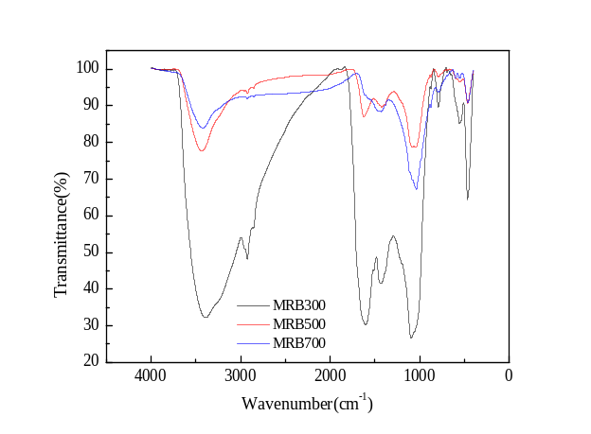
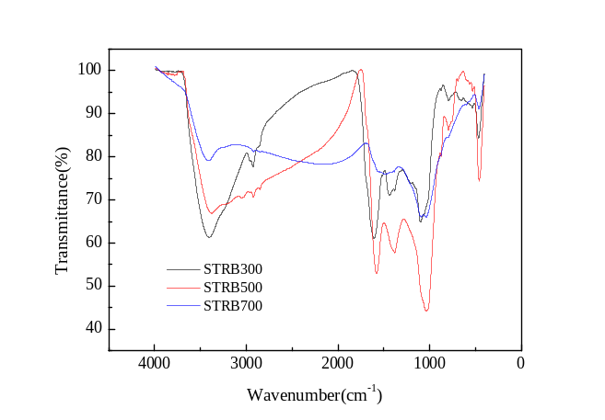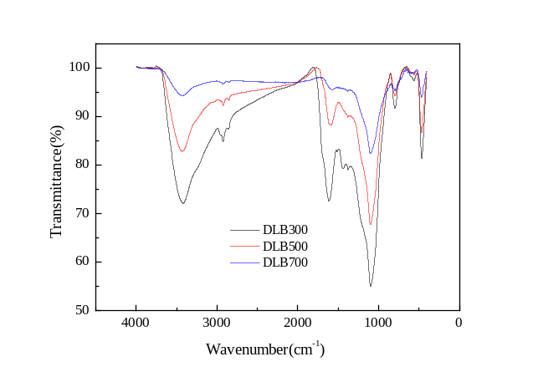
Fig. S2. FT-IR spectra of of different biogas residues biochar at three pyrolysis temperatures. SR: sludge residue; MR: mushroom biogas residue; STR: straw residue; DL: distillery lees; B300: the pyrolysis temperature of biochar is 300℃; B500: the pyrolysis temperature of biochar is 500℃; B700: the pyrolysis temperature of biochar is 700℃.

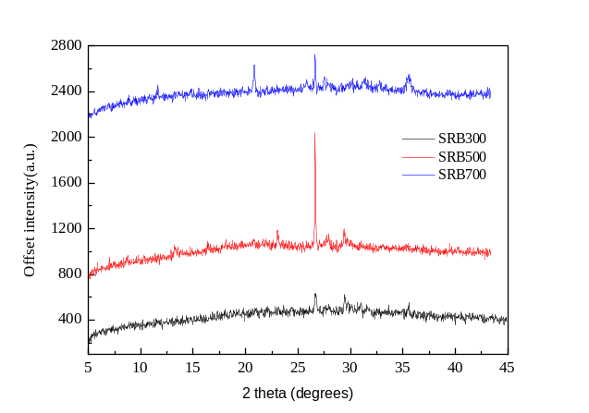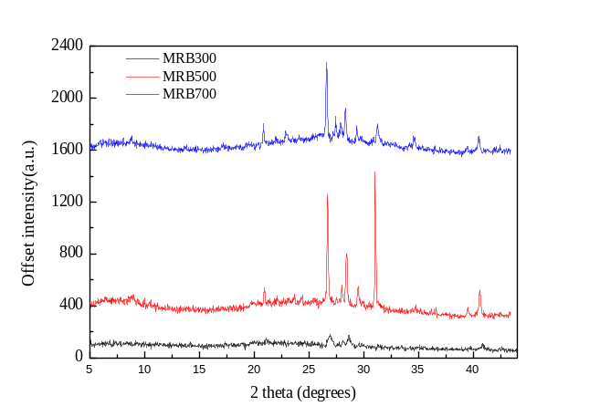
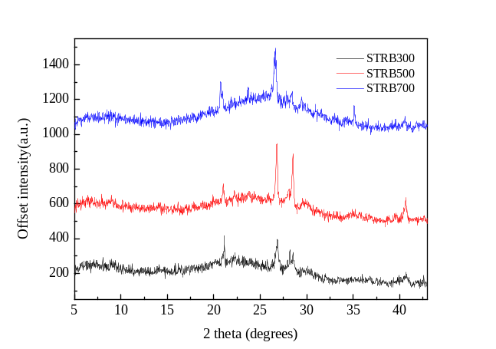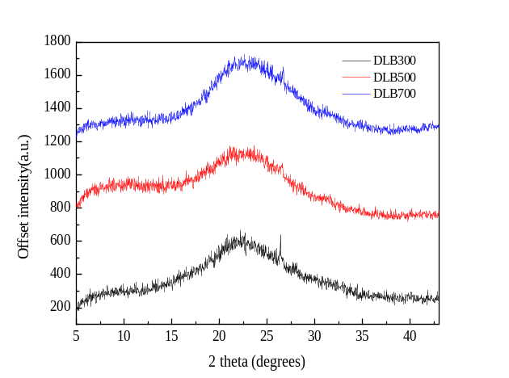
Fig. S3. XRD characterization of different biogas residues biochar at three pyrolysis temperatures. SR: sludge residue; MR: mushroom biogas residue; STR: straw residue; DL: distillery lees; B300: the pyrolysis temperature of biochar is 300℃; B500: the pyrolysis temperature of biochar is 500℃; B700: the pyrolysis temperature of biochar is 700℃.

