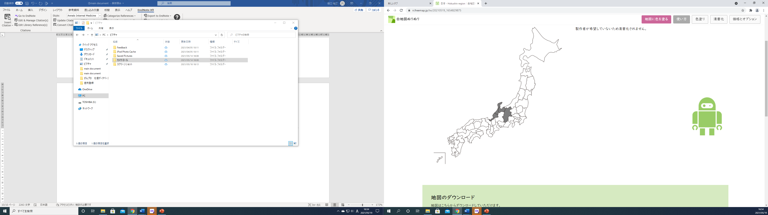
Fukui
Ishikawa
Toyama
Nagano
Hokushin region
Fukui
Ishikawa
Toyama
Hokushin region

Supplementary Figure 1. The Hokushin region is composed of the Fukui, Ishikawa, Toyama, and Nagano prefectures, which have commonalities, such as the population’s age distribution and snowy climates during the winter.

Fukui prefecture | Fukui University Hospital | Ishikawa prefecture | Kanazawa University Hospital
Fukui prefecture | Fukui Prefectural Hospital | Ishikawa prefecture | Kanazawa Medical University Hospital
Fukui prefecture | National Hospital Organization Tsuruga Medical Center | Ishikawa prefecture | Ishikawa Prefectural Central Hospital
Toyama precfecture | Toyama University Hospital | Ishikawa prefecture | National Hospital Organization Kanazawa Medical Center
Toyama precfecture | Toyama City Hospital | Nagano precfcture | Shinshu University Hospital
Toyama precfecture | Kurobe City Hospital | Nagano precfcture | Nagano Municipal Hospital
Toyama precfecture | Toyama Rosai Hospital | Nagano precfcture | Nagano Red Cross Hospital
Toyama precfecture | JA Toyama Kouseiren Takaoka Hospital | Nagano precfcture | Suwa Red Cross Hospital
Toyama precfecture | Takaoka City Hospital | Nagano precfcture | Nagano Children’s Hospital
Toyama precfecture | Tonami General Hospital, | Nagano precfcture | Aizawa Hospital
Toyama precfecture | Toyama Prefectural Central Hospital | Nagano precfcture

Supplementary Table 1.
Lists of participating hospitals in the present study.

