- Table 1. Patient characteristics and numbers of carboplatin-based chemotherapy cycles
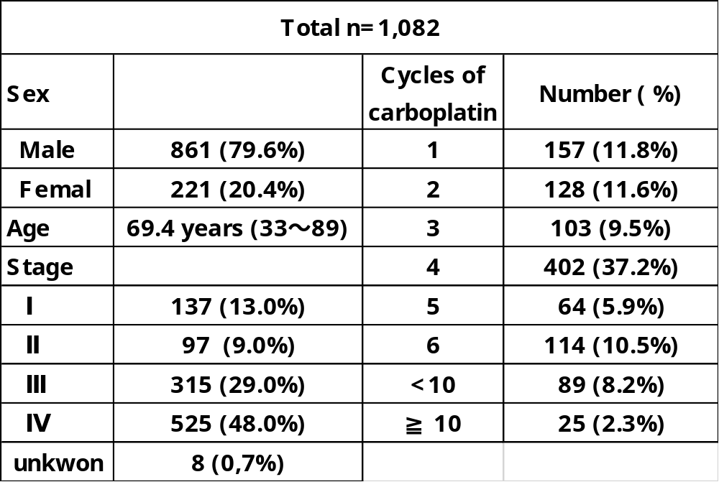

Table 2. Numbers and mean ages of lung cancer patients in the four prefectures in Hokushin region
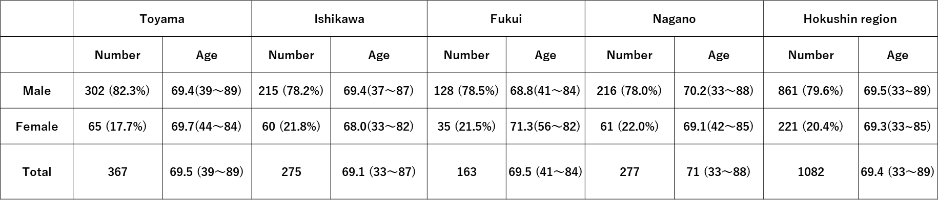

Table 3. Chemotherapy regimens according to double and triple antiemetic therapy

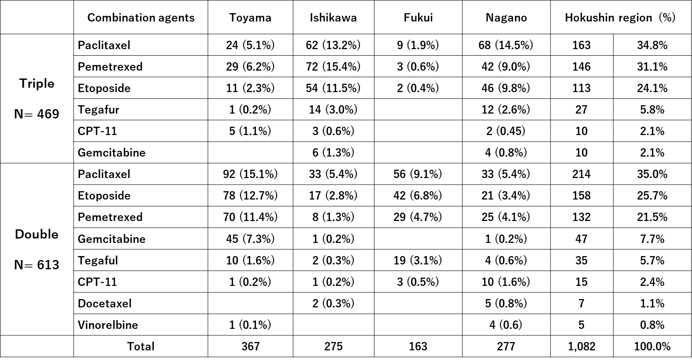

Table 4. Changes in prescription of antiemetics
