Appendix A
Table A1. Dataset of samples used for the research. Samples used for SNP genotyping are in bold.
Name | Group | Lineage | Sex | Date of birth
Bärnburger | O | LC | M | 02.07.2003
Baron | O | L | M | 01.01.2001
Bransk | O | LC | M | 02.06.1997
Donna | O | L | F | 29.06.2002
Elvis | O | L | M | 01.10.2003
Erika | O | L | F | 15.05.2001
Gama | O | LC | F | 29.08.1999
Indi | O | LC | F | 09.05.2006
Izafatty | O | LC | F | 31.08.2003
Izvara | O | LC | F | 06.07.2000
Maika | O | LC | F | 11.10.2000
Nina | O | L | F | 21.06.2002
NL-25* | O | LC | M | 14.06.1998
Plucik | O | L | M | 01.09.2001
Postójka | O | L | F | 01.01.2002
Pristina | O | LC | F | 25.07.1995
Raisa | O | LC | F | 16.06.2000
Rimpsa | O | LC | F | 31.05.2000
Sphinx | O | LC | F | 21.05.1998
Splunkunyr | O | LC | M | 06.05.2005
Thira | O | LC | F | 01.04.1998
Zwursel | O | LC | F | 10.05.2002
Curt | R | LC | M | 20.06.2017
Diestera | R | L | F | 18.06.2018
Deisterix | R | L | M | 28.05.2018
Dekan | R | L | M | 09.07.2018
Dena | R | L | F | 23.04.2017
Denise | R | L | F | 19.08.2017
Denus | R | L | M | 06.05.2017
Eggehexe II | R | LC | F | 01.05.2017
Elaika | R | LC | F | 14.06.2018
Elisabeth | R | LC | F | 10.05.2016
Ella | R | LC | F | 28.05.2017
Elwira | R | LC | F | 28.05.2018
Hogir | R | LC | M | 02.09.2017
Spakko | R | LC | M | 27.06.2018
Spatz | R | LC | M | 27.08.2018
Spectra | R | LC | F | 02.06.2017
Spendera | R | LC | F | 12.05.2018
Spilla | R | LC | F | 22.06.2017
Spresa | R | LC | F | 15.05.2017
Tábor | R | L | M | 07.11.2017

Table A2. PCR conditions for amplification.
 | Temperature | Time
Initiation | 95°C | 2 min
Denaturation | 95°C | 20 sec
Annealing | 59°C | 30 sec
Extension | 65°C | 2 min
Final extension | 65°C | 5 min
Number of cycles |  | 33 cycles
Table A3. Primer sequences of selected regions surrounding potentially longevity-associated SNPs.
Gene | Forward primer sequence | Reverse primer sequence
BCKDHB | TGGCAGTGGGTACTCCTAGA | TGCCAGTAAATTGGGGGTGG
FER1L6 | GGAATTCTACTGCTGTTGGCT | GTCCATTTGCCTGCACTGTC
SERPINI2 | TGCCCAGATCTTAACCAGTGT | TCTTTCCGTTGAACCTACTATGA
XKR4 | CCAGCCCATTCCTACCACTG | TCCCTCTCCCTGAGAAAGCA
Table A4. Results of sequencing of SNP positions in selected genes.
Name | Group | Genotype BCKDHB | Genotype XKR4 | Genotype FER1L6 | Genotype SERPINI2
Bärnburger | O | X | AA | TC | TT
Baron | O | TT | AA | TC | TT
Bransk | O | TG | GG | TT | GG
Donna | O | TT | AA | CC | GT
Elvis | O | GG | X | CC | X
Erika | O | X | X | TT | TT
Gama | O | TT | AA | TC | TT
Indi | O | X | X | TT | X
Izafatty | O | TT | AG | TC | TT
Izvara | O | TG | AA | TC | GG
Maika | O | TT | GG | TT | GT
Nina | O | TT | AA | CC | TT
NL-25* | O | GG | AA | X | X
Plucik | O | TG | AA | CC | TT
Postójka | O | X | X | CC | X
Pristina | O | TT | AG | TC | TT
Raisa | O | TT | GG | TT | GT
Rimpsa | O | TG | AA | TC | TT
Sphinx | O | TG | AG | TC | X
Splunkunyr | O | X | X | CC | X
Thira | O | TT | AA | TC | GG
Zwursel | O | TG | AA | X | GT
Curt | R | GG | X | X | TT
Deisterix | R | TG | AA | CC | TT
Dekan | R | GG | AA | CC | X
Dena | R | GG | X | X | TT
Denise | R | GG | AA | CC | TT
Denus | R | TG | AA | CC | TT
Eggehexe II | R | X | X | TC | X
Elaika | R | TT | AA | TC | X
Elisabeth | R | X | AA | CC | TT
Ella | R | GG | AA | CC | TT
Elwira | R | TG | AA | TC | X
Hogir | R | TT | AA | CC | TT
Spakko | R | X | X | CC | X
Spatz | R | X | X | CC | X
Spectra | R | GG | AA | CC | TT
Spendera | R | X | X | X | TT
Spresa | R | X | X | CC | TT
Tábor | R | GG | AA | CC | TT

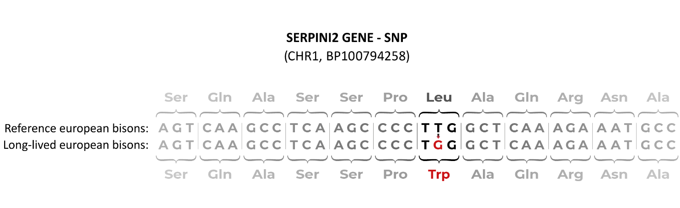
Fig. A1. Nucleotide substitution and amino acid change in SNP BovineHD0100047129 located in the SERPINI2 gene.

