Extended Data for Hartwick+2022

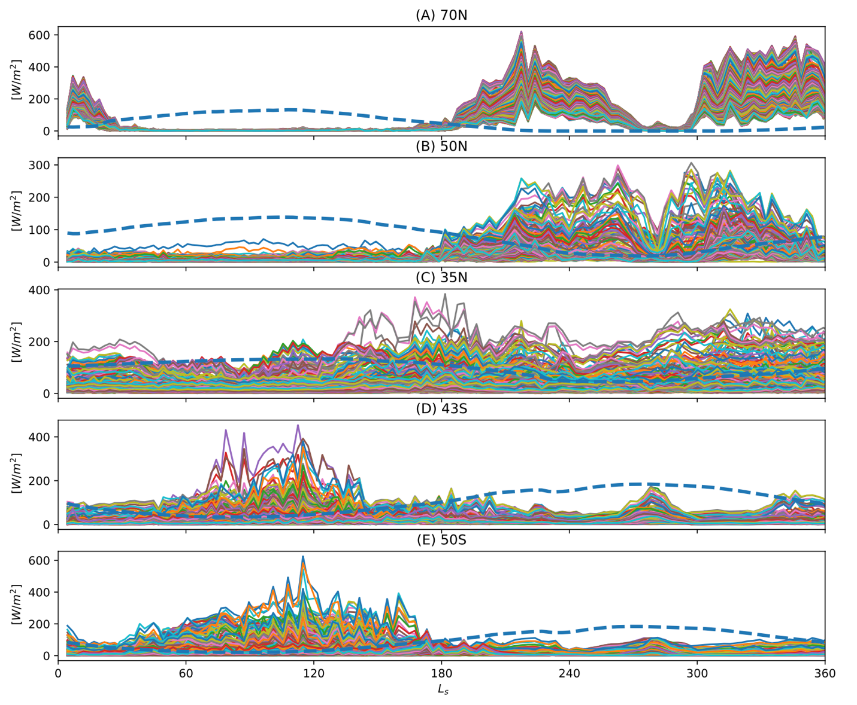
Fig. S1.
Zonal average solar power density [W/m²] (blue dashed line) and wind power density in 1° longitude bands (colored lines) vs solar longitude L_{s} at (A) 70°N, (B) 50°N, (C) 35°N, (D) 43°S and (E) 50°S. Surface short wave flux [W/m²] is calculated in the model based on the atmospheric composition and scattering and absorption by atmospheric aerosols. Solar power is greatest in the summer hemisphere and is reduced during large-scale dust events (as at L_{s}=240° in panels D and E). Wind power regularly exceeds solar power in the winter hemisphere and therefore is well-suited to complement solar arrays to power future human missions.

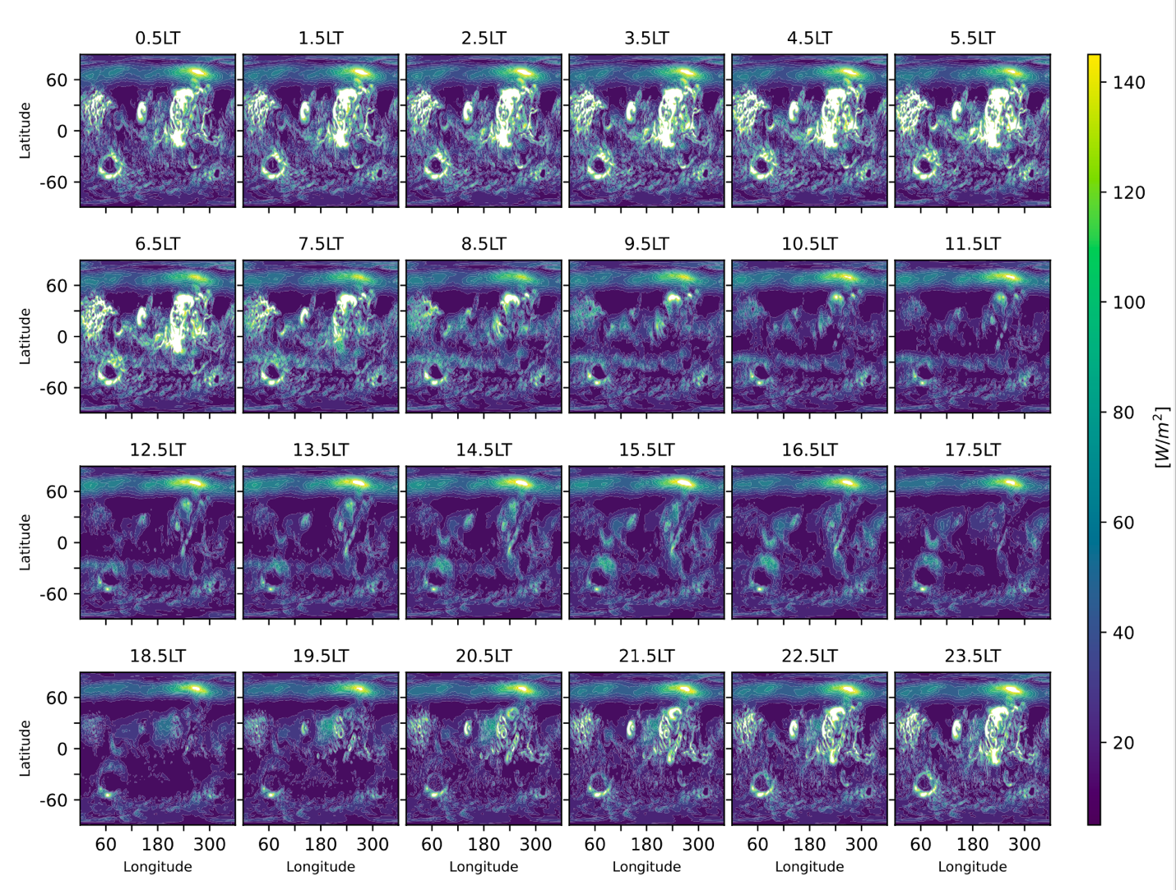

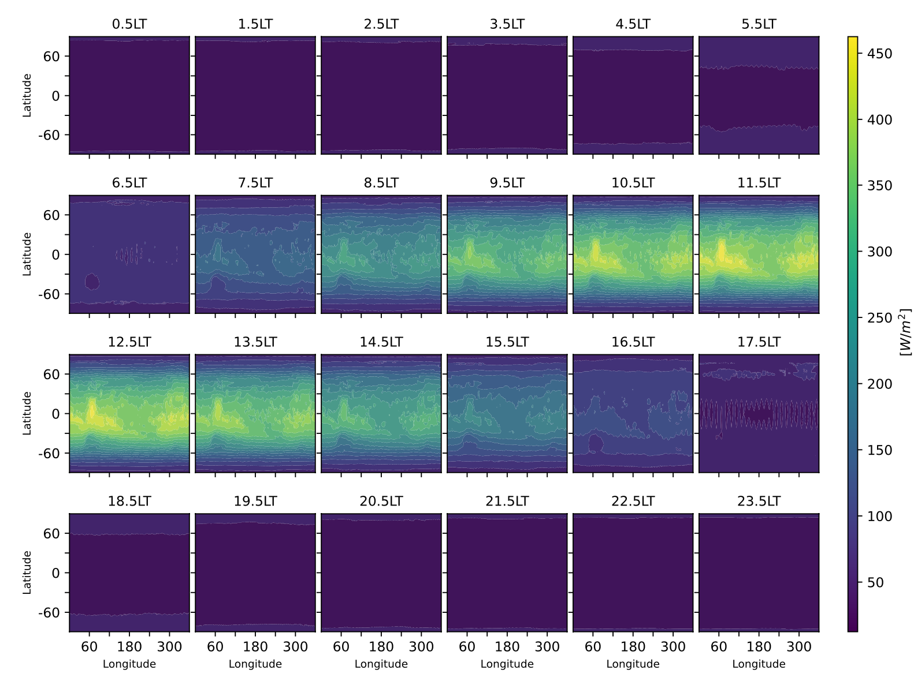
Fig. S2.
Annual average wind (top panels) and solar power density (bottom panels) in W/m² in 1-hour intervals of local time (LT). All locations in each panel show the same local time simultaneously. Solar power exceeds 140 W/m² during daytime hours (~7.5 -15.5 LT) while wind power maximizes at night (~21.5-8.5 LT) and at the poles.

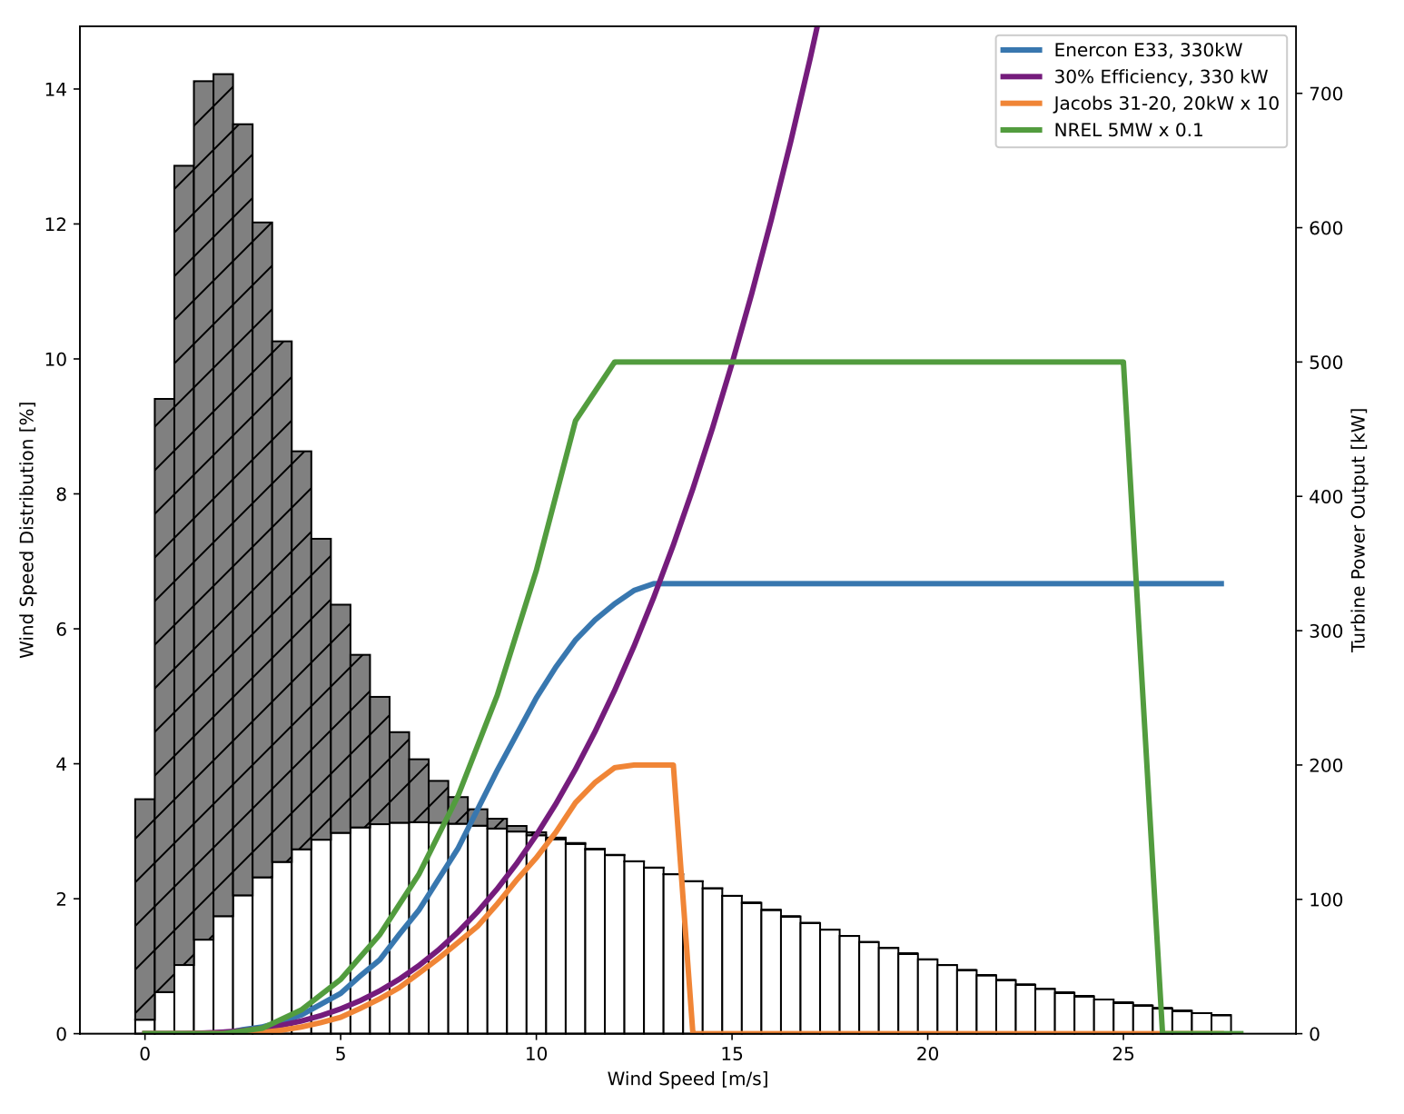Fig. S3.
Enercon E33 (blue line), Jacobs 31-20 (orange line, scaled by a factor of 10), and the National Renewable Energy Laboratory (NREL) 5-MW wind turbine (green line, scaled by a factor of 1/10) wind turbine power curves compared with a theoretical power curve based on Eqn. 2 (purple curve). White bars (bottom) show annual, global average wind speed distribution. Filled bars (top) show the density-adjusted global average wind speed distribution used as inputs for turbine power curves.

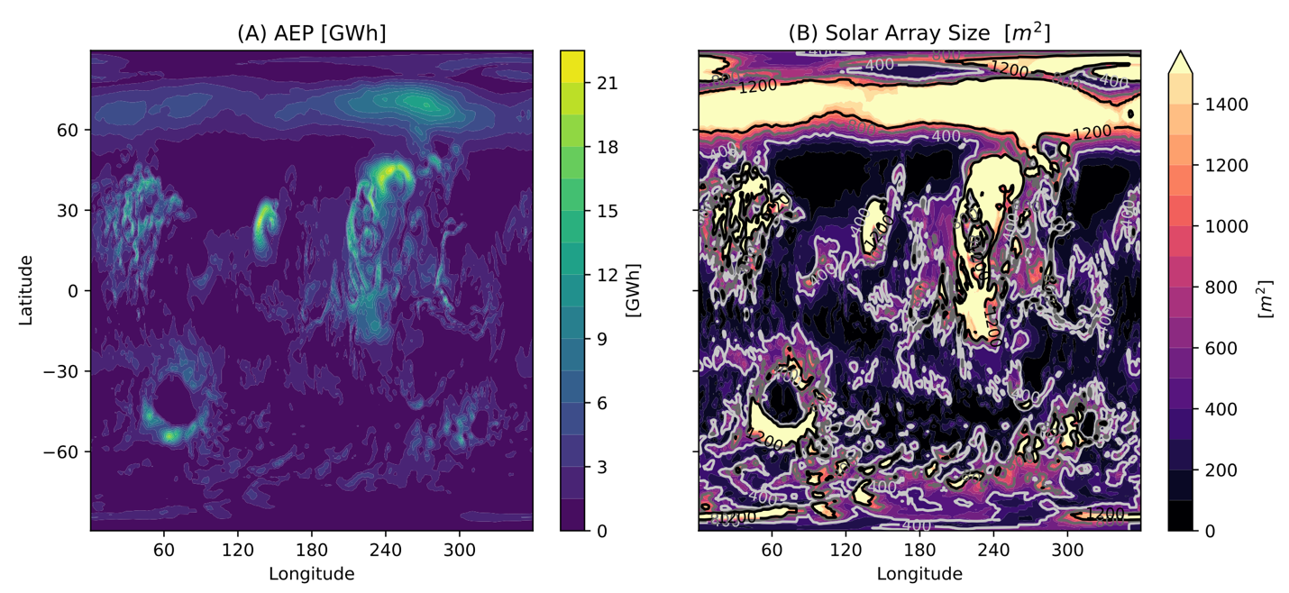
Fig. S4.
Wind turbines generate significant energy on an annual basis. Solar panel arrays would need to exceed 600 m² on average to match energy produced by one wind turbine. (A) Annual energy production (AEP [GWh]) by the Enercon E33 wind turbine over one Mars year compared with (B) the solar panel array dimensions (m²) needed to generate an equivalent amount of energy.
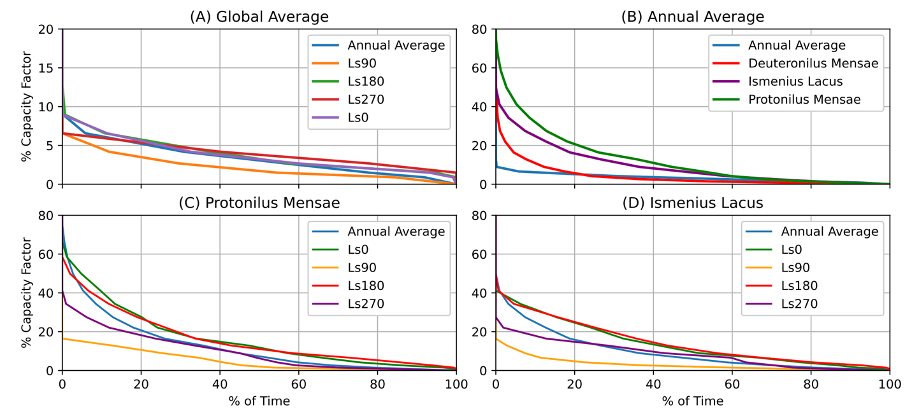

Fig. S5.
Enercon E33 wind turbine load duration curves (A) averaged globally and over the year and seasons, (B) averaged annually at three locations of interest, (C) at Protonilus Mensae (38°N,48°E), and (D) at Ismenius Lacus (29°N,17°E). The annual average lines in panels C and D reproduce the location annual average in panel B. The y-axis upper limit of panel A is 20% versus 80% in panels B-D.

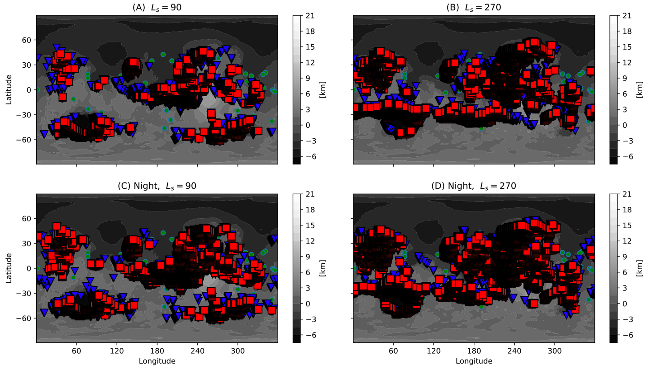
Fig. S6:
Regions that produce (A,B) diurnal average and (C,D) nighttime average power levels greater than 24 kW (red squares), or greater than 14.2 kW (blue triangles) based on output from a single Enercon E33 wind turbine at all sols/nights in the season (e.g. for L_{s} between 80° and 100°). Solid green circles show proposed landing sites from the NASA HLS2 Workshop.

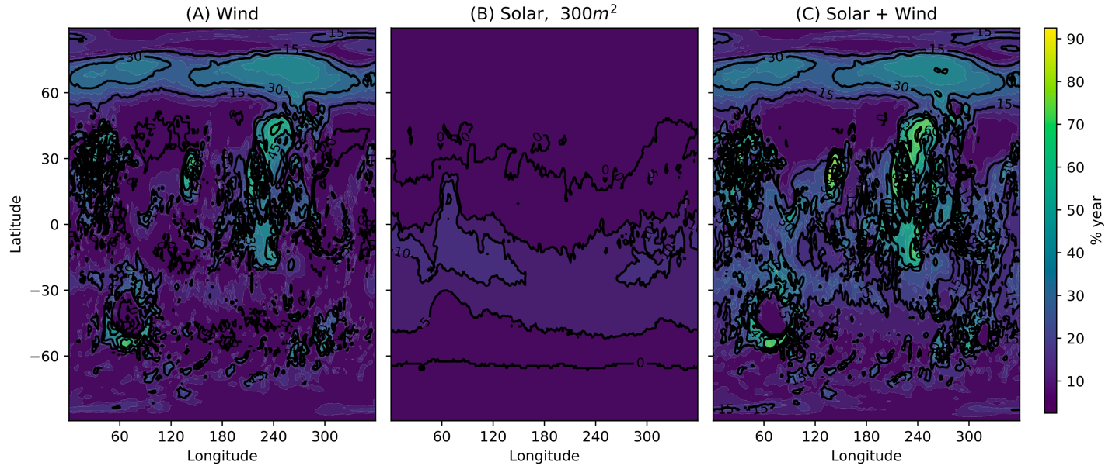
Figure S7:
As in Fig. S6, percent time of MY24 in hourly intervals that wind power, solar power, and wind and solar combined can generates >24 kW. Solar power is calculated based on a 300 m² array (29) with C_{p}=0.2.

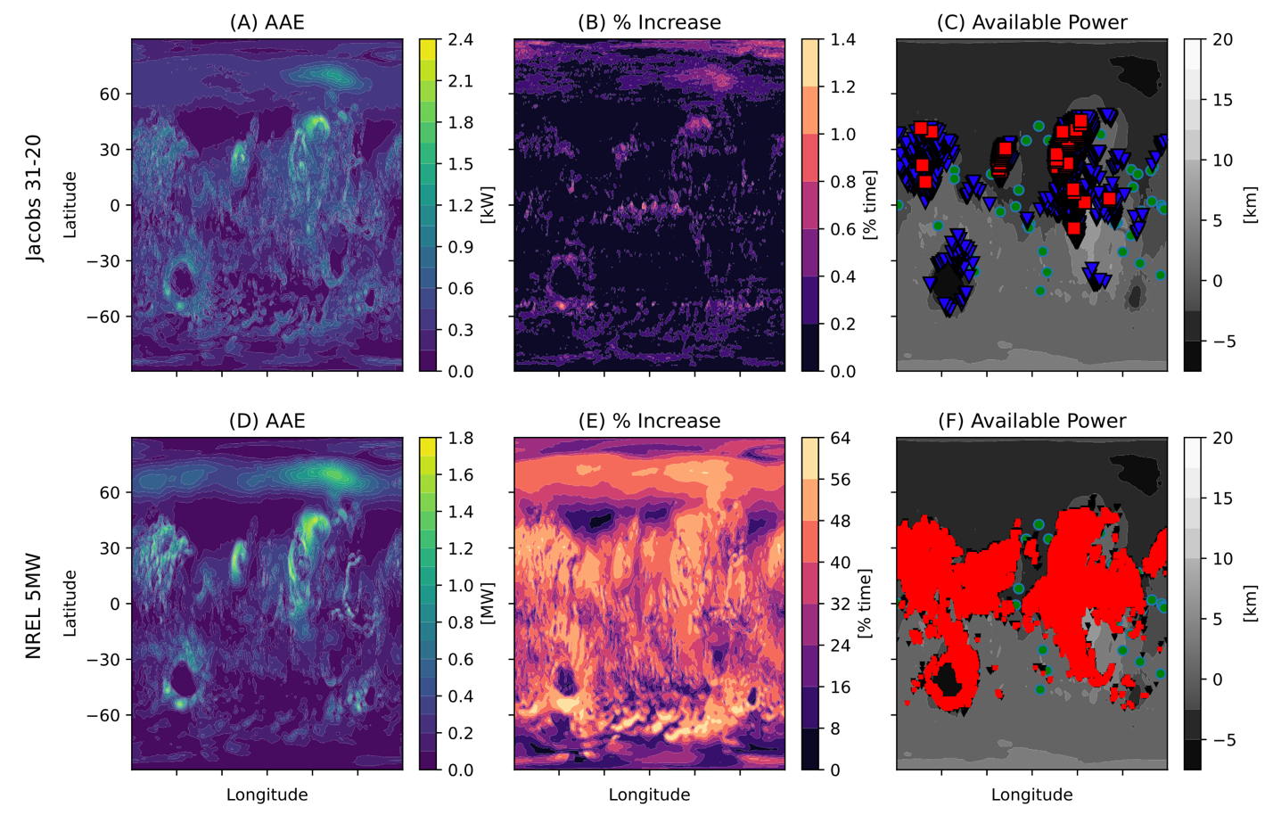
Fig. S8.
(A,D) Annual average power production for Jacobs 31-20 and NREL 5-MW wind turbines; (B,E) the additional percent of the Mars year that power generation exceeds 24kW for a solar array (C_{p}=0.2, array area S=2500m²) and a single turbine, and (C,F) regions that produce diurnal average power greater than 0.2k W (blue triangles) and 0.5 kW (red squares) for the Jacobs 31-20 turbine and greater than 14.2 kW (blue triangles) or 24 kW (red squares) for the NREL 5-MW turbine at all times throughout the Mars year.

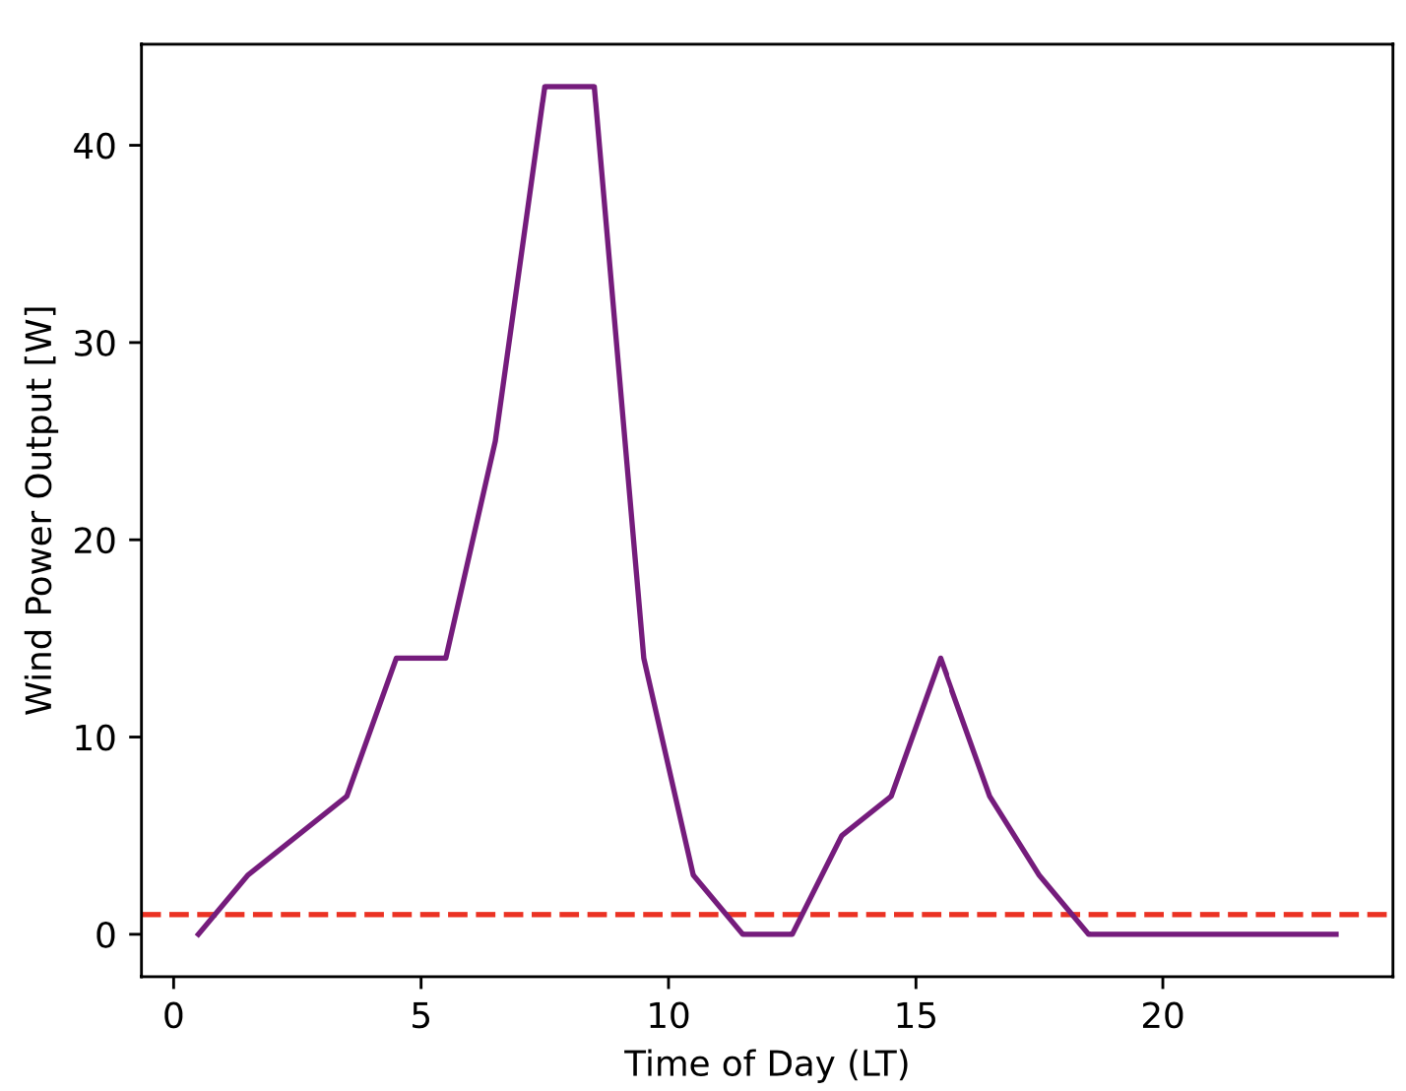Fig. S9.
Aeolos-V average power output (purple line) in the 5-sol period closest to the Mars Opportunity Rover mission end date (June 6, 2018, sol 5111, L_{s}=190.4°) versus local time of day. The red dashed line shows the power requirement to maintain the rover clock.

Table S1.
Wind turbines used in this study. Our base analysis is for the Enercon E33 wind turbine, which has been proposed for Mars missions and is currently used to power Antarctic research bases.

Turbine | Rated power | Cut-in, rated, cut-off wind speed [m/s] | Hub height [m] | Swept area [m²]
Aeolos-V (40) | 300 W | 1.5,10,13.5 | 5 | 1.13
Jacobs 31-20 (38) | 20 kW | 3, 10, 14 | 30 | 70.88
(Base) Enercon E33 (37) | 330 kW | 2.5, 13, 28 | 50 | 876.16
NREL 5MW (39) | 5 MW | 3, 11.4, 25 | 100 | 12867.96

Table S2
Regions of interest (ROI) identified in the NASA Human Landing Site Study (HLS2) with potential for wind energy development based on energy requirements from (24), and the percentage of time on an annual or seasonal basis that a single Enercon E33 wind turbine alone or in combination with a theoretical solar array can generate 24kW.

HSL2 ROI | Annual average  [kW] | Seasonal average [kW] |  | Annual percent time [%]  (wind, solar, total) | Seasonal percent time [%]
HSL2 ROI | Annual average  [kW] | L_{s}90° | L_{s}270° | Annual percent time [%]  (wind, solar, total) | Ls90°  (wind, solar, total) | L_{s}270°  (wind, solar, total)
Deutronilus Mensae 2  (35°N,23°E) | 38.25 | 19.76 | 43.70 | 42,44,80 | 29, 54, 79 | 48, 30, 78
Ismenius Lacus  (29°N,17°E) | 27.33 | 7.72 | 24.10 | 37,44,75 | 7, 50, 60 | 44, 33, 81
Protonilus Mensae  (38°N,48°E) | 36.40 | 14.38 | 29.06 | 46,44,81 | 28, 54, 81 | 47, 29, 78
Hadriacus Palus  (23°S,78°E) | 20.67 | 5.22 | 42.35 | 26,44,55 | 0, 38, 42 | 54, 50, 79
Hellas Rim  (31°S,94°E) | 16.95 | 11.16 | 31.56 | 22,43,56 | 9, 33, 44 | 42, 54, 72
Apollinaris Sulci 2  (11°S,174°E) | 24.37 | 8.30 | 72.4 | 24,44,69 | 2, 42, 44 | 47, 46, 92
Newton Crater  (36°S,200°E) | 7.36 | 2.26 | 40.06 | 5,43,45 | 0, 33, 33 | 49, 54, 57
Eastern Valles Marineris  (3°S,325°E) | 13.50 | 28.18 | 19.68 | 20,45,52 | 57, 42, 65 | 34, 46, 57
Equatorial Valles Marineris  (16°S,311°E) | 19.37 | 33.27 | 14.18 | 29,44,72 | 52, 38,82 | 32, 50, 84
Ausonia Cavus  (28°S, 97°E) | 12.40 | 2.96 | 36.47 | 14, 43, 49 | 0, 34, 38 | 35,50,65

Table S3.
Simulated global average annual energy production (AEP) [kWh] for each tested turbine.

Turbine | Hub height [m] | Rotor diameter [m] | AEP [kWh]
Aeolos-V (40) | 5 | 1.6 | 974.86
Jacobs 31-20 (38) | 30 | 9.45 | 7.35x10⁴
Enercon E33 (37) | 50 | 33.4 | 2.20x10⁶
NREL 5MW (39) | 100 | 126 | 4.72x10⁷

Data S1-S4

Data S1: Aeolos-V 300-W Wind Turbine Power Curve Data (40)

Wind Speed Bin [m/s] | Power [kW]
0-1.5 | 0
1.5-2 | 0.003
2-2.5 | 0.005
2.5-3 | 0.007
3-3.5 | 0.014
3.5-4 | 0.025
4-4.5 | 0.043
4.5-5 | 0.06
5-5.5 | 0.08
5.5-6 | 0.1
6-6.5 | 0.12
6.5-7 | 0.15
7-7.5 | 0.17
7.5-8 | 0.2
8-8.5 | 0.22
8.5-9 | 0.25
9-9.5 | 0.27
9.5-10 | 0.3
10-10.5 | 0.33
10.5-11 | 0.36
11-11.5 | 0.38
11.5-13.5 | 0.4

Data S2: Jacobs 31-20 20-kW Wind Turbine Power Curve Data (38)

Wind Speed Bin [m/s] | Power [kW]
0-3 | 0
3-3.5 | 0.09
3.5-4 | 0.26
4-4.5 | 0.5
4.5-5 | 0.83
5-5.5 | 1.22
5.5-6 | 1.88
6-6.5 | 2.6
6.5-7 | 3.43
7-7.5 | 4.5
7.5-8 | 5.6
8-8.5 | 6.79
8.5-9 | 8.0
9-9.5 | 9.65
9.5-10 | 11.45
10-10.5 | 13.1
10.5-11 | 15
11-11.5 | 17.2
11.5-12 | 18.7
12-12.5 | 19.8
12.5-14 | 20

Data S3: Enercon E33 330-kW Wind Turbine Power Curve Data (37)

Wind Speed Bin [m/s] | Power [kW]
0-2.5 | 0
2.5-3 | 3
3-3.5 | 5
3.5-4 | 9
4-4.5 | 14
4.5-5 | 22
5-5.5 | 30
5.5-6 | 43
6-6.5 | 55
6.5-7 | 74
7-7.5 | 92
7.5-8 | 115
8-8.5 | 138
8.5-9 | 167
9-9.5 | 196
9.5-10 | 223
10-10.5 | 250
10.5-11 | 273
11-11.5 | 293
11.5-12 | 308
12-12.5 | 320
12.5-28 | 330

Data S4: NREL 5-MW Wind Turbine Power Curve Data (39)

Wind Speed Bin [m/s] | Power [kW]
0-3 | 0
3-4 | 40.5
4-5 | 177.7
5-6 | 403.9
6-7 | 737.6
7-8 | 1187.2
8-9 | 1771.1
9-10 | 2518.6
10-11 | 3448.4
11-25 | 4562.5

