Supporting Information
Structural Performance of Chemically Modified Natural Jute Yarn for Strength Demanding Composite Applications
Md. Ashadujjamanª, Abu Saifullah^{b}, Darshill U Shah^{c}, Minglonghai Zhang^{d}, Mahmudul Akonda^{e}, Nazmul karim^{f}, Forkan Sarker^{a*}

^{*a} Department of Textile Engineering, Dhaka University of Engineering & Technology, Gazipur-1700, Bangladesh
^{b} Advanced Materials and Manufacturing (AMM) Research Group, School of Mechanical and Design Engineering, University of Portsmouth, Portsmouth PO1 3DJ, UK
^{c} Department of Architecture, University of Cambridge, Cambridge, CB2 1PX, UK
^{d} Institute of Textile and Clothing, The Hong Kong Polytechnic University, Hong Kong
^{e} School of Materials. The University of Manchester, Manchester, M13 9PL, UK
^{f} Centre for Fine Print Research, University of West of England, Bristol, BS3 2JT, UK

Corresponding author: Dr. Forkan Sarker, email: forkan@duet.ac.bd

Supporting Information 1: Chemical Composition of Jute Fibre, Physical Properties of Jute Yarn.
Table S1 shows the chemical composition of natural fibre. Jute fibre has almost similar cellulose contents compare to flax fibre which is extensively used for making natural fibre composites. However, natural binding materials lignins are only highly presented in jute fibre is considered one of the major flaws of jute fibre. However, other surface impurities (pectins, fat and waxes, water contents) are fairly less than other natural fibres made them a right choice to use as a reinforcing material in composites. Table S2 provides the physical properties of measured for the jute yarn received from the supplier. The yarn has a linear density of ⁓327 Tex and the diameter of the yarn is ⁓0.92 mm.
Table S1 Chemical composition of selected plant based natural fibres.^{[1–4]}
Fibre | Cellulose (%) | Hemicellulose (%) | Lignin (%) | Pectin (%) | Waters soluble content (%) | Fat& Wax (%)
Jute | 71.5 | 13.4 | 13.1 | 0.2 | 1.2 | 0.6
Sisal | 73.1 | 13.3 | 11.0 | 0.9 | 1.4 | 0.3
Hemp | 76.1 | 12.3 | 5.7 | n/a | n/a | n/a
Flax | 64.1 | 16.7 | 2.0 | 1.8 | n/a | 1.5
Ramie | 73 | 13.14 | 1.58 | 4.52 | 6.95 | 4.15

Table S2 Physical properties of jute yarn collected from local manufacturer.
Fibre | Linear  Density (Tex), md | Count, (SI)  (lbs./spindle) | TPI (SI) | Thickness (mm), md
Jute yarn | 327 (±31) | 9.5 | 4.09 | 0.92±0.15
*md: measured in values; SI- supplier information

Supporting Information 2: Jute Yarns and Chemical Treatments Used in This Study
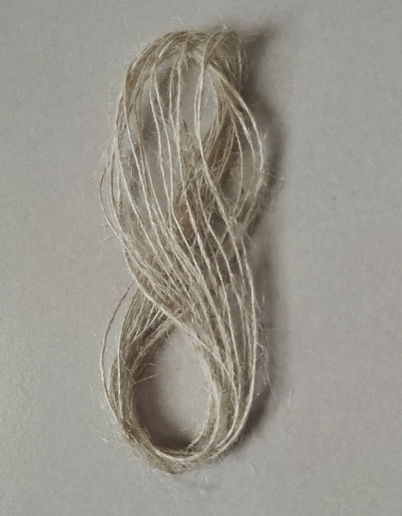
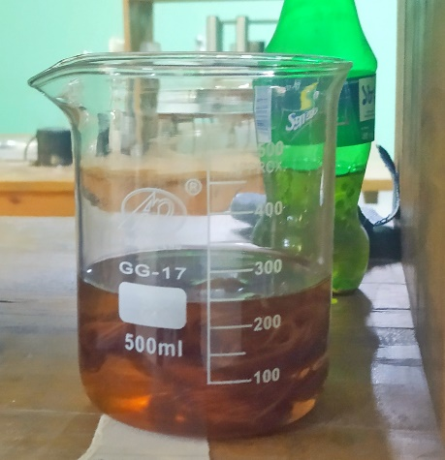
Figure S1 shows the digital photographs of untreated jute yarn and traditional alkali treatment on jute yarns. Jute yarns of single ply were collocated from the package of yarn as shown in Figure S1a and immersed into the solution of alkali at room temperature as shown in Figure S1b.
a
b
Figure S1 Digital photographs: (a) Untreated jute yarn; (b) Jute yarn under alkali treatment.

Figure S2 shows the digital images of glycine treatment used in this study. An infrared lab based dyeing machine. Jute yarns were poured into solution of glycine (M:L ratio 1:20) and run the machine at 100 º C for 1.5 hours (see Figure S6a). Fibres and the solutions were kept in the treatment pod as shown in Figure S2b.
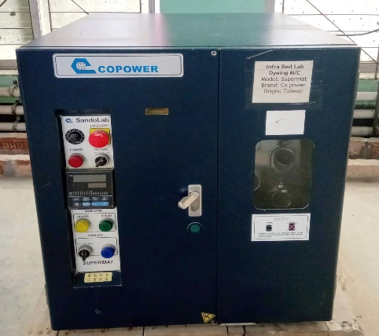
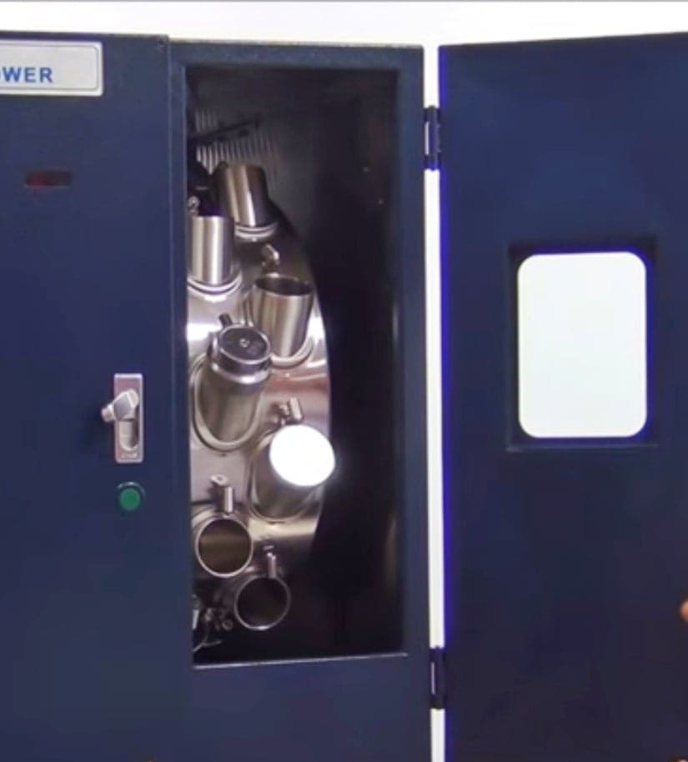
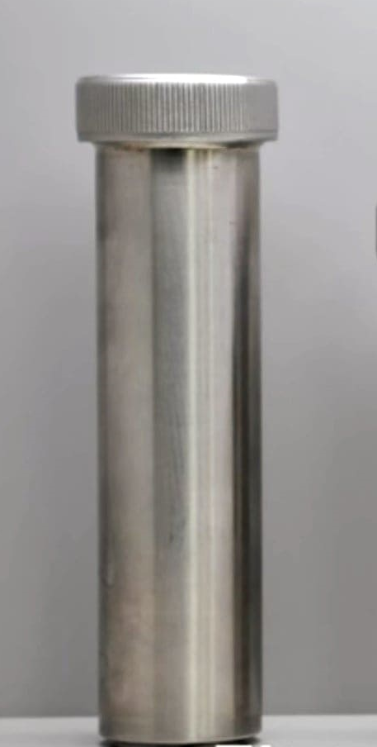
Treatment Pod
a
b
Figure S2 Glycine treatment: (a) Infrared lab dyeing machine; (b) inside chamber of machine (inset treatment pod)

Supporting Information 3: Characterization and Testing Used in The Study
An optical microscope of Model Jiusion, China was used in this study to measure the surface characteristics and diameter of the jute yarn at different magnification as shown in Figure S3. A Universal Tensile Testing machine was used to perform single yarn tensile test. Single yarn was tested with a setting of 50 mm gage length and a crosshead speed of 2 mm/min as reported in the previous work (see Figure S4).¹
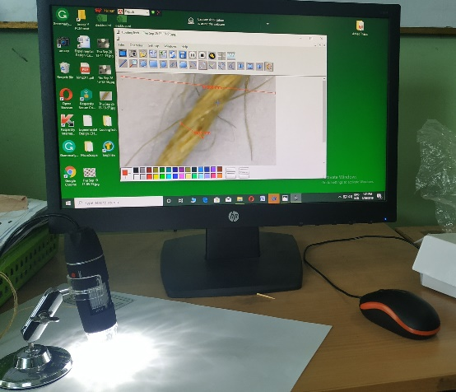
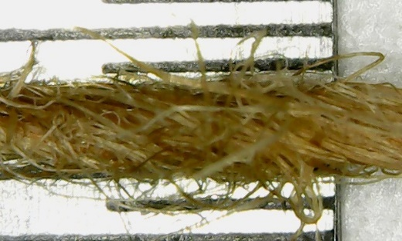
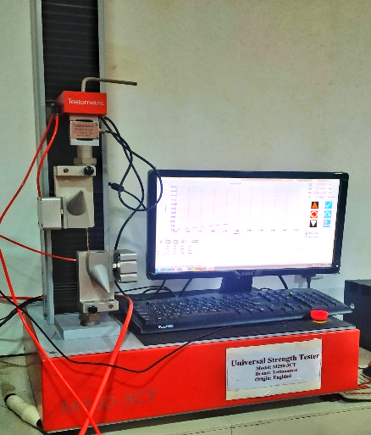
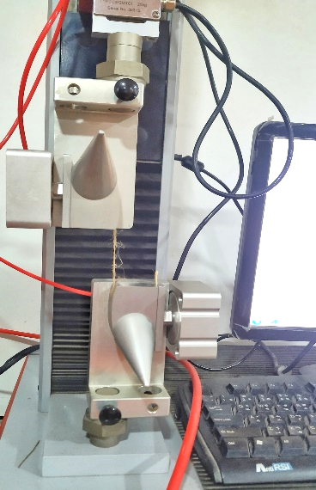
Figure S3 Optical microscope used in this study to measure the diameter of the yarn
a
b
Figure S4 (a) Tensile testing set up at Universal Tensile Testing machine (b) yarn sept up for the test

Supporting Information 4: Surface Properties and Thermal Analysis of Jute Yarn
Figure S5 shows the micrographic images of UTG yarn. After applying glycine on untreated jute fibre surfaces looks still fluffy as shown in Figure S5a. Moreover, scanning electron image in Figure S5b, it is clearly visible the impurities onto the surface UTG yarn even after applying glycine.
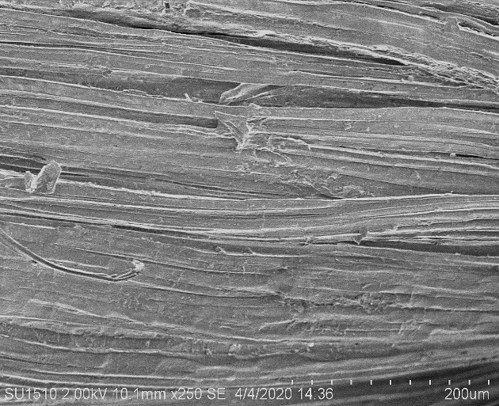
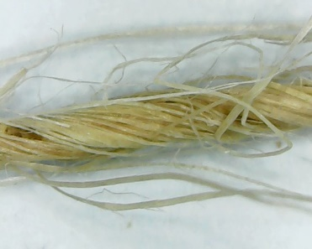
a
b
200 µm
100 µm
a
b
Figure S5 (a) Optical image of UTG jute yarn at X20 magnification (b) SEM image surface of UTG jute yarn surfaces at X250 magnification.

Supporting Information 5: Thermal analysis of Jute Yarn
Table S3 shows the thermal properties analysis particularly with the Onset and End-set temperature and the residue % of untreated and glycine treated jute yarn performed in the study. The results show that Onset and Endset temperature of glycine treated jute yarn (ATG10) increases by 8 ºC and 12 º C, respectively while compare with untreated jute yarn (UT).
Table S3 Thermal properties of treated and untreated jute yarn from the TGA results.
Treatment | Onset temp (℃) | End-set temp (℃) | Residue (%)
UT | 298 | 349 | 1.06
AT | 272 | 356 | 3.6
UTG 10 | 298 | 350 | 0.04
ATG 10 | 306 | 361 | 0.81

Supporting Information 6: Tensile properties analysis ad Weibull Statistics
Table S4 Tensile properties optimized under different treatment conditions
Treatment | Sample ID | Diameter (mm) | Breaking force (N) | Tensile strength (MPa) | Tensile modulus (MPa) | Tensile strain (%)
Untreated | UT | 0.92 (±0.13) | 28 (±9) | 42 (±16) | 324 (±80) | 7.7 (±1.79)
Alkali treatment | 0.25 ATG10 | 0.71 (±0.08) | 31.5(±7) | 77(±19) | 527(±90) | 8.3(±0.9)
Alkali treatment | 0.5 ATG10 | 0.74 (±0.07) | 31.2(±9) | 79(±22) | 458(±70) | 9.5(±1.4)
Alkali treatment | 1 ATG10 | 0.68 (±0.10) | 24.7(±4) | 71(±23) | 648(±170) | 6.8(±0.6)
Alkali treatment | 2 ATG10 | 0.69 (±0.11) | 26.2(±4) | 72(±17) | 649(±230) | 7.2(±1.15)
Glycine | ATG 5 | 0.76 (±0.11) | 38 (±4) | 87 (±21) | 340 (±210) | 10.8 (±1.23)
Glycine | ATG 10 | 0.83 (±0.10) | 42 (±9) | (±34) | 350 (±200) | 11.9(±2.09)
Glycine | ATG 15 | 0.79(±0.10) | 37 (±5) | 77 (±17) | 370 (±110) | 11.1 (±1.17)
Glycine | ATG 20 | 0.75 (±0.13) | 30 (±7) | 69 (±20) | 360 (±120) | 9.5 (±1.61)
pH | ATG 10P3 | 0.79 (±0.08) | 31 (±5) | 65 (±24) | 270 (±190) | 10.9 (±1.86)
pH | ATG10P5 | 0.73 (±0.07) | 25 (±6) | 59 (±12) | 250 (±60) | 9.3 (±1.16)
pH | ATG10P7 | 0.74 (±0.08) | 33 (±7) | 77 (±13) | 230 (±60) | 11.7 (±2.21)
pH | ATG10P11 | 0.75 (±0.08) | 31 (±7) | 76 (±18) | 310 (±0.25) | 10.1 (±2.36)

Table S5 Tensile properties of untreated, alkali treated, and glycine treated jute yarn.
Sample ID | Diameter (mm) | Breaking force (N) | Tensile strength (MPa) | Tensile modulus (MPa) | Tensile Strain (%)
UT | 0.92 (±0.13) | 28 (±9.37) | 42 (±16.31) | 324 (±80) | 7.7 (±1.79)
AT | 0.71 (±0.10) | 31 (±9.04) | 70 (±22.65) | 290 (±85) | 9.7 (±1.95)
UTG 10 | 0.76 (±0.05) | 29 (±8.24) | 63 (±16.74) | 290 (±80) | 9.5 (±1.89)
ATG 10 | 0.74 (±0.06) | 36 (±9.18) | 86 (±22.32) | 276 (±60) | 11.3(±2.07)

Table S4 provides the optimized results obtained after utilizing different surface treatments using 15 samples per treatment types. In alkali treatment section 0.25,0.5,1,2 indicates the concentration of alkali used in the study We then performed and repeated 50 single yarn tests to confirm the improvements. Table S5 shows the details test results obtained after single yarn tensile test performed in this study. It was observed that untreated jute yarn has larger diameter due to presence of impurities onto the surfaces of jute yarn. However, after applying alkali treatment this diameter reduced slightly and glycine treatment does not show any significant changes in the diameter.

Table S6 Weibull parameters obtained from the tensile results of untreated and treated jute yarns
Sample ID | Tensile strength |  | Tensile modulus |  | Tensile strain
Sample ID | Scale parameter,  (α) | Shape parameter,  (β) | Scale parameter,  (α) | Shape parameter,  (β) | Scale parameter,  (α) | Shape parameter,  (β)
UT | 47 | 3 | 354 | 4.5 | 8.3 | 4.8
AT | 94 | 4.4 | 320 | 2.5 | 10.7 | 4.5
UTG | 69 | 4.1 | 318 | 4.1 | 10.5 | 4.6
ATG | 90 | 6.1 | 294 | 5.9 | 12 | 6.1
However, tensile properties are surprisingly affected with the types of treatment done on jute yarn. For example, mechanical properties of ATG10 yarns significantly improved breaking force from 28 N to 42 N, tensile strength from 42 to 78 MPa, tensile strain from 7.7 to 11.9%. The improvement is attributed with the suitable chemical interaction of glycine and cellulose of jute yarns. Though, tensile modulus is not improved sharply as other properties. Table S6 provides the information about details about the Weibull statistical analysis performed with the tensile test results. Shape parameters is known as Weibull modulus that determines the efficacy of any chemical modification used for the removal of flaws present in the yarn. We observe a significant improvement in the Weibull modulus almost 100% improvement clearly indicate that the weakest points present in the fibre due to the flaws are removed and thus it contributed in achieving highest shape parameters in the results. Scale parameter is the theoretical results is also close to experimental results.

Supporting Information 7: Fracture Surface and Comparative Study
Figure S6 shows the scanning electron microscopic fractography of UTG yarn after performing the tensile test. The graph clearly shows the microfibrillar linear breakage of UTG yarns. This clearly indicates the improvement of crystallinity of jute fibre yarn after the glycine treatment even without alkali treatment confirms the reactivity of glycine on jute yarn.
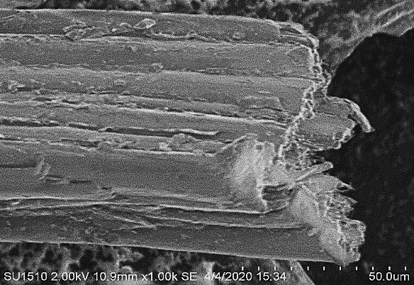
Linear fibrillar breakage
50 µm
Figure S6 SEM image of fracture surface of UTG yarn after tensile test.

Table S7 Tensile properties of jute yarn and their comparison reported in the literatures.
Yarn type | Fineness (Tex) | Diameter (mm) | Tensile strength (MPa) | Tensile strain (%) | References
Jute | -- | 1.7 | 42 | 6.17 | ^{[5]}
Flax | 4187 | -- | 72 | -- | ^{[6]}
Hemp | 4312 | -- | 45 | -- | ^{[6]}
Jute | -- |  | 52 | 4 | ^{[7]}
Jute (ATG) | 327 | 0.74 | 86 | 11.5 | This study
Table S7 shows the comparative study of natural fibre-based yarn after using after surface treatment. It was found that study of natural fibre on improving yarn strength is and strain % is limited in the literature. Present study clearly shows that glycine modified jute yarn has almost 100% more tensile strength and strain % than the jute yarn reported in the literature. This is the highest value reported in the literature for other natural fibre yarn used for making natural fibre composites.

References
[1] D. Perremans, K. Hendrickx, I. Verpoest, A. W. Van Vuure, Compos. Sci. Technol. 2018, 160, 216.
[2] L. Yan, N. Chouw, K. Jayaraman, Compos. Part B Eng. 2014, 56, 296.
[3] J. K. Pandey, S. H. Ahn, C. S. Lee, A. K. Mohanty, M. Misra, Macromol. Mater. Eng. 2010, 295, 975.
[4] K. L. Pickering, Properties and Performance of Natural-Fibre Composites, 2008.
[5] A. M. M. Sharif Ullah, S. Shahinur, H. Haniu, Materials (Basel). 2017, 10, DOI 10.3390/ma10050450.
[6] P. Ouagne, S. Renouard, E. Laine, J. Text. Eng. Fash. Technol. 2017, 1, DOI 10.15406/jteft.2017.01.00034.
[7] Y. Bensmail, A. el moumen, F. Lmai, A. Imad, MATEC Web Conf. 2019, 286, 3003.

