Graphical abstract:
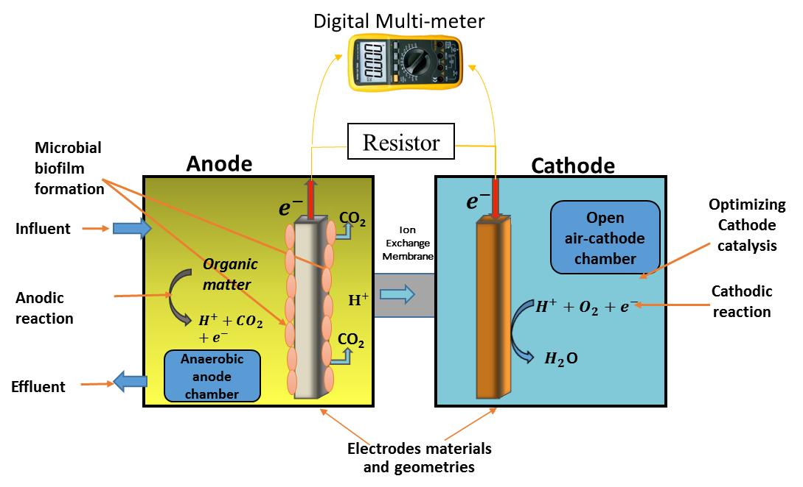

Highlights:
- Considerable extent of bioelectricity can be generated
- Wastewater can be used as electrolyte

