Supplementary Information for
Electrically Driven Bound-State-in-the-Continuum Laser

Yufei Wang^{1,2,3}, Mingjin Wang¹, Ting Fu¹, Xuyan Zhou¹, Xueyou Wang¹, Wenzhen Liu¹, Jian Fan¹, Aiyi Qi¹, Guixin Li⁵, Yuri Kivshar⁶, Wanhua Zheng^{1,2,3,4*}

¹Laboratory of Solid-State Optoelectronics Information Technology, Institute of Semiconductors, Chinese Academy of Sciences, Beijing 100083, China
²College of Future Technology, University of Chinese Academy of Sciences, Beijing 101408, China
³Center of Materials Science and Optoelectronics Engineering, University of Chinese Academy of Sciences, Beijing 100049, China
⁴State Key Laboratory on Integrated Optoelectronics, Institute of Semiconductors, Chinese Academy of Sciences, Beijing 100083, China
⁵Department of Materials Science and Engineering, Southern University of Science and Technology, Shenzhen 518055, China
⁶Nonlinear Physics Center, Research School of Physics, Australian National University, Canberra ACT 2601, Australia

1 Quasi-BIC modes in a tapered photonic crystal slab

At first, the deeply etched depth, period, and the upper and bottom apertures of air holes are set to 1.72 μm, 540 nm, 360 nm, 240 nm, respectively. The transmission TM-like and TE-like bands of taper-hole PC with infinite period as a function of the incident angle are calculated, which is shown in Fig. S1. In case of incident angle 7.01°, the transmittance of 1568.5 nm at the TM-like upper band is extremely small, and the transmission band almost disappears. Due to the taper-hole PC breaks the mirror-flip symmetry along the vertical direction, the avoided crossing of bands occurs, and different TM-like modes interfere destructively in the leaky channels forming the Friedrich-Wintgen (FW) BIC at the upper band.

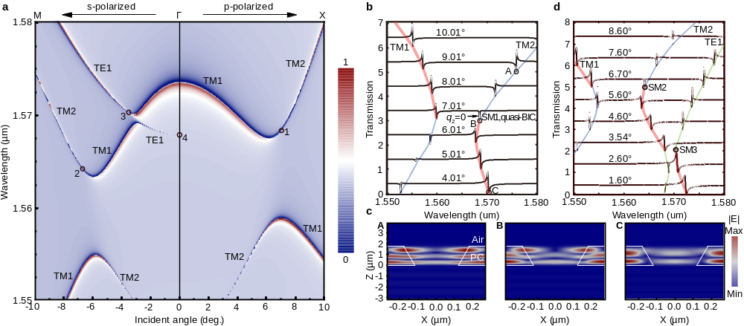

Fig. S1 (a) Transmission TM-like and TE-like bands of taper PC for p-polarized light incident along Г-X direction (0°→10°) and s-polarized light incident along Г-M direction (-10°→0°). (b) Two Fano resonances evolution with the variation of incident angle in the Г-X direction, in which the thick red curves show TM1 Fano resonance dip modes with C included and the thin blue curves TM2 modes including A. The right dip for 7.01° is the supercavity mode (SM), i.e. quasi-BIC (B, SM1). SM1 corresponds to black circle 1 in Fig. S1(a). (c) Corresponding field distributions of dip modes A, B and C, in which the white lines show the outline of the taper air hole. (d) Fano resonances evolution with the increase of incident angle in the Г-M direction. SM2 and SM3 corresponds to black circle 2 and 3 which lie in the avoided crossings of TM1 & TM2 bands, and TM1 & TE1 bands, respectively.

As shown in Fig. S1(b), at the incident angle of 7.01°, q₂ of the second Fano resonance equals 0, corresponding to a supercavity mode SM1, i.e. FW quasi-BIC. Figure S1(c) shows the field distributions of hybridized mode B (SM1), TM2-like mode A and TM1-like mode C on the thin blue and thick red curves in Fig. S1(b), respectively. For the incident angle in the Г-M direction, two supercavity modes SM2 and SM3 are also obtained through avoided crossings of TM1 & TM2 bands, and TM1 & TE1 bands, respectively, which are shown in Fig. S1(d). Focusing on TE1 band from Fig. S1(a) and considering s-polarized light incident along Г-M and Г-X directions, it is easy to conclude that TE1 band has the symmetry with respect to Г point (0°) due to C₄ symmetry, thus black circle 4 corresponds to the symmetry-protected (SP) BIC, which has symmetry-incompatible near-field electric vectors.

2 Red shift and broadening of the lasing peak of accidental BIC

Figure S2 shows the accidental BIC lasing peak has a continuous red shift of 0.7 nm when the injected current is increased from 400 mA to 600 mA. But the FWHM of the lasing peak doesn’t keep increasing. When the current is between 450 mA and 550 mA, the FWHM remains nearly unchanged. This clearly demonstrates the topology protection behaviour of accidental BIC mode.

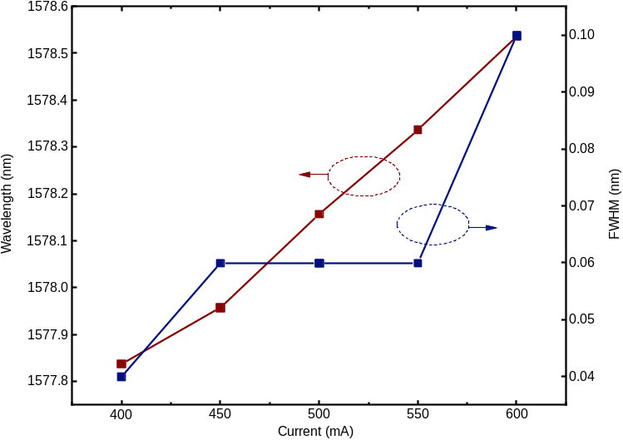
Fig. S2. Red shift and broadening of accidental BIC lasing peak for the shallowly etched PC metacaivty when the injection current is increased from 400 mA to 600 mA.

3 Images of the lasing patterns under different values of the injected current

At the current below threshold of 0.3A and currents above threshold of 0.4A and 0.6A, the laser evolves from spontaneous radiation, accidental BIC single mode lasing to multi-mode lasing process. It is displayed from the electrical injection lasing patterns in the PC area captured by a CCD camera. When the current is increased to above 0.4A, the on focus intensity is so large that the lasing mode cannot be distinguished from the color saturation, although in a strong attenuation of 30 dB. The slightly out of focus images can be utilized to identify the dipole-like intensity pattern. With the current increased to 0.6 A, the multi-mode lasing disturbs the typical distribution.
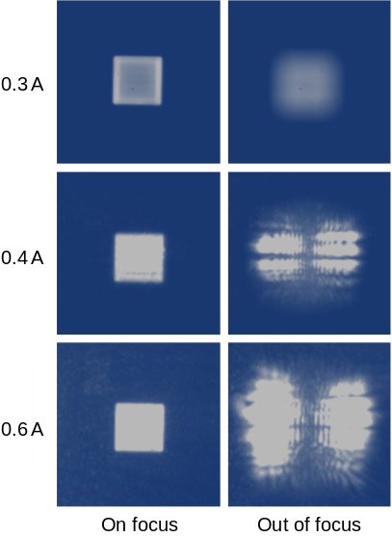

Fig. S3. On-focus and out of focus images of the lasing pattern captured by a CCD camera under different values of the injected current.

