Supporting Information For
Keystone genes confer superior performance in hyperthermophilic composting
Peng Cui¹, Hanpeng Liao^{1*}, Chaofan Ai¹, Zhongbing Xu¹, Zhi Chen¹, Zhen Yu², Shungui Zhou^{1*}
¹ Fujian Provincial Key Laboratory of Soil Environmental Health and Regulation, College of Resources and Environment, Fujian Agriculture and Forestry University, Fuzhou, China
² National-Regional Joint Engineering Research Center for Soil Pollution Control and Remediation in South China, Guangdong Key Laboratory of Integrated Agro-environmental Pollution Control and Management, Guangdong Institute of Eco-environmental Science & Technology, Guangdong Academy of Sciences, Guangzhou, 510650, China
∗ Corresponding author: Hanpeng Liao;
∗ Corresponding author: Shungui Zhou;
Email: sgzhou@soil.gd.cn (Shungui Zhou)

Figure and table legends
Figure S1. Composting performance indices during hyperthermophilic composting (hTC) and conventional thermophilic composting (cTC).
Figure S2. Microbial functional conpostion analysis of hyperthermophilic composting (hTC) and conventional thermophilic composting (cTC).
Figure S3. Normalized signal intensity of detected functional genes involved C-degrading and N-cycling on day 5 and day 44 in hyperthermophilic composting (hTC) and conventional thermophilic composting (cTC).
Figure S4. Relationship between total relative abundance of C-degrading genes or N-cycling genes abundance and composting performance indices in hyperthermophilic composting (hTC) and conventional thermophilic composting (cTC).
Figure S5. Changes in bacterial abundance (16s gene numbers as reviewed by qPCR, left Yaxis) and alpha diversity (Shannon index; right Y-axis) in hyperthermophilic composting (hTC) and conventional thermophilic composting (cTC).
Figure S6. The overall distribution pattern of gene abundance-based function composition dissimilarity in hyperthermophilic composting (hTC) and conventional thermophilic composting (cTC).
Figure S7. Heatmaps showing the taxonomic classification at the genus level of predominant 16S rRNA gene sequences (relative abundance at top 30) in compost samples during hyperthermophilic composting (hTC) and conventional thermophilic composting (cTC).
Figure S8. Procrustes analysis indicating significant correlations between Geochip based functional gene abundances and bacterial composition during hyperthermophilic composting (hTC) and conventional thermophilic composting (cTC).
Figure S9. The linear regressions between pairwise similarities of (a) bacterial community composition and functional structure during hyperthermophilic composting (hTC) and conventional thermophilic composting (cTC). Bray-Curtis distance was used for the similarity calculations.
Table S1. The physicochemical properties of compost samples from hyperthermophilic composting (hTC) and conventional thermophilic composting (cTC).
Table S2. The distribution of various nitrogen form during hyperthermophilic composting (hTC) and conventional thermophilic composting (cTC).
Table S3. Table S3. Normalized signal intensity of detected functional genes involving C-degrading and N-cycling on day 0, day 13, day 23 and d37 in hyperthermophilic composting (hTC) and conventional thermophilic composting (cTC)
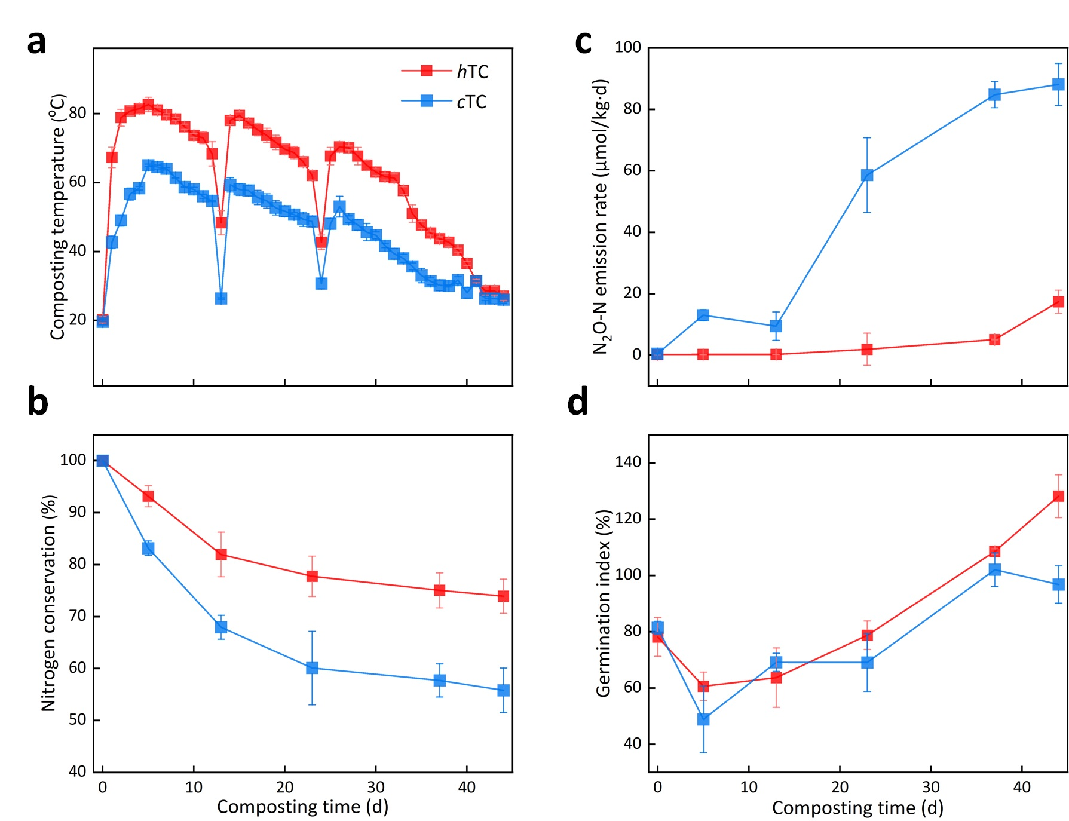
Figure S1. Composting performance indices during hyperthermophilic composting (hTC, in red) and conventional thermophilic composting (cTC, in blue). (a), Composting temperature; (b), Nitrogen conservation; (c), N₂O-N emission rate and (d), Germination index. The results are the average of the three replicates, and vertical bars denote standard errors of the mean (n=3).

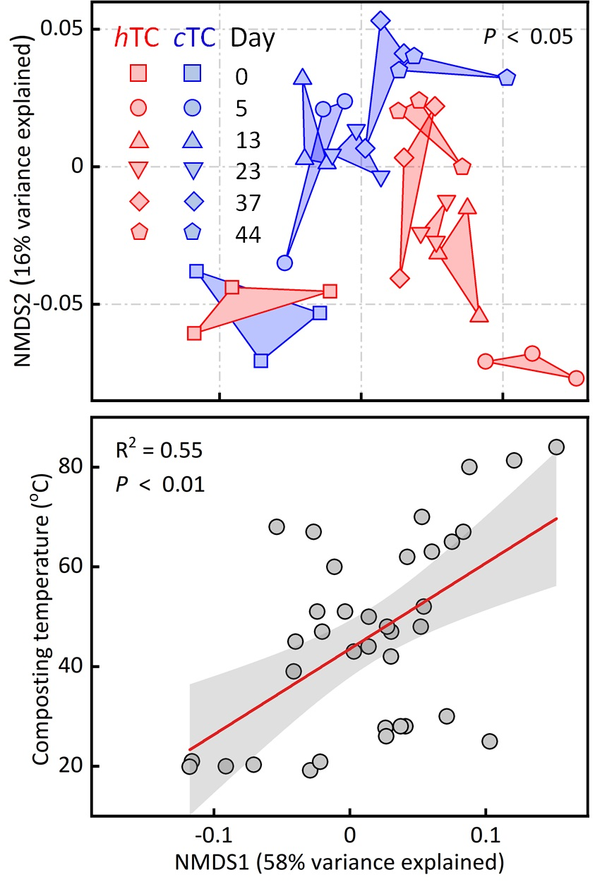
Figure S2. Microbial functional conpostion analysis of hyperthermophilic composting (hTC) and conventional thermophilic composting (cTC). Nonmetric multidimensional scaling (NMDS)-based functional conpostion analysis of hTC and cTC show that samples are not only clearly grouped by their treatment (top, exclude day 0), but also separated by the local temperatures as shown by the strong correlation (R² = 0.55, P < 0.01) between the first NMDS and temperature (bottom).

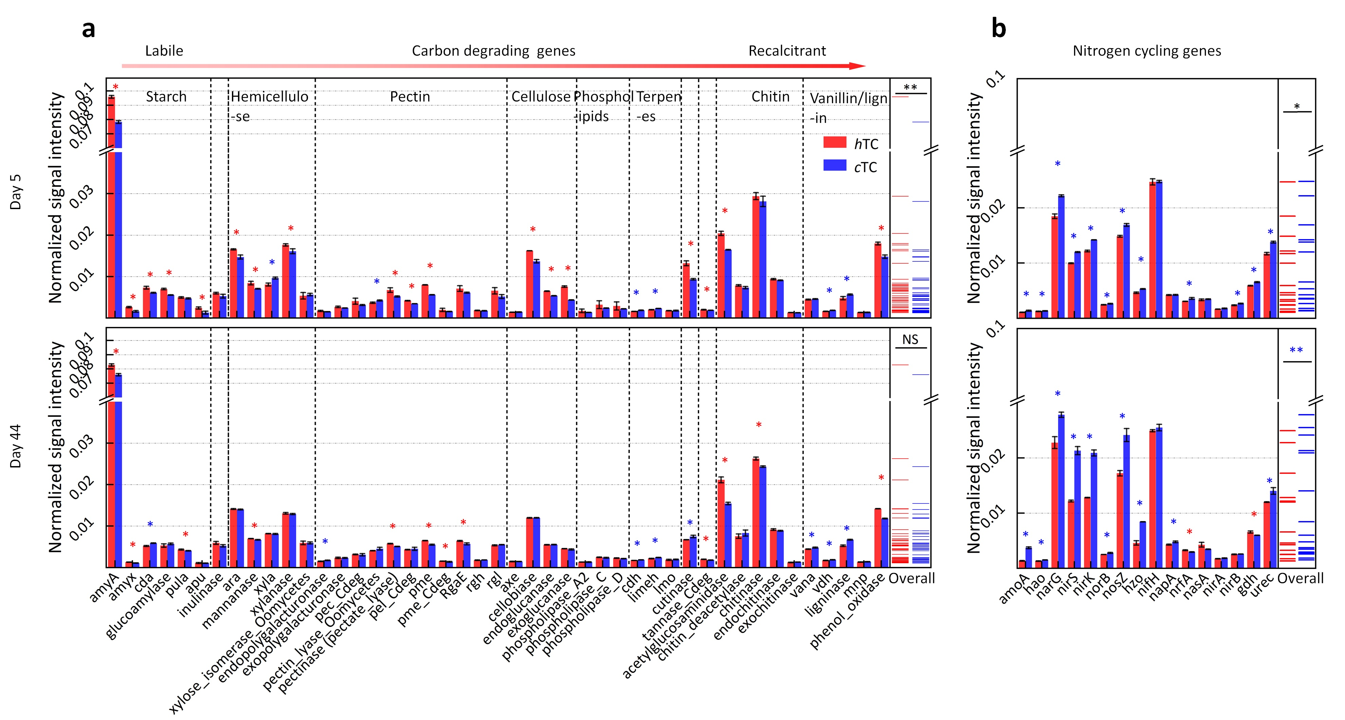
Figure S3. Normalized signal intensity of detected functional genes involved C-degrading and N-cycling on day 5 and day 44 in hyperthermophilic composting (hTC) and conventional thermophilic composting (cTC). (a) The relative abundances of C-degrading and (b) N-cycling genes on day 5 in the two treatment; (c) The relative abundances of C degrading and (d) N cycling genes on day 44 in the two treatment. Red bars represent the average normalized signal intensity of probes of each gene of hTC samples, and blue bars represent cTC amples. Error bars represent standard error of the mean for n = 3 biological replicates. The differences of the functional gene relative abundance between hTC and cTC samples were tested two-sided Fisher’s exact test with confidence intervals at 95% significance using the Benjamini-Hochberg FDR multiple test correction.

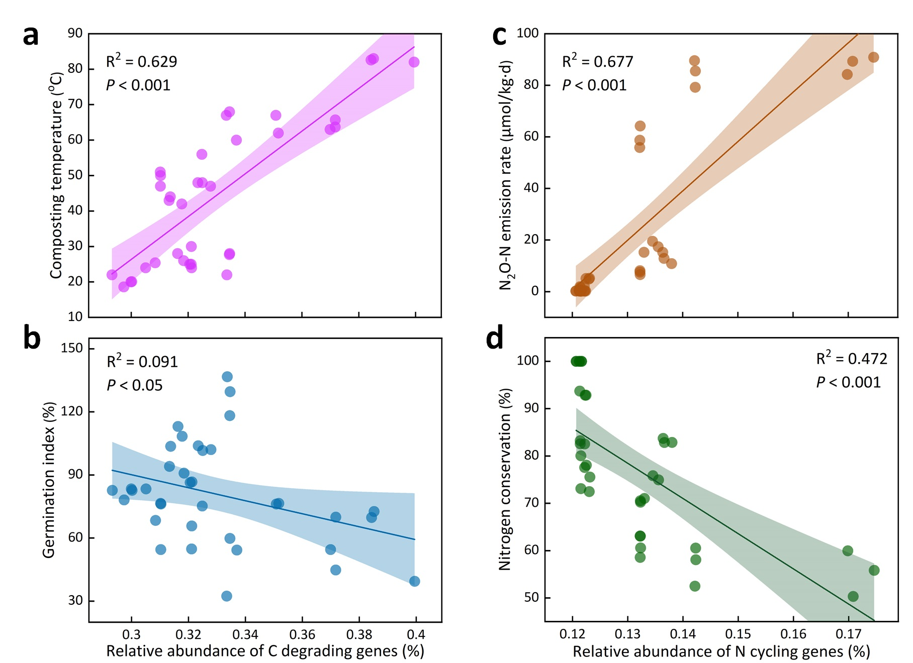
Figure S4. Relationship between total relative abundance of C-degrading genes or N-cycling genes abundance and composting performance indices in hyperthermophilic composting (hTC) and conventional thermophilic composting (cTC). (a) and (b), relationship between total C degrading genes abundance and composting temperature, and germination index, respectively. (c) and (d) relationship between total N-cycling genes relative abundance and N₂O emission rate, and nitrogen conservation, respectively.
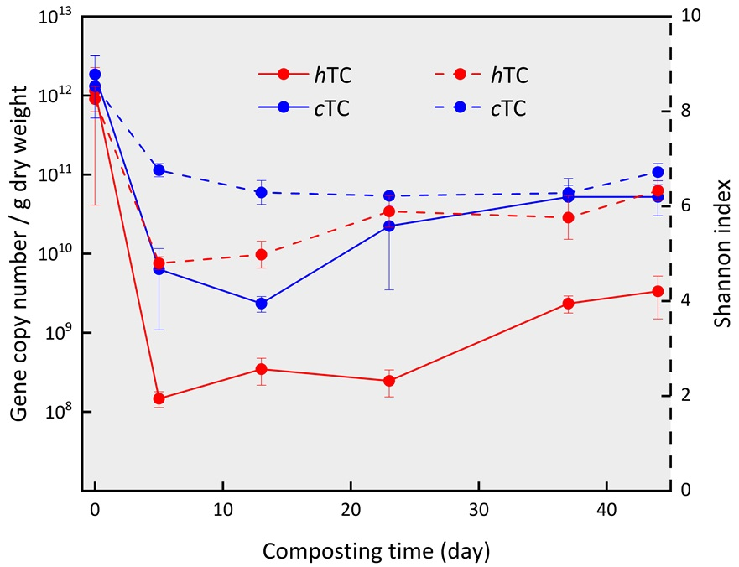
Figure S5. Changes in bacterial abundance (16s gene numbers as reviewed by qPCR, left Yaxis) and alpha diversity (Shannon index; right Y-axis) in hyperthermophilic composting (hTC) and conventional thermophilic composting (cTC).
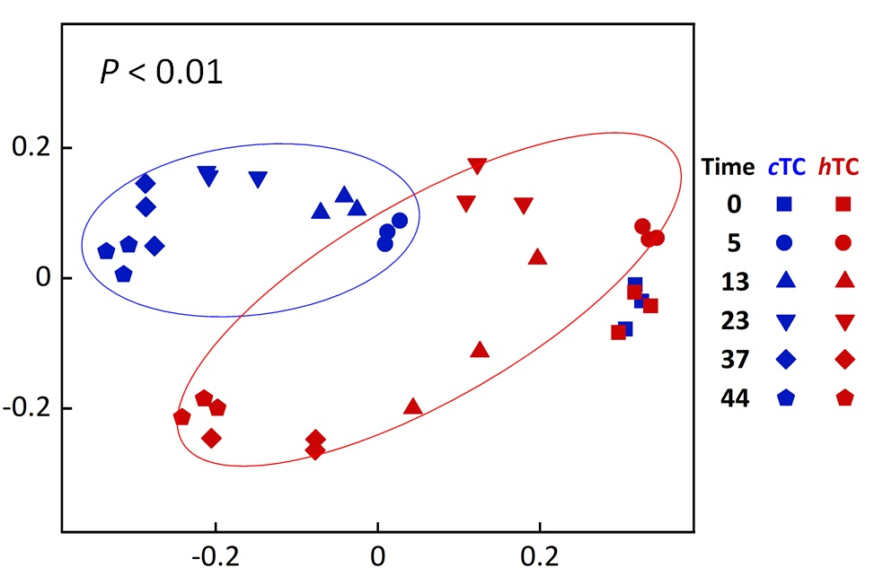
Figure S6. The overall distribution pattern of gene abundance-based function composition dissimilarity in hyperthermophilic composting (hTC) and conventional thermophilic composting (cTC) (ordination derived from weighted-UniFrac distances). Red nodes hTC and blue denote cTC, and different shapes denote different sampling days.
Figure S7. Heatmaps showing the taxonomic classification at the genus level of predominant 16S rRNA gene sequences (relative abundance at top 30) in compost samples during hyperthermophilic composting (hTC) and conventional thermophilic composting (cTC).
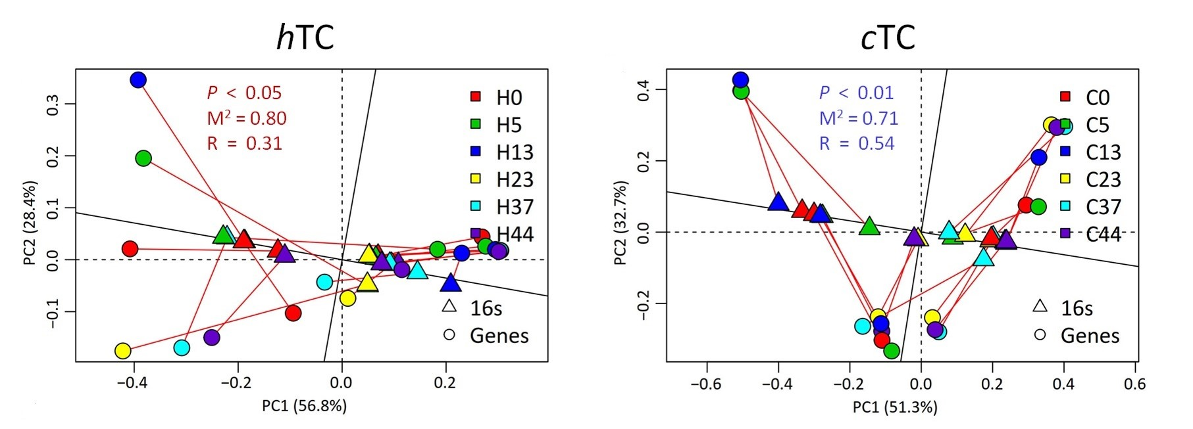
Figure S8. Procrustes analysis indicating significant correlations between Geochip based functional gene abundances and bacterial composition (16S rRNA gene OTU data) on the basis of Bray−Curtis dissimilarity metrics (△, Functional genes○, 16S rRNA gene) during hyperthermophilic composting (hTC) and conventional thermophilic composting (cTC).
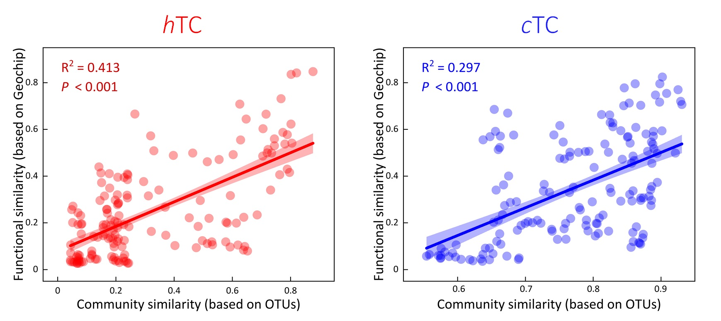Figure S9 The linear regressions between pairwise similarities of (a) bacterial community composition and functional structure during hyperthermophilic composting (hTC) and conventional thermophilic composting (cTC). Bray-Curtis distance was used for the similarity calculations.

Table S1 The physicochemical properties of compost samples from hyperthermophilic composting (hTC) and conventional thermophilic composting (cTC).
Parameters | Raw materials |  |  |  | Initial mixture
Parameters | Chicken manure | Rice husk | hTC end-products | cTC end-products | hTC | cTC
Weight (t) | 10 | 1.5 | 5 | 5 | 16.5 | 16.5
Moisture (%) | 79.8 ± 0.7 | 7.9 ± 0.2 | 35.5 ± 1.4 | 40.8 ± 0.9 | 59.8 ± 1.5 | 62.4 ± 0.6
pH | 8.4 ± 0.1 | ND | 8.2 ± 0.2 | 8.4 ± 0.1 | 8.3 ± 0.1 | 8.3 ± 0.1
NH₄⁺-N (g/kg) | 2.4 ± 0.1 | ND | 5.6 ± 0.3 | 6.5 ± 0.3 | 3.5 ± 0.2 | 3.6 ± 0.3
NO₂⁻-N (mg/kg) | 0.5 ± 0.0 | ND | 5.7 ± 0.9 | 10.2 ± 0.7 | 2.9 ± 0.4 | 3.8 ± 0.1
NO₃⁻-N (mg/kg) | 3.9 ± 0.5 | ND | 19.8 ± 0.5 | 45.6 ± 0.8 | 15.5 ± 1.6 | 20.8 ± 2.4
Total C (g/kg) | 412.8 ± 20.5 | 561.1 ± 11.3 | 192.5 ± 6.3 | 232.5 ± 8.1 | 338.3 ± 9.6 | 351.2 ± 7.1
Total N (g/kg) | 36.2 ± 4.1 | 6.5 ± 0.4 | 26.8 ± 2.8 | 24.2 ± 1.1 | 31.2 ± 2.5 | 30.9 ± 1.6
C/N | 12.6 ± 0.4 | 69.7 ± 2.2 | 7.2 ± 0.1 | 9.6 ± 0.3 | 11.0 ± 0.5 | 11.3 ± 0.2
ND, not detected.
Table S2. The distribution of various nitrogen form during hyperthermophilic composting (hTC) and conventional thermophilic composting (cTC).
Treatments | Day | NO₃⁻-N  (μg/g) | NO₂⁻-N  (μg/g) | NH₄⁺-N  (mg/g) | N₂O-N emission rate  (μM/kg·d) | NH₃-N emission rate  (μM/kg·d)
hTC | 0 | 0.34±0.01 | 0.06±0.04 | 3.81±0.04 | 7.92±0.93 | 104.92±3.01
hTC | 5 | 0.41±0.01 | 0.07±0.01 | 4.13±0.04 | 0.22±0.08 | 164.81±5.61
hTC | 13 | 0.44±0.02 | 0.16±0.04 | 4.17±0.12 | 0.24±0.04 | 136.86±5.25
hTC | 23 | 0.47±0.01 | 0.20±0.01 | 5.03±0.03 | 1.91±0.24 | 42.73±1.69
hTC | 37 | 0.69±0.02 | 0.51±0.02 | 5.15±0.01 | 5.06±0.13 | 53.96±1.73
hTC | 44 | 0.54±0.04 | 0.43±0.01 | 5.42±0.01 | 17.34±1.74 | 40.22±1.15
cTC | 0 | 0.34±0.01 | 0.06±0.04 | 3.811±0.04 | 0.44±0.17 | 226.09±8.16
cTC | 5 | 0.47±0.04 | 0.17±0.04 | 4.31±0.27 | 12.99±1.79 | 352.75±4.45
cTC | 13 | 0.64±0.02 | 0.42±0.02 | 5.97±0.11 | 7.41±0.63 | 147.41±8.98
cTC | 23 | 0.63±0.02 | 0.44±0.03 | 5.47±0.05 | 58.61±2.18 | 54.45±3.36
cTC | 37 | 0.72±0.04 | 0.57±0.06 | 6.31±0.08 | 84.78±4.24 | 32.04±1.63
cTC | 44 | 1.21±0.15 | 1.26±0.27 | 6.62±0.04 | 88.14±2.84 | 30.07±1.63

Table S3. Normalized signal intensity of detected functional genes involving C degrading and N cycling on day 0, day 13, day 23 and d37 in hyperthermophilic composting (hTC) and conventional thermophilic composting (cTC)
 | H0 | stdev.P | H13 | stdev.P | H23 | stdev.P | H37 | stdev.P | C0 | stdev.P | C13 | stdev.P | C23 | stdev.P | C37 | stdev.P
amyA | 0.1016 | 0.0006 | 0.1011 | 0.0015 | 0.1011 | 0.0015 | 0.0984 | 0.0001 | 0.1016 | 0.0006 | 0.0996 | 0.0002 | 0.0957 | 0.0002 | 0.0954 | 0.0004
amyx | 0.0023 | 0.0001 | 0.0022 | 0.0002 | 0.0022 | 0.0002 | 0.0014 | 0.0001 | 0.0023 | 0.0001 | 0.0021 | 0.0000 | 0.0015 | 0.0000 | 0.0014 | 0.0001
cda | 0.0068 | 0.0001 | 0.0067 | 0.0003 | 0.0067 | 0.0003 | 0.0061 | 0.0002 | 0.0068 | 0.0001 | 0.0065 | 0.0000 | 0.0060 | 0.0002 | 0.0060 | 0.0001
glucoamylase | 0.0059 | 0.0001 | 0.0059 | 0.0001 | 0.0059 | 0.0001 | 0.0057 | 0.0000 | 0.0059 | 0.0001 | 0.0057 | 0.0001 | 0.0055 | 0.0001 | 0.0056 | 0.0002
pula | 0.0050 | 0.0001 | 0.0050 | 0.0004 | 0.0050 | 0.0004 | 0.0044 | 0.0000 | 0.0050 | 0.0001 | 0.0048 | 0.0001 | 0.0039 | 0.0001 | 0.0040 | 0.0001
apu | 0.0019 | 0.0003 | 0.0019 | 0.0007 | 0.0019 | 0.0007 | 0.0085 | 0.0012 | 0.0019 | 0.0003 | 0.0012 | 0.0001 | 0.0041 | 0.0014 | 0.0050 | 0.0013
inulinase | 0.0060 | 0.0001 | 0.0059 | 0.0001 | 0.0059 | 0.0001 | 0.0058 | 0.0002 | 0.0060 | 0.0001 | 0.0059 | 0.0003 | 0.0050 | 0.0002 | 0.0051 | 0.0002
ara | 0.0143 | 0.0003 | 0.0143 | 0.0002 | 0.0143 | 0.0002 | 0.0141 | 0.0001 | 0.0143 | 0.0003 | 0.0143 | 0.0001 | 0.0140 | 0.0002 | 0.0142 | 0.0001
mannanase | 0.0073 | 0.0001 | 0.0072 | 0.0001 | 0.0072 | 0.0001 | 0.0071 | 0.0001 | 0.0073 | 0.0001 | 0.0071 | 0.0001 | 0.0068 | 0.0001 | 0.0069 | 0.0001
xyla | 0.0084 | 0.0000 | 0.0083 | 0.0001 | 0.0083 | 0.0001 | 0.0081 | 0.0001 | 0.0084 | 0.0000 | 0.0084 | 0.0000 | 0.0081 | 0.0001 | 0.0080 | 0.0000
xylanase | 0.0138 | 0.0002 | 0.0136 | 0.0003 | 0.0136 | 0.0003 | 0.0135 | 0.0002 | 0.0138 | 0.0002 | 0.0134 | 0.0001 | 0.0126 | 0.0000 | 0.0129 | 0.0000
xylose_isomerase_Oomycetes | 0.0047 | 0.0003 | 0.0047 | 0.0006 | 0.0047 | 0.0006 | 0.0051 | 0.0000 | 0.0047 | 0.0003 | 0.0055 | 0.0011 | 0.0062 | 0.0001 | 0.0050 | 0.0014
endopolygalacturonase | 0.0017 | 0.0000 | 0.0016 | 0.0000 | 0.0016 | 0.0000 | 0.0016 | 0.0000 | 0.0017 | 0.0000 | 0.0016 | 0.0000 | 0.0016 | 0.0000 | 0.0016 | 0.0000
exopolygalacturonase | 0.0025 | 0.0000 | 0.0025 | 0.0001 | 0.0025 | 0.0001 | 0.0025 | 0.0001 | 0.0025 | 0.0000 | 0.0025 | 0.0000 | 0.0022 | 0.0000 | 0.0024 | 0.0000
pec_Cdeg | 0.0030 | 0.0000 | 0.0031 | 0.0001 | 0.0031 | 0.0001 | 0.0032 | 0.0001 | 0.0030 | 0.0000 | 0.0031 | 0.0000 | 0.0031 | 0.0001 | 0.0033 | 0.0001
pectin_lyase_Oomycetes | 0.0036 | 0.0002 | 0.0039 | 0.0002 | 0.0039 | 0.0002 | 0.0041 | 0.0000 | 0.0036 | 0.0002 | 0.0041 | 0.0001 | 0.0042 | 0.0002 | 0.0042 | 0.0001
pectinase(pectate_lyase) | 0.0053 | 0.0000 | 0.0052 | 0.0001 | 0.0052 | 0.0001 | 0.0052 | 0.0000 | 0.0053 | 0.0000 | 0.0051 | 0.0000 | 0.0051 | 0.0000 | 0.0052 | 0.0000
pel_Cdeg | 0.0042 | 0.0003 | 0.0043 | 0.0003 | 0.0043 | 0.0003 | 0.0043 | 0.0000 | 0.0020 | 0.0002 | 0.0020 | 0.0001 | 0.0020 | 0.0002 | 0.0021 | 0.0001
pme | 0.0055 | 0.0001 | 0.0055 | 0.0000 | 0.0055 | 0.0000 | 0.0055 | 0.0001 | 0.0055 | 0.0001 | 0.0055 | 0.0000 | 0.0055 | 0.0001 | 0.0056 | 0.0001
pme_Cdeg | 0.0015 | 0.0000 | 0.0015 | 0.0000 | 0.0015 | 0.0000 | 0.0016 | 0.0000 | 0.0015 | 0.0000 | 0.0016 | 0.0000 | 0.0016 | 0.0001 | 0.0016 | 0.0000
RgaE | 0.0060 | 0.0000 | 0.0059 | 0.0000 | 0.0059 | 0.0000 | 0.0057 | 0.0000 | 0.0060 | 0.0000 | 0.0057 | 0.0000 | 0.0057 | 0.0001 | 0.0057 | 0.0001
rgh | 0.0019 | 0.0000 | 0.0019 | 0.0001 | 0.0019 | 0.0001 | 0.0018 | 0.0000 | 0.0019 | 0.0000 | 0.0019 | 0.0000 | 0.0018 | 0.0000 | 0.0018 | 0.0000
rgl | 0.0056 | 0.0001 | 0.0054 | 0.0003 | 0.0054 | 0.0003 | 0.0054 | 0.0001 | 0.0056 | 0.0001 | 0.0055 | 0.0001 | 0.0056 | 0.0001 | 0.0056 | 0.0001
axe | 0.0014 | 0.0001 | 0.0014 | 0.0000 | 0.0014 | 0.0000 | 0.0014 | 0.0000 | 0.0014 | 0.0001 | 0.0014 | 0.0000 | 0.0015 | 0.0000 | 0.0015 | 0.0001
cellobiase | 0.0120 | 0.0001 | 0.0122 | 0.0001 | 0.0122 | 0.0001 | 0.0120 | 0.0002 | 0.0120 | 0.0001 | 0.0122 | 0.0001 | 0.0119 | 0.0002 | 0.0119 | 0.0001
endoglucanase | 0.0055 | 0.0000 | 0.0055 | 0.0001 | 0.0055 | 0.0001 | 0.0054 | 0.0000 | 0.0055 | 0.0000 | 0.0055 | 0.0000 | 0.0054 | 0.0001 | 0.0055 | 0.0000
exoglucanase | 0.0046 | 0.0001 | 0.0046 | 0.0001 | 0.0046 | 0.0001 | 0.0044 | 0.0001 | 0.0046 | 0.0001 | 0.0046 | 0.0001 | 0.0043 | 0.0001 | 0.0045 | 0.0001
phospholipase_A2 | 0.0014 | 0.0000 | 0.0014 | 0.0000 | 0.0014 | 0.0000 | 0.0014 | 0.0001 | 0.0014 | 0.0000 | 0.0014 | 0.0000 | 0.0013 | 0.0000 | 0.0013 | 0.0001
phospholipase_C | 0.0025 | 0.0000 | 0.0025 | 0.0001 | 0.0025 | 0.0001 | 0.0024 | 0.0000 | 0.0025 | 0.0000 | 0.0024 | 0.0001 | 0.0023 | 0.0000 | 0.0024 | 0.0000
phospholipase_D | 0.0023 | 0.0001 | 0.0023 | 0.0001 | 0.0023 | 0.0001 | 0.0022 | 0.0000 | 0.0023 | 0.0001 | 0.0023 | 0.0000 | 0.0021 | 0.0000 | 0.0022 | 0.0001
cdh | 0.0017 | 0.0000 | 0.0016 | 0.0001 | 0.0016 | 0.0001 | 0.0018 | 0.0000 | 0.0017 | 0.0000 | 0.0017 | 0.0000 | 0.0019 | 0.0000 | 0.0019 | 0.0000
limeh | 0.0020 | 0.0000 | 0.0021 | 0.0002 | 0.0021 | 0.0002 | 0.0022 | 0.0000 | 0.0020 | 0.0000 | 0.0021 | 0.0000 | 0.0025 | 0.0000 | 0.0024 | 0.0001
lmo | 0.0019 | 0.0001 | 0.0018 | 0.0003 | 0.0018 | 0.0003 | 0.0019 | 0.0001 | 0.0023 | 0.0001 | 0.0021 | 0.0000 | 0.0015 | 0.0000 | 0.0014 | 0.0001
cutinase | 0.0063 | 0.0002 | 0.0063 | 0.0003 | 0.0063 | 0.0003 | 0.0068 | 0.0000 | 0.0063 | 0.0002 | 0.0064 | 0.0000 | 0.0076 | 0.0001 | 0.0074 | 0.0001
tannase_Cdeg | 0.0021 | 0.0001 | 0.0021 | 0.0001 | 0.0021 | 0.0001 | 0.0019 | 0.0000 | 0.0021 | 0.0001 | 0.0020 | 0.0000 | 0.0018 | 0.0000 | 0.0018 | 0.0000
acetylglucosaminidase | 0.0176 | 0.0002 | 0.0174 | 0.0007 | 0.0174 | 0.0007 | 0.0167 | 0.0001 | 0.0176 | 0.0002 | 0.0174 | 0.0001 | 0.0156 | 0.0004 | 0.0157 | 0.0003
chitin_deacetylase | 0.0078 | 0.0003 | 0.0080 | 0.0006 | 0.0080 | 0.0006 | 0.0086 | 0.0002 | 0.0084 | 0.0000 | 0.0084 | 0.0000 | 0.0081 | 0.0001 | 0.0080 | 0.0000
chitinase | 0.0246 | 0.0000 | 0.0249 | 0.0001 | 0.0249 | 0.0001 | 0.0247 | 0.0002 | 0.0246 | 0.0000 | 0.0245 | 0.0001 | 0.0245 | 0.0002 | 0.0244 | 0.0001
endochitinase | 0.0095 | 0.0002 | 0.0093 | 0.0002 | 0.0093 | 0.0002 | 0.0091 | 0.0000 | 0.0095 | 0.0002 | 0.0093 | 0.0001 | 0.0087 | 0.0001 | 0.0089 | 0.0000
exochitinase | 0.0013 | 0.0000 | 0.0013 | 0.0000 | 0.0013 | 0.0000 | 0.0014 | 0.0000 | 0.0013 | 0.0000 | 0.0013 | 0.0001 | 0.0013 | 0.0000 | 0.0013 | 0.0000
vana | 0.0043 | 0.0001 | 0.0044 | 0.0002 | 0.0044 | 0.0002 | 0.0045 | 0.0000 | 0.0043 | 0.0001 | 0.0043 | 0.0000 | 0.0049 | 0.0000 | 0.0048 | 0.0001
vdh | 0.0016 | 0.0001 | 0.0017 | 0.0001 | 0.0017 | 0.0001 | 0.0018 | 0.0000 | 0.0016 | 0.0001 | 0.0017 | 0.0000 | 0.0019 | 0.0000 | 0.0018 | 0.0001
ligninase | 0.0049 | 0.0001 | 0.0050 | 0.0004 | 0.0050 | 0.0004 | 0.0053 | 0.0000 | 0.0049 | 0.0001 | 0.0051 | 0.0001 | 0.0058 | 0.0004 | 0.0055 | 0.0004
mnp | 0.0014 | 0.0000 | 0.0013 | 0.0000 | 0.0013 | 0.0000 | 0.0014 | 0.0000 | 0.0014 | 0.0000 | 0.0014 | 0.0000 | 0.0014 | 0.0000 | 0.0014 | 0.0000
phenol_oxidase | 0.0120 | 0.0002 | 0.0122 | 0.0001 | 0.0122 | 0.0001 | 0.0122 | 0.0002 | 0.0120 | 0.0002 | 0.0122 | 0.0001 | 0.0118 | 0.0002 | 0.0119 | 0.0001
amoA | 0.0011 | 0.0000 | 0.0011 | 0.0001 | 0.0011 | 0.0001 | 0.0012 | 0.0001 | 0.0011 | 0.0000 | 0.0014 | 0.0000 | 0.0013 | 0.0000 | 0.0013 | 0.0001
hao | 0.0013 | 0.0001 | 0.0013 | 0.0001 | 0.0013 | 0.0001 | 0.0013 | 0.0000 | 0.0013 | 0.0001 | 0.0013 | 0.0000 | 0.0012 | 0.0000 | 0.0012 | 0.0001
narG | 0.0189 | 0.0002 | 0.0192 | 0.0009 | 0.0192 | 0.0009 | 0.0201 | 0.0001 | 0.0189 | 0.0002 | 0.0194 | 0.0001 | 0.0217 | 0.0000 | 0.0216 | 0.0003
nirS | 0.0122 | 0.0001 | 0.0123 | 0.0000 | 0.0123 | 0.0000 | 0.0127 | 0.0001 | 0.0122 | 0.0001 | 0.0126 | 0.0000 | 0.0123 | 0.0000 | 0.0126 | 0.0001
nirK | 0.0100 | 0.0001 | 0.0101 | 0.0001 | 0.0101 | 0.0001 | 0.0108 | 0.0001 | 0.0100 | 0.0001 | 0.0103 | 0.0000 | 0.0111 | 0.0001 | 0.0111 | 0.0001
norB | 0.0024 | 0.0000 | 0.0024 | 0.0000 | 0.0024 | 0.0000 | 0.0025 | 0.0000 | 0.0024 | 0.0000 | 0.0024 | 0.0000 | 0.0026 | 0.0000 | 0.0026 | 0.0000
nosZ | 0.0149 | 0.0000 | 0.0151 | 0.0002 | 0.0151 | 0.0002 | 0.0155 | 0.0001 | 0.0149 | 0.0000 | 0.0154 | 0.0000 | 0.0159 | 0.0001 | 0.0156 | 0.0002
hzo | 0.0049 | 0.0003 | 0.0053 | 0.0006 | 0.0053 | 0.0006 | 0.0047 | 0.0003 | 0.0049 | 0.0003 | 0.0051 | 0.0003 | 0.0042 | 0.0004 | 0.0045 | 0.0001
nifH | 0.0258 | 0.0004 | 0.0257 | 0.0006 | 0.0257 | 0.0006 | 0.0249 | 0.0003 | 0.0258 | 0.0004 | 0.0259 | 0.0001 | 0.0228 | 0.0000 | 0.0227 | 0.0004
napA | 0.0043 | 0.0001 | 0.0042 | 0.0001 | 0.0042 | 0.0001 | 0.0043 | 0.0000 | 0.0043 | 0.0001 | 0.0043 | 0.0000 | 0.0041 | 0.0001 | 0.0041 | 0.0000
nrfA | 0.0036 | 0.0000 | 0.0036 | 0.0002 | 0.0036 | 0.0002 | 0.0033 | 0.0000 | 0.0036 | 0.0000 | 0.0035 | 0.0000 | 0.0030 | 0.0000 | 0.0030 | 0.0000
nasA | 0.0034 | 0.0001 | 0.0034 | 0.0001 | 0.0034 | 0.0001 | 0.0033 | 0.0000 | 0.0034 | 0.0001 | 0.0034 | 0.0000 | 0.0035 | 0.0000 | 0.0034 | 0.0001
nirA | 0.0016 | 0.0000 | 0.0017 | 0.0000 | 0.0017 | 0.0000 | 0.0017 | 0.0000 | 0.0016 | 0.0000 | 0.0017 | 0.0000 | 0.0018 | 0.0000 | 0.0018 | 0.0000
nirB | 0.0024 | 0.0000 | 0.0025 | 0.0001 | 0.0025 | 0.0001 | 0.0025 | 0.0001 | 0.0024 | 0.0000 | 0.0025 | 0.0000 | 0.0026 | 0.0001 | 0.0026 | 0.0001
gdh | 0.0070 | 0.0001 | 0.0069 | 0.0003 | 0.0069 | 0.0003 | 0.0064 | 0.0000 | 0.0070 | 0.0001 | 0.0067 | 0.0001 | 0.0060 | 0.0001 | 0.0061 | 0.0003
urec | 0.0117 | 0.0002 | 0.0118 | 0.0002 | 0.0118 | 0.0002 | 0.0122 | 0.0001 | 0.0117 | 0.0002 | 0.0118 | 0.0000 | 0.0124 | 0.0001 | 0.0125 | 0.0001

