Supplementary Information
Title: Curcumin piperidone derivatives induce anti-proliferative and anti-migratory effects in LN-18 human glioblastoma cells
Authors:
Nur Syahirah Che Razali¹, Kok Wai Lam³, Nor Fadilah Rajab², A Rahman A Jamal⁴, Nurul Farahana Kamaluddin¹, Kok Meng Chan^{1*}
Authors Affliation:
¹Center for Toxicology and Health Risk Studies, Faculty of Health Sciences, Universiti Kebangsaan Malaysia, 50300 Kuala Lumpur, Malaysia
²Center for Health Ageing and Wellness Studies, Faculty of Health Sciences, Universiti Kebangsaan Malaysia, 50300 Kuala Lumpur, Malaysia
³Centre for Drug and Herbal Development, Faculty of Pharmacy, Universiti Kebangsaan Malaysia, 50300 Kuala Lumpur, Malaysia
⁴UKM Medical Molecular Biology Institute, UKM Medical Centre, 56000 Cheras, Malaysia
Corresponding Author (*):
Center for Toxicology and Health Risk Studies, Faculty of Health Sciences, Universiti Kebangsaan Malaysia, 50300 Kuala Lumpur, Malaysia
Email address: chan@ukm.edu.my

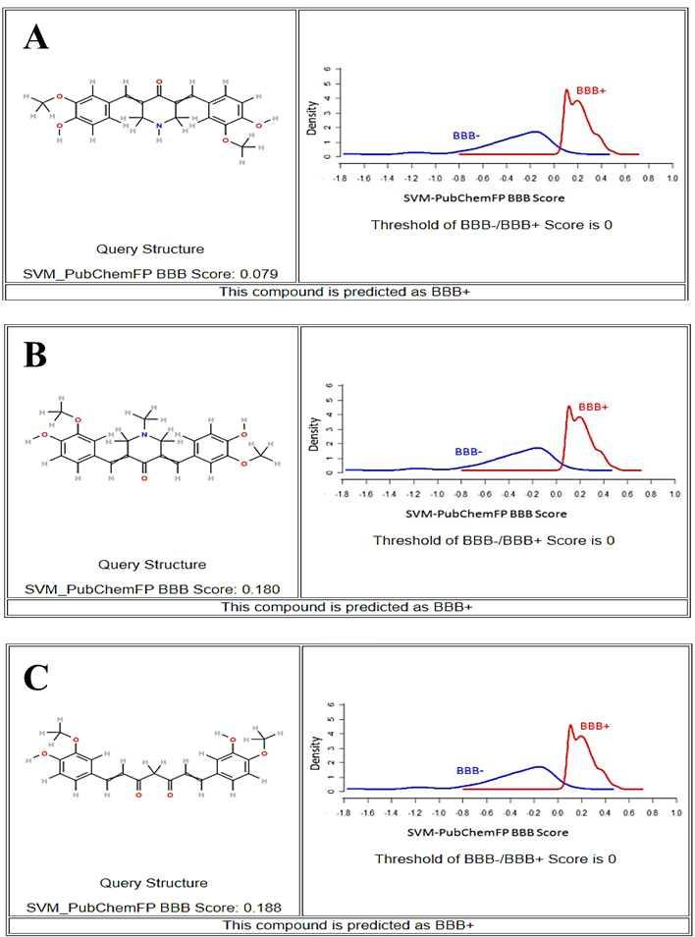
Fig. S1. The prediction of the probability of the analogues penetrating BBB by the online platform AlzPlatform (www.cbligand.org/AD/). The online predictor gave the corresponding calculation BBB score, which indicates whether a compound can cross the blood−brain barrier (BBB+) or not (BBB−). (A) The analysis showed that FLDP-5 curcuminoid analogue had a positive BBB score, which is higher than the threshold of BBB-/BBB+ score, implying that this analogue is penetrable to BBB. (B) FLDP-8 curcuminoid analogue had a positive BBB score, which is higher than the threshold of BBB-/BBB+ score, implying that this analogue is penetrable to BBB. (C) Curcumin had a positive BBB score, which is higher than the threshold of BBB-/BBB+ score, implying that curcumin is penetrable to BBB.

Table S1. The prediction of the probability of the analogues penetrating BBB by the online platform ADMETlab 2.0 (https://admetmesh.scbdd.com/)
Compounds | Probability of being BBB+ | Decision | Comment
FLDP-5 | 0.029 | Excellent | The output  value is the probability of being BBB+
FLDP-8 | 0.38 | Medium | The output  value is the probability of being BBB+
Curcumin | 0.155 | Excellent | The output  value is the probability of being BBB+
(Empirical decision: 0-0.3: excellent; 0.3-0.7: medium; 0.7-1.0: poor)

