Appendix A Graphical Representations of Selected Variables in Their Level Values
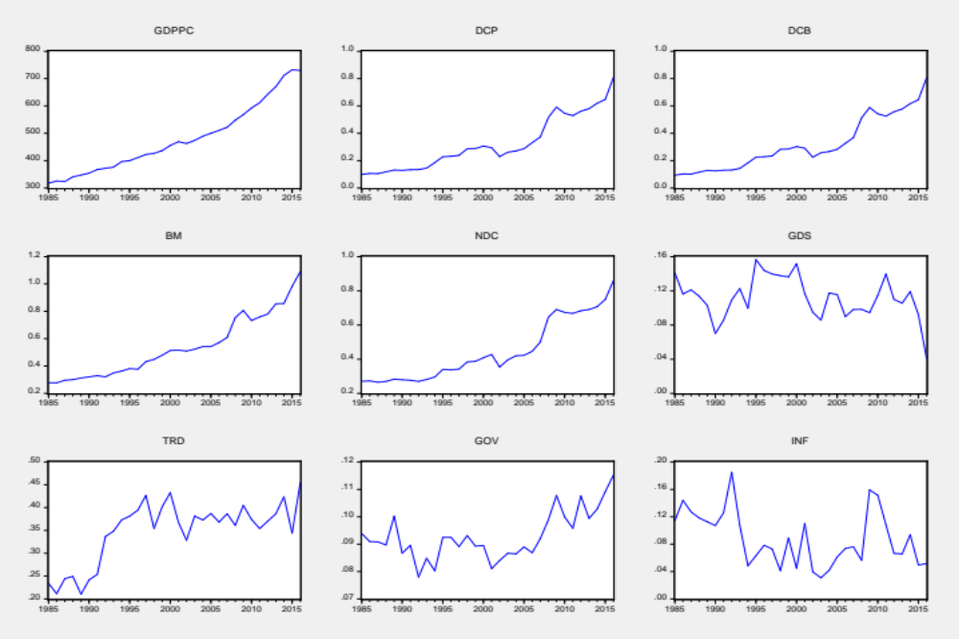
Source: Author’s adaptation from Eviews 10 using data of World Development Indicators (WDI).

Appendix B Plots of CUSUM and CUSUM Squares Tests
Principle Estimation Model: Economic growth is the function of financial development.
Model 1  Dependent Variable: LnGDPPC | Model 2  Dependent Variable: LnGDPPC | Model 3  Dependent Variable: LnGDPPC | Model 4  Dependent Variable: LnGDPPC
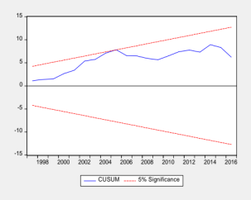 | 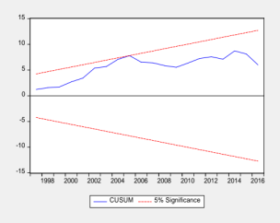 | 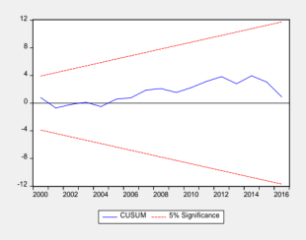 | 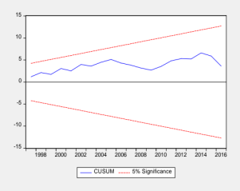
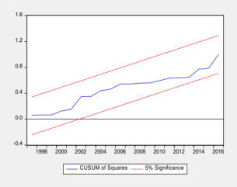 | 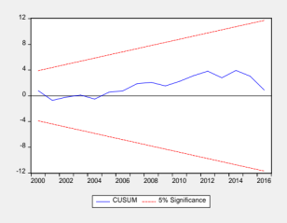  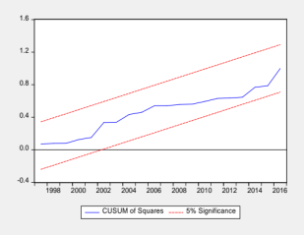 |  | 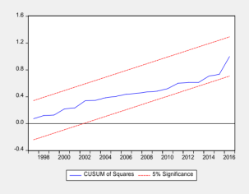
Reverse Estimation Model: Financial development is the function of economic growth.
Reverse 1  Dependent Variable: LnDCP | Reverse 2  Dependent Variable: LnDCB | Reverse 3  Dependent Variable:  LnBM | Reverse 4  Dependent Variable:  LnNDC
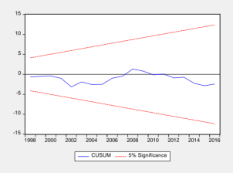 | 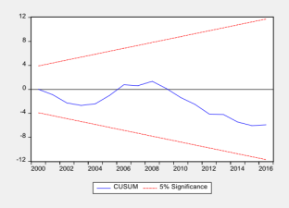 | 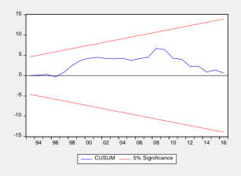 | No Estimation
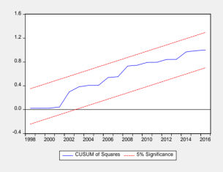 | 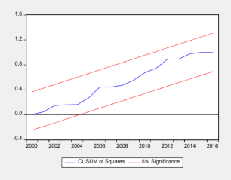 | 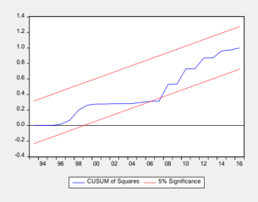 | No Estimation
Source: Author’s adaptation from Eviews 10.

