Supporting Information
catalogue
Figure S1.PF-¹H NMR 3
Figure S2.PF-¹³C NMR 3
Figure S3.5a-¹H NMR 4
Figure S4.5a-¹³C NMR 4
Figure S5.5b-¹H NMR 5
Figure S6.5b-¹³C NMR 5
Figure S7.5c-¹H NMR 6
Figure S8.5c-¹³C NMR 6
Figure S9.5d-¹H NMR 7
Figure S10.5d-¹³C NMR 7
Figure S11.5e-¹H NMR 8
Figure S12.5e-¹³C NMR 8
Figure S13.5f-¹H NMR 9
Figure S14.5f-¹³C NMR 9
Figure S15.5g-¹H NMR 10
Figure S16.5g-¹³C NMR 10
Figure S17.5a-HRMS 11
Figure S18.5b-HRMS 11
Figure S19.5c-HRMS 12
Figure S20.5d-HRMS 12
Figure S21.5e-HRMS 13
Figure S22.5f-HRMS 13
Figure S22.5g-HRMS 14

Figure S1.PF-¹H NMR
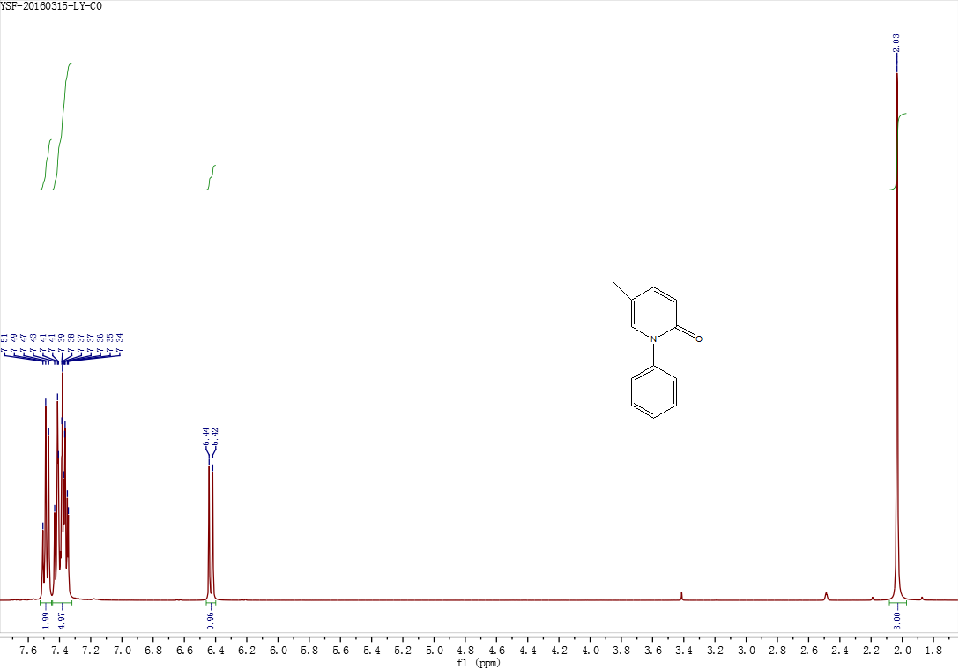

Figure S2.PF-¹³C NMR

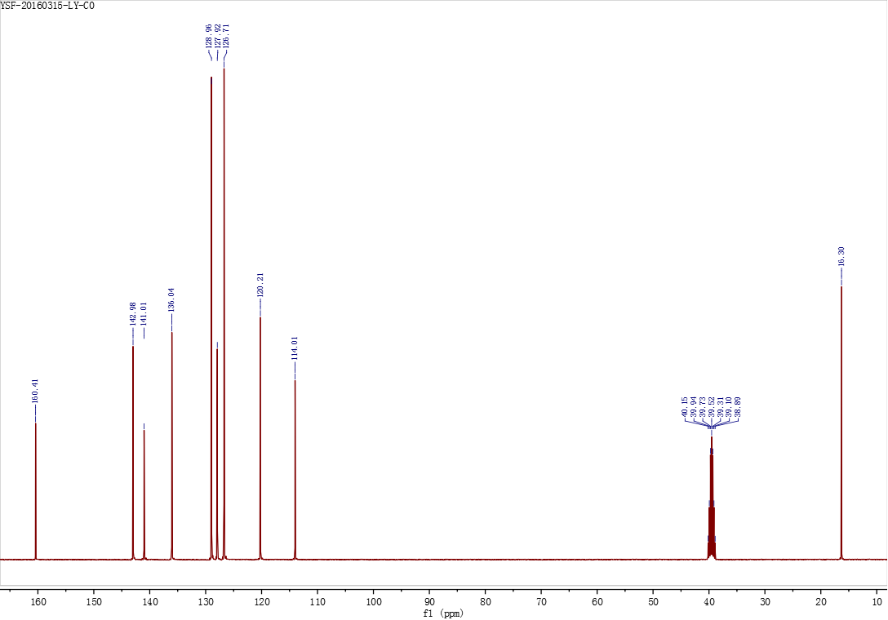

Figure S3.5a-¹H NMR
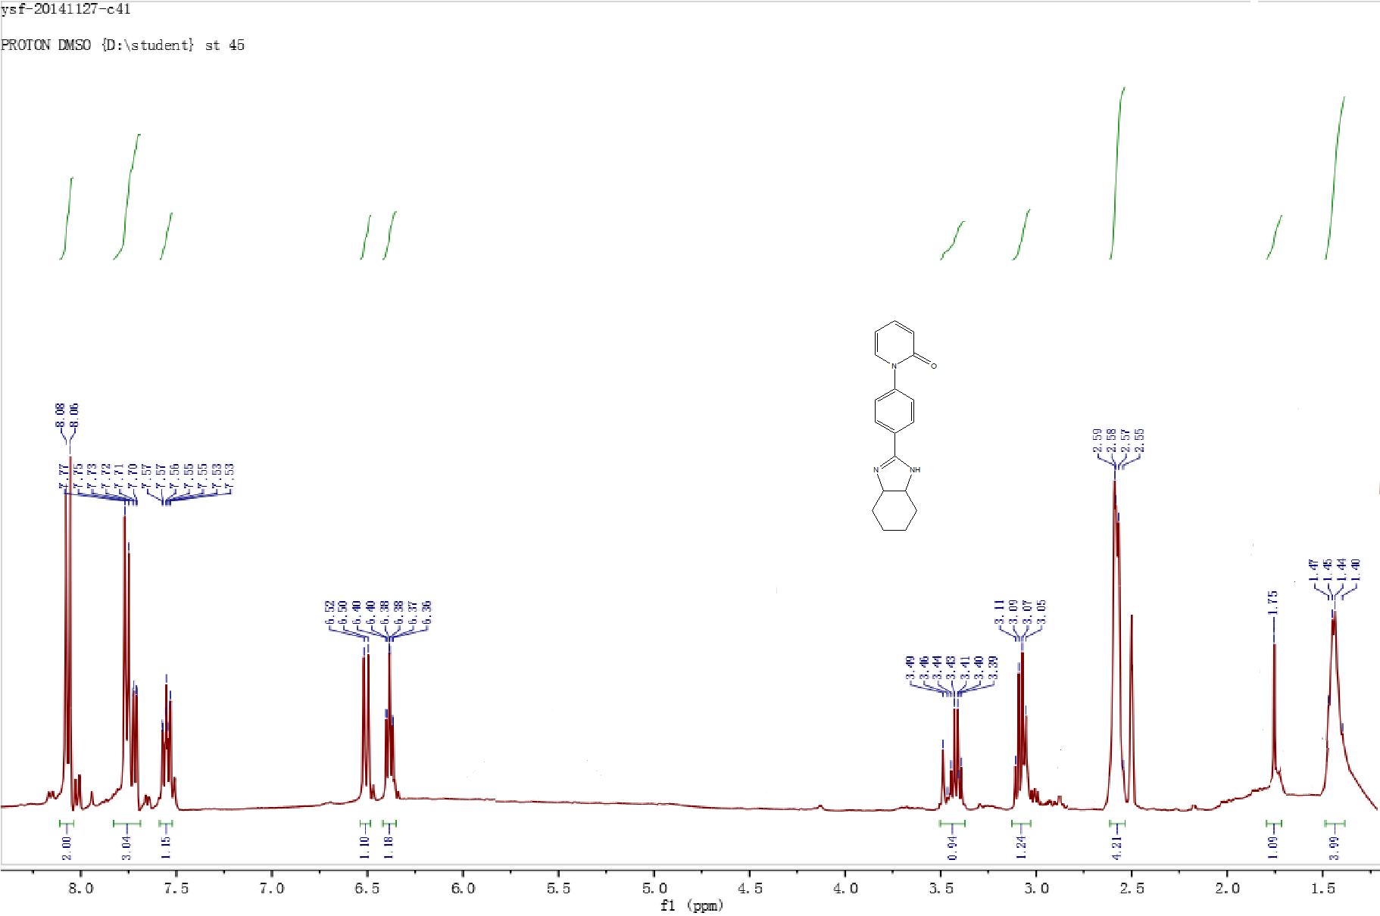

Figure S4.5a-¹³C NMR

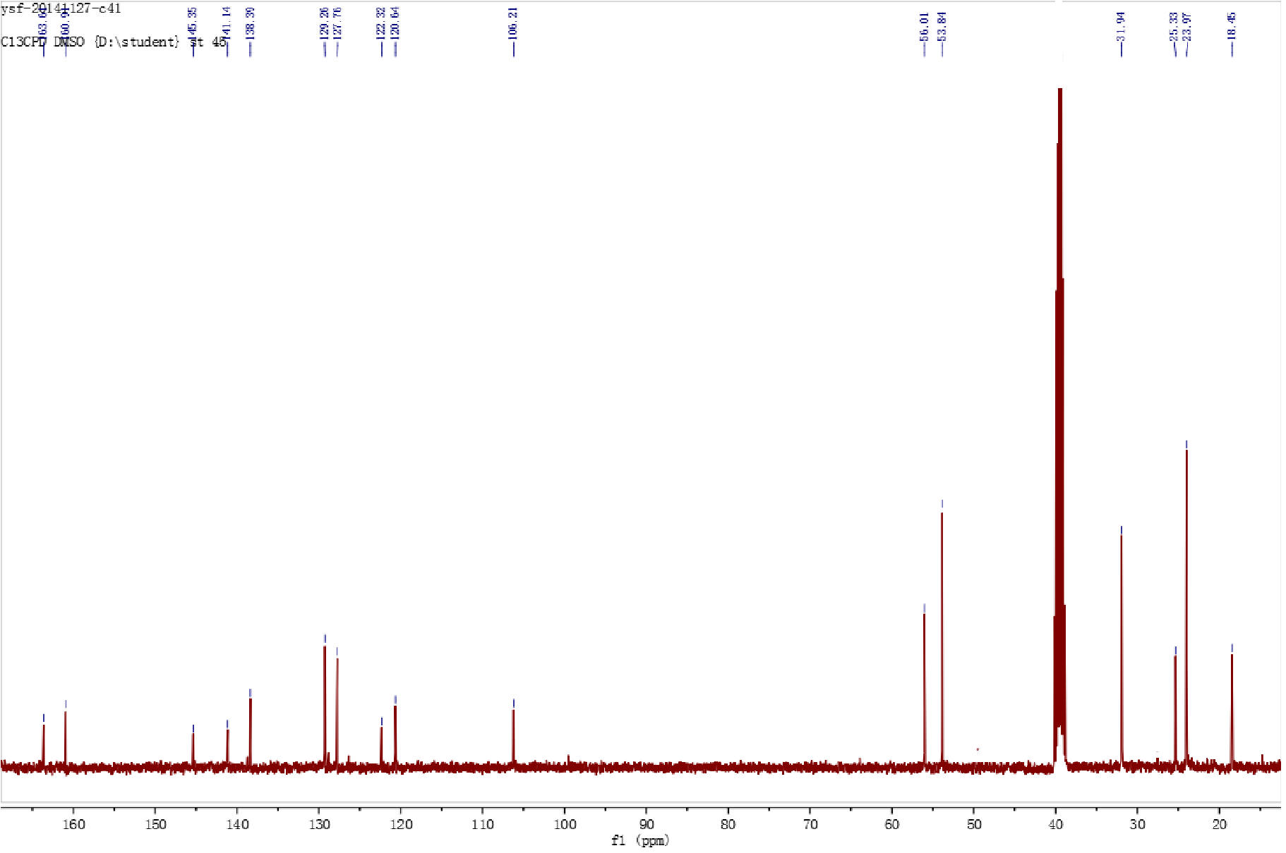

Figure S5.5b-¹H NMR
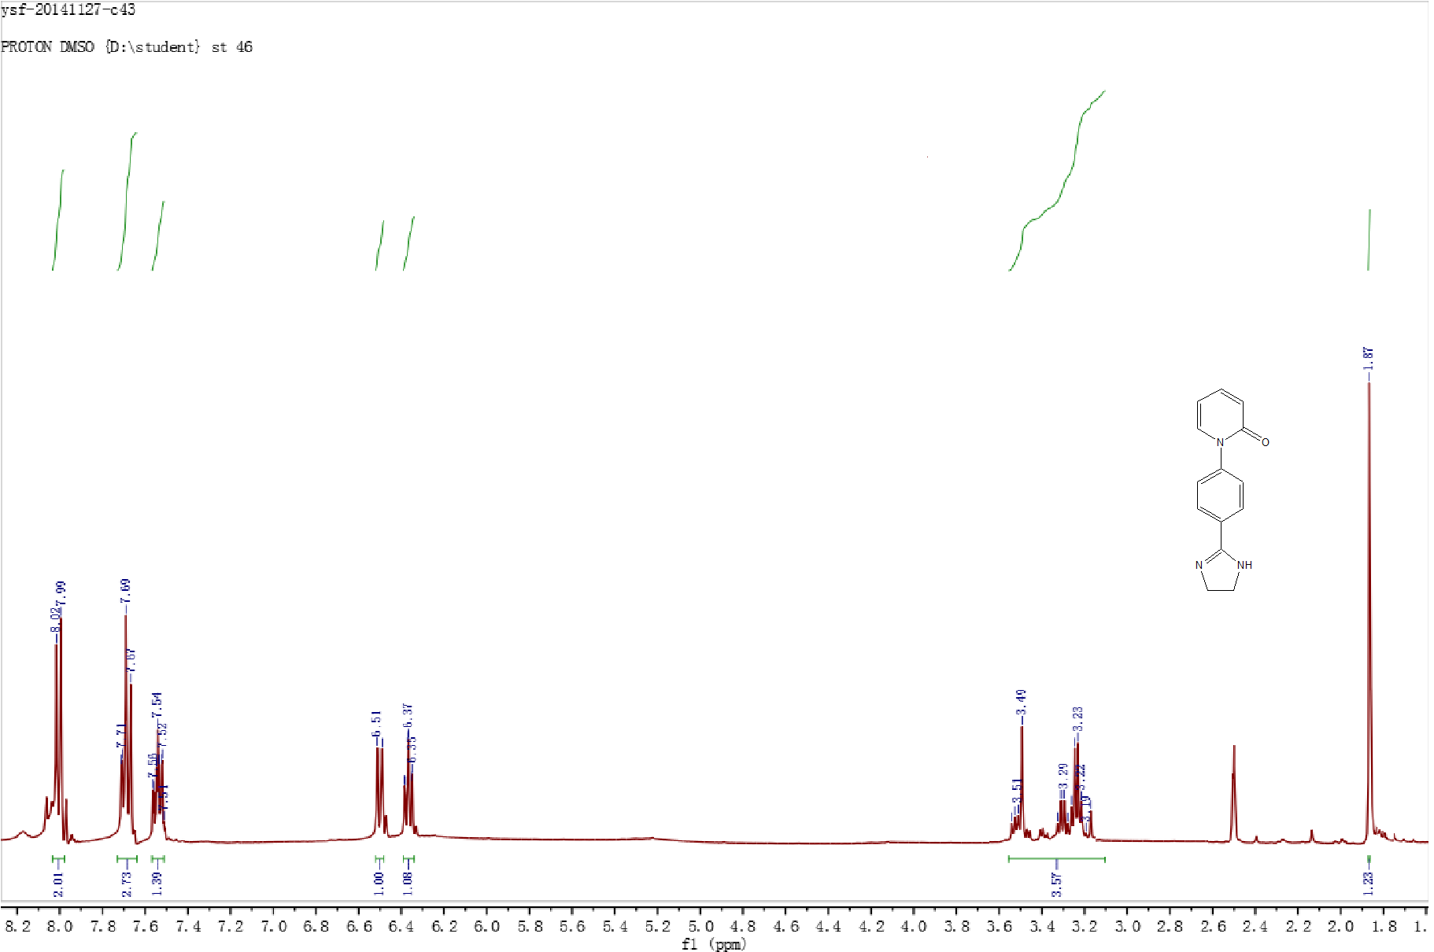

Figure S6.5b-¹³C NMR
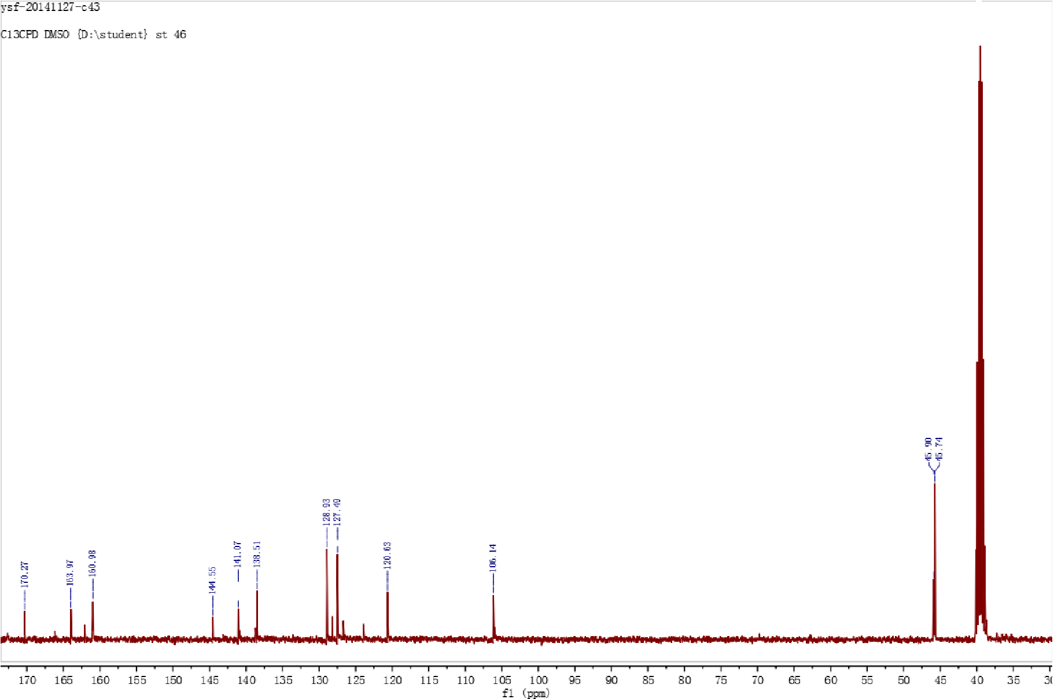

Figure S7.5c-¹H NMR
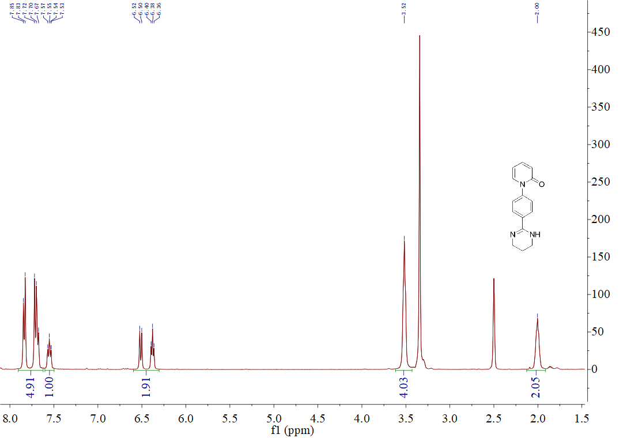

Figure S8.5c-¹³C NMR
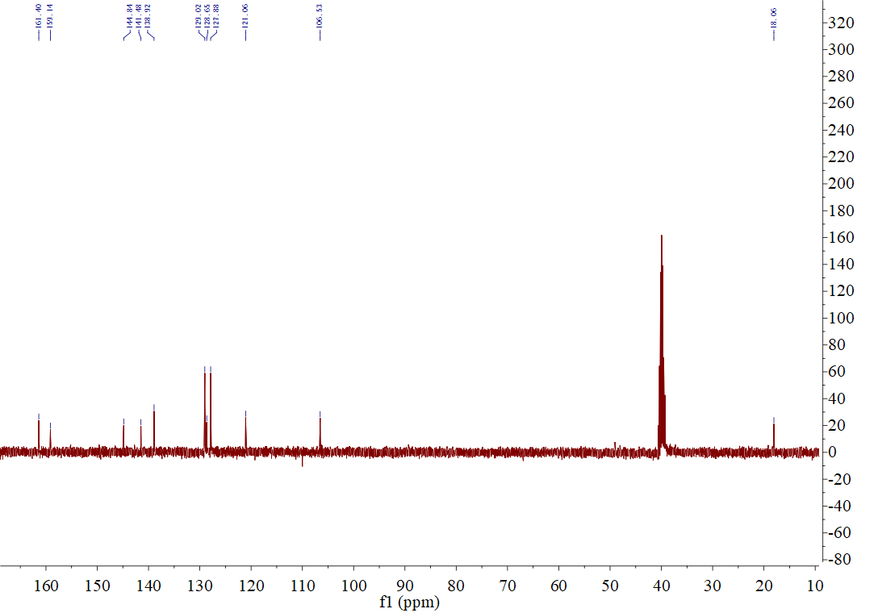

Figure S9.5d-¹H NMR
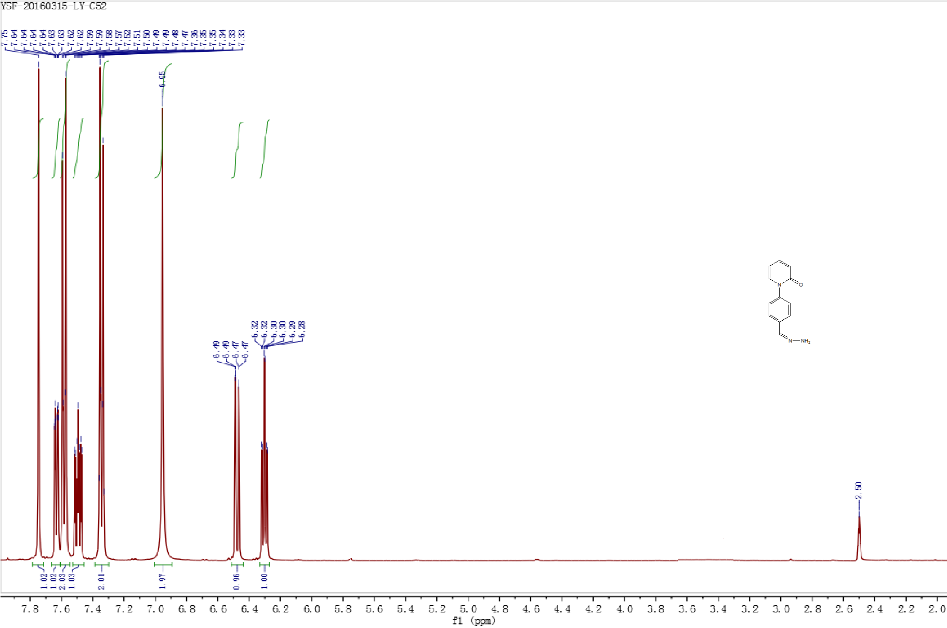

Figure S10.5d-¹³C NMR
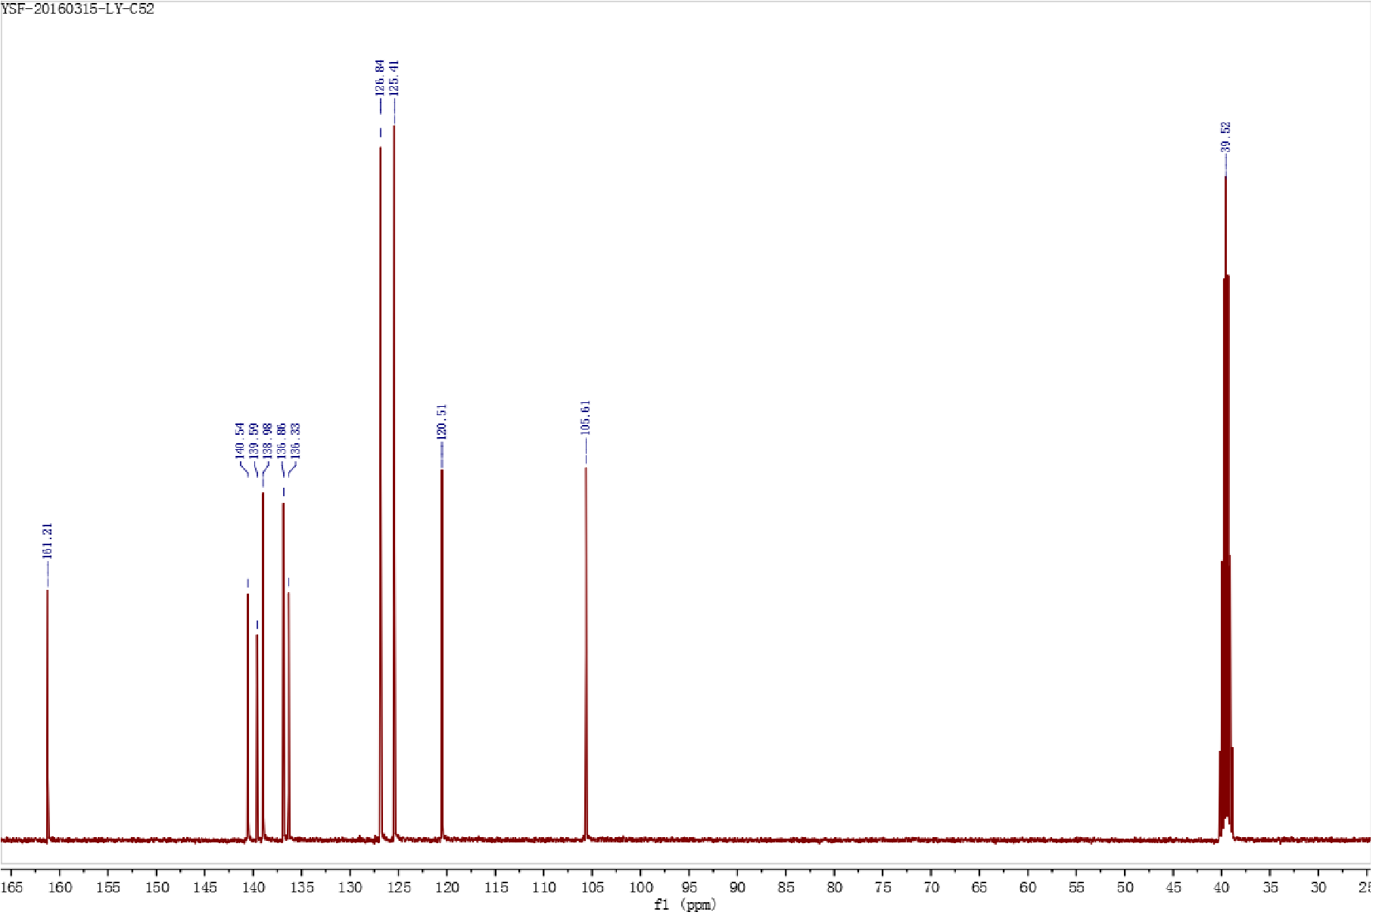

Figure S11.5e-¹H NMR
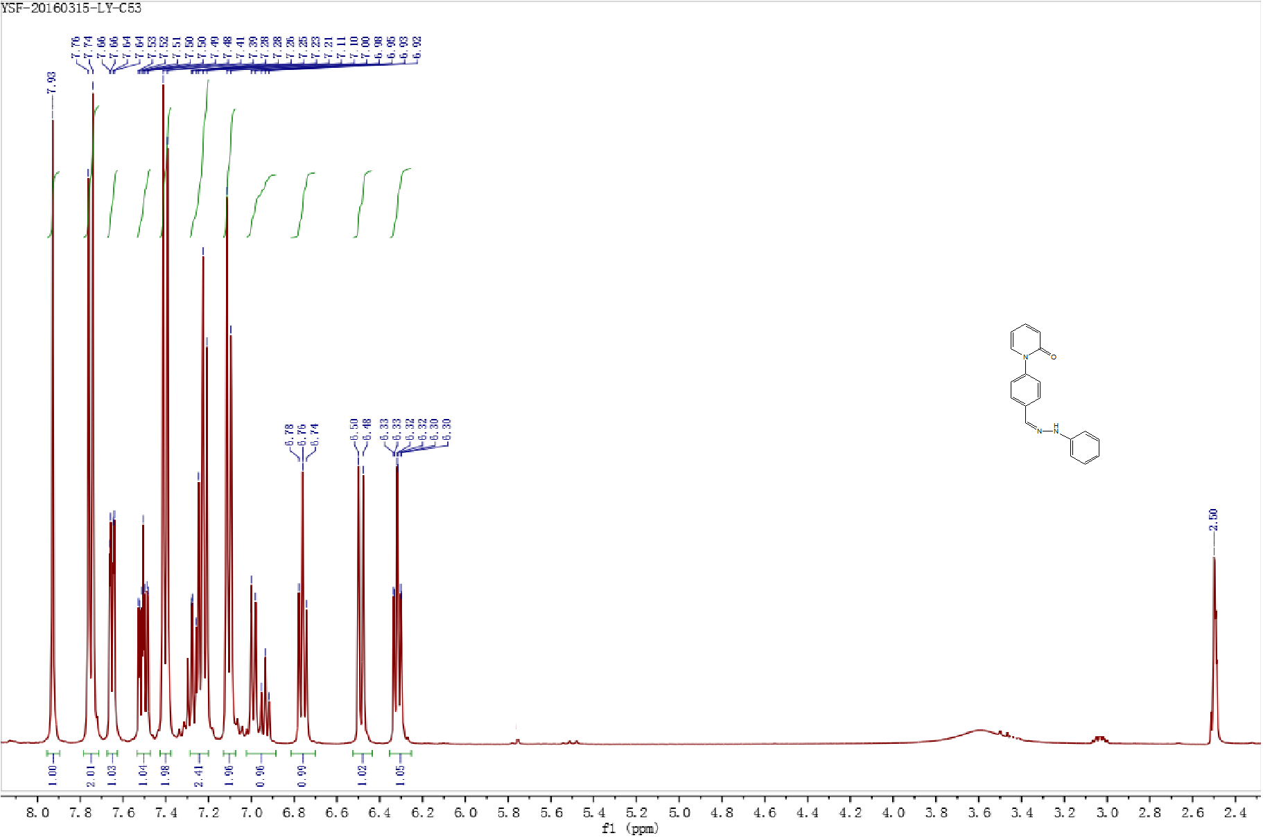

Figure S12.5e-¹³C NMR
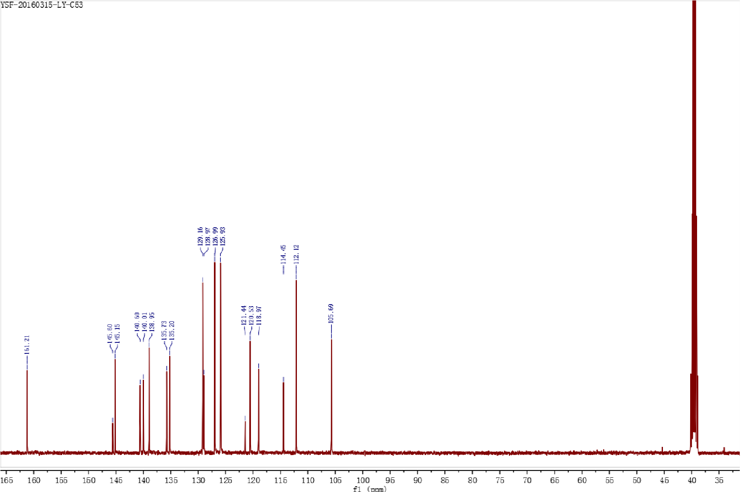

Figure S13.5f-¹H NMR
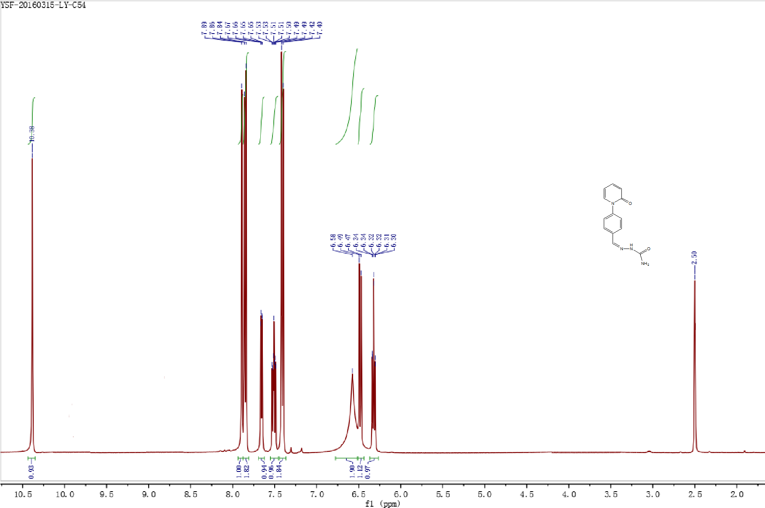

Figure S14.5f-¹³C NMR
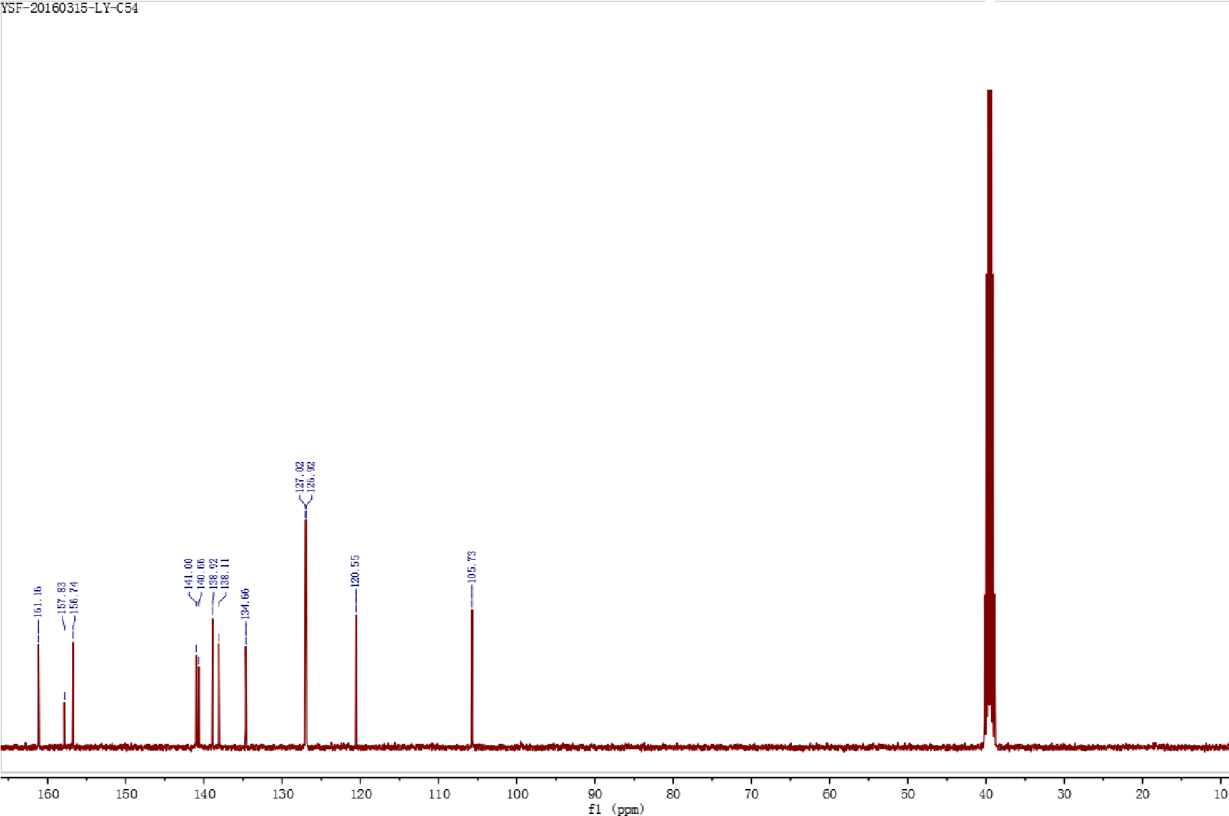

Figure S15.5g-¹H NMR
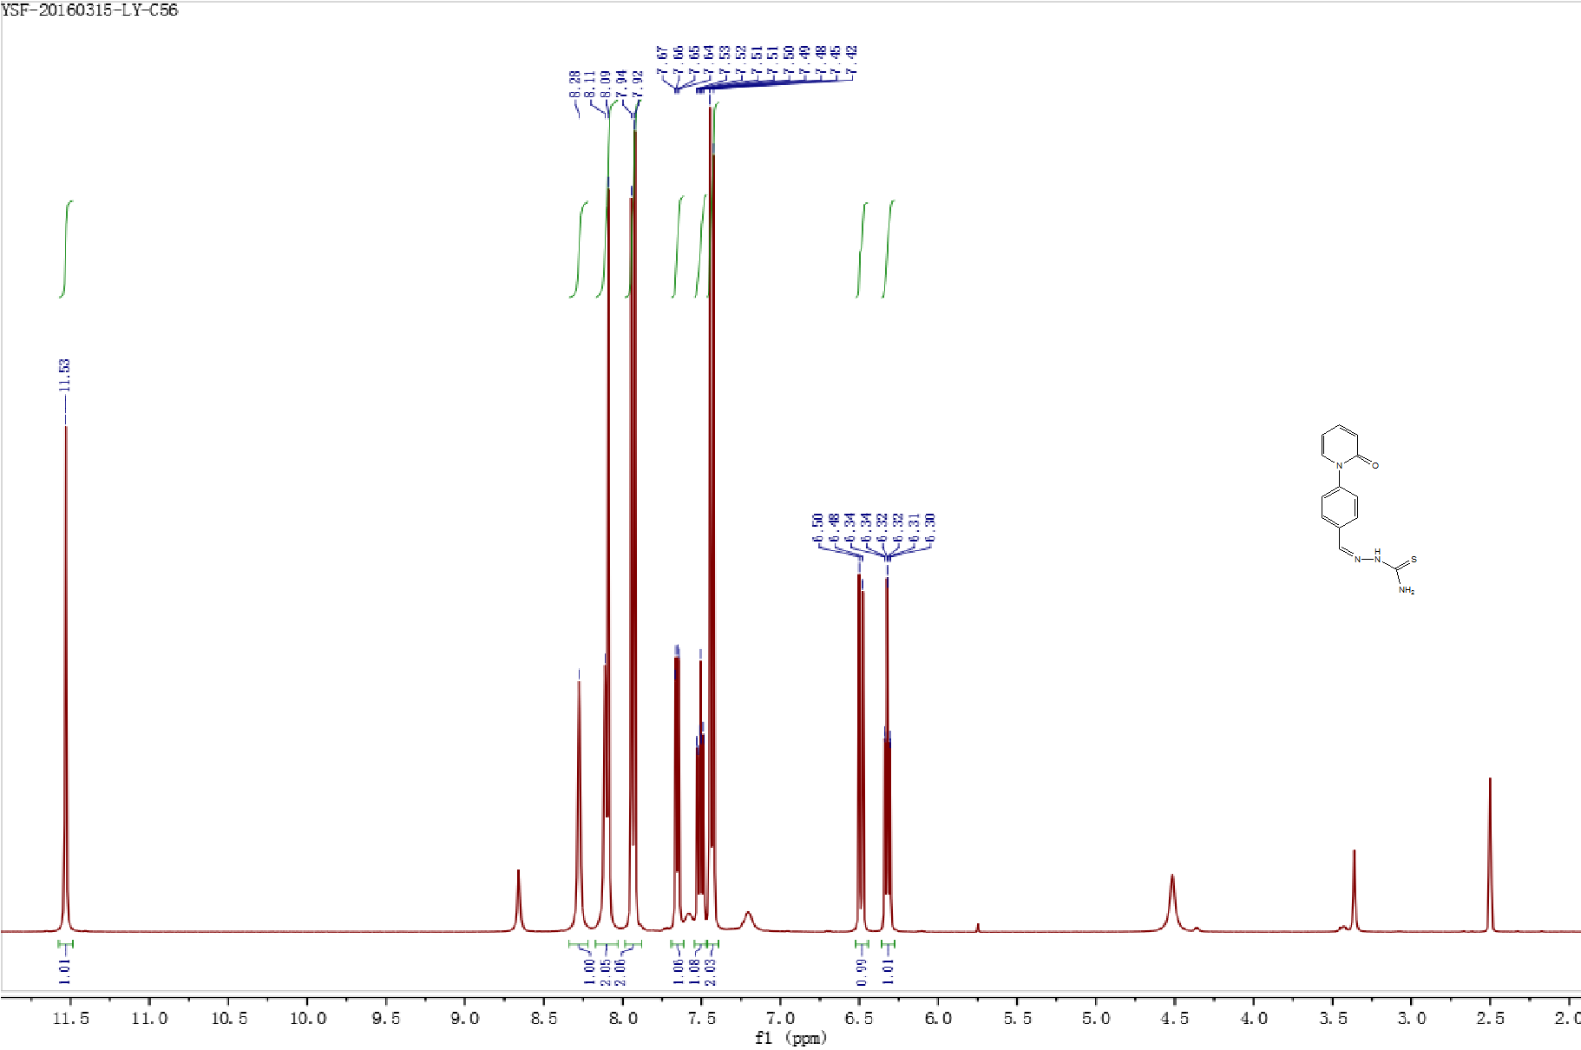

Figure S16.5g-¹³C NMR
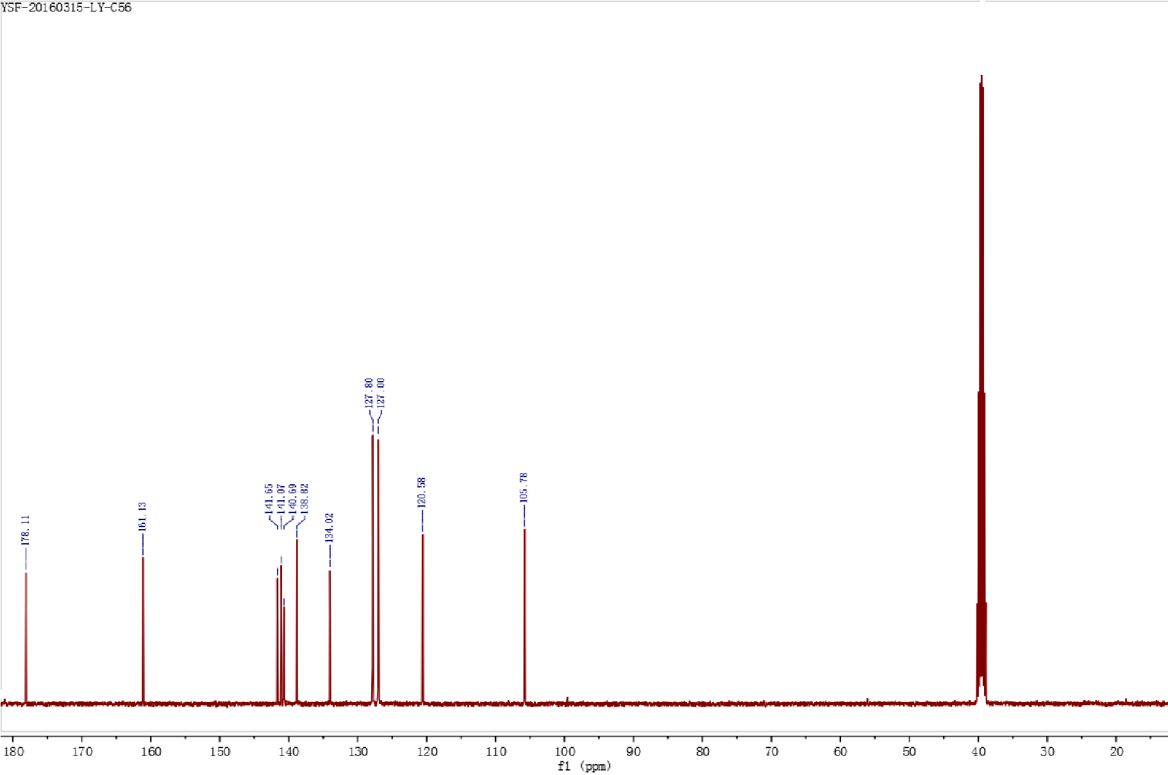

Figure S17.5a-HRMS
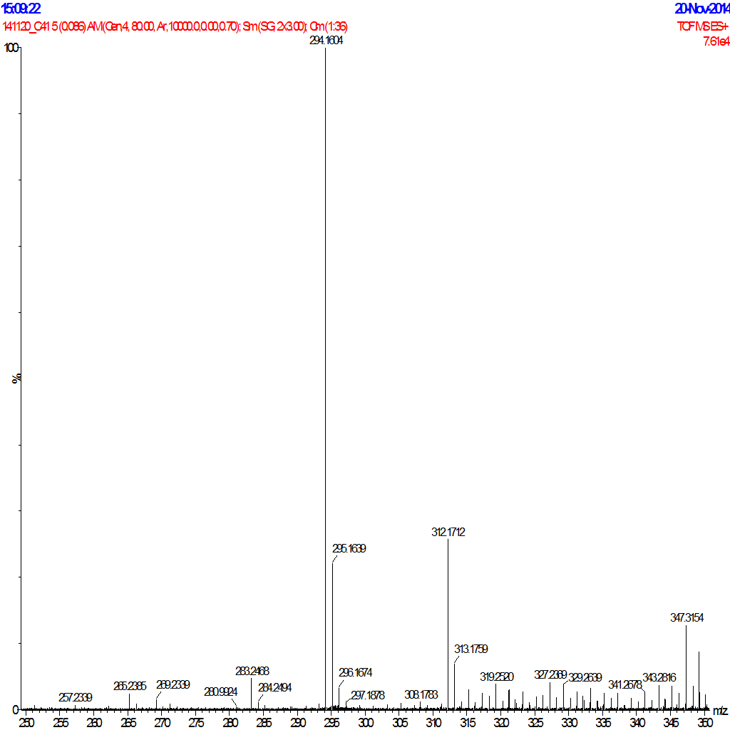

Figure S18.5b-HRMS
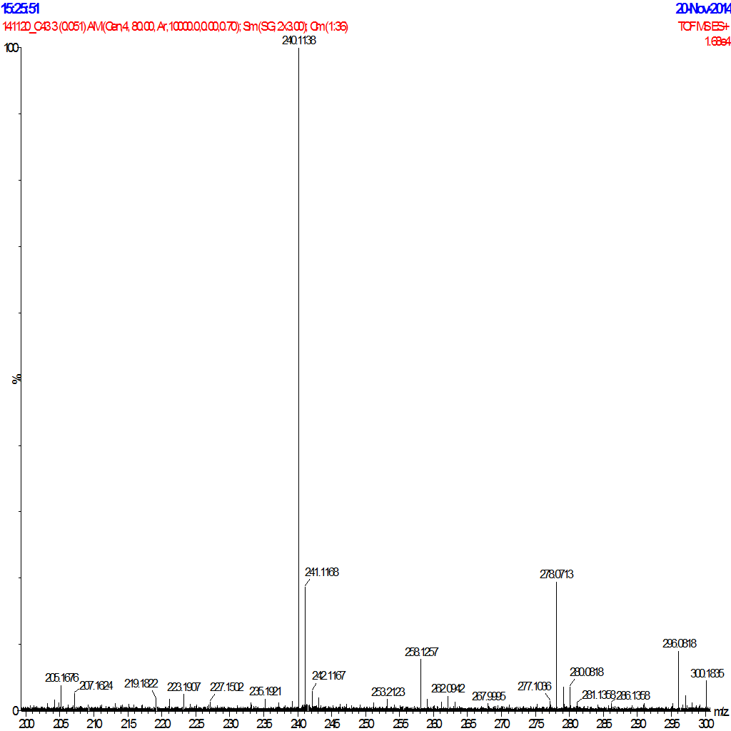

Figure S19.5c-HRMS
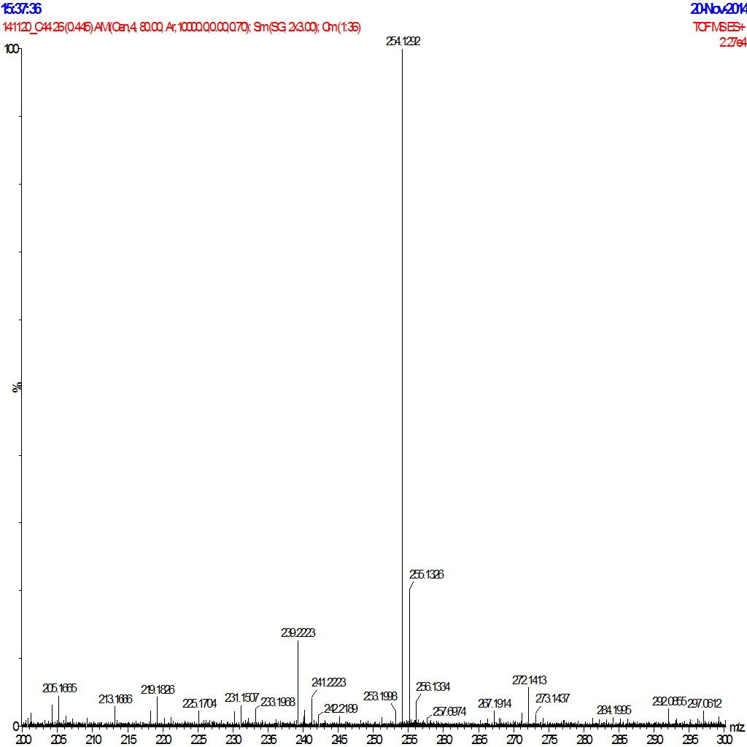

Figure S20.5d-HRMS
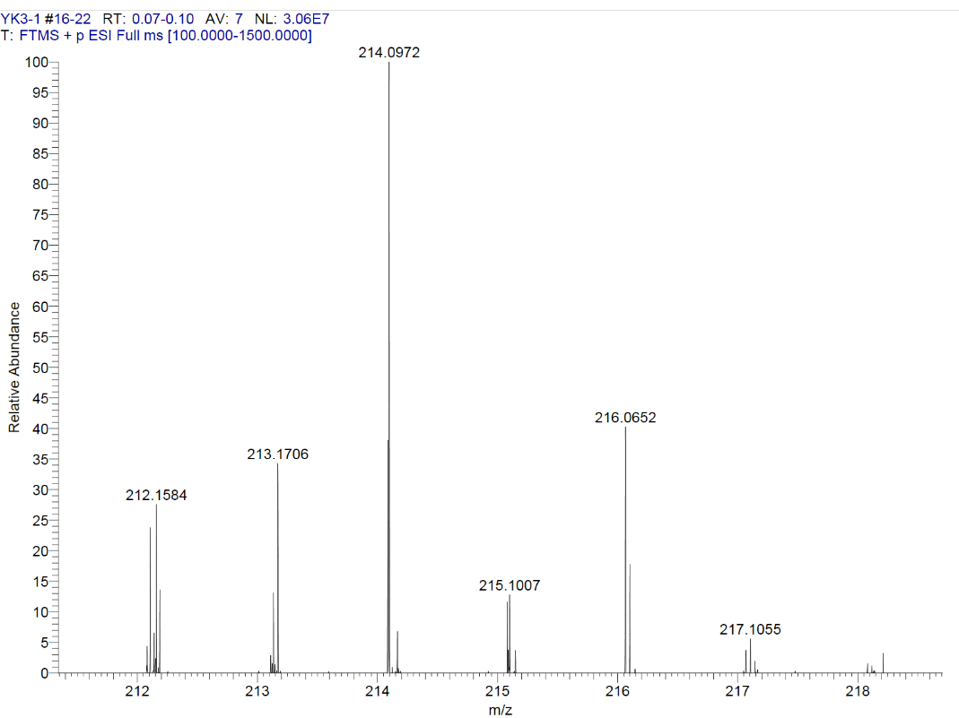

Figure S21.5e-HRMS
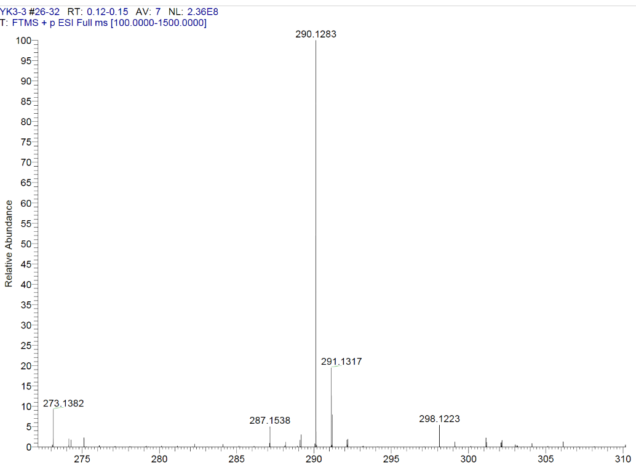

Figure S22.5f-HRMS
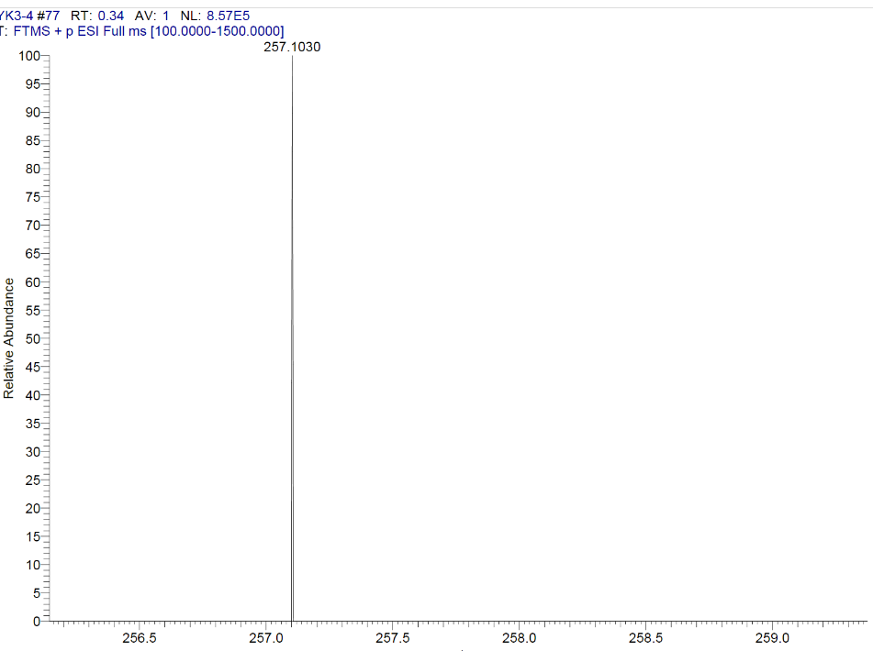

Figure S22.5g-HRMS
