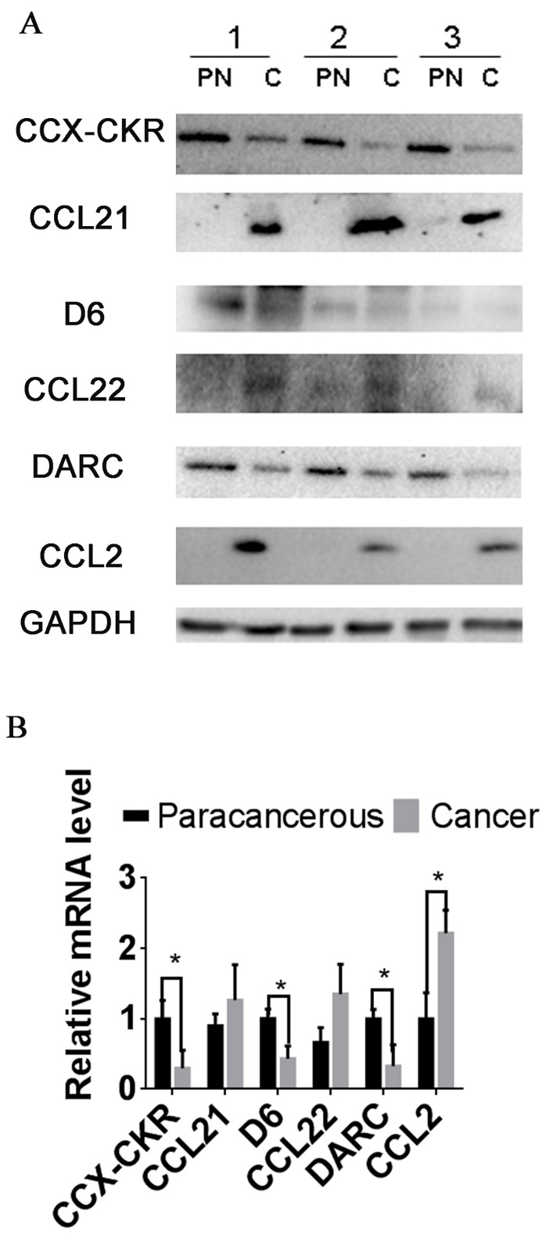
Figure S1. Expression of CCX-CKR, D6, DARC and corresponding ligands, CCL21, CCL22 and CCL2, in normal colorectal tissues and colorectal cancer tissues. Western blot (A) was used to detect the expression of DARC, D6, CCX-CKR and the corresponding CC chemokine ligands CCL2, CCL22 and CCL21, in paracancerous normal tissues (PN) and cancer tissues (Ca) in 21 pairs of specimens. Bar graph (B) indicates the band’ intensity calibrated with β-actin. Error bar presents as mean ± SD. *P< 0.05.

