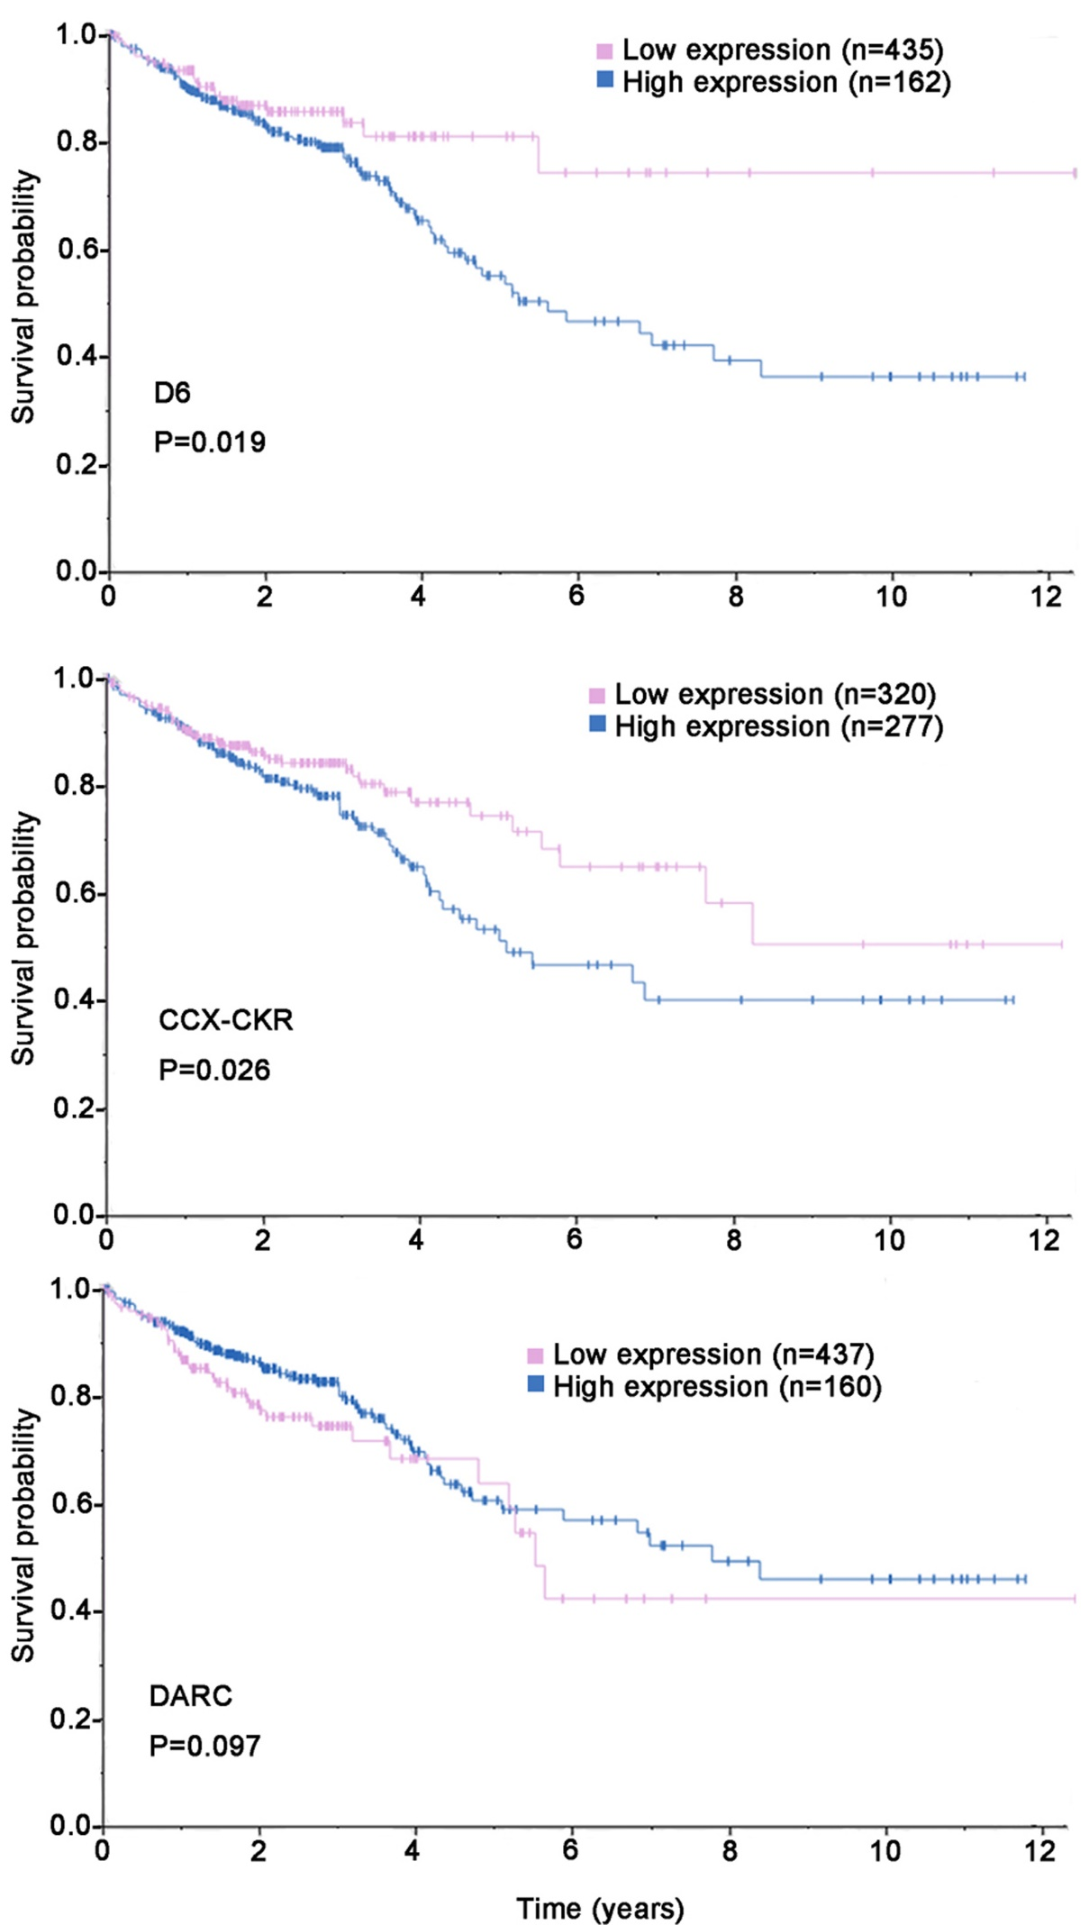
Figure S4. Kaplan-Meier plots summarize results from analysis of correlation between ACKR2/D6, ACKR4/CCXCKR and ACKR1/DARC mRNA expression levels and patient survival (TCGA) analyzed by the Human Protein Atlas (https://www.proteinatlas.org, Version 18.1). Patients were divided based on level of expression into one of the two groups "low" (under cut off) or "high" (over cut off). X-axis shows time for survival (years)

