Supplementary Figure 1: FA and MD heterogenous changes along gestational age
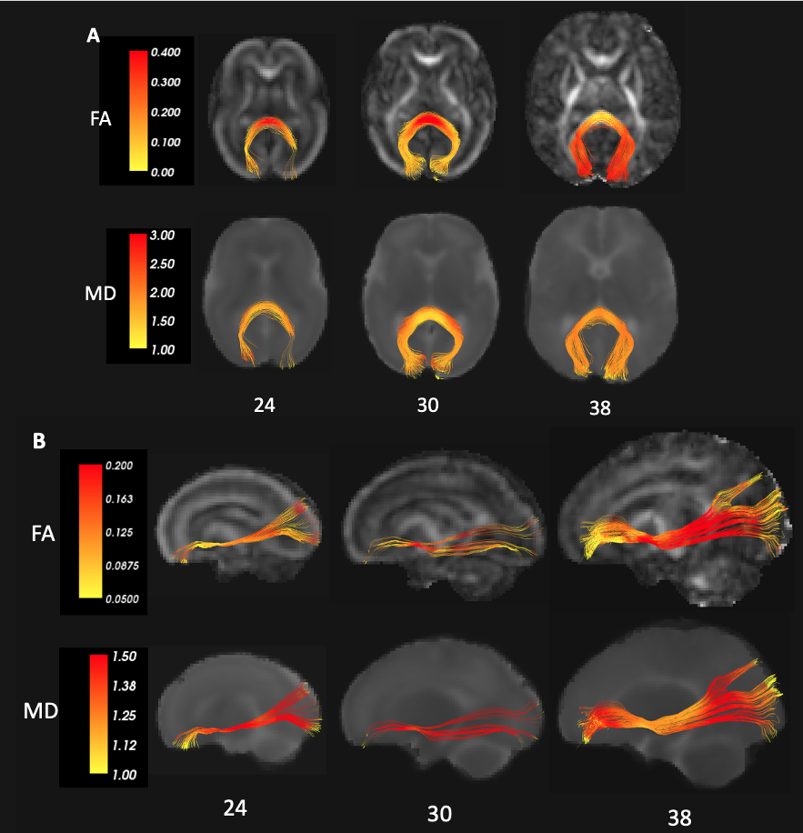

Heat maps of FA and MD at 24, 30 and 38 weeks of gestational age show within tract heterogeneity in progression of microstructural changes in the forceps major (A) and the inferior fronto-occipital fasciculus (B).

Supplementary Figure 2: Premature CST tractography termination in early gestational ages

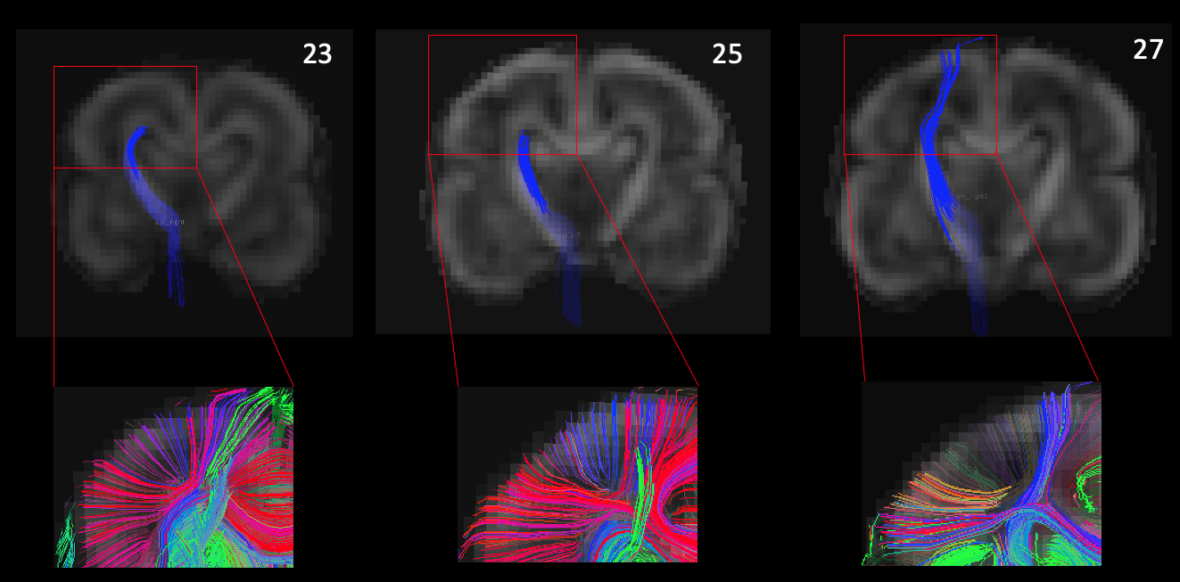

Premature termination of CST fiber tracking due to crossing fibers. The upper row shows serial ROI based tractography images that demonstrate that at early GA (<27 weeks) the CST does not reach the cortex and it terminates fiber tracking in the intermediate zone. Lower row shows magnified view of tractography at the junction of the subplate and intermediate zone with tracts generated using a single coronal slice ROI; the presence of crossing fibers is clearly delineated.

