Table 2. Expert opinion ranking of risk transmission pathways identified by the stakeholders for in-country and transboundary introduction and transmission of ASF virus.
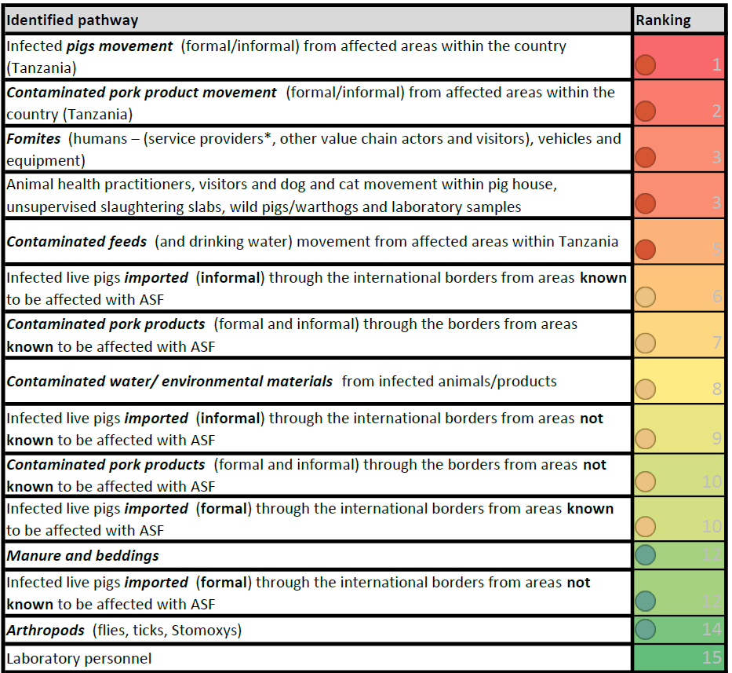
Note: 1 = the riskiest and 15 = the least risky. Experts’ opinions were provided based on selection of persons with significant contributions in the field of ASF research and diagnostics, field practice, teaching and or years of experience. All responses were based on independent empirical evaluations of ASF in farms. Full details of the reasoning behind the ranking are available in the Supplementary Table 4a. It should be understood that wild boars do not occur naturally in sub-Saharan Africa. The environment to pig cycle was described for a cycle identified in northern Europe where wild boars die of ASF and their carcasses contaminate the environment if not rapidly removed, helping to keep the infection going [20]. The ticks to pig cycles are related either to warthogs or to ticks that live in pigsties (as described in Malawi). Whether this affect the low ranking of arthropods and the relationship to wild pig was not evaluated. Perhaps, the ranking may differ in other territories.

Table 3. Expert opinion ranking of facilitators of ASF virus introduction and transmission to new premises for in-country and transboundary.

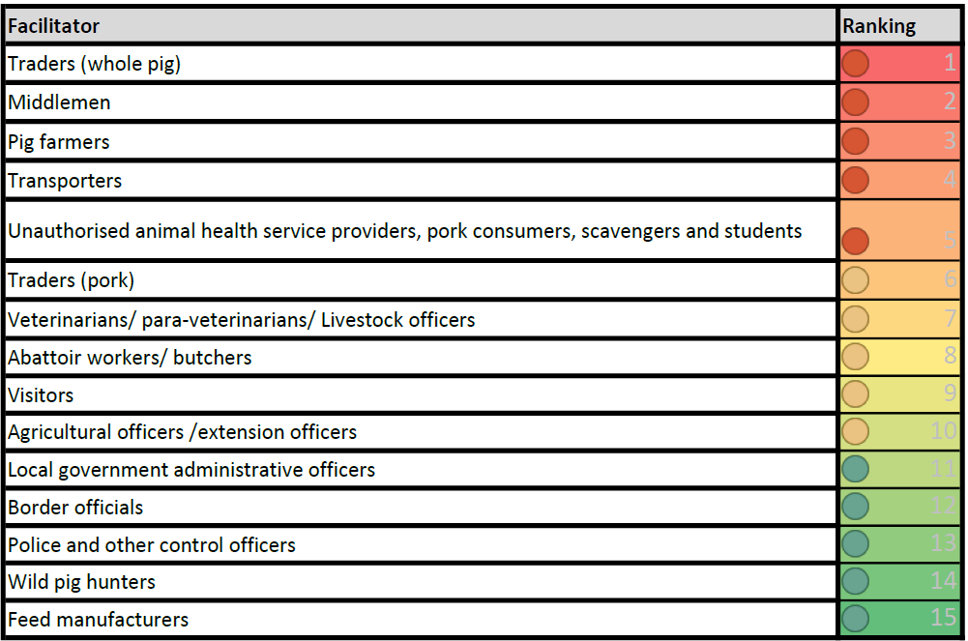
Note: 1 = the most ranked and 15 = the least ranked. Experts’ opinions were provided based on years of experience and empirical evaluation of ASF in farms. At subnational levels, sometimes, the agricultural officers, extension officers, ward and village administrative staff serve as animal health officers and issue animal movement permits. Full details of the reasoning behind the ranking are available in the Supplementary Table 4b.

