Comparison of the Optimal Design of Spinal Hybrid Elastic Rod for Dynamic Stabilization: A Finite Element Analysis.

Supplementary Figure 1.
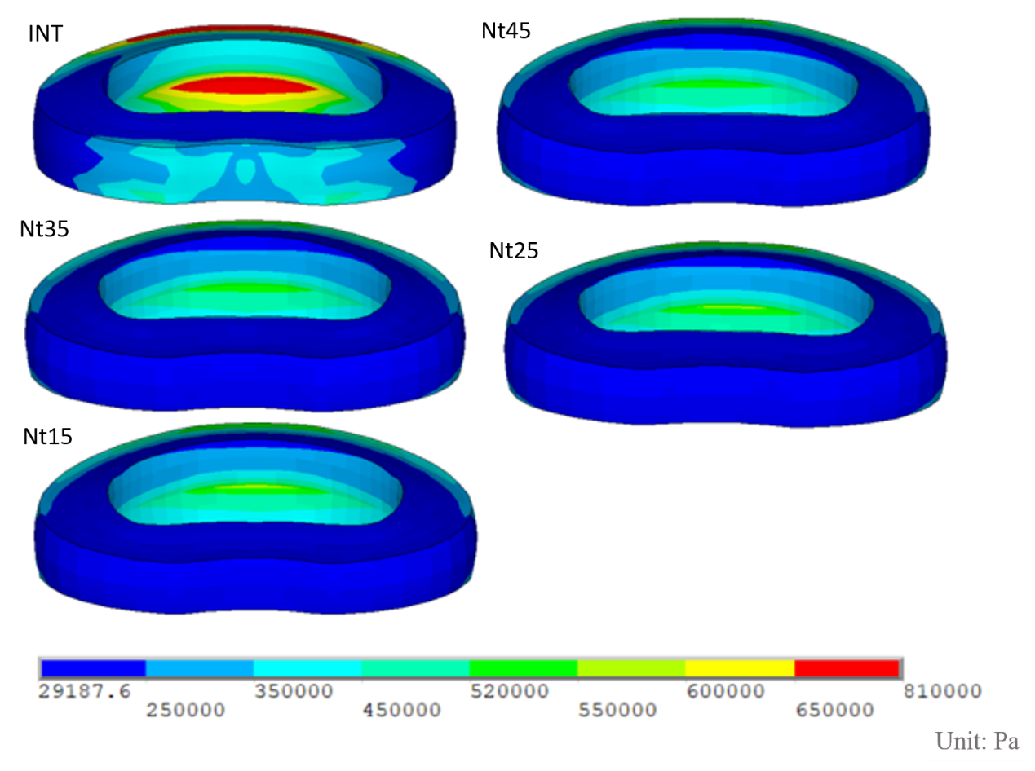
The von-Mises stress distribution of the implanted L3–L4 disc in flexion. The disc stress in all models decreased when compared with INT.
INT, intact lumbar spine model.

Supplementary Figure 2.
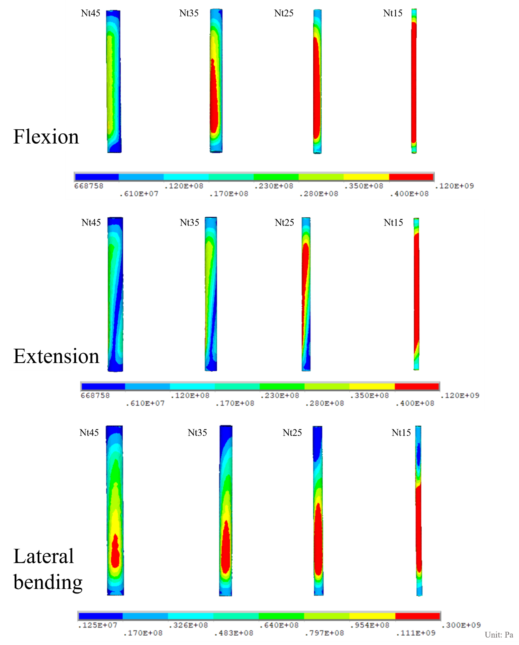
The von-Mises stress on the inner NS markedly increased on the lower portion as the diameter decreased in flexion, extension and lateral bending.
NS, nitinol stick.

Supplementary Table 1.
The biomechanical analysis of the five finite element models in flexion.
 | INT |  | Nt45 |  | Nt35 |  | Nt25 |  | Nt15
Preload (N) | 150
Moment  (Nm) | 14.4 |  | 18.7 |  | 18.7 |  | 18.7 |  | 18.4
Intervertebral range of motion (degree)
L1-L2 | 5.39 |  | 6.43 |  | 6.43 |  | 6.43 |  | 6.35
L2-L3 | 5.71 |  | 6.81 |  | 6.81 |  | 6.81 |  | 6.72
L3-L4 | 5.71 |  | 2.28 |  | 2.31 |  | 2.38 |  | 2.47
L4-L5 | 7.28 |  | 8.60 |  | 8.60 |  | 8.60 |  | 8.51
Total | 24.09 |  | 24.12 |  | 24.15 |  | 24.22 |  | 24.05
Stress of intervertebral disc (Kpa)
L1-L2 | 1080 |  | 1220 |  | 1220 |  | 1230 |  | 1270
L2-L3 | 893 |  | 1130 |  | 1130 |  | 1110 |  | 1110
L3-L4 | 810 |  | 543 |  | 547 |  | 548 |  | 559
L4-L5 | 959 |  | 1200 |  | 1200 |  | 1180 |  | 1180
Facet contact forces (N)
 | Left | Right | Left | Right | Left | Right | Left | Right | Left | Right
L1-L2 | 0 | 0 | 0 | 0 | 0 | 0 | 0 | 0 | 0 | 0
L2-L3 | 0 | 0 | 0 | 0 | 0 | 0 | 0 | 0 | 0 | 0
L3-L4 | 0 | 0 | 0 | 0 | 0 | 0 | 0 | 0 | 0 | 0
L4-L5 | 0 | 0 | 0 | 0 | 0 | 0 | 0 | 0 | 0 | 0
Stress of screws (MPa)
Maximum | - |  | 139 |  | 140 |  | 134 |  | 130
Stress of PCU shell (Mpa)
Maximum | - |  | 4.7 |  | 3 |  | 3.5 |  | 4.9
Stress of Nitinol stick (Mpa)
Maximum | - |  | 44 |  | 54.6 |  | 72.4 |  | 118

Supplementary Table 2.
The biomechanical analysis of the five finite element models in extension.
 | INT |  | Nt45 |  | Nt35 |  | Nt25 |  | Nt15
Preload (N) | 150
Moment  (Nm) | 15.1 |  | 18.4 |  | 18.4 |  | 18.4 |  | 18
Intervertebral range of motion (degree)
L1-L2 | 3.33 |  | 3.86 |  | 3.86 |  | 3.86 |  | 3.80
L2-L3 | 3.17 |  | 3.65 |  | 3.65 |  | 3.65 |  | 3.60
L3-L4 | 2.85 |  | 1.09 |  | 1.12 |  | 1.18 |  | 1.24
L4-L5 | 3.27 |  | 3.97 |  | 3.95 |  | 3.97 |  | 3.88
Total | 12.62 |  | 12.57 |  | 12.58 |  | 12.66 |  | 12.52
Stress of intervertebral disc (Kpa)
L1-L2 | 475 |  | 542 |  | 542 |  | 542 |  | 533
L2-L3 | 488 |  | 556 |  | 556 |  | 556 |  | 548
L3-L4 | 414 |  | 236 |  | 236 |  | 239 |  | 240
L4-L5 | 312 |  | 439 |  | 436 |  | 439 |  | 430
Facet contact forces (N)
 | Left | Right | Left | Right | Left | Right | Left | Right | Left | Right
L1-L2 | 76 | 76 | 95 | 95 | 95 | 95 | 95 | 95 | 93 | 93
L2-L3 | 94 | 94 | 117 | 117 | 118 | 118 | 118 | 118 | 115 | 115
L3-L4 | 105 | 105 | 6 | 5 | 7 | 7 | 11 | 11 | 14 | 15
L4-L5 | 102 | 102 | 129 | 128 | 128 | 128 | 128 | 128 | 125 | 125
Stress of screws (MPa)
Maximum | - |  | 105 |  | 110 |  | 112 |  | 110
Stress of PCU shell (Mpa)
Maximum | - |  | 5.1 |  | 2.7 |  | 3.1 |  | 4.9
Stress of Nitinol stick (Mpa)
Maximum | - |  | 39.5 |  | 46 |  | 58.4 |  | 101

Supplementary Table 3.
The biomechanical analysis of the five finite element models in torsion.
 | INT |  | Nt45 |  | Nt35 |  | Nt25 |  | Nt15
Preload (N) | 150
Moment  (Nm) | 29.0 |  | 31.9 |  | 31.3 |  | 30.2 |  | 29.6
Intervertebral range of motion (degree)
L1-L2 | 3.85 |  | 4.13 |  | 4.07 |  | 3.96 |  | 3.91
L2-L3 | 4.08 |  | 4.28 |  | 4.24 |  | 4.16 |  | 4.12
L3-L4 | 4.60 |  | 3.79 |  | 4.01 |  | 4.22 |  | 4.40
L4-L5 | 6.27 |  | 6.62 |  | 6.55 |  | 6.41 |  | 6.33
Total | 18.80 |  | 18.82 |  | 18.87 |  | 18.75 |  | 18.76
Stress of intervertebral disc (Kpa)
L1-L2 | 683 |  | 740 |  | 728 |  | 707 |  | 694
L2-L3 | 678 |  | 722 |  | 722 |  | 687 |  | 675
L3-L4 | 751 |  | 611 |  | 611 |  | 696 |  | 731
L4-L5 | 927 |  | 1020 |  | 1020 |  | 968 |  | 950
Facet contact forces (N)
 | Left | Right | Left | Right | Left | Right | Left | Right | Left | Right
L1-L2 | 0 | 336 | 0 | 371 | 0 | 363 | 0 | 349 | 0 | 342
L2-L3 | 0 | 336 | 0 | 374 | 0 | 366 | 0 | 351 | 0 | 343
L3-L4 | 0 | 336 | 0 | 213 | 0 | 245 | 0 | 285 | 0 | 323
L4-L5 | 0 | 344 | 0 | 389 | 0 | 380 | 0 | 363 | 0 | 354
Stress of screws (MPa)
Maximum | - |  | 211 |  | 162 |  | 107 |  | 98.9
Stress of PCU shell (Mpa)
Maximum | - |  | 17.4 |  | 7.6 |  | 6 |  | 4.6
Stress of Nitinol stick (Mpa)
Maximum | - |  | 219 |  | 324 |  | 383 |  | 381

Supplementary Table 4.
The biomechanical analysis of the five finite element models in lateral bending.
 | INT |  | Nt45 |  | Nt35 |  | Nt25 |  | Nt15
Preload (N) | 150
Moment  (Nm) | 19.1 |  | 23.2 |  | 23.2 |  | 23.2 |  | 22.6
Intervertebral range of motion (degree)
L1-L2 | 6.12 |  | 7.25 |  | 7.25 |  | 7.24 |  | 7.10
L2-L3 | 6.12 |  | 7.15 |  | 7.15 |  | 7.14 |  | 7.01
L3-L4 | 6.17 |  | 2.63 |  | 2.77 |  | 2.96 |  | 3.16
L4-L5 | 6.45 |  | 7.79 |  | 7.78 |  | 7.76 |  | 7.62
Total | 24.86 |  | 24.82 |  | 24.95 |  | 25.10 |  | 24.89
Stress of intervertebral disc (Kpa)
L1-L2 | 1230 |  | 1510 |  | 1500 |  | 1500 |  | 1470
L2-L3 | 1160 |  | 1440 |  | 1430 |  | 1430 |  | 1400
L3-L4 | 1130 |  | 512 |  | 544 |  | 585 |  | 621
L4-L5 | 1040 |  | 1320 |  | 1320 |  | 1320 |  | 1290
Facet contact forces (N)
 | Left | Right | Left | Right | Left | Right | Left | Right | Left | Right
L1-L2 | 21 | 5 | 30 | 10 | 30 | 10 | 30 | 9 | 28 | 9
L2-L3 | 53 | 31 | 82 | 38 | 82 | 37 | 80 | 35 | 74 | 33
L3-L4 | 41 | 9 | 0 | 0 | 0 | 0 | 1 | 0 | 9 | 0
L4-L5 | 55 | 0 | 61 | 0 | 61 | 0 | 61 | 0 | 59 | 0
Stress of screws (MPa)
Maximum | - |  | 158 |  | 178 |  | 181 |  | 175
Stress of PCU shell (Mpa)
Maximum | - |  | 6.8 |  | 5.1 |  | 5 |  | 7.2
Stress of Nitinol stick (Mpa)
Maximum | - |  | 127 |  | 145 |  | 187 |  | 275

