_{Supplementary Information}
Nonomura Title: Characterization and eradication of the high concentration infection source of oral segment of Candida by infection examination diagnosis system
Contents
Supplementary Notes ------------------------------------------------------------------------------------------------ 3
S1－Infection field -------------------------------------------------------------------------------------------------- 3
S2－Diffusion field -------------------------------------------------------------------------------------------------- 3
S3－Gradient concentration ( / Infection Distance ) ------------------------------------------------------------ 3
S4－Spread field ----------------------------------------------------------------------------------------------------- 3
S5－Carrier field ----------------------------------------------------------------------------------------------------- 3
S6－(Local) Infection Source -------------------------------------------------------------------------------------- 3
S7－Global Infection Source --------------------------------------------------------------------------------------- 3
S8－Internal transmission and external transmission ----------------------------------------------------------- 3
S9－Infection chain (chain of infection) ----------------------------------------------------------------------- 3
S10－Fixed (local) infection field and movable (local) infection field.---------------------------------------3
S11－Material method 1 ------------------------------------------------------------------------------------------ 3
S12－Material method 2 ------------------------------------------------------------------------------------------ 4
S13－Material method 3 ------------------------------------------------------------------------------------------ 4
S13－Material method 4 ------------------------------------------------------------------------------------------ 4
S14－Adhesive colonization level -------------------------------------------------------------------------------- 4
S15－Fixed colonization level ------------------------------------------------------------------------------------- 4
S16－Outbreak colonization level --------------------------------------------------------------------------------- 4
S17－Adhesion, fixing, outbreak of CA -------------------------------------------------------------------------- 4
S18－colony level 1, level2, level3, and level 4 ----------------------------------------------------------------- 4
S19－The area and character of diffusion field and spread field----------------------------------------------- 4
S20－Resist Field and Receptor field ----------------------------------------------------------------------------- 5
S21－The proceeding of initial infection and fixing (Table 9) ----------------------------------------------- 5
S22－Colony concentration and caries level --------------------------------------------------------------------- 5
S23－Character of the infection route which is visible from space analysis --------------------------------- 5
S24－The reason a dental-caries tooth is a fixing place of CA ------------------------------------------------- 6
S25－Treatment (operating) method -------------------------------------------------------------------------------·6
S26－Prediction and breaking of infection chain (IC) ----------------------------------------------------------- 6
S27－Phase------------------------------------------------------------------------------------------------------------- 6
S28－In the future ---------------------------------------------------------------------------------------------------- 6
Supplementary primitive operators and equations --------------------------------------------------------------- 6
Supplementary Abbreviation -------------------------------------------------------------------------------------- 6
Supplementary Tables ------------------------------------------------------------------------------------------------ 7
Supplementary Figure ----------------------------------------------------------------------------------------------- 36
Supplementary Figure Legends ------------------------------------------------------------------------------------ 42
Supplementary Data -------------------------------------------------------------------------------------------------- 43
Acknowledgements -------------------------------------------------------------------------------------------------- 43
References ------------------------------------------------------------------------------------------------------------- 43
Conflicts of interest --------------------------------------------------------------------------------------------------- 43
Supplementary Notes
S1─Infection field
The infection field (IF) consists of the IS and the three fields (DF, SF, and CF).
S2─Diffusion field
The (primary) diffusion field (DF) (area) by the concentration gradient from IS,
S3─Gradient concentration ( / Infection distance )
The concentration gradient by the concentration/infection distance to a neighbor tooth (in CA). The Infection distance (ID) is the distance from IS to another infected substance.
S4─Spread field (the spread field independent of a concentration gradient)
The spread-field (SF) of distant transition from infection source without concentration gradient,
S5─Carrier field (The infected field by a carrier)
The carrier field (CF) depending on media, such as food, a toothbrush, and floss,
S6─(Local) Infection Source
Source of infection
S7─Global Infection Source
The increasing field in the natural worlds without person
S8─Internal transmission (in a broad sense) and external transmission (in a broad sense)
Internal transmission is transmission in the living body. (The difference of Table7 and Table8 has suggested internal transmission) External transmission is transmission in a living body from the outside of the living body. (Table 9 indicates external transmission) Here, the oral cavity was defined in the living body.
S9─Infection chain (Chain of infection)
S10─Fixed (local) Infection field and Movable (local) infection field
The character of index tissue is decided by whether it is movable or immobility.
1 Fixed (local) infection field
Example: dental-caries teeth
2 Movable (local) infection field
Example: food in oral cavity, tooth-brush etc. (food is also global IS.)
3 The mobility of IS or IF is decided by the movable or the un-movable, of an infection-object.
S11─Material method 1
MS Phase contrast microscope (Co. Ltd. Microdent, at Nagoya city, Japan)
S12─Material method 2
The apparatus and method is shown by pat. No.5337353 (No. 4440626). MicroDent Co., Ltd., Nagoya city, Japan,
1 On the schale of CHROMagar (made by BD) pasted the dental formula medium (DFM).
2 WVG-agar (Corp. nicken) which used pat. No. 4440626 and No. 5337353 as WVG.
The trade mark of dental formula (measurement analysis) medium (DFM), No5341950, MicroDent Co., Ltd.
Nagoya city, Japan
The CHROMagarTM Cnadida, BD BBLTM, Becton Dickinson and Company,
http://www.bdj.co.jp/micro/products/1f3pro00000rxnvr.html
S13─Material method 4
Usage swab EOG sterilization swab
S14─Table10 considered to be adhesive-level
The colony concentration of CA positive tooth in healthy tooth is 1 restored healthy tooth and 1 true healthy tooth. The phenomenon considered to be divided into adhesion and fixing. The colony concentration of the healthy tooth removable by cleaning is the reference of adhesion.
S15─Fixed colonization level (Table7, 8, 9, and Table10)
The part which subtracted the " the adhesion level Table10 from Table7, 8, and 9" has suggested fixed colonization.
S16─Outbreak (of colonization) (Table7)
Or more 100 values are considered to be explosive colonization level.
S14. S15. S16. S17.
They are considered to be Data which deserves predicting adhesion, fixing, and explosion, of CA.
S18─Detail (contents) of colony level
level 1 is less than 5;
level 2 is from 5 to less than 15;
level 3 is from 15 to less than 100.
level 4: is 100 or more,
Detail (contents) of colony level
Colony level 1:
The adhesion level made the level 1 from one colony to four colonies in CHROMagar. (Table 10) (Two of the nAdj-RHT CC 5-9 of Table 10 is the concentration 7; I excepted the value which is very different, the CC 7 not being a value of a border in Table 8, etc.)
Colony level 4:
At a CC of 100 or more, a microorganism outbreak occurs (as in Table 7) It is defined as level 4.
Colony level 2 and level 3:
Therefore, the colony level from the level 2 to the level 3 is defined as from five or more colonies to less than 100 colonies. It is increase (growth) condition.
The threshold of the level 2 and the level 3 is 15: level 2 is from 5 to less than 15; and level 3 is from 15 to less than 100.
This was decided from the colony count of the teeth with caries (Table 8a).
From 5 colonies to less than 15 colonies (5–14) was 11; from 15 colonies to less than 100 colonies (15–99) was 11; this was considered the same proportion.
S19─The area and character of diffusion field and spread field
Diffusion Field and Spread Field of CA in comparison with LB
A: In LB, the colony exists at random in all the teeth (background) on a dental formula medium.
This originates in LB concentration in the saliva adhering to the teeth, LB concentration in the saliva which exists in an environment, LB concentration of (marginal) periodontal tissue. Moreover, it is detected by the dental-caries tooth at high concentration, and the influence by the concentration diffusion to the neighbor tooth of a high concentration detection tooth is not observed. (Supplementary Figure 6 and 7)
In above thing, even if LB does not have carrier, LB can be transferred. Moreover, in cases where it is distributed all the area of the mouth at random. LB is indigenous bacteria in the oral cavity. This is one basis of the necessary condition of indigenous bacteria.
B: In CA, the colony does not exist in all the teeth (background) in a dental formula medium.
In CA, spread field (SF) is not observed in the sensitivity on a dental formula medium. Since diffusion field of CA is surmised that it is within about 3 or 4 teeth and concentration is moreover decreasing exponentially from Supplementary Figs.11, 12, and 13, it is considered to be about one (tooth). However, it thought that it is natural to conclude that short distance diffusion is also prevented by existence of resist field (RsF). (Supplementary Table S18 and S22；Supplementary Figure2-5 etc.) And the negative dental caries tooth in supplementary TableS18 is an example which has not done infection transition at a dental caries tooth, although CA exists (such as a neighbor tooth etc.) in the same oral cavities. Furthermore, it is predicted that carrier and an especially adhesive carrier are required for sufficient infection of CA.
S20─Resist field (RsF) and receptor field (RcF) by dental-caries tooth
Although a dental caries is a field (receptor field {RcF}) of main (invasion) colonization of CA, however, it is also the fact that the dental caries tooth which is not adhered and fixed even if exposed to IF exists. Although CA is brushed especially to the dental caries tooth of CA (-) with the toothbrush from the teeth of CA (+) every day, or it had a food and has received contamination of CF, it is not infected. 48.0% of teeth of examination without dummy and 26.8% of only caries is negative. 93.9% for 46 persons among 49 persons is negative (Table4, Supplementary Table S18). These are a certain resist field (RsF), it have suggested existence of RsF strongly. Although initial adhesion is observed also in a healthy tooth, the case which does not form the colony (invasion) at all without adhering even if it receives the above-mentioned encounter exists plentifully. This has also suggested existence of resist field (RsF) strongly. (Supplementary Table S18；Supplementary Fig2) LB is strongly related to this. (Supplementary Figure4, 5, and 6)
S21─Progress of initial infection and fixing is observed from the teeth group which became positivity from negativity by examination. (Table 9)
It provides determination of an infection route with useful information.
It is necessary to verify the time factor which became positivity from negativity.
It is necessary to also verify the case infected in the restoration.
S22─A dental-caries stage (level) and colony concentration
Mean concentration of Table 8 of each colony concentration of a single dental-caries tooth
C2 <C3pul<<C3per and the upward tendency.
6.15 <6.8 < 22.38
In the early stage of the dental caries (C1 and C2), CA increases slowly.
If stage of caries transfers to C3pul, invasion (increasing) of CA will progress slowly. And if it transfers to C3Per of the last stage, it will increase explosively.
This invasion (increasing) of CA has two speeds.
They are considered that, the first loose increase suggested a possibility of decline of the immunity by pulp injury, and, the increase of explosion suggested a possibility of being loss of the immunity by loss of pulp.
And from these facts, it can be considered at least that the infection of CA is a disease of end stage and CA is microorganism (fungus) of final phase (for LB or Str. Mutants etc.). Moreover, it is an item into which examination of the amplification coefficient γ should be made in a next report.
These things can be said to be one of the character which should advance research in the teeth as a feature which is common in other internal organs.
S23─Character of the infection route (IR) which is visible from space analysis
An infection route and the medium of infection are surmised from spatial analysis (CAP; partial CA examination) of the first teeth group to be infected. (The next report describes.)
1. Droplet-infection type: It is thought that carriers, such as biofilm etc. of a food type, the ground, water, saliva, splash (as for saliva and splash, CA is cluster-ization in the inside), and the colony-ized huge cluster, and a medium are required.
2. Pharynx nasal cavity type: It is thought that carriers, such as pus and colony-ized biofilm, are required.
3. Esophagus, respiratory tract type: Carriers, such as pus and colony-ized biofilm, are considered to be subjects.
4. The aerial-infection type (pattern), this is not recognized from this result.
S24─The basis whose dental caries tooth is a fixing place of CA
1. The rate of eradication by dental caries medical treatment is about 100%.
2. Adhesion of a healthy tooth and a treatment healthy tooth can remove by cleaning.
3. The dental caries tooth diagnosed as tooth extraction, the dental caries tooth with which a patient does not desire medical treatment, and the dental caries neglected for the sake of a patient's convenience, they are generating CA continuously. (Supplementary Fig. 2)
4. In a small number of teeth with CA, the CA is cleanly detected only from a dental-caries tooth. Moreover, by dental-caries extermination of the part, the tooth shows CA negativity. (Fig4)
5. In dental-caries phase, i.e., C2, C3Pul, and C3per, CA concentration increases. (Supplementary table S19)
6. The high concentration colony outbreak is especially observed by C3per. (Table 7; Supplementary table S22)
7. In all teeth CA examinations (in oral cavity unit) before dental-caries surgical operation (dental treatment), CA negative patients are more nearly intentionally (than positive patients) few. (Table1)
8. In CA investigation of a tongue and a tooth, even if it is overwhelmingly detected from the teeth and is detected from the tongue, the disinfection is easy.
9. In space-analysis of Lactobacillus, colonies are scattered in the background of all the teeth in many cases. This phenomenon is not observed by CA, although considering influence of large SF. (Supplementary Fig4-6)
In the above mention, many bases whose fixing spaces of CA are dental caries exist. These will not appear without the space analysis by a dental formula medium, etc., considering as an indigenous microorganism sometimes, and hiding the true figure.
S25─Treatment method
Dental operation (treatment) treats according to Supp. Figure S14.
S26─Prediction and breaking off infection chain (IC)
1. Considering that microorganisms in the tooth can transfer to the lungs and digestive organ etc.
2. Considering that microorganisms through the mouth can transfer to the lungs and digestive organ etc.
3. It is infected to a vagina from the local infection field of a dental caries in the oral cavity, and is infected with an eye from a vagina at childbirth, and eye part muddiness, and central-nerves infection, etc. are predicted.
Therefore, in above the IES, an infection field (IF) is disinfected by the caries treatment, moreover a special survey by IES and cleaning are done, and that break off the infection chain (IC).
S27─Phase (Especially, Only phase analysis, It define as comparison of multiple microorganisms.)
The phase of time
Time transition of the colony level of a microorganisms is observable as a wave as signal.
(Encounter, fixing, increase, and explosion are a digital waves as signal.)
Comparison of their wave is a phase. The comparison is possible by the same microorganisms or other microorganisms (Fig 4, 5).
The phase of space
Multiple IS(s) are observable with interference of a spatial phase.
Although multiplex phase interference of CA is observed as an indigenous microorganisms, specific IS is observable if it decomposes for each phase (Fig 4, 5).
The phase of microorganisms
Multiple microorganisms do inhibition and amplification. It is observable by phase.
For an example is LB and CA (Supplementary Fig. 5).
The phase of dental-caries
See S24.5 and S22 for dental-caries phase,
S28─In the future
1. Transition to the further high precision of infection field (IF) and infection chain (IC), a clarification of receptor field (RcF), highly precise investigation of resist field (RsF), highly precise investigation of reinfection (include high precision infection rout), applicability a dental-caries focus including development of the antifungal from RsF, etc., and, establishment of CA-free in the living body.
2. In particular, the tissue fluid extracted at the time of the puncture should be examined by the CHROMagar medium.
3. Examination of the re-infection after disinfection
For this, I believe that cooperation from other departments and information dissemination is of particular importance. Subsequently, I encountered an example of strong re-infection, and re-analyzed the infection route analysis was done.
4. In addition, there is a high possibility that a powerful new antifungal agent will occur after from the further analysis of RsF.
5. In dentistry, the IE(D)S provides information indispensable to diagnostics of dental caries and periodontitis, treatment, and prevention.
Supplementary primitive operators and equations
Supp. POE S1 (ref. 13)
In primitive operators (POE), right-Str operator shows a relative minus, and left-Str operator shows a relative plus. In this study,
Left-Str-Zai is increasing function: active, infection, acceleration, this function expresses them.
Right-Str-Zai is decreasing function: decline, defense, inhibition, this function expresses them.
Supp. SDE in C4RDE (C4 simultaneous relative differential equation and its simultaneous solution) (ref. 13)
A segment is defined by two C4RDE simultaneous equations for IF which has active property activity (active coefficient ε_{a}) and decline property activity (decline coefficient ε_{d}); the solution (infection solution and defense solution) of the C4RDE consists of an infection function (infection coefficient γ_{c}) and a defense function (defense coefficient γ_{s}). For the result, the value of the infection solution constitutes the infection source (IS) in the segment. The contents of active coefficient ε_{a} and the decline coefficient ε_{d} each add a unique character following under bar. Target tissue defines the receptor property (receptor coefficient ε_{a_rc}) in the receptor field (RcF) and the resistant property (resistance coefficient ε_{d_rs}) in the resistant field (RsF). Glucose is one of the energy sources of a microorganism (CA etc.), it is included as active coefficient ε_{a} (ε_{a_glucose} etc.).
Moreover, an inhibitory term is included in decline coefficient ε_{d}, and an acceleration term is included in active coefficient ε_{a}. The factor that influences all the infection can be easily described (without limit) by active-coefficient ε_{a} and decline-coefficient ε_{d}.
₁N₀ is the initial value of inhibitor, and ₂N₀ is the initial value of pathogenic object (In the case of CA). The τ ratio (τ_{r}) is used if the reaction time of existence 1 (₁N) and existence 2 (₂N) is different:
₁N depicts the leukocytes; ₂N indicates the infective antigen (bacteria or microorganisms); ε is an interference coefficient; ε₁₂ is the active coefficient ε_{a} pertaining to the leukocytes; and ε₂₁ is the decline coefficient ε_{d}.
Active coefficient ε_{a} and decline coefficient ε_{d}: After the characters “a” and “d”, each content attaches under bar and adds the unique character.
1. Each term of Differential equation
1.1 Inhibition term (treatment, prevention, medicine, defense, decline term), as the relative decrease factor to antigen, in C4RDE:
Decline coefficient ε_{d}
$$ε_{d}=ε_{d_RsF}+ε_{a_\overline{DF}}+ε_{a_\overline{SF}}+ε_{a_\overline{CF}}+ε_{d_trt}$$
$ε_{d}=ε_{d_RsF}+ε_{d_trt}$ without anti field.
1.2 Infection term (microorganism term, CA term) as the relative increase factor to antigen, in C4RDE:
Active coefficient ε_{a}
$$ε_{a}=ε_{a_RcF}+ε_{a_DF}+ε_{a_SF}+ε_{a_CF}+ε_{a_growth}$$
1.3 Each coefficient
1.3.1 ε_{d} : decline coefficient
RsF coefficient: ε_{d_RsF}, anti-DF coefficient: $ε_{d_\overline{DF}}$, anti-SF coefficient: $ε_{d_\overline{SF}}$_, anti-CF coefficient: $ε_{d_\overline{CF}}$_, treatment coefficient: $ε_{d_trt}$ (dental treatment etc.)
1.3.2 ε_{a}: active coefficient
RcF coefficient: ε_{a_RcF}, DF coefficient: ε_{a_DF}, SF coefficient: ε_{a_SF}, CF coefficient: ε_{a_CF}, growth factor coefficient: ε_{a_growth},
1.3.3 Value of IF (in medium sensitivity),
SF: ε_{a_SF} = 0, DF: ε_{a_DF} << 1,CF: ε_{a_CF} <1, in Japan.
By cleaning with antifungal agent or treatment (operation) of the caries tooth, ε_{a_DF}=0, and simultaneously $ε_{d_\overline{DF}}$=0. Generally, the main CF is toothbrushes and food. The toothbrush CF is zero for treatment. In Japan, Food Sanitation Law (ref. 22) prohibits contamination with pathogenic microorganisms. Therefore, in the dental field in Japan, CF is zero. (Other CF is next paper.)
1.4 Other factors
An inhibitory factor is included in decline coefficient ε_{d}.
An acceleration factor is included in active coefficient ε_{a}. (Growth factor etc.)
2. Simple operation, calculation, and stability, (although they are influenced by various conditions. It does not have error with an infinitesimal real number (ref. 13).)
The solution (ref. 13) is, relatively simple (Supplementary POE S1):
₁N which is the opposing microorganisms and antibacterial factors, ₂N is the number of CA. In the treatment, the active factor of CA is only the growth factor (RcF and RsF influence). The γ_{i} = 0.4–0.5 from ref. 24. Correspondingly, the control of γ_{i} and/or γ_{d} is important for treatment and prevention. Doctor should be treated as γ_{d}>0.
It is important that doctor increases the number ₁N of inhibitory factors by the (living) activity. In addition, IE(D)S shows the interaction of two or more kinds of microorganisms, like CA and LB. We should also investigate the interaction of CA and coronavirus COVID-19.

Supp. Abbreviation
Candida albicans (CA), C3 restored tooth: C3rst, CA positivity: CA(+), CA negativity: CA(-), nAdj-THT: non-adjacent true healthy tooth, nAdj-RHT: non-adjacent restored healthy teeth, Adj-THT: adjacent true healthy tooth, Adj-RHT: adjacent restored healthy teeth, infection examination system: IES, infection examination diagnosis system: (IEDS)
NCDT: Number of colony detection teeth

Supplementary table

Supp. Table S1-The certification table of Table1
Supp. Table S2-The analysis of variance table of Table 1
Supp. Table S3-Bartlett's test
Supp. Table S4-Multiple comparison: Scheffe
Supp. Table S5-Test table of Table 2
Supp. Table S6-The analysis of variance table of Table 2
SSD: Sum of squares of deviations, DoF: Degree of freedom, AS: Average square
Supplementary Table S7-Bartlett's test
DoF: Degree of freedom
Since hypothesis of homogeneity of variance was not rejected, the following multiple comparisons are valid.
Supplementary Table S8- Multiple comparison: Scheffe

Supplementary Table S9-Table４ CAP Patient (Whole and WVG )

Supplementary Table S10- Details of colony detection adjacent teeth except caries tooth in Table5

Supplementary Table S11-Details of colony detection non-adjacent teeth except caries tooth in Table5

Supplementary Table S12-The parameter and rate of caries tooth in each caries stage of Table 4

Supplementary Table S13- Space-analysis operator

Supplementary Table S14-In Table 7 Dental-caries stage and a colony count (Whole: WVG + CHROMagar)

Supplementary Table S15-The colony count in each dental-caries tooth of Table7
(Using WVG + CHROMagar)

Supplementary Table S16-CA of tooth and tongue

Spp. Table S17-The caries stage and colony count of Table 7, 49 patients using (CHROMagar)

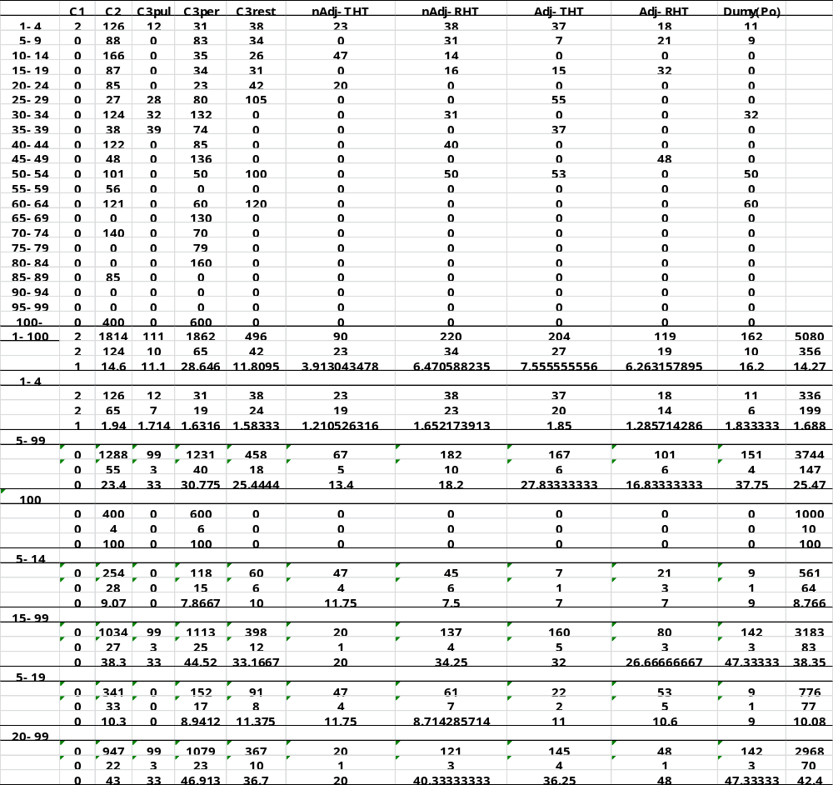

Supplementary Table S18-Details of patients without and with positive caries tooth, in table 4
Supplementary Table S19- (Using CHROMagar)
Table 8a A CA-positive single tooth with caries in a single jaw, Table 8b A CA-positive single tooth with caries in the whole jaw
Supplementary Table S20-The stage of dental caries and colony count immediately after shift to positive from negativity in the first examination (Using CHROMagar)

Supplementary Table S21- CA-positive single healthy tooth (CHROMagar)
Table 11a CA-positive single healthy tooth in a single jaw, Table 11b CA-positive single healthy tooth in the whole jaw

Supplementary Table S22-Adjacent (both) colony count of CA negative tooth (infection prevention, InfDist) (CHROMagar)

Supplementary Table S23-Example of space analysis

Supplementary Figure
Supp. Figure 0 no ethics problems
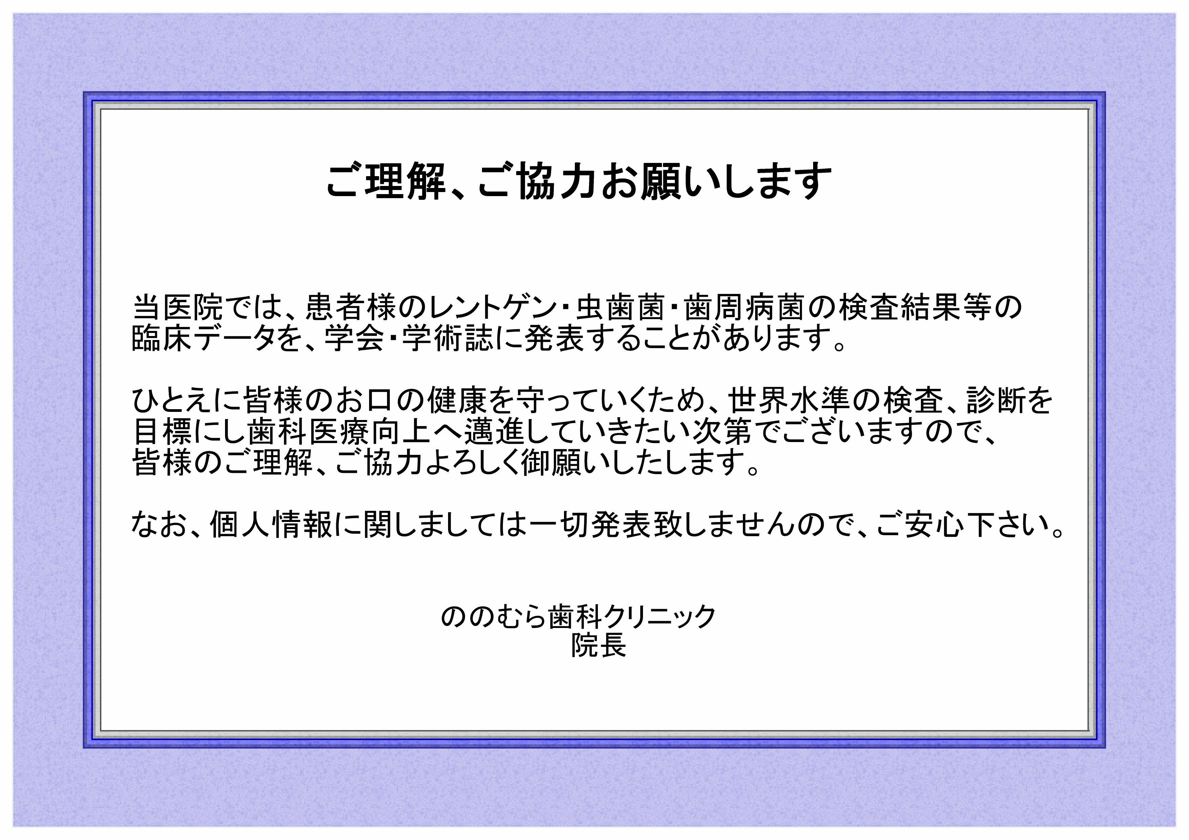

Supp. Figure 1 Microscope CA image: Mycelium and spore
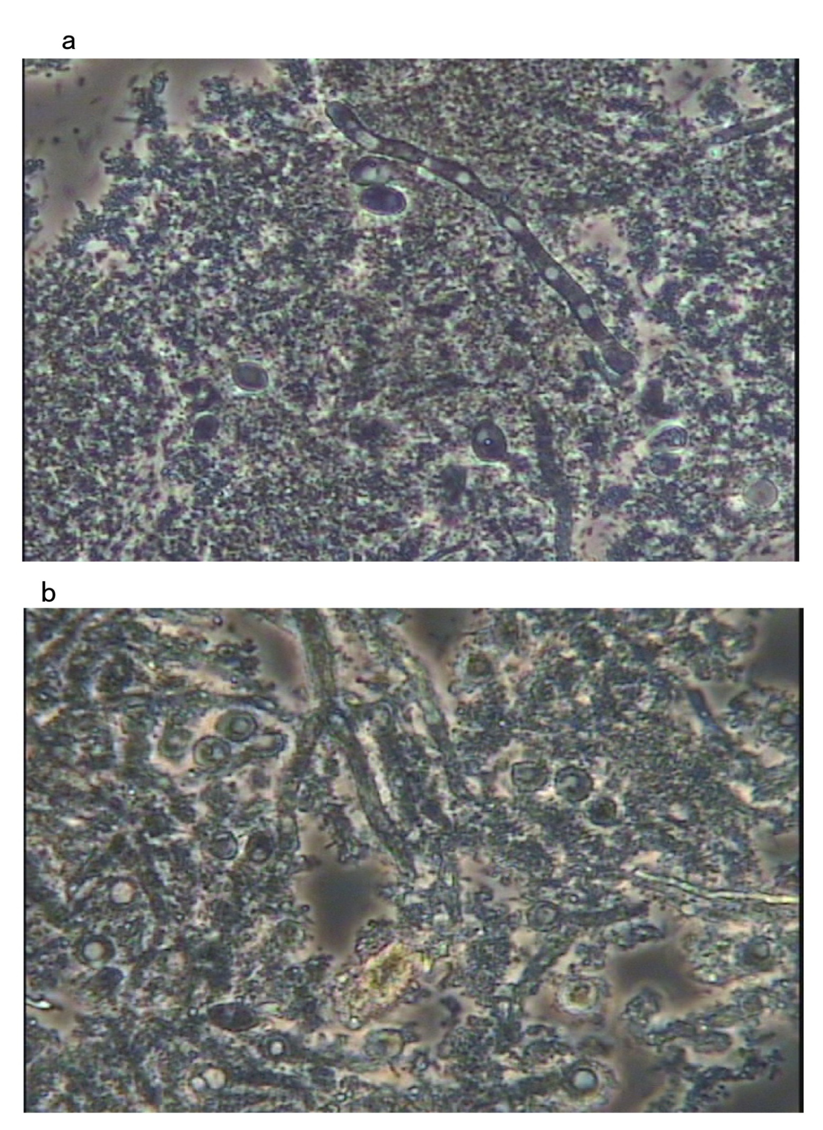
Supp. Figure2
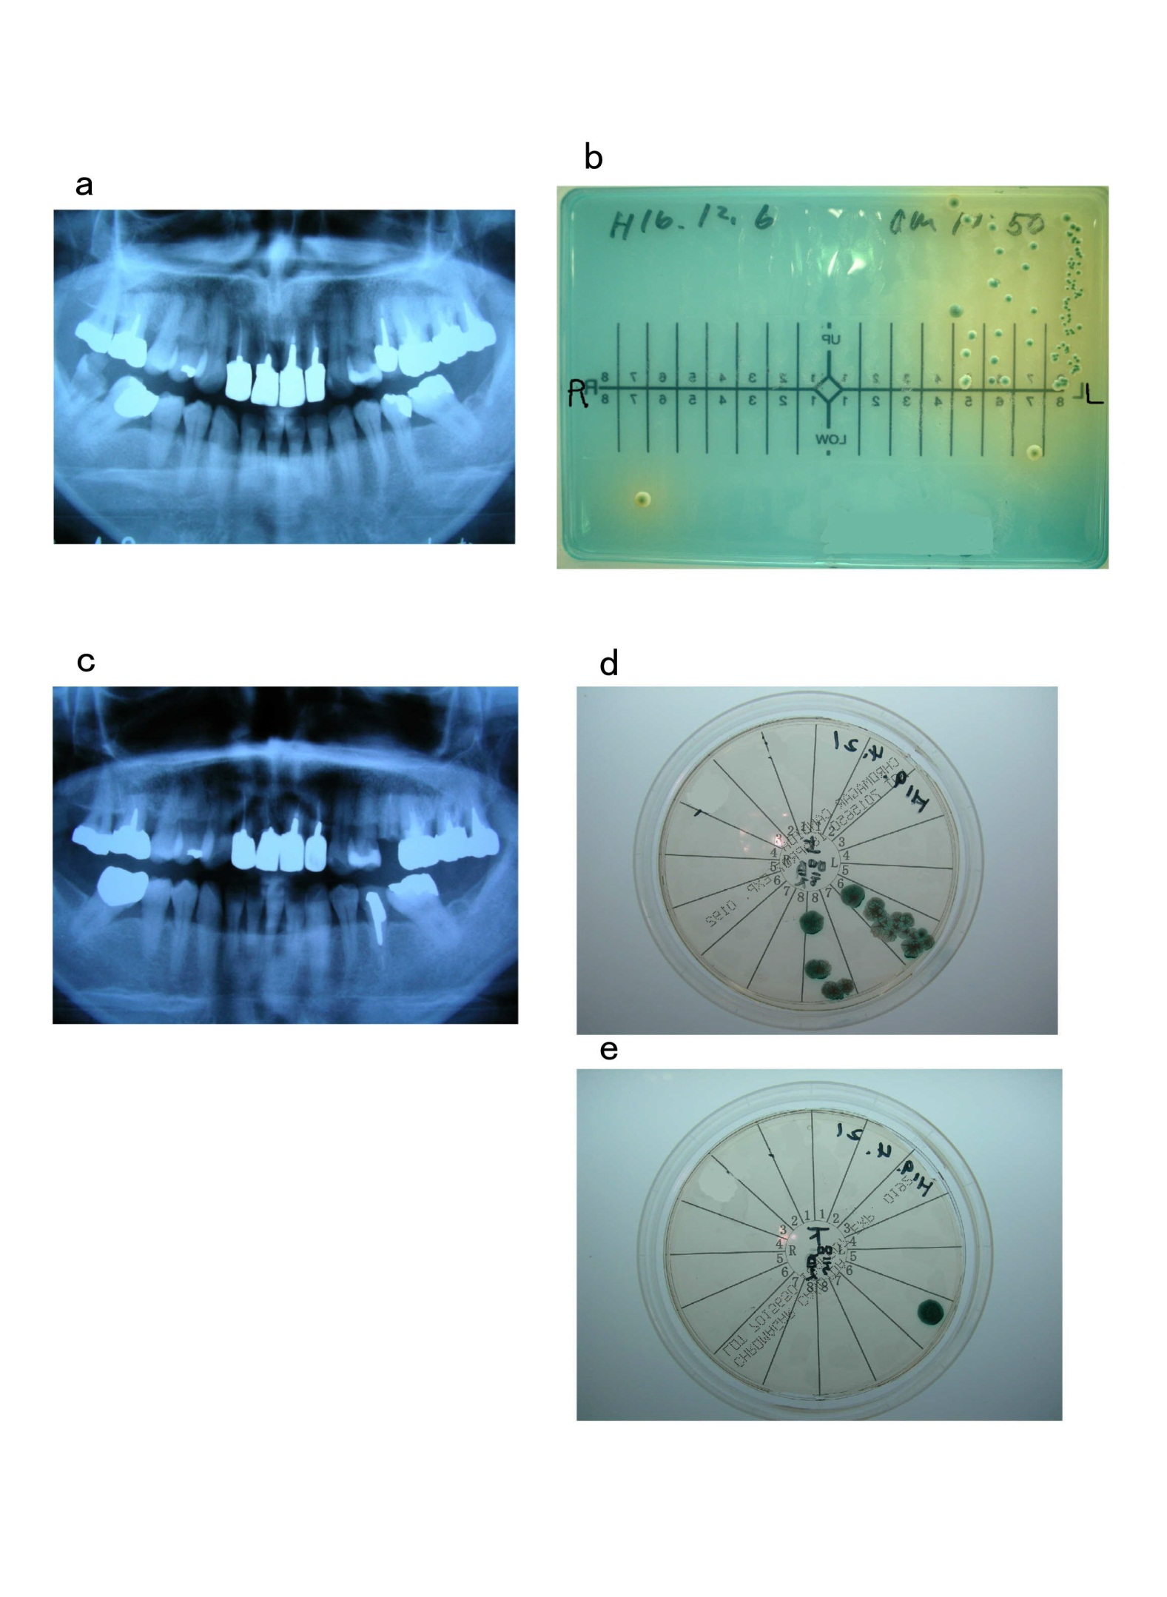
Supp. Figure3
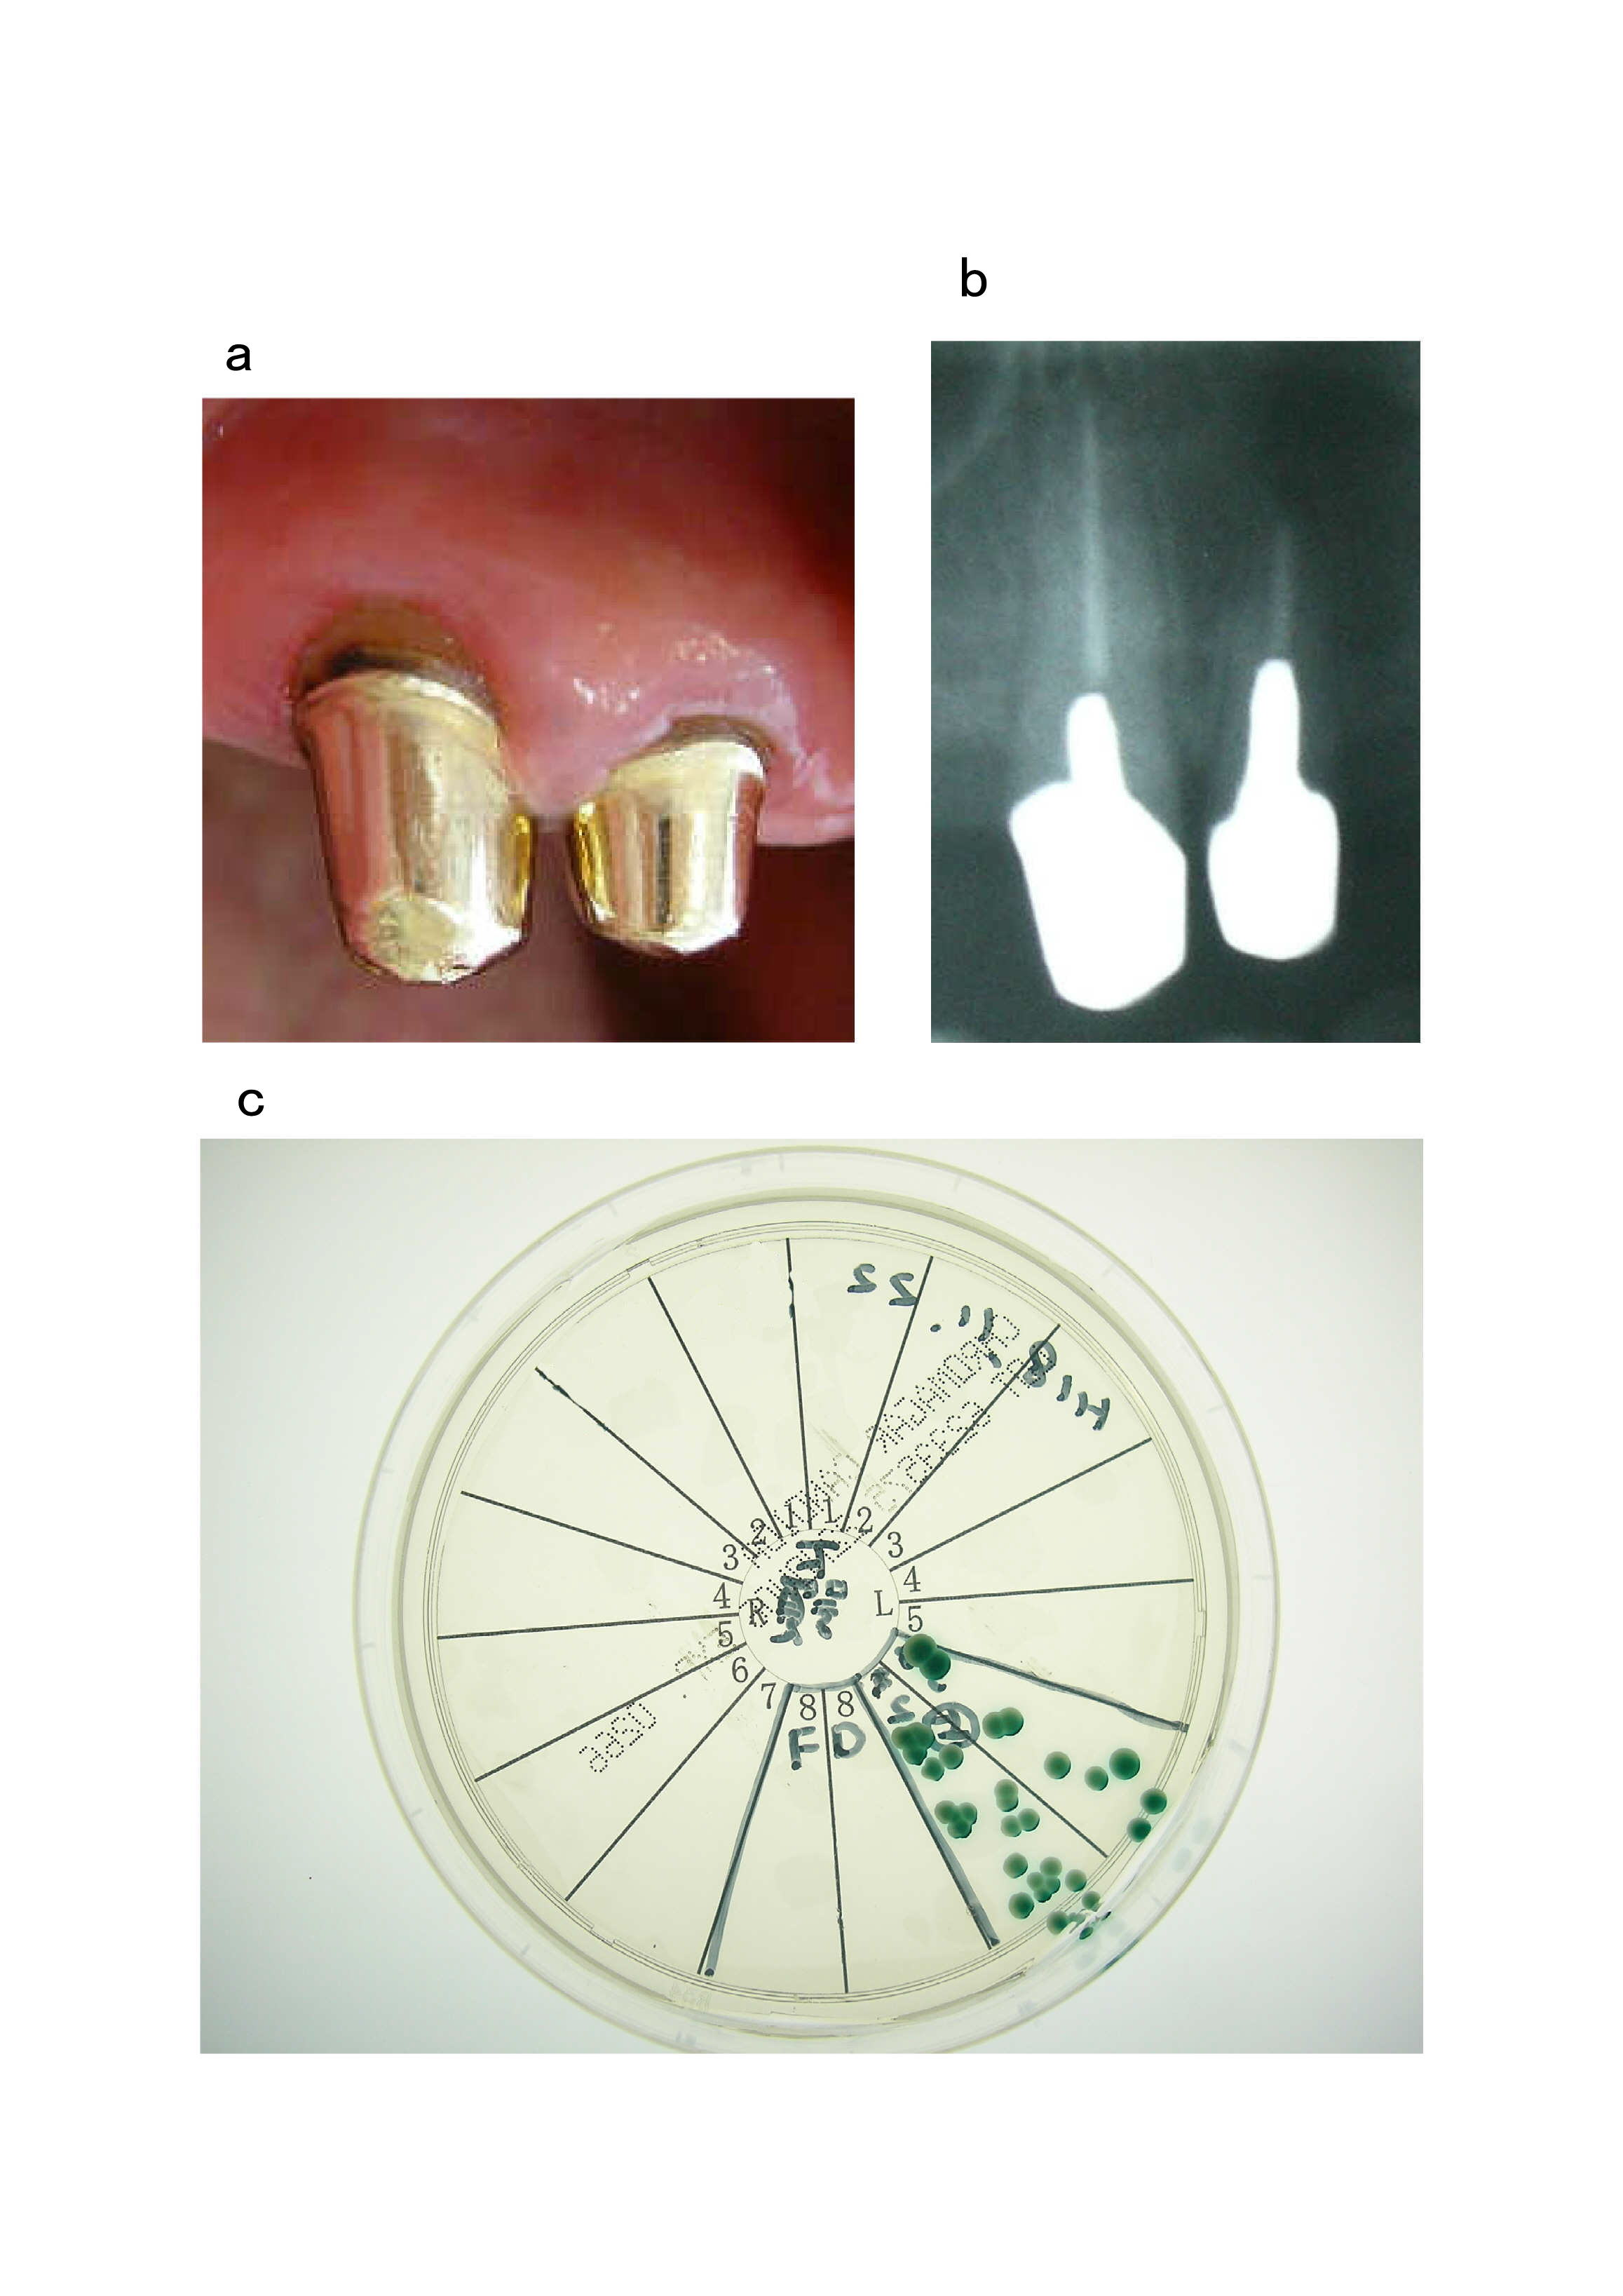
Supp. Figure4
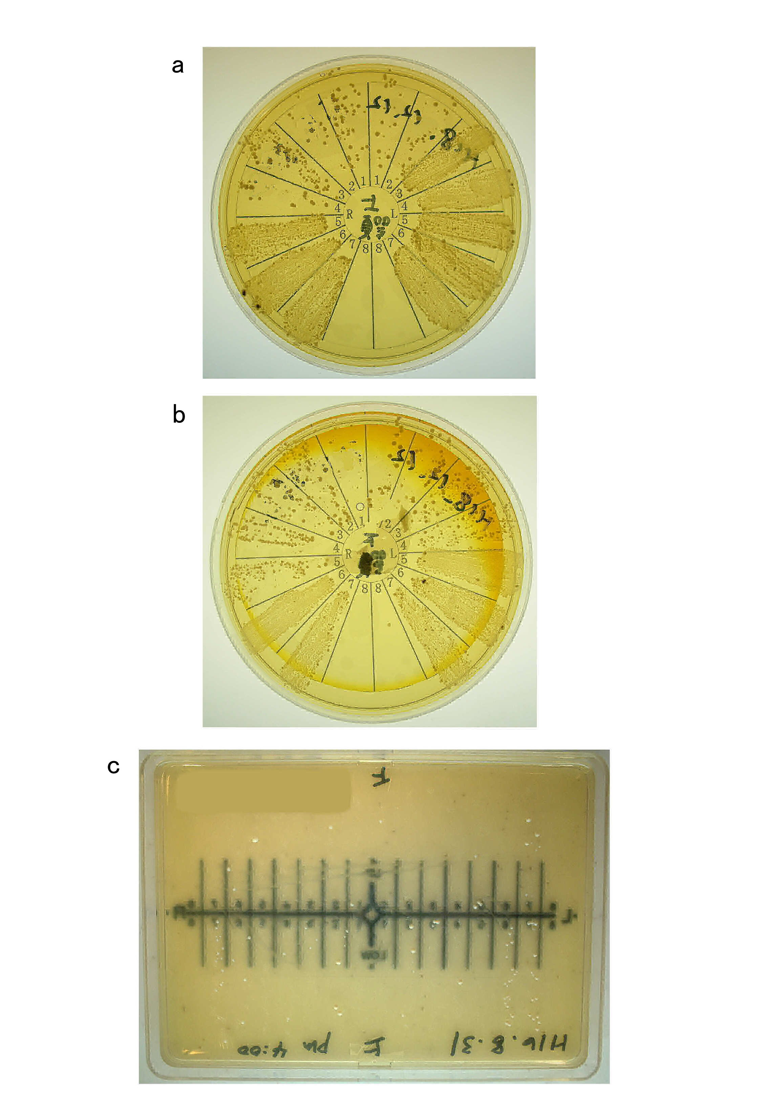
Supp. Figure5
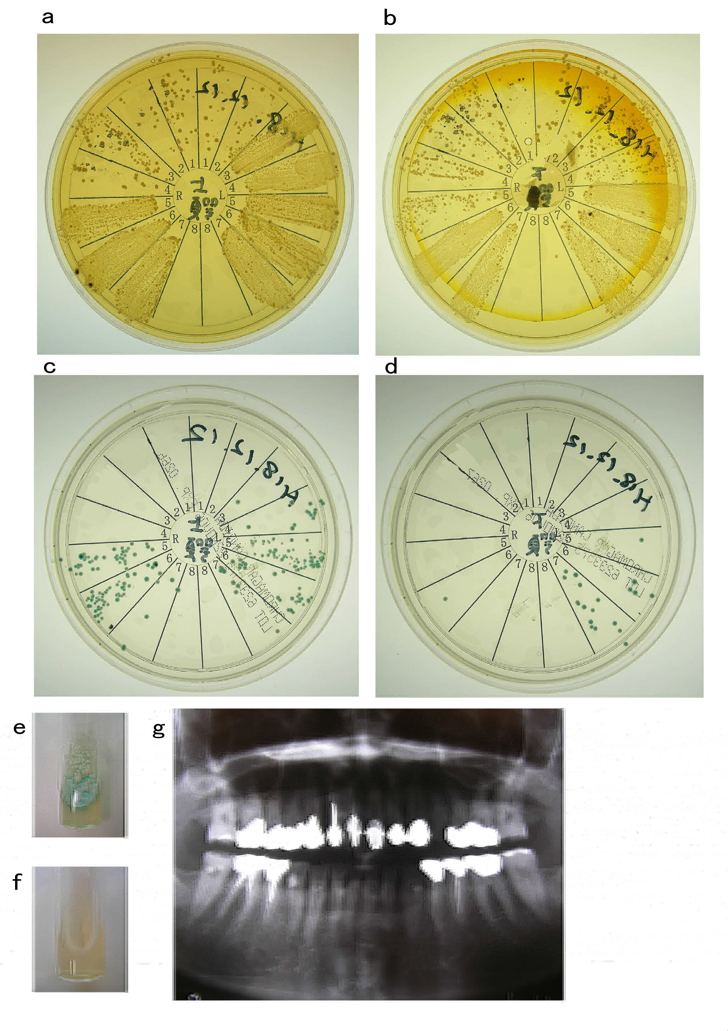
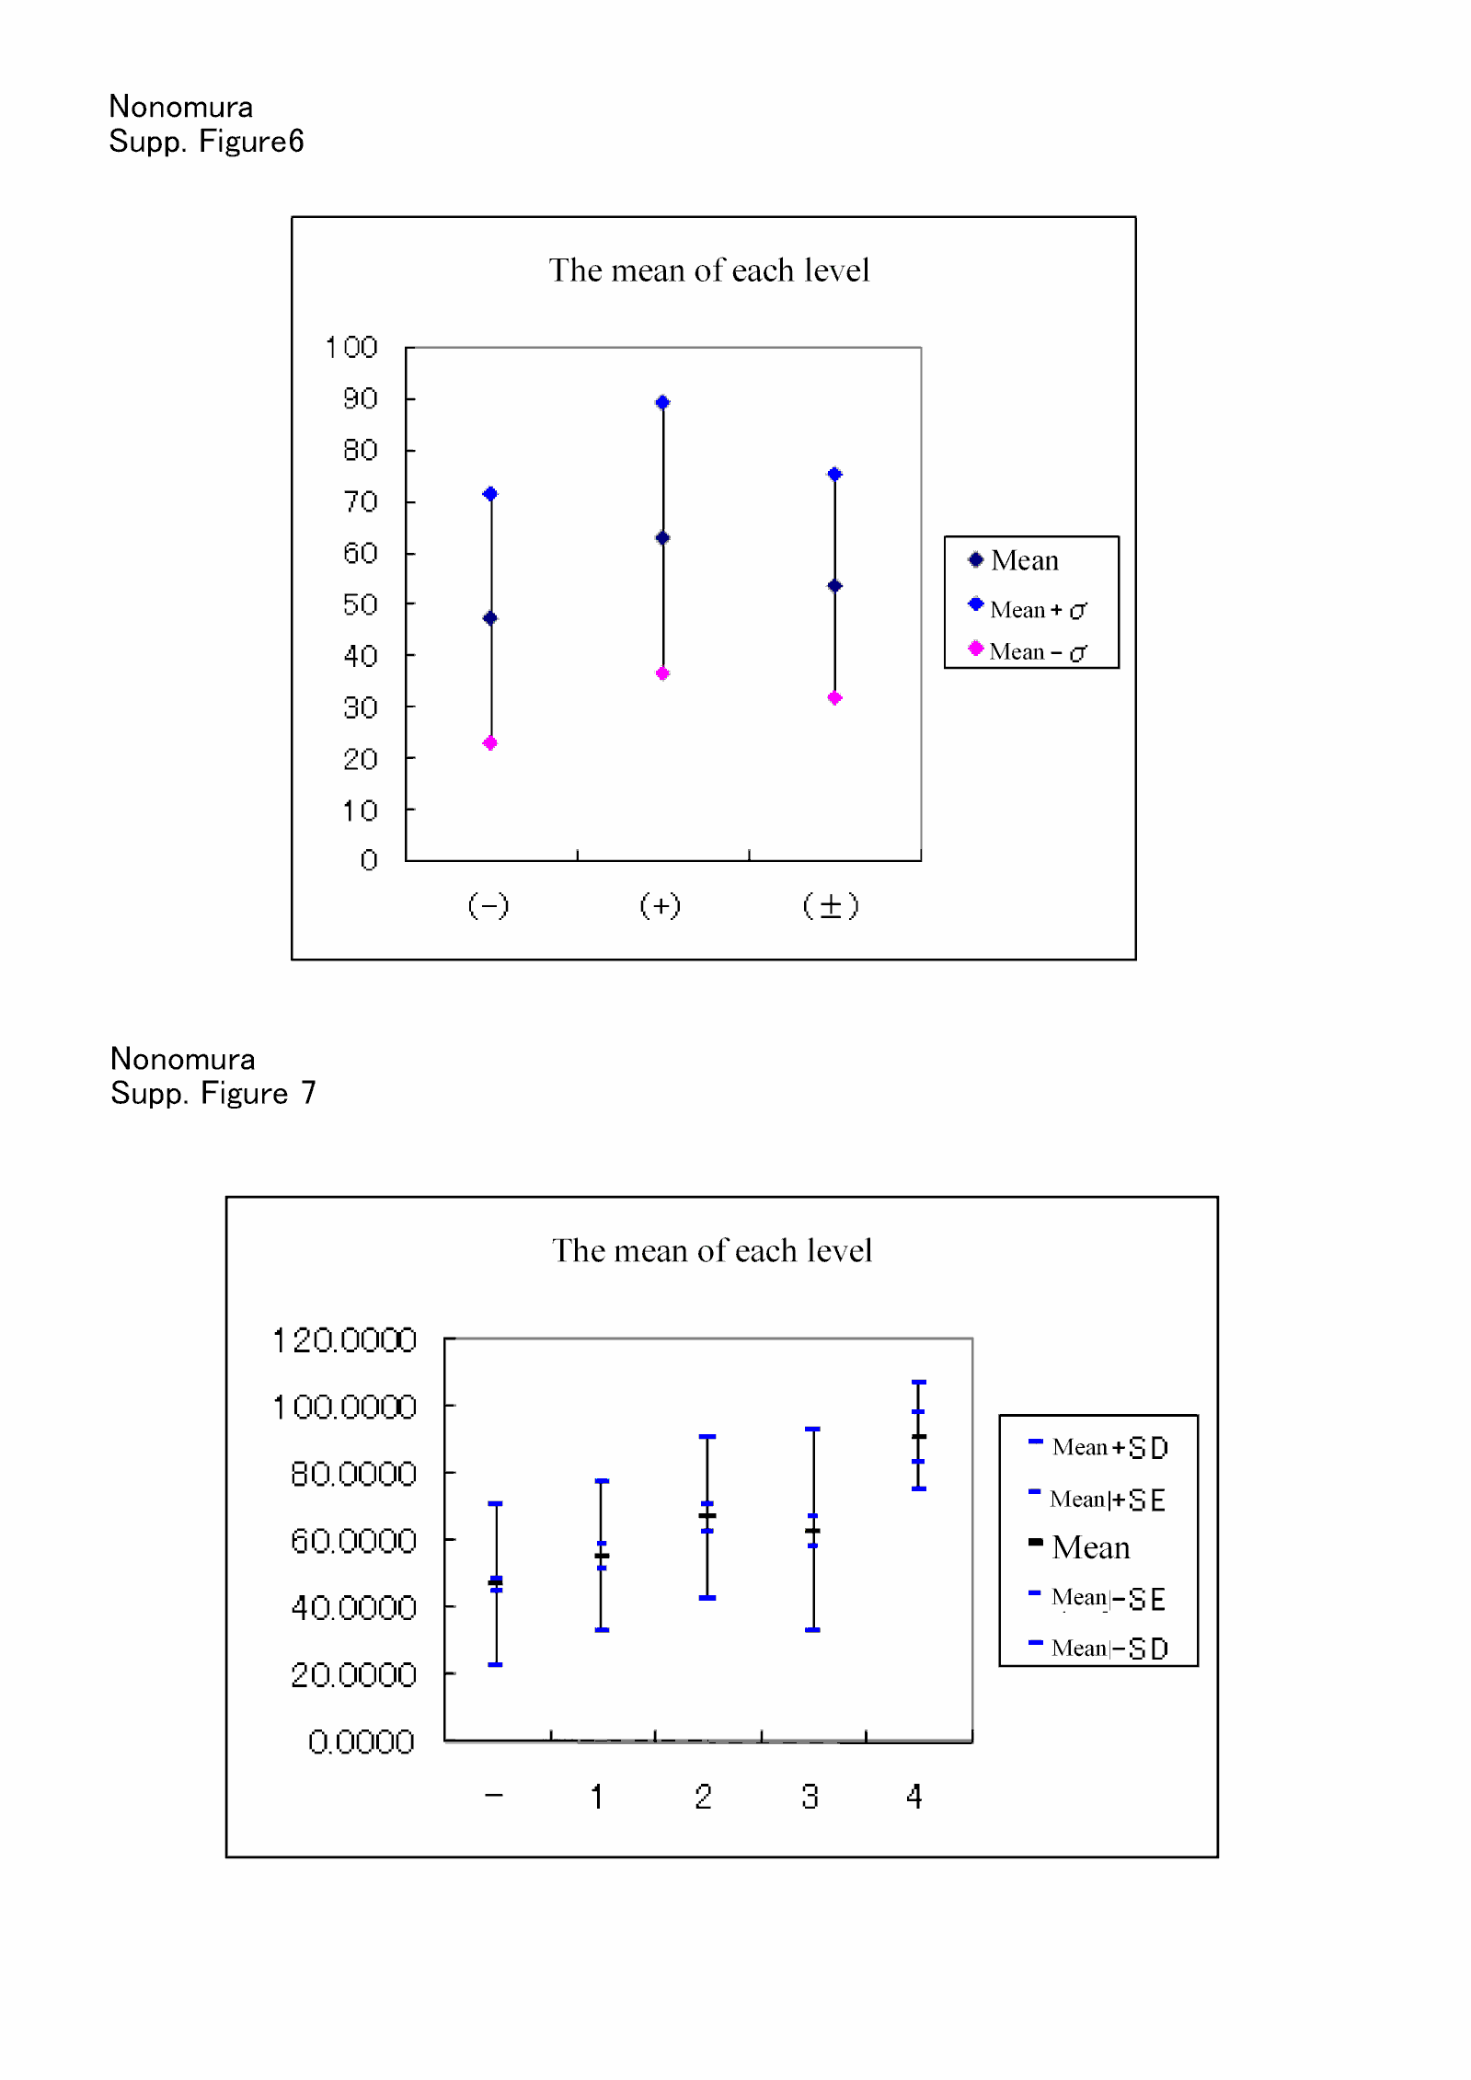
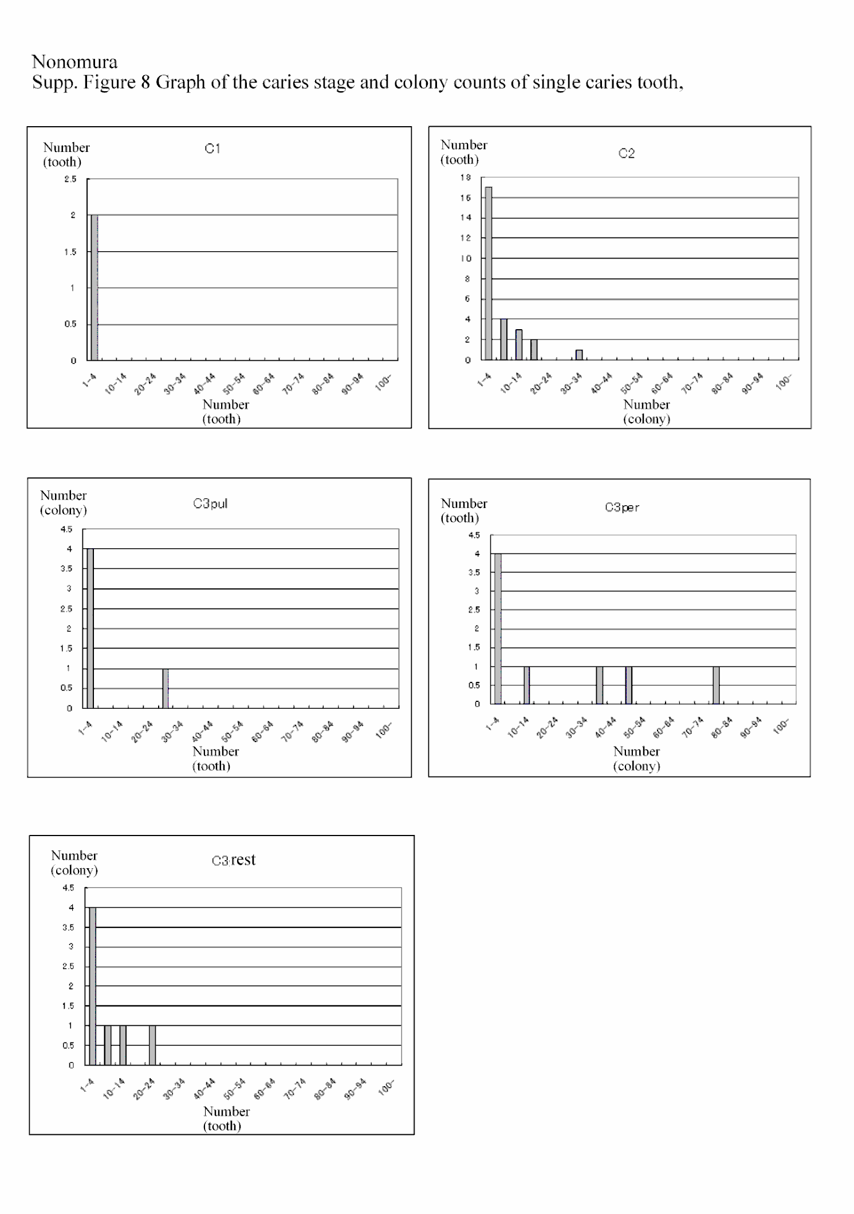
Nonomura
Supp Fig 9 from Table S14 (include Table 7)
a 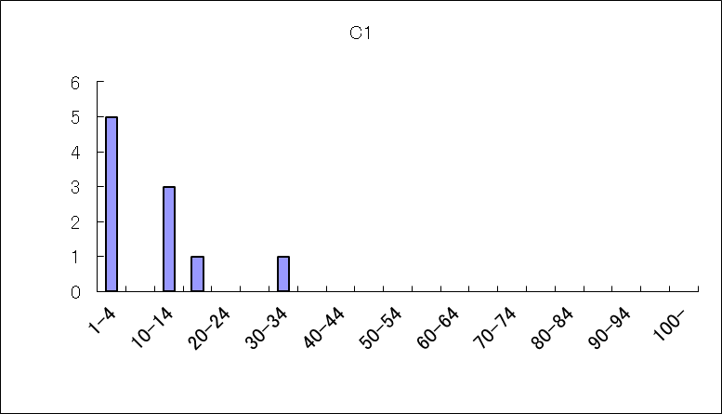 b 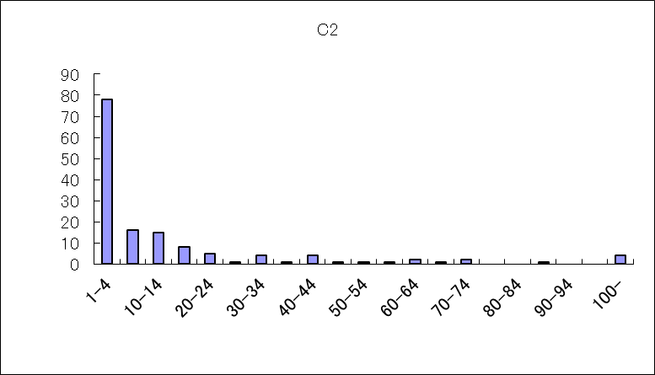
c 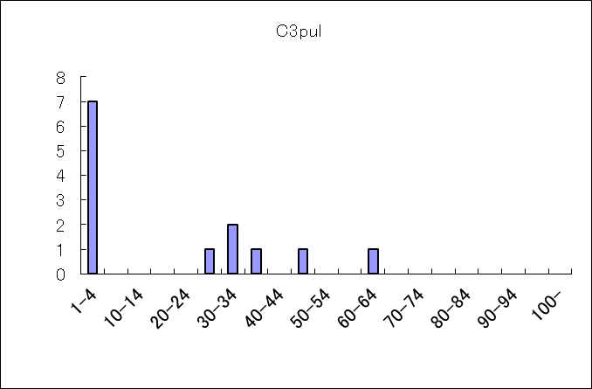 d 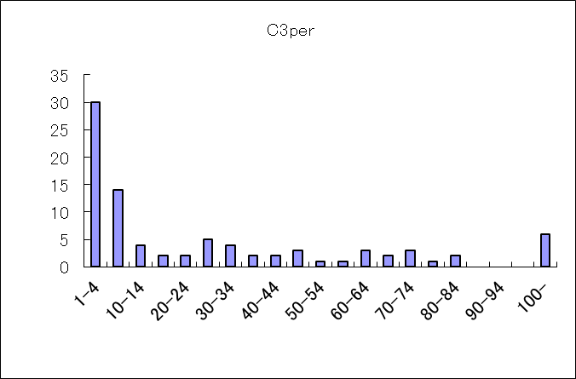
e 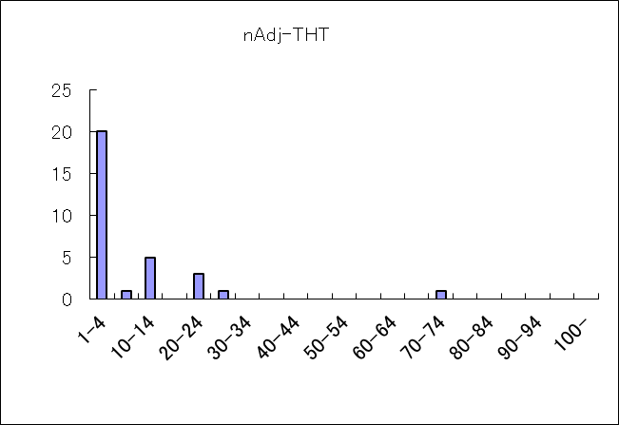 f 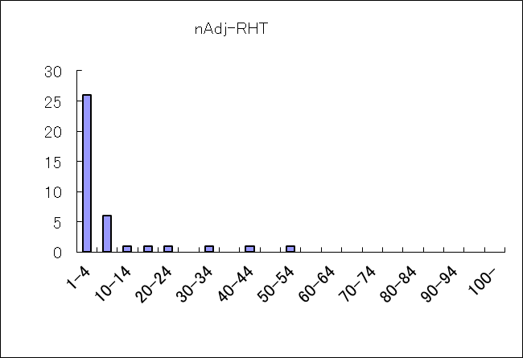
g 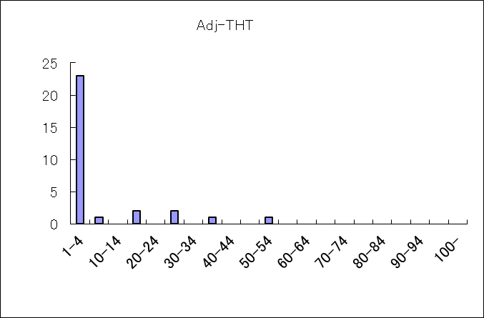 h 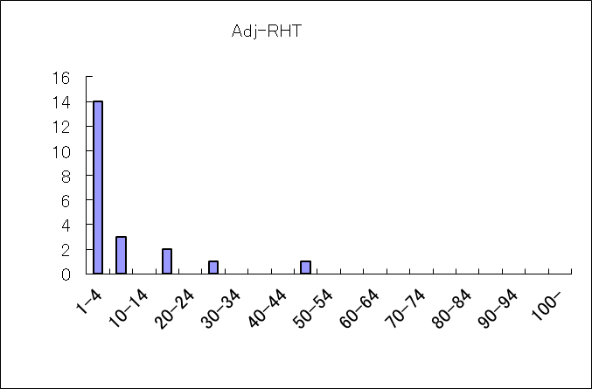
I 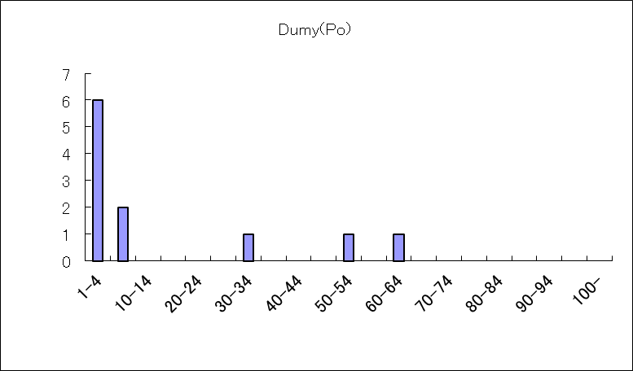
Supp Fig 9 Graph of the frequency of the colony counts in each dental caries tooth
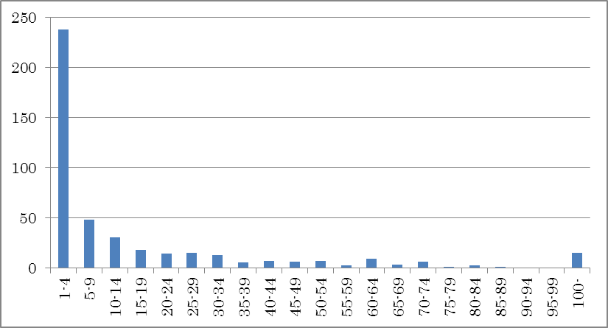
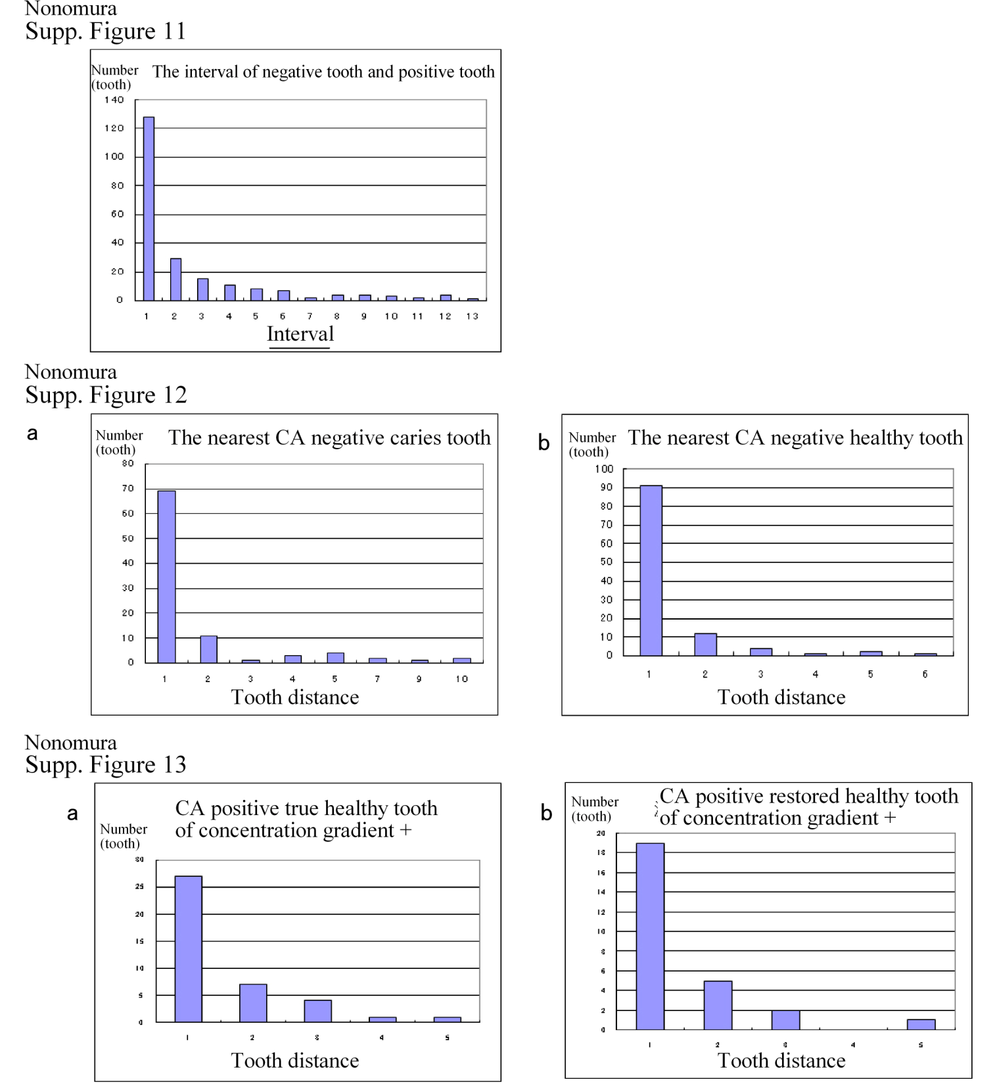

Nonomura
Supp. Figure S14
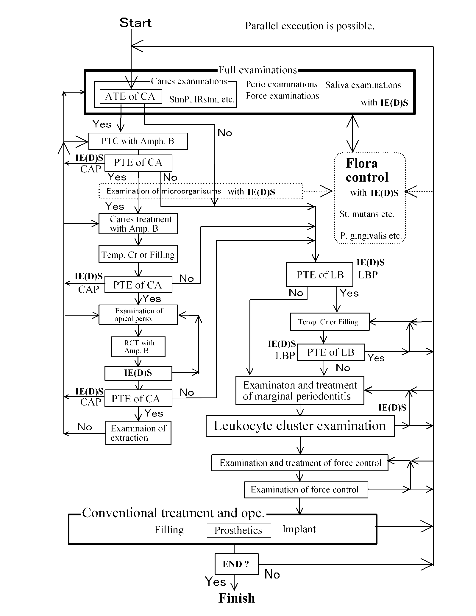
Supplementary Figure Legends
Supplementary Figure S1-Microscopic images
(The multi-formation image of mycelium and spore is observed.)
Image sizes are 125μm×92μm.
Supplementary Figure S2-Long-range neglect case
b: December 6, 2004, d: April 21, 2007, e: April 21, 2007
UL5 of d and e is the examination after treatment.
Supplementary Figure S3-Visible secondary caries
With the naked eye, dental caries with difficult observation is detectable.
The secondary dental caries of Konus Krone
Supplementary Figure S4-Lactobacillus infection dental-formula case by LBP
The colony are scattered at random on background, i.e., spread field (SF) is observed.
In CA, the phenomenon does not observe.
Supplementary Figure S5-X-ray, disinfection result, etc. of Supplementary Figure S4 a and b
a UR5, 6, 7, UL3, 4, 5, 6, 7 are strong reaction.
b LR6, 7, LL5, 6, 7 are strong reaction.
c UR5, 6, UL5, 6, (7) are strong reaction.
Phase of CA is delayed to LB. A possibility that LB is concerned in RsF is very strong.
The CA colony level is,
UR5 40, UR6 57, UR7 6, UL3 3, UL4 14, UL5 71, UL6 30, UL7 7, LR6 1, LL5 1 LL6 4 and LL7 15
e Result of all teeth examinations (oral cavity unit examination) before treatment (ope.), it is level 3.
f Result of all teeth examinations (oral cavity unit examination) after treatment (ope.), it is negative.
g Orthopantomography
Supplementary Figure S6-Mean and deviation of patient's positivity rate at the first examination,
Supplementary Figure S7-Mean and deviation of the colony number of colony level 1, 2, 3, and 4
Supplementary Figure S8- In table8b, Dental-caries stage and a colony count of single caries tooth
a: C1 b: C2 c: C3pul
d: C3per e: C3 restored
Supplementary Figure S9-In table S14 (include table 7), Dental-caries stage and a colony count
a: C1, b: C2, c: C3pul,
d: C3per e: non-adjacent true healthy tooth f: non-adjacent restored healthy tooth
g: adjacent true healthy tooth h: adjacent restored healthy tooth, i: Dumy
Supplementary Figure S10- In table S14 (include table 7), Frequency graph of colony number of each dental caries tooth
Supplementary Figure S11- In table7, the space of negative caries tooth and positive caries tooth Supplementary Figure S12- In table8b, a: the nearest negative caries tooth, b: the nearest negative healthy tooth
Supplementary Figure S13- In table7, a: CA positive true healthy tooth of which the concentration gradient is positive, b: CA positive restored healthy tooth of which the concentration gradient is positive
Supplementary Figure S14 Treatment diagram
Leukocyte cluster examination (inflammation biomarker): http://biorxiv.org/cgi/content/short/543611v2, (2019), by Y. Nonomura, Measurement and self-operating computer of the leukocyte continuum as a fixed space–time continuum in inflammation,

Supplementary Data
CHROMagarTM Cnadida, BD BBLTM, http://www.bdj.co.jp/micro/products/1f3pro00000rxnvr.html

Acknowledgements
I would like to thank the staff at Nonomura Dental Clinic for their clinical assistance; Dr. Sachiko Nisida and Dr. Hiroko Kamide for their assistance with language editing; Miss Haruko Kobayashi, Miss Manami Niwa, and Mr. Keita Taki for searches for references, Mrs. Tomomi Okuda and Miss Saori Nishida for their assistance with the photographs and figures, and Mrs. Kaori Sato, Mrs. Tomomi Okuda, Miss Haruki Kuwayama, Dr. Tomohiro Yosida, and Dr. Haruna Isikawa for their assistance with editing text, figure, and statistical data.

Conflicts of interest
The author declares no conflicts of interest, except for the patents, trademark and copy right of DFM.
1) 2003-381874, Dental diagnostic system, November 12, 2003, in Japan,
2) 2003-421304, Dental formula system, December 18, 2003, in Japan,
3) 2007-138463, Dental formula Apparatus, May 24, 2007, in Japan,
4) 2008-209406, Infection inflammation immune response measuring diagnostic apparatus, August 18, 2008, in Japan,
5) 2020-41422 Arithmetic unit, March 10 2020, in Japan, especially, about details of C4RDE,
6) Japanese Pat No6555573, 2019.8.7, Computer arithmetic unit, Riken Co., Ltd.,
7) Japanese Pat No6555574, 2019.8.7, Computer arithmetic unit, Riken Co., Ltd.,
8) Japanese Pat No6796295, 2020.11.18, Str Arithmetic unit, Riken Co., Ltd.,
9) Japanese Pat No6800460, 2020.11.27, Arithmetic unit, Riken Co., Ltd.,
10) Trade Mark of dental formula (measurement analysis) medium (DFM), MicroDent Co., Ltd., No5341950,
11) Copyright of dental formula (measurement analysis) medium (DFM), MicroDent Co., Ltd.,

References: See the references of main text.

No ethics problems
I have posted using clinical data for journal, and such as society, on the noticeboard of my clinic (Figure S0). Therefore, there is no ethics problem.

Setting
The location of setting is Nonomura Dental Clinic.
Address: Nonomura Dental Clinic, in National Yagata bldg 2F,
3-6,higasiyamatoori,chikusa-ku,Nagoya-city Aichi 4640807 JAPAN（†）
Telephone No +81 52-781-4182 Fax No +81 52-781-4185
E-mail n-dent@tulip.ocn.ne.jp
The relevant date is 2005/2/14~2007/2/5.
Many patients are doing follow-up and a data collection continuously.

