Tables:

Table 1: First examination of 353 patients (using CHROMagar medium)
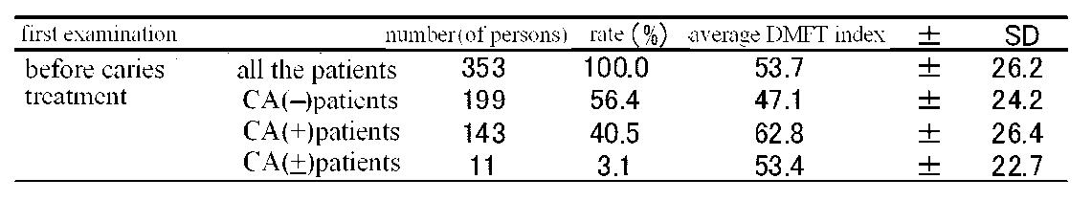

Table 2: Candida albicans (CA) examination and DMFT in the whole (teeth, periodontal tissue) oral cavity
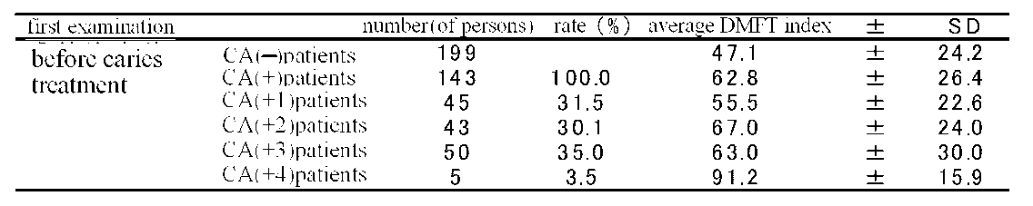

Table 3 Space analysis operator
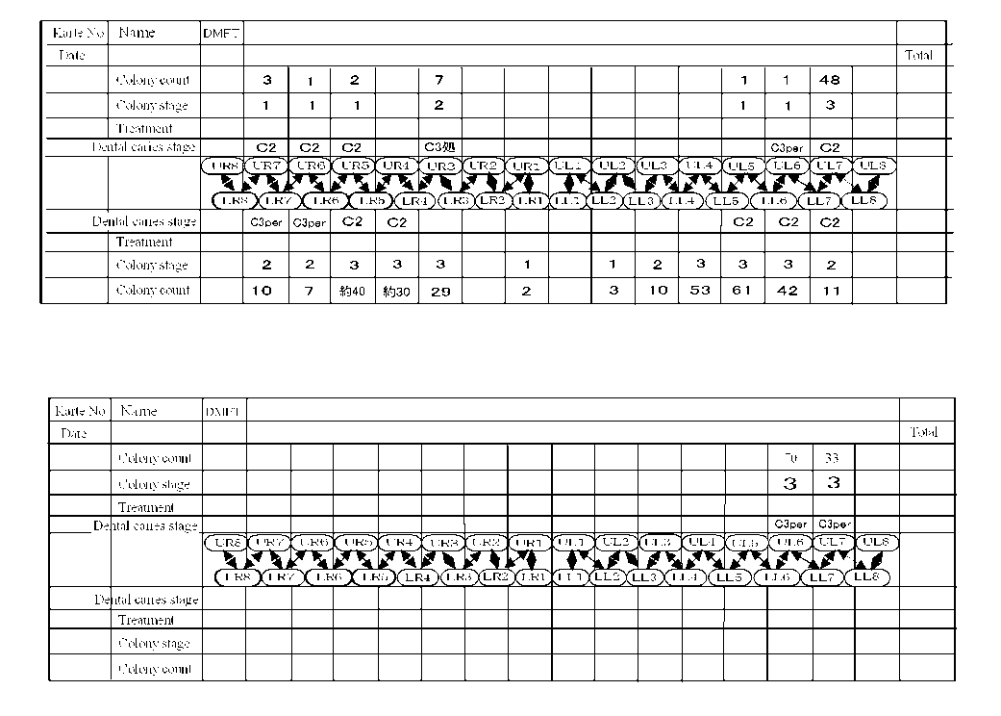

Table 4. CA (CHROMagar) examination of 49 patients, 19.8 remaining teeth
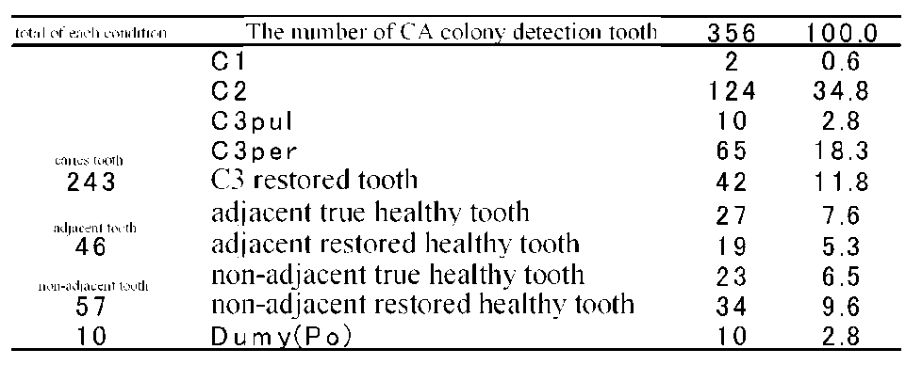

Table 5 Whole circumstances of colony detection for teeth, except for teeth with caries in Table 4
Table 5a
Table 5b

Table ６ Disinfection results
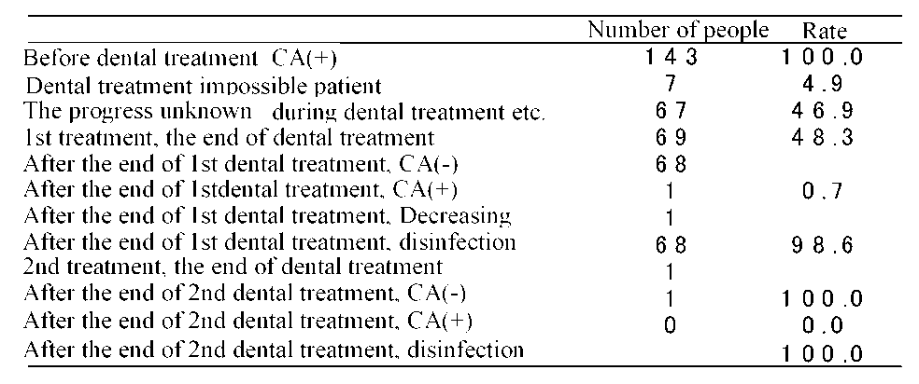

Table 7 Stage of dental caries and colony count using CHROMagar.
nAdj-THT: non-adjacent true healthy tooth, nAdj-RHT: non-adjacent restored healthy teeth,
Adj-THT: adjacent true healthy tooth, Adj-RHT: adjacent restored healthy teeth

Table 8a A CA-positive single tooth with dental caries in a single jaw (Using CHROMagar (a and b) )
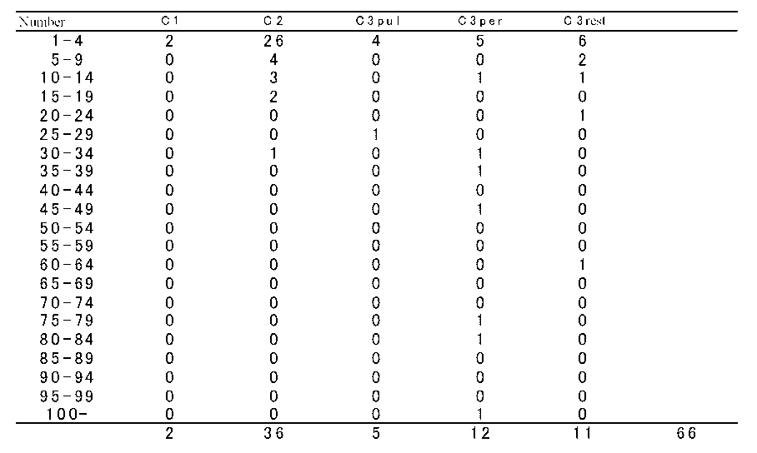
Table 8b A CA-positive single tooth with dental caries in the whole jaw
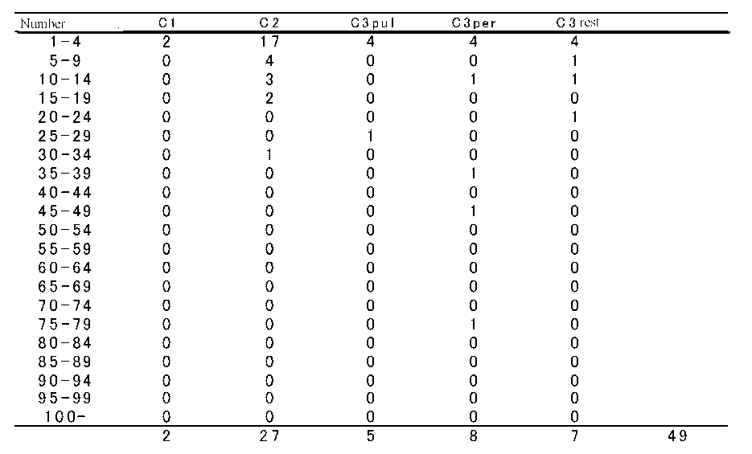

Table 9 The stage of dental caries and colony count immediately after the shift to positive from negative in the first examination (Using CHROMagar)
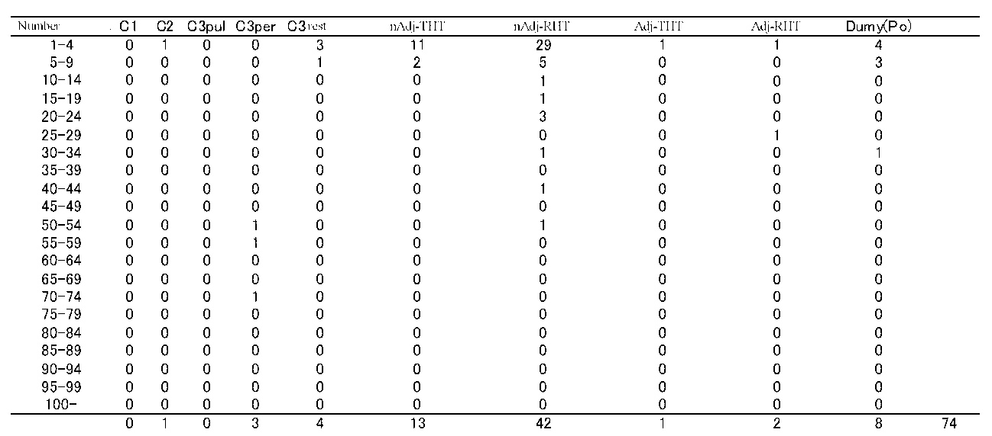

Table 10a CA-positive single healthy tooth in a single jaw (Using CHROMagar)
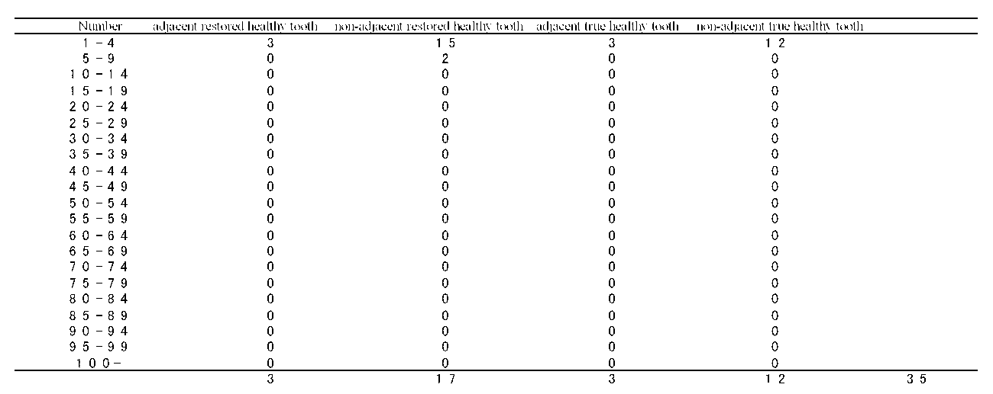

Table 10b CA-positive single healthy tooth in the whole jaw (Using CHROMagar)
