Additional file 1
Human Umbilical Cord Mesenchymal Stem Cells Combined with Pirfenidone upregulates the Expression of RGS2 in the Pulmonary Fibrosis in Mice

Contents
Table S1
Table S2
Table S3
Table S4
Table S5

Figure S1
Figure S2
Figure S3

Table S1
Basic data of the number of dead mice treated with different doses of PFD.
Days | Groups
 | N | B | B+P₁₀ | B+P₃₀ | B+P₁₀₀ | B+P₃₀₀
1 | 0 | 0 | 0 | 0 | 0 | 0
2 | 0 | 0 | 0 | 0 | 0 | 0
3 | 0 | 0 | 0 | 0 | 0 | 0
4 | 0 | 0 | 0 | 0 | 0 | 0
5 | 0 | 1 | 0 | 0 | 0 | 0
6 | 0 | 0 | 1 | 0 | 0 | 0
7 | 0 | 0 | 0 | 1 | 1 | 0
8 | 0 | 1 | 0 | 0 | 0 | 1
9 | 0 | 0 | 0 | 0 | 0 | 0
10 | 0 | 0 | 0 | 0 | 0 | 0
11 | 0 | 1 | 1 | 1 | 0 | 0
12 | 0 | 0 | 0 | 0 | 0 | 1
13 | 0 | 0 | 1 | 1 | 0 | 1
14 | 0 | 1 | 0 | 0 | 1 | 0
15 | 0 | 0 | 1 | 0 | 0 | 0
16 | 0 | 2 | 0 | 0 | 0 | 0
17 | 0 | 0 | 0 | 1 | 1 | 0
18 | 0 | 0 | 2 | 1 | 0 | 0
19 | 0 | 1 | 0 | 0 | 0 | 0
20 | 0 | 0 | 0 | 0 | 0 | 1
21 | 0 | 0 | 0 | 0 | 0 | 0
N: control group , B: bleomycin model group, P_{10:} P₁₀ group (10 mg/kg PFD), P_{30:} P₃₀ group (30 mg/kg PFD), P_{100:} P₁₀₀ group (100 mg/kg PFD), P_{300:} P₃₀₀ group (300 mg/kg PFD).

Table S2
Basic data of the number of dead mice treated with different doses.
Days | Groups
 | N | N+M | B | B+M | B+P₁₀₀ | B+M+P₃₀
1 | 0 | 0 | 0 | 0 | 0 | 0
2 | 0 | 0 | 0 | 0 | 0 | 0
3 | 0 | 0 | 0 | 0 | 0 | 0
4 | 0 | 0 | 0 | 0 | 0 | 0
5 | 0 | 0 | 1 | 0 | 0 | 0
6 | 0 | 0 | 0 | 0 | 1 | 0
7 | 0 | 0 | 0 | 1 | 0 | 0
8 | 0 | 0 | 0 | 1 | 0 | 0
9 | 0 | 0 | 1 | 0 | 1 | 0
10 | 0 | 0 | 0 | 0 | 0 | 1
11 | 0 | 0 | 0 | 0 | 0 | 0
12 | 0 | 0 | 0 | 0 | 0 | 0
13 | 0 | 0 | 1 | 0 | 0 | 0
14 | 0 | 0 | 0 | 1 | 0 | 1
15 | 0 | 0 | 1 | 0 | 1 | 0
16 | 0 | 0 | 0 | 0 | 0 | 0
17 | 0 | 0 | 1 | 1 | 0 | 0
18 | 0 | 0 | 0 | 1 | 1 | 0
19 | 0 | 0 | 0 | 0 | 0 | 0
20 | 0 | 0 | 1 | 0 | 0 | 0
21 | 0 | 0 | 0 | 0 | 0 | 0
N: control group , N+M: hUC-MSCs control group, B: bleomycin model group, B+M: hUC-MSCs treatment group, P_{100:} P₁₀₀ group(100 mg/kg PFD), B+M+P_{30:} hUC-MSCs+P₃₀ group (hUC-MSCs+30 mg/kg PFD).

Table S3
Basic data of the Ashcroft scores of HE and Masson staining treated with different doses of PFD.
 | Groups
 | N | B | B+P₁₀ | B+P₃₀ | B+P₁₀₀ | B+P₃₀₀
HE | 1.175±0.096 | 6.6±0.216 | 6.5±0.216 | 6.075±0.386 | 5.075±0.411 | 5.85±0.42
Masson | 1.25±0.208 | 6.6±0.294 | 6.625±0.15 | 6.175±0.359 | 5.075±0.492 | 5.925±0.299
Data are presented as mean ± SEM. N: control group , B: bleomycin model group, P_{10:} P₁₀ group (10 mg/kg PFD), P_{30:} P₃₀ group (30 mg/kg PFD), P_{100:} P₁₀₀ group (100 mg/kg PFD), P_{300:} P₃₀₀ group (300 mg/kg PFD).

Table S4
Basic data of the Ashcroft scores of HE and Masson staining treated with PFD and hUC-MSCs.
 | Groups
 | N | N+M | B | B+M | B+P₁₀₀ | B+M+P₃₀
HE | 1.25±0.191 | 1.3±0.183 | 6.525±0.33 | 6.425±0.33 | 5.075±0.403 | 3.95±0.387
Masson | 1.275±0.126 | 1.4±0.216 | 6.675±0.299 | 6.6±0.183 | 5.05±0.42 | 4.025±0.222
Data are presented as mean ± SEM. N: control group , N+M: hUC-MSCs control group, B: bleomycin model group, B+M: hUC-MSCs treatment group, P_{100:} P₁₀₀ group(100 mg/kg PFD), B+M+P_{30:} hUC-MSCs+P₃₀ group (hUC-MSCs+30 mg/kg PFD).

Table S5
Basic data of the intrapulmonary collagen content was measured by Sircol method.
 | Groups
 | N | B | B+P₁₀ | B+P₃₀ | B+P₁₀₀ | B+P₃₀₀
collagen content | 108.108±19.782 | 690.666±45.555 | 658.451±68.79 | 644.799±69.574 | 464.328±49.785 | 556.164±71.957
 | N | N+M | B | B+M | B+P₁₀₀ | B+M+P₃₀
collagen content | 104.298±31.481 | 122.248±44.163 | 711.133±64.413 | 707.845±72.08 | 480.454±58.503 | 270.298±64.669
Data are presented as mean ± SEM.

Figure S1
Flow cytometry detection of surface mesenchymal stem cell markers of hUC-MSCs.
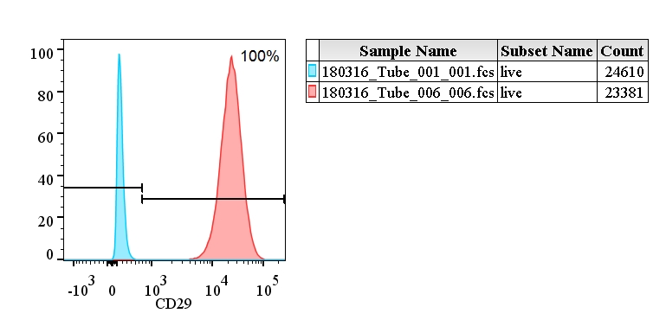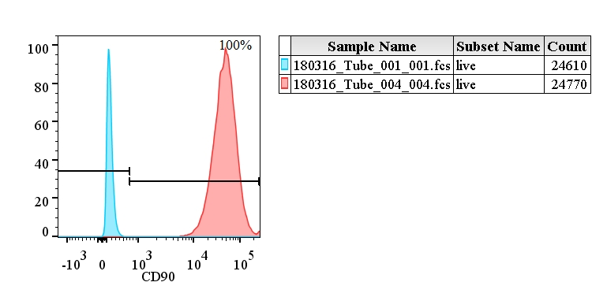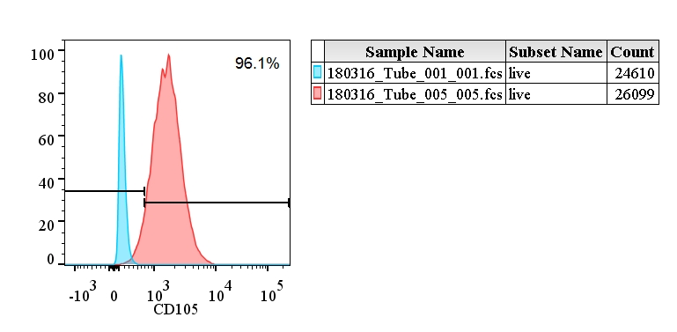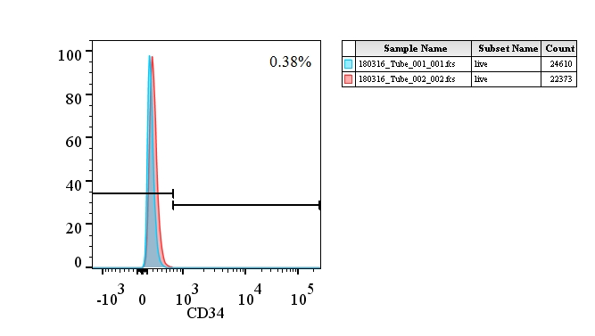
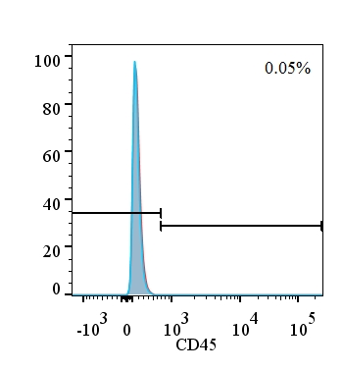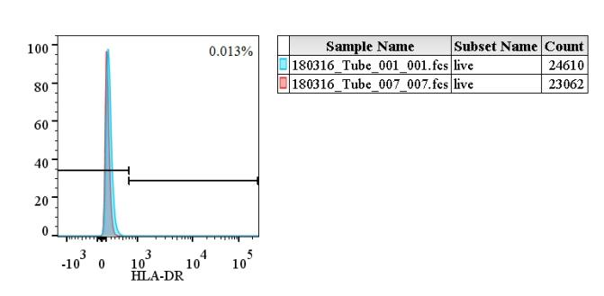

Figure S2
The primitive view of the differentiation of hUC-MSCs.
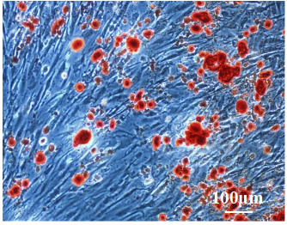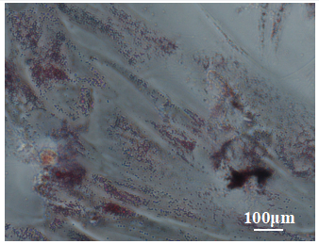
C
B
A
A: chrondrocytes, B: osteocytes, C: adipocytes.

Figure S3
Original images of protein expression of RGS2 in the lung tissue.
β-actin
RGS2

A

