Supplementary information
Haoran Zhang^{ab}, Lu Zhang^{ab}, Yipeng Xu^{c}, Shaoyong Chen^{d}, Zhenyi Ma^{e}, Mingdong Yao^{ab}, Fangyin Li^{c}, Bo Li^{ab}, Yingjin Yuan^{ab*}

a: Frontier Science Center for Synthetic Biology and Key Laboratory of Systems Bioengineering (Ministry of Education), Tianjin University, Tianjin 300072, PR China.
b: School of Chemical Engineering and Technology, Tianjin University, Tianjin 300072, PR China.
c: Department of Urology, The Cancer Hospital of the University of Chinese Academy of Sciences (Zhejiang Cancer Hospital), Hangzhou, China.
d: Hematology-Oncology Division, Department of Medicine, Beth Israel Deaconess Medical Center and Harvard Medical School, Boston, MA, 02215, USA.
e: School of Basic Medical Sciences, Tianjin Medical University, Tianjin 300070, PR China.
Extended Fig. 1. Yeast assay tests. a, DHT dose-response assay in designer yeast using both liquid and solid cultures. b, Readouts from five independent tests validate the reliability of designer yeast (n = 3, 10 nM DHT).
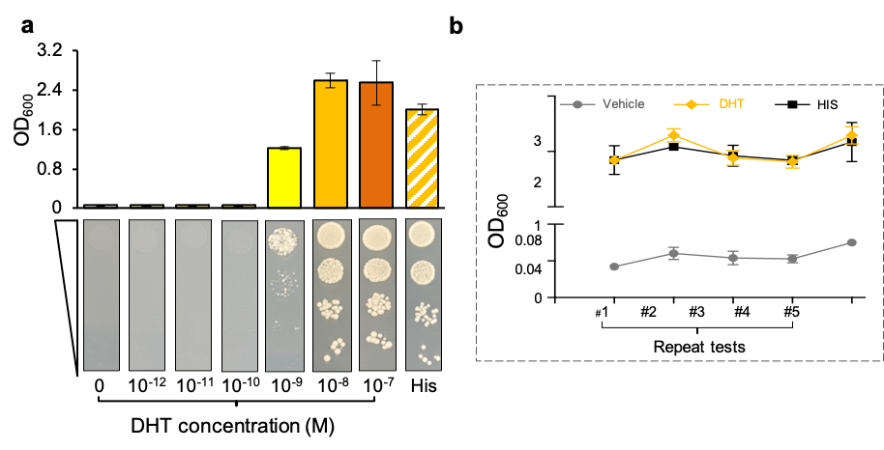
Extended Fig. 2. Dose-response of assessed compounds in yeast liquid culture (OD₆₀₀ was measured at 36 h for ENZ/CPA/DHT and at 60 h for BIC, n = 3).
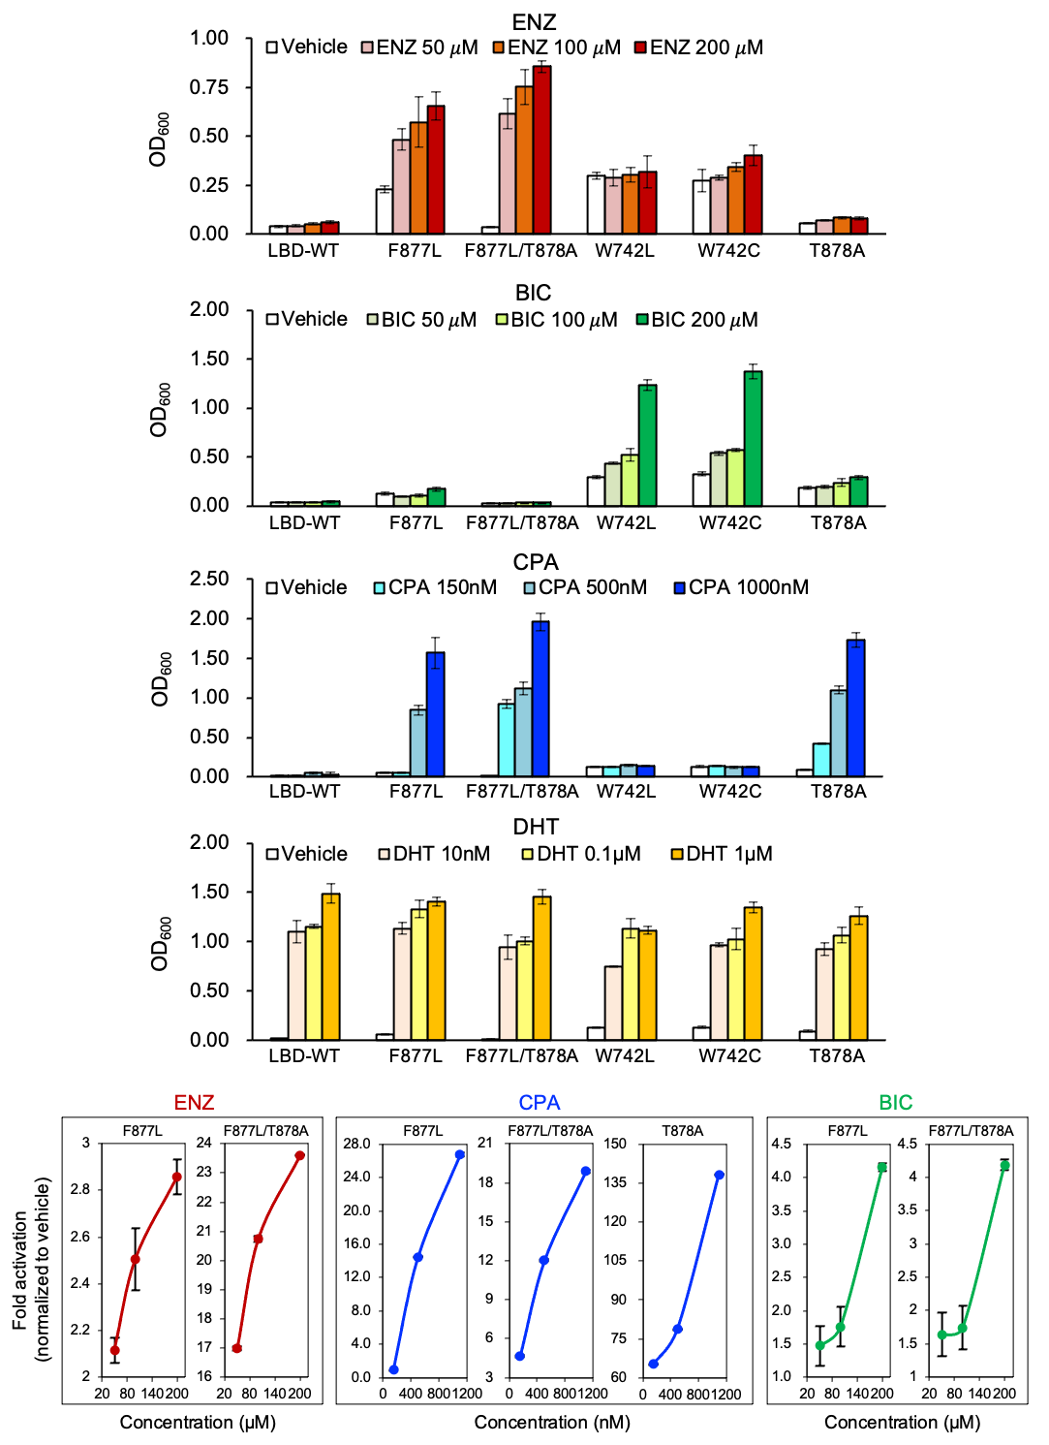
Extended Fig. 3. Continuous growth of yeast on culture plates containing ligands. Ligand conditions: 100 µM ENZ, 200 µM BIC, 500 nM CPA, 100 nM DHT, HIS (histidine), Vehicle (dimethyl sulfoxide).
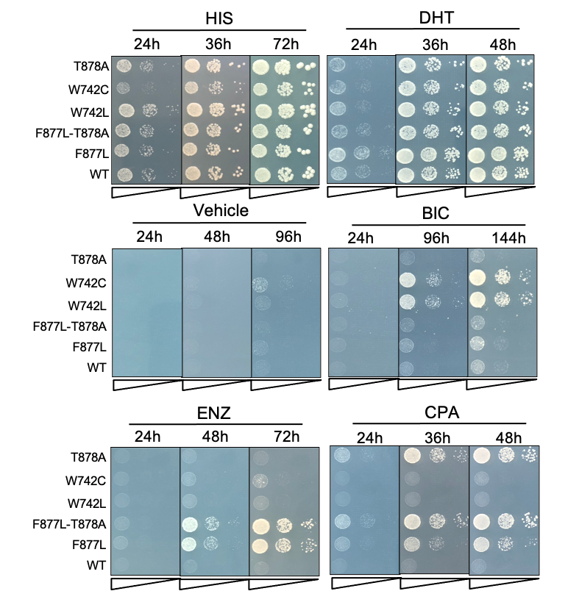
Extended Fig. 4. Tests to validate the sensitivity of designer yeast. a, BIC dose-response in plate culture. b, Ranking results of the resistance levels of AR mutants (full-length) against ENZ in Hep3B. c, Ranking results of the resistance levels of AR mutants (full-length) against CPA in Hep3B. d, Luciferase assay of assessed AR mutants (full-length) against various ligands.
