Supporting information
Two Cu(I\II) coordination polymers for photocatalytic degradation of organic dyes and efficient detection of Fe³⁺ ions
Chenyan Xu^{1#}, Wenqian Chen^{1#}, Jiajun Wang¹*, Qiuyu Wu¹, Pengyan Wu²*, Liang Tang¹*

- Key Laboratory of Organic Compound Pollution Control Engineering, Ministry of Education, School of Environmental and Chemical Engineering, Shanghai University, Shanghai 200444, PR China
- School of Chemistry and Materials Science, Jiangsu Normal University, 221116, PR China

# Equal contribution
* Corresponding author. E-mail addresses: Jiajun Wang (email: wangjiajun123@shu.edu.cn) Pengyan Wu (email: wpyan@jsnu.edu.cn) Liang Tang (email: tang1liang@shu.edu.cn)

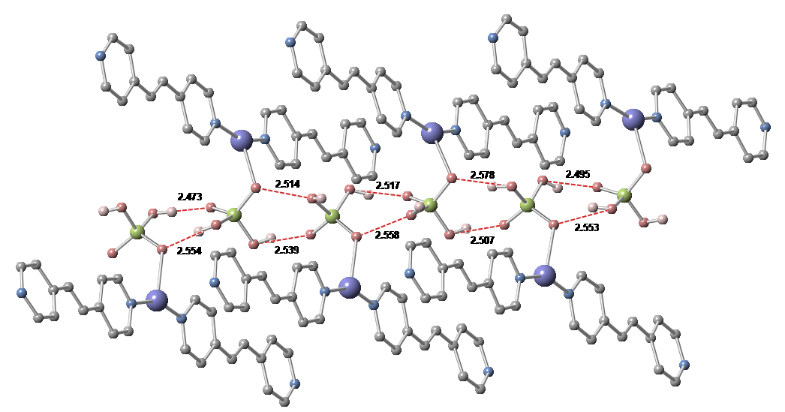
Figure S1. H-bonded network of Cu-dpe(I) (O-H…O in the orthophosphate). Hydrogen bonds are highlighted with a red dotted line. Cu, P, N, O, C and H atoms are shown in purple, green, light blue, red, gray and light pink, respectively. The unit of the H-bond distance is Å.

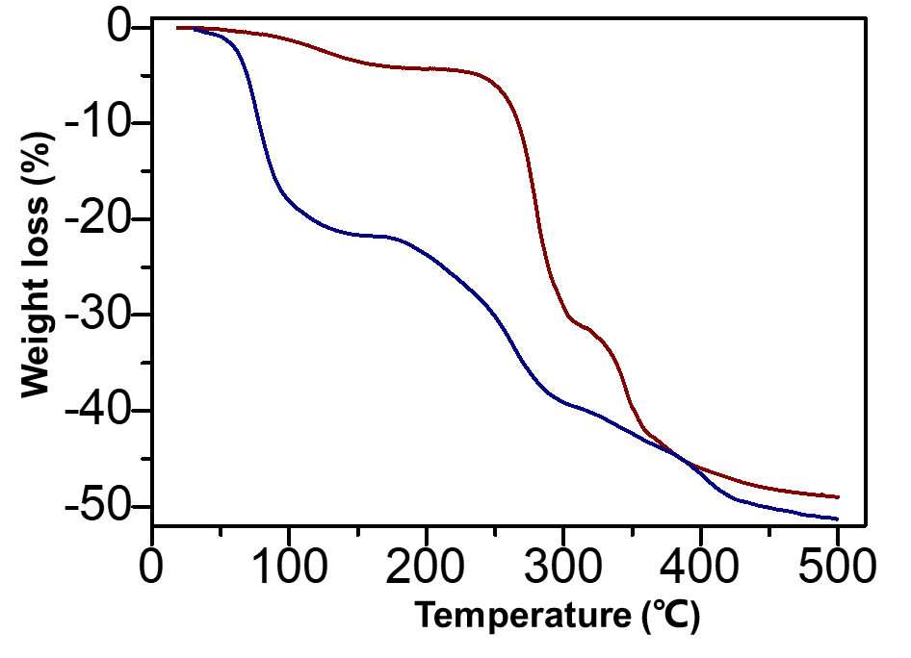
Figure S2. TGA of Cu-dpe(I) (red) and Cu-dpe(II) (blue).

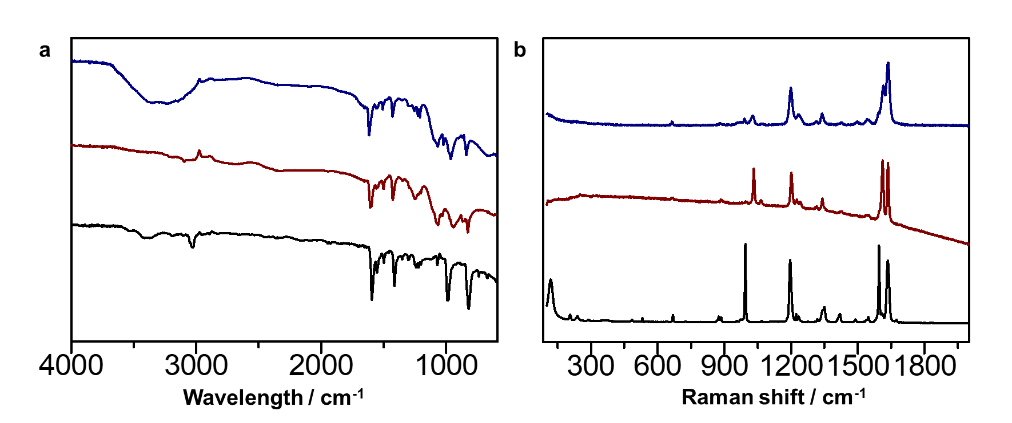
Figure S3. (a) Infra-red (IR) spectroscopy of ligand dpe (black), Cu-dpe(I) (red) and Cu-dpe(II) (blue). (b) Raman of ligand dpe (black), Cu-dpe(I) (red) and Cu-dpe(II) (blue).

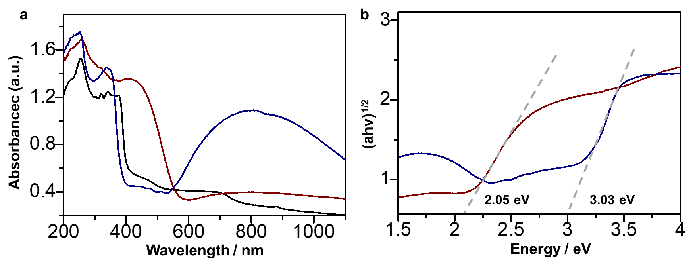
Figure S4. (a) UV-vis absorption spectra of ligand dpe (black), Cu-dpe(I) (red) and Cu-dpe(II) (blue). (b) The Tauc plot (αhv)^{1/2} vs (hv) of Cu-dpe(I) (red) and Cu-dpe(II) (blue), where α is absorbance.

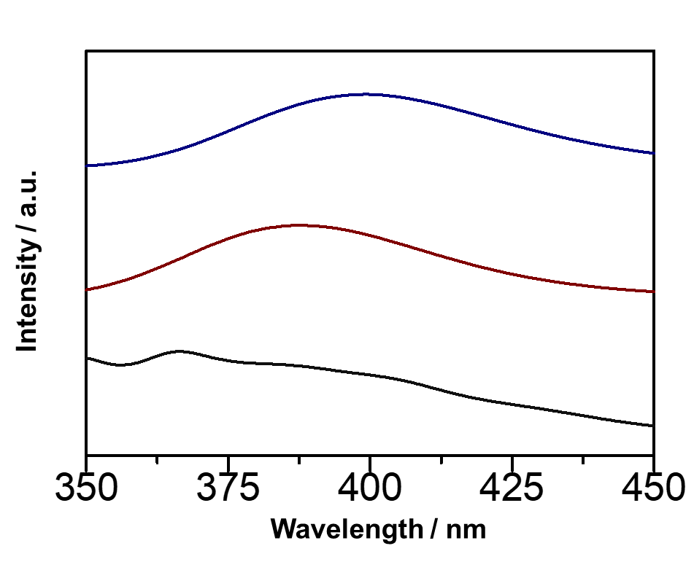
Figure S5. Solid-state fluorescence intensity of ligand dpe (black), Cu-dpe(I) (red) and Cu-dpe(II) at a room temperature.

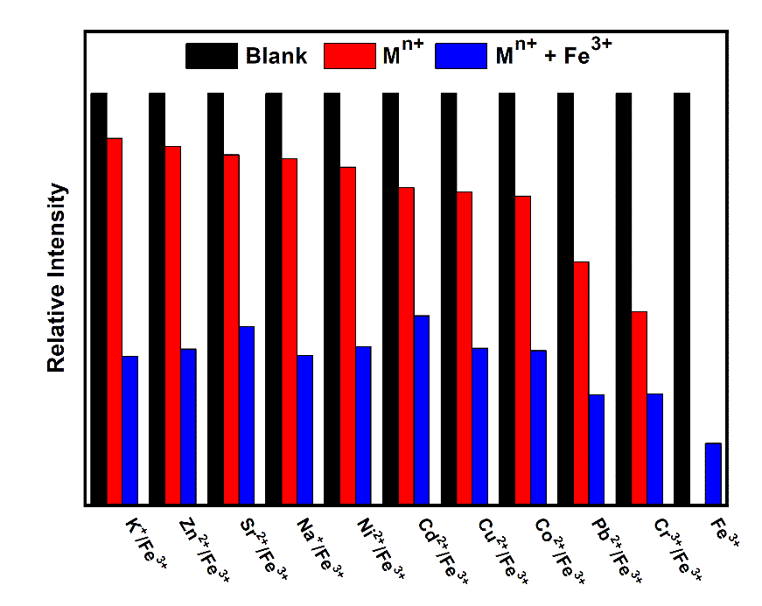
Figure S6. A control experiment: fluorescence intensities of Cu-dpe(I) in aqueous solution (black), addition of 200 μL M(NO₃)_{n} solutions (1 × 10⁻³ mol L⁻¹; red), and with Fe³⁺ ions (1 × 10⁻³ mol L⁻¹; blue) under an excitation of 381 nm.

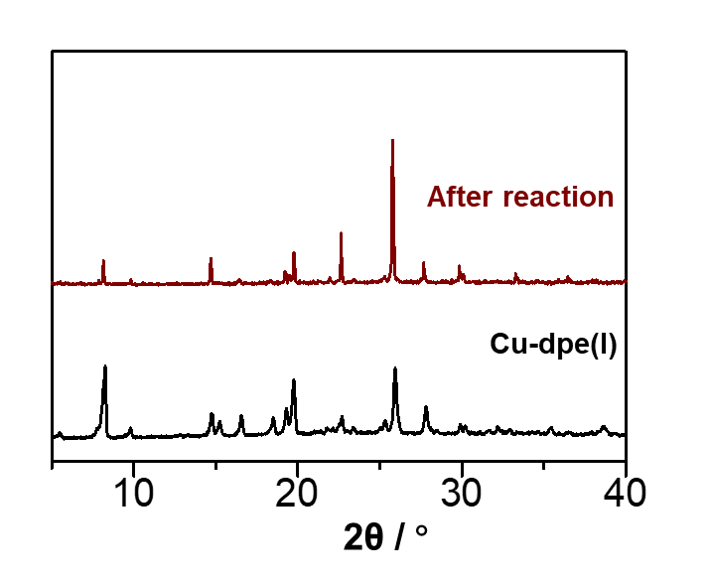
Figure S7. PXRD patterns of Cu-dpe(I) (black) and Cu-dpe(I) after dispersed in Fe³⁺ solution (10⁻³ M) for 24 hours (red).

Table S1. Crystallographic data for Cu-dpe(I) and Cu-dpe(II).
Compound | Cu-dpe(I) | Cu-dpe(II)
Empirical Formula | C₆₆H₆₅Cu₅N₁₁O₂₇P₅ | C₁₂H₂₂CuN₂O₁₀P
Formula weight (g mol⁻¹) | 1916.84 | 448.82
Crystal system | Monoclinic | Monoclinic
Space group | C2/c | C₂
a (Å) | 34.041 (7) | 8.2343(19)
b (Å) | 17.776 (4) | 26.830(6)
c (Å) | 26.056 (5) | 9.490(2)
α (°) | 90 | 90.00
β (°) | 93.06 (3) | 115.245(2)
γ (°) | 90.00 | 90.00
Volume (Å³) | 15744(5) | 1896.4(8)
Z | 8 | 4
ρ (g cm⁻³) | 1.617 | 1.572
μ (mm⁻¹) | 1.516 | 1.288
F (000) | 7792.0 | 928.0
GOF | 1.127 | 1.032
R₁ | 0.1019 | 0.0346
wR₂ | 0.3270 | 0.0932
Selected bond length (Å) and bond angle (º) for Cu-dpe(I).
Cu(1) - N(1) | 1.919 (5) | N(1) - Cu(1) - O(1) | 103.689 (18)
Cu(1) - O(1) | 2.238 (4) | N(1) - Cu(1) - N(2) | 153.2 (2)
Cu(1) - N(2) | 1.917 (5) | O(1) - Cu(1) - N(2) | 103.03 (18)
Cu(2) - N(3) | 1.907 (5) | N(3) - Cu(2) - O(2) | 105.13 (18)
Cu(2) - O(2)  Cu(2) - N(4)  Cu(3) - N(6)  Cu(3) - O(3)  Cu(3) - N(5)  Cu(4) - N(8)  Cu(4) - O(4)  Cu(4) - N(7)  Cu(5) - O(5)  Cu(5) - N(9)  Cu(5) - N(10) | 2.222 (4)  1.922 (5)  1.915 (5)  2.250 (4)  1.924 (4)  1.922 (5)  2.334 (5)  1.921 (5)  2.238 (4)  1.914 (5)  1.917 (5) | N(3) - Cu(2) - N(4)  N(4) - Cu(2) - O(2)  N(6) - Cu(3) - N(5)  N(6) - Cu(3) - O(3)  N(5) - Cu(3) - O(3)  N(8) - Cu(4) - O(4)  N(7) - Cu(4) - N(8)  N(7) - Cu(4) - O(4)  N(9) - Cu(5) - O(5)  N(9) - Cu(5) - N(10)  N(10) - Cu(5) - O(5) | 152.8 (2)  102.01 (18)  153.8 (2)  105.07 (18)  101.06 (17)  104.08 (19)  152.9 (2)  102.04 (19)  105.78 (19)  153.0 (2)  101.07 (18)
Selected bond length (Å) and bond angle (º) for Cu-dpe(II).
Cu(1) - O(5¹) | 1.948 (2) | O(5¹) - Cu(1) - N(1) | 89.3 (4)
Cu(1) - N(1) | 2.026 (11) | O(5¹) - Cu(1) - N(9) | 89.6 (4)
Cu(1) - N(9) | 2.076 (14) | O(5¹) - Cu(1) - O(7w) | 112.38 (10)
Cu(1) - O(1) | 1.938 (2) | N(1) - Cu(1) - N(9) | 175.75 (12)
Cu(1) - O(7w) | 2.307 (3) | N(1) - Cu(1) - O(7w) | 88.1 (4)
 |  | N(9) - Cu(1) - O(7w) | 88.5 (4)
 |  | O(1) - Cu(1) - O(5¹)  O(1) - Cu(1) - N(1)  O(1) - Cu(1) - N(9)  O(1) - Cu(1) - O(7w) | 154.94 (11)  92.4 (4)  90.4 (4)  92.67 (10)

Compounds | Removal efficiencies & Time | Reference
[Cu(tptc)_{0.5}(bpy)(H₂O)]_{n} | 90.07%, 120 min，Xe lamp (250 W) | Inorg. Chem. Commun, 2020, 119, 108121
[Zn₂(bbmb)₂(tdc)₂]·2H₂O | 87.00%, 120 min,Hg lamp (500 W) | Inorg.Chem. Commun, 2019, 106, 81-85
[Ni(4-pmp)(H₂O)₃] | 93.93%, 100 min,Xe lamp (300 W) | Inorg.Chem. Commun, 2020, 119, 108123
{[Zn₃(mtrb)₃(btc)₂]·3H₂O}_{n} | 64.30%, 180 min, Xe lamp | Dalton Transactions, 2018, 47, 6189-6198
[1-D [Cu(tba)₂(H₂O)]⋅2H₂O | 84.90%, 90 min,Hg lamp (300 W) | Colloids Surf A Physicochem Eng Asp, 2020, 603, 125147
Cu-dpe(I) | 88.10%, 120 min,LED | This work
Cu-dpe(II) | 97.20%, 120 min,LED | This work
Table S2. Degradation rate of the reported CPs for methylene blue.

Compounds | Quenching Constant (K_{sv} / M⁻¹) | Reference
[Zn₅(hfipbb)₄(trz)₂(H₂O)₂] | 4.09 × 10⁴ | Inorg. Chem., 2016, 5, 10580-10586
Eu–HODA | 2.09 × 10⁴ | Inorg. Chem., 2016, 55, 12660–12668
[Zn₂(L)₂(bpe)₂(H₂O)₂] | 2.395 × 10³ | Dalton Trans., 2015, 44, 18795–18803
{[Cd(L)(BPDC)]·2H₂O}_{n} | 6.4 × 10³ | Cryst. Growth Des., 2016, 17, 67-72
{[Cd(L)(SDBA)(H₂O)]·0.5H₂O}_{n} | 4.97 × 10³ | Cryst. Growth Des., 2016, 17, 67-72
H₃O[In₃(dcpy)₄(OH)₂]·3DMF·4H₂O | 4.3 × 10³ | Inorg. Chem., 2018, 57, 15262-15269
{[Cd(1,4-ndc)(3-abit)].H₂O}_{n} | 9.54 × 10³ | New. J. Chem., 2017, 41, 8107-8117
{[Zn₂(1,4-ndc)₂(3-abpt)]·2DMF}_{n} | 2.38 × 10⁴ | New. J. Chem., 2017, 41, 8107-8117
Cu-dpe(I) | 1.25 × 10⁴ | This work
Table S3. Quenching constants of the reported LCPs for Fe³⁺ in aqueous solution.

