Supplementary Information
Table S1. Taxa with statistical differences between poultry waste.
Taxonomic classification | M | L | W-statistic value | clr mean difference

Phylum
Gemmatimonadetes | 0.01±0.01 | 1.48±0.98 | 9 | 139.85
Cloacimonetes | 0.53±0.80 | 0±0 | 8 | 47.91

Class
Longimicrobia | 0.01±0.01 | 1.21±1.03 | 11 | 32.18
Gemmatimonadetes; S0134 terrestrial group | 0±0 | 0.25±0.09 | 10 | 37.73
Acidimicrobiia | 0.01±0.01 | 0.06±0.01 | 3 | 71.37
Coriobacteriia | 0.04±0.01 | 0.01±0.01 | 3 | 101.40

Order
Rhodospirillales | 0.01±0.01 | 8.36±4.85 | 56 | 440.02

Family
Rhodospirillaceae | 0.01±0.01 | 8.36±4.85 | 54 | 351.39
Chitinophagaceae | 2.18±0.74 | 0.1±0.02 | 3 | 487.49
Coriobacteriaceae | 0.04±0.01 | 0.01±0.01 | 2 | 242.96
Clostridia; MBA03; uncultured | 0.11±0.04 | 0.01±0.01 | 3 | 159.31

Genera
Rhodospirillaceae; uncultured | 0.01±0.01 | 8.26±4.79 | 87 | 407.08
Proteiniphilum | 5.73±1.91 | 0.01±0.01 | 19 | 319.39
Relative abundance per treatment expressed as mean±SD. Clr: centered log-ratio. Mean values (n=3) ± SD. M: poultry manure, L: chicken litter,

Table S2. Main taxa found in poultry waste.
Phylum | Family | Chicken litter | Poultry manure
Bacteroidetes |  | 29.97±15.30% | 34.04±12.89%
 | Sphingobacteriaceae | 17.81±10.99% | 5.75±5.97%
 | Flavobacteriaceae | 2.66±1.31% | 13.26±6.78%
 | Porphyromonadaceae | 2.66±1.31% | 13.26±6.78%
Proteobacterias |  | 42.42±10.09% | 38.09±14.08%
 | Xanthomonadaceae | 10.1±4.53% | 8.68±7.5%
 | Halomonadaceae | 10.58±1.44% | 2.54±1.34%
 | Rhodospirillaceae | 8.36±4.85% | 0.01±0.01%
 | Alcaligenaceae | 3.31±0.88% | 3.15±0.36%
Firmicutes |  | 14.53±17.85% | 23.13±7.66%
 | Clostridiales-Family XI | 0.22±0.2% | 2.93±0.47%
 | Staphylococcaceae | 1.35±0.22% | 0.89±0.99%
 | Bacillaceae | 9.05±12.4% | 4.71±2.77%
Relative abundance expressed as mean (n=3) ±SD

Table S3. Main taxa found in amended soils.
Phylum | Family | SL | SM | SC
Acidobacteria |  | 15.5±7.32% | 15.76±4.23% | 9.82±1.61%
 | Blastocatellaceae (Subgroup 4) | 3.26±1.34% | 3.41±1.09% | 3.17±0.59%
 | Acidobacteria (uncultured Subgroup 6) | 2.57±0.8% | 5.52±1.5% | 1.66±0.45%
 | Solibacteraceae (Subgroup 3) | 3.41±2.93% | 1.91±1.88% | 0.89±0.39%
Actinobacteria |  | 31.83±18.53% | 19.72±3.85% | 50.36±5.19%
 | uncultured Acidimicrobiales | 2.88±1.15% | 3.07±1.19% | 4.59±1.23%
 | Micromonosporaceae | 1.52±1.02% | 0.96±0.56% | 3.26±0.8%
 | Gaiellaceae | 5.95±2.93% | 2.12±0.41% | 8.13±0.62%
Gemmatimonadetes |  | 5.85±1.87% | 7.24±1.22% | 4.91±0.29%
 | Gemmatimonadaceae | 5.27±1.47% | 5.64±0.39% | 4.17±0.43%
Proteobacteria |  | 25.25±3.82% | 30.4±6.98% | 19.41±1.43%
 | Sphingomonadaceae | 4.42±1.7% | 1.98±1.09% | 2.56±0.08%
 | Nitrosomonadaceae | 2.12±0.79% | 3.91±1.34% | 0.86±0.48%
Relative abundance expressed as mean (n=3) ±SD

Table S4: Spearman correlation of the bacterial diversity present in soil samples (Observed AVS, Faith-pd, Shannon and evenness’s diversity indexes) and physicochemical and phytotoxic parameters.
Parameter | Observed ASVs | Faith-pd | Shannon | Evenness
DM (%) | ρ=0.6167, p=0.0769 | ρ=0.4500, p=0.2242 | ρ=0.6167, p=0.0769 | ρ=0.0833, p=0.8312
OM(%) | ρ=-0.333, p=0.9322 | ρ=-0.0833, p=0.8312 | ρ=0.0333, p=0.9322 | ρ=-0.1677, p=0.6682
TN (%) | ρ=0.3614, p=0.3393 | ρ=0.2101, p=0.5874 | ρ=0.5630, p=0.1145 | ρ=0.4958, p=0.1747
NH₄⁺-N (mg/Kg) | ρ=0.4108, p=0.2721 | ρ=0.4108, p=0.2721 | ρ=0.4108, p=0.2721 | ρ=-0.2739, p=0.4758
NO₃⁻-N (mg/Kg) | ρ=0.0000, p=1.0000 | ρ=-0.1369, p=0.7254 | ρ=-0.2739, p=0.4758 | ρ=-0.4108, p=0.2721
pH | ρ=-0.1333, p=0.7324 | ρ=0.0500, p=0.8984 | ρ=-0.0833, p=0.8312 | ρ=-0.2667, p=0.4879
EC (mS/cm) | ρ=-0.4667, p=0.2054 | ρ=-0.3333, p=0.3807 | ρ=-0.4167, p=0.2646 | ρ=-0.0500, p=0.8984
TP (mg/kg) | ρ=-0.6833, p=0.0424 | ρ=-0.5167, p=0.1544 | ρ=-0.6333, p=0.0671 | ρ=-0.0500, p=0.8984
eP | ρ=-0.3000, p=0.4328 | ρ=-0.0667, p=0.8647 | ρ=-0.1667, p=0.6682 | ρ=0.1667, p=0.6682
DM= Dry matter; OM = Organic matter; TN = Total Kjeldahl nitrogen on a dry weight basis; EC = Electrical conductivity; NH4⁺-N = ammonium-N on a dry weight basis; NO3⁻-N = nitrate-N on a dry weight basis; TP = Total phosphorous on a dry weight basis; eP = Extractable phosphorous

Fig S1. Volcano and box plots at phylum (A) and genera (B) level of poultry waste. Red dots in volcano plots show taxa with statistical significant difference between poultry waste. The relative abundance of those taxa is represented in the boxplot under the volcano plot.

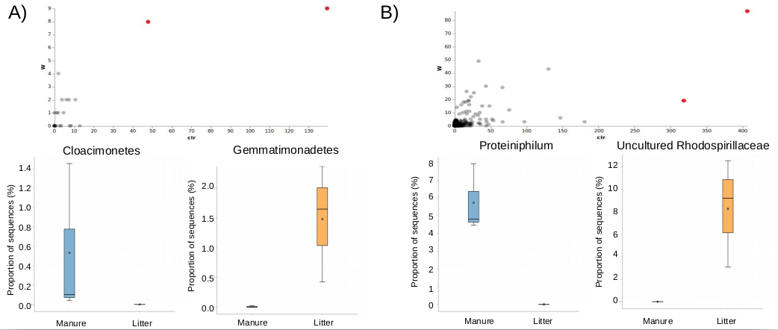
Fig S2. Boxplots of Observed ASVs (A) and Shannon index (B) for poultry waste.
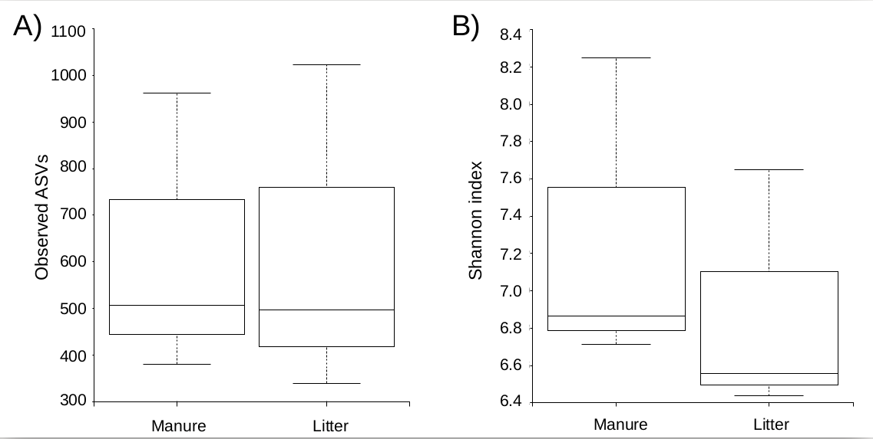

Fig S3. PCoA 3D plots from weighted (A) and unweighted (B) UniFrac metrics for poultry waste.

