SUPPLEMENTAL INFORMATION FOR
The incoming dNTP makes human DNA polymerase ε discriminative against RNA-containing primers
Alisa E. Lisova, Andrey G. Baranovskiy, Lucia M. Morstadt, Nigar D. Babayeva, Tahir H. Tahirov

Tahir H. Tahirov
Email: ttahirov@unmc.edu

Table S1. Oligonucleotides used in this study
Sequence | Description | Application | Length
5'-AATGTTTCTAGGCAGCTCGGAGTCC ª | Template (DNA) | kinetic studies | 25
5'-/Cy3/GGACTCCGAGCTGCC (D15) | Primer (DNA) | kinetic studies | 15
5'-/Cy3/GGACTCCGAGCTGCC ^{b} (D14-R1) | Primer (chimeric) | kinetic studies | 15
5'-/Cy3/GGACUCCGAGCUGCC (R15) | Primer (RNA) | kinetic studies | 15
5'-/Cy3/GGACUCCGAGCUGCC (R14-D1) | Primer (chimeric) | kinetic studies | 15
5'-/Cy3/GGACUCCGAGCUGCC (R12-D3) | Primer (chimeric) | kinetic studies | 15
5'-/Cy3/GGACUCCGAGCTGCC (R10-D5) | Primer (chimeric) | kinetic studies | 15
5'-/Cy3/GGACUCCGAGCTGCC (R8-D7) | Primer (chimeric) | kinetic studies | 15
5'-/BiotinTEG/AATACATAAGCGCTCCAGGCAAT | Template (DNA) | Octet K2 | 23
5'-GCCUGGAGCGC (R11) | Primer (RNA) | Octet K2 | 11
5'-GCCUGGAGCG/ddC/ (R10-D1) | Primer (chimeric) | Octet K2 | 11
5'-GCCUGGAGCG/ddC/ (R8-D3) | Primer (chimeric) | Octet K2 | 11
5'-GCCUGGAGCG/ddC/ (R6-D5) | Primer (chimeric | Octet K2 | 11
5'-GCCUGGAGCG/ddC/ (R4-D7) | Primer (chimeric) | Octet K2 | 11
5'-GCCTGGAGCG/3ddC/ (D11) | Primer (DNA) | Octet K2 | 11
5'-ATTATGGCAGCTCGGAGTCC | Template (DNA) | EMSA | 20
5'-/Cy3/GGACTCCGAGCTGCC (D15) | Primer (DNA) | EMSA | 15
ª The template regions complementary to a primer are italic.
^{b} Deoxy- and dideoxy- nucleotides in the chimeric primer sequences are underlined.

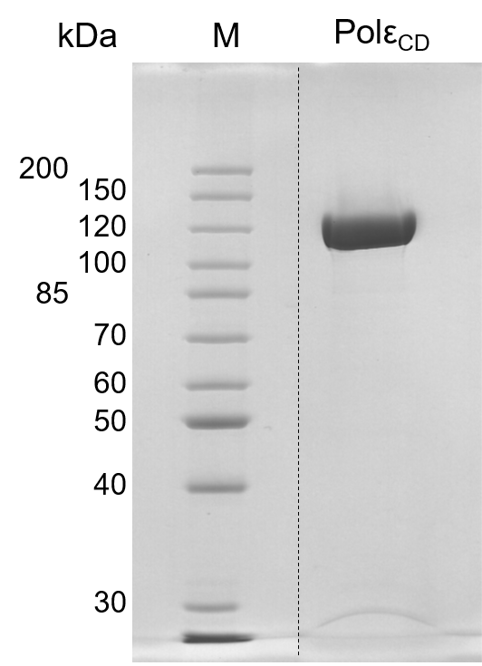
Figure S1. Analysis of hPolε_{CD} purity. Proteins were separated by 8% SDS-PAGE and stained by Coomassie Brilliant Blue R-250. M – molecular weight markers. The dashed line indicates splicing of the original image.

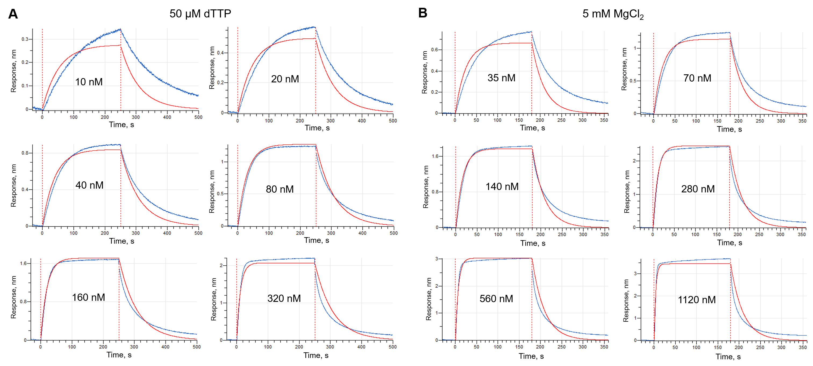
Figure S2. Kinetics of hPolε_{CD}/DNA complex formation and dissociation in the presence of 50 µM dTTP (A) or 5 mM MgCl₂ (B). Binding studies were conducted in the buffer containing 30 mM Tris-Hepes, pH 7.8, 100 mM NaCl, 2 mM TCEP, and 0.002% Tween 20. Enzyme concentration is indicated on each graph. DNA is attached to the streptavidin coated biosensor (SAX, Sartorius AG). Each binding cycle consists of next steps: baseline, association, and dissociation. The blue line depicts the actual binding curve. The red line represents the model curve build by the Data Analysis HT software (Sartorius AG) with use of global fitting.

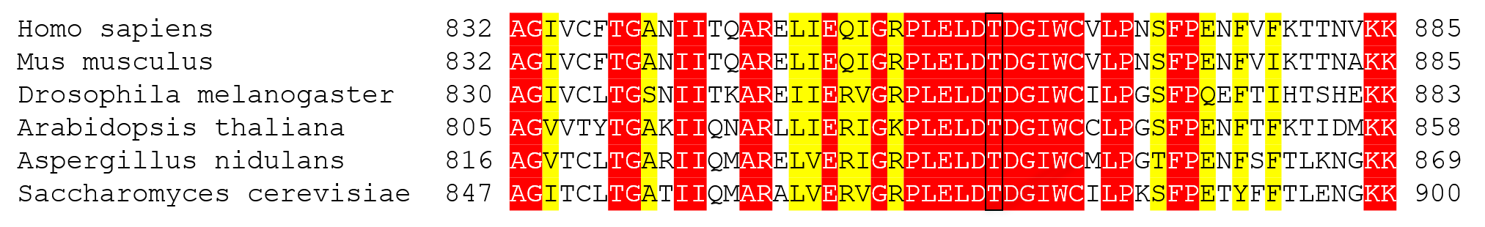
Figure S3. Thr861 of hPolε is conserved. Amino acid sequence alignment was performed using ClustalW. The conserved and similar residues are highlighted with red and yellow, respectively. The conserved threonines are boxed.

