Appendix 1
Commands line code
The FASTA files for each microbiome were formatted. This was carried out using the commands prompt from the terminal on the Bio-Linux 8 softwaere. The commands that were used are:
- multiple_split_libraries_fastq.py -i /sample -o OUT
- pick_otus.py -i OUT/seqs.fna -o OUT/out/uclust_picked_otus
- mkdir OUT/out/rep_set
- pick_rep_set.py -i OUT/out/uclust_picked_otus/seqs_otus.txt -f OUT/seqs.fna --rep_set_picking_method most_abundant -o OUT/out/rep_set/seqs_rep_set.fasta
- assign_taxonomy.py -i OUT/out/rep_set/seqs_rep_set.fasta -m rdp -o OUT/out/rdp_assigned_taxonomy
- make_otu_table.py -i OUT/out/uclust_picked_otus/seqs_otus.txt -t OUT/out/rdp_assigned_taxonomy/seqs_rep_set_tax_assignments.txt -o OUT/out/otu_table.biom
- align_seqs.py -i OUT/out/rep_set/seqs_rep_set.fasta -o OUT/out/pynast_aligned_seqs
- filter_alignment.py -i OUT/out/pynast_aligned_seqs/seqs_rep_set_aligned.fasta -o OUT/out/pynast_aligned_seqs
- make_phylogeny.py -i OUT/out/pynast_aligned_seqs/seqs_rep_set_aligned_pfiltered.fasta -o OUT/out/rep_set.tre
- summarize_taxa_through_plots.py -i OUT/out/otu_table.biom -m map.txt -o OUT/out/taxa_summary
- alpha_rarefaction.py -i OUT/otu_table.biom -m map.txt -t OUT/rep_set.tre -o out/arare
- beta_diversity_through_plots.py -i OUT/otu_table.biom -o OUT/ bdiv_even146/ -t OUT/rep_set.tre -m mergedmap.txt -e 146
- principal_coordinates.py -i OUT/beta_div/unweighted_unifrac_otu_table.txt -o OUT/beta_div/unbeta_div_coords_weighted.txt
- make_2d_plots.py -i OUT/bdiv_even146/unweighted_unifrac_pc.txt -m mergedmap.txt -o OUT/bdiv_even146/unweighted_unifrac_2d

Appendix Figs
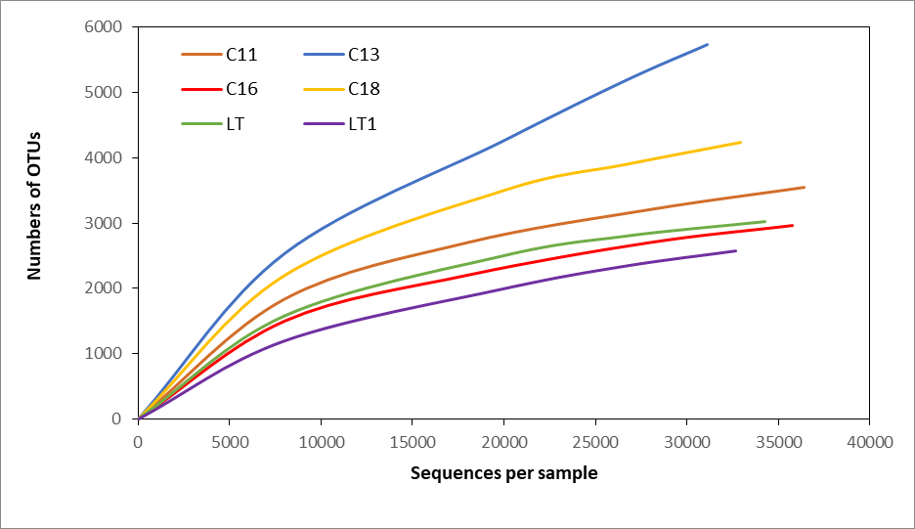
Fig. 4 Rarefaction curves for the six leachate samples at an OTU threshold of 97% sequence similarity

Fig. 5 The evolutionary tree of top 100 genera. Different colours of the branches represent different

