Numerical simulation of Quantum Dots as a buffer layer in CIGS Solar Cells: A Comparative study
Asmaa Soheil Najm^{*a}, Araa Mebdir Holi ^{b} Asla Abdullah Al-Zahrani ^{c}
ª Department of Electrical Electronic & Systems Engineering, Faculty of
Engineering and Built Environment, Universiti Kebangsaan Malaysia, 43600
UKM Bangi, Selangor, Malaysia
^{b} Department of Physics, College of Education, University of Al-Qadisiyah, Al-
Diwaniyah, Al-Qadisiyah 58002, Iraq
^{c} Imam Abdulrahman bin Faisal University, Eastern Region, Dammam, Kingdom
of Saudi

Supplementary data
Fig A1. Band diagram at Bulk bandgap at N_{D}=10¹⁷
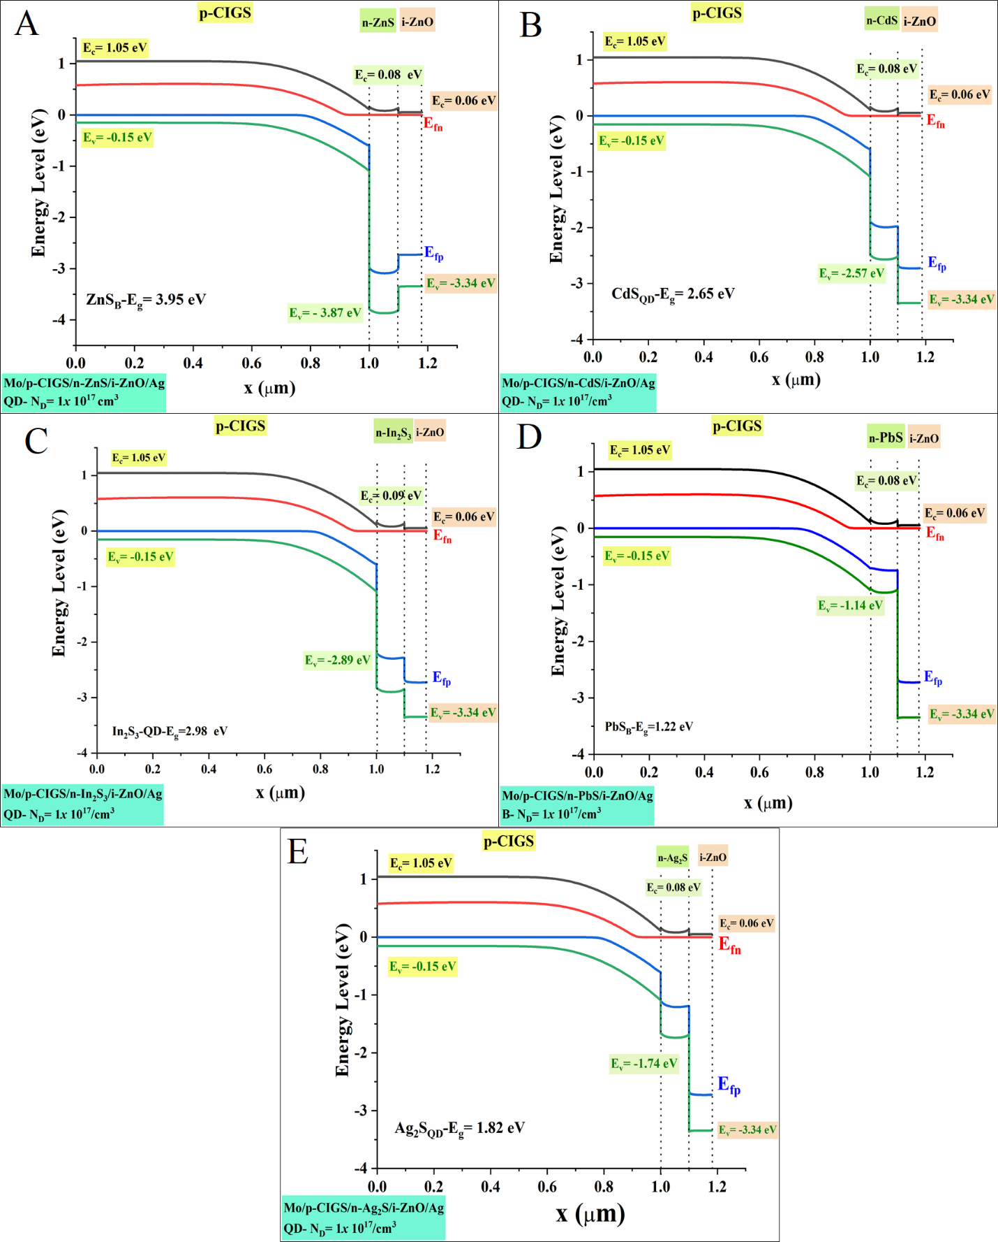
Fig B1. Band diagram at Quantum bandgap at N_{D}=10¹⁷

Fig A2. Band diagram at Bulk bandgap at N_{D}=10¹⁹
Fig B2. Band diagram at Quantum bandgap at N_{D}=10¹⁹

