Supplementary Tables
Table S1: Correlation matrix of annual mean coral SST and various SST products centered at Enggano Island (5°S, 102°E) for the time period 1982-2008 (n=26). All correlations are statistically significant (p<0.01, *p<0.05).
 | PB | KN2 | Enggano | OISST | SODA3 | GODAS | ERSST5 | HadISST1
PB | x | 0.81 | 0.95 | 0.76 | 0.78 | 0.45* | 0.68 | 0.66
KN2 |  | x | 0.94 | 0.76 | 0.8 | 0.61 | 0.59 | 0.75
Enggano |  |  | x | 0.81 | 0.81 | 0.61 | 0.65 | 0.72
OISST |  |  |  | x | 0.95 | 0.77 | 0.86 | 0.9
SODA3 |  |  |  |  | x | 0.83 | 0.87 | 0.86
GODAS |  |  |  |  |  | x | 0.83 | 0.68
ERSST5 |  |  |  |  |  |  | x | 0.83
HadISST1 |  |  |  |  |  |  |  | x

Table S2: Correlation matrix of annual mean coral SST and various historical SST products centered at Enggano Island (5°S, 102°E) for the time period 1930-2008 (regular, n=77) and 1958-2008 (bold, n=50). All correlations are statistically significant (p<0.01).
 | PB | KN2 | Enggano | SODA2.2.4 | ERSST5 | HadISST1
PB | x | 0.58 | 0.87 | 0.53 | 0.53 | 0.54
KN2 | 0.74 | x | 0.77 | 0.61 | 0.58 | 0.64
Enggano | 0.93 | 0.93 | x | 0.63 | 0.61 | 0.54
SODA2.2.4 | 0.67 | 0.7 | 0.72 | x | 0.88 | 0.88
ERSST5 | 0.69 | 0.66 | 0.69 | 0.87 | x | 0.87
HadISST1 | 0.69 | 0.75 | 0.78 | 0.87 | 0.87 | x

Supplementary Figures
Fig. S1: Skewness of September-November mean SSTs in the Indian Ocean as portrayed in various SST products for the time period 1982-2008. The location of Enggano Island is marked by a red x. Charts computed at the knmi climate explorer (https://climexp.knmi.nl; date accessed 14/03/2022). 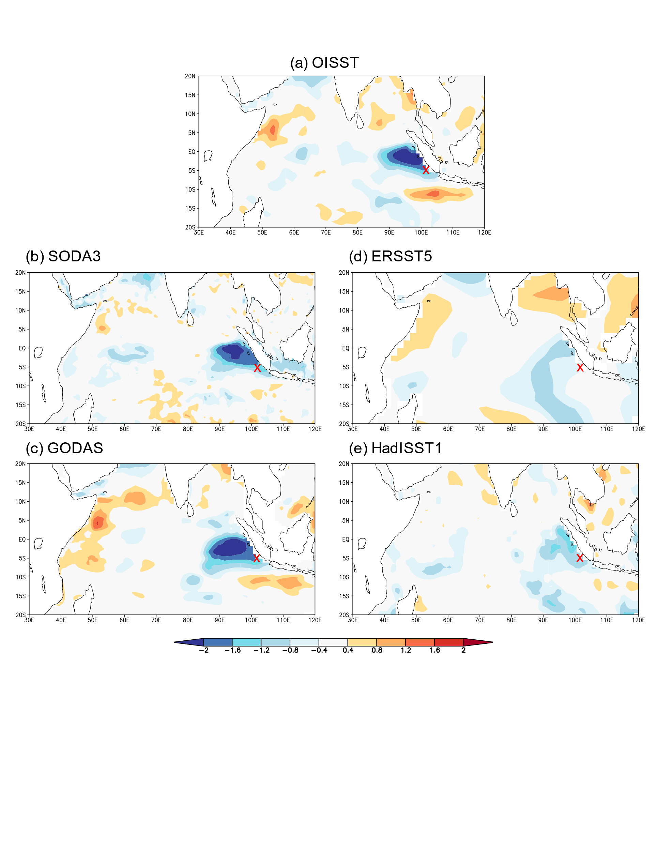

Fig. S2: Standard deviation of September-November mean SSTs in the Indian Ocean as portrayed in various SST products for the time period 1982-2008. The location of Enggano Island is marked by a green x. Charts computed at the knmi climate explorer (https://climexp.knmi.nl; date accessed 14/03/2022).
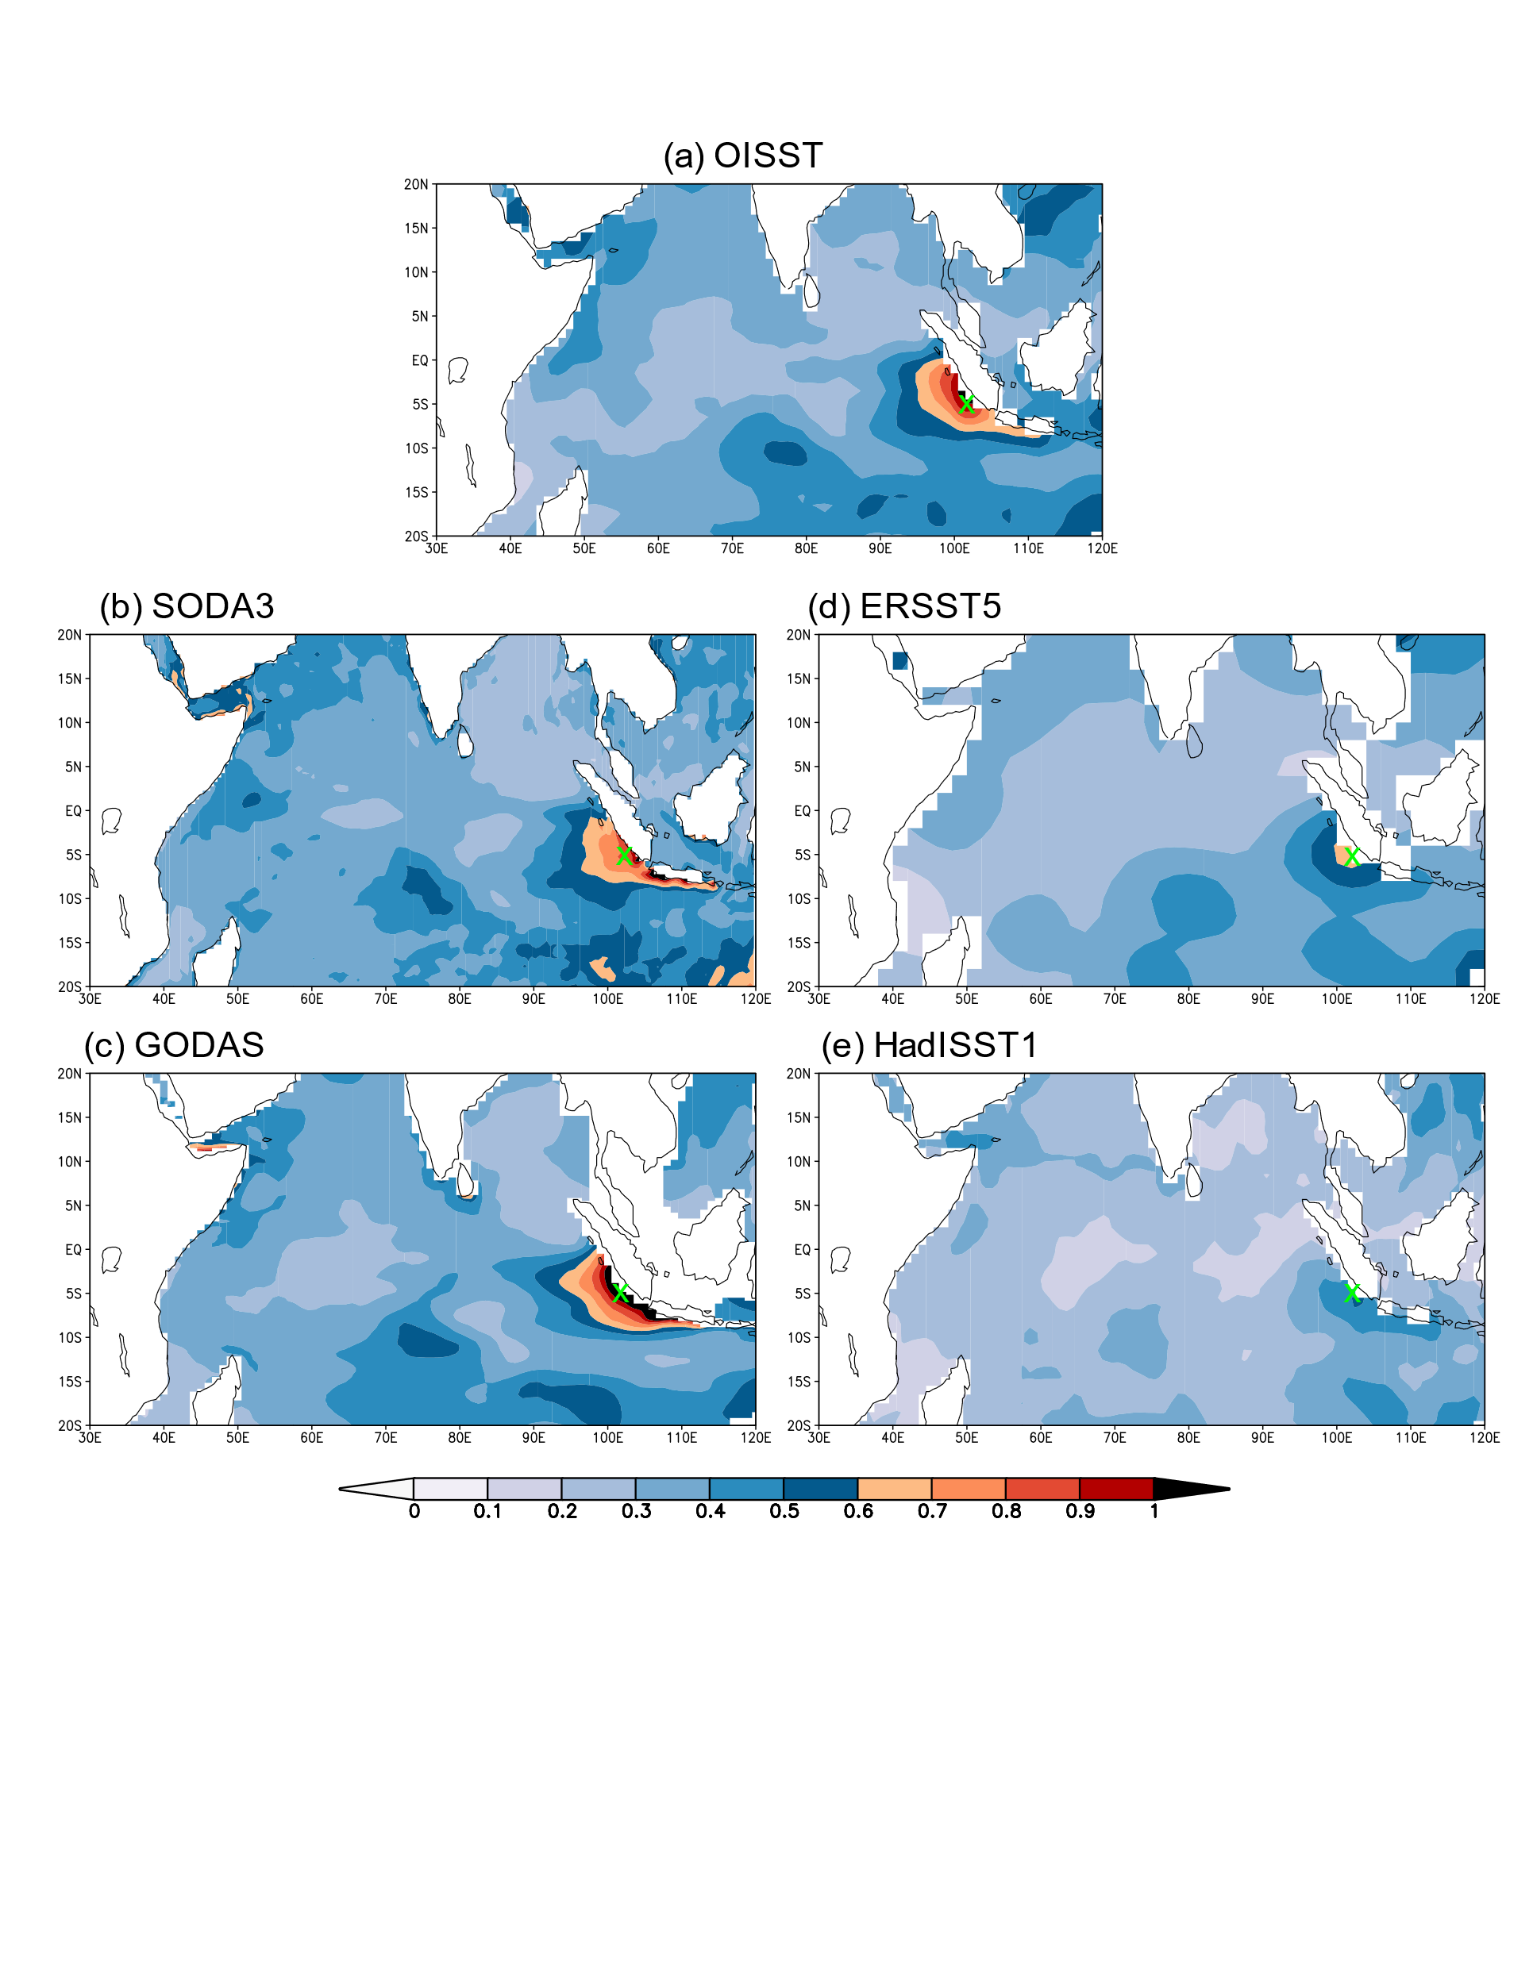

Fig. S3: Left: Location of Enggano Island off the coast of Sumatra (Indonesia). Right: Enggano Island and location of coral cores. Charts computed at the knmi climate explorer and Google Earth, respectively. Date accessed: 9/3/2022.
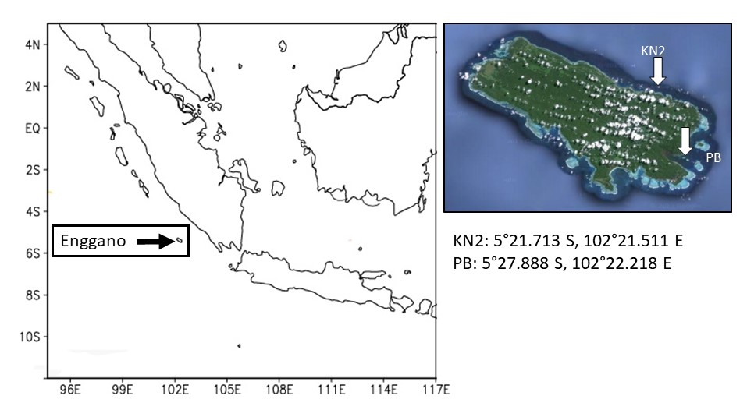

Fig. S4: X ray images of core PB showing sampling transects (red lines) and annual density bands. Note the goodness of fit between slabs.

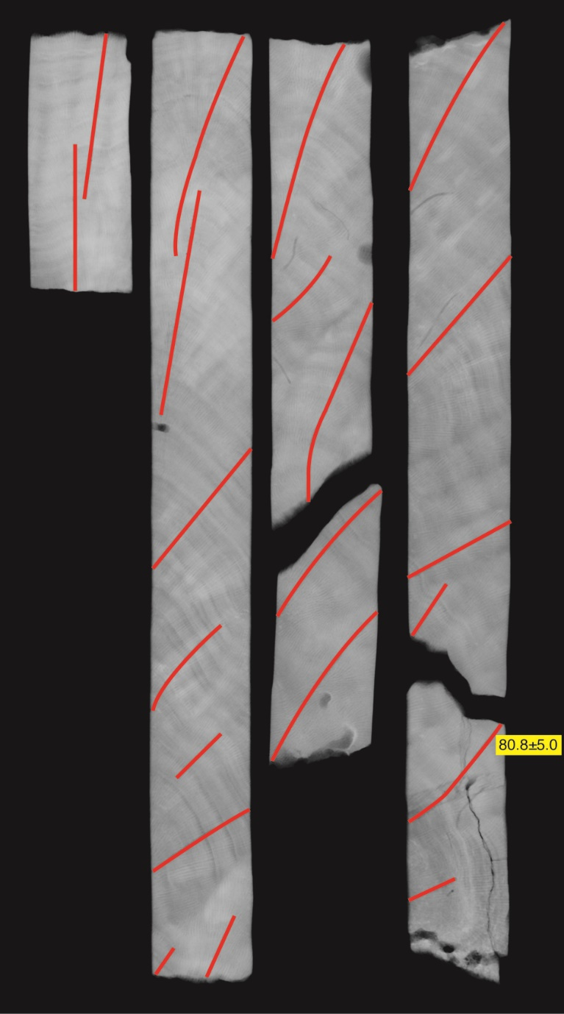

Fig. S5: X ray images of core KN2 showing sampling transects (red lines). Annual density bands are not very clear so that the age model relies on the seasonality of the trace element data. Note the goodness of fit between slabs.
