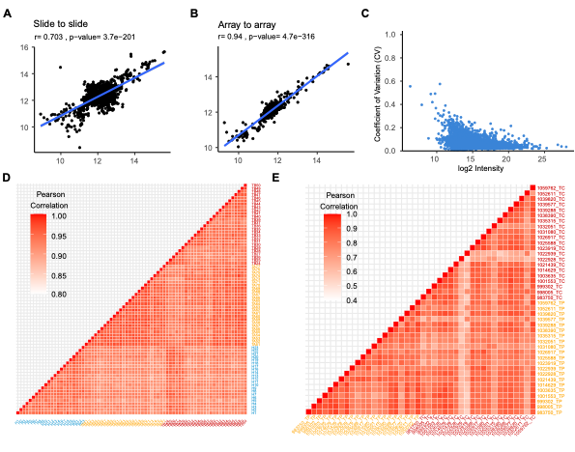
Supplementary Figure 1. Reproducibility of serum antibody microarray detection (A-B) and DIA-MS (D). (C, E) Reproducibility of tissue DIA-MS.
Abbreviations: DIA-MS: Data Independent Acquisition Mass Spectrometry.

Supplementary Figure 2. Differential serum expressions of FN1 and GSN levels were validated between patients with benign nodules (A) and PTC by Elisa tests in an independent cohort (B).

