Why carry out this study?
Increased MACEs have been reported after stent implantation for coronary stenotic lesions combined with distal myocardial bridges. Further, the longer postoperative dual antiplatelet treatment (DAPT) after stent implantation lead to higher bleeding events. Use of drug coating balloons (DCB) in this setting hasn’t clear recommendations in domestic and international guidelines. This study assesses the efficacy and safety of drug-coated balloons (DCB) in treating coronary artery stenosis combined with a distal myocardial bridge (MB).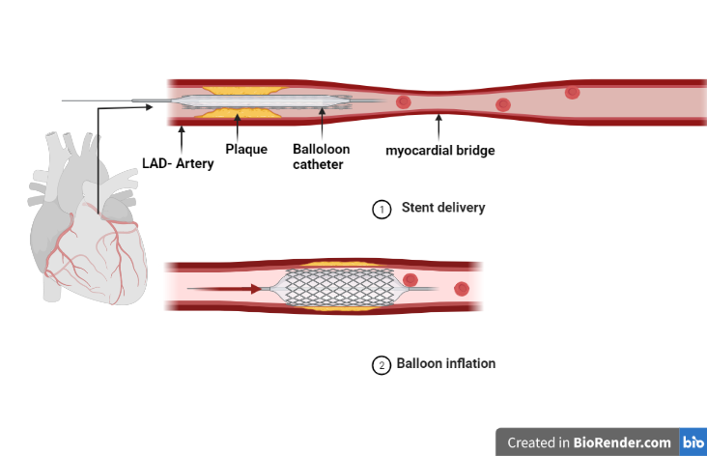
What did the study ask?
- Based on the shortage of drug-eluting stent (DES) of increased MACEs in this setting, we hypothesize that a drug-coated balloon is a better alternative to DES in dealing with myocardial bridge combined with proximal stenosis.
- The aim of this study was to investigate the effectiveness and safety of DCB in dealing with proximal stenosis of the myocardial bridge.
What was learned from the study?
- For MB combined with proximal coronary stenosis lesions, treatment with DCB only is safe and effective, and the long-term results are better than DES.
- The quantitative analysis of coronary angiography is shown in Figure 1.
- The incidence of MACEs in DCB group compared with DES group is shown in Figure 2
- No high-pressure post-dilation was required for DCB treatment.
- The contrasting use, mean operation time time, and radiation dosage were less in the DCB group than in the DES group (p<0.05).
- No in-stent thrombotic events occurred after 1 month of DAPT after DCB treatment.
- In summary, these findings suggest that DCB treatment for proximal stenosis of myocardial bridge is more concise compared with DES, with fewer postoperative complications. The application of DCB is better than DES in safety and effectiveness.

