Electronic Supplementary Information (ESI).
SELECTIVE ALKYLATION BY ZEOLITE CATALYSIS OPENS UP A SUSTAINABLE PLATFORM OF BISPHENOL SUBSTITUTES FROM BIOMASS

I. Materials and methods S2
II. Figures S7
III. Tables S36
IV. References S42

I. Materials and methods

M1. Chemicals and materials
All commercial chemicals were analytical reagents and were used without further purification. Isoeugenol (IE, 99%, mixture of 11% cis and 88% trans), guaiacol (G, ≥99%), 4-n-propylguaiacol (≥99%), 2-isopropylphenol (>98%), N-methyl-N-(trimethylsilyl) trifluoroacetamide (MSTFA, ≥98.5%), triphosgene (BTC, bis(trichloromethyl) carbonate, ≥99%), terephthaloyl chloride (>99%), triethylamine (≥99%), benzyltriethylammonium chloride (99%), tetrabutylammonium chloride (≥97%), epichlorohydrin (>99%), bisphenol A diglycidylether (BADGE, >95%), Isophorone diamine (IPDA, >99%), 5wt.% Ru on carbon, 17β-estradiol (E2, >98%), dichloromethane (DCM, >99%), methanol (anhydrous and degassed, >99%), pyridine (anhydrous, 99.8%), tetrahydrofuran (THF, >99%), chloroform-d (CDCl₃, 99.8 atom % D), acetone-d₆ ((CD₃)₂CO, 99.9 atom %D) and dimethyl sulfoxide-d₆ ((CD₃)₂SO, 99.9 atom % D), trifluoromethanesulfonic acid (CF₃SA, 98%), phosphomolybdic acid hydrate (H₃PMO₁₂O₄₀), silicomolybdic acid hydrate (H₄SiMO₁₂O₄₀), phosphotungstic acid hydrate (H₃PW₁₂O₄₀), tungstosilicic acid hydrate (H₄SiW₁₂O₄₀) methanesulfonic acid (MeSA, >99%), 1-hexadecanesulfonic acid (C₁₆SA, 98%), camphorsulfonic acid (CSA, 99%), p-toluenesulfonic acid (p-TSA, >98%), 4-dodecylbenzenesulfonic acid (C₁₂BSA, >95%), Amberlyst® 15 dry (H⁺, moisture content ≤1.6%, particle size <300µm), Nafion® SAC-13, Nafion® NR-50, Amberlite® IR-118, Aquivion® PW98, Aquivion® PW79S and H-Al-MCM-41 (Si/Al 39.5) were purchased from Merck (former Sigma-Aldrich). Anhydrous acetone ( ≥99.5%), sodium hydroxide (NaOH, 99.4%), hydrogen chloride (HCl, 37%), acetic acid (CH₃COOH, 99%) were purchased from Fisher Scientific. Ethyl ferulate (>97%) and bisphenol A (BPA, >99.0%) were purchased from TCI Europe. Methyl ferulate (99%), ferulic acid (99%) and chloroform (≥99.5%) were purchased from Alfa Aesar. Sulfuric acid (H₂SO₄, 98%), nitric acid (HNO₃, 65%), ethanesulfonic acid (EtSA, 95%), 1-propanesulfonic acid (PrSA, 95%), acetonitrile (ACN, ≥99.9%), ethyl acetate (≥99.8%), n-butanol (≥99%) and n-heptane (≥99%), Dowex® 50x8 100, Dowex® 50x8 (20-50) and Dowex® 50x2 (100) were purchased from Acros Organics. Phosphoric acid (H₃PO₄, 87%) from Chem-lab. Dimethylsulfoxide (DMSO, 99.5%) was purchased from Labscan. 4-vinylguaiacol (VG, 98%) was purchased from J&K Scientific. Used commercial zeolites: ZSM-5 (MFI, Si/Al 15, CBV-3024E, NH₄⁺-form), CBV-300 (FAU, Si/Al 2.5, NH₄⁺-form), CBV-500 (FAU, Si/Al 2.6, NH₄⁺-form), CBV-712 (FAU, Si/Al 6, NH₄⁺-form) CBV-720 (FAU, Si/Al 15, H⁺-form), CBV 760 (FAU, Si/Al 30, H⁺-form) CBV-780 (H-USY, FAU, Si/Al 40, H⁺-form), CP814E* (BEA-25, Si/Al 12.5, NH₄⁺-form), CP814C* (BEA-38, Si/Al 19, NH₄⁺-form) from Zeolyst (former PG) and CZB150 (H-Beta, BEA-150, Si/Al 75, H⁺-form) from Clariant (former Süd-Chemie AG). The biomass was milled and sieved to obtain a sawdust fraction with a size of 250-500 µm. The sawdust was Soxhlet extracted with an ethanol/toluene (1/2 v/v) mixture for 3 h to remove most extractives. Ultrapure water (Type 1) was taken from a Millipore Milli-Q® Advantage A10 water purification system with a resistivity ≥ 18 MΩ·cm at 25 ºC.

M2. Zeolite acid density, pre-treatment, and regeneration
The theoretical maximum Brønsted acid density (mmol H⁺ g⁻¹) of each zeolite was calculated based on the framework Si/Al ratio and used to determine the mass of each zeolite (g) required for reaching the same molar amount of catalytically active site (mol H⁺)., respective Acid densities of 1.04, 0.41 and 0.22 mmol H⁺ g⁻¹, respectively, were defined for the zeolites ZSM-5 (Si/Al = 15), H-USY (Si/Al = 40) and H-Beta (Si/Al = 75).
Prior to their use, the zeolites were calcined at 550 ºC for 6 h under static air reached at a rate of 1 ºC min⁻¹. After calcination, the zeolites were air-equilibrated for 5 days and stored in glass vials until use.
Two different protocols were used to regenerate zeolite H-USY. In protocol one, the zeolites were washed three times with acetone, dried at 80 °C overnight and air-equilibrated for 5 days. In protocol two, the drying is followed by calcination (at 550 ºC for 6 h under static air reached at a rate of 1 ºC min⁻¹).

M3. Reaction analysis: methodology and quantification.

» Gas Chromatography – Flame Ionization Detector (GC-FID) analysis:
For the quantification of the alkylation products (i.e., bisguaiacols and cyclic dimers) the following GC methodology was used: The injection port and initial oven temperatures were 300 °C and 100 ºC, respectively. This temperature was held for 1 min, increased to 305 ºC at 10 ºC min⁻¹, and held for 4 min. For the quantification of the lignin oil and the alkylation products thereof, the GC methodology was adapted to provide a better separation of the lignin monomers. The injection port and initial oven temperatures were 300 °C and 50 ºC, respectively. This temperature was held for 1 min, increased to 150 ºC at 15 ºC min⁻¹, then to 305 °C at 10 °C/min and held there for 12 min. For both GC-methodologies the detector temperature was 310 °C.
Quantification of mono- and dimers was done by calibration of pure (isolated) reagent/product against the applied internal standard. Relative response factors were obtained by (i) calibration with commercial compounds (ii) calibration with pure (isolated) reagent/product, and/or (iii) deduction by interpolation, taking into account the basic principles of the ‘effective carbon number’ method.¹ The product yield is expressed as the theoretical yield in mol% (equation (1)), the calculation of the chemo- and regioselectivity (mol%) is shown in equation 2-3:
$Yield \left[mol\%\right]=\frac{product [mol]}{theoretical max. product [mol]} x 100$ (1)
$Chemoselectivity \left[mol\%\right]=\frac{bisguaiacols \left[mol\right]}{bisguaiacols \left[mol\right] + cyclic dimers [mol]} x 100$ (2)
$Regioselectivity \left[mol\%\right]=\frac{p,p^{'}-bisguaiacol \left[mol\right]}{ all regioisomers [mol]} x 100$ (3)

» Quantitative High Pressure Liquid Chromatography (HPLC) analysis:
A Waters Alliance HPLC system (e2695 seperation module) was used, equipped with a C₁₈ –column (SUPELCOSILTM LC-18, 250 mm x 4.6 mm, 5 µm) and a UV/Vis detector (2489 UV/Vis detector) at 280 nm. Two solvent mixtures were used for the mobile phase: (A) 95 vol.% ACN with 5 vol.% of H₂O and (B) 5 vol.% ACN and 95 vol.% H₂O. The analysis of the reaction mixture was performed at 40 °C, with an injection volume of 15 µL and a flow rate of 1 mL min⁻¹. The following A:B-gradient elution was applied: 0-1 min: 26:74, 1-20 min: linear gradient to 37:63, 20-30 min: linear gradient to 100:0, 30-35 min: 100:0, 35-36 min: linear gradient to 26:74, 36-45 min: 26:74. Samples were prepared by dissolving 20 mg of the reaction mixture in 1 mL of 26:74 (A:B).

» Preparative HPLC fractionation:
A Shimadzu Prominence HPLC system was used, equipped with a C₁₈ column: (i) prep HPLC guard column (Shim-Pack GIS (G) C18 50 mm x 20 mm, 5 µm) and (ii) prep HPLC column (Shim-Pack GIS C18 250 x 20mm, 5 µm). The system contained the following units: pump (LC-20AP), helium degasser (DGU-10B), valves (FCV-200AL), UV/Vis detector (SPD-20A), fraction collector (FRC-10A) and controller (CBM-20A). Two solvents were used for the mobile phase: (A) 100% ACN and (B) 100% H₂O. The separation and fractionation of the reaction products was performed with a flow rate of 10 mL min⁻¹ and injection volume of 5 mL. The following A:B-gradient elution was applied: 0-1 min: 20:80, 1-20 min: linear gradient to 40:60, 20-21 min: linear gradient to 100:0, 20-25 min: 100:0, 25-26 min: linear gradient to 20:80, 26-30 min: 20:80. Samples were prepared by dissolving 100-250 mg of the reaction mixture in 5 mL of 20:80 (A:B).

» Qualitative Gel Permeation Chromatography (GPC) analysis:
A Waters Alliance GPC system (e2695 seperation module) was used, equipped with an Agilent PLgel column (Mixed E, 3 µm) and a Waters 2998 photodiode array (PDA) detector. The mobile phase consisted out of pure THF. The separation was performed with an isocratic flow (1 mL min⁻¹) for 15 min at 40 °C. The photodiode array (PDA) detector measured wavelengths in a range of 240-300 nm, the data acquired at 280 nm was extracted and analyzed.

» Size Exclusion Chromatography (SEC) analysis of polymers:
A Shimadzu SEC system was used, equipped with an Agilent PLgel column (Mixed-D, 300 x 7.5 mm, 5 µm) and UV/Vis detector (SDP-10Avp) at 254 nm. The system contained the following units: pump (LC-10ADvp), column oven (CTO-10Avp), gradient controller (SCL-10Avp) and UV/Vis detector (SDP-10Avp). The mobile phase consisted of pure DCM, the separation was performed with an isocratic flow (1 mL min⁻¹) at 30 °C. Samples were prepared by dissolving 1-2 mg of the reaction mixture in 1 mL of DCM. The system was calibrated with low-disperse polystyrene (PS) standards.
The software used for data processing, analyses and imaging are: Chemstation (GC-FID and GC-MS), Empower 3 (Waters HPLC), Labsolutions (Shimadzu HPLC), TopSpin and Mestrenova (NMR) and Microsoft Office (general).

M4. Kinetic study.
Confined microporous catalysts, such as zeolite H-USY zeolite, may control reaction selectivity by impeding or promoting specific molecular interactions, through (i) surface interactions (i.e. adsorption/desorption), (ii) spatial limitations, restricting particular reaction transition-states and/or (iii) pore-diffusion limitations of reagents and products. In the presence of pore-diffusion limitations, the concentration of reagents around the catalytic active sites deviates from the bulk concentration. Given that a low concentration of IE (1a) benefits the chemoselectivity towards bisguaiacols (2a), it was hypothesized that pore-diffusion limitations of 1a might induce chemoselectivity.
Therefore, the presence of pore-diffusion limitations was initially examined in this kinetic study via the differential method. To obtain representative results, the experiments were performed in B mode with low 1a concentration (ratio IE:G = 1:160), simulating optimal FB conditions (Supplementary Fig. S12).
In general, the substrate (1a) and product (2a and 3a) rate equations are written as:
$-\frac{d\left[1a\right]}{dt}= k_{2a}{\left[1a\right]}^{n_{1a}^{2a}}{\left[G\right]}^{n_{G}^{2a}}+ k_{3a}{[1a]}^{n_{1a}^{3a}}$ (4)
$\frac{d\left[2a\right]}{dt}= k_{2a}{\left[1a\right]}^{n_{1a}^{2a}}{\left[G\right]}^{n_{G}^{2a}}$(5)
$\frac{d\left[3a\right]}{dt}= k_{3a}{[1a]}^{n_{1a}^{3a}}$(6)
With $k_{a}$ the reaction rate constant [M⁻¹ s⁻¹] for product a, [1a] and [G] the concentration [M] of isoeugenol and guaiacol, respectively and $n_{b}^{a}$ the observed reaction order in b for product a.
Using an excess of G, the concentration of G during the reaction is assumed constant. Therefore, a pseudo reaction rate constant ${k'}_{BGP}$ [s⁻¹]s defined as:
${k'}_{2a}= k_{2a}{\left[G\right]}^{n_{G}^{2a}}$(7)
Hence, substituting (7) into (5) gives:
$\frac{d\left[2a\right]}{dt}= {k'}_{2a}{\left[1a\right]}^{n_{1a}^{2a}}$(8)
Taking the natural logarithm of equation (6) and (8):
$\ln{\frac{d\left[3a\right]}{dt}}= \ln{k_{3a}+ n_{1a}^{3a}∙} \ln{[1a]}$ (9)
$\ln{\frac{d\left[2a\right]}{dt}}= \ln{{k'}_{2a}+ n_{1a}^{2a}∙} \ln{[1a]}$ (10)
In the presence of pore-diffusion limitations the observed reaction order in 1a is expected to be lower than the intrinsic reaction order in kinetic regime, free from diffusion limitations. Hence, to evaluate the presence of diffusion limitations, the homogeneous catalyst H₂SO₄ was included in this kinetic study. Plotting the natural logarithm of the 1a concentration to the natural logarithm of the product formation rate, the reaction order n and reaction rate constant can be extracted from the slope and intercept, respectively. The product (P) formation rate was defined as the derivative ($\frac{dP}{dt}$ ) of the product concentration in time $P(t)$. The function $P\left(t\right)$ was derived using a nonlinear least square fit (polynomial fit), model equation (11) (Supplementary Fig. S13-14). The parameters and R-squared values of the fit are presented in Supplementary table S1.
$P\left(t\right)=at^{2}+bt+c$ (11)
$\frac{dP}{dt}=2at+b$ (12)
For all reactions, the reaction orders were equal for both catalysts, indicating the absence of pore-diffusion limitations for both reaction pathways using the H-USY zeolite. As a result, it was found that (i) the alkylation of guaiacol towards 2a depends in a first order of reaction in 1a and (ii) the self-dimerisation towards 3a depends in a second order of reaction in 1a.
Subsequently the influence of temperature on the reactions kinetics was analyzed. If the assumption is made that, in addition to the equal order of reaction in 1a, the order of reaction in G is the same for both catalysts, the main factor controlling the product formation rate, hence chemoselectivity, according the rate equation is the rate constant of the different reaction pathways (i.e., $k_{2a}$ and $k_{3a}$). According to the Arrhenius equation (13) the reaction rate constant is temperature dependent and controlled by (i) the energy barrier or apparent activation energy ($E_{a})$ of the reaction and (ii) a pre-exponential factor that is associated with entropic effects ${(k}_{0})$. Therefore, $E_{a}$ and $k_{0}$ provide valuable information about the underlying mechanism controlling the rate constants and chemoselectivity. To define$E_{a}$ and $k_{0}$ for the different reaction pathways and both catalysts, $k_{2a}$ and $k_{3a}$ were determined at different reaction temperatures (313-353 K) via the integrated method. Using this information, Arrhenius plots were constructed (Supplementary Fig. S15) from which $E_{a}$ and $k_{0}$ were derived. To assure high quality results, only the two major products (i.e, p,p’-2a and α-3a) were included in this study, representing the two competitive reaction pathways.
$k=k_{0}\exp{{(-E_{a}}/{RT})}$ (13)
The factor $k_{0}$ is related to entropic effects by the Eyring equation (14) or the transition state theory. While the Arrhenius equation represents the ‘overall’ reaction, the Eyring equation applies only to one elementary reaction step. This equation describes the relation between $k_{0}$ and the standard Gibbs free energy $∆G^{‡}$ of activation, thus, the standard entropy $∆S^{‡}$ and enthalpy $∆H^{‡}$ of activation related to the transition state of the reaction. From the slopes and intercepts of the corresponding Eyring-Polanyi plots $∆S^{‡}$ and $∆H^{‡}$ were derived (Supplementary Fig. S16, Table S2).
$k=\frac{κk_{B}T}{h}∙e^{\frac{{ΔS}^{‡}}{R}}∙{e^{\frac{{- ΔH}^{‡}}{RT}}}$ (14)

With $κ$ the transmission coefficient, $k_{B}$ the Boltzmann constant, $h$ the Planck’s constant and $R$ the gas constant.

M5. In vitro estrogen receptor transactivation assays.

» Detailed description MELN bioassay.
MELN cells (provided by INSERM, Montpellier, FR; Balaguer et al. (1999)²) are estrogen-sensitive human breast cancer cells (MCF7) stably transfected with the estrogen-responsive luciferase gene (ERE-βGlo-Luc-SVNeo) carried by integrated plasmids. In addition to the antibiotic resistance selection gene (SVNeo), these plasmids also contain estrogen-responsive elements to which the estrogen receptor (ER)-ligand complex can bind, hence inducing the transcription of the luciferase reporter gene. MELN cells were cultured in DMEM:F12 medium with GlutaMaxTM I supplemented with 1% penicillin/streptomycin (all Gibco, ThermoFisher, Gent, BE), 1 mg mL⁻¹ G418 sulphate (InvivoGen, Toulouse, FR) and 7.5% fetal bovine serum superior (Biochrome, Gentaur, Kampenhout, BE). The cell line was maintained in an incubator at 37 °C, a relative humidity of 95% and a CO₂ concentration of 5%. A standard set-up has been developed to expose MELN cells and measure ER-transactivation for xeno-estrogenic compounds. To decrease the background signal, cells were adapted to charcoal/dextran treated fetal calf serum (Gibco, ThermoFisher, Gent, BE). Cells were seeded at a density of 8 x 10⁵ cells per well, in estrogen-free black 96-well plates with transparent bottoms (Costar). Cells were maintained in 100 µL test medium for 24 h. Serial dilutions of the test compounds were made in estrogen-free dimethyl sulfoxide (DMSO). Dilutions of the test compound were added to the test medium and 100 µL of each concentration was added to three replica wells. The final solvent concentration was always 0.1 vol% DMSO. Cells were treated with the test compounds for 19-20 h. Each compound was studied in a range finding experiment (10⁻³–10⁻¹⁰ M; see Table S5), and subsequent repeat experiments in an appropriate working range to determine EC₅₀ (see Data Analyses). In each experiment, for each concentration three replica wells were tested. At the end of the incubation period, the remaining medium was removed for analysis of cell damage using the CytoTox-OneTM Homogenous Membrane Integrity Assay (Promega) as previously described by Berckmans et al. (2007).³ Next, cells were lysed by adding 30 µL reporter lysis buffer (Promega, Leiden, NL) in each well. After shaking plates for 25 min, plates were frozen (-80 °C) for minimum 1 h and maximum 1 week. After thawing the plates, luminescence was measured using a luminometer (Luminoskan) after injection of 50 µL luciferase reagent (Promega, Leiden, NL) in each well. Results are expressed as relative light units (RLU).

» Detailed description CALUX bioassay.
The CALUX assay is a reporter gene mammalian bioassay which uses a recombinant human breast cancer (variant MCF7) cell line, stably transfected with an estrogen-responsive luciferase gene (i.e., pGudLuc7.ERE) plasmid which responds to estrogenically active compounds, resulting in in the induction of luciferase reporter gene expression.^{4,5} Cell treatment, exposure and luciferase measurements were carried out as described previously.⁶ Briefly, the cells were cultured in α‐MEM (Alpha-Minimum Essential Medium), supplemented with 10% FBS (Fetal Bovine Serum) and 1% penicillin-streptomycin. At least 48 h before cell harvesting, the medium was replaced with phenol red-free DMEM (Dulbecco’s Modified Eagle Medium), supplemented with 5% CS-FBS (Charcoal Stripped-FBS), 5% L-glutamine and 1% penicillin-streptomycin. The cells were harvested using phenol red free trypsin and seeded in white 96-well plates with transparent bottoms at a density of 40.000 cells/well, after which they were incubated for 24 h. Serial dilutions of test compounds in DMSO were made, added to medium (at a final concentration of 1% DMSO), and 200 µL of each concentration was dosed in triplicate wells. The cells were exposed to the test compounds for 19-22 h. Each compound was first studied in a range finding experiment (10⁻³-10⁻¹² M; see Table S6), after which the appropriate working range to obtain full concentration response curves was determined and used to calculate the EC₅₀ (see data analysis). In each experiment, each concentration was tested in triplicate wells, and a positive assay control (17β-E2) was included as a reference. After the incubation period, the medium was removed, the cells were rinsed with 100 μL PBS (Phosphate-Buffered Saline) and each well was visually inspected under the microscope for cell death. Next, the cells were lysed by adding 50 μL lysis. After shaking the plates for 10 min, they were placed in the luminometer (Tristar2S Multimode Reader, Berthold Technologies) which automatically adds 50 μL of luciferin to each well. The light output was then measured in relative light units (RLUs) after a lag time of 6 seconds and an integration time of 3 seconds.
Dimethyl sulfoxide DMSO was obtained from Sigma Aldrich (Germany) and used to make all standard dilutions. All glassware (borosilicate grade) was baked at 450 °C for at least 4h prior to use. Alpha-Minimum Essential Medium (α-MEM), Dulbecco’s Modification of Eagle’s Medium (DMEM), penicillin-streptomycin, FBS (Fetal Bovine Serum), CS-FBS (Charcoal Stripped-FBS), PBS (Phosphate Buffered Saline), L-glutamine and trypsin with and without phenol red were purchased from Life Science Technology (United Kingdom). The lysis reagent (25 mM trisphosphate, 2 mM dithiothreitol, 2 mM 1.2-diaminocyclohexane-N,N,N’,N’-tetraacetic acid, 10 vol.% glycerol, 1 vol.% Triton X-100) and luciferin (20 mM tricine, 1.07mM magnesium carbonate, 2.67 mM magnesium sulphate, 0.1 mM ethylenediaminetetraacetic acid, 33.3mM dithiothreitol, 270 µM coenzyme A, 470µM D-luciferin) were homemade in the lab.⁷

» Data analysis
Results are presented as induction of ERα activation expressed as percentage of luciferase induction relative to the positive control, 17β-E2 (E2) (set at 100%). These data (excluding those with cytotoxicity; few compounds at highest concentrations 10⁻⁴-10⁻³ M) were used to fit sigmoidal concentration response curves with a variable slope to calculate EC₅₀ values using Graphpad Prism software (version 9.1.0, 2021). The EC₅₀ values, the concentration with 50 % effect representing ER activation, allow to rank the compounds for their potency (i.e. higher EC₅₀, less potent). The relative estrogenic efficacy (REE) was calculated by dividing the maximal efficacy (E_{max}) for each compound by the E_{max} of the reference E2.

M6.Determination of the total lignin content
Product yields in lignin depolymerization literature are typically based on the amount of acid insoluble lignin, also called Klason lignin, in the lignocellulose sample. The determination of the Klason lignin content of pine was based on a procedure from Lin & Dence.⁸ Triplicate samples of pre-extracted pine (330 mg each) were transferred to 20 mL vials after which 5 mL of a 72 wt.% H₂SO₄ solution was added. The mixture was left at room temperature for 2 h while being continuously stirred with a magnetic rod. Afterwards the content of each vial was transferred to a Scotch bottle which already contained some water. The vials were rinsed and additional water was added until a H₂SO₄ concentration of 3 wt.% was reached. The diluted solution was heated to 95 °C for 20 h, the closed Schott bottle ensures a constant volume and acid concentration. After filtration of the hot solution, a brown lignin precipitate was retained. 20 mL of this solution was kept aside for acid soluble lignin analysis. The precipitate was washed with water to remove any leftover acid and the obtained residue was dried at 80 °C overnight. The reported total lignin content of 24.6 wt.% was determined relative to the oven dried substrate by averaging the measured weight of the residues.

II. Figures
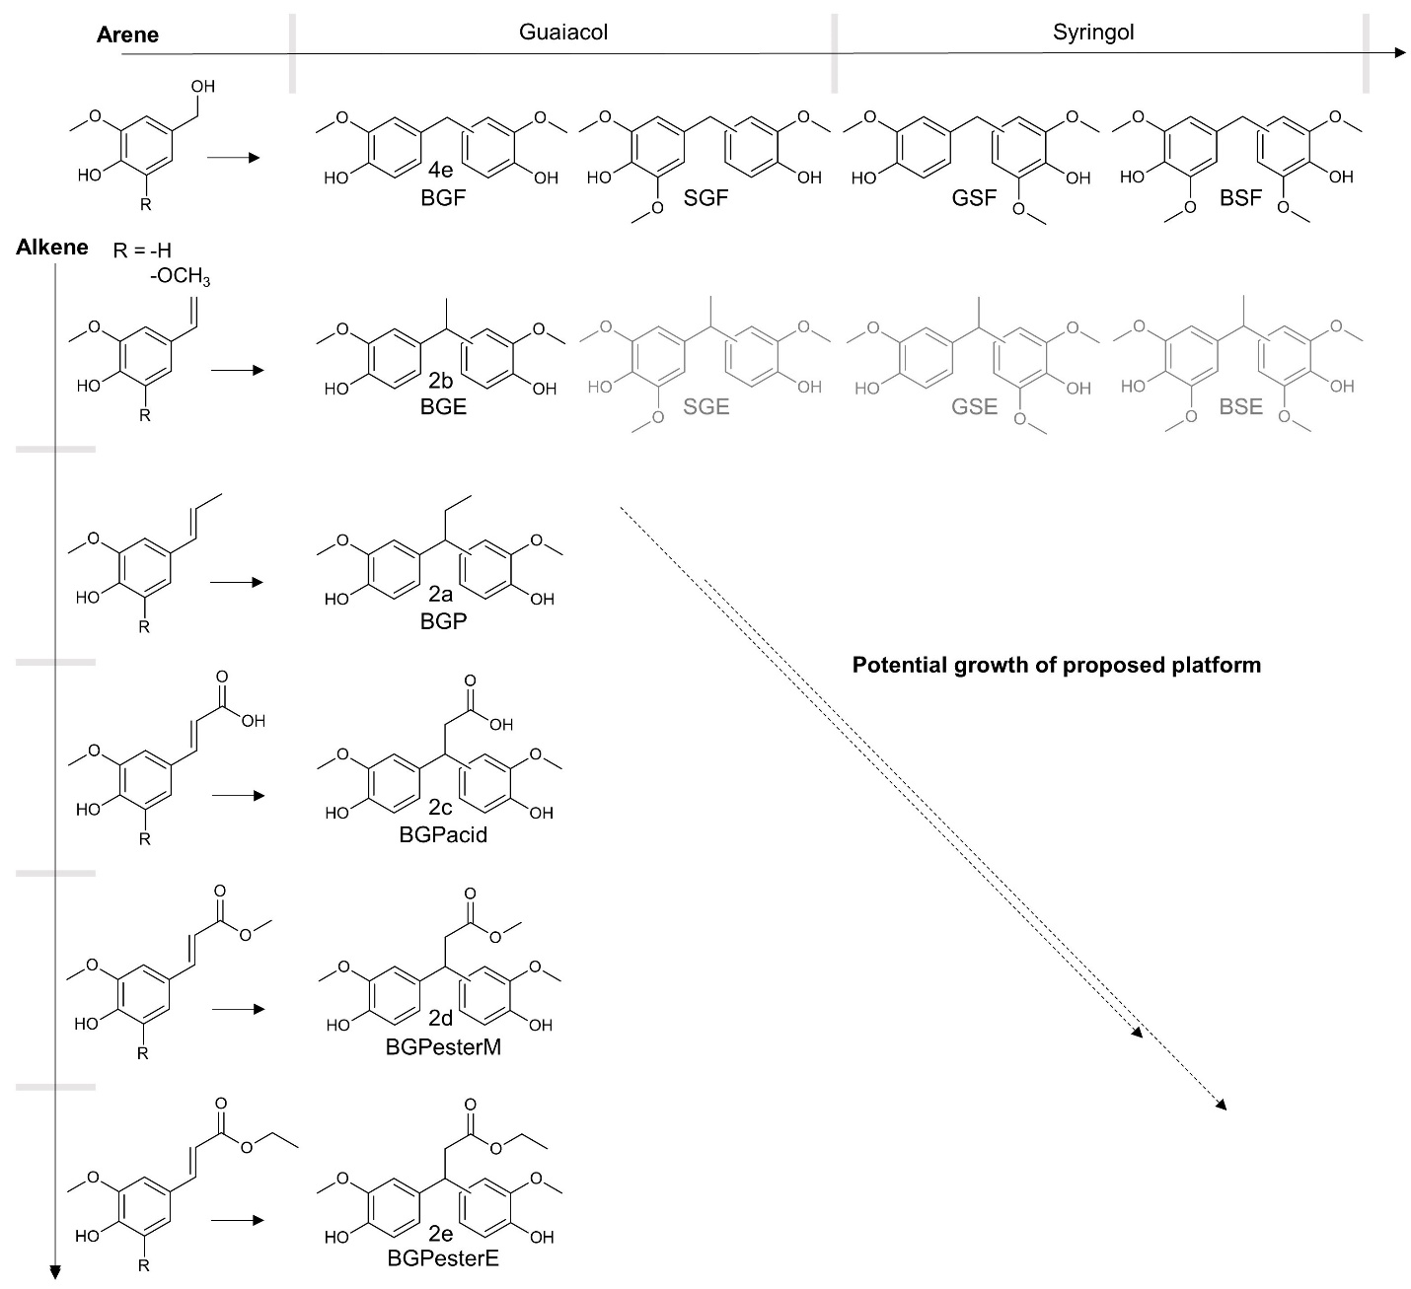
Fig. S1 | Conceptual illustration of the platform’s growth potential. (in black) State-of the art bisguaiacol F (4e) and the proof-of-concept bisguaiacols (2a-2e). (in grey) Demonstration of the platform growth potential with varying substrate choice.

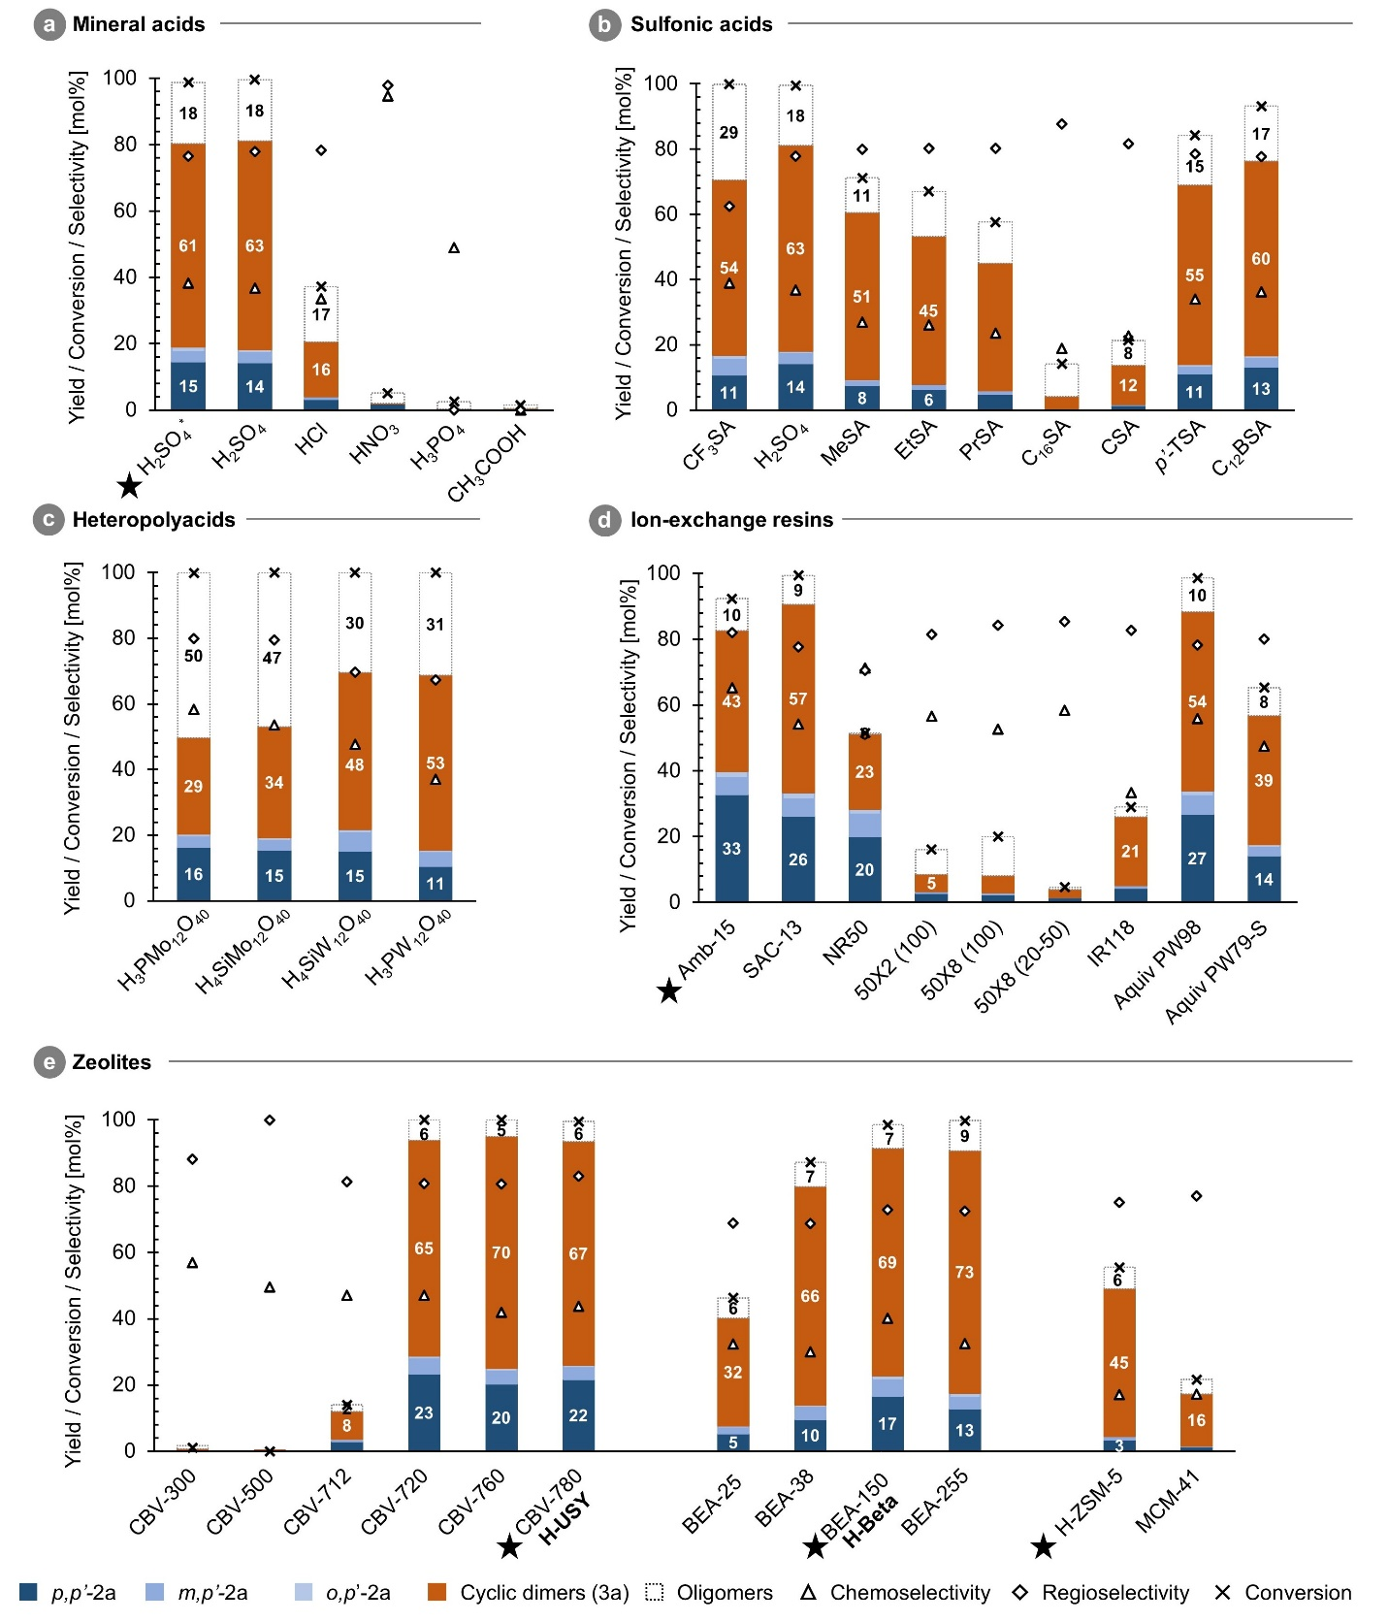
Fig. S2 | Catalyst screening for the alkylation of G with 1a in batch reaction set-up. Yield, conversion and selectivity for (a) mineral acids, with H₂SO₄* at 80 °C and others at 40 °C (0.05 mmol H⁺), (b) sulfonic acids (40 °C, 0.05 mmol H⁺), (c) (hetero)polyacids (40 °C, 0.05 mmol H⁺), (d) ion-exchange resins (80 °C, 0.1 mmol H⁺) and (e) zeolites (80 °C, 0.05 mmol H⁺). Reaction conditions: batch, 1 mmol 1a, 20 mmol G, 2 h and 750 rpm. Products quantified by GC-FID analysis after trimethylsilylation. (star) selected catalysts for FB mode (main text) and, if different, naming (bold). Catalyst abbreviations see chemicals and materials section (M1)
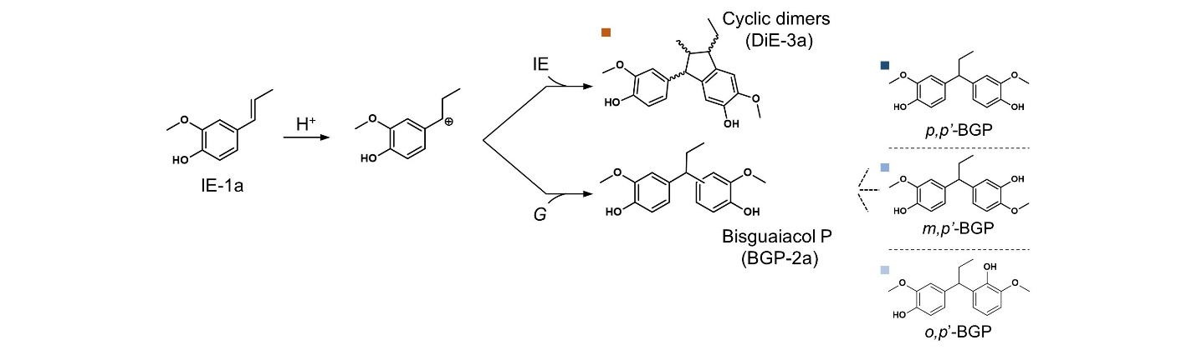
Fig. S3 | Reaction pathway and products. Molecular representations of the main reaction pathways and products.
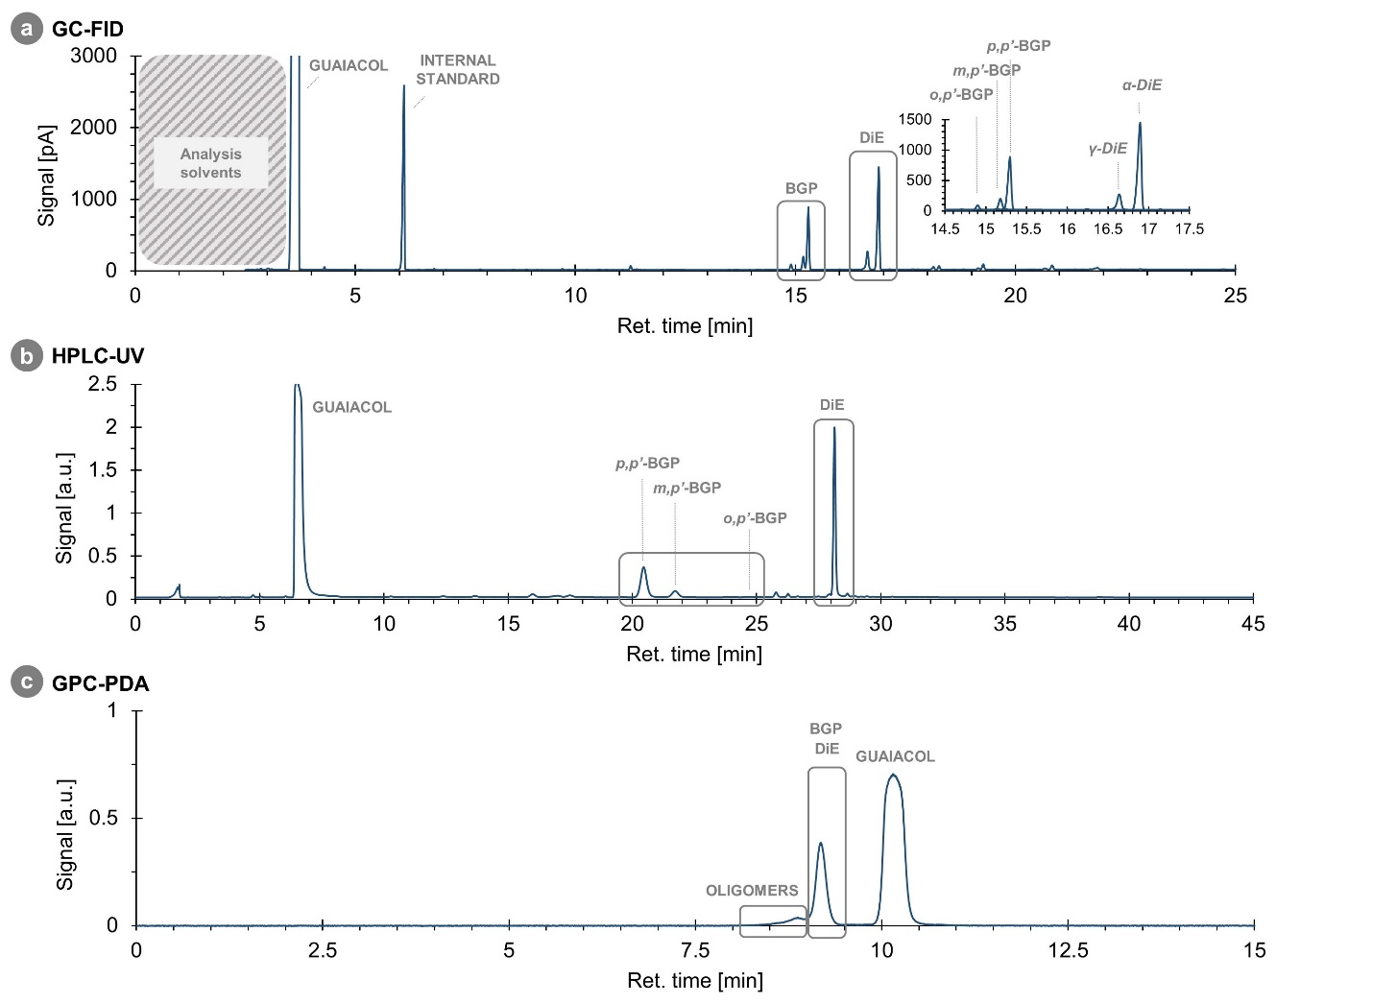
Fig. S4 | Reaction products for H₂SO₄ as detected by (a) GC-FID, (b) HPLC-UV and (c) GPC-PDA analysis. Derivatization by trimethylsilylation for GC-FID analysis. Reaction conditions: batch, 1 mmol 1a, 20 mmol G, 0.05 mmol H⁺ (H₂SO₄), 80 °C, 2 h and 750 rpm.

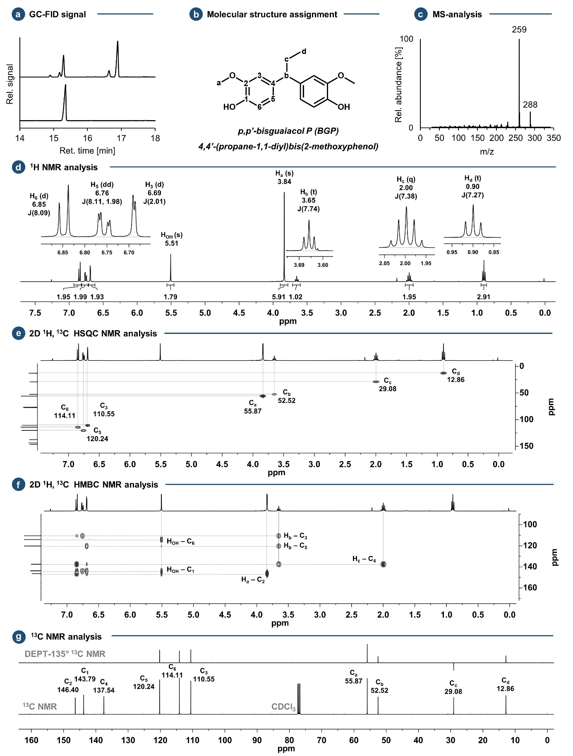
Fig. S5| Identification of p,p’-2a. (a) GC-FID chromatogram insets of (top) reaction mixture and (bottom) purified product, (b) molecular structure and C/H assignment, (c) mass spectra, (d) ¹H-NMR spectra, (e) 2D ¹H,¹³C-HSQC NMR spectra, (f) 2D ¹H,¹³C-HMBC NMR spectra and (g) ¹³C- and DEPT-135° ¹³C-NMR spectra (400 MHz).
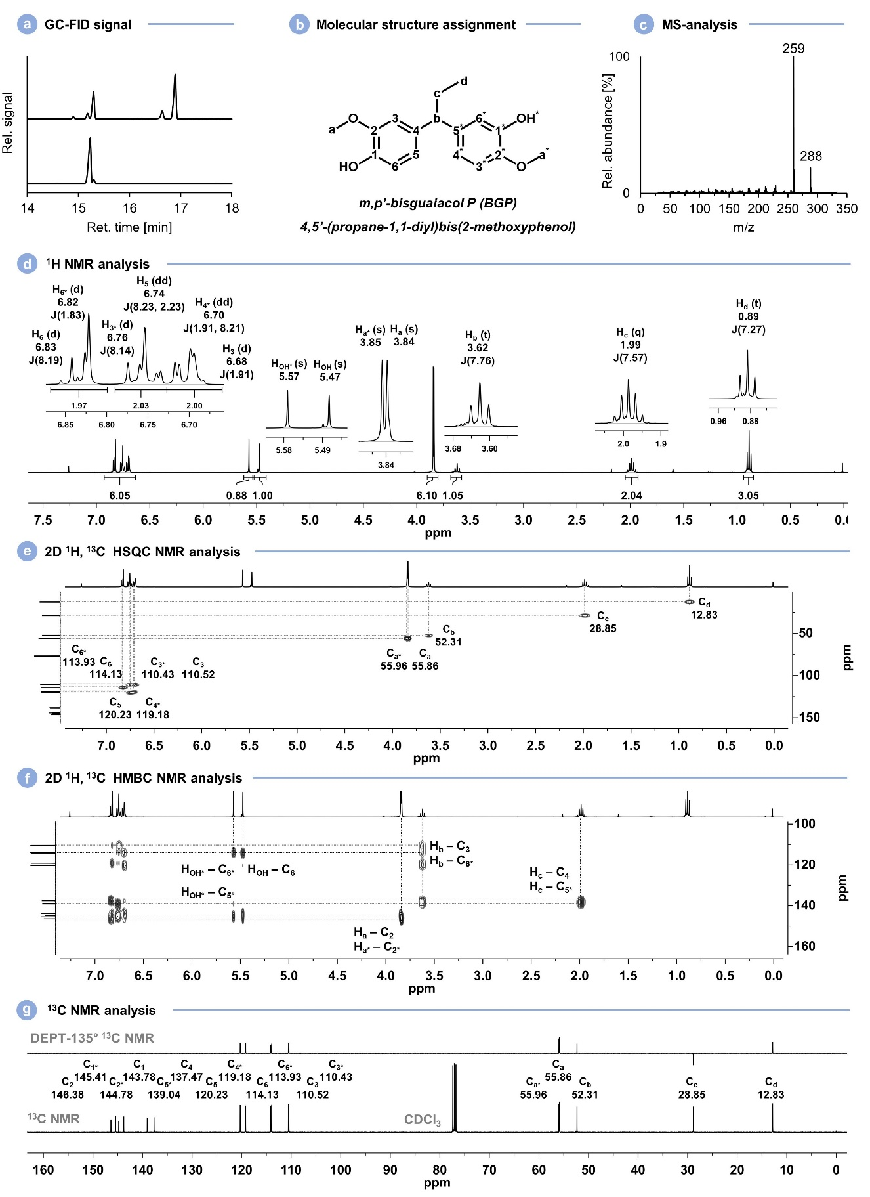
Fig. S6| Identification of m,p’-2a. (a) GC-FID chromatogram insets of (top) reaction mixture and (bottom) purified product, (b) molecular structure and C/H assignment, (c) mass spectra, (d) ¹H-NMR spectra, (e) 2D ¹H,¹³C-HSQC NMR spectra, (f) 2D ¹H,¹³C-HMBC NMR spectra and (g) ¹³C- and DEPT-135° ¹³C-NMR spectra (400 MHz).
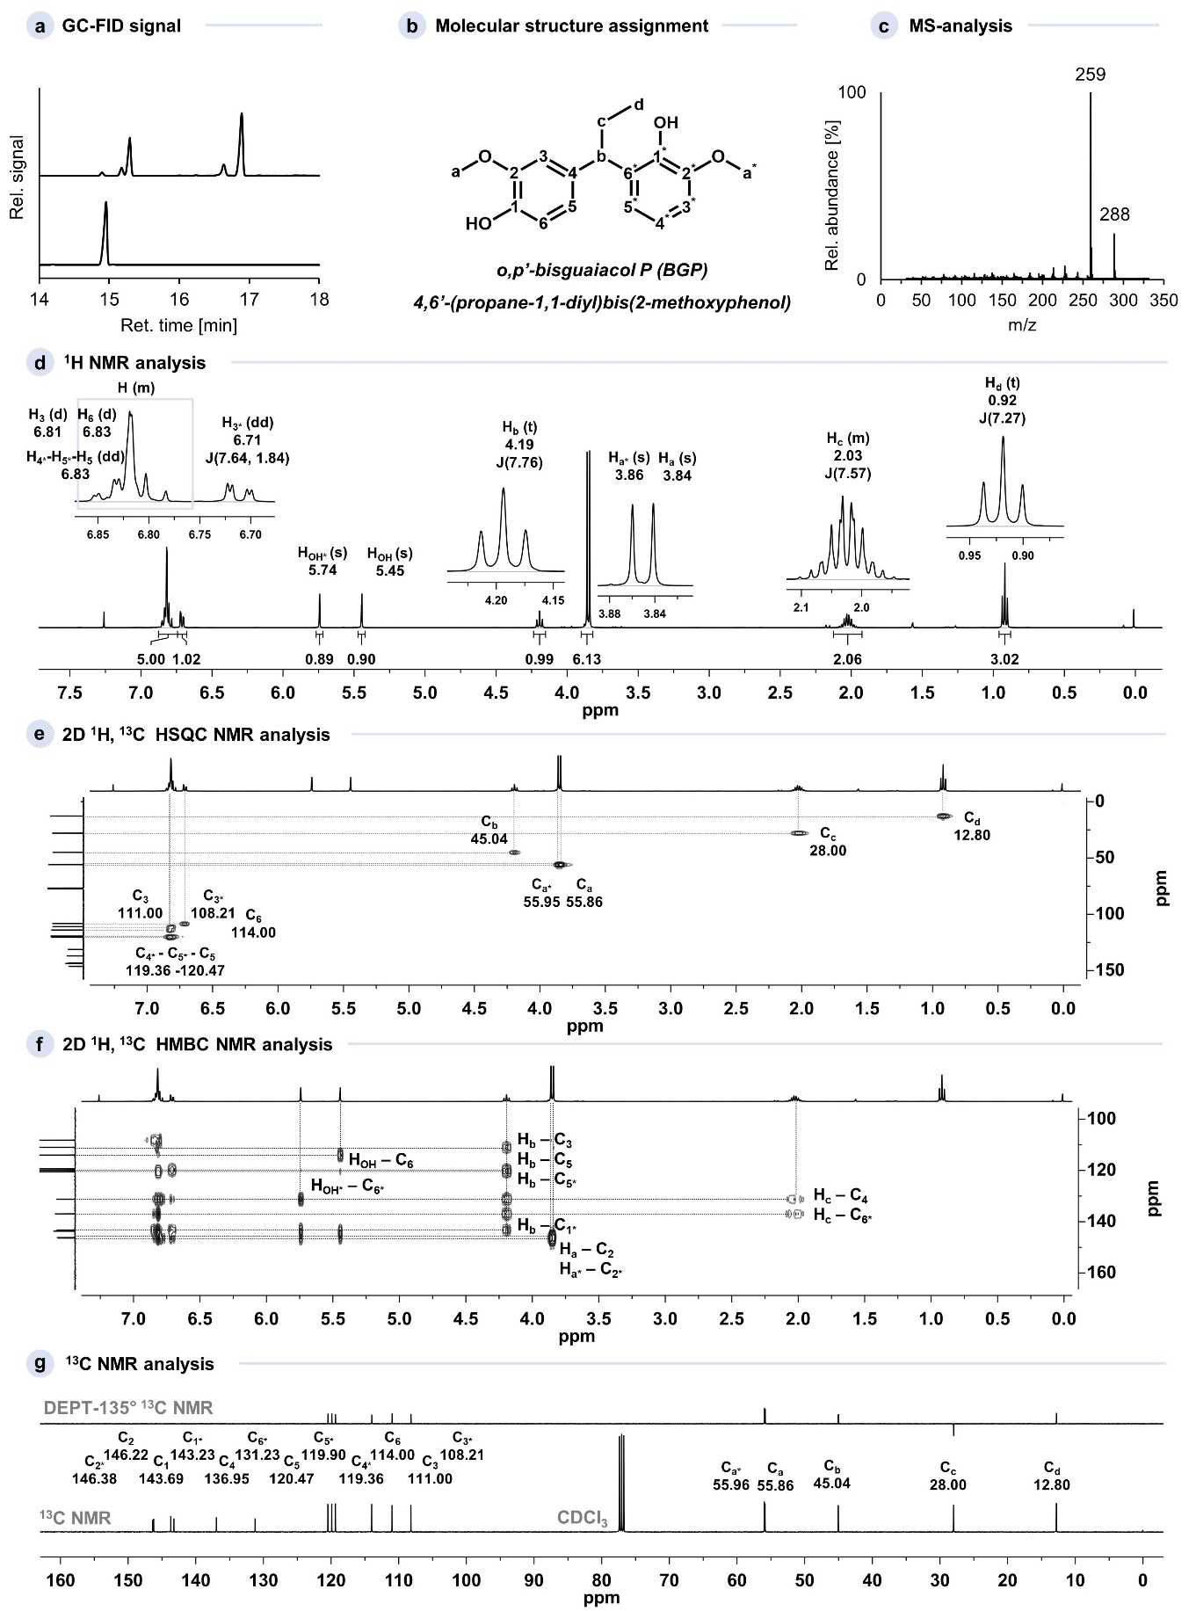
Fig. S7| Identification of o,p’-2a. (a) GC-FID chromatogram insets of (top) reaction mixture and (bottom) purified product, (b) molecular structure and C/H assignment, (c) mass spectra, (d) ¹H-NMR spectra, (e) 2D ¹H,¹³C-HSQC NMR spectra, (f) 2D ¹H,¹³C-HMBC NMR spectra and (g) ¹³C- and DEPT-135° ¹³C-NMR spectra (400 MHz).
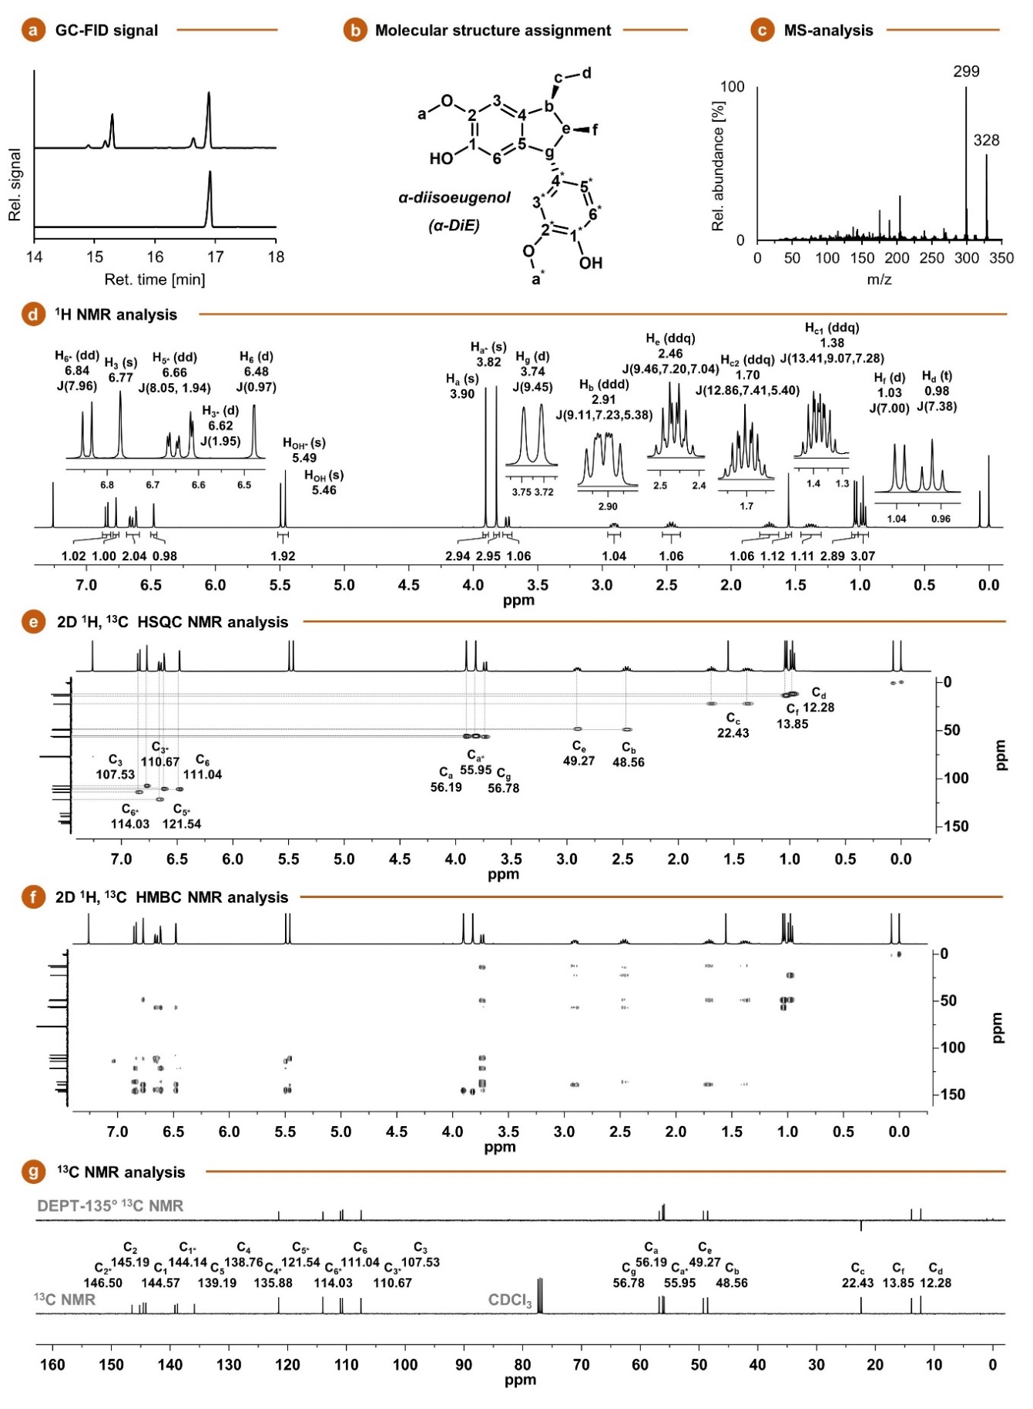
Fig. S8| Identification of α-3a. (a) GC-FID chromatogram insets of (top) reaction mixture and (bottom) purified product, (b) molecular structure and C/H assignment⁹, (c) mass spectra, (d) ¹H-NMR spectra, (e) 2D ¹H,¹³C-HSQC NMR spectra, (f) 2D ¹H,¹³C-HMBC NMR spectra and (g) ¹³C- and DEPT-135° ¹³C-NMR spectra (400 MHz).
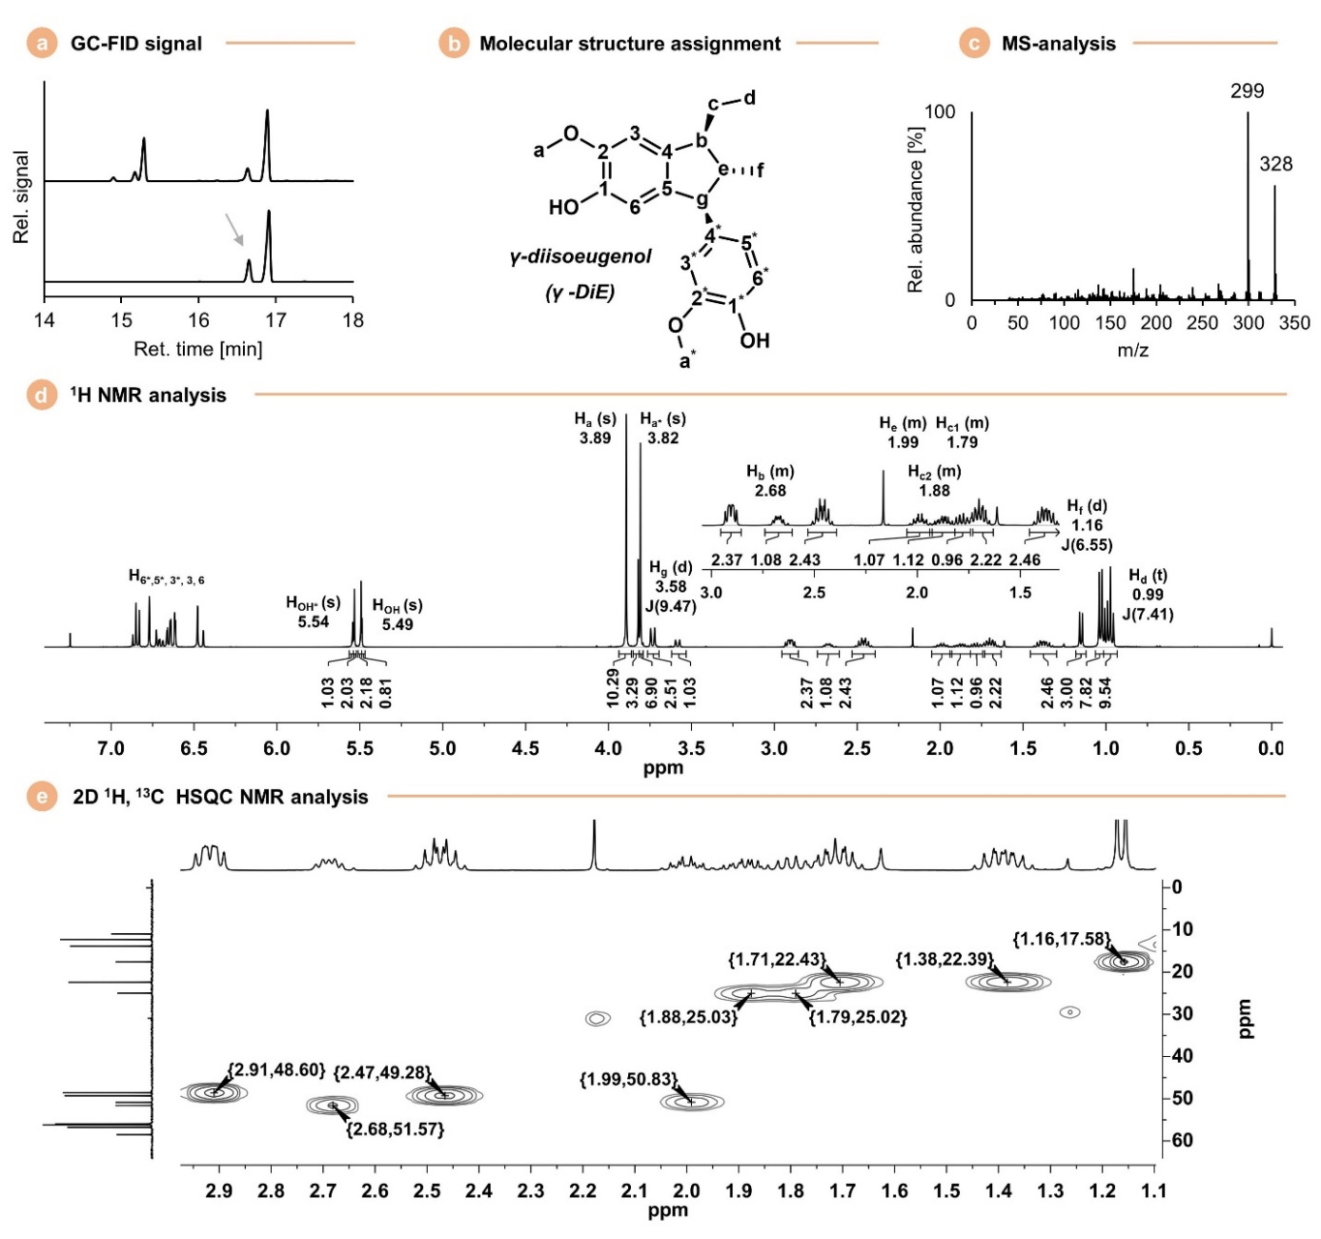
Fig. S9| Identification of γ-3a. (a) GC-FID chromatogram insets of (top) reaction mixture and (bottom) purified product, (b) molecular structure and C/H assignment, (c) mass spectra (d) ¹H-NMR spectra (e) 2D ¹H,¹³C-HSQC NMR spectra. The identification of the γ-diastereoisomer was based on the information provided by Alesso et al. (2003).¹⁰

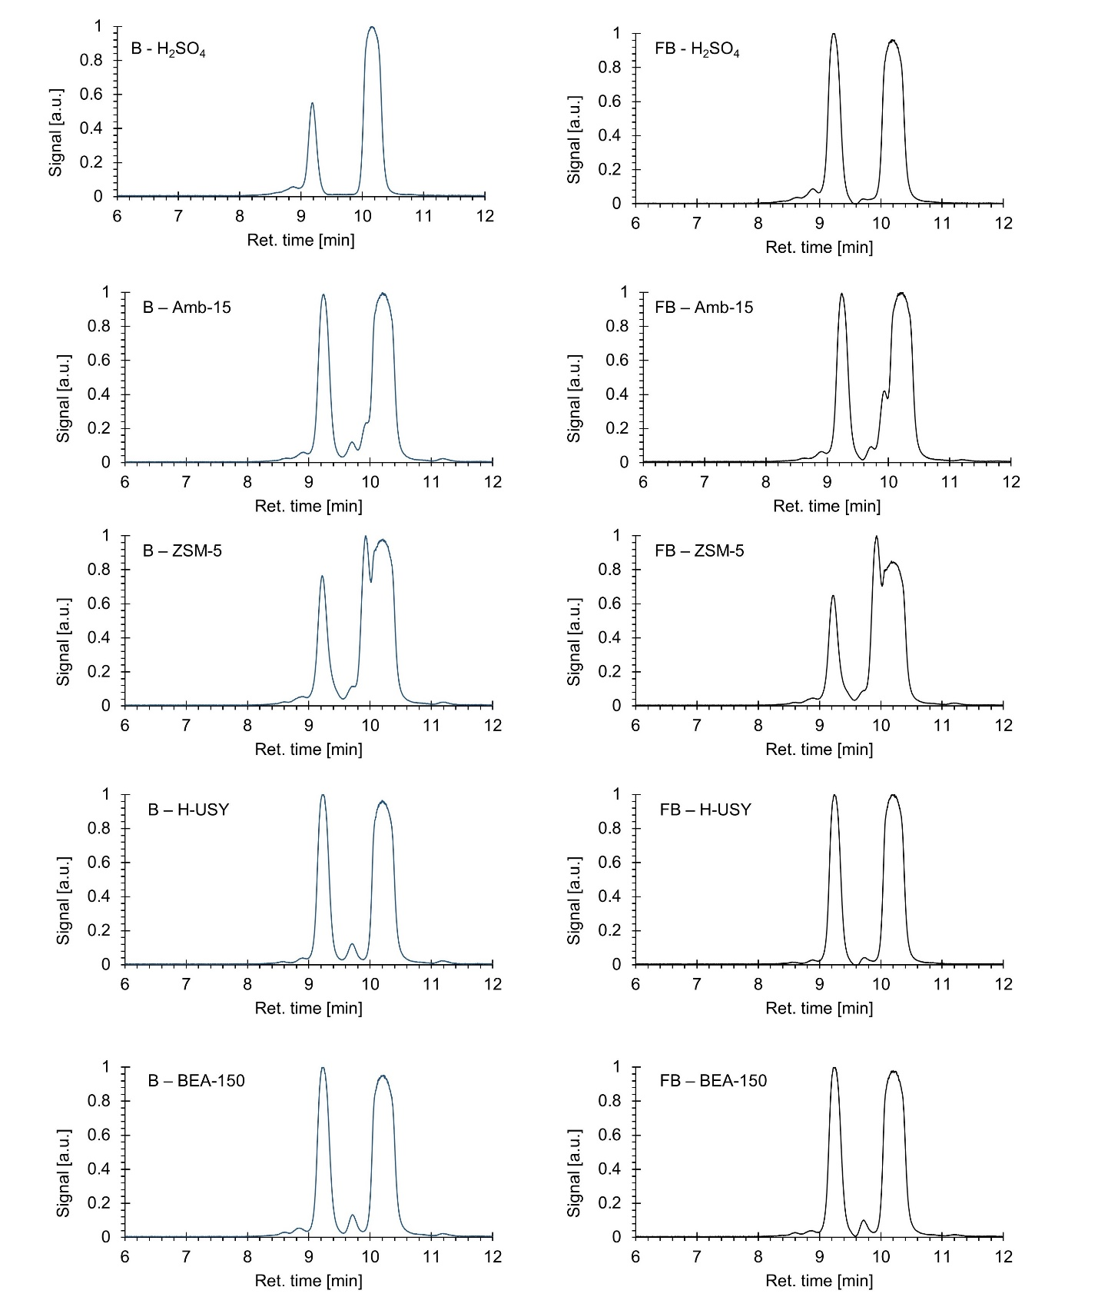
Fig. S10 | GPC-PDA chromatograms of selected reaction mixtures. GPC-chromatograms of the reaction mixture for different catalysts in a batch (left) fed-batch (right) reactor set-up. Reaction conditions: 1 mmol 1a, 20 mmol G, 0.05 mmol H⁺, 80 °C, 2 h and 750 rpm.

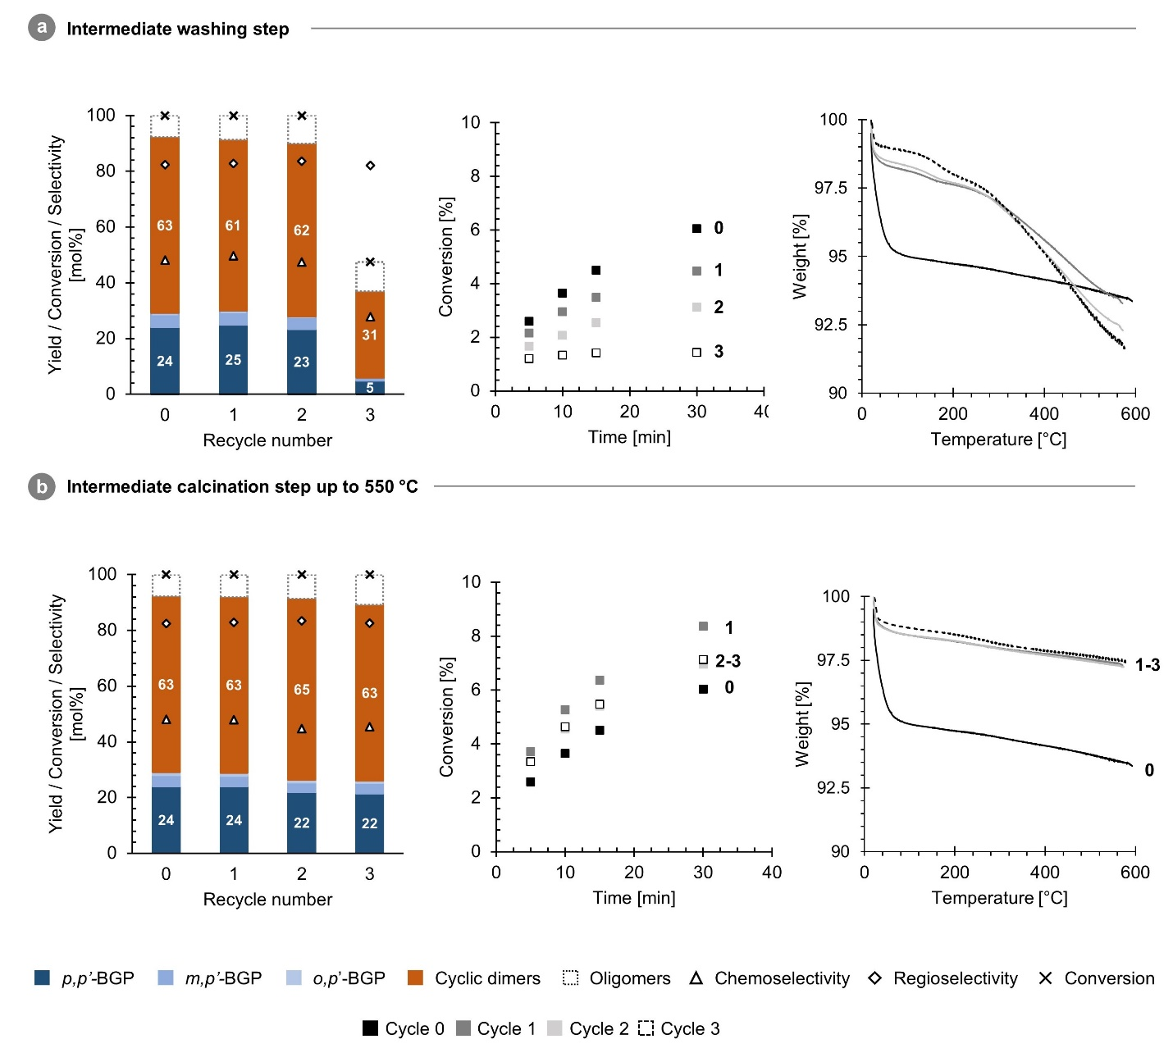
Fig S11 | Zeolite H-USY regeneration by (a) intermediate washing with acetone and (b) intermediate washing with acetone followed by calcination. (left) Product distribution after 2 h reaction in batch set-up (1 mmol 1a, 20 mmol G, 0.05 mmol H⁺, 80 °C, 2 h, 750 rpm), (middle) Conversion in function of time (5-30 min) in batch set-up. (1 mmol 1a, 20 mmol G, 0.005 mmol H⁺, 80 °C, 5-30 min, 750 rpm), (right) TGA of the zeolite catalyst after reaction at full conversion. Regeneration procedures: a) washing with acetone, drying at 80 °C and air-equilibration for 5 days, b) washing with acetone, drying at 80 °C, calcination for 6 h at 550 °C (heating at 1°C·min⁻¹) and air-equilibration for 5 days. No calcination of the fully air-equilibrated zeolite catalyst before cycle 0.
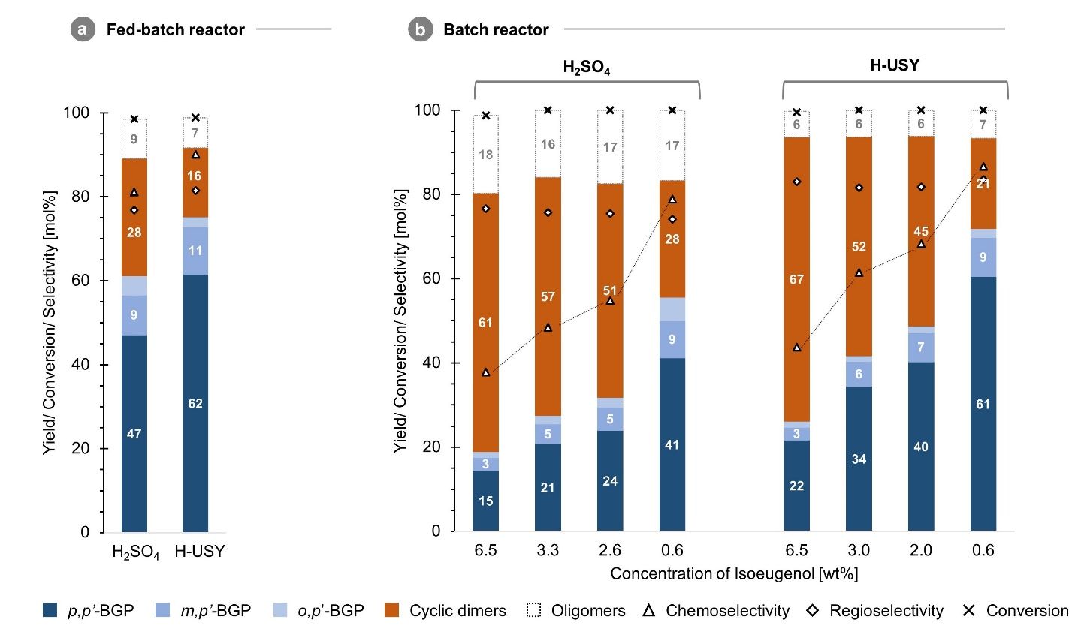
Fig. S12 | Diluted batch, simulated fed-batch for H₂SO₄ and H-USY. (a) Yield, conversion and selectivity in fed-batch set-up. (b) Yield, conversion and selectivity for simulated fed-batch set-up by performing batch reactions with varying initial 1a concentrations. Reaction conditions: 0.125 to 1 mmol 1a, 20 mmol G, 0.05 mmol H⁺, 80 °C, 2 h and 750 rpm.

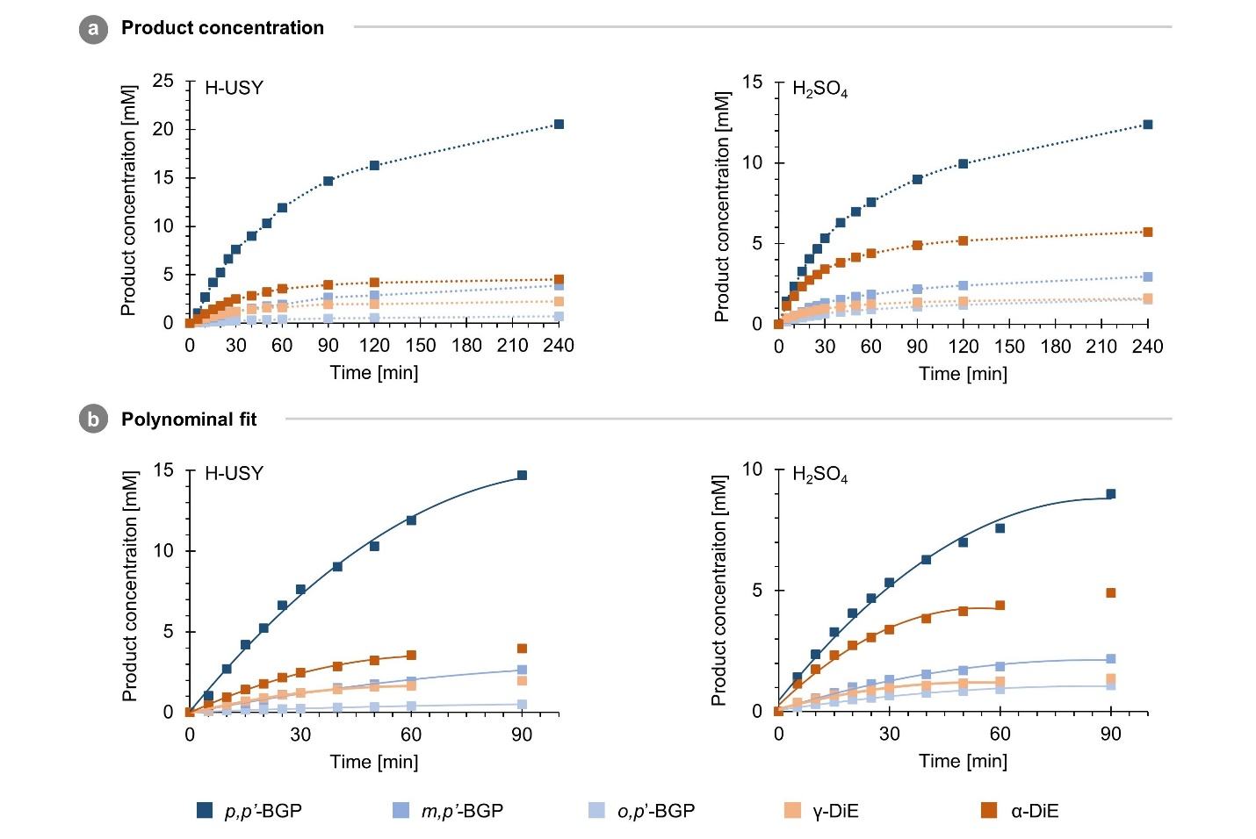
Fig S13 | Product concentration in time and polynomial fit. (a) Product concentration (mM) in time (min) for all reaction products. Reaction conditions: 1.5 mmol 1a, 200 mmol G, 0.015 mmol H⁺, 80 °C and 750 rpm. (b) Polynomial fit according to P(t) = at² + bt + c with parameters a, b and c provided in Table S1.
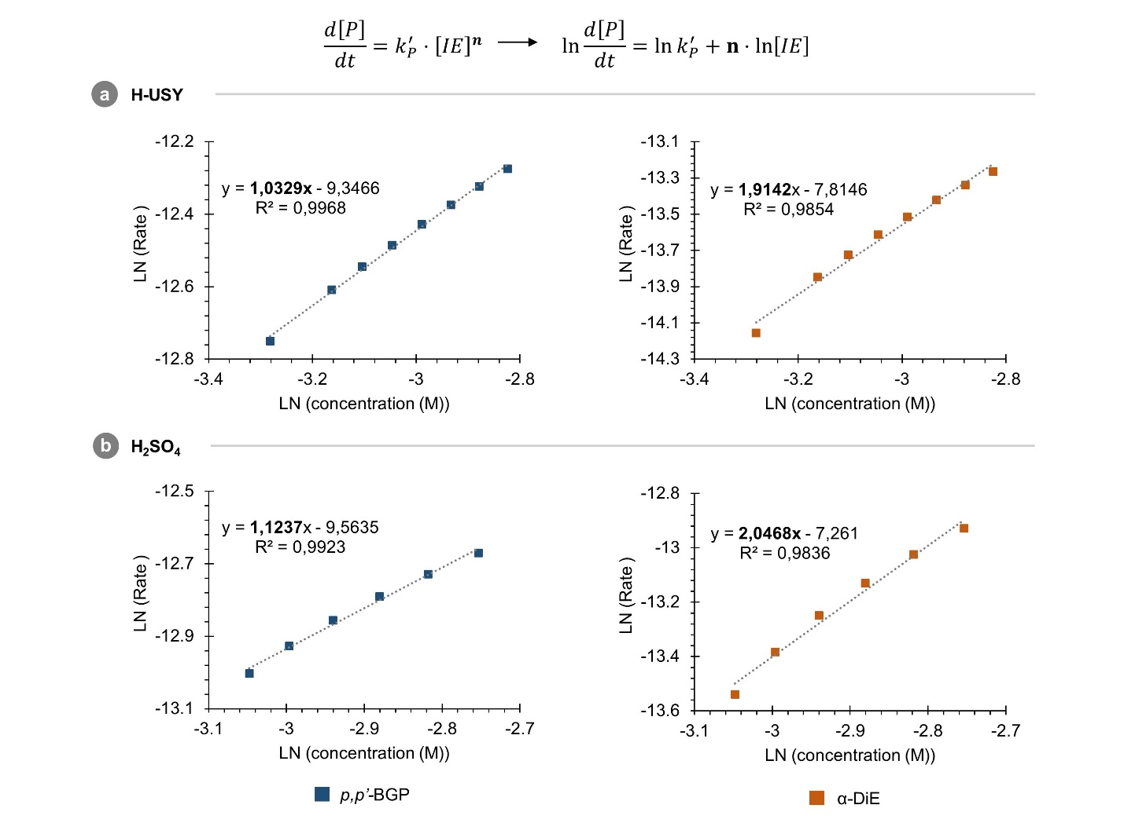

Fig. S14 | Reaction order in 1a – differential method. The reaction order extracted from the plot: ln(rate) in function of ln([1a]) for p,p’-2a and α-3a in the presence of (a) H-USY and (b) H₂SO₄. Rate: $\frac{d[P]}{dt}=2at+b$.

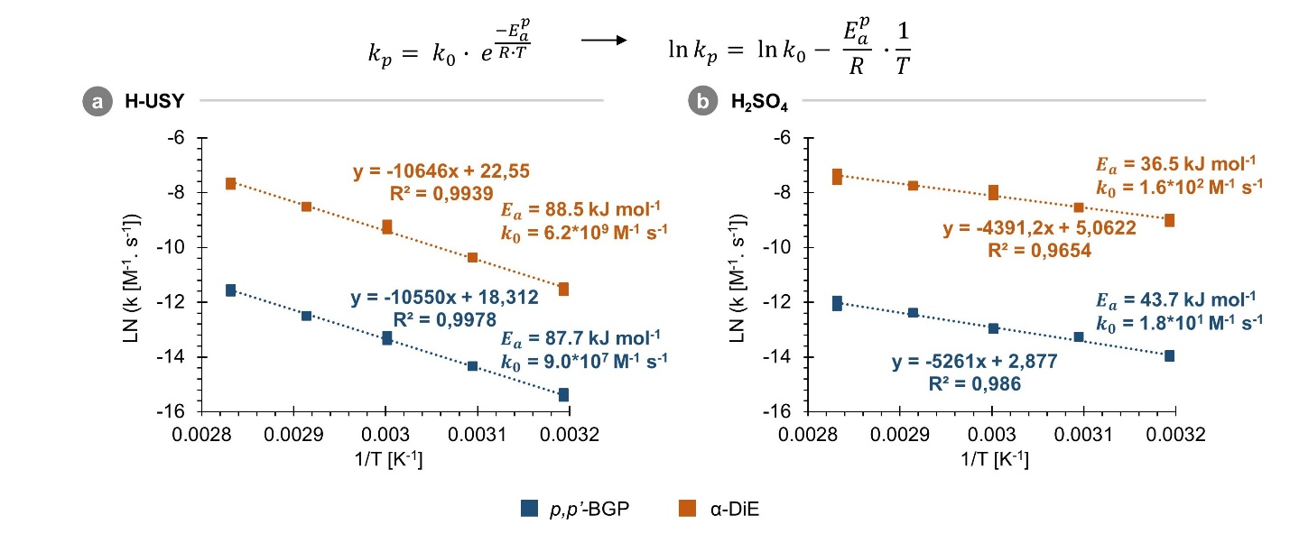
Fig. S15| Arrhenius plots. Ln($k_{p}$(M⁻¹s⁻¹)) in function of 1/T (K⁻¹) with $k_{p}$ the product rate constant (M⁻¹s⁻¹) and $E_{a}^{p}$ the observed product activation energy (kJ mol⁻¹).

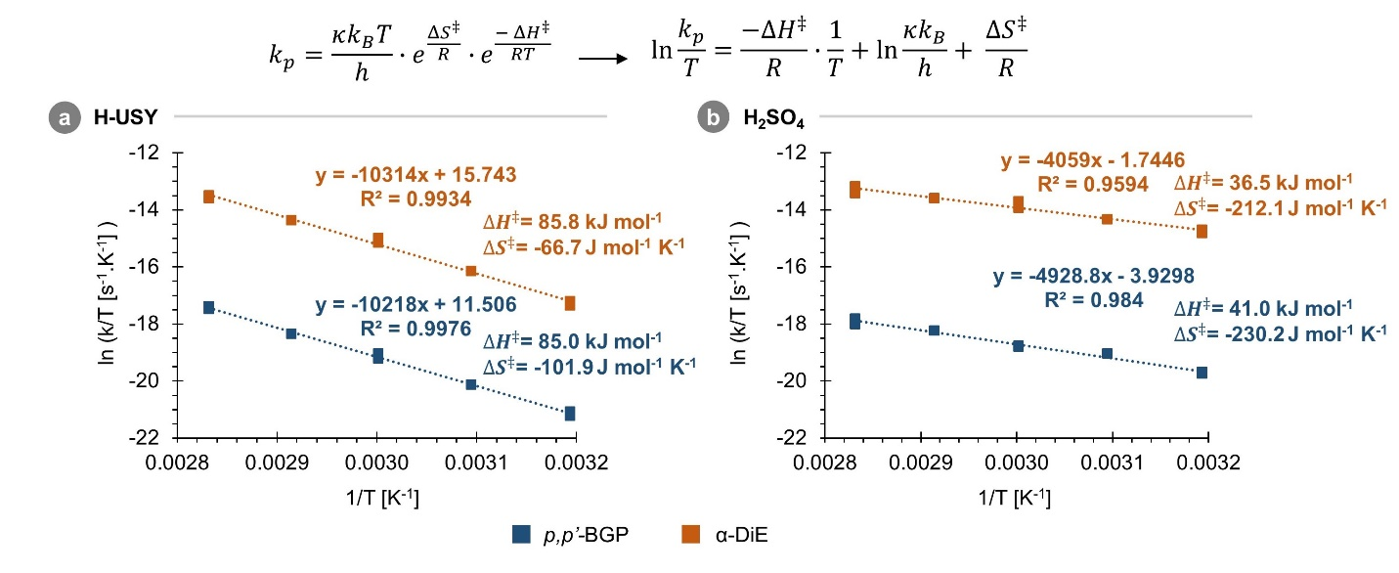
Fig. S16 | Eyring plots. Ln($k_{p}/T$(s⁻¹K⁻¹)) in function of 1/T (K⁻¹) with $k_{p}$ the standardized¹¹ product rate constant (s⁻¹), $∆S^{‡}$ the standard entropy and $∆H^{‡}$ the standard enthalpy of activation related to the transition state of the reaction.

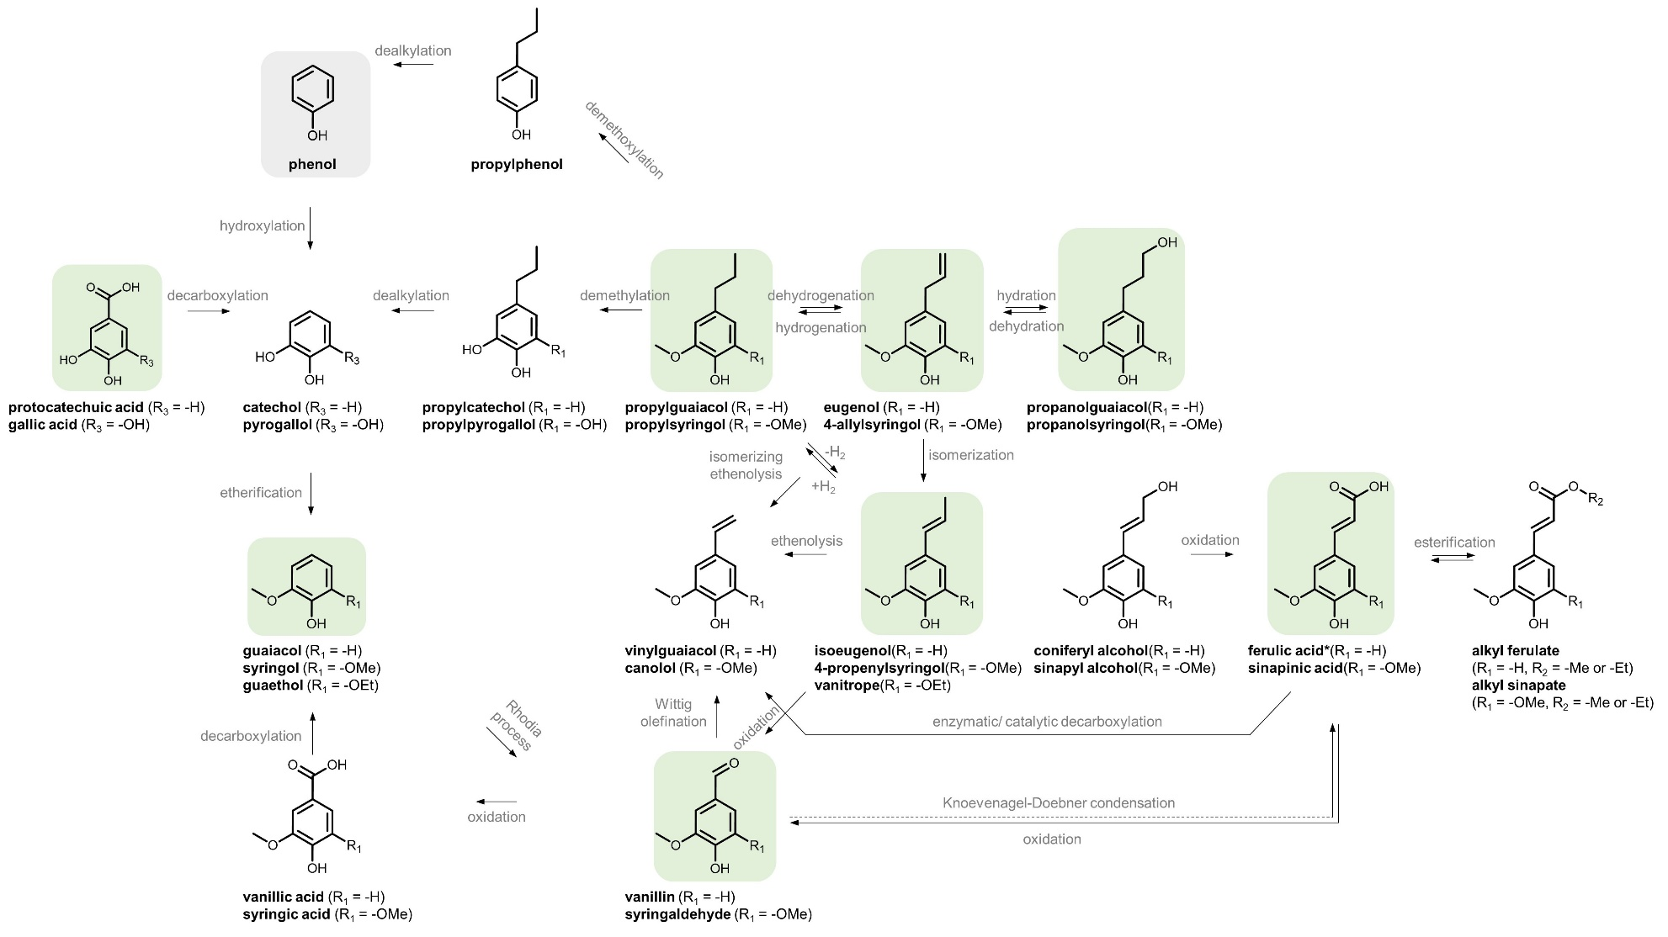
Fig. S17 | Overview of interconnected plant-based aromatic alkene. Representation of different, interconnected, chemical processes to form aromatic alkenes from starting compounds via a petrochemical and different biochemical route(s). Starting from a petroleum-based compound (in grey) or different bio-based compounds (in green).^{12–21}

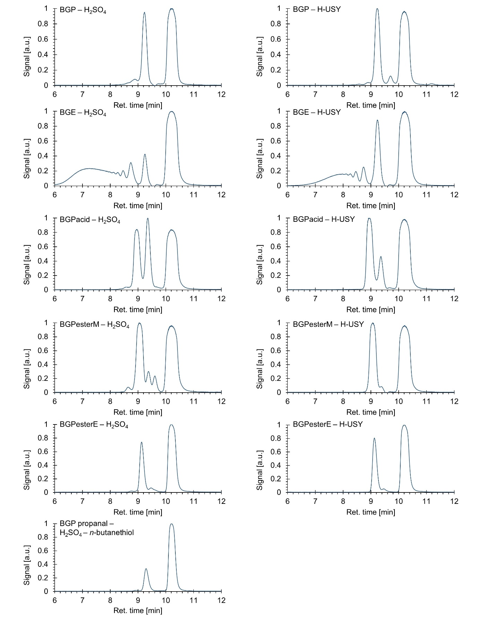Fig. S18 | GPC-PDA chromatograms of reaction with various plant-based aromatic alkenes in B mode. Reaction conditions: 1 mmol alkene (1a-e) or propanal, 20 mmol G, 0.05 mmol H⁺, 750 rpm, 80 °C, 2 h and 750 rpm.
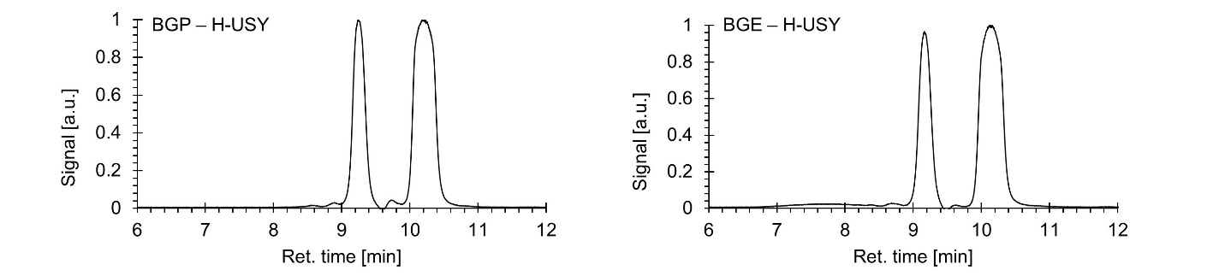
Fig. S19 | GPC-PDA chromatograms of reactions with 1a (left) and 1b (right) in FB mode. Reaction conditions: 1 mmol·h⁻¹ alkene, 20 mmol G, 0.05 mmol H⁺, 80 °C, 2 h and 750 rpm.
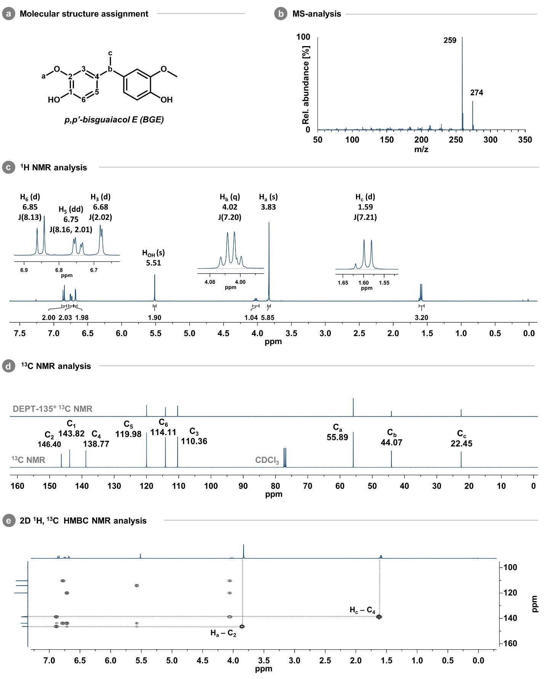Fig. S20 | Identification and full characterization of p,p’-2b. (a) Molecular structure and H/C assignments, (b) Mass spectra (c) ¹H-NMR spectra, (d) ¹³C-NMR and dept-135° ¹³C-NMR spectra, (e) 2D ¹H,¹³C HMBC NMR spectra (400MHz).
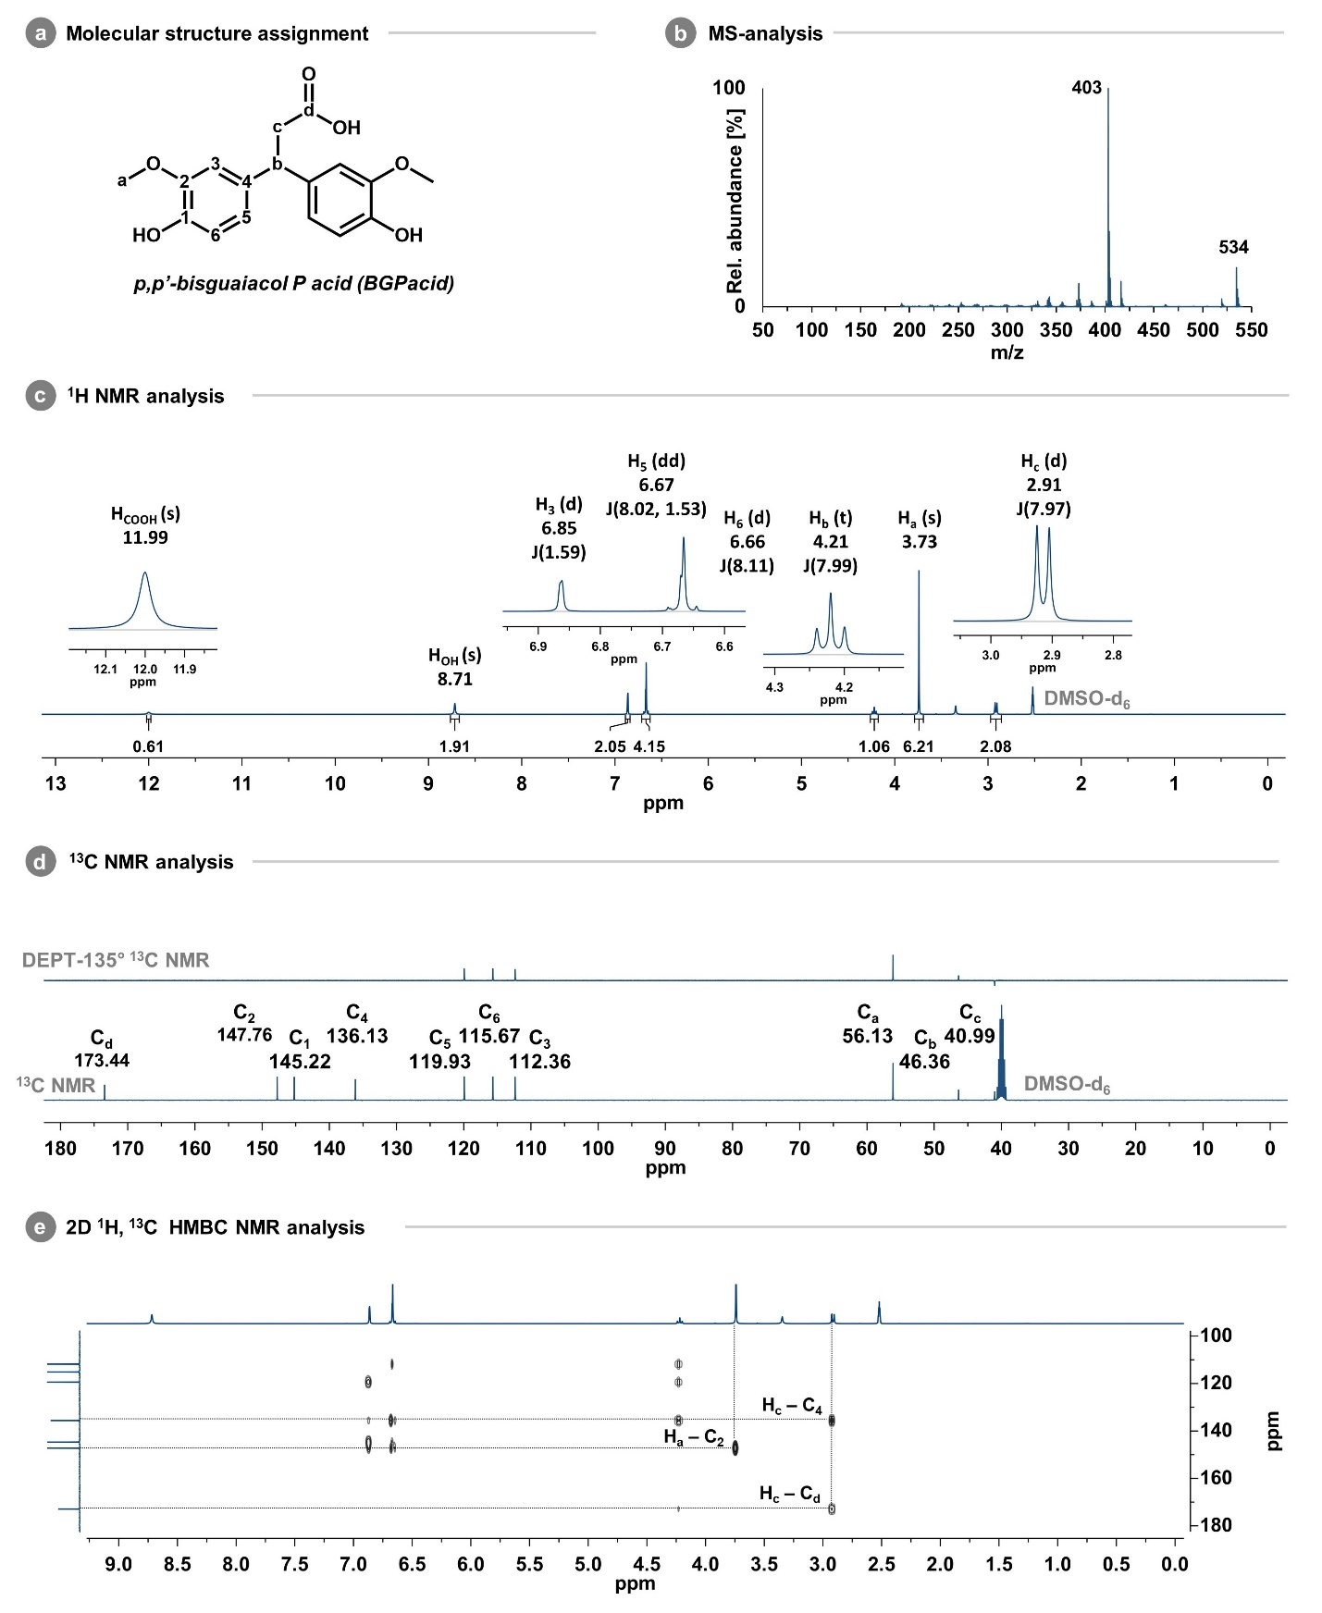
Fig. S21 | Identification and full characterization of p,p’-2c. (a) Molecular structure and H/C assignments, (b) Mass spectra (c) ¹H-NMR spectra, (d) ¹³C-NMR and dept-135° ¹³C-NMR spectra, (e) 2D ¹H,¹³C HMBC NMR spectra (400MHz).
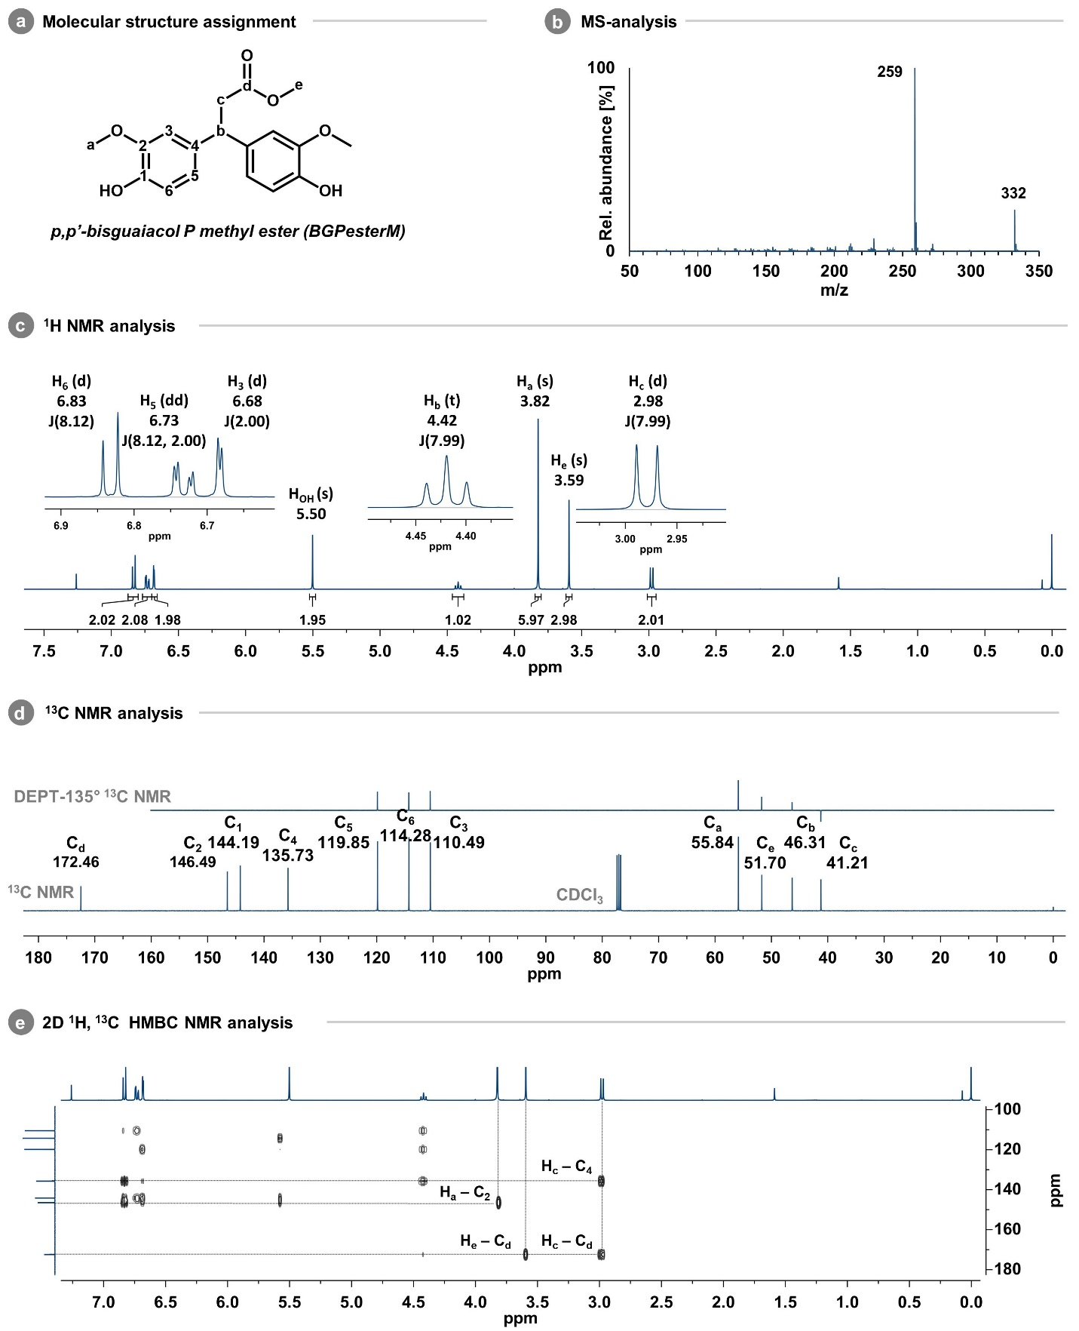Fig. S22 | Identification and full characterization of p,p’-2d. (a) Molecular structure and H/C assignments, (b) Mass spectra (c) ¹H-NMR spectra, (d) ¹³C-NMR and dept-135° ¹³C-NMR spectra, (e) 2D ¹H,¹³C HMBC NMR spectra (400MHz).

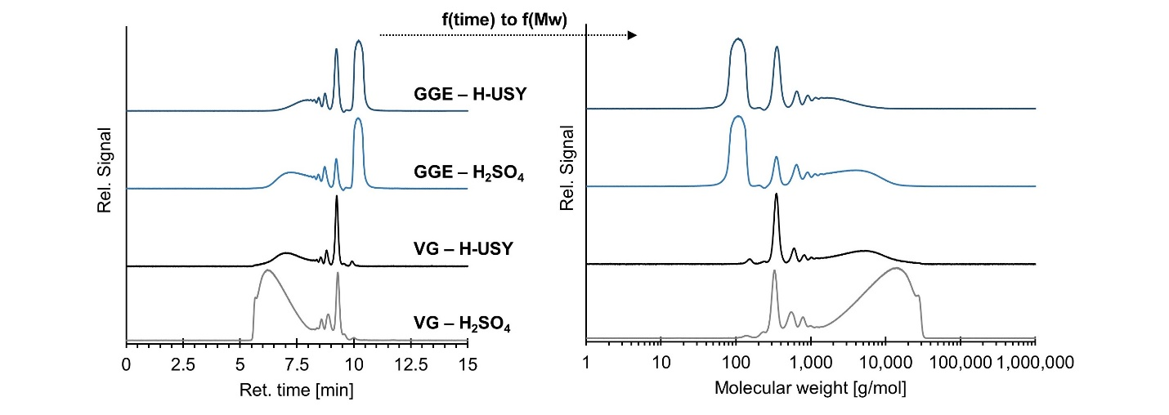
Fig. S23 | Transformation of GPC-PDA data in function of retention time [min] to molecular weight [g.mol⁻¹] for selected reaction with 1b to determine the major reaction pathway towards oligo-/polymerization: reaction of 1b in absence (black) or presence (blue) of G catalyzed by either H-USY (dark) or H₂SO₄ (light). Reaction conditions: 1 mmol of 1b, 20 mmol G or in acetonitrile (ACN), 0.05 mmol H⁺, 80 °C, 2 h and 750 rpm. GPC-PDA data were calibrated using polystyrene molecular weight standards as a reference. Notice the distinct difference in oligo-/polymer MW for H-USY (up to 8 kg mol⁻¹) compared to H₂SO₄ (up to 15 kg mol⁻¹).
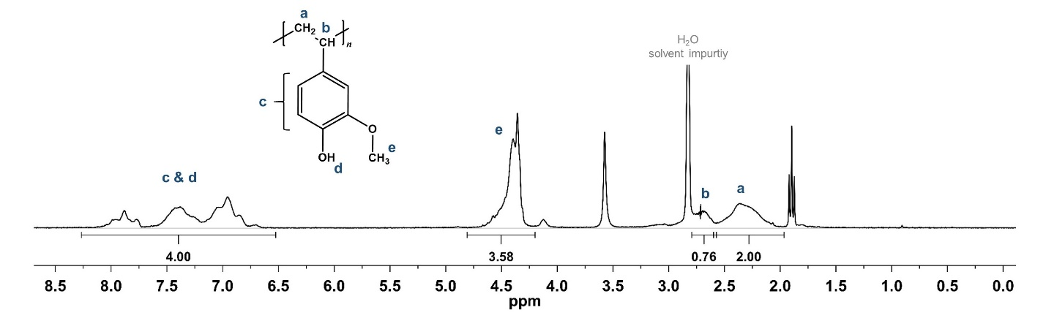
Fig. S24| ¹H-NMR spectra of poly(4-vinylguaiacol) in (CD₃)₂CO at 400 MHz. Reaction mixture after reaction of 1b in acetonitrile (ACN) in the presence of H₂SO₄. The major resonances were assigned to poly(4-vinylguaiacol) based on Leisch et al. (2013)¹⁴ and Takeshima et al. (2017).²² Reaction conditions: 1 mmol of 1b, excess of ACN, 0.05 mmol H⁺, 80 °C, 2 h and 750 rpm.

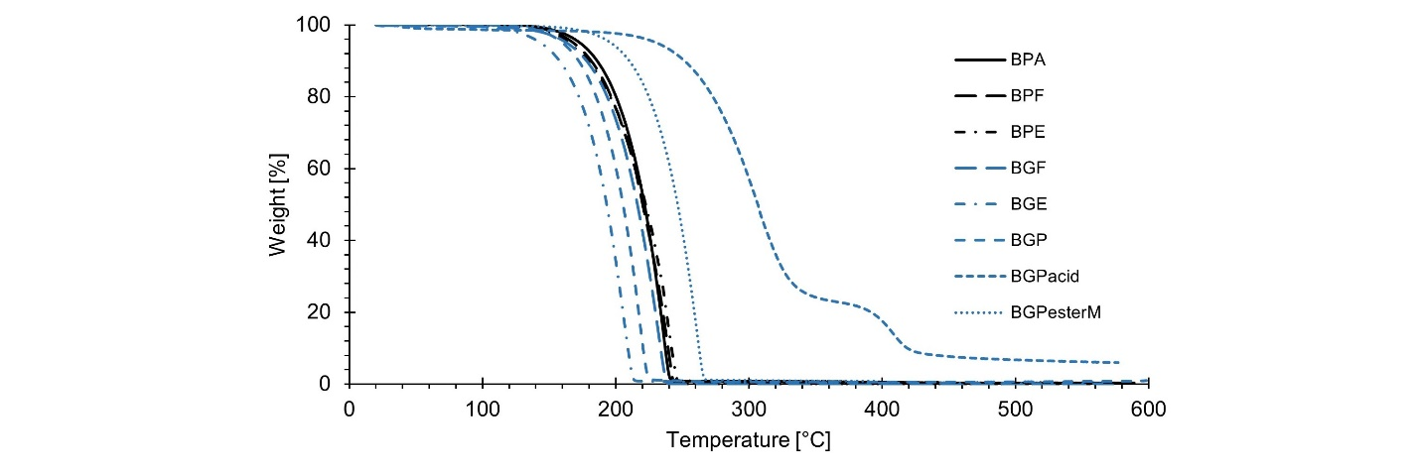
Fig. S25 | TGA data of the industrial bisphenols (4a-c), the state-of-the-art bisguaiacols (4d-c) and the extended bisguaiacol platform (2a-d). Analysis conditions: heating up to 600 ºC at 10 °C·min⁻¹ under N₂ atmosphere.
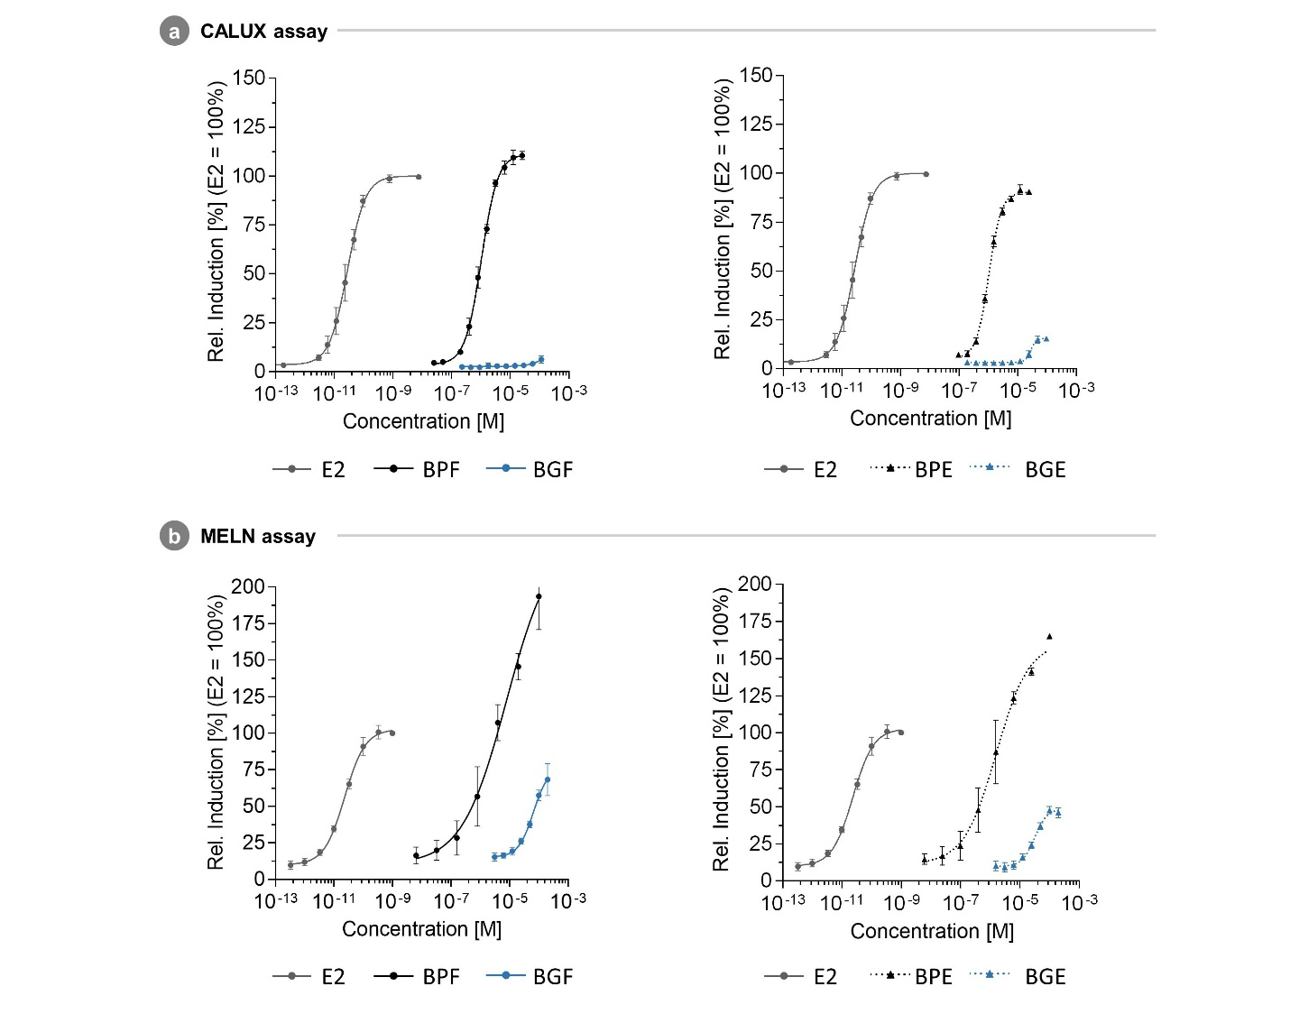
Fig. S26 | Concentration-response curves of E2-BPE-BGE and E2-BPF-BGF. Relative induction to E2 of analogous compounds BPE (4c) –BGE (2b) and BPF (4b) –BGF (4e) in (a) the CALUX assay and (b) the MELN assay.
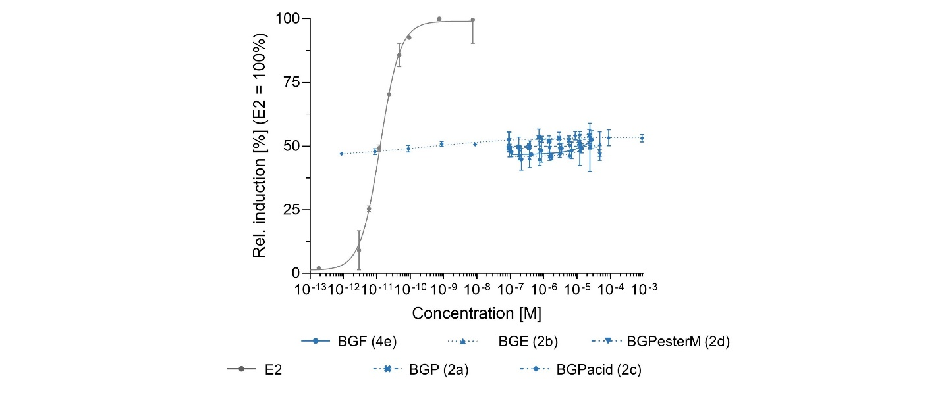
Fig. S27 | In vitro antagonist hERα bioassay. Relative induction to E2 in presence of EC₅₀ concentration of E2 in an antagonist CALUX bioassay.
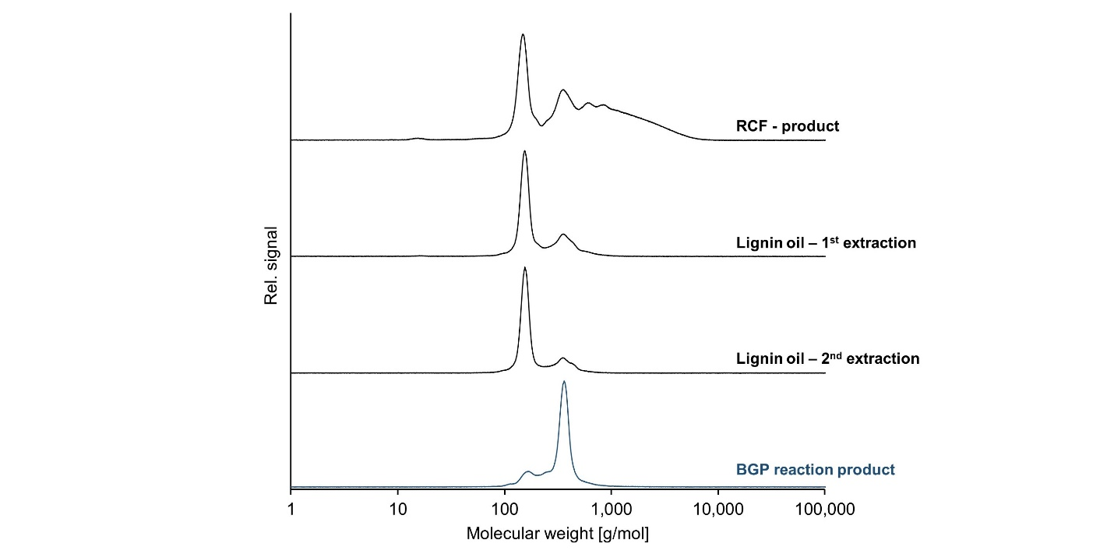
Fig. S28 | GPC-PDA chromatograms after each unit operation. (top) Product mixture resulting from RCF of softwood. (middle) Product mixture after the first and second extraction. (bottom, in blue) Product mixture resulting from H-USY-catalysed alkylation of G with the crude 2nd extract (after distillation). See methods section for RCF, extraction and reaction conditions.
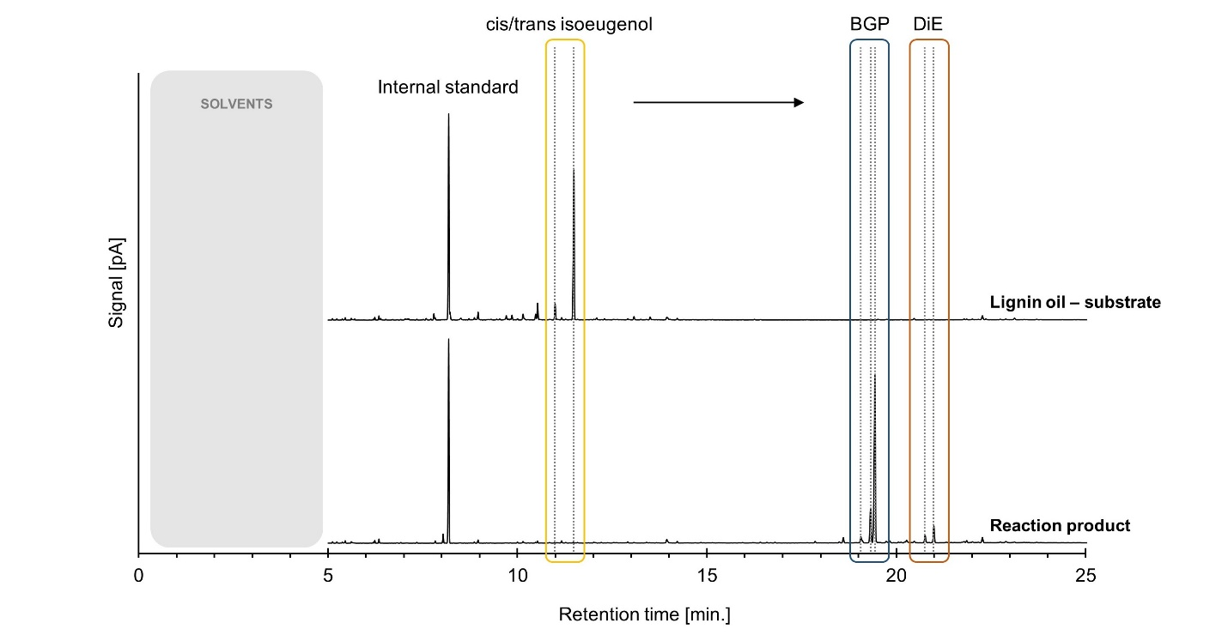
Fig. S29 | GC-FID chromatograms of lignin oil extract and the product mixture after alkyation with indication of 2-isopropylphenol (internal standard), cis-/trans-isoeugenol (in yellow), bisguaiacols (2a, in blue) and cyclic dimers (3a, orange). The standard dimer GC-FID measuring method was adapted to improve the monomer analysis (e.g., resolution), a more detailed description of the temperature program is provided in the experimental section.

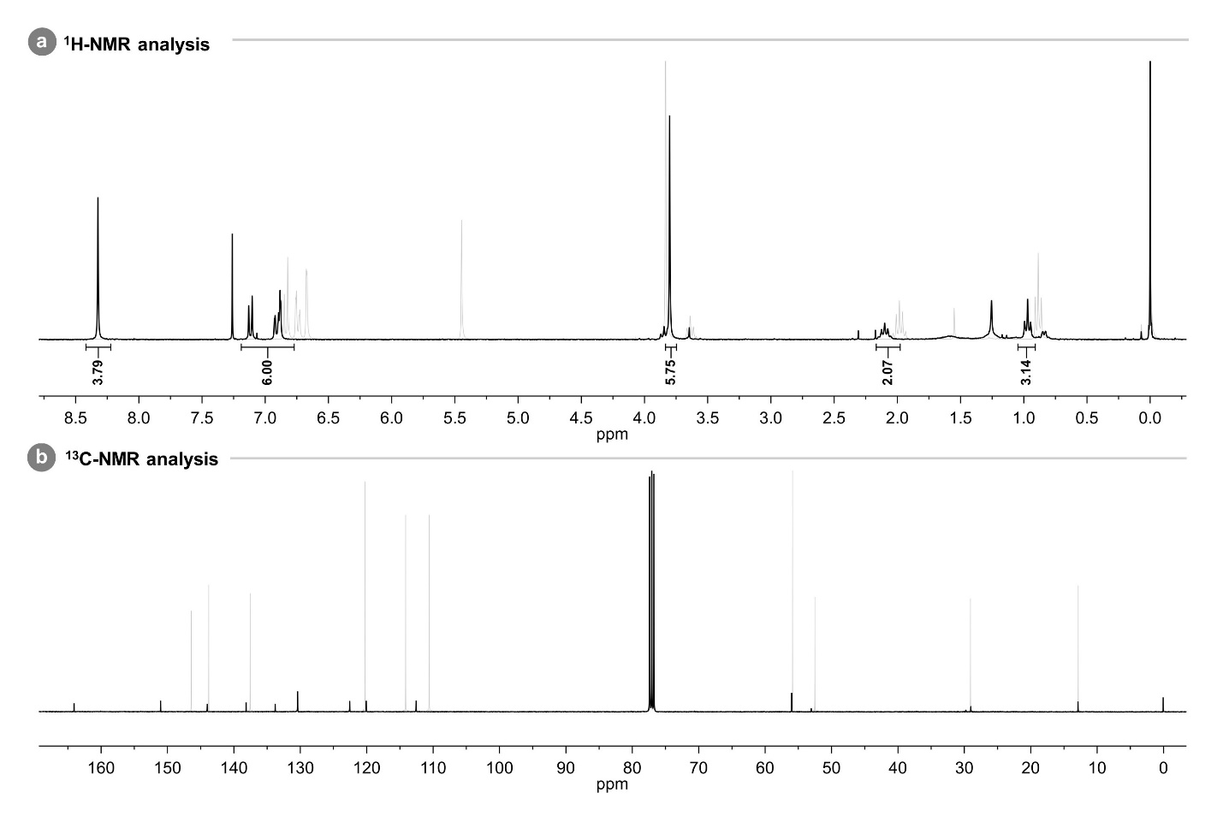
Fig. S30 |¹H-NMR and ¹³C-NMR of Poly(2a-terephthalate). Superimposed representation of the (a) ¹H-NMR (300 MHz) and (b) ¹³C-NMR (400 MHz) spectra of 2a-PT (black) and 2a (light grey). CDCl₃ used as NMR solvent.
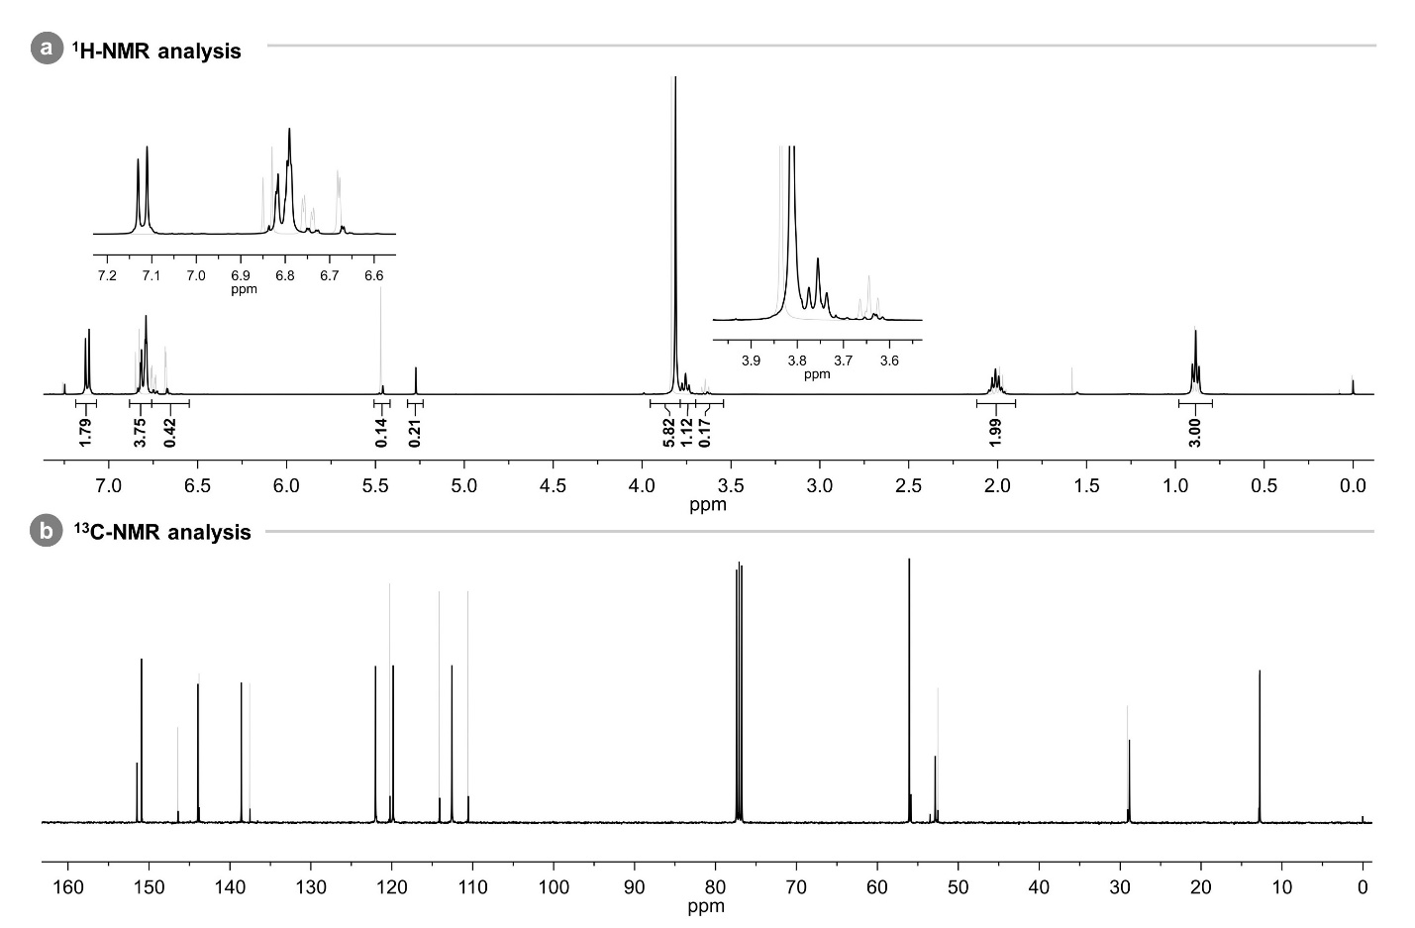Fig. S31 |¹H-NMR and ¹³C-NMR of Poly(2a-carbonate). Superimposed representation of the (a) ¹H-NMR (400 MHz) and (b) ¹³C-NMR (400 MHz) spectra of 2a-PC (black) and 2a (light grey). CDCl₃ used as NMR solvent.

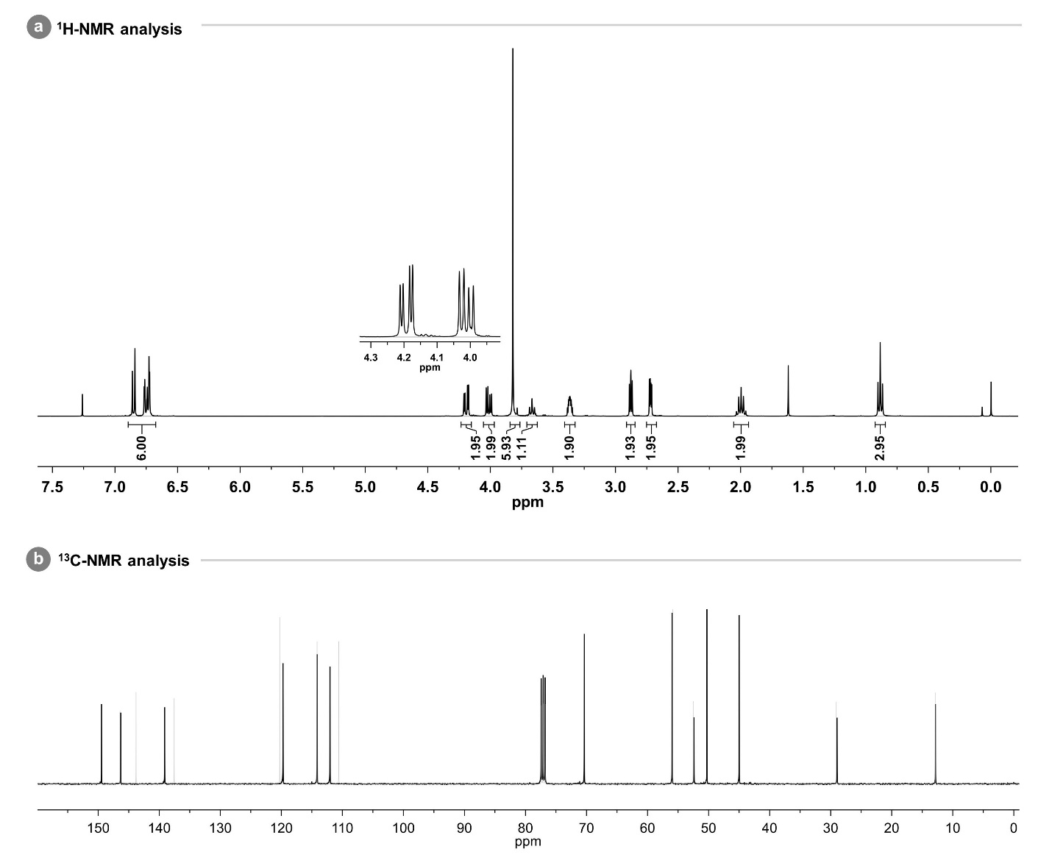
Fig. S32 |¹H-NMR and ¹³C-NMR of 2a diglycidyl ether. Superimposed representation of the (a) ¹H-NMR (400 MHz) and (b) ¹³C-NMR (400 MHz) spectra of 2a-DGE (black) and 2a (light grey). CDCl₃ used as NMR solvent
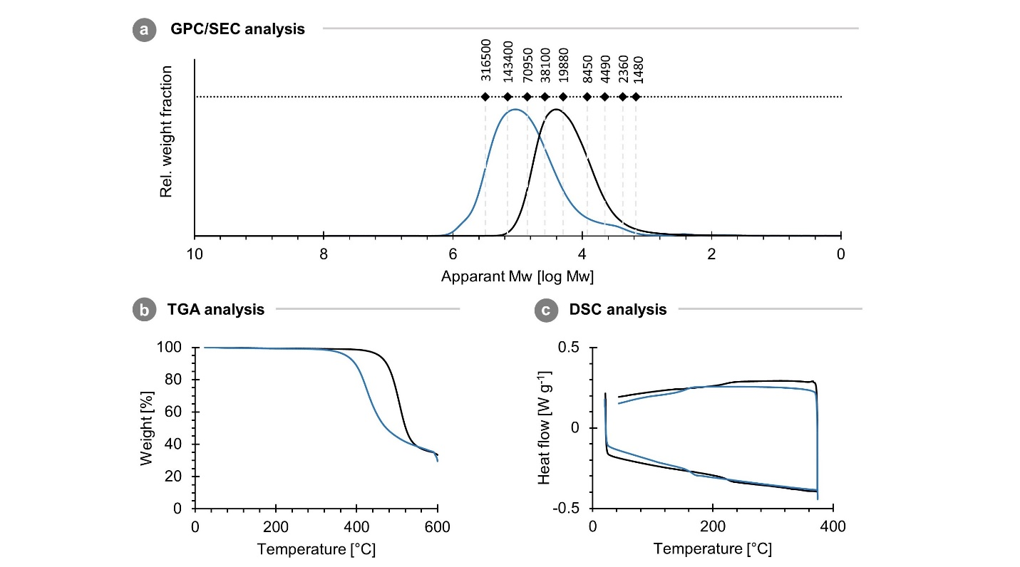Fig. S33 | Poly(2a-terephthalate) characterization. (a) Estimation of the M_{w} distribution by GPC/SEC analysis and thermal characterisations as measured by (b) TGA and (c) DSC (Exo up). 2a-PT (blue) and 4a-PT (black).
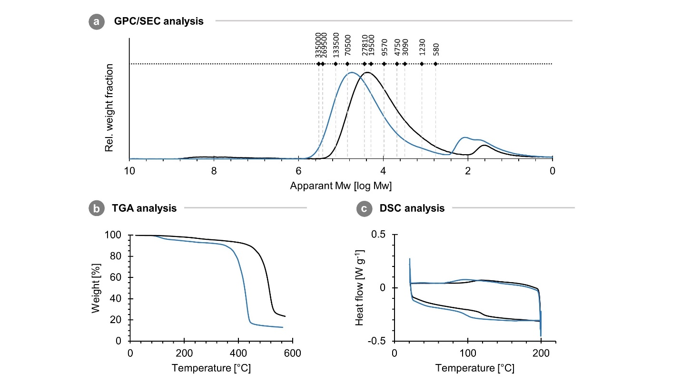Fig. S34 | Poly(2a-carbonate) characterization. (a) Estimation of the M_{w} distribution by GPC/SEC analysis and thermal characterisations as measured by (b) TGA and (c) DSC (Exo up). 2a-PC (blue) and 4a-PC (black).

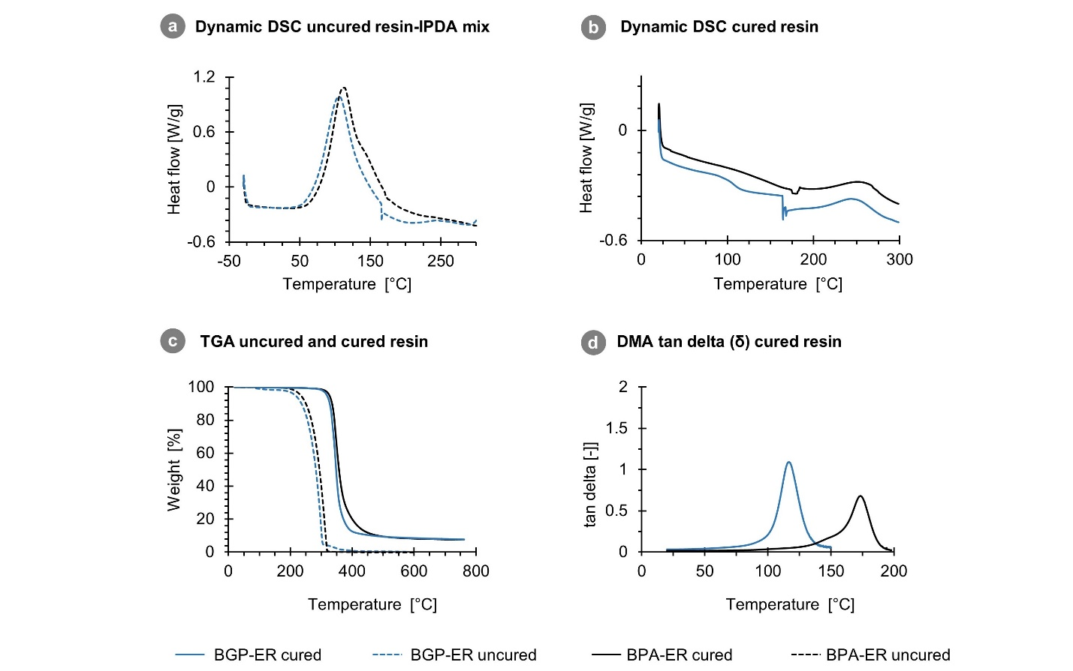
Fig. S35 |2a diglycidyl ether and epoxy resin characterization. (a) Dynamic DSC scan (10 °C/min) of mixture 2a-DGE and IPDA to screen reactivity and determine the total heat of cure (∆H_{TOTAL}). (b) First heating cycle of dynamic DSC scan (20 °C/min, 20-300 °C) of 2a-ER to determine the curing degree: (1- (∆H_{cycle}/∆H_{TOTAL})) x 100. (c) TGA of 2a-DGE and 4a-DGE (dashed line) and 2a-ER and 4a-ER (full line), 10 °C/min under N₂ atmosphere. (d) tan delta (δ) measured by DMA (20 to 200 °C, 2 °C/min) to determine T_{g}. 2a-DGE/-ER (blue) and 4a-DGE/-ER (black).

III. Tables
Table S1. ª Parameters and R-square of the polynomial fit of product concentration (M) in time (s): P(t) = at² + bt + c, ^{b} rate $\frac{dP}{dt}$, ^{c} Observed reaction order in isoeugenol (IE, 1a) derived from slope, ^{d} Intercept ln(k).
 | Polynomial fitª |  |  |  | Plot ln(rate^{b}) vs. ln(C_{IE})
H-USY | a | b | c | R² | n_{obs}^{c} | ln(k)^{d} | R²
o,p’-2a | -9.6 10⁻¹² | 1.4 10⁻⁷ | 2.2 10⁻⁵ | 0.996 | 0.95 | -13.1 | 0.994
m,p’-2a | -4.6 10⁻¹¹ | 7.3 10⁻⁷ | -9.6 10⁻⁶ | 0.995 | 0.85 | -11.7 | 0.995
p,p’-2a | -3.7 10⁻¹⁰ | 4.7 10⁻⁶ | 6.1 10⁻⁵ | 0.996 | 1.03 | -9.3 | 0.997
γ-3a | -1.3 10⁻¹⁰ | 9.2 10⁻⁷ | -3.6 10⁻⁵ | 0.998 | 2.3 | -7.4 | 0.978
α-3a | -2.1 10⁻¹⁰ | 1.7 10⁻⁶ | -3.0 10⁻⁶ | 0.998 | 1.9 | -7.8 | 0.985
H₂SO₄ | a | b | c | R² | n_{obs}^{c} | ln(k)^{d} | R²
o,p’-2a | -3.7 10⁻¹¹ | 3.8 10⁻⁷ | 6.4 10⁻⁵ | 0.989 | 1.23 | -11.4 | 0.987
m,p’-2a | -7.7 10⁻¹¹ | 7.9 10⁻⁷ | 9.8 10⁻⁵ | 0.991 | 1.16 | -10.8 | 0.992
p,p’-2a | -3.0 10⁻¹⁰ | 3.1 10⁻⁶ | 4.7 10⁻⁴ | 0.991 | 1.12 | -9.6 | 0.992
γ-3a | -1.1 10⁻¹⁰ | 6.8 10⁻⁷ | 1.1 10⁻⁴ | 0.978 | 2.09 | -8.4 | 0.983
α-3a | -3.7 10⁻¹⁰ | 2.4 10⁻⁶ | 3.0 10⁻⁴ | 0.987 | 2.05 | -7.3 | 0.984

Table S2. Standard entropy (∆S‡), enthalpy (∆H‡) and gibbs free energy (∆G‡) of activation derived from the Eyring-Polanyi analysis. ª∆G‡ calculated at 353 K (80 °C).
 | H-USY |  | H₂SO₄
 | p,p’-2a | α-3a | p,p’-2a | α-3a
∆H‡ [kJ mol⁻¹] | 85.0 | 85.8 | 41.0 | 33.7
∆S‡ [J mol⁻¹ K⁻¹] | -101.9 | -66.7 | -230.2 | -212.1
∆G‡ [kJ mol⁻¹]ª | 120.9 | 109.3 | 122.3 | 108.6
∆(∆G‡)[kJ mol⁻¹]ª | 11.6 |  | 13.7

Table S3. Thermal properties measured by ªDSC and ^{b}TGA under N₂ of the presented bisguaiacols: BGE, BGP, BGPacid, BGPesterM, reference bisguaiacol BGF and industrial bisphenols BPA,BPF and BPE. ^{c}Properties obtained from literature.
 | T_{m}ª | T_{d,5%}^{b} | T_{d,10%}^{b} | T_{d,max}^{b}
 | [°C] | [°C] | [°C] | [°C]
BPA (4a) | 158-159^{c} | 184 | 197 | 246
BPF (4b) | 162-164^{c} | 181 | 194 | 250
BPE (4c) | 123-127^{c} | 181 | 196 | 255
BGF (4e) | 106 | 168 | 183 | 236
BGE (2b) | 108 | 149 | 164 | 211
BGP (2a) | 121 | 162 | 174 | 219
BGPacid (2c) | 69 | 231 | 252 | 307
BGPesterM (2d) | 118 | 200 | 214 | 264

Table S4. Results of the in vitro oestrogenic potency screenings: MELN assay and CALUX bioassay. ªHalf-maximal effective concentration (potency). ^{b}Relative estrogenic efficacy (REE), calculated as the ratio of the maximal luciferase induction of the compound to the maximal induction of 17β-E2*100.^{c}No significant detection, REE ≈ signal noise. N/A: not applicable, ND: not detected.
 | MELN assay |  |  | CALUX assay
 | EC₅₀ª | Log(EC₅₀) | REE^{b} | EC₅₀ª | Log(EC₅₀) | REE^{b}
 | [M] | [%] | [%] | [M] | [%] | [%]
17β-E2 | 2.3 10⁻¹¹ | -10.6 | 100.0 | 2.8 10⁻¹¹ | -10.6 | 100.0
BPA (4a) | 1.2 10⁻⁶ | -5.9 | 103.3 | 2.8 10⁻⁷ | -6.6 | 119.0
BPF (4b) | 4.9 10⁻⁶ | -5.3 | 193.5 | 1.0 10⁻⁶ | -6.0 | 111.2
BPE (4c) | 1.4 10⁻⁶ | -5.9 | 148.3 | 1.0 10⁻⁶ | -6.0 | 91.9
BGF (4e) | 6.9 10⁻⁵ | -4.2 | 68.2 | N/A | N/A | 6.2
BGE (2b) | 3.1 10⁻⁵ | -4.5 | 48.0 | 2.9 10⁻⁵ | -4.5 | 16.0
BGP (2a) | 4.1 10⁻⁵ | -4.4 | 56.6 | 2.1 10⁻⁵ | -4.7 | 20.5
BGPacid (2c) | ND | ND | 10.3^{c} | ND | ND | ^{c}3.5
BGPesterM (2d) | 9.3 10⁻⁵ | -4.0 | 59.7 | N/A | N/A | 7.7

Table S5. Additional experimental details from the in vitro oestrogenic potency screening – MELN assay. ªHalf-maximal effective concentration (potency). ^{b}Calculated as the ratio of the maximal luciferase induction of the compound to the maximal induction of 17β-E2*100. ^{c}Maximum range in preliminary test, range refined in repeated tests. ^{d}Lowest concentration with cytotoxicity by visual microscopy or CytoTox-OneTM assay. ^{e}No significant detection, REE ≈ signal noise, ND: not detected.
 | EC₅₀ª | EC₅₀ range [M] |  | REE^{b} | REE range [%] |  | Range tested^{c} |  | Cytotoxicity^{d}
 | [M] | Min. | Max. | [%] | Min. | Max. | Min. | Max. | [M]
17β-E2 | 2.3 10⁻¹¹ | 2.0 10⁻¹¹ | 2.6 10⁻¹¹ | 100.0 | 100.0 | 100.0 | 10⁻¹⁴ | 10⁻⁹ | > 9.0 10⁻⁹
BPA (4a) | 1.2 10⁻⁶ | 1.0 10⁻⁶ | 1.6 10⁻⁶ | 103.3 | 99.1 | 107.4 | 10⁻¹⁰ | 10⁻⁴ | > 1.0 10⁻⁴
BPF (4b) | 4.9 10⁻⁶ | 3.8 10⁻⁶ | 5.9 10⁻⁶ | 193.5 | 174.8 | 218.6 | 10⁻¹⁰ | 10⁻⁴ | > 5.0 10⁻⁴
BPE (4c) | 1.4 10⁻⁶ | 1.1 10⁻⁶ | 1.9 10⁻⁶ | 148.3 | 139.4 | 165.1 | 10⁻¹⁰ | 10⁻⁴ | > 1.0 10⁻⁴
BGF (4e) | 6.9 10⁻⁵ | 4.2 10⁻⁵ | 8.6 10⁻⁵ | 68.2 | 55.9 | 76.8 | 10⁻⁷ | 10⁻⁴ | > 4.0 10⁻⁴
BGE (2b) | 3.1 10⁻⁵ | 2.5 10⁻⁵ | 3.9 10⁻⁵ | 48.0 | 45.0 | 50.8 | 10⁻⁷ | 10⁻⁴ | > 4.0 10⁻⁴
BGP (2a) | 4.1 10⁻⁵ | 3.8 10⁻⁵ | 4.6 10⁻⁵ | 56.6 | 56.3 | 56.9 | 10⁻⁷ | 10⁻⁴ | 4.0 10⁻⁴
BGPacid (2c) | ND | ND | ND | 10.3e | 9.0 | 12.2 | 10⁻⁹ | 10⁻³ | > 1.0 10⁻³
BGPesterM (2d) | 9.3 10⁻⁵ | 4.6 10⁻⁵ | 1.3 10⁻⁴ | 59.7 | 56.9 | 63.8 | 10⁻⁹ | 10⁻³ | > 1.0 10⁻³

Table S6. Additional experimental details from the in vitro oestrogenic potency screening – CALUX assay. ªHalf-maximal effective concentration (potency). ^{b}Calculated as the ratio of the maximal luciferase induction of the compound to the maximal induction of 17β-E2*100. ^{c}Maximum range in preliminary test, range refined in repeated tests. ^{d}Lowest concentration with cytotoxicity by visual microscopy. ^{e}No significant detection, REE ≈ signal noise. N/A: not applicable, ND: not detected.
 | EC₅₀ª | EC₅₀ range [M] |  | REE^{b} | REE range [%] |  | Range tested^{c} |  | Cytotoxicity^{d}
 | [M] | Min. | Max. | [%] | Min. | Max. | Min. | Max. | [M]
17β-E2 | 2.8 10⁻¹¹ | 2.0 10⁻¹¹ | 3.4 10⁻¹¹ | 100.0 | 100.0 | 100.0 | 10⁻¹⁴ | 10⁻⁹
BPA (4a) | 2.8 10⁻⁷ | 2.6 10⁻⁷ | 3.0 10⁻⁷ | 119.0 | 112.3 | 124.9 | 10⁻⁸ | 10⁻⁵ | > 1.0 10⁻⁵
BPF (4b) | 1.0 10⁻⁶ | 9.6 10⁻⁷ | 1.1 10⁻⁶ | 111.2 | 108.2 | 113.0 | 10⁻⁷ | 10⁻⁴ | > 5.0 10⁻⁵
BPE (4c) | 1.0 10⁻⁶ | 9.9 10⁻⁷ | 1.1 10⁻⁶ | 91.9 | 89.9 | 93.1 | 10⁻⁷ | 10⁻⁴ | > 5.0 10⁻⁵
BGF (4e) | N/A | N/A | N/A | 6.2 | 4.2 | 7.9 | 10⁻¹² | 10⁻³ | > 1.0 10⁻⁴
BGE (2b) | 2.9 10⁻⁵ | 2.5 10⁻⁵ | 3.3 10⁻⁵ | 16.0 | 15.1 | 16.8 | 10⁻¹² | 10⁻³ | > 1.0 10⁻⁴
BGP (2a) | 2.1 10⁻⁵ | 1.8 10⁻⁵ | 3.0 10⁻⁵ | 20.5 | 18.1 | 23.5 | 10⁻¹² | 10⁻³ | > 5.0 10⁻⁵
BGPacid (2c) | ND | ND | ND | ^{e}3.5 | 2.8 | 4.0 | 10⁻¹² | 10⁻³ | ND
BGPesterM (2d) | N/A | N/A | N/A | 7.7 | 6.7 | 8.8 | 10⁻¹² | 10⁻³ | > 1.0 10⁻⁴

Table S7. F and P-value of one-way ANOVA.
Assay | Variable | F (DFn,DFd) |  | P value
MELN | Log(EC₅₀) | F(7,20) | =1225 | < 0.0001
MELN | REE | F(8,23) | =135 | < 0.0001
CALUX | Log(EC₅₀) | F(5,13) | = 4405 | < 0.0001
CALUX | REE | F(8,19) | = 1202 | < 0.0001

Table S8. Tukey’s multiple comparisons test evaluating the logEC₅₀ in the MELN assay. 1 family, 28 comparisons, α = 0.05.
Pairs | Mean Diff,  ∆logEC₅₀ | 95,00% CI of diff. | Below threshold? | Adjusted P Value
E2 vs. BPA | -4.717 | -5.007 to -4.427 | Yes | <0.0001
E2 vs. BPF | -5.327 | -5.641 to -5.014 | Yes | <0.0001
E2 vs. BPE | -4.767 | -5.081 to -4.454 | Yes | <0.0001
E2 vs. BGF | -6.461 | -6.774 to -6.148 | Yes | <0.0001
E2 vs. BGE | -6.127 | -6.417 to -5.837 | Yes | <0.0001
E2 vs. BGP | -6.258 | -6.571 to -5.945 | Yes | <0.0001
E2 vs. BGPesterM | -6.577 | -6.867 to -6.287 | Yes | <0.0001
BPA vs. BPF | -0.6103 | -0.9235 to -0.2971 | Yes | <0.0001
BPA vs. BPE | -0.05011 | -0.3633 to 0.2631 | No | 0.9992
BPA vs. BGF | -1.744 | -2.057 to -1.430 | Yes | <0.0001
BPA vs. BGE | -1.41 | -1.700 to -1.120 | Yes | <0.0001
BPA vs. BGP | -1.541 | -1.854 to -1.228 | Yes | <0.0001
BPA vs. BGPesterM | -1.86 | -2.150 to -1.570 | Yes | <0.0001
BPF vs. BPE | 0.5602 | 0.2253 to 0.8950 | Yes | 0.0004
BPF vs. BGF | -1.133 | -1.468 to -0.7985 | Yes | <0.0001
BPF vs. BGE | -0.7995 | -1.113 to -0.4862 | Yes | <0.0001
BPF vs. BGP | -0.9305 | -1.265 to -0.5956 | Yes | <0.0001
BPF vs. BGPesterM | -1.249 | -1.562 to -0.9360 | Yes | <0.0001
BPE vs. BGF | -1.694 | -2.028 to -1.359 | Yes | <0.0001
BPE vs. BGE | -1.36 | -1.673 to -1.046 | Yes | <0.0001
BPE vs. BGP | -1.491 | -1.825 to -1.156 | Yes | <0.0001
BPE vs. BGPesterM | -1.809 | -2.123 to -1.496 | Yes | <0.0001
BGF vs. BGE | 0.3339 | 0.02066 to 0.6471 | Yes | 0.0316
BGF vs. BGP | 0.2029 | -0.1320 to 0.5377 | No | 0.4806
BGF vs. BGPesterM | -0.1159 | -0.4291 to 0.1973 | No | 0.9073
BGE vs. BGP | -0.131 | -0.4442 to 0.1822 | No | 0.8423
BGE vs. BGPesterM | -0.4498 | -0.7398 to -0.1598 | Yes | 0.0009
BGP vs. BGPesterM | -0.3188 | -0.6320 to -0.005575 | Yes | 0.0442

Table S9. Tukey’s multiple comparisons test evaluating the REE in the MELN assay. 1 family. 36 comparisons. α = 0.05.
Pairs | Mean Diff.  ∆REE | 95.00% CI of diff. | Below threshold? | Adjusted P Value
E2 vs. BPA | -3.337 | -24.52 to 17.84 | No | 0.9997
E2 vs. BPF | -93.54 | -116.4 to -70.67 | Yes | <0.0001
E2 vs. BPE | -48.26 | -71.14 to -25.39 | Yes | <0.0001
E2 vs. BGF | 31.78 | 8.907 to 54.66 | Yes | 0.0024
E2 vs. BGE | 52.04 | 30.87 to 73.22 | Yes | <0.0001
E2 vs. BGP | 43.36 | 20.49 to 66.24 | Yes | <0.0001
E2 vs. BGPesterM | 40.27 | 19.09 to 61.45 | Yes | <0.0001
E2 vs. BGPacid | 89.73 | 68.55 to 110.9 | Yes | <0.0001
BPA vs. BPF | -90.21 | -113.1 to -67.33 | Yes | <0.0001
BPA vs. BPE | -44.92 | -67.80 to -22.05 | Yes | <0.0001
BPA vs. BGF | 35.12 | 12.24 to 57.99 | Yes | 0.0007
BPA vs. BGE | 55.38 | 34.20 to 76.56 | Yes | <0.0001
BPA vs. BGP | 46.7 | 23.83 to 69.58 | Yes | <0.0001
BPA vs. BGPesterM | 43.61 | 22.43 to 64.79 | Yes | <0.0001
BPA vs. BGPacid | 93.06 | 71.89 to 114.2 | Yes | <0.0001
BPF vs. BPE | 45.28 | 20.83 to 69.74 | Yes | <0.0001
BPF vs. BGF | 125.3 | 100.9 to 149.8 | Yes | <0.0001
BPF vs. BGE | 145.6 | 122.7 to 168.5 | Yes | <0.0001
BPF vs. BGP | 136.9 | 112.5 to 161.4 | Yes | <0.0001
BPF vs. BGPesterM | 133.8 | 110.9 to 156.7 | Yes | <0.0001
BPF vs. BGPacid | 183.3 | 160.4 to 206.1 | Yes | <0.0001
BPE vs. BGF | 80.04 | 55.59 to 104.5 | Yes | <0.0001
BPE vs. BGE | 100.3 | 77.43 to 123.2 | Yes | <0.0001
BPE vs. BGP | 91.63 | 67.17 to 116.1 | Yes | <0.0001
BPE vs. BGPesterM | 88.53 | 65.66 to 111.4 | Yes | <0.0001
BPE vs. BGPacid | 138 | 115.1 to 160.9 | Yes | <0.0001
BGF vs. BGE | 20.26 | -2.613 to 43.14 | No | 0.111
BGF vs. BGP | 11.58 | -12.87 to 36.04 | No | 0.7869
BGF vs. BGPesterM | 8.49 | -14.38 to 31.37 | No | 0.9312
BGF vs. BGPacid | 57.94 | 35.07 to 80.82 | Yes | <0.0001
BGE vs. BGP | -8.68 | -31.56 to 14.19 | No | 0.9229
BGE vs. BGPesterM | -11.77 | -32.95 to 9.407 | No | 0.6224
BGE vs. BGPacid | 37.68 | 16.50 to 58.86 | Yes | 0.0001
BGP vs. BGPesterM | -3.091 | -25.97 to 19.78 | No | >0.9999
BGP vs. BGPacid | 46.36 | 23.49 to 69.24 | Yes | <0.0001
BGPesterM vs. BGPacid | 49.45 | 28.28 to 70.63 | Yes | <0.0001

Table S10. Tukey’s multiple comparisons test evaluating the LogEC₅₀ in the ERα-CALUX cells bioassay. 1 family. 15 comparisons. α = 0.05.
Pairs | Mean Diff. ∆logEC₅₀ | 95.00% CI of diff. | Below threshold? | Adjusted P Value
E2 vs. BPA | -4.004 | -4.165 to -3.843 | Yes | <0.0001
E2 vs. BPF | -4.577 | -4.738 to -4.416 | Yes | <0.0001
E2 vs. BPE | -4.577 | -4.737 to -4.416 | Yes | <0.0001
E2 vs. BGE | -6.021 | -6.182 to -5.860 | Yes | <0.0001
E2 vs. BGP | -5.88 | -6.041 to -5.719 | Yes | <0.0001
BPA vs. BPF | -0.5732 | -0.7451 to -0.4013 | Yes | <0.0001
BPA vs. BPE | -0.5726 | -0.7445 to -0.4006 | Yes | <0.0001
BPA vs. BGE | -2.017 | -2.189 to -1.845 | Yes | <0.0001
BPA vs. BGP | -1.876 | -2.048 to -1.704 | Yes | <0.0001
BPF vs. BPE | 0.000635 | -0.1713 to 0.1726 | No | >0.9999
BPF vs. BGE | -1.444 | -1.616 to -1.272 | Yes | <0.0001
BPF vs. BGP | -1.303 | -1.475 to -1.131 | Yes | <0.0001
BPE vs. BGE | -1.445 | -1.617 to -1.273 | Yes | <0.0001
BPE vs. BGP | -1.304 | -1.476 to -1.132 | Yes | <0.0001
BGE vs. BGP | 0.141 | -0.03090 to 0.3130 | No | 0.1367

Table S11. Tukey’s multiple comparisons test evaluating the REE in the CALUX assay. 1 family. 36 comparisons. α = 0.05.
Pairs | Mean Diff.  ∆REE | 95.00% CI of diff. | Below threshold? | Adjusted P Value
E2 vs. BPA | -19 | -25.86 to -12.15 | Yes | <0.0001
E2 vs. BPF | -11.18 | -18.03 to -4.325 | Yes | 0.0005
E2 vs. BPE | 8.067 | 1.212 to 14.92 | Yes | 0.0141
E2 vs. BGF | 93.81 | 86.96 to 100.7 | Yes | <0.0001
E2 vs. BGE | 83.98 | 77.12 to 90.83 | Yes | <0.0001
E2 vs. BGP | 79.53 | 72.67 to 86.38 | Yes | <0.0001
E2 vs. BGPesterM | 92.31 | 85.46 to 99.16 | Yes | <0.0001
E2 vs. BGPacid | 96.54 | 89.68 to 103.4 | Yes | <0.0001
BPA vs. BPF | 7.822 | 0.4939 to 15.15 | Yes | 0.0311
BPA vs. BPE | 27.07 | 19.74 to 34.40 | Yes | <0.0001
BPA vs. BGF | 112.8 | 105.5 to 120.1 | Yes | <0.0001
BPA vs. BGE | 103 | 95.65 to 110.3 | Yes | <0.0001
BPA vs. BGP | 98.53 | 91.20 to 105.9 | Yes | <0.0001
BPA vs. BGPesterM | 111.3 | 104.0 to 118.6 | Yes | <0.0001
BPA vs. BGPacid | 115.5 | 108.2 to 122.9 | Yes | <0.0001
BPF vs. BPE | 19.25 | 11.92 to 26.57 | Yes | <0.0001
BPF vs. BGF | 105 | 97.67 to 112.3 | Yes | <0.0001
BPF vs. BGE | 95.16 | 87.83 to 102.5 | Yes | <0.0001
BPF vs. BGP | 90.71 | 83.38 to 98.03 | Yes | <0.0001
BPF vs. BGPesterM | 103.5 | 96.16 to 110.8 | Yes | <0.0001
BPF vs. BGPacid | 107.7 | 100.4 to 115.0 | Yes | <0.0001
BPE vs. BGF | 85.75 | 78.42 to 93.07 | Yes | <0.0001
BPE vs. BGE | 75.91 | 68.58 to 83.24 | Yes | <0.0001
BPE vs. BGP | 71.46 | 64.13 to 78.79 | Yes | <0.0001
BPE vs. BGPesterM | 84.24 | 76.92 to 91.57 | Yes | <0.0001
BPE vs. BGPacid | 88.47 | 81.14 to 95.80 | Yes | <0.0001
BGF vs. BGE | -9.836 | -17.16 to -2.509 | Yes | 0.0041
BGF vs. BGP | -14.29 | -21.62 to -6.960 | Yes | <0.0001
BGF vs. BGPesterM | -1.503 | -8.831 to 5.824 | No | 0.9979
BGF vs. BGPacid | 2.724 | -4.603 to 10.05 | No | 0.9211
BGE vs. BGP | -4.452 | -11.78 to 2.876 | No | 0.4921
BGE vs. BGPesterM | 8.333 | 1.005 to 15.66 | Yes | 0.0188
BGE vs. BGPacid | 12.56 | 5.233 to 19.89 | Yes | 0.0003
BGP vs. BGPesterM | 12.78 | 5.457 to 20.11 | Yes | 0.0002
BGP vs. BGPacid | 17.01 | 9.685 to 24.34 | Yes | <0.0001
BGPesterM vs. BGPacid | 4.228 | -3.100 to 11.56 | No | 0.5557

IV. References
1.Holm, T. Aspects of the mechanism of the flame ionization detector. J. Chromatogr. A 842, 221–227 (1999).
2.Balaguer, P., François, F., Comunale, F., Fenet, H., Boussioux, A.-M., Pons, M., Nicolas, J.-C. & Casellas, C. Reporter cell lines to study the estrogenic effects of xenoestrogens. Sci. Total Environ. 233, 47–56 (1999).
3.Berckmans, P., Leppens, H., Vangenechten, C. & Witters, H. Screening of endocrine disrupting chemicals with MELN cells, an ER-transactivation assay combined with cytotoxicity assessment. Toxicology in Vitro 21, 1262–1267 (2007).
4.Croes, K., Debaillie, P., Van den Bril, B., Staelens, J., Vandermarken, T., Van Langenhove, K., Denison, M. S., Leermakers, M. & Elskens, M. Assessment of estrogenic activity in PM10 air samples with the ERE-CALUX bioassay: Method optimization and implementation at an urban location in Flanders (Belgium). Chemosphere 144, 392–398 (2016).
5.Rogers, J. M. & Denison, M. S. Recombinant Cell Bioassays for Endocrine Disruptors: Development of Stably Transfected Human Ovarian Cell Line for the Detection of Estrogenic and Anti-Estrogenic Chemicals. In Vitr. Mol. Toxicol. 13, (2000).
6.Vandermarken, T., De Galan, S., Croes, K., Van Langenhove, K., Vercammen, J., Sanctorum, H., Denison, M. S., Goeyens, L., Elskens, M. & Baeyens, W. Characterisation and implementation of the ERE-CALUX bioassay on indoor dust samples of kindergartens to assess estrogenic potencies. J. Steroid Biochem. Mol. Biol. 155, 182–189 (2016).
7.Wettey, F. R. & Jackson, A. P. Reviews and Protocols in DT40 Research, Luciferase reporter assay. 40, (Springer, 2006).
8.Dence, C. W. in Methods of Lingin Chemistry, The Determination of Lignin (Springer, 1992).
9.Morita, N., Mashiko, R., Hakuta, D., Eguchi, D., Ban, S., Hashimoto, Y., Okamoto, I. & Tamura, O. Gold-Catalyzed Dimeric Cyclization of Isoeugenol and Related 1-Phenylpropenes in Ionic Liquid: Environmentally Friendly and Stereoselective Synthesis of 1,2,3-Trisubstituted 2,3-Dihydro-1H-indenes. Synthesis 48, 1927–1933 (2016).
10.Alesso, E., Torviso, R., Lantaño, B., Erlich, M., Finkielsztein, L. M., Moltrasio, G., Aguirre, J. M. & Brunet, E. Synthesis of 1-ethyl-2-methyl-3-arylindanes. Stereochemistry of five-membered ring formation. Arkivoc 2003, 283–297 (2003).
11.Doyle, P. J., Savara, A. & Raiman, S. S. Extracting meaningful standard enthalpies and entropies of activation for surface reactions from kinetic rates. React. Kinet. Mech. Catal. 129, 551–581 (2020).
12.Avendaño Villarreal, J. A., Granato, A. V., Delolo, F. G. & dos Santos, E. N. Efficient synthesis of styrene derivatives through ethenolysis of renewable propenylbenzenes. J. Mol. Catal. 509, 111631 (2021).
13.Takemoto, M. & Achiwa, K. Synthesis of styrenes through the decarboxylation of trans-cinnamic acids by plant cell cultures. Tetrahedron Lett. 40, 6595–6598 (1999).
14.Leisch, H., Grosse, S., Morley, K., Abokitse, K., Perrin, F., Denault, J. & Lau, P. C. K. Chemicals from agricultural biomass: chemoenzymatic approach for production of vinylphenols and polyvinylphenols from phenolic acids. Green. Process. Synth. 2, 7–17 (2013).
15.L. Morley, K., Grosse, S., Leisch, H. & K. Lau, P. C. Antioxidant canolol production from a renewable feedstock via an engineered decarboxylase. Green Chem. 15, 3312–3317 (2013).
16.Kunitsky, K., Shah, M. C., Shuey, S. W., Trost, B. M. & Wagman, M. Method for preparing hydroxystyrenes and acetylated derivatives thereof. (US7586013) (2009).
17.Simpson, C. J., Fitzhenry, M. J. & Stamford, N. P. J. Preparation of vinylphenols from 2- and 4-hydroxybenzaldehydes. Tetrahedron Lett. 46, 6893–6896 (2005).
18.Valkute, T. R., Aratikatla, E. K. & Bhattacharya, A. K. Efficient synthesis of functionalized olefins by Wittig reaction using Amberlite resin as a mild base. Synth. Commun. 47, 581–589 (2017).
19.Mouterde, L. M. M. & Allais, F. Microwave-Assisted Knoevenagel-Doebner Reaction: An Efficient Method for Naturally Occurring Phenolic Acids Synthesis. Front. Chem. 6, (2018).
20.Peng, Y. & Song, G. Combined microwave and ultrasound accelerated Knoevenagel–Doebner reaction in aqueous media: a green route to 3-aryl acrylic acids. Green Chem. 5, 704–706 (2003).
21.Yepez, R., García, S., Schachat, P., Sánchez-Sánchez, M., H. González-Estefan, J., González-Zamora, E., A. Ibarra, I. & Aguilar-Pliego, J. Catalytic activity of HKUST-1 in the oxidation of trans -ferulic acid to vanillin. New J. Chem. 39, 5112–5115 (2015).
22.Takeshima, H., Satoh, K. & Kamigaito, M. Bio-Based Functional Styrene Monomers Derived from Naturally Occurring Ferulic Acid for Poly(vinylcatechol) and Poly(vinylguaiacol) via Controlled Radical Polymerization. Macromolecules 50, 4206–4216 (2017).

