Supporting Information

Reliable Gas-Phase Tautomer Equilibria of Drug-like Molecule Scaffolds and the Issue of Continuum Solvation

Andreas H. Göller
Bayer AG, Computational Molecular Design, Aprather Weg 18a, 42096 Wuppertal, andreas.goeller@bayer.com

Figure S1: DFT / Water energy plots
Figure S2: DFT / gas energy plots
Figure S3: DFT / Water delta histograms
Figure S4: DFT / gas delta histograms
Figure S5: cheap / Water energy plots
Figure S6: cheap / gas energy plots
Figure S7: cheap / Water delta histograms
Figure S8: cheap / gas delta histograms
Table T1: water tautomer energies and deltas
Table T2: gas-phase tautomer energies and deltas

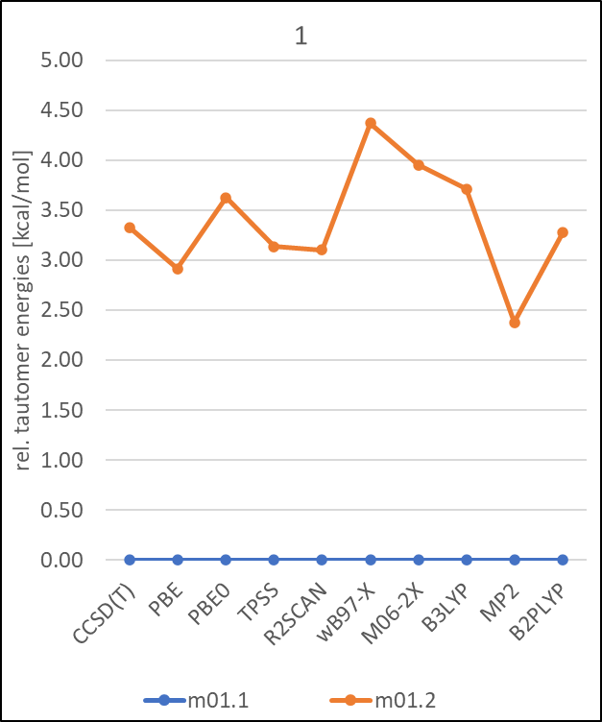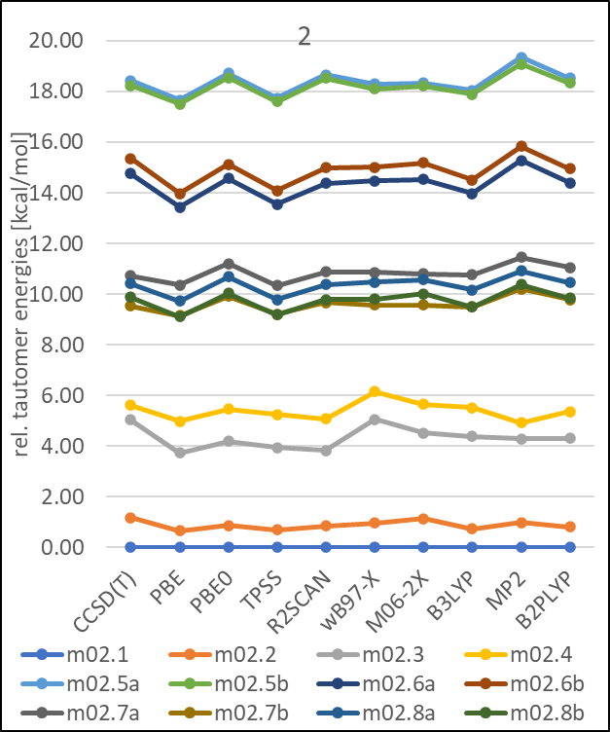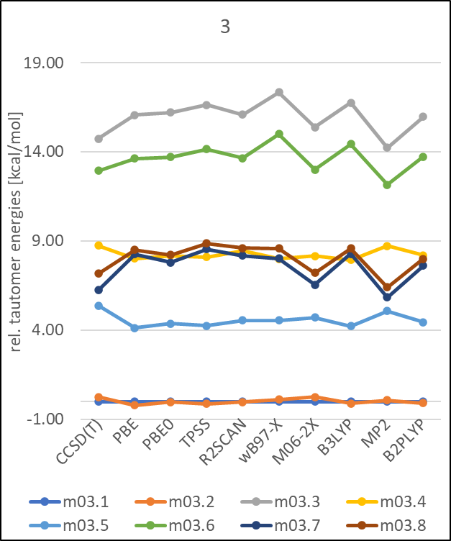

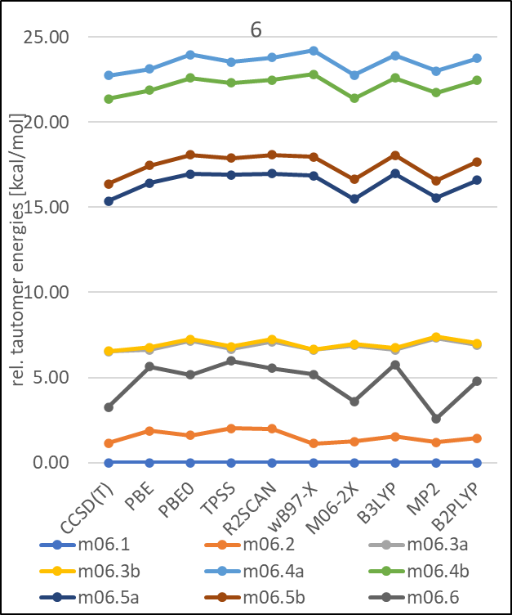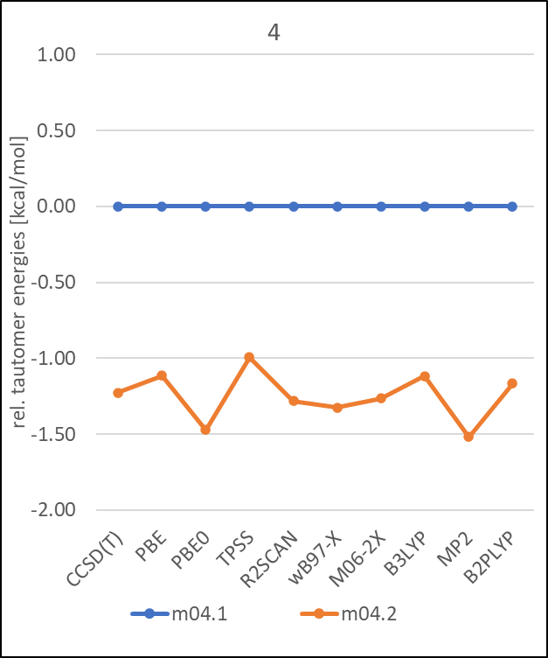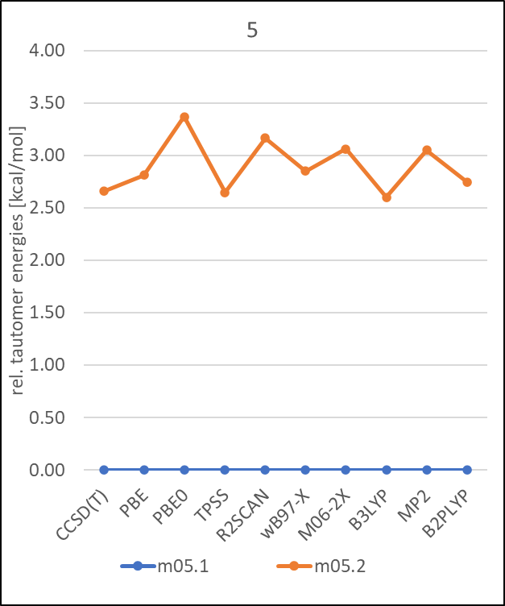

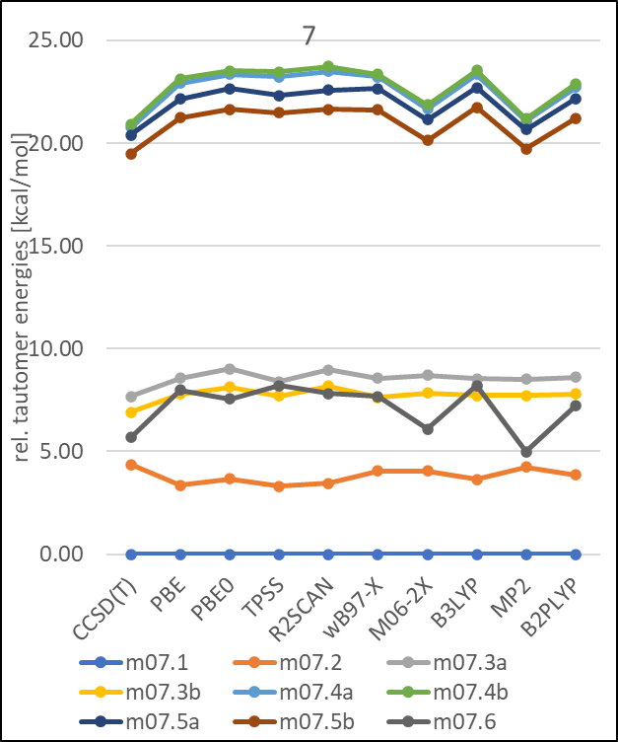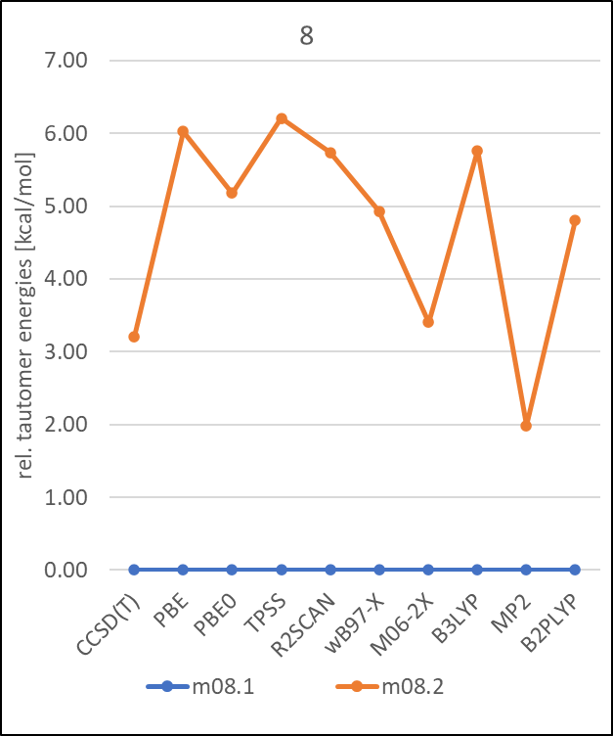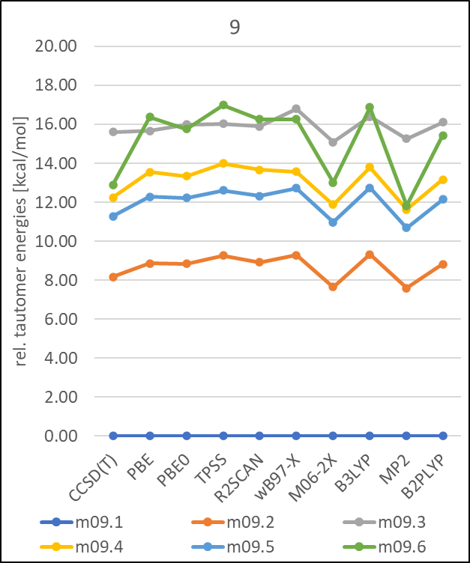
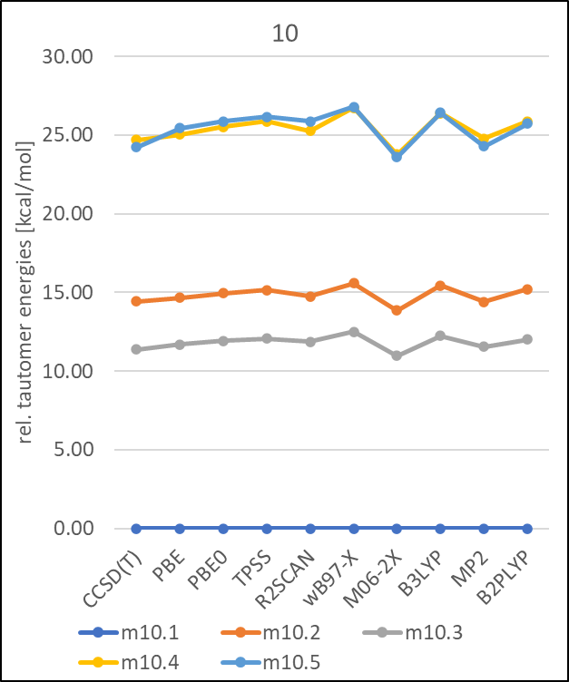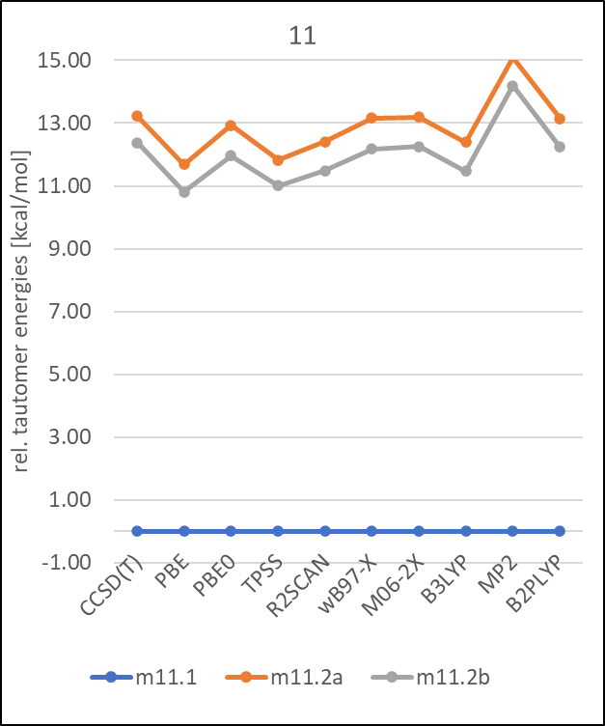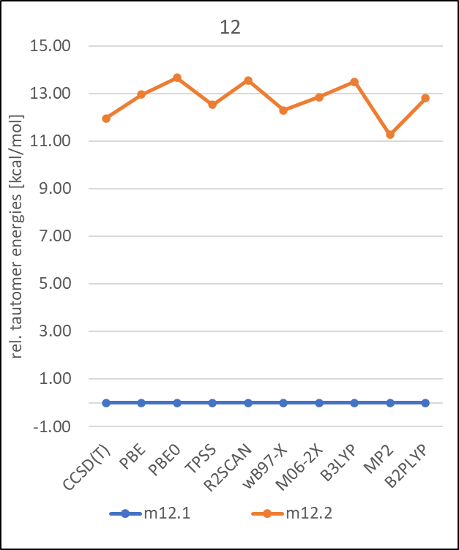

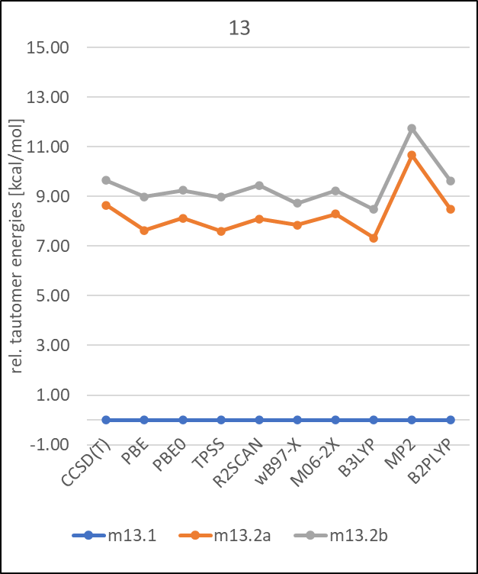
Figure S1: Comparison of tautomer state energies calculated with CCSD(T), MP2 and various DFT methods and def2-QZVPP basis set the 13 molecules.in SMD continuum solvation model.

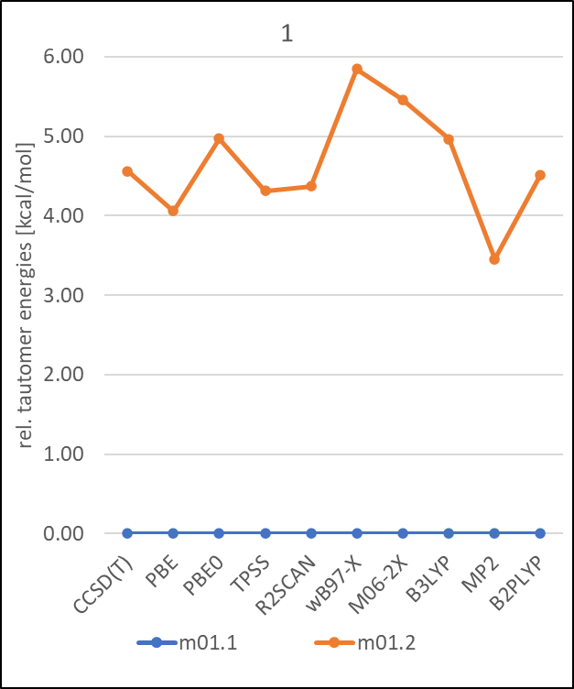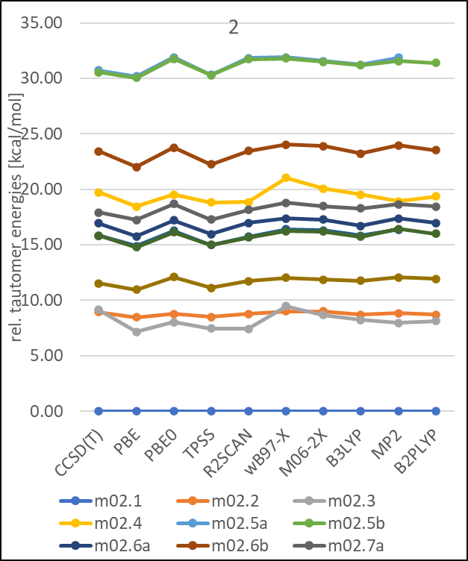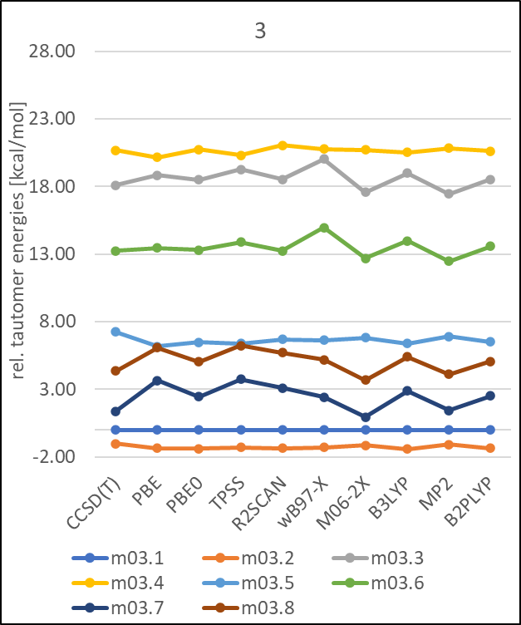

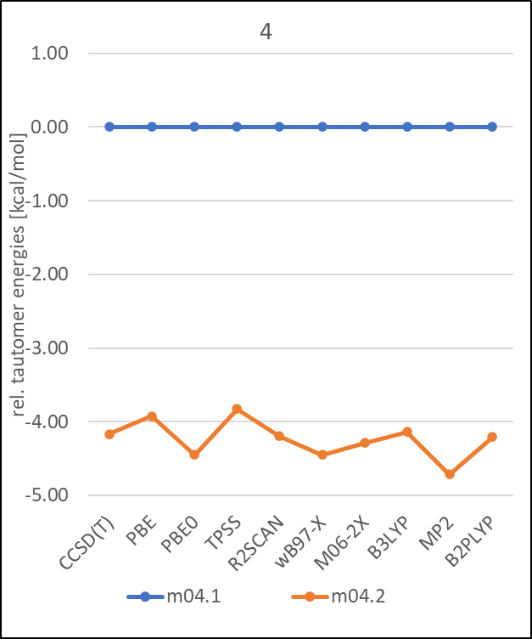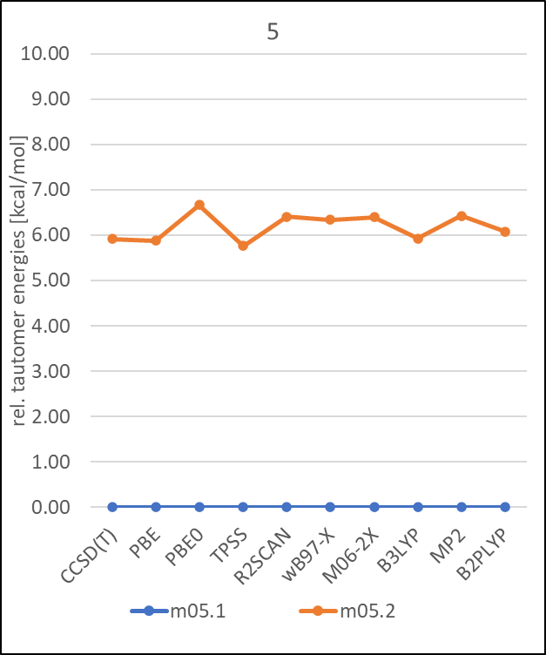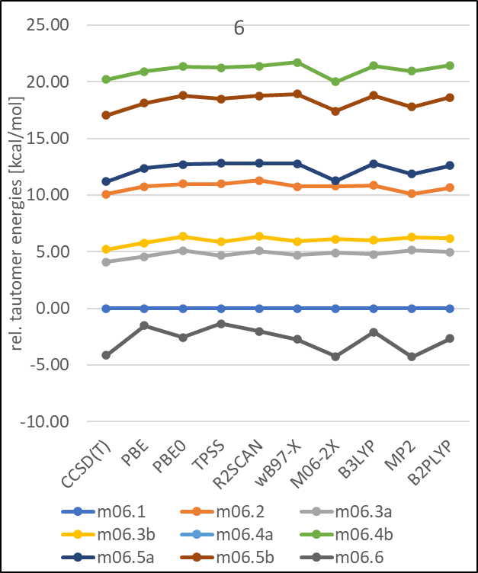

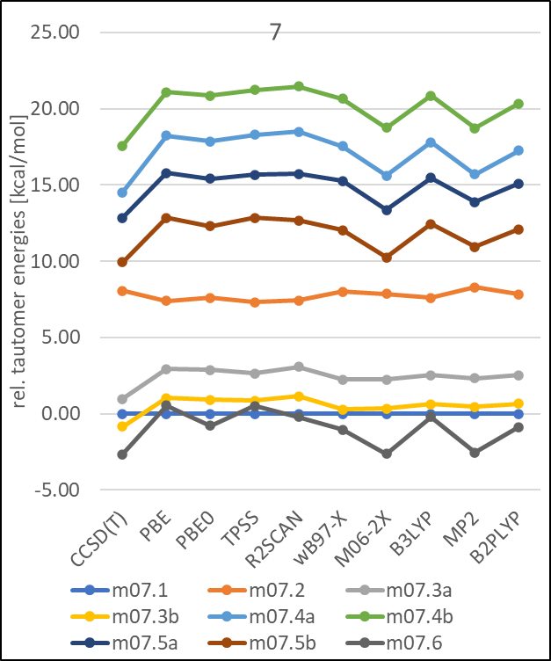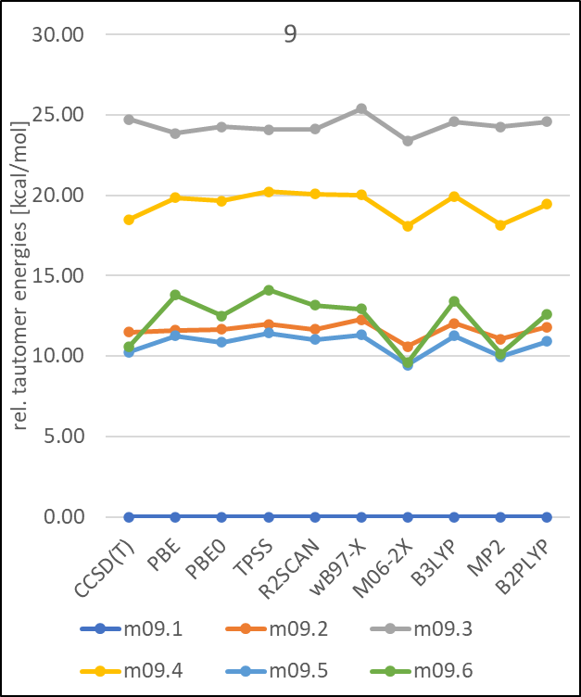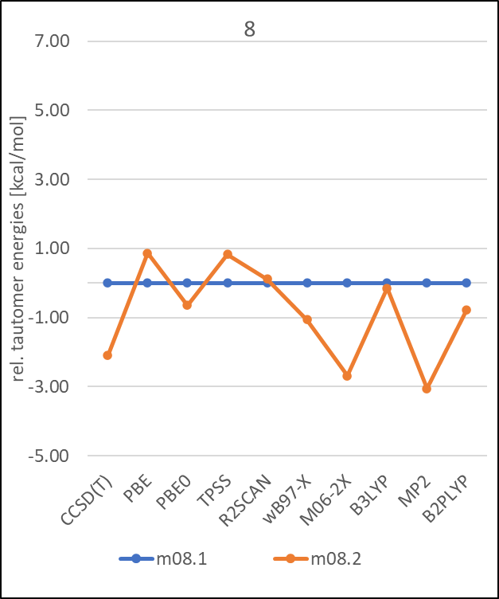

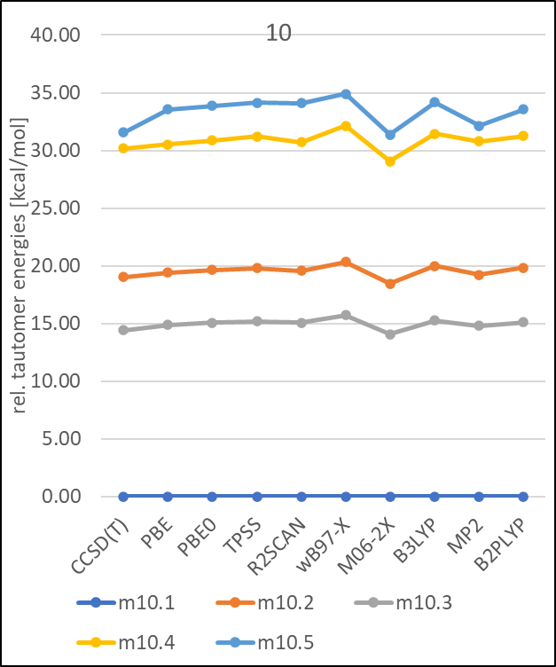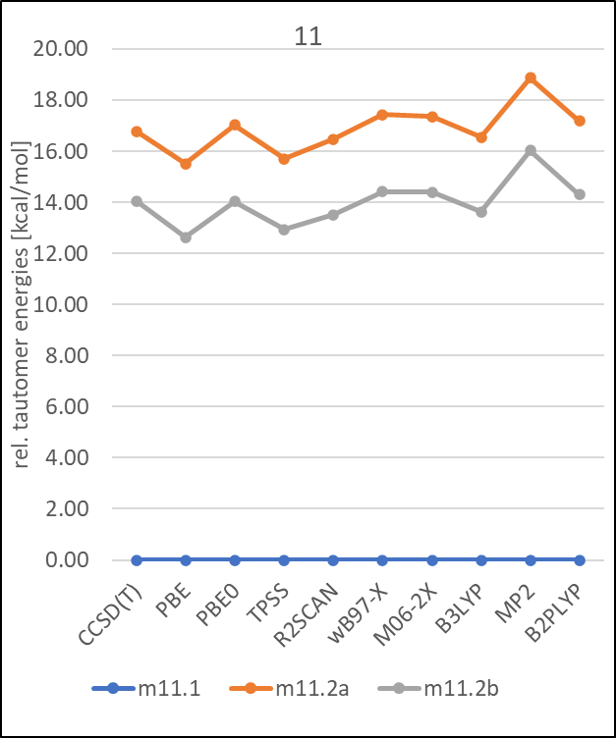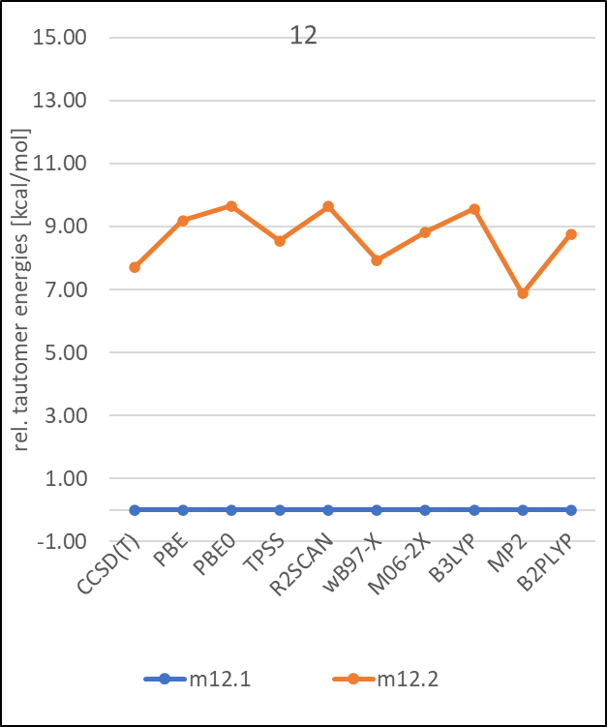

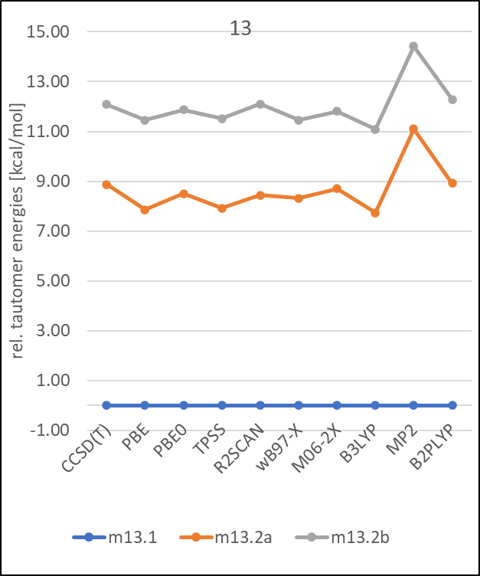
Figure S2: Comparison of tautomer state energies calculated with CCSD(T), MP2 and various DFT methods and def2-QZVPP basis set the 13 molecules.in gas-phase.

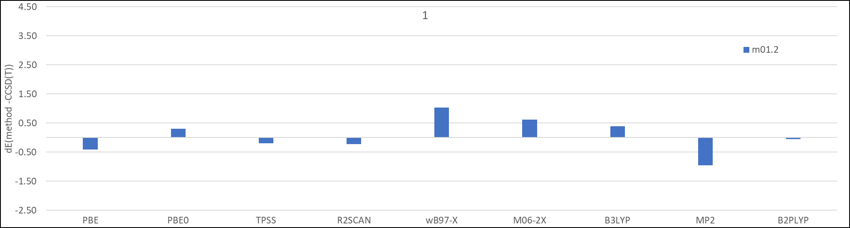
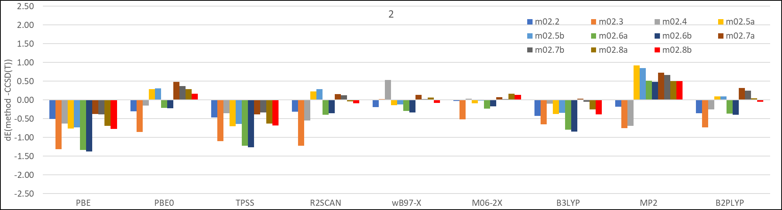
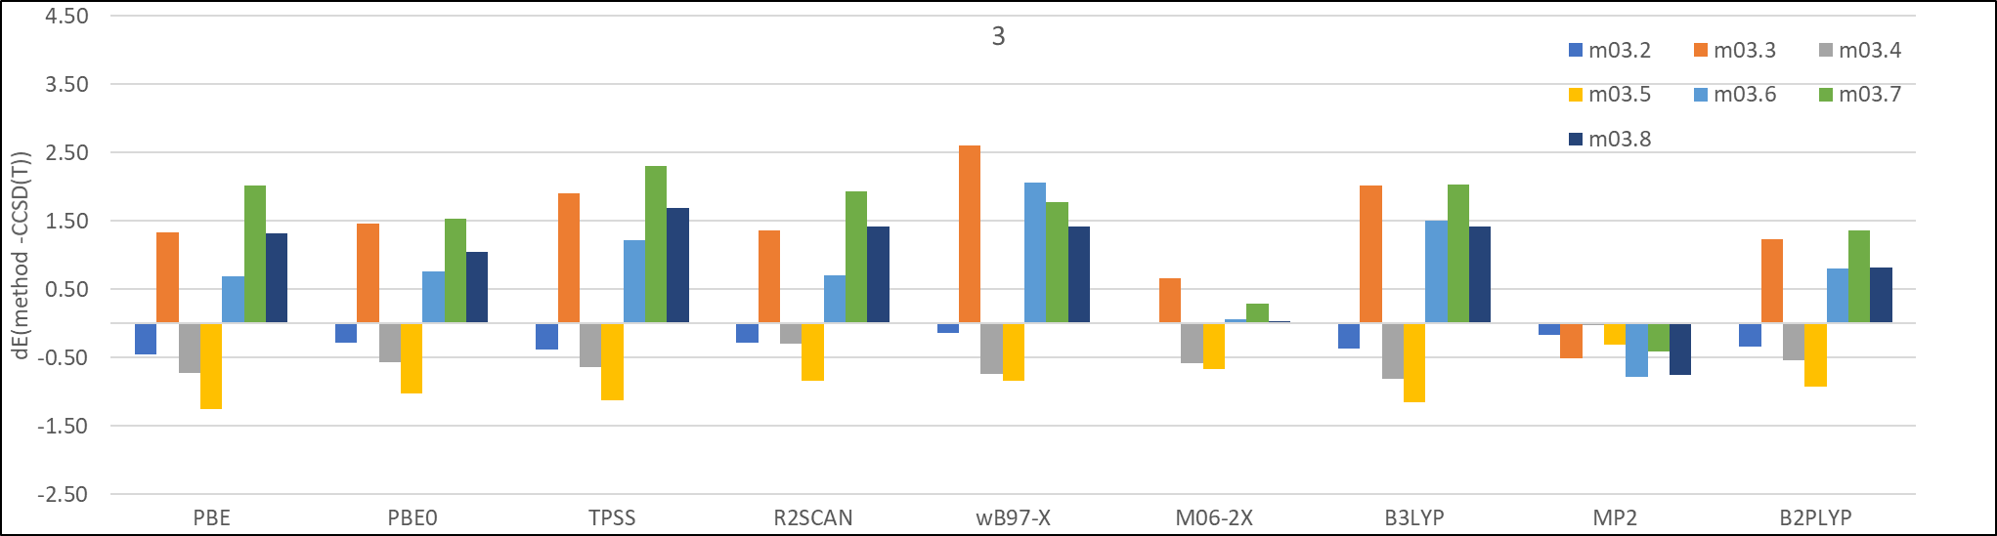
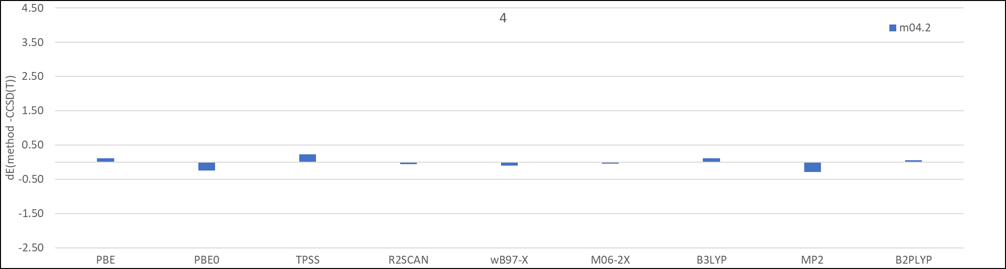
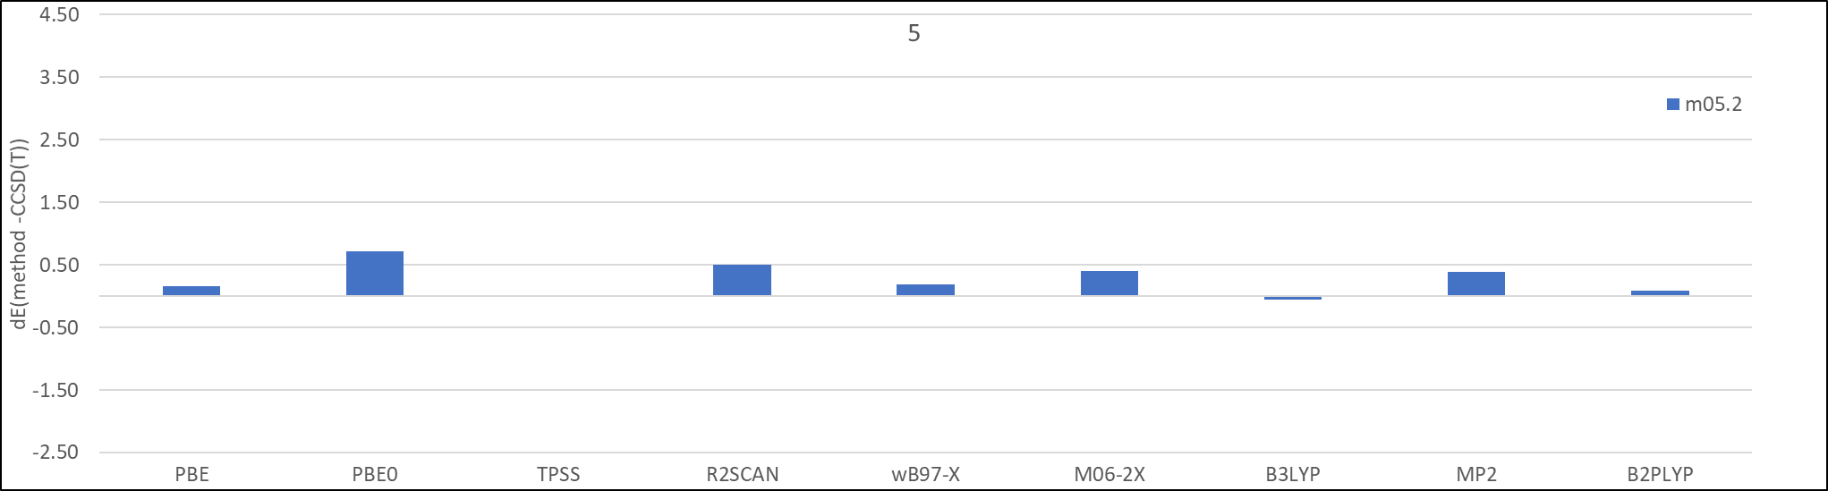
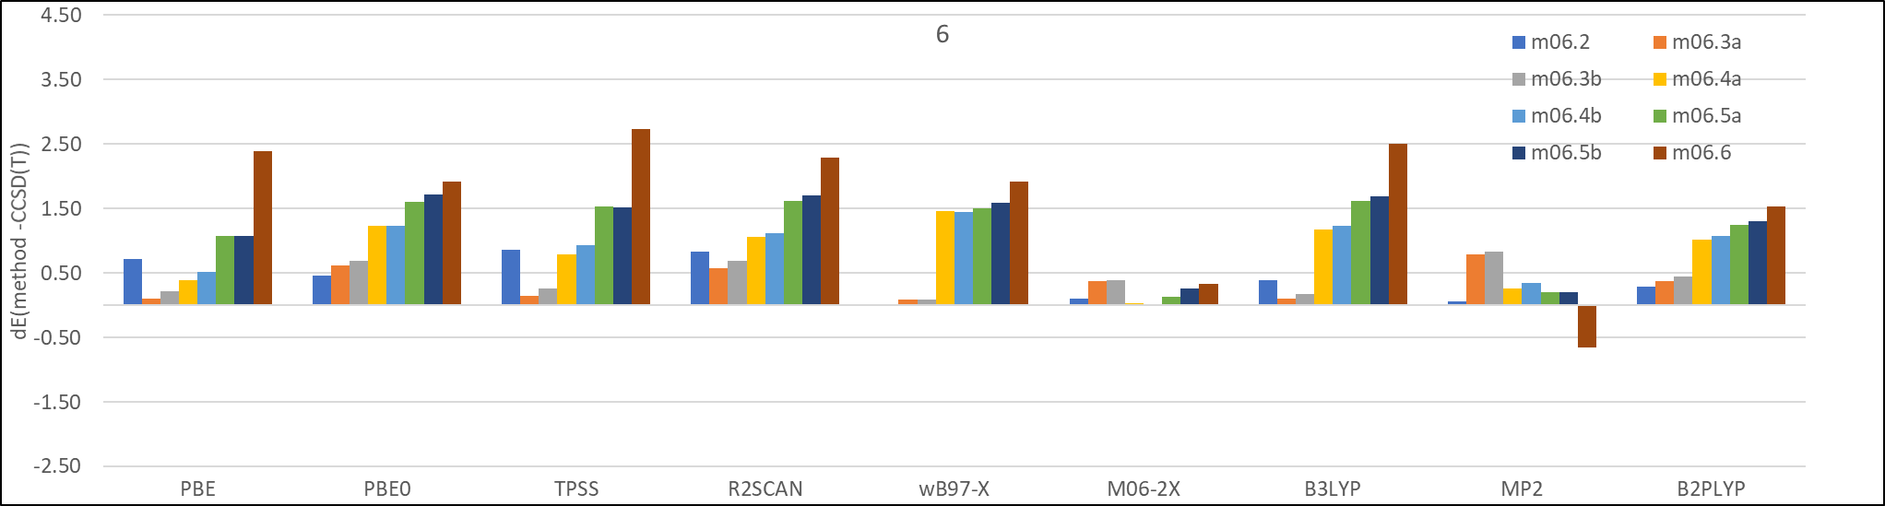
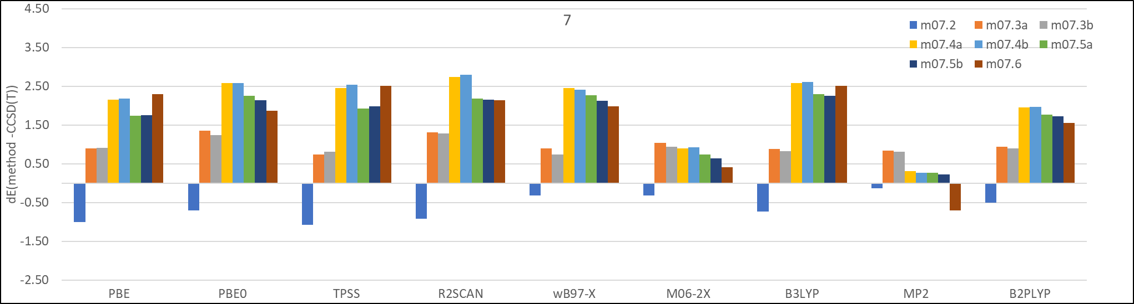
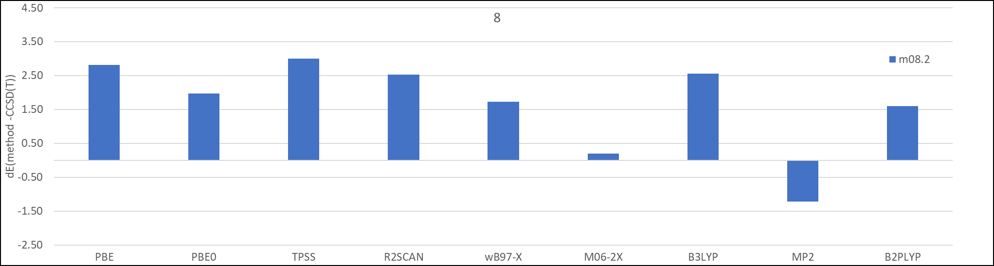
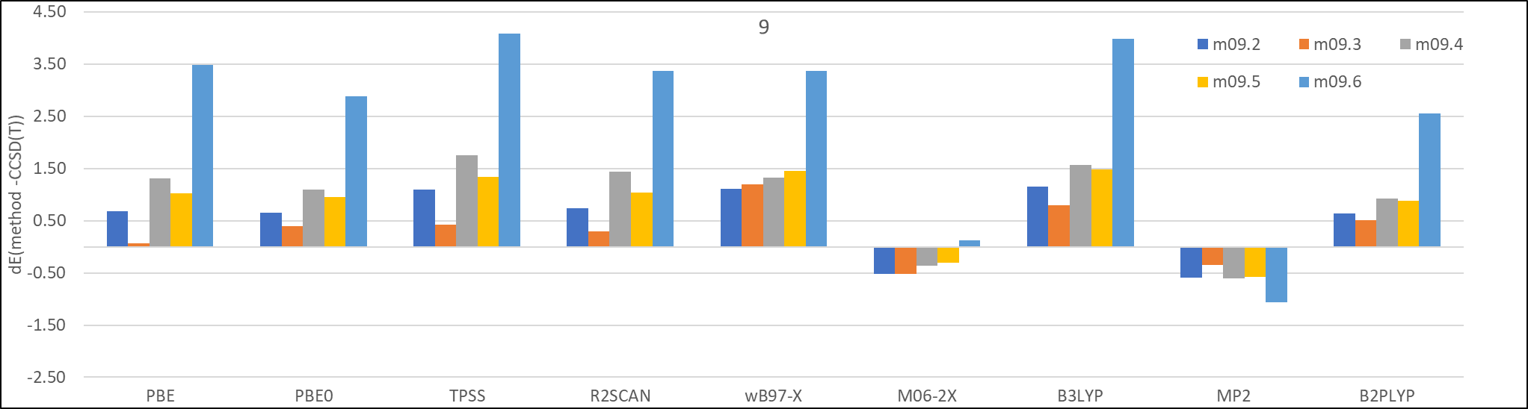
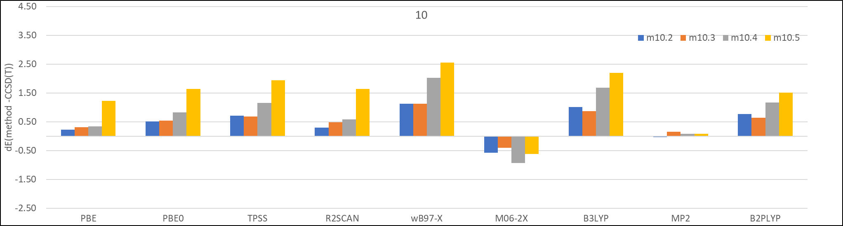
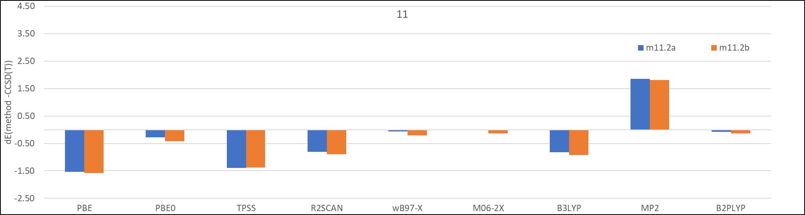
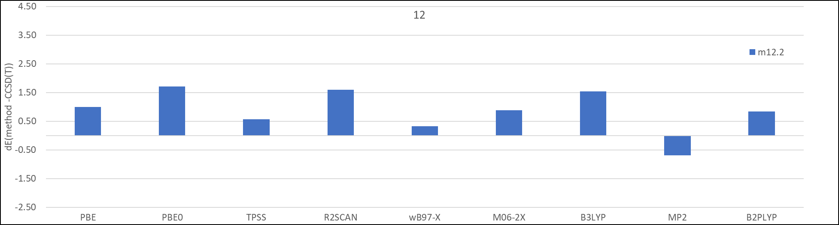
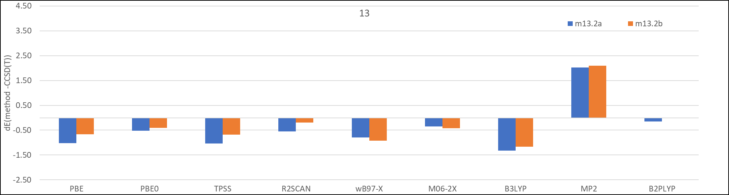
Figure S3: SMD water solvation tautomer state energy differences in kcal/mol relative to CCSD(T) energy differences for each state for each density functional method and MP2 for calculations (Note that y-axis scales are different for the plots).

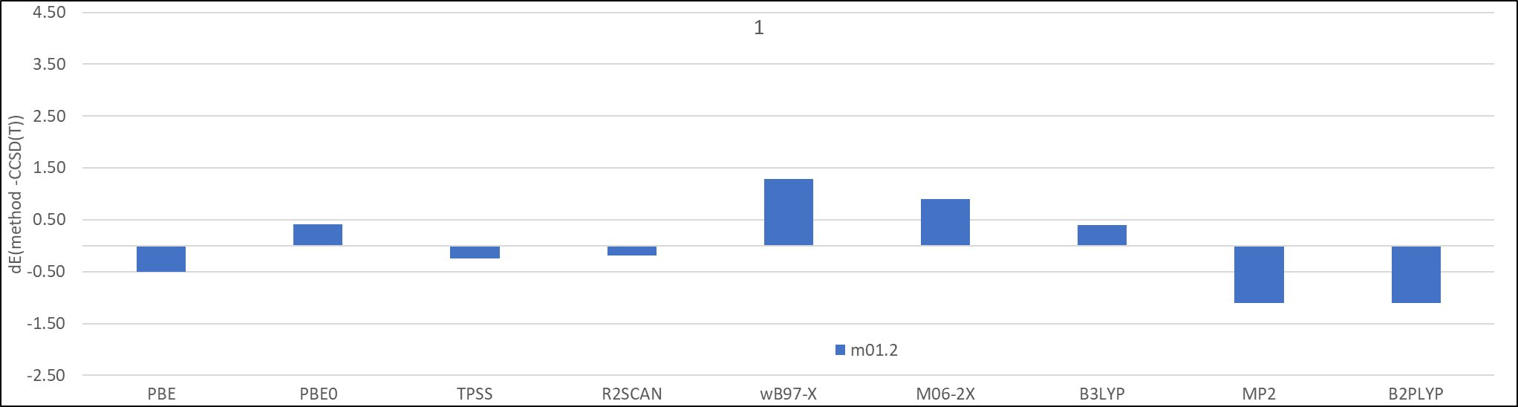
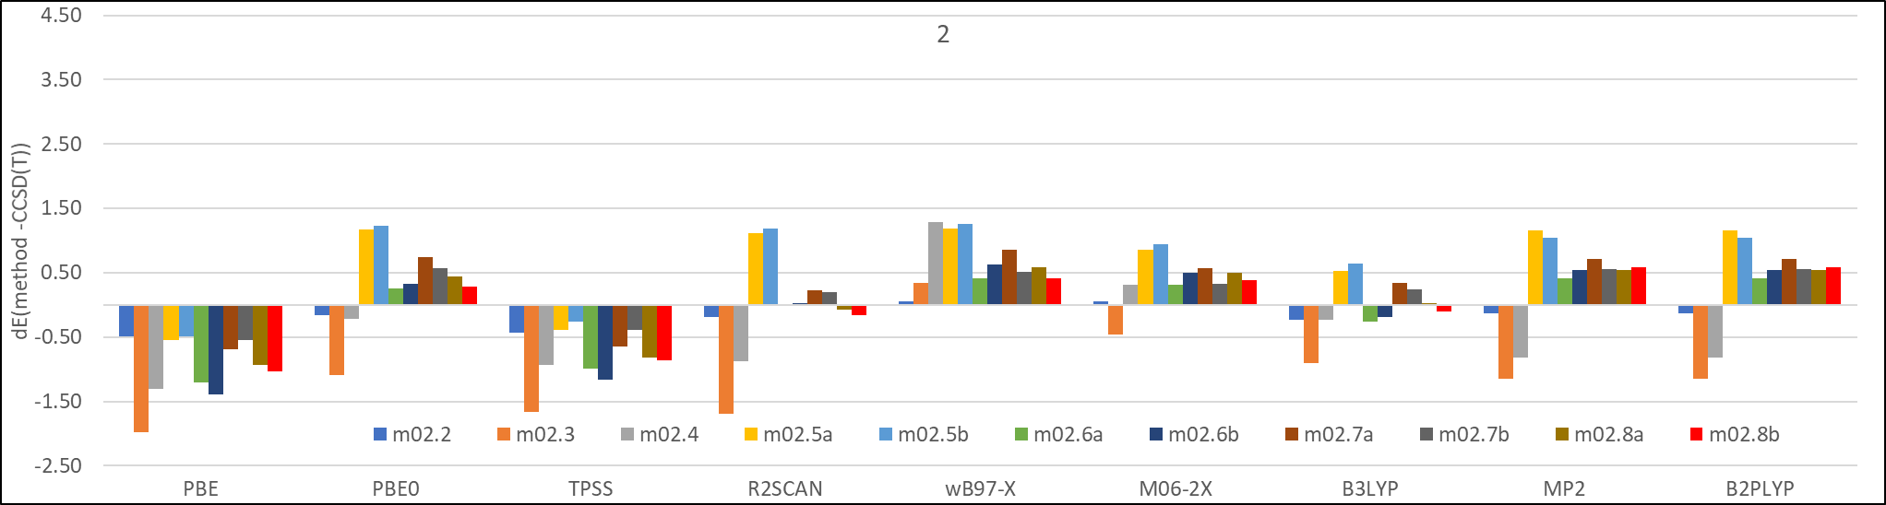
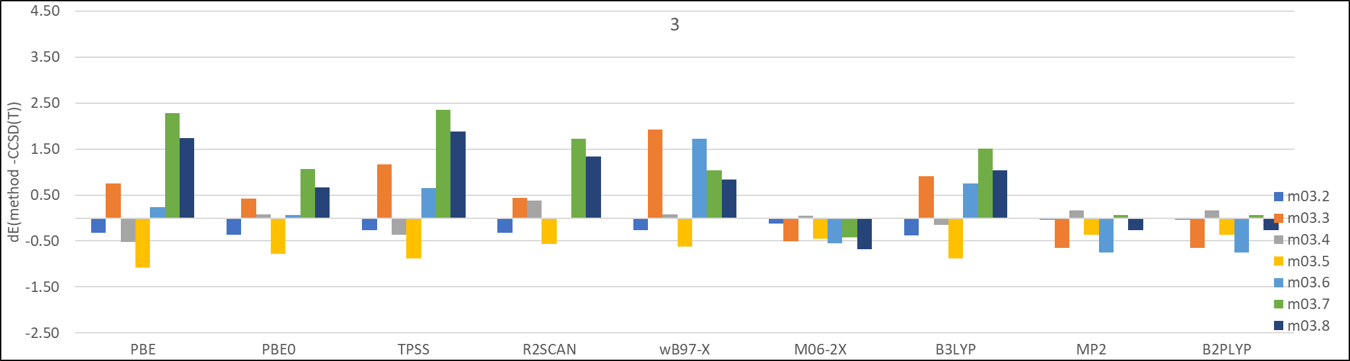
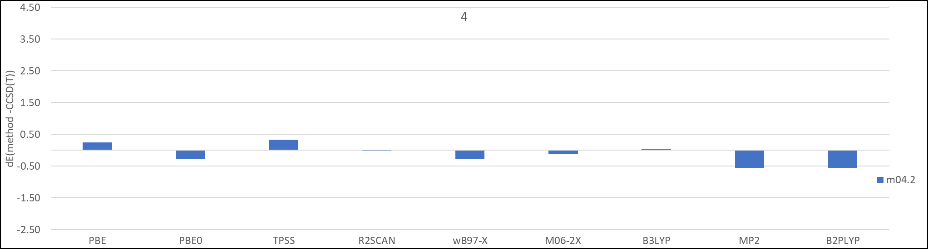
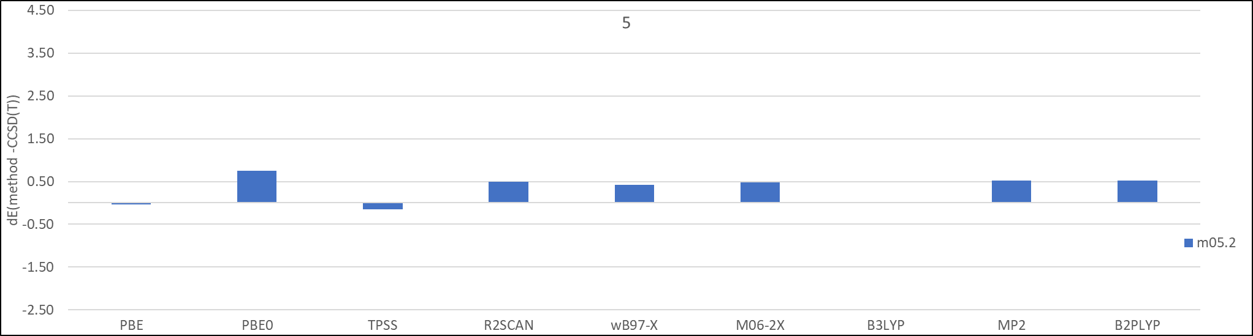
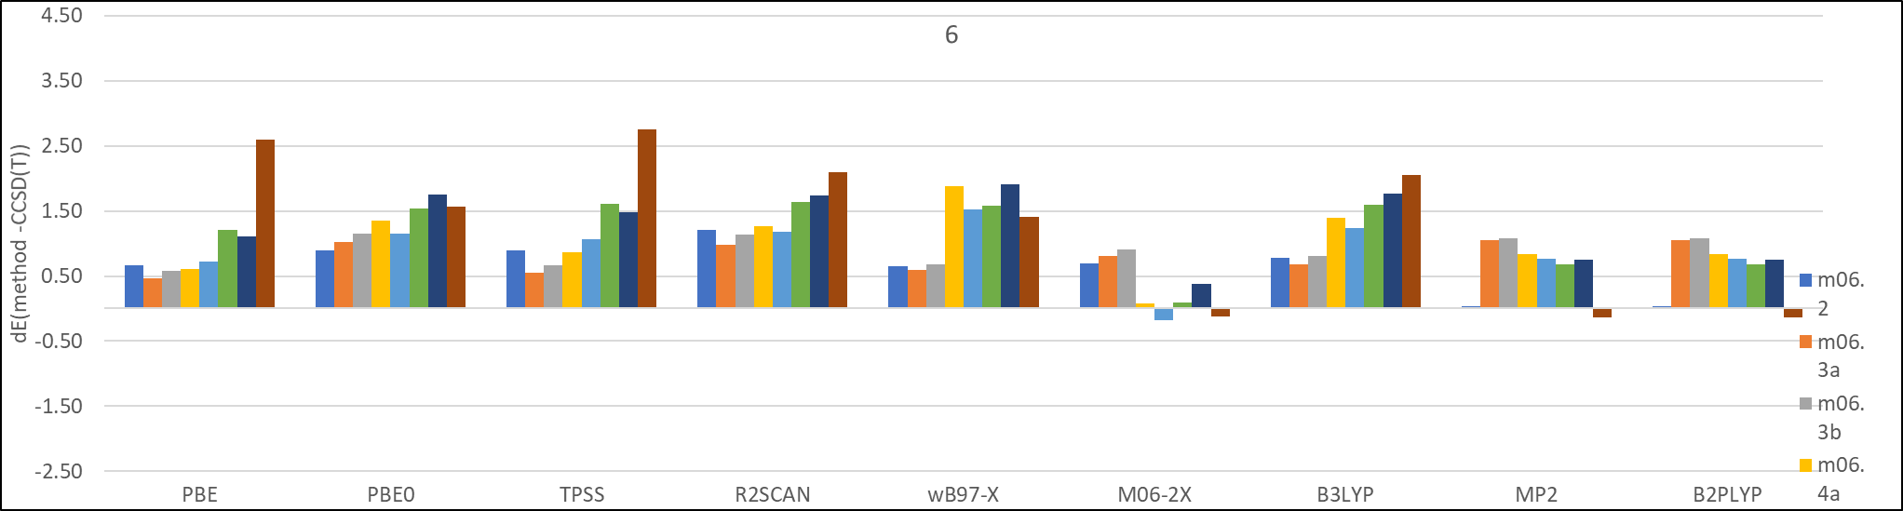
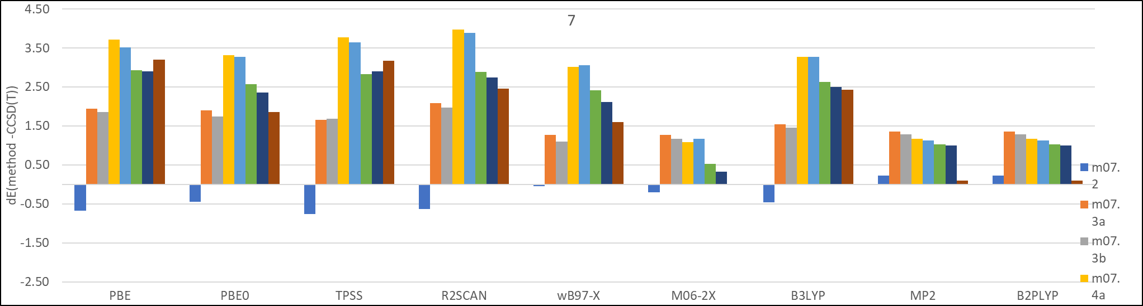
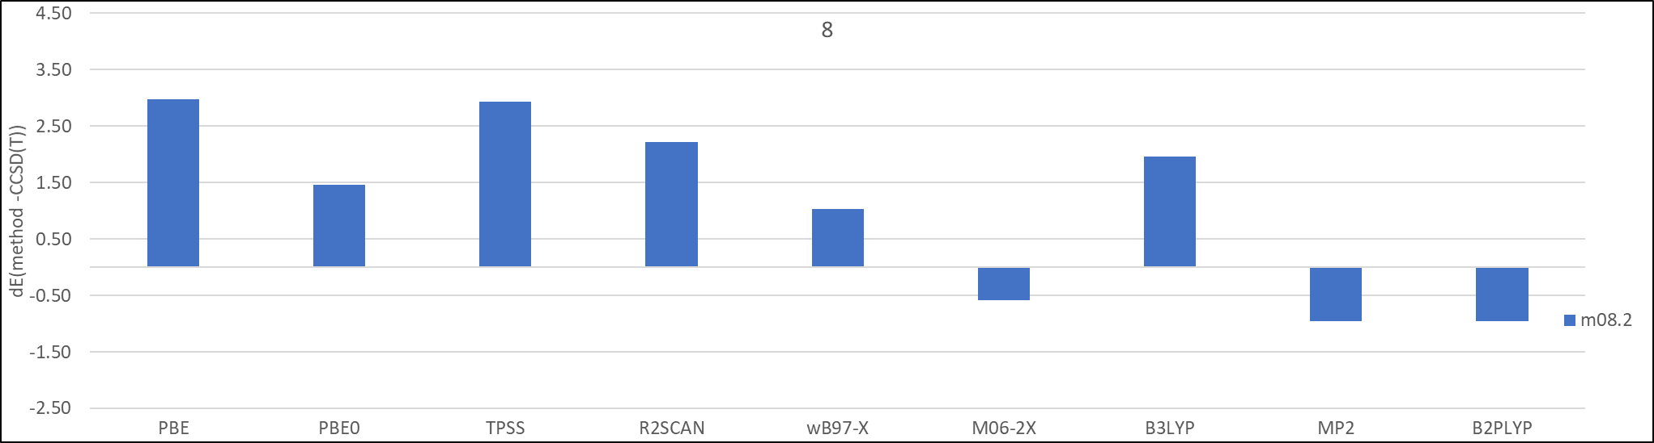
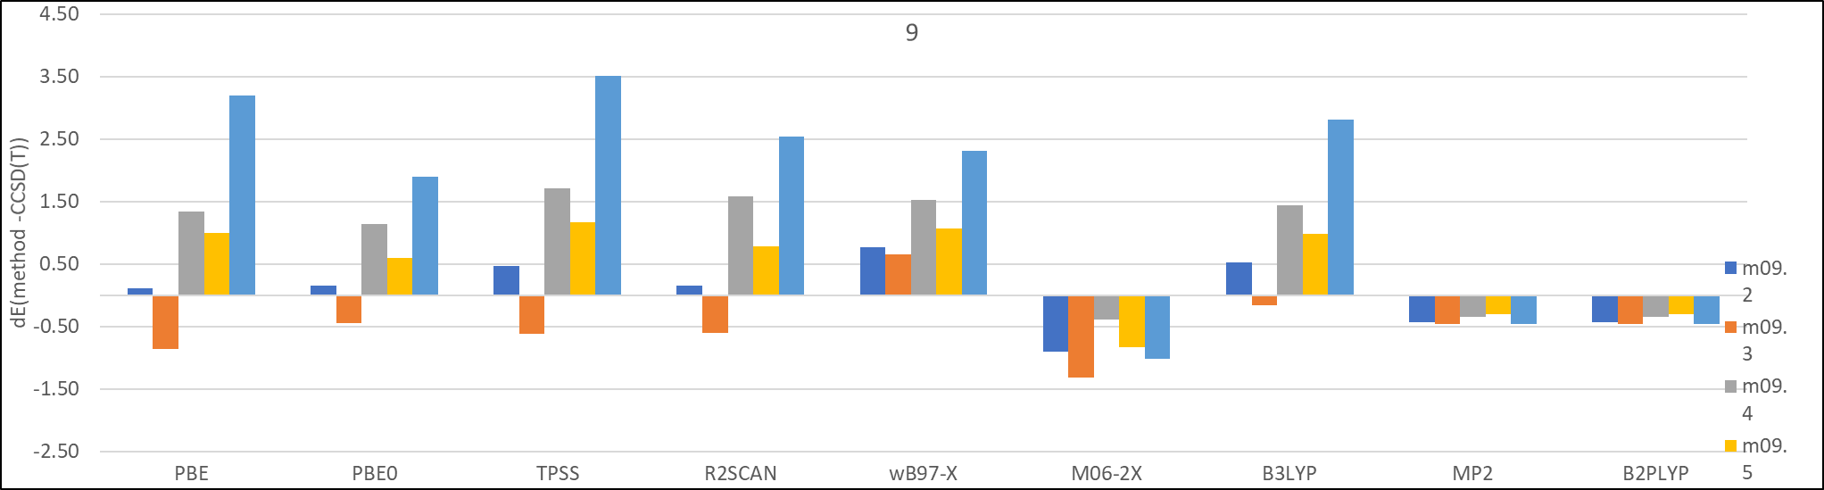
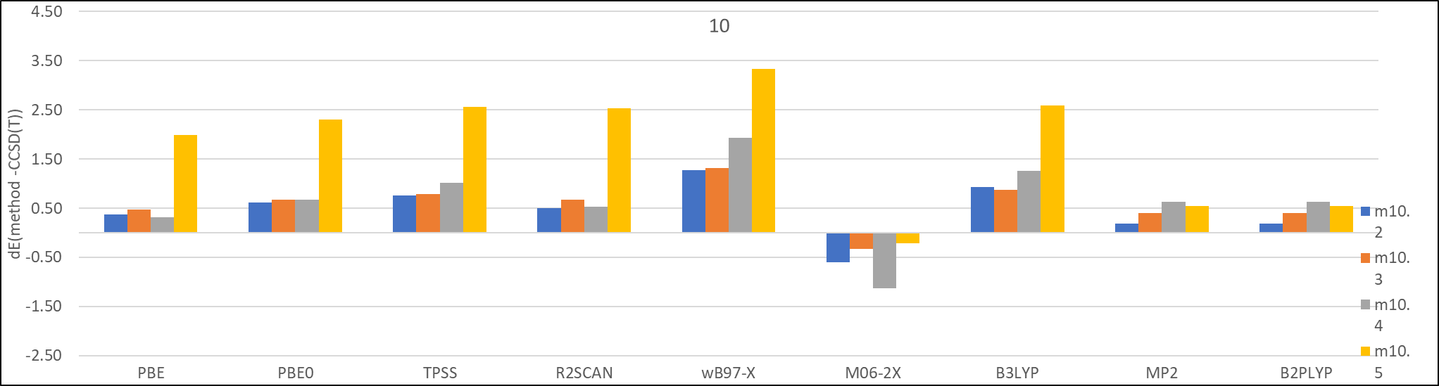
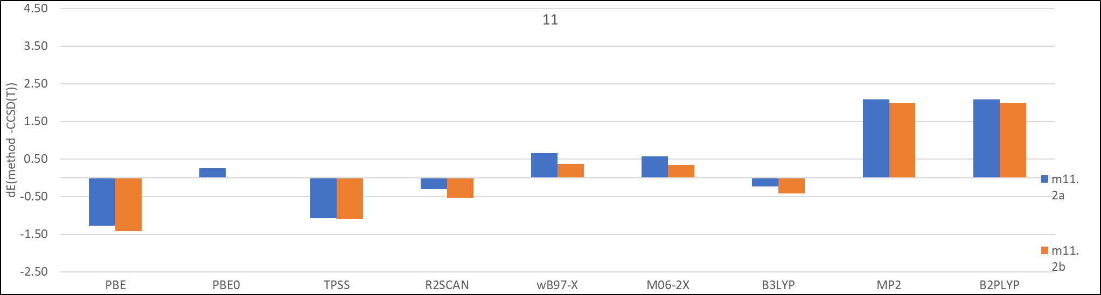
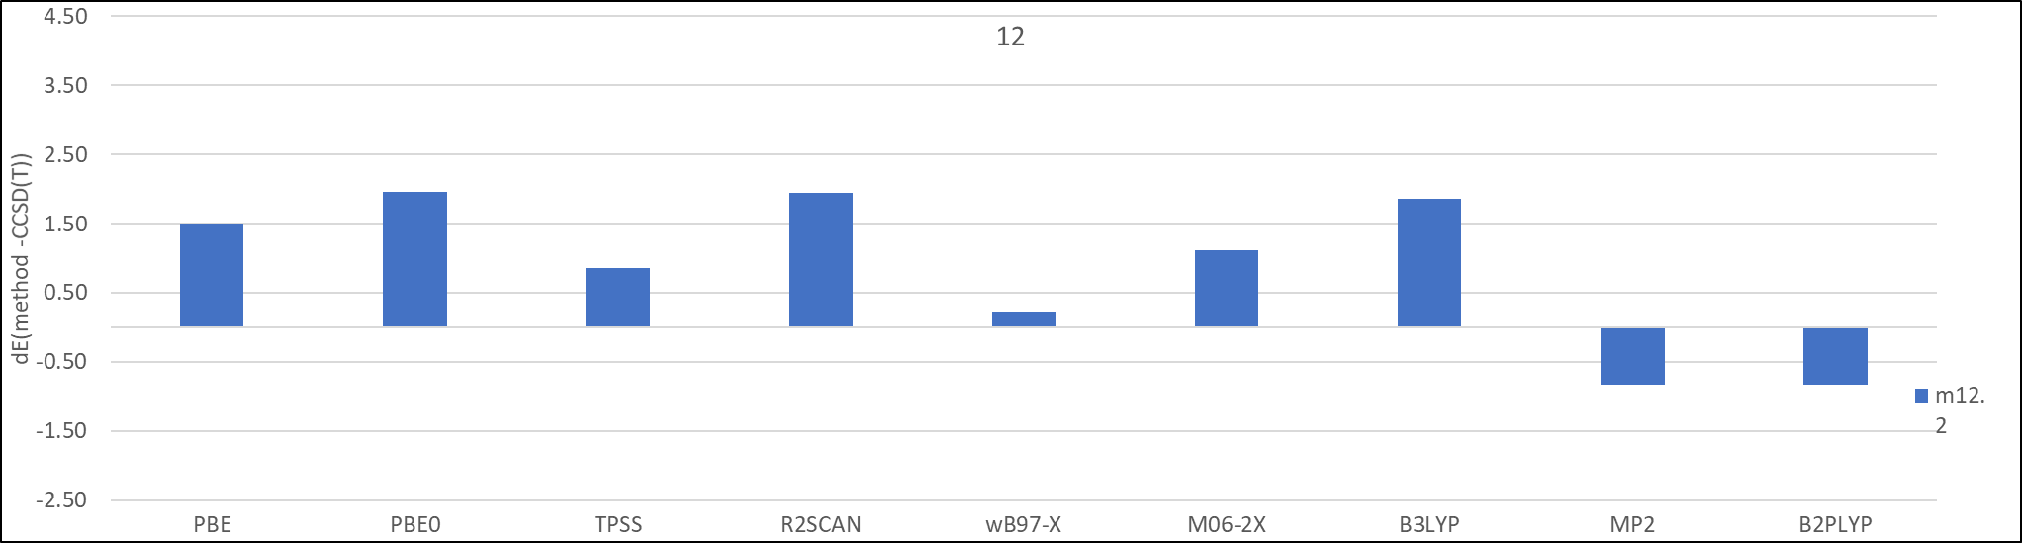
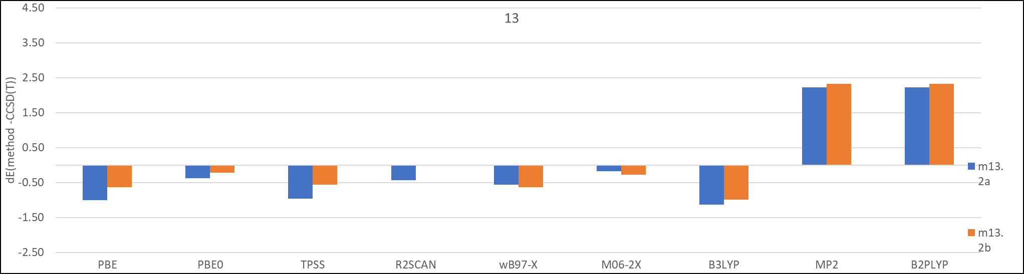
Figure S4: Gas-phase tautomer state energy differences in kcal/mol relative to CCSD(T) energy differences for each state for each density functional method and MP2 for calculations (Note that y-axis scales are different for the plots).

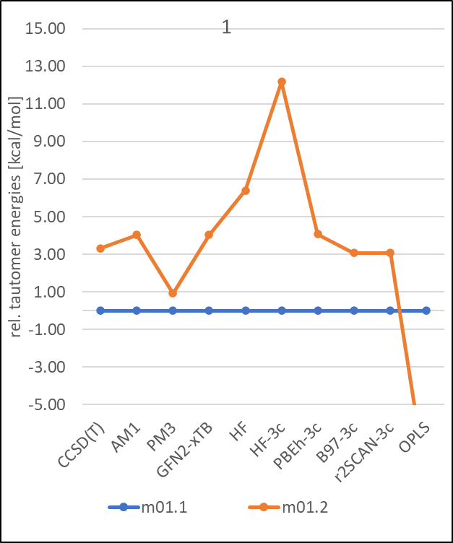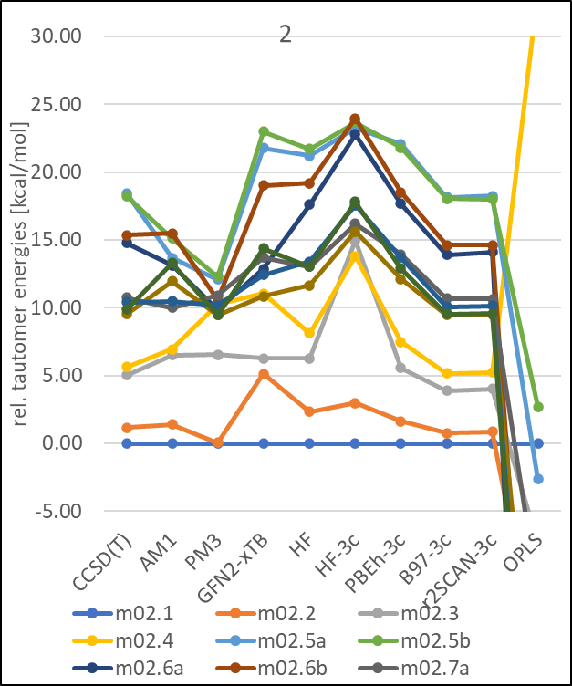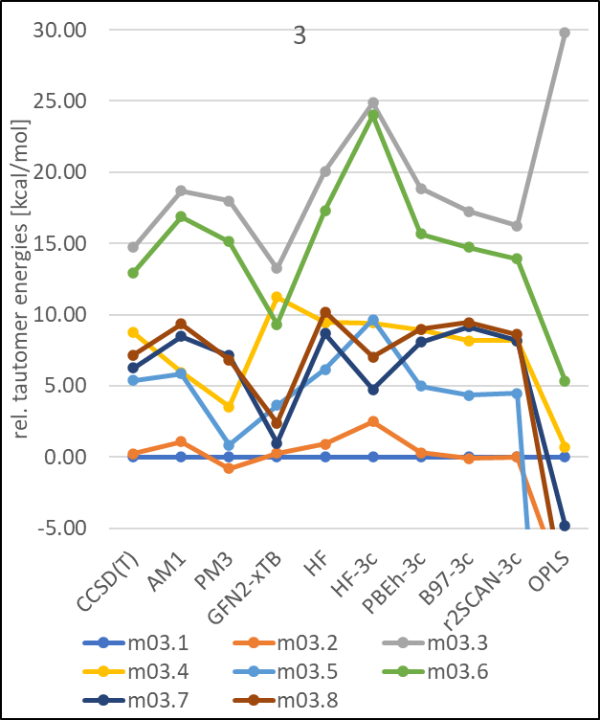

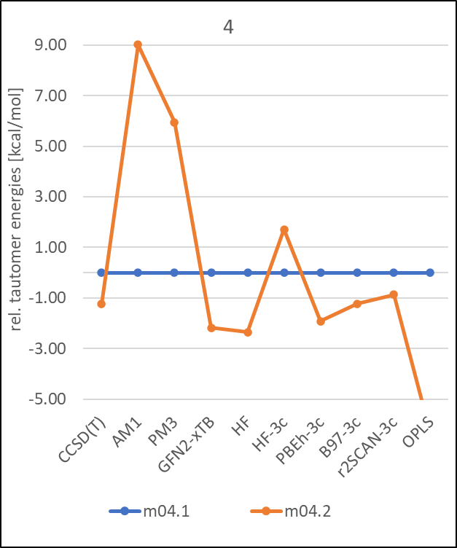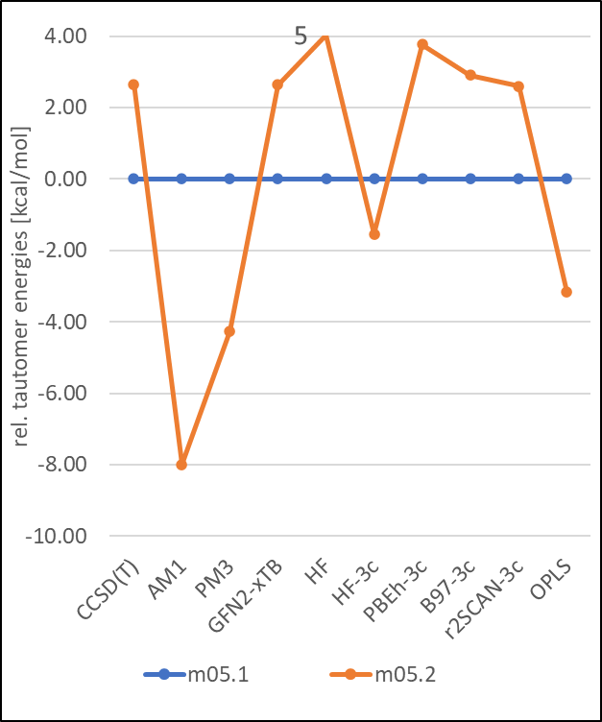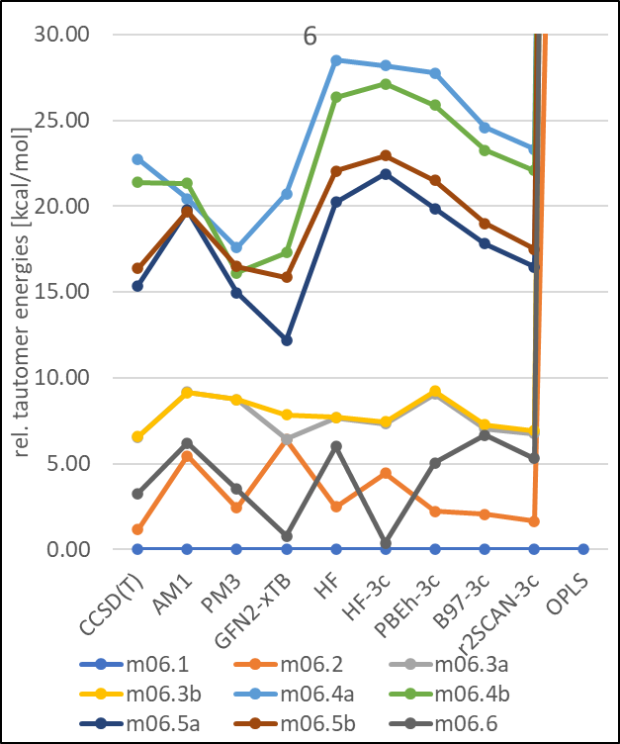

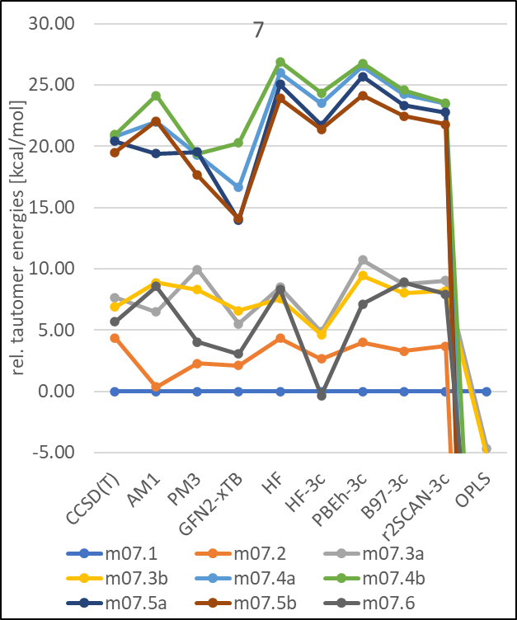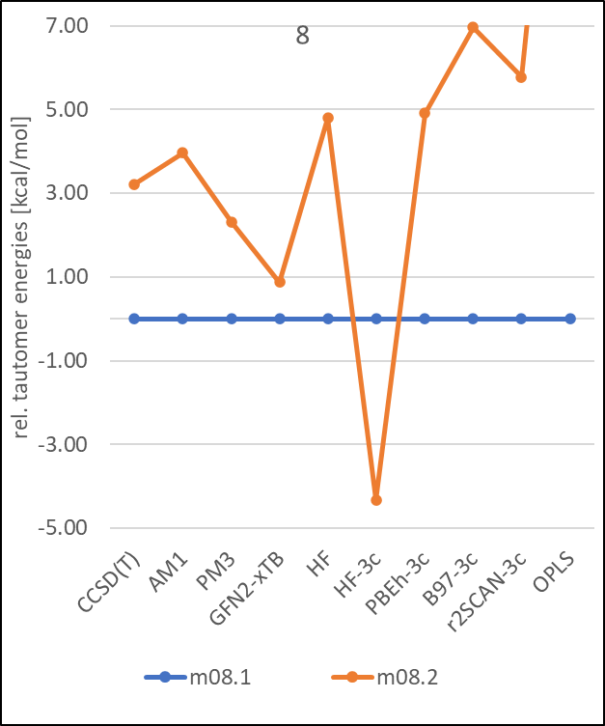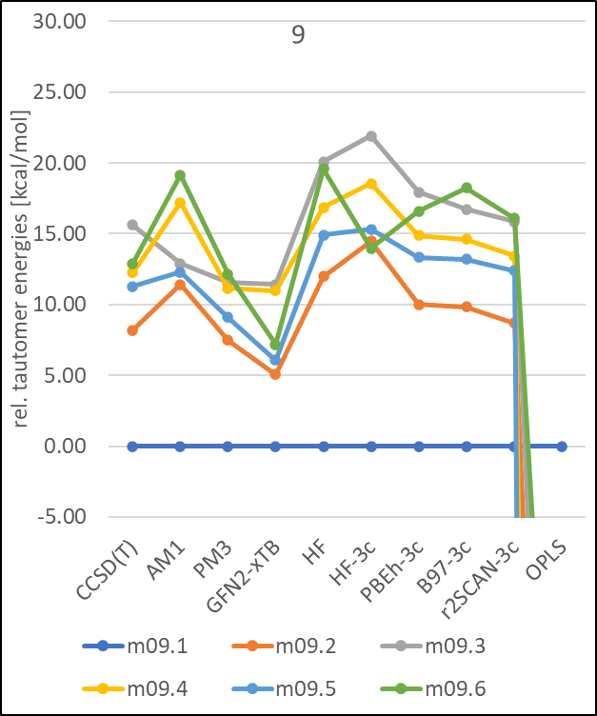

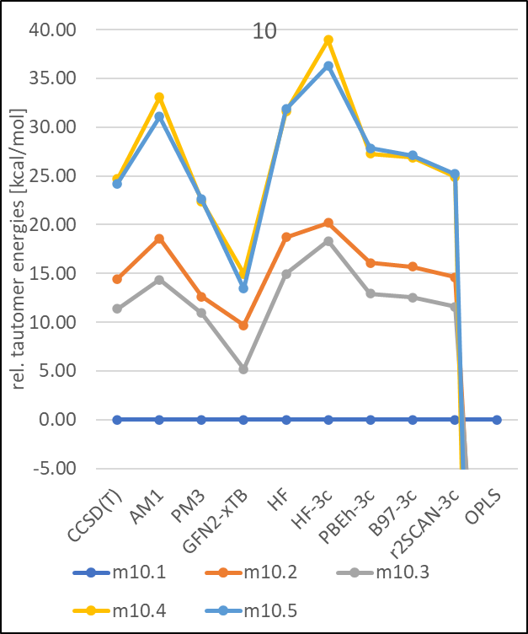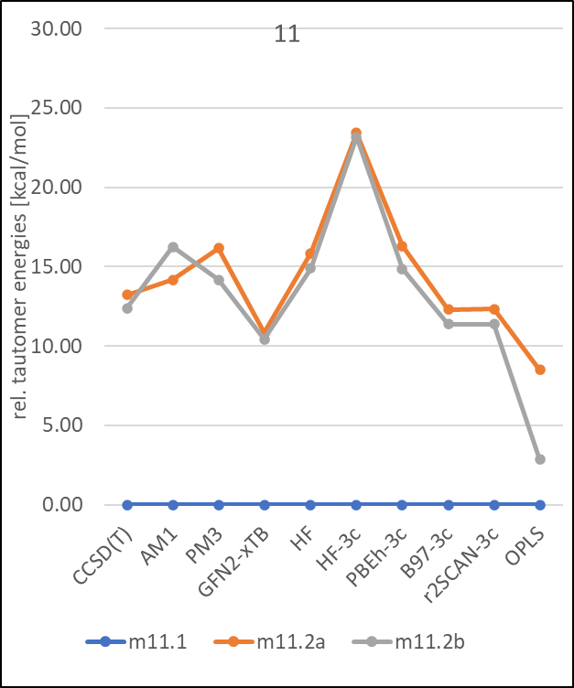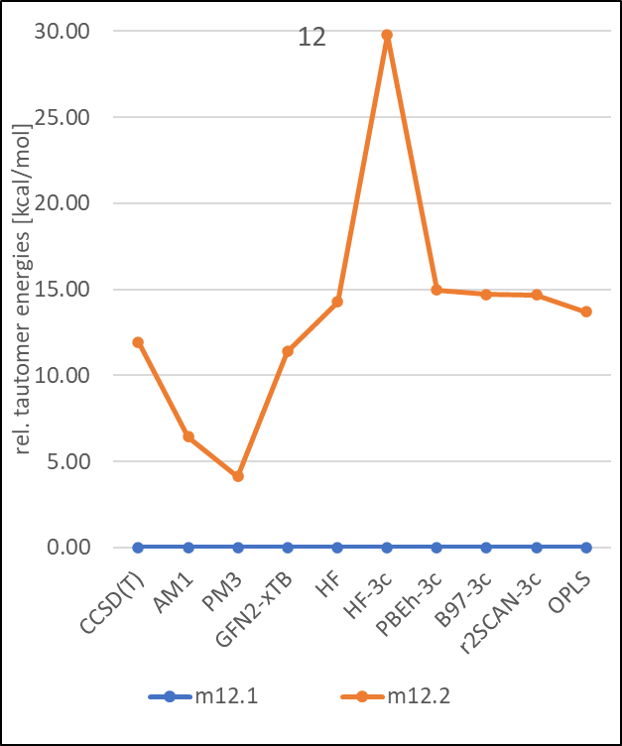

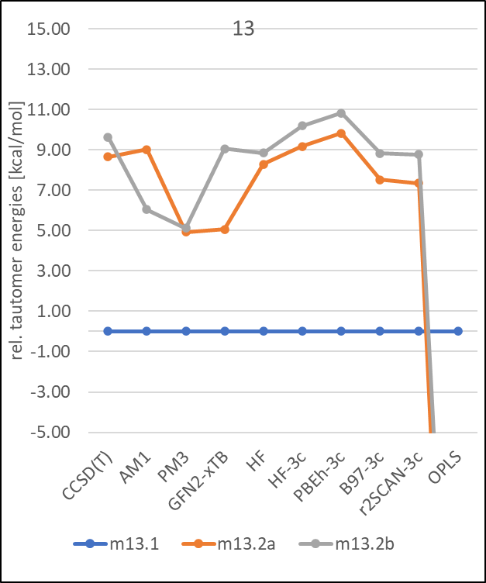
Figure S5: Comparison of tautomer state energies in kcal/mol calculated with CCSD(T), HF, semiempirical, cost-optimized DFT and all-atom force-field OPLS4 for the 13 molecules with different method default solvent models (see Methods for details).

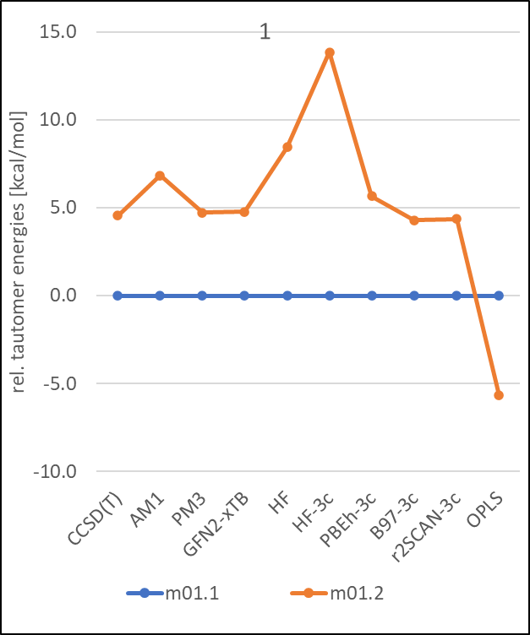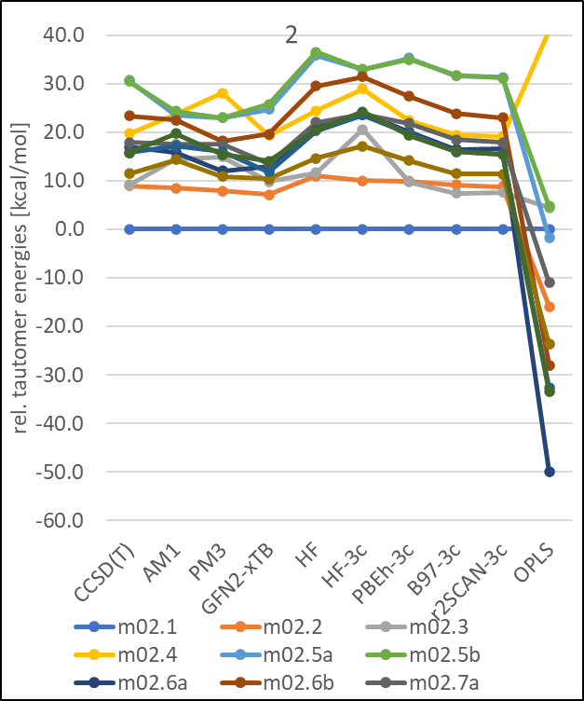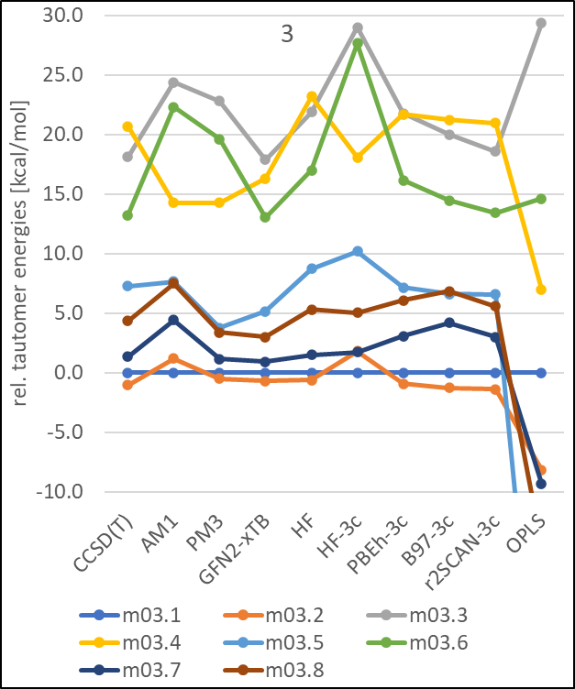

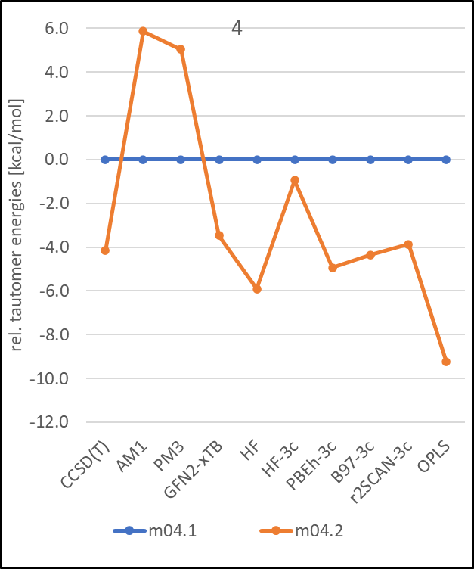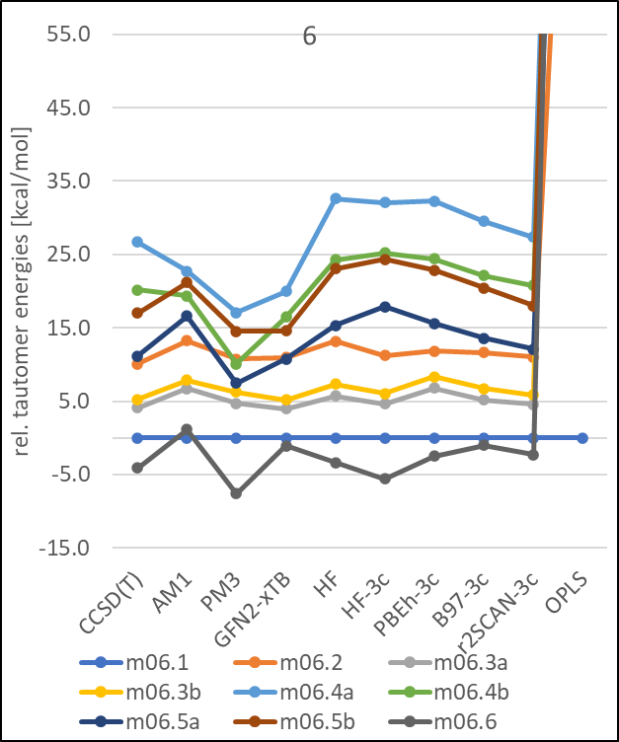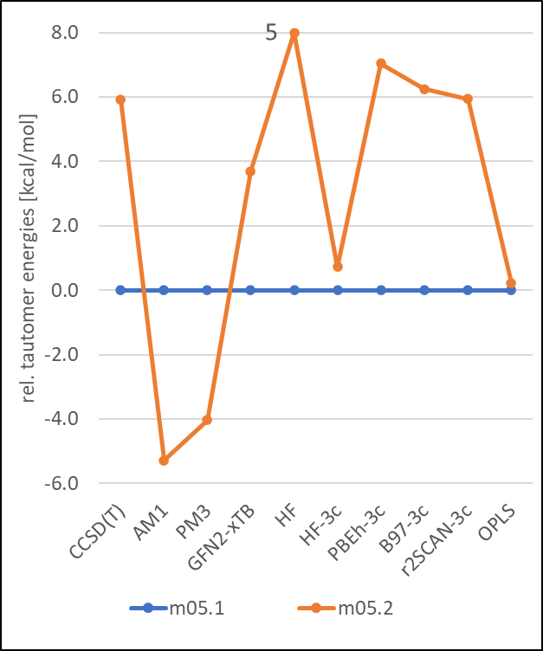

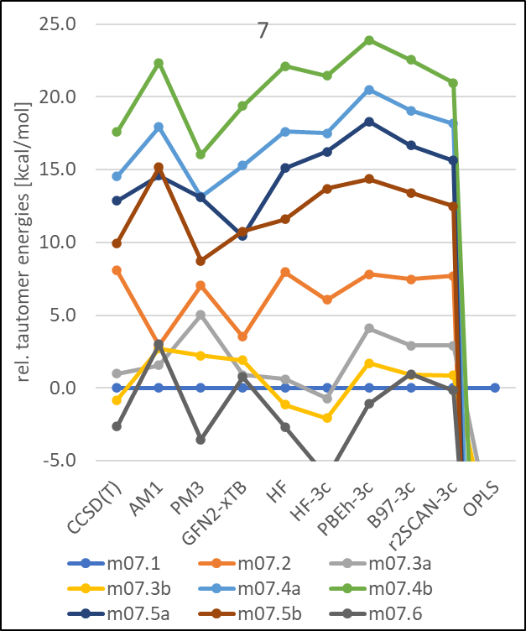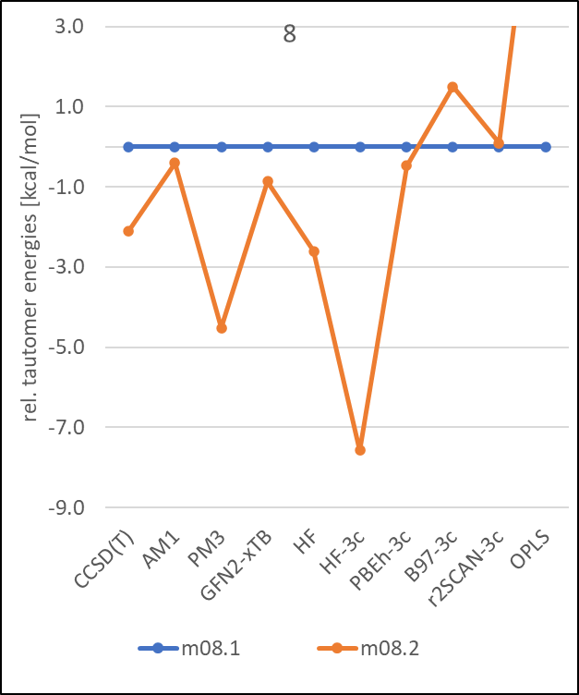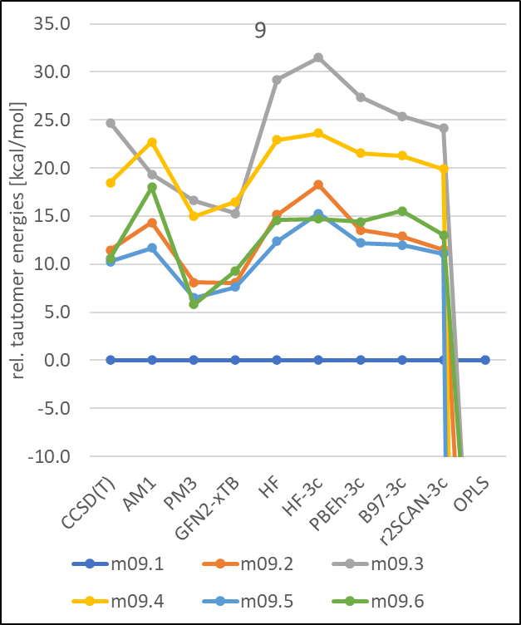

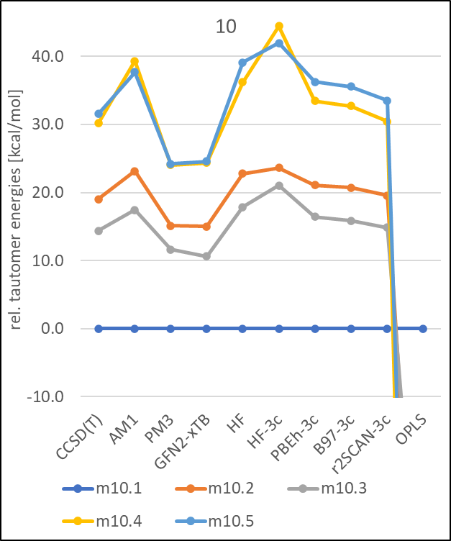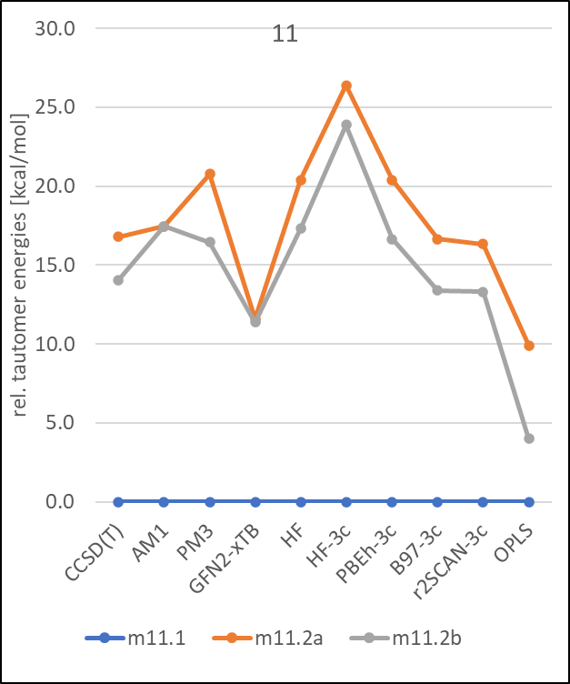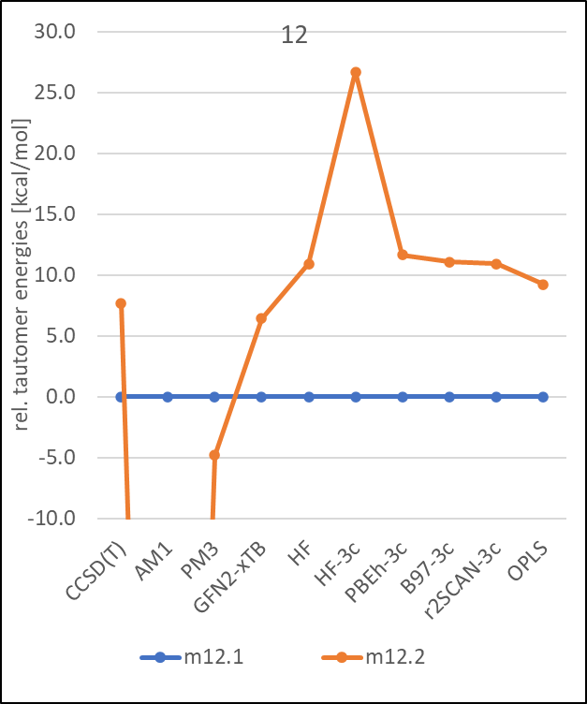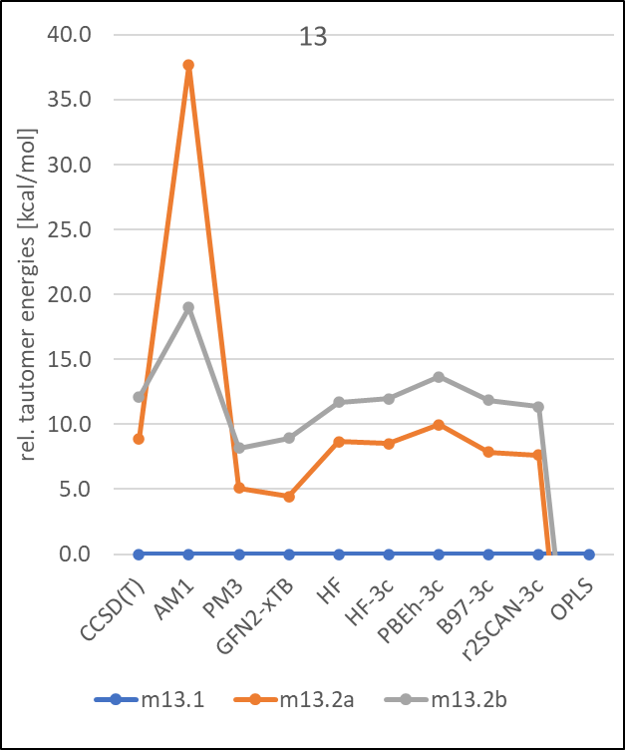
Figure S6: Comparison of tautomer state energies in kcal/mol calculated with CCSD(T), HF, semiempirical, cost-optimized DFT and all-atom force-field OPLS4 for the 13 molecules in gas-phase.

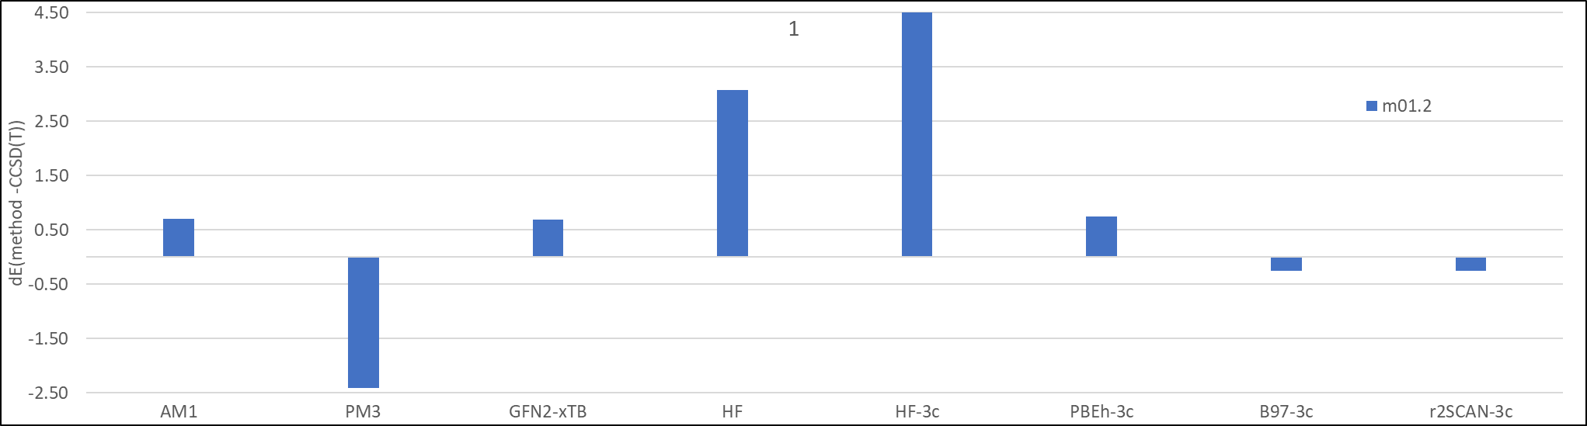
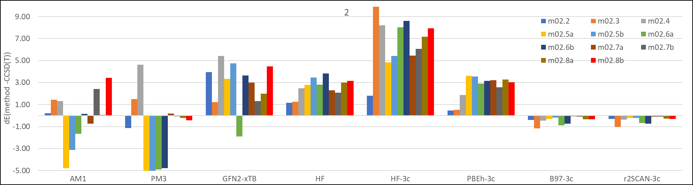
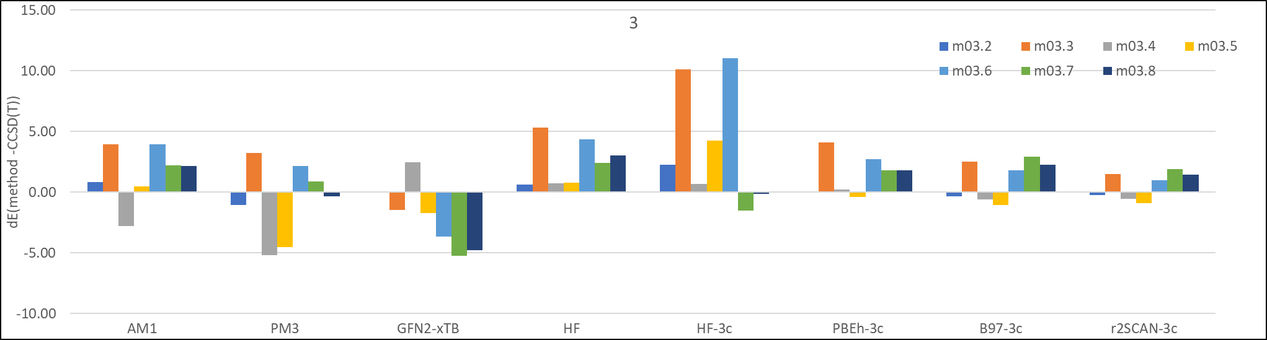
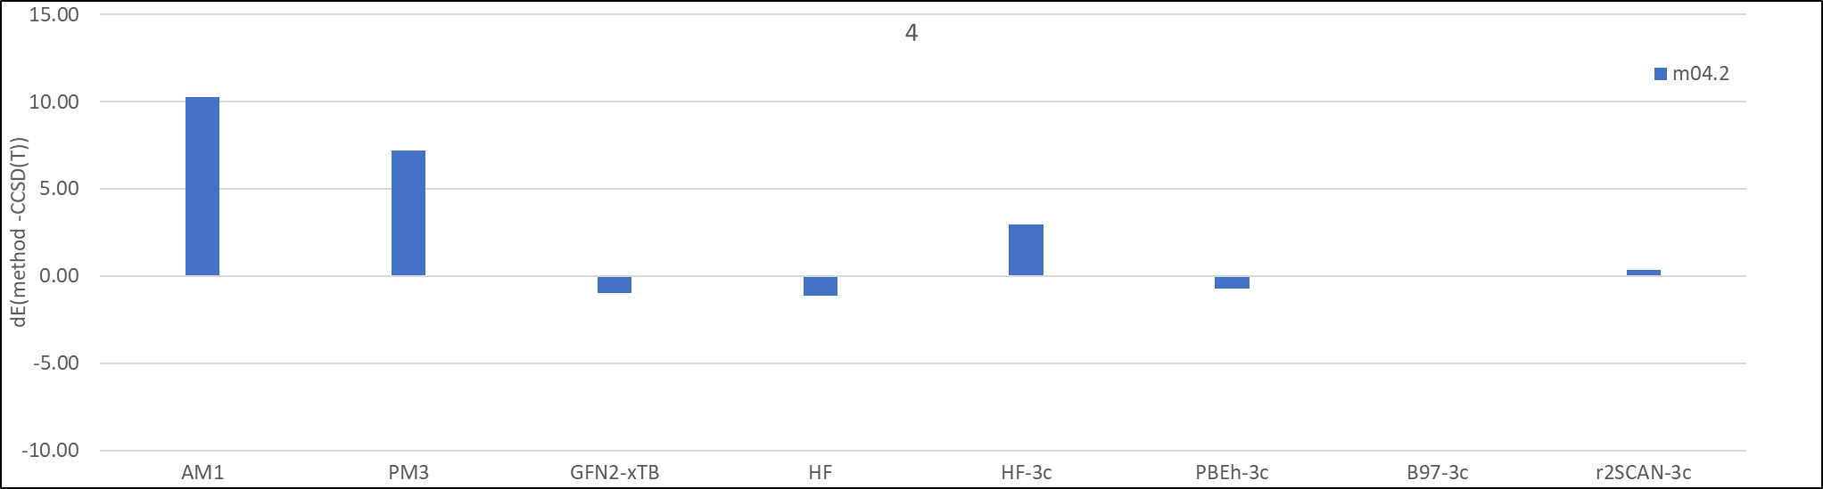
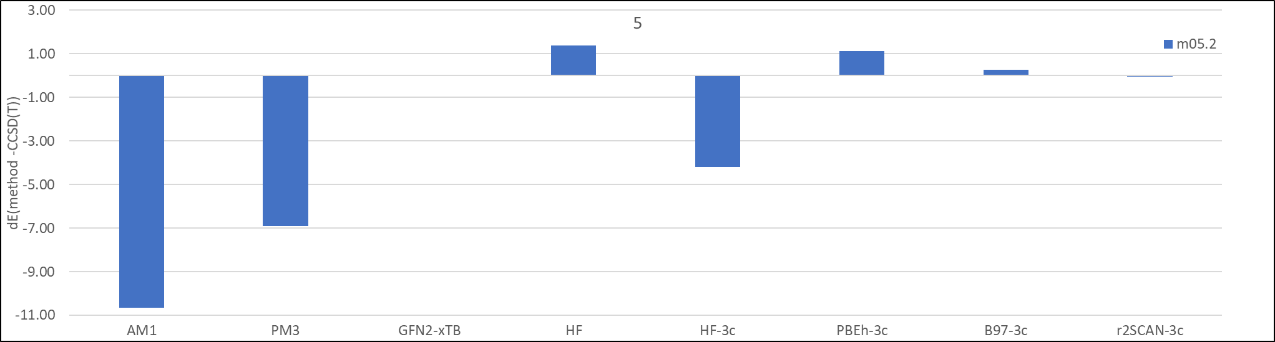

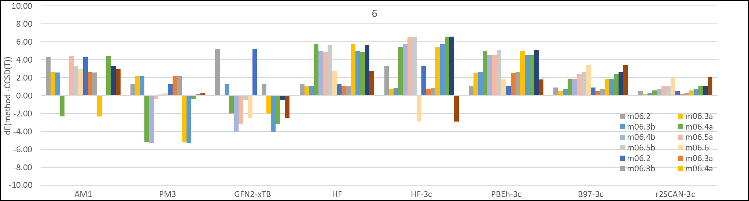
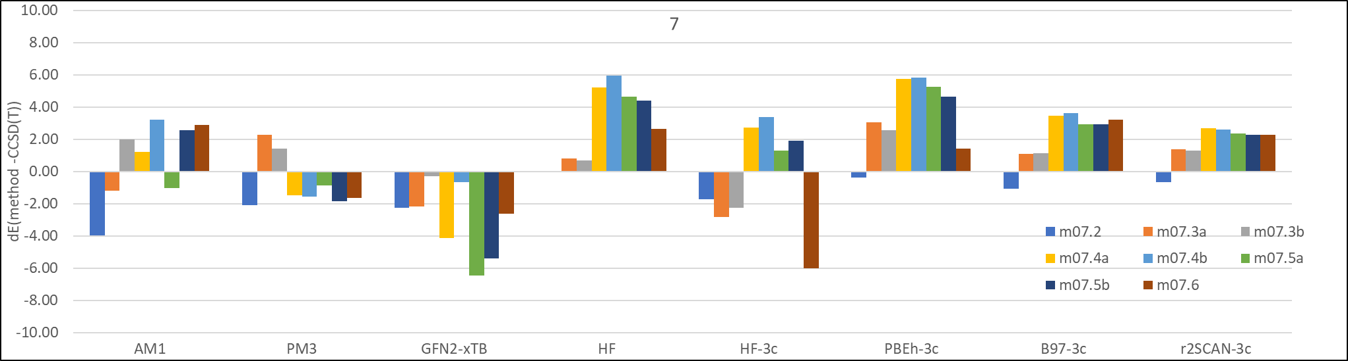
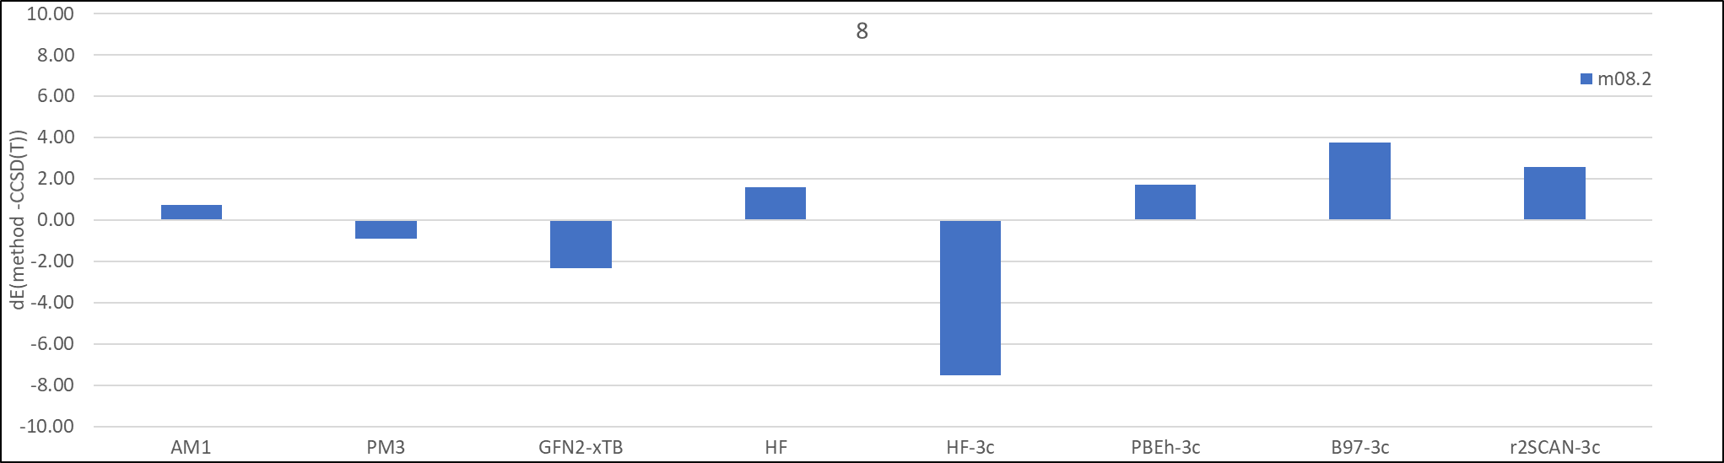
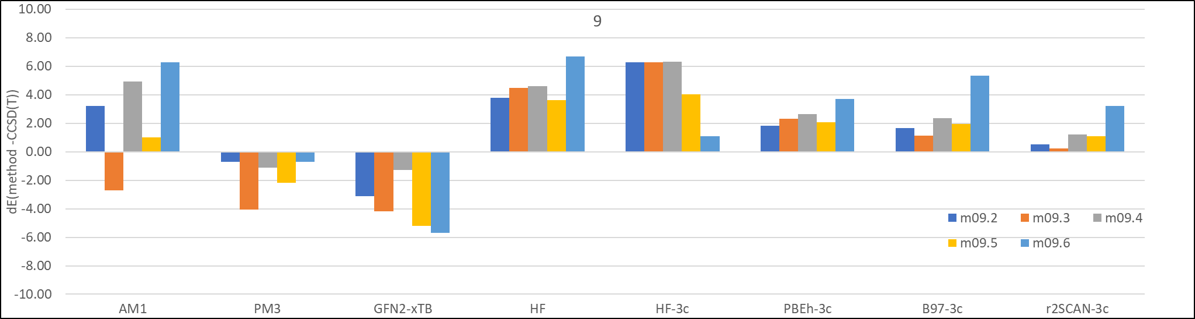
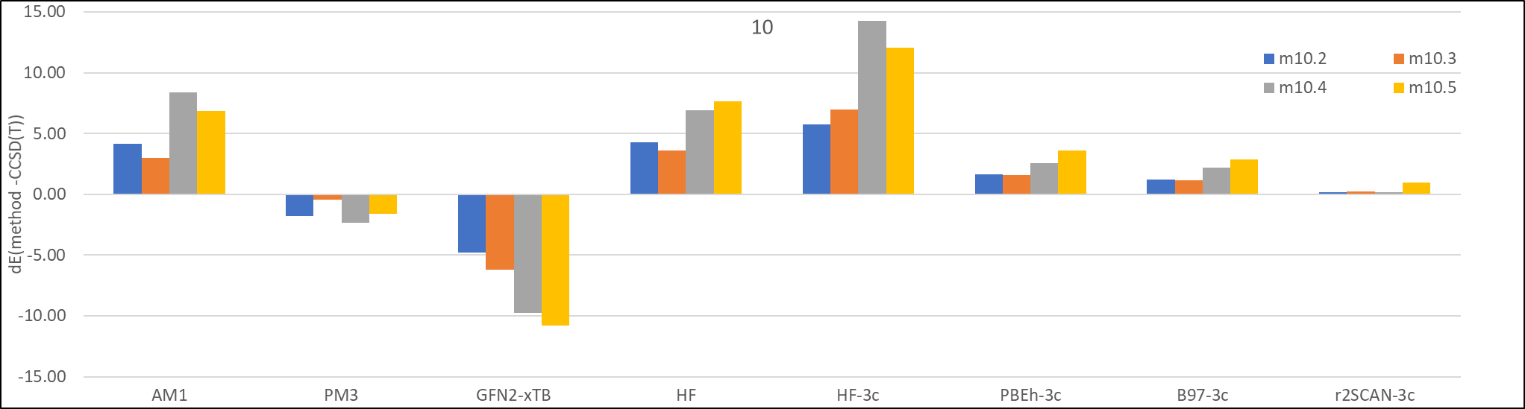
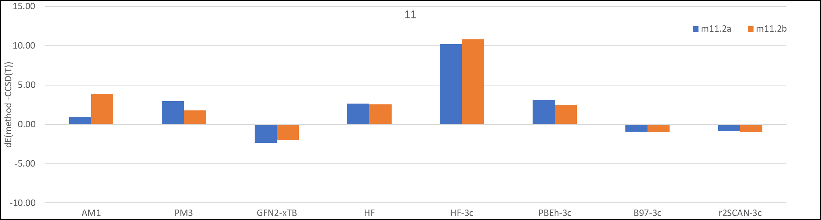
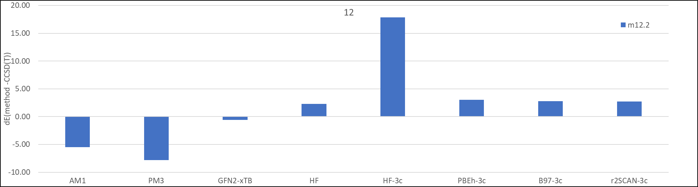
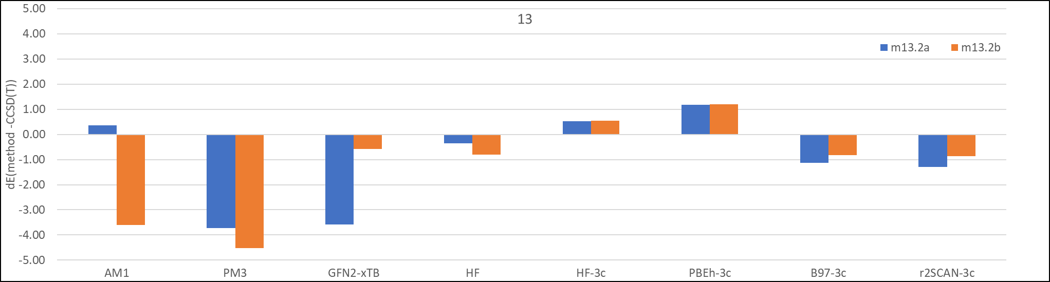
Figure S7: Tautomer state energy differences in kcal/mol relative to CCSD(T) energy differences for each state for various low-cost quantum-mechanics, semiempirical and DFT methods for calculations in solvent water. (Note that y-axis scales are different for the plots).

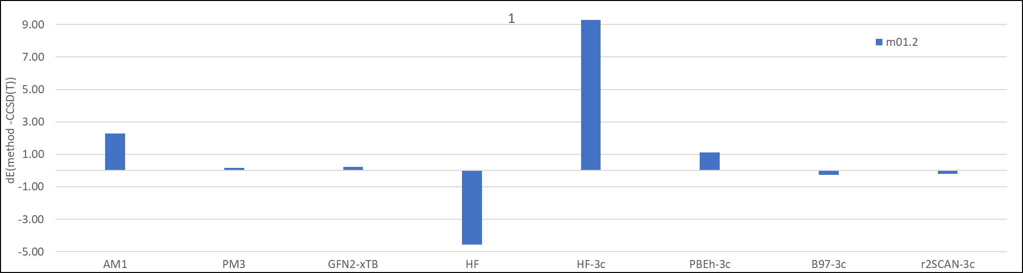
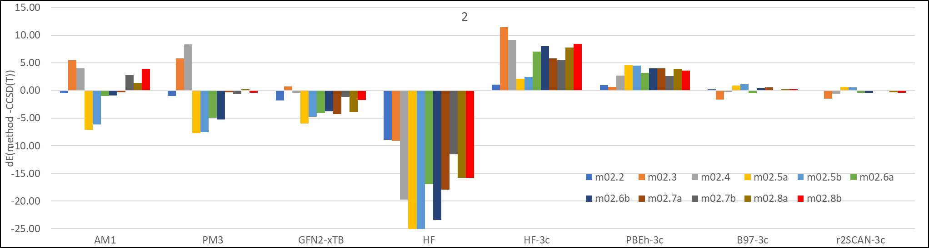
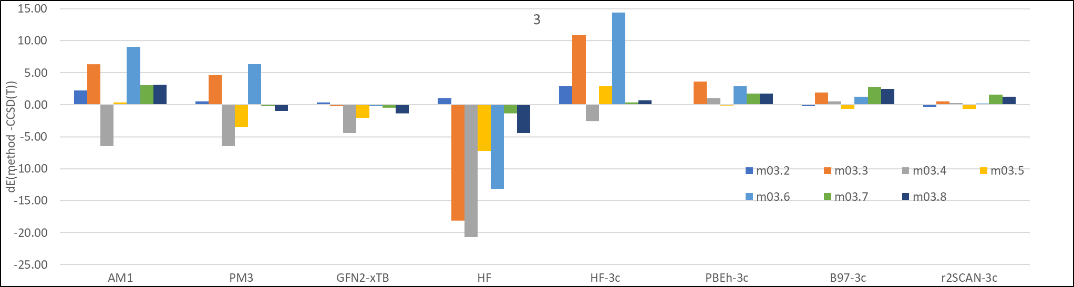
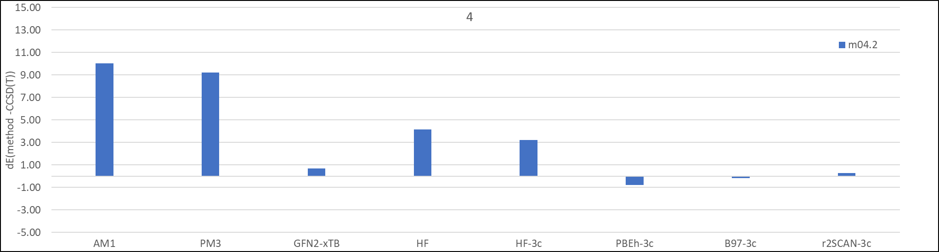
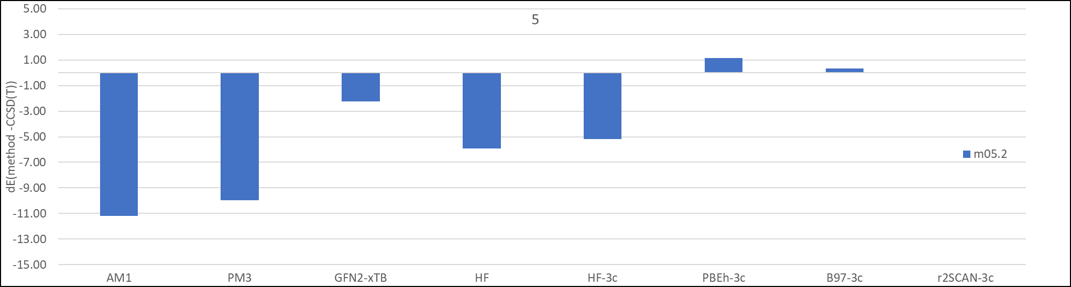
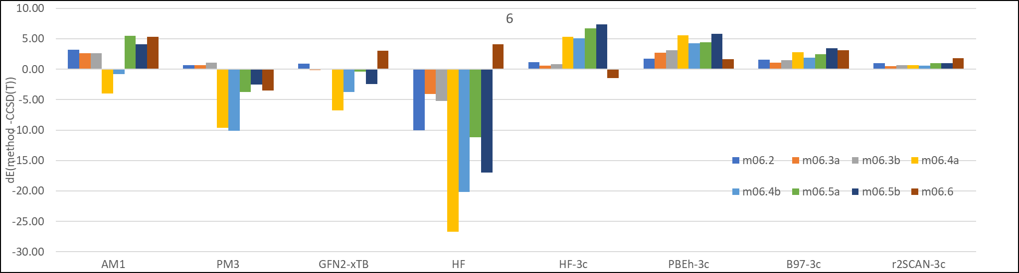
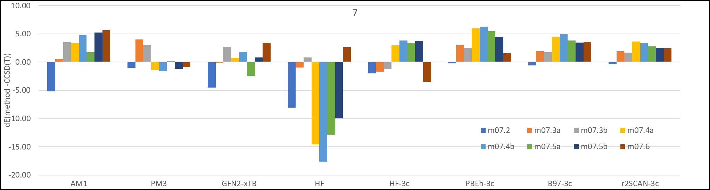
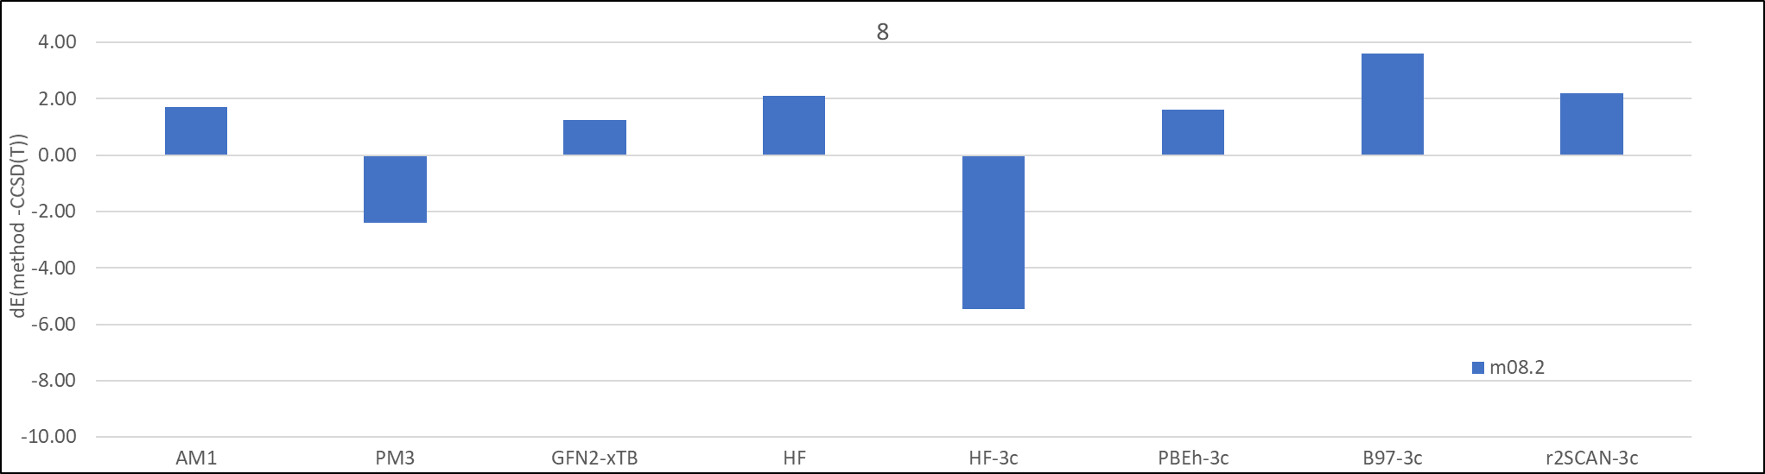
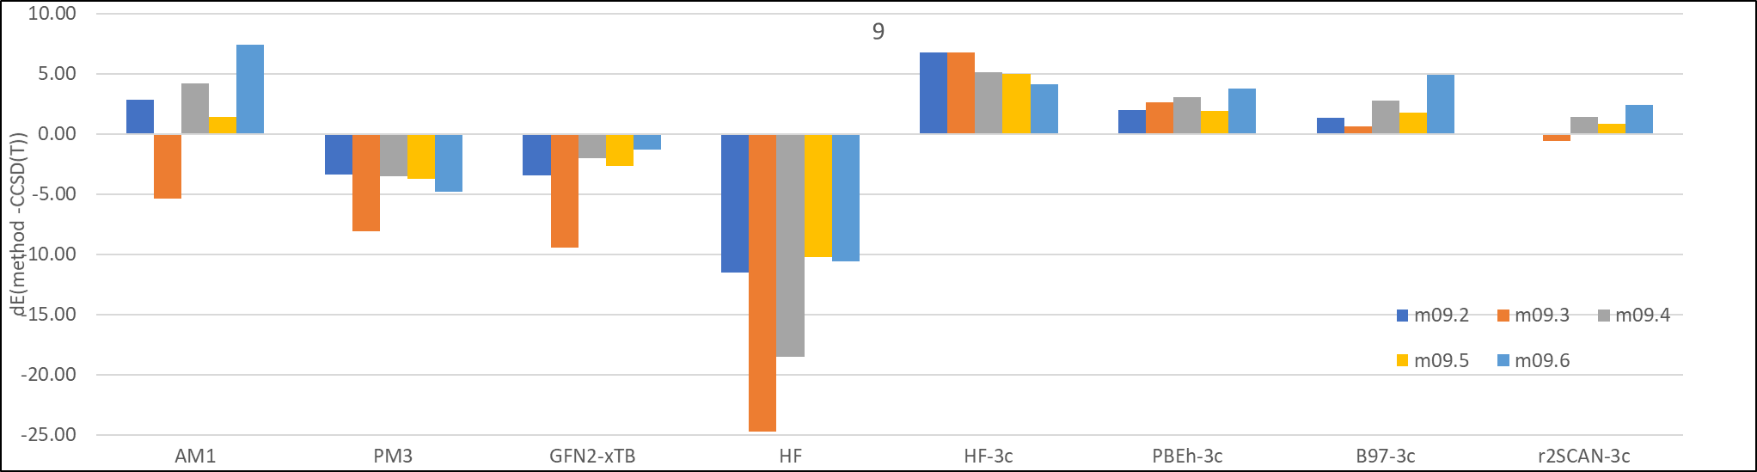
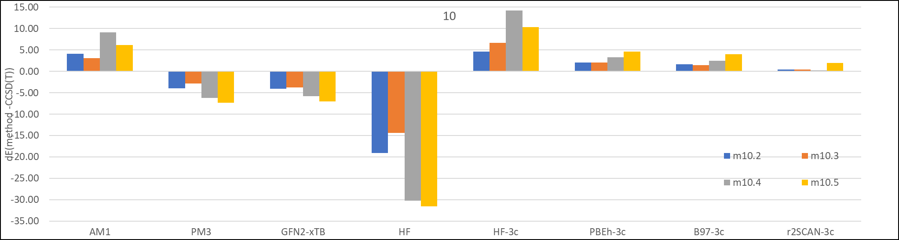
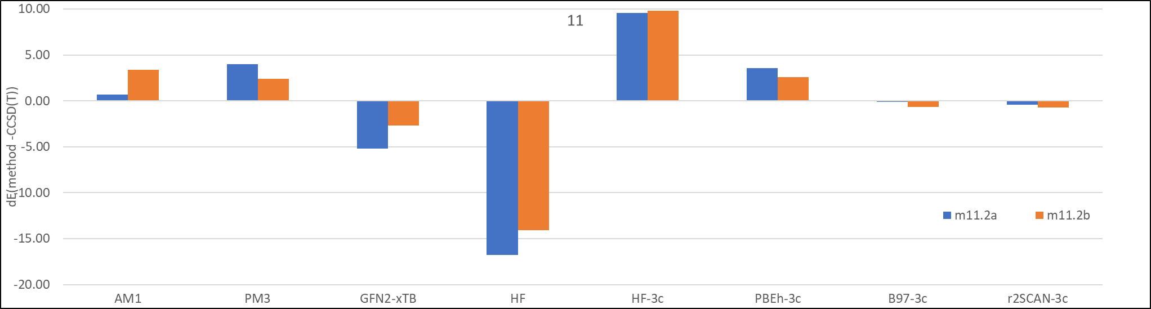
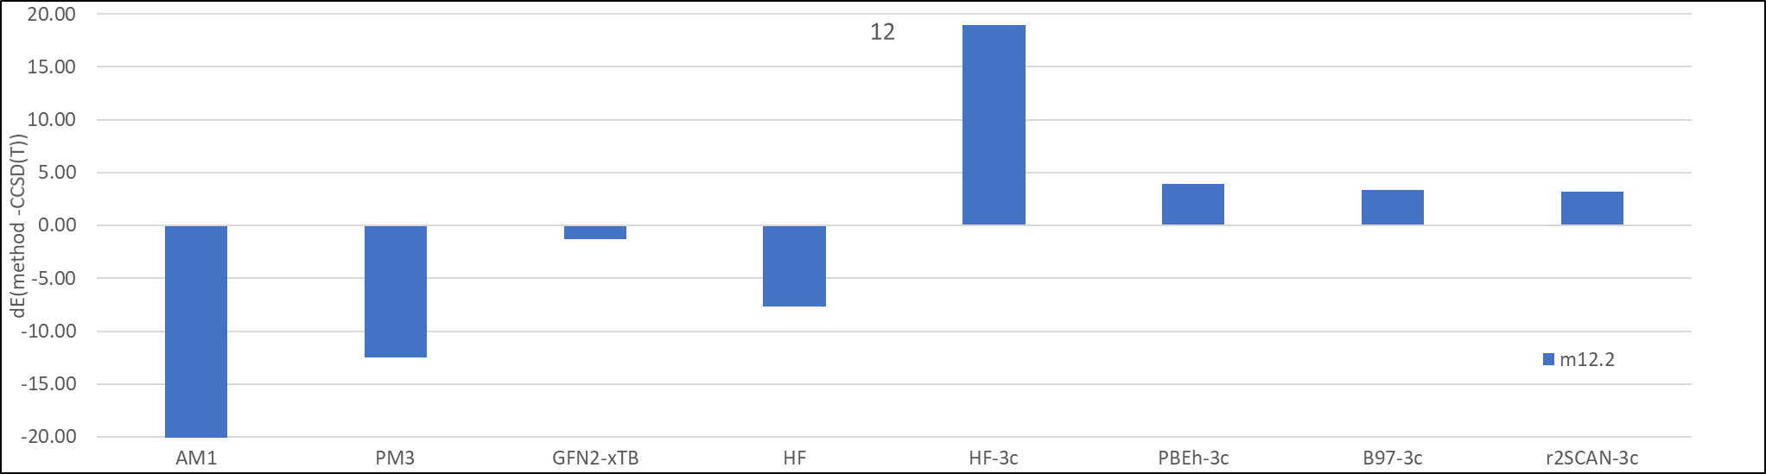
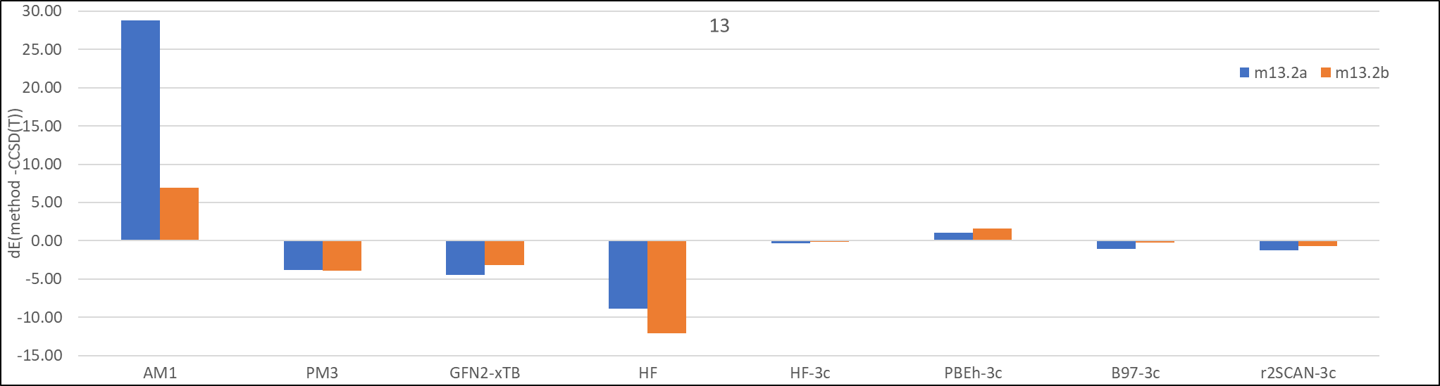
Figure S8: Tautomer state energy differences in kcal/mol relative to CCSD(T) energy differences for each state for various low-cost quantum-mechanics, semiempirical and DFT methods for calculations in gas-phase. (Note that y-axis scales are different for the plots).

 |  | Tautomer energy deltas |  |  |  | Deltas to experiment
pair | dE (exp) kcal/mol | M06-2X /Q | M06-2X /T | r2SCAN-3c | CCSD(T) /Q | M06-2X /Q | M06-2X /T | r2SCAN-3c | CCSD(T) /Q
1A_1B | -4.80 | -3.40 | -3.60 | -5.76 | -3.21 | 1.40 | 1.20 | -0.96 | 1.59
2A_2B | -6.10 | -6.38 | -6.55 | -7.96 | -5.92 | -0.28 | -0.45 | -1.86 | 0.18
3A_3B | -7.20 | -7.63 | -7.93 | -9.34 | -7.27 | -0.43 | -0.73 | -2.14 | -0.07
4A_4B | -2.30 | 0.82 | 0.63 | -2.29 | 0.99 | 3.12 | 2.93 | 0.01 | 3.29
5A_5B | -4.80 | -3.56 | -3.77 | -5.54 | -3.28 | 1.24 | 1.03 | -0.74 | 1.52
6A_6B | -9.20 | -10.81 | -11.16 | -12.28 | -10.34 | -1.61 | -1.96 | -3.08 | -1.14
7A_7B | 7.00 | 5.16 | 5.74 | 6.36 | 6.23 | -1.84 | -1.26 | -0.64 | -0.77
10B_10C | -2.90 | -1.14 | -1.22 | -3.85 | -0.83 | 1.76 | 1.68 | -0.95 | 2.07
10D_10C | -1.20 | -1.14 | -1.22 | -3.85 | -0.83 | 0.06 | -0.02 | -2.65 | 0.37
12D_12C | -1.80 | -0.10 | -0.12 | -2.71 | 0.08 | 1.70 | 1.68 | -0.91 | 1.88
14D_14C | 0.30 | 1.20 | 1.00 | -0.10 | 2.65 | 0.90 | 0.70 | -0.40 | 2.35
15A_15B | 0.90 | 2.88 | 3.24 | 5.56 | 4.07 | 1.98 | 2.34 | 4.66 | 3.17
15A_15C | -1.20 | 2.87 | 3.31 | 3.82 | 5.65 | 4.07 | 4.51 | 5.02 | 6.85
15B_15C | -2.20 | -0.02 | 0.07 | -1.74 | 1.59 | 2.18 | 2.27 | 0.46 | 3.79
Table T1: Calculated energy differences for the SAMPL2 subset compounds with four methods selected and deltas between experimental and calculated energy differences in kcal/mol. Q denotes def2-QZVPP and T denotes def2-TZVP basis sets, respectively.
 | Tautomer energy deltas |  |  |  | Absolute energy delta to CCSD(T)
pair | M06-2X /Q | M06-2X /T | r2SCAN-3c | CCSD(T) /Q | M06-2X  /Q | M06-2X  /T | r2SCAN-3c
1A_1B | 2.68 | 2.34 | -0.11 | 2.10 | 0.57 | 0.24 | 2.21
2A_2B | -1.96 | -2.28 | -3.82 | -2.14 | 0.18 | 0.14 | 1.68
3A_3B | -3.64 | -4.04 | -5.62 | -3.92 | 0.28 | 0.12 | 1.70
4A_4B | 9.08 | 8.74 | 5.16 | 8.94 | 0.13 | 0.20 | 3.79
5A_5B | 1.13 | 0.78 | -1.35 | 0.68 | 0.46 | 0.11 | 2.03
6A_6B | -10.48 | -10.98 | -12.37 | -10.45 | 0.03 | 0.52 | 1.92
7A_7B | 10.21 | 11.06 | 11.46 | 11.16 | 0.94 | 0.09 | 0.30
10B_10C | 5.41 | 5.15 | 2.34 | 5.17 | 0.25 | 0.02 | 2.83
10D_10C | 5.41 | 5.15 | 2.34 | 5.17 | 0.25 | 0.02 | 2.83
12D_12C | 8.03 | 7.82 | 5.11 | 7.72 | 0.32 | 0.10 | 2.61
14D_14C | 4.99 | 4.63 | 3.48 | 6.26 | 1.26 | 1.62 | 2.78
15A_15B | 1.85 | 2.43 | 5.07 | 3.52 | 1.67 | 1.08 | 1.56
15A_15C | 7.75 | 8.43 | 8.81 | 10.85 | 3.11 | 2.42 | 2.04
15B_15C | 5.90 | 6.00 | 3.74 | 7.34 | 1.44 | 1.34 | 3.60
mean |  |  |  |  | 0.8 | 0.6 | 2.3
median |  |  |  |  | 0.4 | 0.2 | 2.1
max |  |  |  |  | 3.1 | 2.4 | 3.8
min |  |  |  |  | 0.0 | 0.0 | 0.3
Table T1: Calculated gas-phase tautomer energy differences for the SAMPL2 subset compounds with four methods selected and deltas between CCSD(T) and respective method’s tautomer energy deltas in kcal/mol. Q denotes def2-QZVPP and T denotes def2-TZVP basis sets.

