mRNA analysis identifies deep intronic splicing variants leading to Alport syndrome and overcomes the problem of negative results of exome sequencing
Xiaoyuan Wang, Yanqin Zhang, Jie Ding, Fang Wang

Supplementary information

Supplemental Fig. 1 Agarose gel images of RT-PCR products of COL4A3 mRNA isolated from proband 1 urine. M: DNA molecular mass marker. Lane 1 to 10: 10 overlapping PCR products covering the entire COL4A3 cDNA.

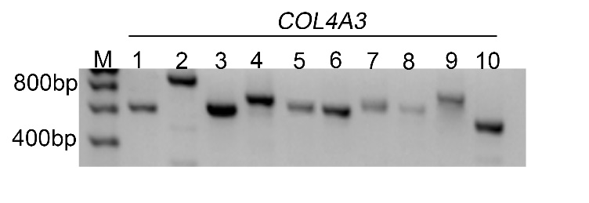

Supplemental Fig. 2 Agarose-gel images of RT-PCR products of COL4A5 mRNA isolated from proband 1 urine. M: DNA molecular mass marker. Lane 1 to 10: ten overlapping PCR products covering the entire COL4A5 cDNA.
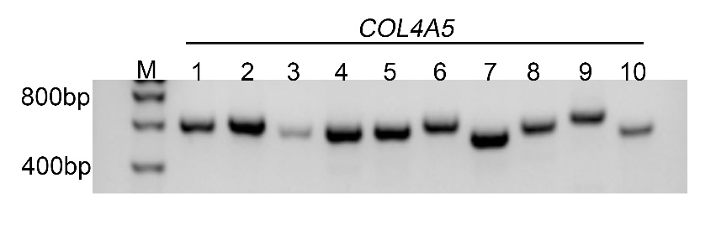

Supplemental Fig. 3 Agarose-gel images of RT-PCR products of COL4A3 mRNA isolated from proband 2 urine. M: DNA molecular mass marker. Lane 1 to 10: ten overlapping PCR products covering the entire COL4A3 cDNA.
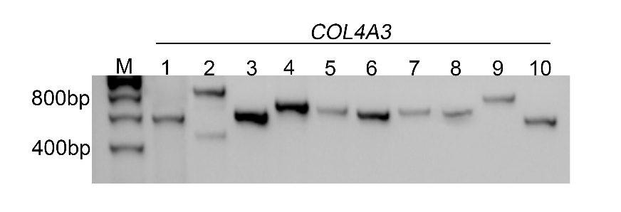

Supplemental Fig. 4 Agarose-gel images of RT-PCR products of COL4A4 mRNA isolated from proband 2 urine. M: DNA molecular mass marker. Lane 1 to 10: ten overlapping PCR products covering the entire COL4A4 cDNA.
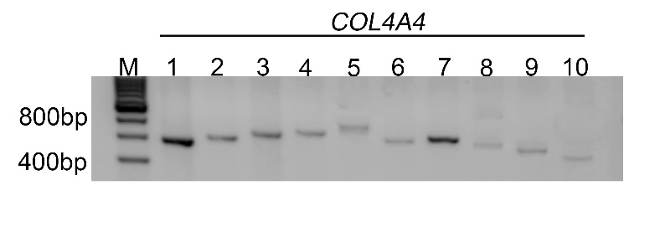

Supplementary Figure 5. Uncropped original images from agarose gels
