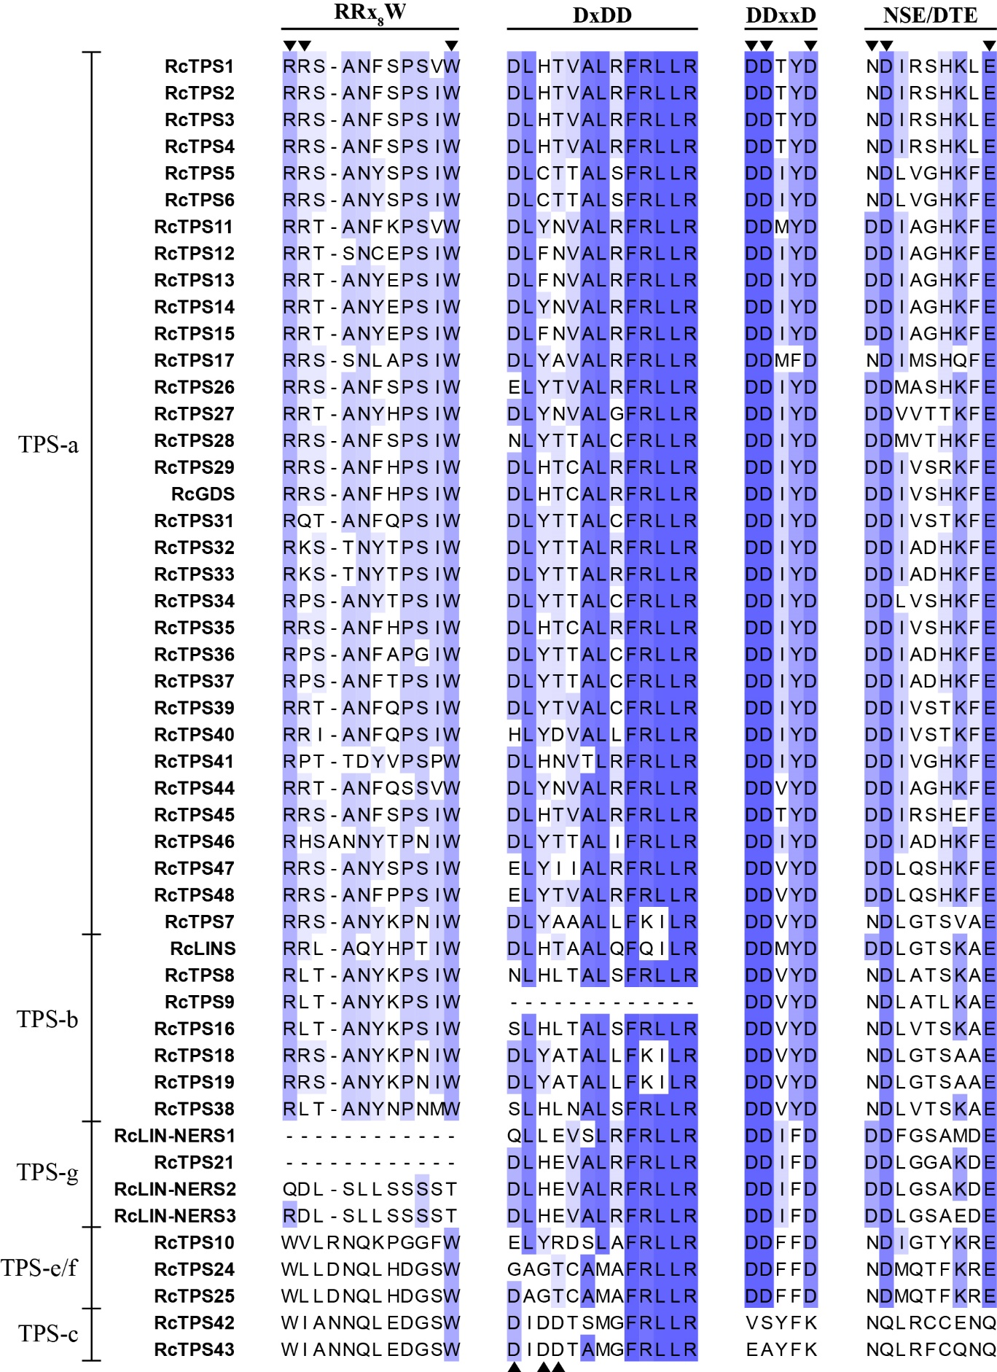
Figure S1. Comparison of R(R)x₈W, DxDD, DDxxD, and NSE/DTE motifs in Rosa chinensis TPS proteins.
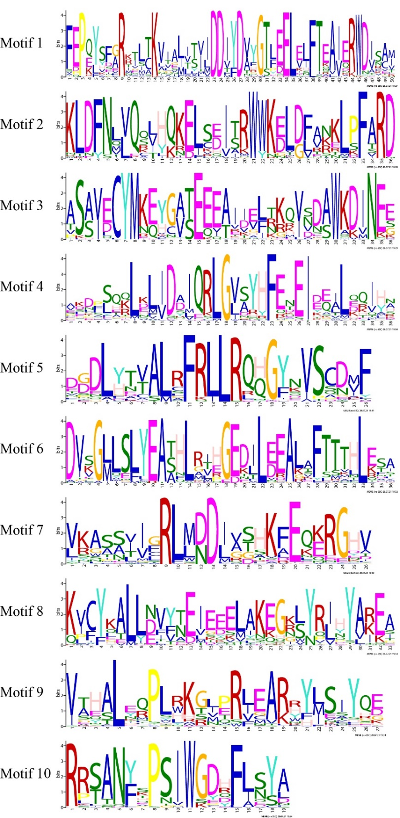
Figure S2. Identified motifs of Rosa chinensis RcTPS genes.

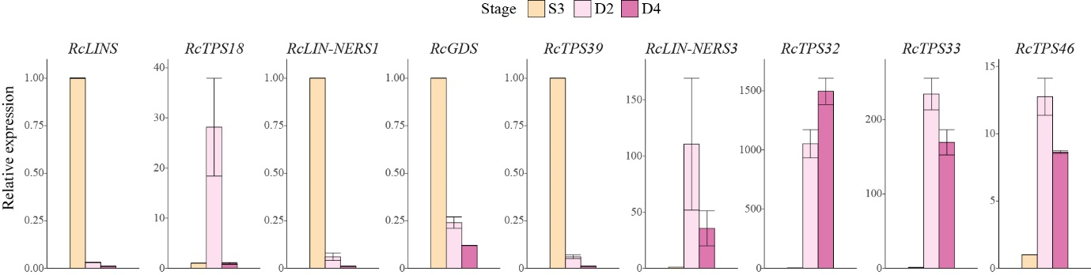
Figure S3. qRT-PCR validation of nine RcTPSs expressed in three samples of butterfly rose flowers.
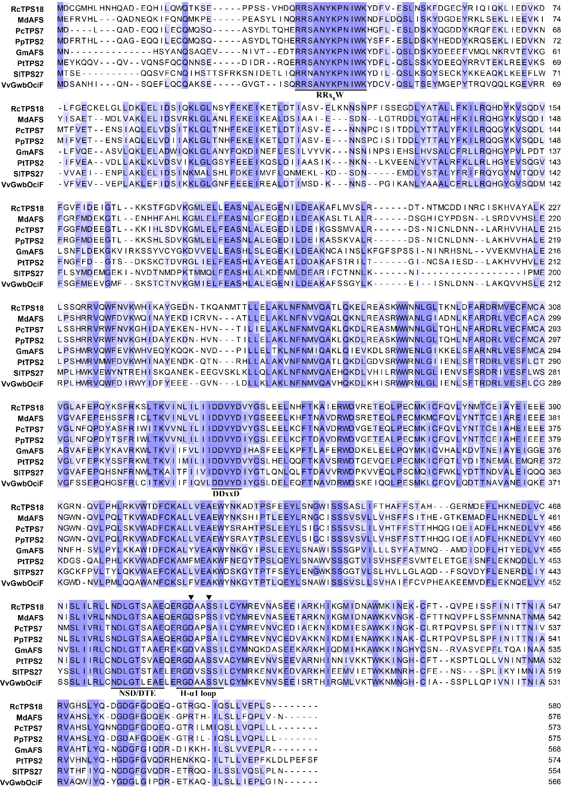
Figure S4. Protein sequence alignment of RcTPS18 with other (E,E)-α-farnesene synthases. MdAFS (Malus domestica), PcTPS7 (Prunus campanulata), PpTPS2 (Prunus persica), GmAFS (Glycine max), PtTPS2 (Populus trichocarpa), SlTPS27 (Solanum lycopersicum), and VvGwbOciF (Vitis vinifera). Four conserved motifs are labelled: the ‘RRx₈W’ motif, the ‘DDxxD’ motif, the ‘NSD/DTE’ motif and the ‘H-α1 loop’.
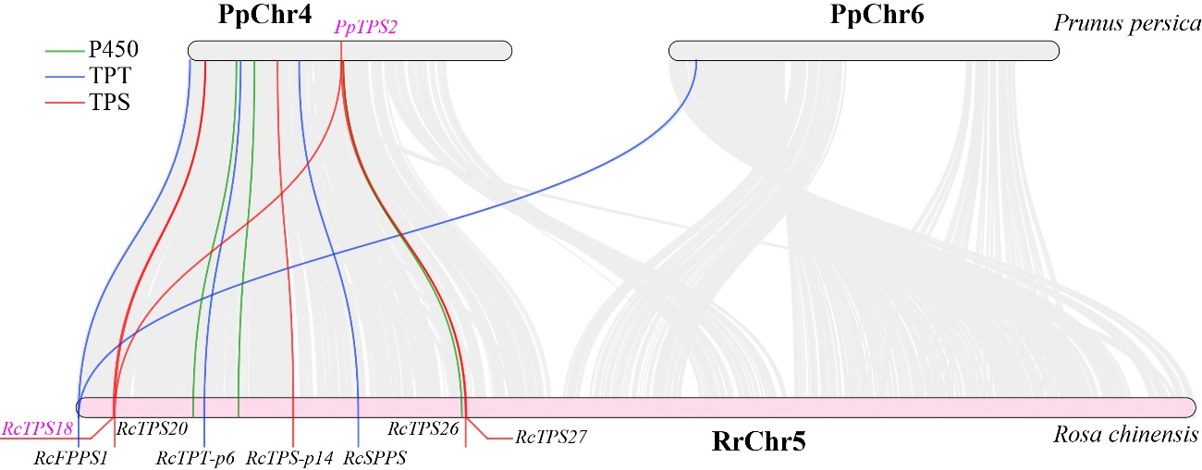

Figure S5. Collinearity genes between the fifth chromosome of Rosa chinensis and Prunus persica.

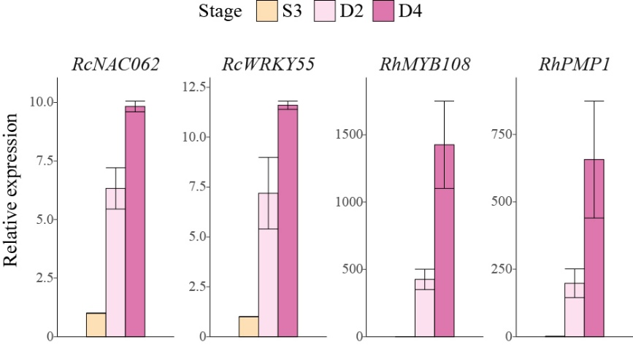
Figure S6. qRT-PCR validation of four differentially expressed genes.

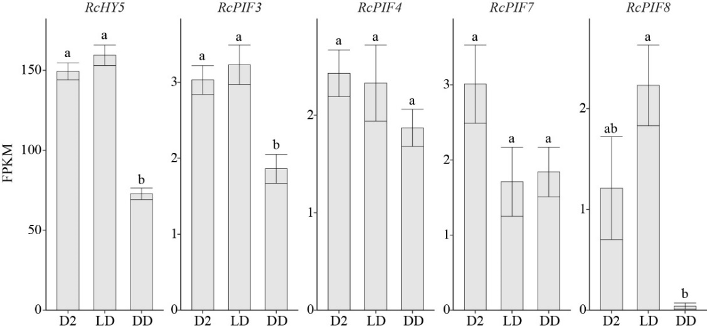
Figure S7. Expression levels of RcHY5 and RcPIF genes in different samples of R. chinensis ‘Mutablis’. Bars represent standard error (n = 3). Different lowercase letters indicate statistically significant differences (P < 0.05). The genome ids of genes mentioned in this figure are as follows: RcHY5 (Chr6g0298231), RcPIF3 (Chr3g0458701) RcPIF4 (Chr2g0152511), RcPIF7 (Chr7g0182341), RcPIF8 (Chr1g0348781). The expression of RcPIF1 (Chr6g0285491) is too low (FPKM <1 in all samples) and not shown in the figure.

