Supporting Information
Insitu synthesis of Cu-doped ZIF-8 for efficient photocatalytic water splitting

Sagar Varangane,ª Chandra Shobha Vennapoosa,^{a,b} Amritanjali Tiwari,^{c} Sanna Kotrappanavar Nataraj,^{d} Yendrapati Taraka Prabhu,^{*ab} Ujjwal Pal^{*a,b}

ªDepartment of Energy & Environmental Engineering, CSIR-Indian Institute of Chemical Technology, Tarnaka, Hyderabad, Telangana-500007, India.
^{b}Academy of Scientific & Innovative Research (AcSIR), Ghaziabad, Uttar Pradesh-201002, India
^{c}School of Chemistry, University of Hyderabad, Hyderabad 500046, India
^{d}Centre for Nano and Material Sciences, Jain University, Jain Global Campus, Bengaluru, 562112, Karnataka, India

Table of content
Content |  | Page No.
S1 | Characterization | 3
S2 | Color images of all composites | 4
S3 | Photocatalytic Hydrogen Evolution | 4
Figure S1 | AQE calculation for hydrogen production | 5
Figure S2 | Schematic diagram demonstrating the apparatus for H₂ production | 5
Figure S3 | Elemental mapping and EDAX of ZIF-8 and CDZ-20 composites | 6
Figure S4 | Changes occurred in CDZ-20 after photocatalytic stability test | 7
References |  | 7

S1. Characterization:
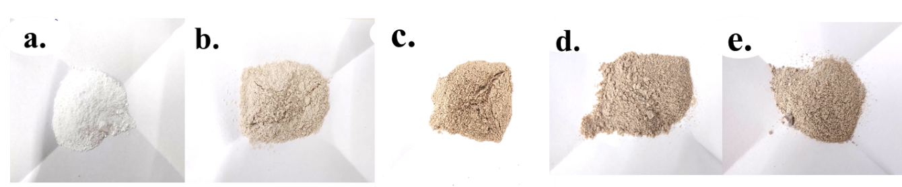
Powder X-ray diffraction patterns (XRD) of the photocatalysts were recorded on a Bruker AXS diffractometer (D8 advance) at a generator voltage of 40 kV and current 30 mA using Cu-Kα radiation (λ = 1.5406 Å). The scan range was 2θ = 10º to 80º with a scan rate of 0.02 °/s for analysis. Morphological, surface features of the resultant samples and compositional studies were explored with FESEM (JEOL JSM 7610F). For FESEM analysis, samples were ultrasonicated in ethanol for 2 min and finally drop-casted onto the carbon tape supported onto the aluminum stub. Energy dispersive X-ray spectroscopy (EDS) elemental mapping studies were also studied for the existence of Cu⁺² in ZIF-8 nanostructures. To attain a comprehensive understanding of the morphology and to substantiate for the additional support existence of nanostructures, TEM studies were carried out. Samples were prepared by ultrasonicating the resultant samples in methanol and then drop casting the sample onto a carbon-coated 400-mesh copper grid. Images were recorded on a Technai G2 20 (FEI) performing at 200 kV (accelerating voltage). The light harvesting capability of the samples were assessed by using solid state diffuse reflectance spectroscopy (DRS) measurements of the samples have been measured using Perkin Elmer Lambda-6000 instrument using BaSO4 as a reference. 100 mg of the sample has been placed in the sample holder for the measurement and the light is allowed to pass through the sample which leads to the absorption of the light and the light emitted by the sample has been recorded. The valance states and surface chemical composition heterojunction nanocomposite was studied by XPS measurements on AXIS SUPRA XPS System (Shimadzu group company) using monochromated Al Ka radiation. Nitrogen adsorption/desorption isotherms were measured using NOVA 2200e apparatus to determine the textural properties such as surface area (S_{BET}), total pore volume (V_{TOTAL}) and mean pore volume (V_{MEAN}). The catalysts were initially degassed for 3 h at 523 K under liq. nitrogen as adsorbent and then subjected to stepwise N₂ gas for the adsorption-desorption studies. The porosity of the catalysts was studied by the adsorption studies of N₂ at 77 K. Photoelectrochemical measurements were performed at room temperature using a three-electrode system with Pt wire as counter electrode, Ag/AgCl as reference electrode and Indium tin oxide (ITO) coated PET (2 x 5 cm² area) with the sample as the working electrode in a CH Instruments Inc., USA CHI6005E electrochemical work station with Potentiostat. A 0.1 M Na₂SO₄ solution was used as the electrolyte, the as synthesized sample (1mg) was dispersed in 10 μL of Nafion and 1 mL ethanol and sonicated for 5 min later on, 15 μL of the solution is drop casted on Indium tin oxide (ITO) coated PET (2 x 5 cm² area) metal tip of the glassy carbon electrode, which is allowed to dry. The initial electrode potential values have been obtained from the Open Circuit Potential Measurements and have been used. LSV scan were performed between – 1.0 V to 1.5 V vs Ag/AgCl at scan rate of 2 mV s⁻¹.
Fig. S1 Colour images of ZIF-8 (a), CDZ-2 (b), CDZ-6 (c), CDZ-20 (d), CDZ-25 (e).
S2. Photocatalytic Hydrogen Evolution:
As described in our previous article, ⁽¹⁾ the photocatalytic hydrogen evolution reaction was carried out. In a standard test, 10 mg of the as-prepared catalyst was put in 50 mL of DI water in a Qaurtz photoreactor (100 mL) comprising SEDs, 0.35 M of Na₂S and 0.25 M of Na₂SO₃. To drive the photocatalytic reaction, a 420 W Xe arc lamp was positioned 6 cm far to the reactor. A gas chromatograph (Perkin Elmer Clarus 590 GC with Molecular Sieve/5 column) with a thermal conductivity detector was used to analyse the hydrogen output yield (TCD). The photocatalyst's stability was verified for 4 cycles in a row. The 1st cycle of the experiment involved continuous photocatalytic action for 4 hours, after which removing gas and nitrogen gas purging before the second cycle. Experiments for the third and fourth cycles were carried out in the same way. For hydrogen production, the apparent quantum efficiency (AQE) was assessed (Table S1). Using different catalysts prepared in this analysis, the same procedure was followed. Supporting Information includes a schematic diagram showing the H₂ processing apparatus (Fig. S2).
S3. AQE calculation for hydrogen production:
Here we have calculated the apparent quantum efficiency of CDZ-20 for photocatalytic hydrogen evolution at $λ=±420 nm$. 420W Xe lamp was used as the light source. The average incident irradiation was determined to be 1.92Wcm⁻² by Newport (Oriel) specific area of irradiation was 12.62 cm². The hydrogen produced by CDZ- 20 was found to be 13.9 g⁻¹ cat h⁻¹. The calculation is given below.
The number of incident photon in 1hour
$N_{photon}=\frac{1.92×12.62×420×{10}^{-9}×3600}{6.626×{10}^{-34 }×3×{10}^{8}} = 1.843×{10}^{23}$ (1)
$N_{photon}=\frac{(2×the no of H_{2 }molecules produced) }{The no. of incident photons} =100\%$ (2)
$N_{photon}=\frac{2×13.9×{10}^{-3}×6.023×{10}^{23}}{1.843×{10}^{23}}×100= 9.08 \%$
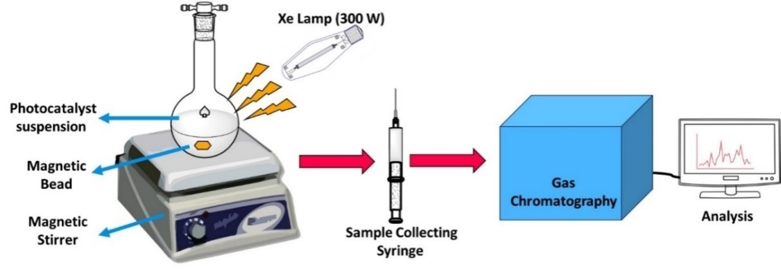
Fig. S2. Schematic diagram demonstrating the apparatus for H₂ production.
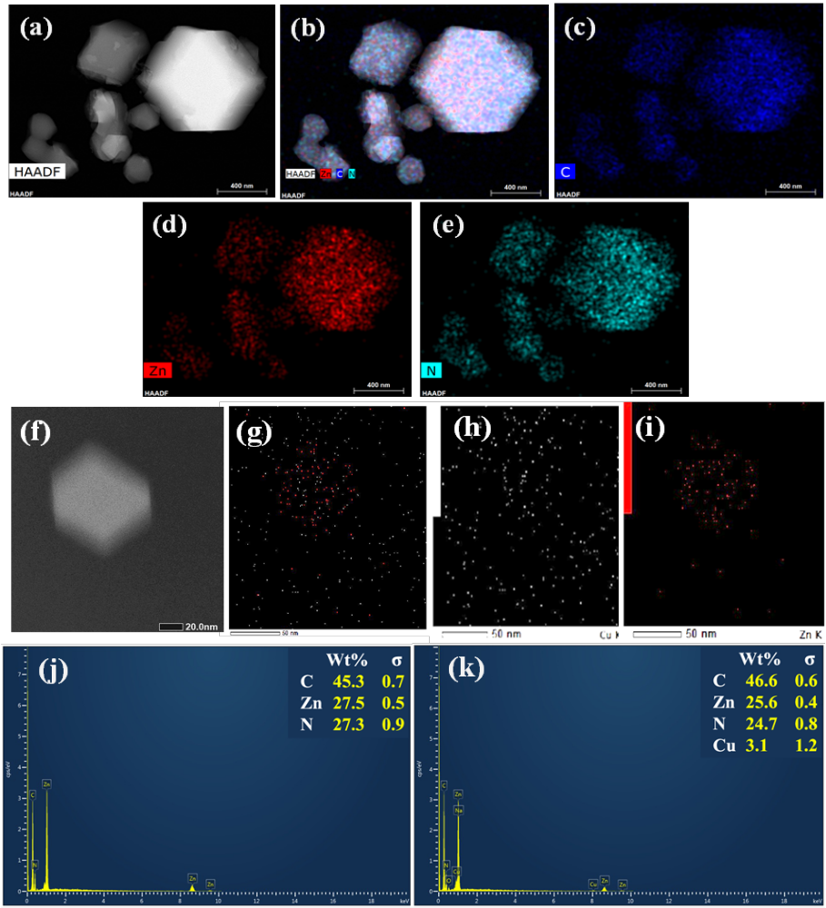
Fig. S3. Elemental mapping of ZIF-8 (a-e), and CDZ-20 (f-i), EDAX of ZIF-8 (j) and CDZ20 (k).

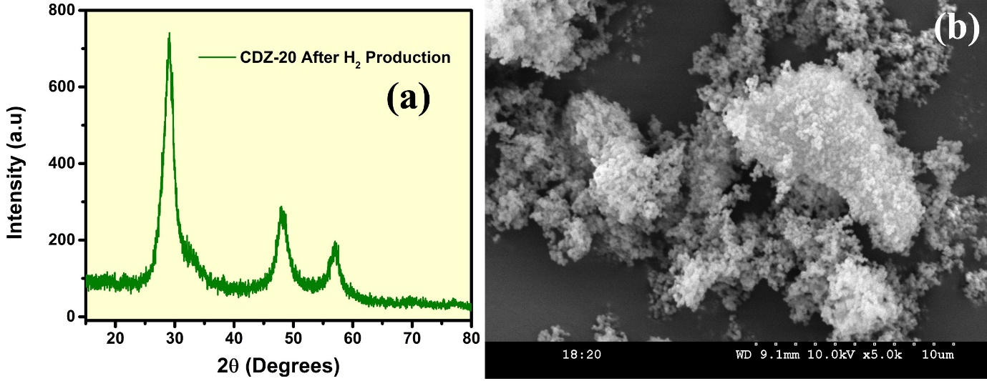

Fig. S4 Changes occurred in CDZ-20 after photocatalytic stability test.

REFERENCES:
- Y.T. Prabhu, Rashmi Kumari, Amit Gautam, B. Sreedhar, Ujjwal Pal, (2021) Highly oriented MoS₂@CdIn₂S₄ nanostructures for efficient solar fuel generation, Nano-structures & Objects, 26, 100682.

