TOC

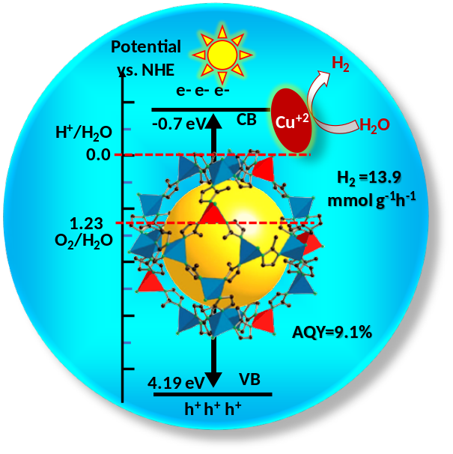
Modulation of Cu-doped ZIF-8 band structures with improved visible-light response enables enhanced photocatalytic hydrogen production.

