Table 5. Accuracy and Loss curves for ANN models.
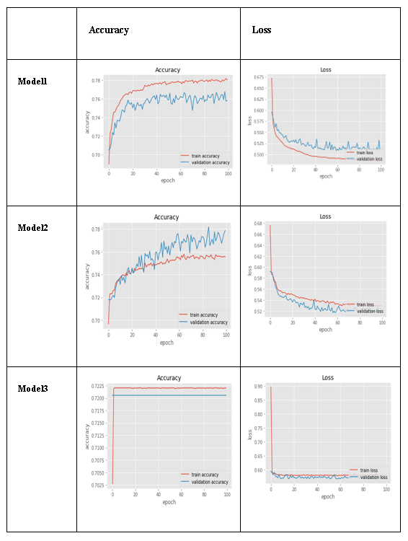

Table 7. Accuracy and loss curves for CNN models.

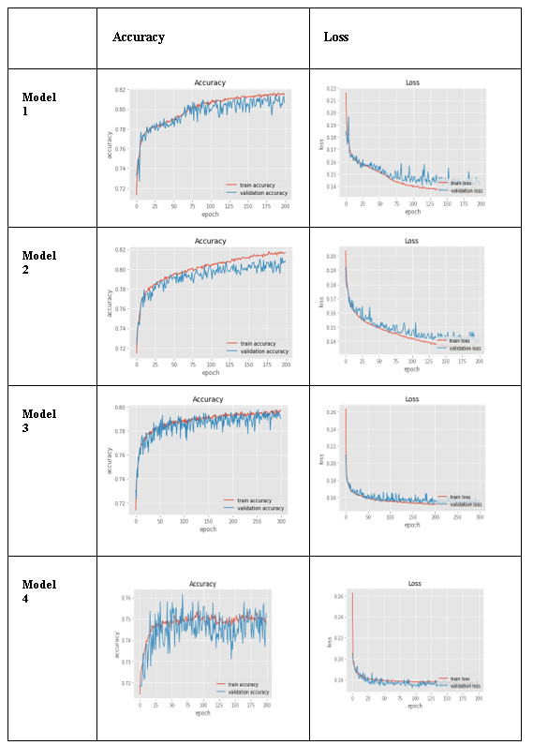

Table 9. Accuracy and loss curves for LSTM models.

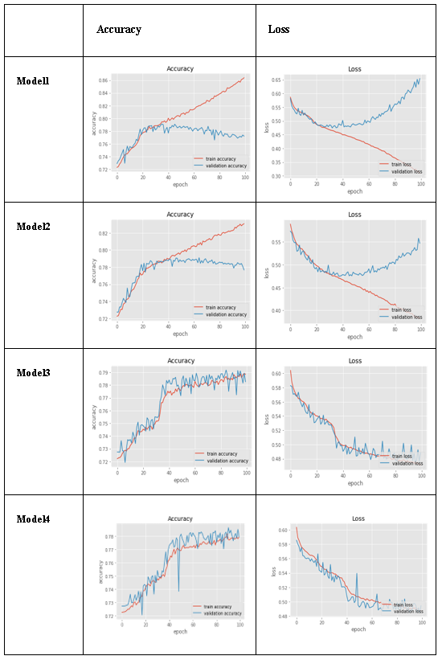

Table 11. Accuracy and loss curves for vanilla LSTM-Conv1D models.

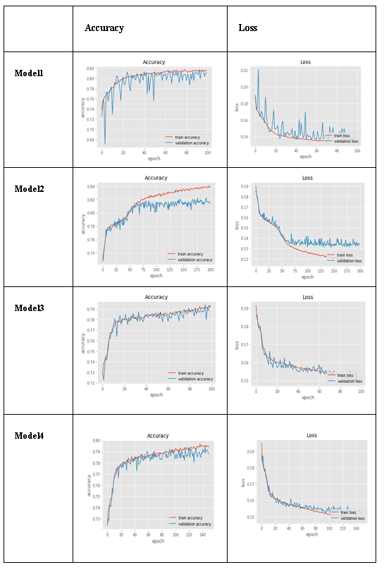

Table 13. Accuracy and loss curves for bidirectional LSTM-Conv1D models.

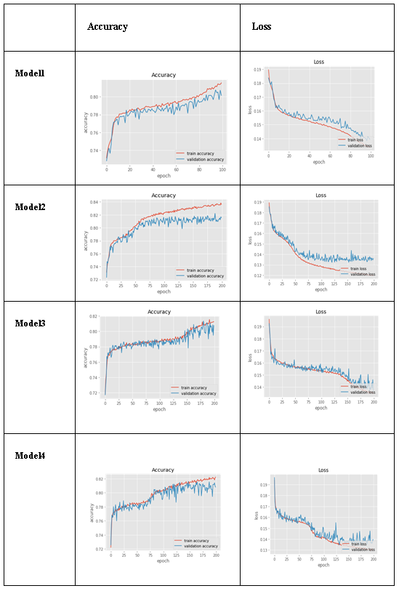

Table 15. Accuracy and loss curves for stacked bidirectional LSTM-Conv1D models.

