Supporting Materials for
An Aqueous, Electrode-Decoupled Redox-Flow Battery for Long Duration Energy Storage
Shrihari Sankarasubramanian, Yunzhu Zhang, Cheng He, Thomas Gregory, Vijay Ramani
Corresponding Author’s email: ramani@wustl.edu

This PDF file includes:

Supplementary Text
Materials and Methods
Figs. S1 to S25
Tables S1 to S42

S1. Identification of possible RFB actives
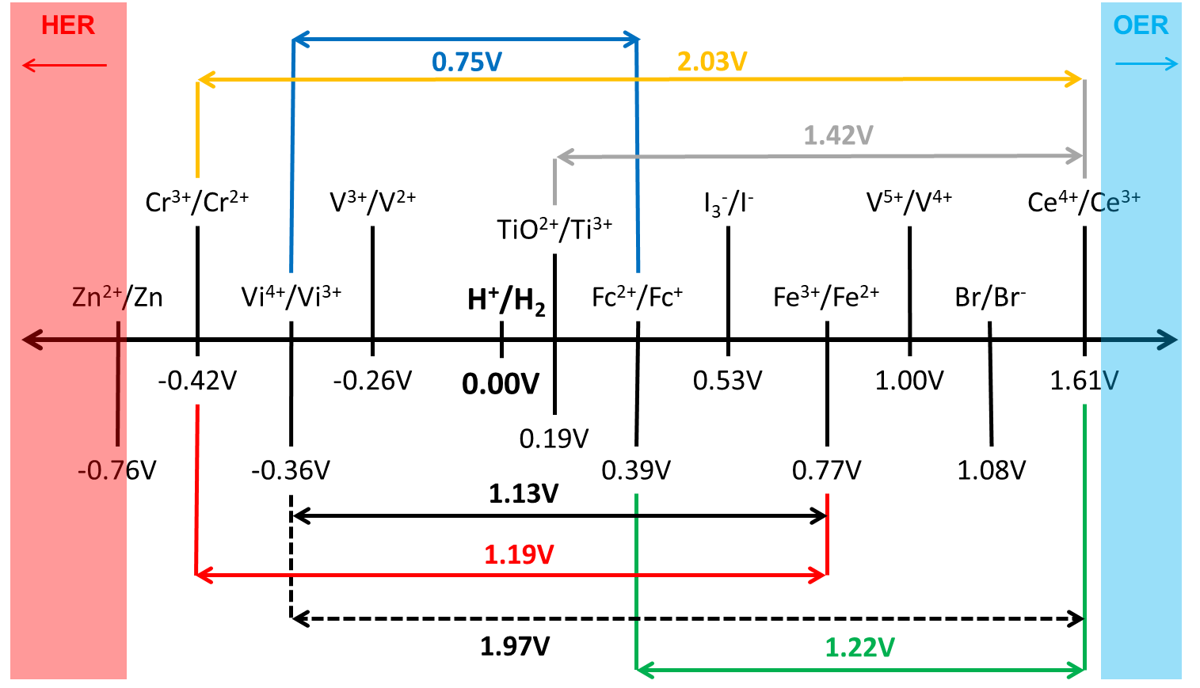

Fig. S1. Aqueous electrochemical series of various electroactive species.
The selection space for RFB actives in aqueous systems is constrained due to –
- The hydrogen evolution reaction (HER) and the oxygen evolution reaction (OER)
- pH range for a given redox species and its compatibility in a proposed pair
- Possible side reactions with salt or supporting electrolyte anions
- Differences in solubility between oxidation states of a given active
- Changes in pH over the course of cycling
Further, any chosen active must also be able to meet DOE’s stringent cost targets. In light of all this, the following selection criteria was established.
S1.1 Criterion for selection of electrochemical actives
We chose RFB actives that would lead to-
- Minimal H₂ or O₂ evolution or a clear pathway to mitigating HER/OER
- Near or greater than 1V cell
- No plating processes on either electrode to prevent dendrite driven failure modes
- Preferably benign (non-toxic, no side reactions), non-volatile electrolytes stable across a wide operating temperature range
As discussed in the main manuscript, Ti and Ce were identified as the actives satisfying these criteria.
S2. Formulation of the Ti and Ce Electrolytes
The identification of suitable supporting electrolytes has been a major issue with the Ti-Ce system. As seen from the Pourbaix diagram below (Fig. S2), Ti has a very narrow pH window where the desired 4⁺ and 3⁺ oxidation states are accessible without the use of super acids. This limited the possible supporting electrolytes to the common mineral acids.
The use of HCl and HNO₃ were precluded as cerium undergoes the following reaction with the free chloride ions in solution¹:
Ce⁴⁺ + Cl⁻ → Ce³⁺ + ½ Cl₂ (S1)
This evolution of chlorine (Fig. S3(a)) would lead to problems with the charging step of a RFB incorporating this active, with the charging cycle being driven by chlorine evolution and the “chemical” discharge of the Ce active. A similar reaction is also possible in the presence of NO₃⁻ ions. In the presence of NO₃⁻ ions, a very positive standard electrode potential for an active would lead to evolution of NO₂ (Fig. S3(b)). The representative reaction in the case of cerium is as follows²:
Ce³⁺ + NO₂⁺ ↔ Ce⁴⁺ + NO₂ (S2)
This is further compounded by the fact that an equilibrium exists between NO₃⁻ and NO₂ with a standard potential around 0.8V vs. SHE –
NO₃⁻ + 2H⁺ + e⁻ ↔ NO₂ + H₂O (0.8V vs SHE) (S3)
Fig. S2. Pourbaix diagrams of (a) Ti and (b) Ce with the desired pH windows highlighted.
Fig. S3. Side reactions in Ce electrolytes with (a) HCl – evolution of Cl₂ imparts a green tinge to the electrolyte (b) HNO₃ – notice yellow tinge of NO₂ at the counter electrode.
Thus, the possible supporting electrolytes were found to be H₂SO₄ and CH₃SO₃H. As seen from the solubility data presented in Fig. S4, the Ce is significantly more soluble in CH₃SO₃H as compared to H₂SO₄. But Ce³⁺ and Ce⁴⁺ solubilities have an inverse relationship with the CH₃SO₃H concentration, making 4M the ideal supporting electrolyte concentration, allowing us to realize a 0.9M electrolyte. Higher concentrations are not possible without significant electrolyte engineering.
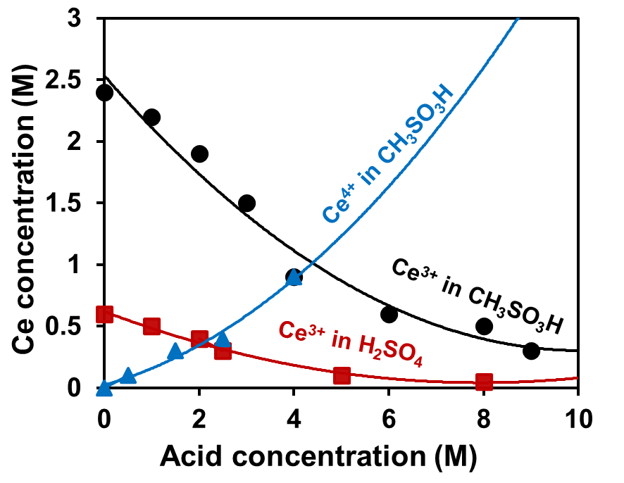
Fig. S4. Effect of acid concentration on Ce³⁺ solubility and Ce⁴⁺ solubility from Kreh et al.³.
The cerium methanesulfonate is made by a well-known reaction between methanesulfonic acid and cerium carbonate^{4,5}-
Ce₂(CO₃)₃ + 6CH₃SO₃H → 2Ce(CH₃SO₃)₃ + 3CO₂ + 3H₂O (S4)
Initial searches of the literature indicated that this reaction has to be carried out around 80^{ᵒ}C, would result in the incomplete consumption of the carbonate and poor control over the final Ce concentration. After carrying out this reaction with cerium carbonate sourced form Sigma-Aldrich (99.9%) over the course of 4 days, a persistent precipitate is observed (Fig. S5(a)). Whereas the cerium carbonate sourced from Treibacher Industrie A.G. resulted in a stoichiometric reaction that yielded a clear cerium methanesulfonate solution after a few minutes of reaction at room temperature. We gathered that this issue has been encountered before - F.C. Walsh⁴ states in the context of Zn-Ce batteries– “Cerium (III) carbonate from different suppliers was tested but only the one from the supplier mentioned above yielded a clear solution of cerium (III) methanesulfonate with no residual precipitated carbonate, after being stirred for 6 h.” We unequivocally confirm this observation of Walsh. The purity of both cerium carbonate powders was >99% and no significant differences in residual impurities was identified. The particle morphology may be the cause of the observed solubility differences.
All further production of cerium methanesulfonate was carried out using cerium carbonate sourced form Treibacher Industrie A.G.
Fig. S5. Effect of cerium carbonate source on reaction with methanesulfonic acid (a) Sigma-Aldrich and (b) Treibacher Industrie A.G.
Efforts to increase the Ce concentration beyond 0.9M were stymied by the inverse correlation between Ce³⁺ and Ce⁴⁺ solubilities with methanesulfonic acid concentration. TiOSO₄ is highly soluble in H₂SO₄ and solution of up to 10M have been prepared and characterized as shown in Fig. S6(a). Unfortunately, Ti is much less readily soluble in CH₃SO₃H. Even CH₃SO₃H concentration of 6M resulted in precipitation of the Ti salt as seen in Fig. S6(b). Thus, electrolytes with 0.9M actives and 4M CH₃SO₃H were experimentally determined to be the ideal combination for further use in the ED-RFB. Some alternative mixed electrolyte combinations are discussed in the next section.
Fig. S6. Effect of acid concentration on Ti solubility - (a) solubility and electrochemical performance in H₂SO₄ (b) Precipitation of Ti at a 6M CH₃SO₃H concentration.
S3. Electrochemical evaluation of Ti and Ce electrolytes
S3.1 Electrolyte formulation
The electrochemical characteristics of the proposed electrolytes were examined by cyclic voltammetry in a small volume electrochemical cell from Pine. A 0.07 cm² polished glassy carbon disk was used for all the measurements and was paired with a Pt spiral counter electrode and a Ag/AgCl reference electrode.
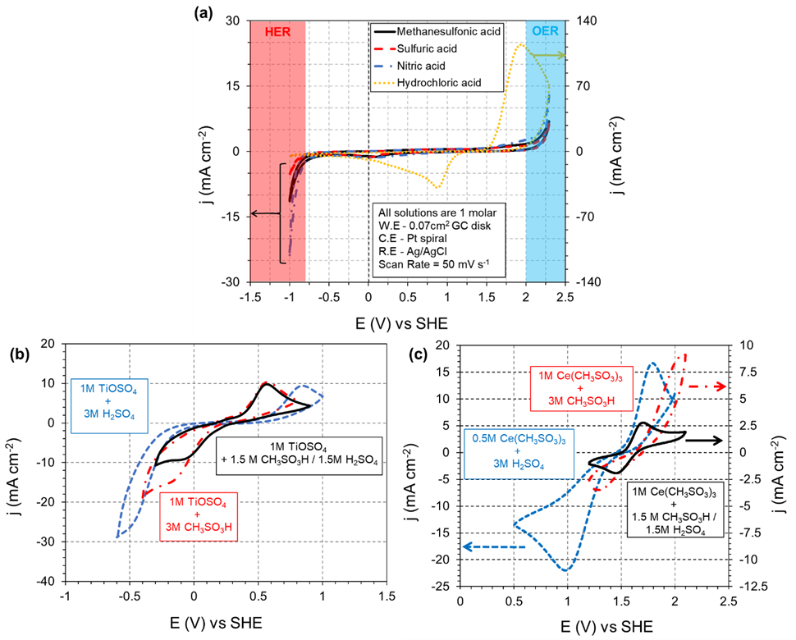
Fig. S7. (a) Voltage stability windows of common aqueous RFB supporting electrolytes; (b) Cyclic voltammograms of TiOSO₄ dissolved in acidic supporting electrolytes; (c) Cyclic voltammograms of Ce(SO₄)₂ dissolved in acidic supporting electrolytes
The various supporting electrolytes discussed in section S2 were examined and, with the exception of HCl, all supporting electrolytes were found to be electrochemically stable (Fig. S7(a)). Nevertheless, accounting for the other side-reactions, H₂SO₄ and CH₃SO₃H are the only viable candidates. The electrochemistry of Ti and Ce in H₂SO₄, CH₃SO₃H and their equimolar mixture is depicted in Fig. S7 (b) and (c).The CVs with Ti and Ce both indicate that a mixture of H₂SO₄ and CH₃SO₃H is ideal in terms of reversibility and columbic efficiency of the system. But issues with variable and inversely correlated solubility of the Ce ion has led us to avoid using these mixed systems pending further fundamental study. The use of supporting CH₃SO₃H electrolytes was expected to result in a RFB with a slightly higher OCV due to the observed shift in E_{1/2} of the Ce electrolyte when used with CH₃SO₃H. There was no indication of any undesirable side reaction in this system.
S 3.2 Diffusion coefficienct measurment
Fig. S8 depicts the cyclic voltammograms recorded at progressively increasing scan rates within this potential window of interest.
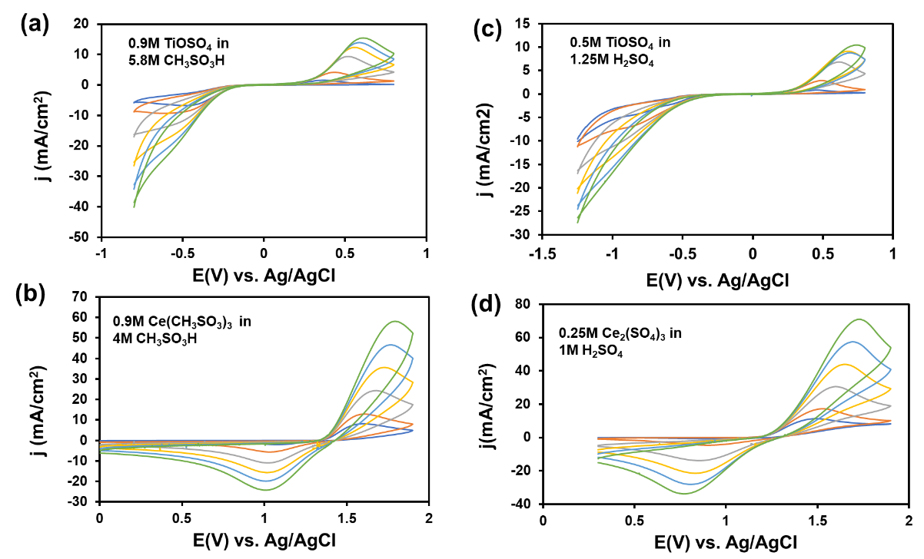
Fig. S8. Cyclic voltammograms of Ti-Ce ED-RFB electrolytes (compositions provided in figure) at scan rates of 10, 25, 100, 225, 400, and 625 mV.s⁻¹.
These voltammograms displayed the characteristic 30/α mV shift in the reduction peak position of the CV for a 10-fold increase in scan rate along with a greater than 59mV difference betweent the reduction and oxidation peak potentials, indicating an irreversible reaction.⁶ Thus, the Nicholson-Shain (N-S) relationship^{7,8} was used to relate the reduction peak currents and the the scan rate. The relationship is as follows:
$i_{p}=2.99X{10}^{5} n^{\frac{3}{2}}α^{\frac{1}{2}}AC_{sp}D_{sp}^{\frac{1}{2}}ν^{\frac{1}{2}}$ (S5)
Where, ip is the peak current, A is the geometric area of electrode, C_{sp} is the saturation concentration of the species of interest, D_{sp} is the diffusion coefficient of the species of interest, ν is the potential scan rate and α is the transfer coefficent. The transfer coefficient was, by convention, taken to be 0.5. The various electrolyte parameters were obtained from the literature.^{4,9,10} The Nicholson-Shain plot is depicted in Fig. S9 and the diffusion coefficients are listed in Table S1.
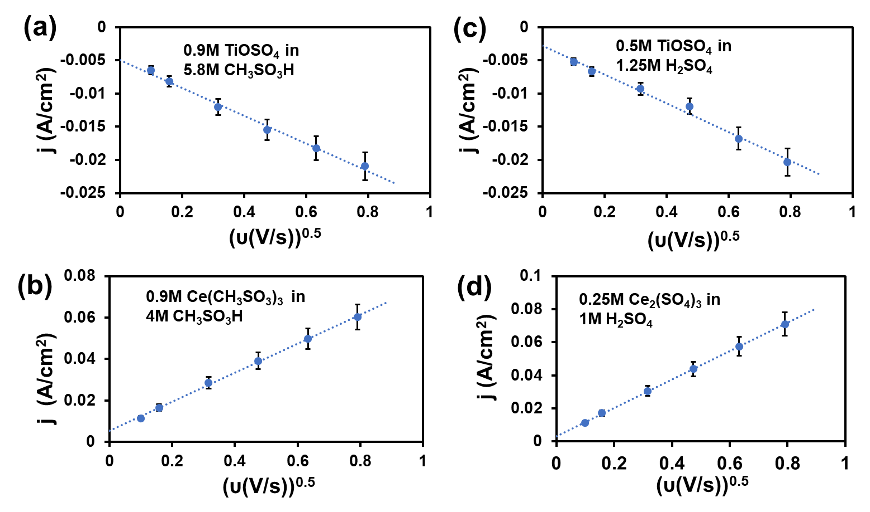
Fig. S9. Nicholson-Shain plots for Ti-Ce ED-RFB electrolytes (compositions provided in figure) obtained from the CV peak currents in Fig. S8. Error bars depict 10% standard error.

Table S1. List of diffusion coefficients in Ti and Ce electrolytes. The species measured correspond to the charge process of the Ti-Ce battery.
Electrolyte composition | Diffusion coefficient (x 10⁻⁵ cm² s⁻¹)
0.5M TiOSO₄ in 1.25M H₂SO₄ | 6.50 ± 0.59
0.9M TiOSO₄ in 5.8M CH₃SO₃H | 12.31 ± 1.3
0.25M Ce₂(SO₄)₃ in 1M H₂SO₄ | 26.68 ± 3
0.9M Ce(CH₃SO₃)₃ in 4M CH₃SO₃H | 83.39 ± 10

S 3.3 Rate constant measurement
The CVs for both Ti and Ce in H₂SO₄ and CH₃SO₃H indicate that their respective redox reactions are irreversible as seen from the peak separation being greater than 59 mV. Thus, the method proposed by Klingler and Kochi¹¹ to measure the heterogenous rate constant from totally irreversible electrode processes was employed herein. The formal potentials were calculated from the cathodic and anodic peaks as ($E_{form}=(E_{cathodic}+E_{anodic})/2$) and was used as an experimental proxy for the standard electrode potential (E⁰) when calculating the equilibrium rate constant (k₀) using the following equation –
$k_{0}\exp\left[\frac{βnF}{RT}\left(E_{p}-E^{0}\right)\right]=2.18{\left[\frac{DβnFν}{RT}\right]}^{\left(\frac{1}{2}\right)}$ (S6)
Where we define $χ=exp\left[\frac{βnF}{RT}\left(E_{p}-E^{0}\right)\right]$. Thus, a plot of χ vs. ν^{1/2} will allow us to calculate the k₀ from the slope. The plot of χ vs. ν^{1/2} is depicted in Fig. S10.
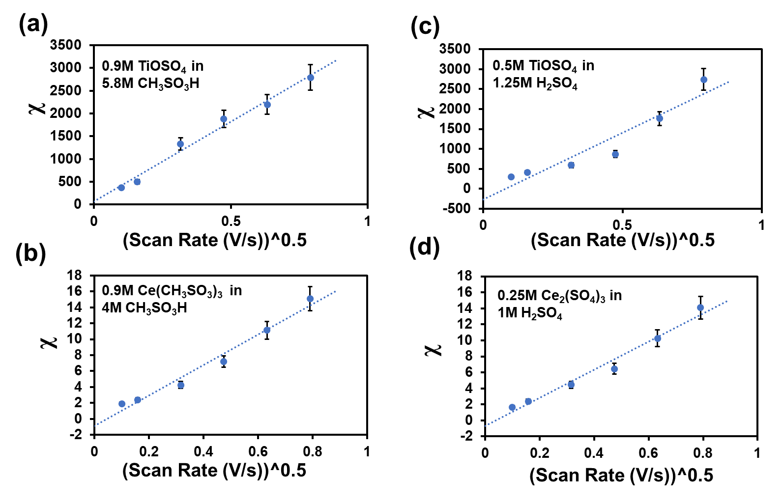
Fig. S10. Plot of χ vs. ν^{1/2} which is used to calculate the equilibrium rate constant k₀ (i.e., k at E=E⁰) using equation S6. The corresponding CV data is depicted in Fig. S8. Error bars depict 10% standard error.

The k₀ values were used to calculate the rate constants k vs. applied potential (E) using the equation $k=k_{0}exp\left[\frac{βnF}{RT}\left(E-E_{0}\right)\right]$. The plots are depicted in Fig. S11. Given that the electrolytes are made in the initial, discharged configuration, Ti undergoes reduction and Ce undergoes oxidation. Thus, k for Ti increases with decreasing potential while k for Ce increases with increasing potential. In all cases the transfer coefficient (β) was calculated using $β=\frac{1.86RT}{F\left(E_{P}-E_{\frac{P}{2}}\right)}$ .
Table S2. List of k₀ in Ti and Ce electrolytes. The reactions measured correspond to the charge process of the Ti-Ce battery.
Electrolyte composition | k₀ (x 10⁻⁴ cm s⁻¹)
0.5M TiOSO₄ in 1.25M H₂SO₄ | 2.33 ± 0.4 x 10⁻⁷
0.9M TiOSO₄ in 5.8M CH₃SO₃H | 4.34 ± 0.5 x 10⁻⁷
0.25M Ce₂(SO₄)₃ in 1M H₂SO₄ | 9.88 ± 1 x 10⁻⁴
0.9M Ce(CH₃SO₃)₃ in 4M CH₃SO₃H | 14.27 ± 1.3 x 10⁻⁴
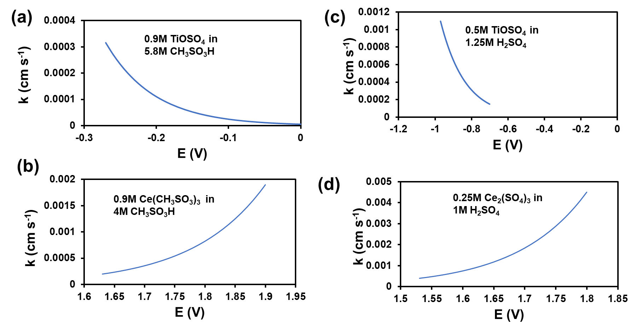
Fig. S11. Potential dependence of the rate constants for the charging process for the Ti-Ce ED-RFB electrolytes (compositions provided in figure) obtained from the CVs in Fig. S8 using the method of Klingler and Kochi.
S4. ED-RFB separator synthesis
The process to prepare the quaternized cardo-poly(ether ketone) (QPEK-C) based AEM functionalized with the trimethylamine (TMA) cation has been previously reported by us in Yun et. al.¹² The present effort in synthesizing QPEK-C-TMA involved increasing the IEC of the ionomer and to ensure good control over the chloromethylation process so to obtain the desired IEC. The in-situ composite membranes were prepared adapting the procedures described in Yun et al.¹³. The ex-situ composites were synthesized by simple mixing. The procedures are summarized below.
S 4.1 Synthesis of chloromethylated cardo-polyetherketone (PEK-C)
10 g of C-PEK (Xuzhou Vat Chemical Company, China) was dissolved completely in 500 ml 1,1,2,2-tetrochloroethane (98.5%, Acros Organics). 6 g of paraformaldehyde (96%, Acros),25 ml of chlorotrimethylsilane (98% Acros), and 0.47 ml of tin tetrachloride (>99%, Sigma Aldrich) were added into the solution, mixing well. The mixture was heated, and the reaction carried out at 80 °C for a week with reflux. The reaction solution was precipitated in methanol (3~4 times the volume of the reaction mixture). The white precipitate was filtered and purified by re-dissolving in dimethyformamide (DMF, 99.8%, Acros Organics) followed by re-precipitation in methanol. The purification process was carried out 2~3 times. And then the precipitation was dried at 40 °C overnight and stored for further use. The white solid C-PEK was obtained with a degree of chloromethylation (chloromethyl groups per polymer repeating unit) of 0.8-0.9.
S 4.2 Synthesis of quaternary ammonium PEK-C in chloride form (QPEK-C-TMA⁺ Cl⁻)
0.5 g of PEK-C was dissolved completely in 9 ml of DMF followed by the addition of 0.7 ml of trimethylamine (TMA) to the mixture. The solution was stirred and reacted at 30 °C for 2 days. The membrane was obtained by casting the reaction solution onto a 3” x 3” of flat glass plate in an oven at 70 °C overnight on a leveled surface. The thickness of membranes was approximately 40 µm.
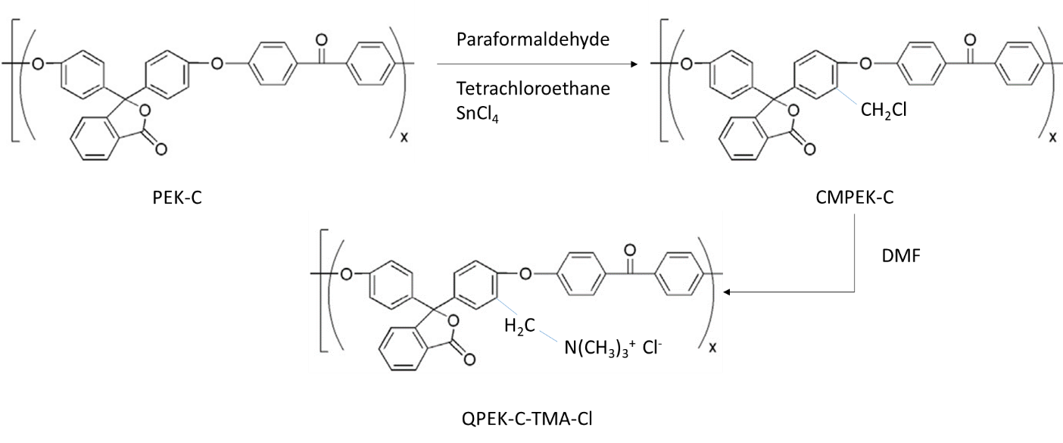
Fig. S12. Scheme for the chloromethylation of CPEK and the synthesis of CPEK-based AEMs.
S 4.3 Synthesis of composite membranes
Materials and chemicals - Titanium dioxide (<25 nm particle size, 99.7 trace metals basis, Sigma-Aldrich), dimethyl sulfoxide (ACS spectrophotometric grade, ≥99.9% Sigma-Aldrich), tetraethyl orthosilicate (99.999%, Sigma-Aldrich), N,N-dimethylformamide (99.8%, Sigma-Aldrich), hydrochloric acid (37%, Sigma-Aldrich),
Fabrication of ionomer composites incorporating TiO₂ and Al₂O₃ - 0.6 g of quaternary ammonium cardo-polyetherketone in chloride form (QPEK-C TMA⁺ Cl⁻) was dissolve in 9 ml dimethyl sulfoxide (DMSO). 5 wt% (0.03g) and 7 wt% (0.042g) titanium dioxide (TiO₂) were dispersed in 0.5 ml DMSO and sonicated for 1 hour. Mix the dissolved QPEK-C TMA⁺ Cl⁻ solution with the dispersed TiO₂ and stir vigorously overnight. The mixed solution was cast on a 3” x 3” flat glass plate in an oven at 40 °C overnight on a leveled surface. The thickness of membranes was approximately 40 µm. The Al₂O₃ composites were prepared using the same method but replacing TiO₂ and Al₂O₃.
Fabrication of ionomer-SiO₂ composites - 100 μl of tetraethyl orthosilicate (TEOS) was added to 1 ml of N, N-dimethylformamide (DMF). The mixture was slowly mixed well with addition of 36 μl of deionized water. TEOS mixture was slowly added to 0.5 g of QPEK-C TMA⁺ Cl⁻ in 9 ml of DMF. Few drops of hydrochloric acid were added into the mixture and stirred well. The solution was heated at 30°C to prevent aggregate and then cast on 3” x 3” of flat glass at 55°C overnight. The thickness of membranes was approximately 60 µm.
S5. Characterization of ED-RFB separators
The membrane characterization methods detailed below follow the procedures we have previously detailed.
Ion exchange capacity (IEC) -The IECs of membranes in chloride form (i.e., ion exchanged to ensure the mobile anions are Cl⁻ ions) were determined by the argentometric Volhard titration method¹⁴. A vacuum dried QPEK-C-based AEM in the chloride form (dried at < 0.1 inHg at 60 °C for 12 hours) was weighed (about 0.1 g) and immersed in 20 mL of 1 M sodium nitrate for 48 h at room temperature. Subsequently, 5.0 mL of 0.1 M silver nitrate (an excess being added to ensure the complete precipitation of the chloride) was added to precipitate the chloride ions with a white silver chloride precipitate being observed if the membrane had any IEC. Quantification was carried out by titration with 0.1 M potassium thiocyanate (0.1 M KSCN, standard solution) using 2-3 drops of 11 wt% iron (III) nitrate in DI water as indicator with the end point being a color change from a light orange to a medium-dark orange color. A control sample was prepared by mixing 20 mL of 1 M NaNO₃ with 5.0 mL of 0.1 M AgNO₃ and 2-3 drops of 11wt% of Fe(NO₃)₃ and titrated with 0.1 M KSCN. The difference in volume used to titrate the control solution and the sample solution was used for calculating the IEC:
${IEC}_{{Cl}^{-}} [mmol g^{-1}]=\frac{\left({Vol}_{cont.}-{Vol}_{test}\right)·100 mM KSCN}{Wt_{dry}}$ (S7)
Where, IEC_{Cl}- was the experimental ion-exchange capacity (mmol g⁻¹); Vol_{cont.} was the volume of 0.1 M KSCN used to titrate the control sample (L); Vol_{test.} was the volume of 0.1 M KSCN used to titrate the sample (L); and Wt_{dry} was the weight of the AEM (g)
Ionic conductivity -In-plane ionic conductivity measurements were carried out in a 4-point conductivity cell (BT-110, Scribner Associates) using electrochemical impedance spectroscopy (EIS) to measure the resistance. A 1 cm × 3 cm membrane was placed in the PTFE conductivity cell in contact with the 4 platinum electrodes and immersed in a temperature-controlled DI water bath. A Gamry series G750 potentiostat was used to measure the impedance in the frequency range 100kHz to 0.1 Hz. The high frequency resistance was estimated from the Bode plots (corresponding to a phase angle of zero). The membrane conductivity was calculated using equation S8:
$σ=\frac{L}{R·t·w}$ (S8)
where, σ was the in-plane membrane conductivity (mS cm⁻¹); R was the in-plane membrane resistance (mOhm); t was the membrane thickness (fully hydrated) (cm); w was the membrane width (fully hydrated) (cm); L was the distance between the two inner electrodes (cm).
Ion permselectivity and transport numbers - Membrane permselectivity and transport numbers were measured using the membrane potential method in a lab-made diffusion cell. The AEM was clamped between two well-stirred compartments containing different concentrations of the same salt (0.1 M and 0.5 M KCl). Two identical calomel reference electrodes were used to measure the potential difference (E_{s} (mV)) between the two solutions arising from the different mobilities of chloride and potassium ions through the membrane. The membrane potential was used to calculate the membrane permselectivity (selectivity of the anion exchange membrane towards anions) and the transport numbers (in this case for chloride and potassium). The following equation was used to calculate anion and cation transport numbers and membrane permselectvity:
$E_{m}=\left(2t_{-}-1\right)\left(\frac{RT}{F}\right)\ln\left(\frac{a_{A}}{a_{B}}\right)=(t_-t_{+})\left(\frac{RT}{F}\right)\ln\left(\frac{a_{A}}{a_{B}}\right)$ (S9)
Where t₊ and t₋ are the transport numbers for the cation (K⁺) and the anion (Cl⁻) respectively, a_{A} and a_{B} the activities of the electrolyte (KCl) at in the concentrated and diluted compartments separated by the membrane, T the absolute temperature, R is the gas constant and F is the Faraday constant. The coefficient (2t₋ -1) is commonly referred as the membrane permselectivity and represents the difference between the transport numbers for anions and cations.
Table S3. Summary of the characteristics of the QPEK-C-TMA based ED-RFB separators
Properties | QPEK-C TMA⁺ Cl⁻ | QPEK-C TMA⁺ Cl⁻ + TiO₂ | QPEK-C TMA⁺ Cl⁻ + SiO₂ | QPEK-C TMA⁺ Cl⁻ + Al₂O₃
Cl⁻ ionic conductivity at 60⁰C (mS/cm) | 26 ± 4 | 13 ± 1.5 | 26 ± 3 | 11 ± 2
IEC (mmol/g) | 1.71 ± 0.09 | 1.63 ± 0.04 | 1.52 ± 0.01 | 1.38 ± 0.06
Permselectivity | 0.909 | 0.919 | 0.914 | 0.958
Transport number (t_{Cl- ;} t_{K+} ) | 0.954; 0.046 | 0.960; 0.040 | 0.957; 0.043 | 0.979; 0.021

Nuclear magnetic resonance (NMR) characterization - NMR measurements were carried out on a Bruker Avance 360 MHz NMR spectrometer. To characterize the AEMs and identify any degradation products, three NMR experiments were done: 1)¹H-NMR (spectrum collected at 360 MHz, 48 scans) 2) ¹³C NMR to detect possible degradation of the quaternary carbons using the attached proton test (APT) (spectrum collect at 600 MHz, 48 scans) and 3) ¹H-¹³C heteronuclear multiple-quantum correlation spectroscopy (HMQC) measurements were carried out using gradient pulse for selection, incremental resolution of 1024 x 128 and 10 scans each. The samples for NMR spectra acquisition were prepared by dissolving approximately 50 mg of the polymer in 0.85 mL of deuterated dimethylsulfoxide. 35 mL of tetramethylsilane was added as an internal standard to all samples. Fig. S13 depicts the ¹H NMR measurements carried out successively for pristine EK-C, quaternized PEK-C and chloromethylated QPEK-C following the chloromethylation reaction. Successfully reactions at all steps were confirmed in line with our previous report¹².Fig. S14 depicts the HMQC measurements where we see that the QPEK-C separator’s characteristic signals are unchanged after long duration cycling in the Ti-Ce RFB. The lack of any oxidative attack at the quaternary and methylene carbons was confirmed using the APT shown in Fig. S15. In the APT experiment, quaternary and methylene carbons (CH₂) are phased negatively while methine (CH) and methyl (CH₃) carbons are phased positively. We see that none of the signals were lost following long term RFB cycling.
Fig. S13. Representative ¹H NMR spectrum of PEK-C and further reaction products. The DF of CMPEK-C was calculated from the ratio of the areas of peak h and aromatic protons (peaks a–g)
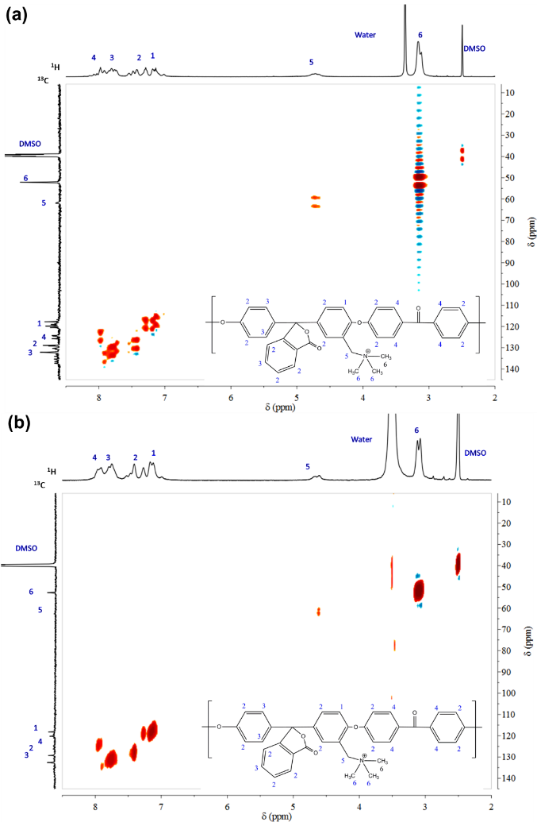
Fig. S14. ¹H-¹³C heteronuclear multiple-quantum correlation spectroscopy (HMQC) measurements of the QPEK-C-TMA separators in (a) pristine condition, (b) after long term cycling in a Ti-Ce RFB.
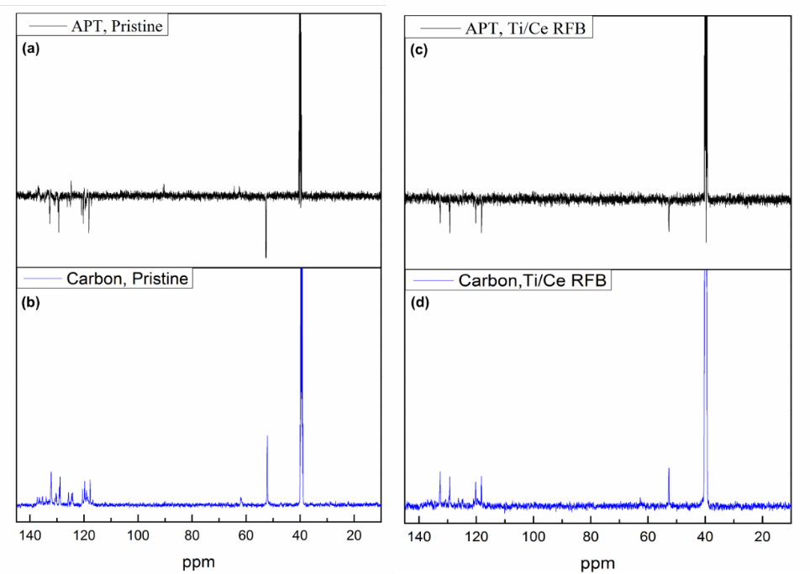
Fig. S15. Attached proton test (APT) data from ¹³C NMR measurements of the QPEK-C-TMA separators in (a) pristine condition, (b) after long term cycling in a Ti-Ce RFB.

S6. Ti-Ce ED-RFB
The representative charge-discharge curves of Ti-Ce RFBs with H₂SO₄ and CH₃SO₃H supporting electrolytes is depicted in Fig. S16.
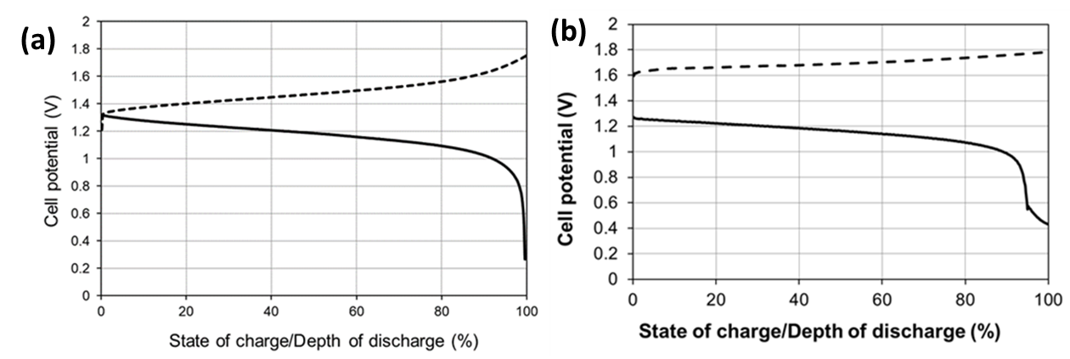
Fig. S16. Representative charge-discharge curves of the Ti-Ce ED-RFB with a (a) H₂SO₄ and (b) CH₃SO₃H supporting electrolyte.
The various efficiencies of the ED-RFB were calculated using the following relationships –
$$Coulombic efficiency \left(CE\right)=\frac{volumetric discharge capacity \left(Ah.L^{-1}\right)}{volumetric charge capacity \left(Ah.L^{-1}\right)} x 100$$ | (4)
$$Energy efficiency \left(EE\right)=\frac{energy discharged \left(Wh.L^{-1}\right)}{energy supplied upon charging \left(Wh.L^{-1}\right)} x 100$$ | (5)
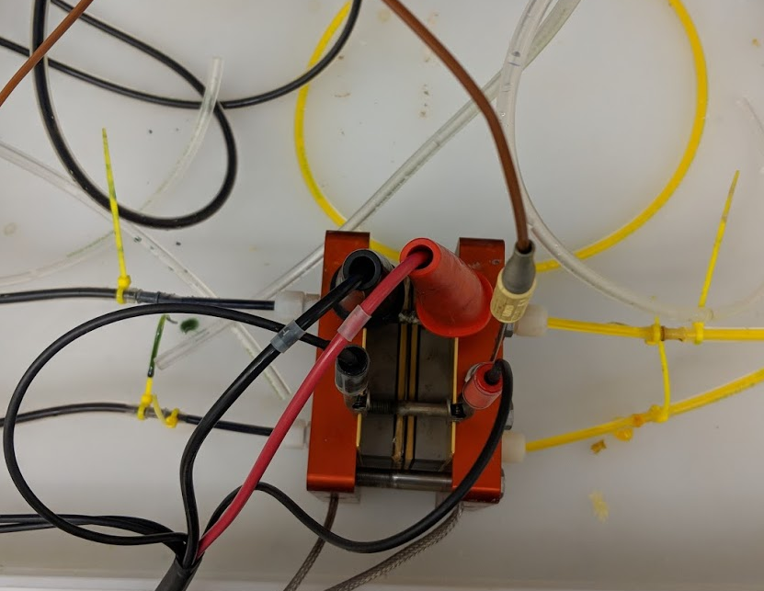
Fig. S17. Top-view of the Ti-CE RFB with a QPEK-C separator and methanesulfonate counterion. Notice the difference in colors between the positive and negative side electrolytes suggesting very high permselectivity.
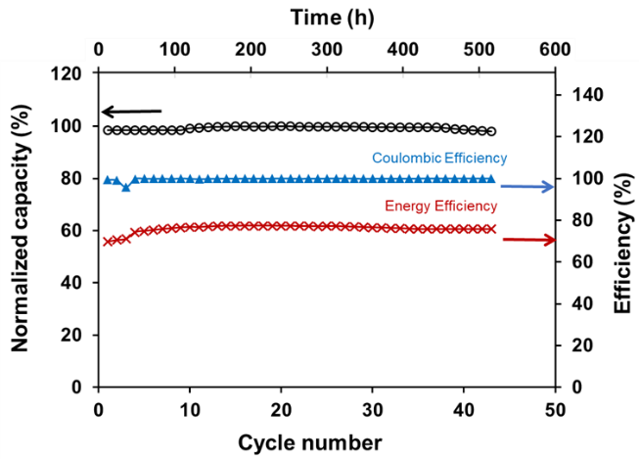 | 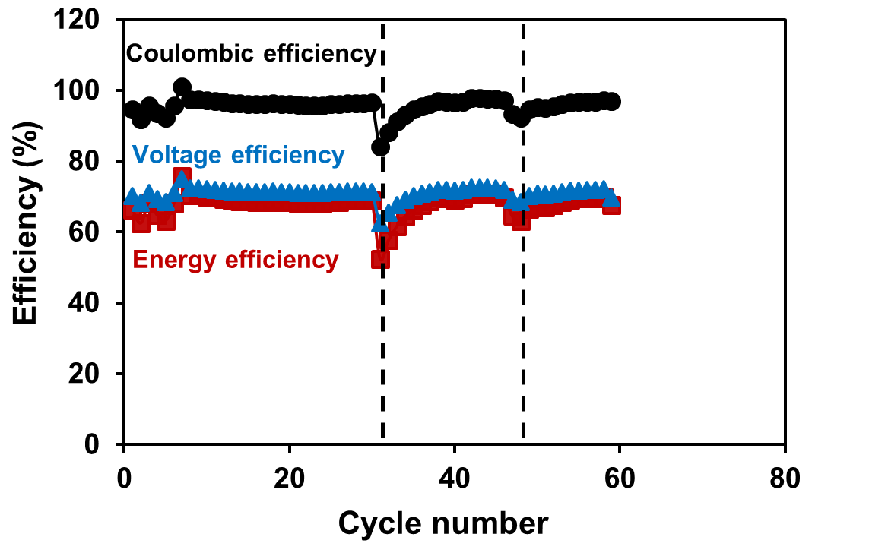
(a) | (b)

Fig. S18. Multiple independent runs of the Ti-Ce RFB with the H₂SO₄ supporting electrolyte (a) 12-hour cycle cell performance and (b) 24-hour cycle cell performance of a Ti-CE RFB with a QPEK-C + Al₂O₃ separator. Dashed lines indicate incidence of tube failure that did not result in a need to replace the membrane separator.

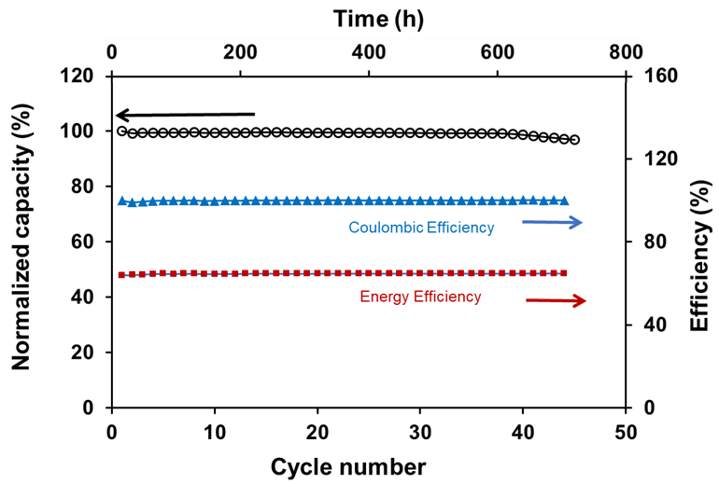
(a)
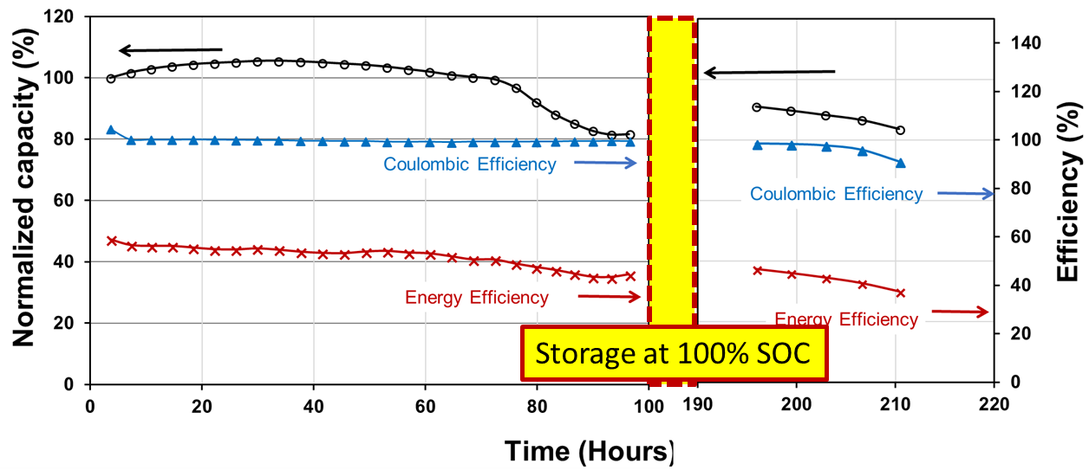
(b)
Fig. S19. Multiple independent runs of the Ti-Ce RFB with the CH₃SO₃H supporting electrolyte (a) 12-hour cycle cell performance and (b) charge-store-discharge performance (corresponding to the polarization curves in Fig. 5).
S7. Cost modeling
S7.1 Separator cost
The CPEK polymer is not commercially available and hence its potential commercial selling price was estimated based on comparison with the commercially available PEEK polymer. CPEK synthesis is similar to PEEK synthesis but substitutes phenolphthalein for disodium hydroquinone and the monomers for PEEK cost $12.77/kg while the required monomers for CPEK cost $11.48/kg. This allowed us to estimate that CPEK would cost ~$99/kg when purchased form a commercial vendor. All further analysis is carried out using this cost

S7.1.1 Cost of manufacture of CM-CPEK @ 1000 MTA scale

It was assumed that a dedicated production plant would be built for CM-CPEK production at this capacity for a total capital investment of $125MM. Based on this capital estimate and raw material usage as determined in lab syntheses and estimates for solvent recovery and recycle, variable and fixed costs for CM-PEK were estimated as shown in tables S4 and S5. Cost estimates for derivatives of CM-CPEK were determined via similar methodology.

Table S4. Variable Cost: Raw materials & waste treatment

Cost Item | Unit Ratio, Kg/Kg CM-CPEK | Unit Price, $/Kg | Total Cost, $/Kg CM-CPEK
C-PEK | 0.94 | 99.00 | 93.06
1,1,2,2-tetrachloroethane | 16 | 3.00 | 48.00
p-Formaldehyde | 0.56 | 0.59 | 0.33
Chlorotrimethylsilane | 2.01 | 2.00 | 4.02
SnCl₄ | 0.10 | 12.00 | 1.20
Methanol | 50 | 0.39 | 19.50
DMF | 30 | 0.70 | 21.00
Waste Treatment | 99 | 0.50 | 49.50
Total Variable Cost |  |  | 237

Table S5. Fixed Costs: Labor, utilities, maintenance, overhead, taxes, insurance, and depreciation
Cost Item | $/Kg CM-CPEK
Labor | 2.40
Utilities | 1.56
Overhead | 3.12
Maintenance | 4.68
Taxes & Insurance | 1.56
Depreciation | 10.14
Total | 23.5

Estimated cost of manufacture for CM-CPEK is $261/Kg.

S7.1.2 Cost of manufacture for 1000 MTA TMA-CPEK-Cl Film

Production of TMA-CPEK-Cl film involves conversion of CM-CPEK to TMA-CPEK-Cl via reaction with trimethylamine in DMF followed by film casting and solvent evaporation. Variable and fixed costs for this conversion are shown in tables S6 and S7.

Table S6. Variable Cost: Raw materials & waste treatment

Cost Item | Unit Ratio, Kg/Kg CM-CPEK | Unit Price, $/Kg | Total Cost, $/Kg TMA-CPEK-Cl
DMF | 0.85 | 0.70 | 0.60
Trimethylamine | 0.09 | 1.50 | 0.14
Waste Treatment | 0.86 | 0.43 | 0.37
Total Variable Cost |  |  | 1.17

Table S7. Fixed Costs: Labor, utilities, maintenance, overhead, taxes, insurance, and depreciation
Cost Item | $/Kg CM-CPEK
Labor | 2.4
Utilities | 0.68
Overhead | 1.36
Maintenance | 2.04
Taxes & Insurance | 0.68
Depreciation | 4.42
Total | 11.6

Estimated cost of manufacture for TMA-CPEK-Cl film is $11.0212/m². Since we require 0.2 m²/kWh in a cell, the film cost of manufacture per KWh is $2.204/ kWh at a scale of 1000 MTA.

S7.2 Development of the separator cost model

The cost model was developed based on the techniques outlined in “Technoeconomic Analysis of Battery Material Development and Production” presented by T. Gregory and J. Anderson at the 34th International Battery Seminar & Exhibit, Ft. Lauderdale, FL, March 20, 2017. The model was used to produce the capital and operating costs reported here and also to carry out a sensitivity analysis to determine future areas for process optimization and improvement.
It was recognized that several risk factors exist:
- Several production-scale process concepts are untested
- Reaction times and material yields may be different at production scale vs. lab scale
- Early stage process capital analysis techniques tend to have large uncertainties at the scale of operation envisioned here, especially for mechanically complex operations.
The cost estimate was made based on a dedicated plant construction scenario (vs. contract manufacturing) with a production of 1000 MTA.

S7.2.1 Chloromethylated CPEK (CM-CPEK) cost of manufacture estimate

Table S8. Estimated raw material and component prices

Cost Item | Unit Ratio, Kg/Kg CM-CPEK | Unit Price, $/Kg | Total Cost, $/Kg CM-CPEK
C-PEK | 0.94 | 99.00 | 93.06
1,1,2,2-tetrachloroethane | 16 | 3.00 | 48.00
p-Formaldehyde | 0.56 | 0.59 | 0.33
Chlorotrimethylsilane | 2.01 | 2.00 | 4.02
SnCl₄ | 0.10 | 12.00 | 1.20
Methanol | 50 | 0.39 | 19.50
DMF | 30 | 0.70 | 21.00
Waste Treatment | 99 | 0.50 | 49.50
Total Variable Cost |  |  | 237

The >100MTA contract manufacturing production was modeled as depicted in Fig. S20.

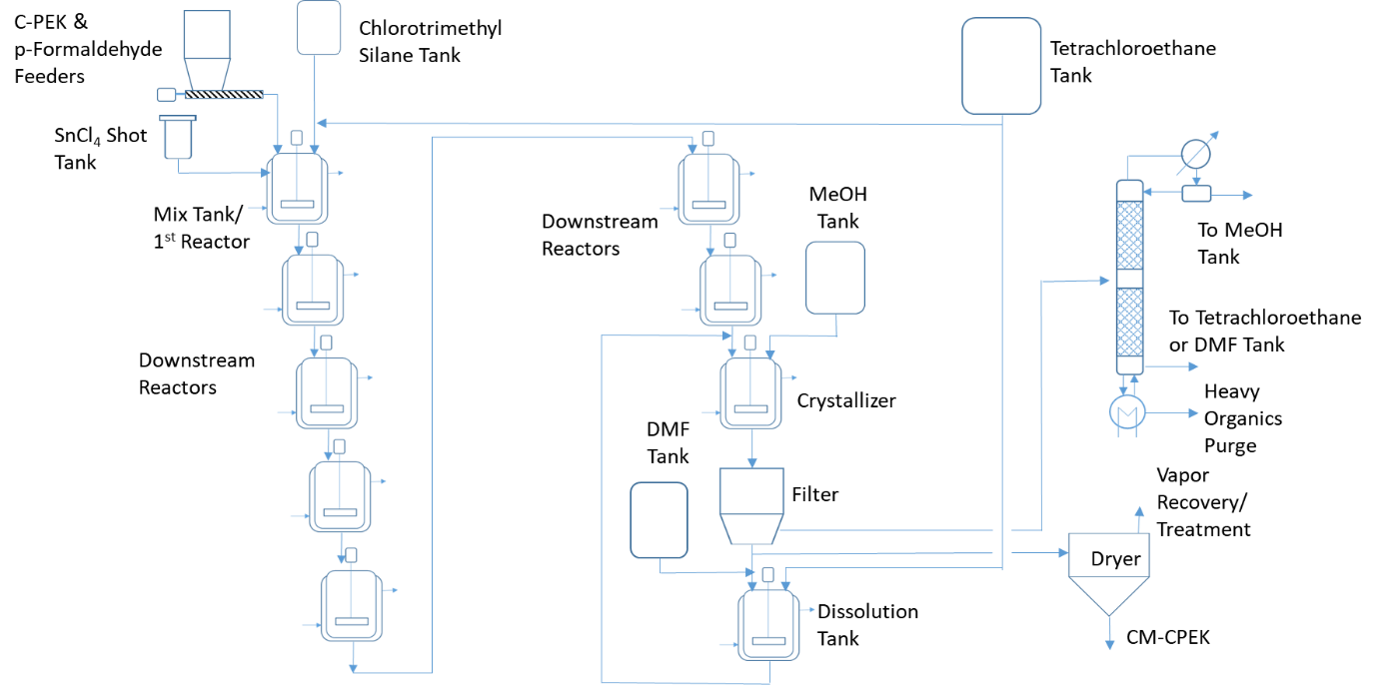
Fig. S20. >10MTA process to chloromethylated CPEK.

The following was assumed regarding the process:
- Instead of one large reactor running for seven days, seven smaller reactors in series are utilized, each with a 1-day residence time, reducing the reactors to a manageable size
- For 1000 MTA production rate and 5 reactors, each reactor would need to be ~40,000 gal in volume, which is comparable to industrial phenol-acetone reactors
- For 1000 MTA production rate and 5 reaction trains with 7 reactors/train, each reactor would need to be ~5000-gal volume, a much more reasonable size
- First reactor is main mix tank
- Downstream reactors are designed for liquid mixing & constant temperature
- Reflux condensers not shown in flow diagram but considered to be an integral part of reactor systems
This is a very substantial plant footprint but allows complete processing of finished batch in a single day in reasonably sized downstream equipment. The capital costs for this system was estimated using the step counting capital estimation method of Bridgewater adjusted for the specific plant size. The formula used is as follows:
$$ISBL=0.164N {\left(\frac{Q}{s}\right)}^{0.331}$$
Where ISBL is the Inside Battery Limits CAPEX (cost of equipment & facilities directly involved in producing product), N is the number of process steps, Q is the annual production capacity (MTA) and S is the reactor productivity (Kg product/Kg reactor feed). The following values, N=18 and s=0.039 were used.

Table S9. Capital costs for a dedicated plant

Q, MTA | Inside Battery Limits CAPEX (ISBL) Capital, $MM | Outside Battery Limits CAPEX (OSBL) Capital, $MM | Total Fixed Capital, $MM
100 | 37 | 22 | 59
1000 | 78 | 47 | 125

Other fixed costs were calculated as a percentage of the unit ISBL with the labor being separately estimated with 4 operators, 2 technicians and 1 clerical staff per shift for the 100 MTA plant and 6 operators, 3 technicians and 3 clerical staff per shift for the 1000 MTA plant.

Table S10. The fixed costs for a dedicated plant

Fixed Cost Item | % of ISBL CAPEX | 100 MTA Plant $MM/yr. | 1000 MTA Plan $MM/yr.
Labor |  | 1.68 | 2.40
Utilities | 2 | 0.74 | 1.56
Overhead | 4 | 1.48 | 3.12
Maintenance | 6 | 2.22 | 4.68
Taxes & Insurance | 2 | 0.74 | 1.56
Depreciation | 10% ISBL + 5% OSBL | 4.81 | 10.14
Total |  | 11.7 | 23.5

The impact of the plant sizing was examined and a clear anti-correlation between the plant size and the cost to manufacturer (COM) was observed (Fig. S21).

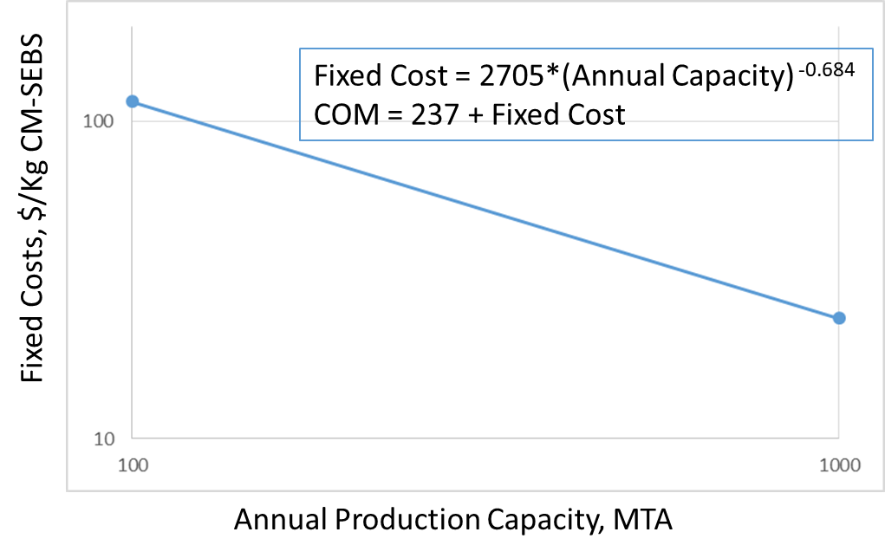
Fig. S21. Impact of scale-up on the plant fixed costs

Some key insights from this analysis are:
- The cost of the CPEK polymer (39%), solvent loss (37%) and need for waste treatment (38%) are major variable cost drives - Solvent recycle should be used to recover as much of the solvent as possible.
- A dedicated manufacturing plant for CPEK instead of buying it at a premium in the market would reduce up to 50% of CPEK price.
- The long reaction time and dilute reaction mass also contribute to the high fixed costs. Active research is needed to address this.

S 7.2.2 CPEK-Trimethylamine (CM-CPEK-TMA-Cl) cost of manufacture estimate

The manufacturing process for functionalizing the CM-QPEK-C with TMA+ is designed as follows:
- PEK-C is dissolved in DMF & trimethylamine is added to the mixture
  - 30ºC, 2-day reaction
- QPEK-C-TMA/DMF solution is cast into a film via solvent evaporation on a moving belt
- DMF/TMA vapor is condensed and re-used; uncondensed vapor is adsorbed on activated carbon or thermally oxidized (95% recovery assumed)
- Trimethylamine is supplied as a pressurized liquid and is absorbed into DMF prior to use
- Film is sent to dryer for residual DMF/TMA removal; some solvent drag-out may occur and require handling
- DMF/TMA vapor is condensed for re-use; uncondensed vapor is treated similarly to other unrecovered vapor (95% DMF recovery assumed; 90% net utilization of TMA assumed)
- Film is rolled onto cores prior to use in membrane production
- Note that solvent recoveries are higher than for PEK-C manufacture due to simplicity of this process vs. distillation recovery in PEK-C process
- 90% net yield of usable film is assumed
The process designed with these assumptions is depicted below:
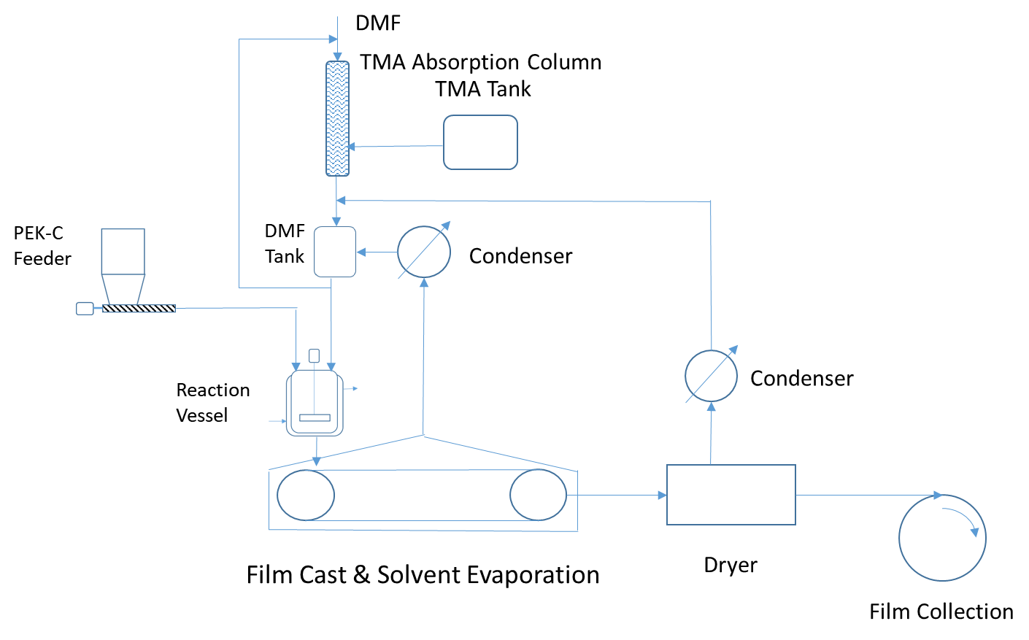
Fig. S22. TMA addition process

Table S11. The raw materials prices used for conversion of CM-CPEK to CM-CPEK-TMA-Cl film manufacture analysis

Cost Item | Unit Ratio, Kg/Kg CM-CPEK | Unit Price, $/Kg | Total Cost, $/Kg TMA-CPEK-Cl
DMF | 0.85 | 0.70 | 0.60
Trimethylamine | 0.09 | 1.50 | 0.14
Waste Treatment | 0.86 | 0.43 | 0.37
Total Variable Cost |  |  | 1.17

The capital costs were estimated following the same procedure as described for the dedicated plant scenario to manufacture CM-CPEK.

Table S12. The fixed costs for CM-CPEK-TMA-Cl film manufacture

Fixed Cost Item | % of ISBL CAPEX | 104 MTA Plant $MM/yr. | 1040 MTA Plan $MM/yr.
Labor |  | 1.68 | 2.4
Utilities | 2 | 0.32 | 0.68
Overhead | 4 | 0.64 | 1.36
Maintenance | 6 | 0.96 | 2.04
Taxes & Insurance | 2 | 0.32 | 0.68
Depreciation | 10% ISBL + 5% OSBL | 2.08 | 4.42
Total |  | 6.0 | 11.6

The overall costs were found to be anti-correlated with the plant size similar to the observation for the CM-CPEK plant.

Table S13. Manufacturing costs on a per m² basis

Plant Size, MTA | Conversion Cost, $/m² at 40g/m² TMA-CPEK-Cl
Plant Size, MTA | PEK-C Feed | Conversion | Total | Total Annual Film Production, MM m²
100 | 14.16 | 2.45 | 16.61 | 2.5
1000 | 9.48 | 0.51 | 9.99 | 25

A sensitivity analysis performed at both plant scales showed that the overall cost of producing the functionalized membrane was most sensitive to the cost of the chloromethylated precursor. It was observed that even a doubling of the capital expenses to setup the plant only led to a 1% increase in the CM-CPEK-TMA cost. But a 50% increase in the CM-CPEK cost lead to a 43% rise in the final product cost. This justifies a dedicated plant for the production of CPEK followed by subsequent chloromethylation.
S 7.2.3 Manufacturing cost of composite membranes
The composite membranes are assumed to be made using an ex-situ mixing process with the following steps and assumptions –
- Dissolve QPEK-C-TMA-Cl in DMSO
- Add nano-TiO₂ (<25 nm average particle size) at 5-7 wt.% (polymer basis)
- Cast film & evaporate solvent
- Product is 40μm thick membrane
- 95% DMSO recovery assumed
- 90% film recovery assumed
- Film scrap from QPEK-C-TMA-Cl film casting used to make up for loss in composite film casting operation, resulting in production of 100/1000 MTA of composite film
The cost of the metal oxide is only 0.13% of the total cost. Thus, the production process for the composite membrane would not influence the final cost (both in-situ and ex-situ processes will have the same cost). The costs for manufacturing the membrane was calculated based on a 100 MTA and 1000 MTA production volume of CM-CPEK.

Table S14. The variable costs for the composite membrane

Variable Cost Item | Unit Ratio, Kg/Kg Film | Unit Price, $/Kg | Total Cost, $/Kg Film
QPEK-C-TMA-Cl | 1.06 | 415/250* | 440/265
TiO₂ | 0.056 | 6.00** | 0.34
DMSO | 1.75 | 1.25 | 2.19
Waste Disposal |  | 0.93 | 0.93
Total |  |  | 444/269
* Price of QPEK-C-TMA-Cl film per Kg at 100 & 1000 MTA production rates
**Price of nano-TiO₂ assumed to be that same as fumed SiO₂ +10%

The process is very similar to the TMA-CPEK-Cl film production and hence the same capital and fixed costs are used.
Table S15. Overall membrane costs at two different scales

Plant Size, MTA | Conversion Cost, $/Kg composite membrane |  |  | Total Cost, $/m²
Plant Size, MTA | Variable | Fixed | Total | Total Cost, $/m²
100 | 444 | 60.00 | 504 | 20.20
1000 | 269 | 11.60 | 281 | 11.20

S 7.2.4 Effect of changing the cation from TMA to TRIS
To estimate a ratio of the prices of TMA and TRIS cations, it is assumed that the prices scale up linearly.
Table S16. Estimated cation retail prices
Cation | Price, $/g
trimethylamine (TMA) | 0.9
tris (2,4,6-trimethoxyphenyl) phosphine (TRIS) | 14.2

Assuming this price ratio of 15.2 holds, the variable costs for the conversion of QPEK-C-TMA. increases by $0.942. The ~$1 increase translates to a ~1% increase in the final price of the ionomer. Note that these prices are subject to change (especially with a specialty chemical like TRIS). Thus, another method to estimate this cost is to examine the percentage of the total cost of the membrane that is contributed by the cation. TMA contributes $0.06/$110 x 100 = 0.054% of the membrane cost. Assume a 100-times increase in TMA cost, this will result in the membrane price rising by 5.45%. Thus, we see that large increases in the cation price has minimal impact on the total membrane cost. Another factor to note is that this analysis estimates the cost of manufacture for the membranes. If the membrane is supplied to the cell stack manufacturer by a separate supplier they may charge significantly more for the membrane than if the membrane is made by the cell stack manufacturer to account for various corporate expenses and profit. The impact of this can be determined by examining the sensitivity of redox flow battery economics on membrane cost.
S 7.3 Redox-flow battery cost estimate
S 7.3.1 Design basis

- 12.5 GWh total capacity, 10 GWh nominal capacity
- 1V operating voltage
- Electrolytes:
  - 0.5M TiOSO₄ in 3M H₂SO₄/0.5M Ce₂(SO₄)₃ in 3M H₂SO₄
  - 0.9M Ti(CH₃SO₃)₄ in 4M CH₃SO₃H/0.9M Ce(CH₃SO₃)₃ in 4M CH₃SO₃H
- Active component supply options:
  - TiOSO₄: Purchase or make from TiO₂ and 20% oleum
  - Ce₂(SO4)₃: Purchase or make from Ce₂(CO₃)₃ and H₂SO₄
  - Ti(CH₃SO₃): Make from TiOSO₄ & CH₃SO₃H
  - Ce₂(CH₃SO₃)₂: Make from Ce₂(CO3)₃ & CH₃SO₃H

S 7.3.2 Methodology

- Estimate purchased equipment costs for cell components (including AE membrane) and fluid handling equipment (electrolyte storage tanks and pumps)
- Include factors for equipment installation, piping, instrumentation, electrical wiring, paint, and insulation to obtain total installed equipment cost
- Add costs for initial electrolyte supply
- Total cost does not include costs for transformers, inverters, site prep, foundations, buildings, land, site services, etc.

S 7.3.3 Design parameters

Cell stack operating conditions:
- 1000 A/m² current density
- 1 V operating voltage
Membrane options:
- Composite QPEK-C-TMA/TiO₂ @ $11.20/m²
- The impact of changing the membrane architecture and supply scenario is incorporated via sensitivity analysis.
System parameters:
- 5 hr nominal operating time
- 80% round trip DC-DC efficiency
  - Need 12.5 kWh total active material capacity per kWh useful battery capacity
Systems scales considered:
- 1 MW/4 MWh distributed power system
- 2 GW/10 GWh utility-scale system

S 7.3.4 Active materials cost

Table S17. Component prices

Component | Price, $/Kg | Pricing Source
TiOSO₄ | 4.50 | Alibaba.com
Ce₂(SO₄)₃ | 5.00 | Alibaba.com
Ce₂(CO₃)₃ | 2.00 | Alibaba.com, zauba.com
CH₃SO₃H | 2.50 | Alibaba.com, zauba.com
TiO₂ | 2.50 | Echemi.com
H₂SO₄ | 0.10 | ICIS.com long term average
20% Oleum (H₂SO₄/SO₃) | 0.20 | Estimate
DI water | 0.005 | On-site production estimate
CaCO₃ | 0.12 | Zauba.com

S 7.3.5 Electrolyte production

- 0.5M TiOSO₄/3M H₂SO₄ Electrolyte
- Option 1: Purchase TiOSO₄, dissolve in 3M H₂SO₄
- Option 2: Purchase TiO₂, dissolve in 20% oleum, dilute with DI water

Table S18. Raw material cost for composition a

Raw Material | Unit Ratio, Kg/Kg Electrolyte | Unit Price, $/Kg | Total Cost, $/Kg Electrolyte
Option 1
TiOSO₄ | 0.058 | 4.50 | 0.261
H₂SO₄ | 0.214 | 0.10 | 0.021
DI water | 0.727 | 0.005 | 0.004
Total RM Cost Option 1 |  |  | 0.29
Option 2
TiO₂ | 0.029 | 2.50 | 0.073
20% Oleum | 0.243 | 0.20 | 0.049
DI water | 0.728 | 0.005 | 0.004
Total RM Cost Option 2 |  |  | 0.13

- 0.5M Ce₂(SO₄)₃/3M H₂SO₄ Electrolyte
- Option 1: Purchase Ce₂(SO₄)₃, dissolve in 3M H₂SO₄
- Option 2: Purchase Ce₂(CO₃)₃, dissolve in H₂SO₄, dilute with DI water

Table S19. Raw material cost for composition b

Raw Material | Unit Ratio, Kg/Kg Electrolyte | Unit Price, $/Kg | Total Cost, $/Kg Electrolyte
Option 1
Ce₂(SO₄)₃ | 0.180 | 5.00 | 0.900
H₂SO₄ | 0.186 | 0.10 | 0.019
DI water | 0.634 | 0.005 | 0.003
Total RM Cost Option 1 |  |  | 0.92
Option 2
Ce₂(CO₃)₃ | 0.138 | 2.00 | 0.276
H₂SO₄ | 0.264 | 0.10 | 0.026
DI water | 0.598 | 0.005 | 0.003
Total RM Cost Option 2 |  |  | 0.31

- 0.9M Ti(CH₃SO₃)₄ /4M CH₃SO₃H Electrolyte
Synthesis:
TiO₂ + 6 H₂SO₄.0.167SO₃ + 6 CaCO₃ → TiOSO₄ + 6 CaSO₄ + 6 H₂O + 6 CO₂
TiOSO₄ + 4 CH₃SO₃H + CaCO₃ → Ti(CH₃SO₃)₄ + CaSO₄ + CO₂ + 2 H₂O

Table S20. Raw material cost for composition c

Raw Material | Unit Ratio, Kg/Kg Electrolyte | Unit Price, $/Kg | Total Cost, $/Kg Electrolyte
TiO₂ | 0.024 | 2.50 | 0.060
Oleum | 0.344 | 0.20 | 0.069
CaCO₃ | 0.356 | 0.12 | 0.043
CH₃SO₃H | 0.434 | 2.50 | 1.085
DI water | 0.565 | 0.005 | 0.003
Total RM Cost |  |  | 1.26

- 0.9M Ce(CH₃SO₃)₃ /4M CH₃SO₃H Electrolyte
Synthesis: Ce₂(CO₃)₃ + 6 CH₃SO₃H → 2 Ce(CH₃SO₃)₃ + 3 CO₂ + 3 H₂O
Table S21. Raw material cost for composition d

Raw Material | Unit Ratio, Kg/Kg Electrolyte | Unit Price, $/Kg | Total Cost, $/Kg Electrolyte
Ce₂(CO₃)₃ | 0.117 | 2.50 | 0.293
CH₃SO₃H | 0.357 | 2.50 | 0.893
DI water | 0.566 | 0.005 | 0.003
Total RM Cost |  |  | 1.19

S 7.3.6 Electrolyte production strategy

Manufacture of active materials appears to be more economical than purchasing them
- If purchased, need to blend electrolyte anyway so cost to produce active materials is likely to be lower
- Production strategy would be to construct a plant with the flexibility to make all possible active materials and block-operate it to make each material as needed
- Would need storage tanks for each liquid raw material, hoppers and solids feeders for each powder raw material, a DI water production system, and storage tanks for finished electrolytes
- Ti(CH₃SO₃)₄ production would require production of TiOSO₄ first
- Assume an annual production volume sufficient to supply 10 GWh worth of anolyte + catholyte
- 10 GWh @ 80% utilization = 12.5 GWh annual production per active material = 12.5 GAh @ 1V

Table S22. Electrolyte requirements

Electrolyte | Ahr/Kg Electrolyte | MT for 12.5 GWh
0.5M TiOSO₄/3M H₂SO₄ | 9.75 | 1.28MM
0.5M Ce₂(SO₄)₃/3M H₂SO₄ | 17 | 0.73MM
0.9M Ti(CH₃SO₃)₄ /4M CH₃SO₃H | 13.6 | 0.92MM
0.9M Ce(CH₃SO₃)₃ /4M CH₃SO₃H | 13.7 | 0.91MM

S 7.3.8 Electrolyte production plant (2MM MTA)

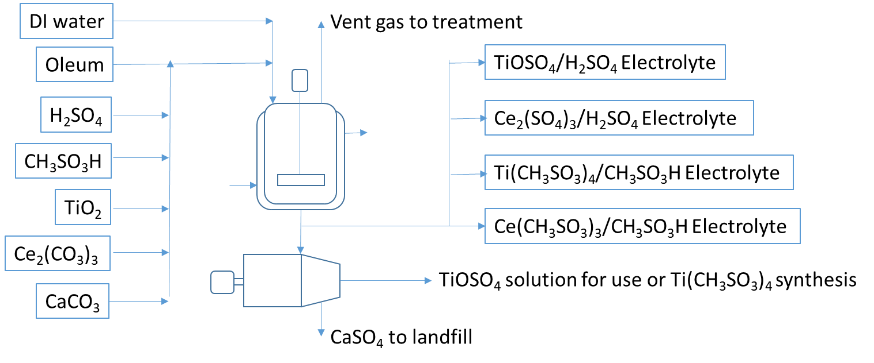
Fig. S23. Schematic of the proposed electrolyte production plant

Plant consists of:
- 12 storage tanks/bins (6 equivalent process steps)
- 1 DI water system
- 1 reaction step
- 1 waste treatment step
- 1 centrifugation step
- 10 total process steps
ISBL capital cost estimated using Bridgewater correlation:
ISBL CAPEX = 0.084 (10 steps) (2MM metric tons)^{0.331} = $102MM = $0.05/Kg electrolyte
Fixed costs -
Labor:
- Operating labor: 4 operators/shift, 4 shifts/week, $75,000/operator = $1.2MM/yr
- Non-operating labor (supervision, clerical, QA/QC, etc.) = 1x operating labor = $1.2MM/yr
- Total labor cost = $2.4MM/yr

Table S23. Other fixed costs for the 2MM MTA electrolyte plant

Fixed Cost Item | % of ISBL CAPEX | $MM/yr
Utilities | 2 | 2.04
Overhead | 4 | 4.08
Maintenance | 6 | 6.12
Taxes & Insurance | 2 | 2.04
Depreciation | 10% ISBL + 5% OSBL | 13.3
Total including labor |  | 30.0

Table S24. Variable costs for the 2MM MTA electrolyte plant

Electrolyte | Kg/kWh | Variable Cost
Electrolyte | Kg/kWh | $/Kg | $/kWh
0.5M TiOSO₄/3M H₂SO₄ | 103 | 0.13 | 13.40
0.5M Ce₂(SO₄)₃/3M H₂SO₄ | 59 | 0.31 | 18.30
0.9M Ti(CH₃SO₃)₄ /4M CH₃SO₃H | 74 | 1.31 | 96.90
0.9M Ce(CH₃SO₃)₃ /4M CH₃SO₃H | 73 | 1.19 | 86.90

Table S25. The electrolyte cost of manufacturing estimate

Electrolyte Pair | Fixed Cost, $/kWh | Variable Cost, $/kWh | Estimated COM, $/kWh
TiOSO₄/Ce₂(SO₄)₃ | 0.015 | 31.70 | 31.70
Ti(CH₃SO₃)₄/Ce(CH₃SO₃)₃ | 0.015 | 184 | 184

The sulfate-based electrolytes are seen to be substantially cheaper, largely driven by the lower cost of sulfuric acid.

S 7.3.9 Sensitivity analysis of the electrolyte cost

Table S26. Sensitivity analysis for SO₄²⁻ electrolytes

Scenario | Estimated electrolyte COM, $/Kg | % change from base case
TiOSO₄ base case | 0.13 | 0
TiO₂ price -25% | 0.11 | -15
TiO₂ price +25% | 0.15 | +15
Ce₂(SO₄)₃ base case | 0.31 | 0
Ce₂(CO₃)₃ price -25% | 0.27 | -13
Ce₂(CO₃)₃ price +25% | 0.35 | +13

Table S27. Sensitivity analysis for CH₃SO₃⁻ electrolytes

Scenario | Estimated electrolyte COM, $/Kg | % change from base case
Ti(CH₃SO₃)₄ base case | 1.31 | 0
CH₃SO₃H price -25% | 1.04 | -21
CH₃SO₃H price +25% | 1.58 | +21
Ce(CH₃SO₃)₃ base case | 1.19 | 0
CH₃SO₃H price -25% | 0.97 | -18
CH₃SO₃H price +25% | 1.41 | +18

S 7.3.10 Fluid handling components

- Purchased equipment is primarily solution tanks and pumps
- Requires sufficient tankage to hold active material solutions + 1 additional tank per electrolyte to act as a receiver
  - As each tank is emptied, it becomes the next receiver
Cost estimation methodology -
- Estimate capacity, number, and material of construction of tanks and pumps
- Determine cost of each item from published sources such as http://matche.com/equipcost/Default.html and update costs to present date if needed
- Multiply purchased equipment cost by direct cost factors for installation, piping, electrical, instrumentation, and insulation and paint
- Note: This estimate does not include facilities such as inverters, transformers, buildings, and site services and also does not include engineering, contingency, and contractor fees

S 7.3.11 Installation costs

This cost is estimated as a factor of the purchase price of the equipment. The total installation factor is defined as -
Total installation factor = equipment installation factor * (1+ piping + electrical + insulation & paint + instrumentation factors)

Table S28. Direct installation cost factors

Factor | Multiplier
Equipment installation | 1.4
Piping | 0.5
Electrical | 0.15
Instrumentation | 0.15
Insulation & paint | 0.05
Total installation factor | 2.6

S 7.3.12 Overall RFB cost estimates

These estimates are for two different scales and includes the cell stack, fluid handling and active solution costs. It excludes inverters, siting, project management, grid connection and other such non-system, BOP costs. The sulfate and methanesulfonate cases are separately considered.

S 7.3.12.1 Methanesulfonate electrolytes

Table S29. Estimate for a 1MW/4MWh system

Component | Purchased Cost, $ | Installation Factor | Installed Cost, $ | $/kWh
Cell stack | 167,000 | 2.6 | 434,000 | 109
Fluid handling | 530,000 | 2.6 | 1,380,000 | 345
Solutions | 737,000 | 1.0 | 737,000 | 184
Total |  |  | 2.550,000 | 640

Table S30. Estimate for a 2GW/10GWh system

Component | Purchased Cost, $MM | Installation Factor | Installed Cost, $MM | $/kWh
Cell stack | 330 | 2.6 | 860 | 86
Fluid handling | 90 | 2.6 | 230 | 23
Solutions | 1840 | 1.0 | 1840 | 184
Total |  |  | 2930 | 290

Table S31. Avenues for cost reduction

Change | Cost Reduction, $/kWh @ 5 hr operating time*
30% lower actives cost (lower methanesulfonic acid cost) | 55
50% reduction in cell hardware (electrodes, frames, gaskets, etc.) cost | 43
Total savings | 98

Table S32. Final cost of the 2GW/10GWh system

Component | $/kWh
Cell stack | 43
Fluid handling | 23
Solutions | 129
Total | 192

S 7.3.12.2 Sulfate electrolytes

Table S33. Estimate for a 1MW/4MWh system

Component | Purchased Cost, $ | Installation Factor | Installed Cost, $ | $/kWh
Cell stack | 167,000 | 2.6 | 434,000 | 109
Fluid handling | 530,000 | 2.6 | 1,380,000 | 345
Solutions | 127,000 | 1.0 | 127,000 | 32
Total |  |  | 1,940,000 | 490

Table S34. Estimate for a 2GW/10GWh system

Component | Purchased Cost, $MM | Installation Factor | Installed Cost, $MM | $/kWh
Cell stack | 330 | 2.6 | 860 | 86
Fluid handling | 90 | 2.6 | 230 | 23
Solutions | 320 | 1.0 | 320 | 32
Total |  |  | 1410 | 140

Table S35. Avenues for cost reduction

Change | Cost Reduction, $/kWh @ 5 hr operating time*
30% lower actives cost (lower Ti and Ce salt costs) | 7
50% reduction in cell hardware (electrodes, frames, gaskets, etc.) cost | 43
Total savings | 50

Table S36. Final cost of the 2GW/10GWh system

Component | $/kWh
Cell stack | 43
Fluid handling | 23
Solutions | 24
Total | 90

Note on membrane cost: Assuming that membrane purchase from a separate supplier rather than manufacture by the stack supplier could double the membrane cost, the additional membrane cost would increase the total cost of this system to $94/kWh (+4.4%), which is within the likely uncertainty of this estimate.

S 7.4 Ti-Ce Electrode-decoupled Redox-flow Battery Levelized Cost of Storage Estimation

S 7.4.1 Design basis

Cell stack
- Uses QPEK-C-TMA-Cl membranes
- Power density 1 kW/m² based on 1V discharge voltage per cell
- Stack cost $167/kW
  - Membranes represent 10% of stack cost
Electrolytes
- 0.5M TiOSO₄/3M H₂SO₄, 86L/kWh capacity, $0.16/L
- 0.5M Ce(SO₄)₂/3M H₂SO₄, 49L/kWh capacity, $0.37/L
- Total electrolyte cost is $32/kWh
System
- Polypropylene tanks, $0.26/L purchase cost (DOE)
- Centrifugal pumps, 1/tank + 10% spares, $2000/pump
- Heat exchangers to cool electrolyte solutions, $88/kW (Y.K. Zheng, et al, J. Power Sources, 300 (2015) 438-443; cost updated to 2018)
- Cooling pond to remove heat from cooling water, $14/kW (matche.com; note that this assumes that the RFB installation would have sufficient land area to allow cooling pond construction)
- Power conversion system, $220/kW (Zheng; cost updated to 2018)
All system capital is considered to be inside battery limits (ISBL); no OSBL capital associated with this system i.e., Site is considered to have all facilities & services needed for this system already in place

S7.4.2 System operating assumptions

- Electrolyte loss due to leaks, breaks, spills, degradation = 2%/yr.
- Stack maintenance (seals, membranes, etc.) cost = 10% of original stack cost per 5000 hours of operation
- Operating labor = utility integration scenario (i.e. RFB is installed at an electricity generation station and shares operating labor with the generation facility) $30,000/yr. independent of system size
- Utilities (not including electricity input for charging RFB) = 2% of system capital cost/yr.
- Maintenance (not including stack maintenance) = 3% of system capital cost/yr.
- Overhead/taxes & insurance = 2% of system capital cost/yr. each
- Depreciation is not included in operating & maintenance cost

S 7.4.3 System cost estimates
Table S37. Power components cost

Component | $/kW | Installation factor | Installed cost, $/kW
Cell stack | 167 | 1.5 | 250
Power conditioning system | 220 | 1 | 220
Heat exchangers | 88 | 1.5 | 132
Cooling pond | 14 | 1 | 14
Unspecified equipment |  |  | 62
Total installed cost |  |  | 680
Direct cost factor |  | 2.5 | 1700
Indirect cost factor |  | 1.6 | 2720

Table S38. Energy components cost

Component | $/kWh | Installation factor | Installed cost, $/kWh
Tanks | 44 | 1.5 | 66
Pumps | 11 | 1.5 | 17
Unspecified equipment |  |  | 8
Total installed cost |  |  | 91
Direct cost |  | 2.5 | 228
Indirect cost |  | 1.6 | 364
Electrolytes | 32 | 1.1 | 36
Total |  |  | 400

S 7.4.4 The levelized cost of storage (LCOS)

LCOS = cost of system inefficiency + [(total invested capital + net present value of operating & maintenance costs over system lifetime)/(total kWh delivered by system over system lifetime)
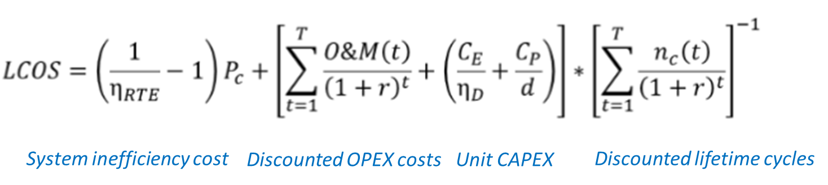
Where η_{RTE} = total round-trip efficiency of system
O&M(t) = total operating & maintenance cost in year t
C_{E} + C_{P}/d = total capital cost of system, $
η_{DC-AC} = Efficiency of conversion of DC from RFB to AC

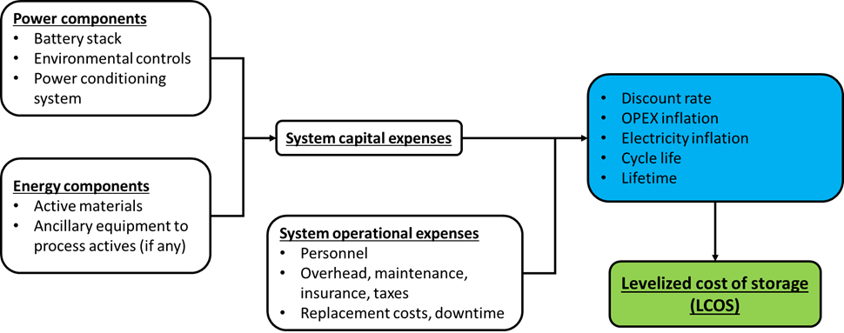

Fig. S24. LCOS methodology summary.

S 7.4.4.1 Assumptions for the LCOS calculations

Electrical efficiencies:
- 80% for AC-DC & DC-AC conversions
- 80% for RFB (1.25V charge, 1.0V discharge, 100% current efficiency)
Expenses:
- Operating & maintenance expense constant over lifetime of system
- Increases due to inflation cancelled out by improvement optimization
- Labor requirement is 1 operator/shift in a utility integration scenario = $30,000/yr.
- Electrolyte loss assumed to be 2%/yr. due to leaks, line breaks, spills, maintenance losses, chemical degradation
- Expenses estimated as percentages of system fixed capital: non-stack maintenance (3%), overhead (2%), utilities (2%), taxes & insurance (2%)
- Assumes that depreciation is not considered part of O&M costs in this calculation
Discharge cycles: 10 hr., 300 cycles/yr. and 100 hr., 42 cycles/yr.
System sizes: 1000- & 10,000-kW nominal

Table S39. LCOS equation elements

LCOS Element | Value w/depreciation | Value w/o depreciation
System inefficiency cost | $0.00625/kWh | $0.00625/kWh
Discount factor [∑1/(1+r)^{t}] | 8.513564 | 8.513564
Unit OPEX costs | $31.42/kWh | $21.90/kWh
Unit CAPEX | $190/kWh | $190/kWh
Cycles/yr. | 300 | 300
LCOS | $0.185/kWh | $0.154/kWh

Table S40. LCOS Sensitivity Analysis w/depreciation

Scenario | LCOS, $/kWh | % change from base case
Base Case | 0.185 | 0
CAPEX -50% | 0.104 | -44
CAPEX +100% | 0.348 | +88
OPEX -50% | 0.133 | -28
OPEX + 50% | 0.238 | +29
Optimistic (CAPEX & OPEX -50%) | 0.074 | -60
Pessimistic (CAPEX +100%, OPEX + 50%) | 0.312 | +69

Table S41. Impact of Manufacturing Scale on Posolyte & Negolyte Costs

Solution | Variable Cost, $/Kg | Fixed Cost, $/Kg |  | Est. Cost of Manufacture, $/Kg
Solution | Variable Cost, $/Kg | 10 GWH annual capacity | 100 MWH annual capacity | 10 GWH annual capacity | 100 MWH annual capacity
TiOSO₄/H₂SO₄ | 0.13 | 0.010 | 0.049 | 0.140 | 0.179
Ce₂(SO₄)₂/H₂SO₄ | 0.51 | 0.005 | 0.028 | 0.516 | 0.538

System thermal management

- Base case assumption: heat exchanger cost = $56/kW system power
- Independent analysis:
  - Total heat load = 25% of total stack power (ref. D. Bryans et al, Characterization of a 200 kW/400 kWh Vanadium Redox-flow Battery, Batteries 2018, 4, 54; doi:10.3390/batteries4040054)
    - 15% charge-discharge electrochemical efficiency
    - 5% AC-DC-AC power conversion
    - 5% pump power due to flow rate/pressure drop
    - Net heat load = 25% of stack power = 250 kW for 1 MW/10 MWH system
      - Assume max load = 2X average load = 500 kW heat removal
    - Assuming one heat exchanger per 2 tanks/pump, need 6 heat exchangers with a capacity of 83 kW each = 283,000 BTU/hr. each
  - Assume a shell & tube heat exchanger with cooling tower water inlet of 85ºF & outlet 95ºF, Posolyte/Negolyte inlet 50ºC (122ºF), outlet 40ºC (104ºF)
    - Exchanger log mean temperature difference = 22.8ºF
  - Exchanger overall heat transfer coefficient = 98 BTU/hr./ft²/ºF (included fouling resistance; ref. engineeringtoolbox.com)
  - Exchanger heat transfer area = (283,000 BTU/hr.)/[(98 BTU/hr./ft²/ºF)(22.8ºF)] = 127 ft²
  - Exchanger cost = $11,400 each (ref. www.matche.com, carbon steel shell, 316 stainless steel tubes, cost updated to 2019 using Chemical Engineering equipment cost index)
    - Purchased cost = ($11,400/exchanger)(6 exchangers)/1000 kW system power = $68.40/kW system power
Table S42. Summary of LCOS at various scales
Scale | Total solution cost, $/kWh | LCOS w/o depreciation (1MW/10 MWH system)
100 MWH | 44.20 | 0.156
10 GWH | 50.20 | 0.154

S7.4.4.2 Pathway to lower LCOS

Substantially reducing the cost of the RFB is necessary to reduce the LCOS to the desired level
- Simpler stack design with fewer parts, simpler assembly
- Higher stack power density
- Significant increase in concentration of active components in electrolytes would reduce tank & pump costs
- Replacing traditional tanks with enclosed in-ground reservoirs or siting the system at a site with existing available tankage may also be feasible
- Refine cost estimate for power conditioning system; is a cheaper option available?

Fig. S25. LCOS reduction pathway. Case 1: baseline, 0.1W/cm2, 1M electrolyte, 300 cycles/year; Case 2: air-cooled baseline system (no heat exchanger), 0.3W/cm2, 600 cycles/year; Case 3: air-cooled, 0.3W/cm2, 600 cycles/year , $0.15/L tank cost, no supervisor; Case 4: air-cooled, 0.5W/cm2, 2M electrolyte, 800 cycles/year , $0.15/L tank cost, no supervisor.

References
1. A. W. Maverick and Q. Yao, Inorg. Chem., 32, 5626–5628 (1993) https://pubs.acs.org/doi/abs/10.1021/ic00076a034.
2. Y. Wei, B. Fang, T. Arai, and M. Kumagai, J. Appl. Electrochem., 35, 561–566 (2005).
3. R. P. Kreh, R. M. Spotnitz, and J. T. Lundquist, J. Org. Chem., 54, 1526–1531 (1989).
4. P. K. Leung, C. Ponce De León, C. T. J. Low, and F. C. Walsh, Electrochim. Acta, 56, 2145–2153 (2011).
5. M. D. Gernon, M. Wu, T. Buszta, and P. Janney, Green Chem., 1, 127–140 (1999) http://pubs.rsc.org/en/content/articlehtml/1999/gc/a900157c.
6. A. J. Bard and L. R. Faulkner, Electrochemical Methods: Fundamentals and Applications, 2nd ed., p. 864, Wiley, (2000) http://glearning.tju.edu.cn/pluginfile.php/74331/mod_resource/content/0/参考书/Electrochemical_methods_2ed_2001_-_Bard_Faulkner.pdf.
7. R. S. Nicholson, Anal. Chem., 37, 1351–1355 (1965) http://pubs.acs.org/doi/abs/10.1021/ac60230a016.
8. R. S. Nicholson and I. Shain, Anal. Chem., 36, 706–723 (1964).
9. P. K. Leung et al., J. Power Sources, 196, 5174–5185 (2011).
10. F. C. W. R.G.A. Wills, C. Ponce de Leon, Electr. Energy Storage Appl. Technol., 57–60 (2011) http://www.sandia.gov/EESAT/2011/papers/Monday/11_Wills_RGAW_EESAT_Abstract.pdf.
11. R. J. Klingler and J. K. Kochi, J. Phys. Chem., 85, 1731–1741 (1981).
12. S. Yun, J. Parrondo, and V. Ramani, J. Mater. Chem. A, 2, 6605–6615 (2014).
13. S. Yun, J. Parrondo, and V. Ramani, Int. J. Hydrogen Energy, 41, 10766–10775 (2016) http://dx.doi.org/10.1016/j.ijhydene.2016.04.060.
14. Z. Wang, J. Parrondo, and V. Ramani, J. Electrochem. Soc., 164, F1216–F1225 (2017) http://jes.ecsdl.org/lookup/doi/10.1149/2.1561712jes.

