Supplementary Information

Atomic Engineering Bifunctional Niobium (V)-based Heterostructure Nanosheet for High Efficiency Lean-Electrolyte Lithium-Sulfur Full Batteries
Shi et al.

Methods
Preparation of Nb₄N₅-Nb₂O₅ heterostructure. 160 mg niobium oxalate (C₁₀H₅NbO₂₀, 98%, Macklin) was dissolved in 56 mL deionized water and 24 mL ethylene glycol (Sigma-Aldrich, AR), followed by slowly adding drops of ammonium hydroxide (Aladdin, AR) to adjust the pH of the solution to 9 to form homogenous solution. Then, the reaction mixture was transferred and sealed in a 200 mL Teflon-lined stainless autoclave and kept at 180 ℃ for 24 h. The resulting white precipitate was collected by centrifugation and washed with deionized water three times, followed by freeze-drying. After calcination at 650 ℃ in air for 3 h with a heating rate of 2 ℃ min⁻¹, the bare 2D Nb₂O₅ were obtained. The bare 2D Nb₄N₅ was prepared by annealing the as-prepared bare Nb₂O₅ under ammonia atmosphere at 700 ℃ for 3 h with a heating rate of 2 ℃ min⁻¹. The Nb₄N₅-Nb₂O₅ heterostructure nanosheet with a ratio of 1:1 was prepared via heating the Nb₂O₅ under ammonia atmosphere at 550 ℃ for 2 h with a heating rate of 2 ℃ min⁻¹.
Synthesis of Sulfur Composite electrode. The sulfur composite was prepared via the classical melt-diffusion method¹. The sample powder (Nb₂O₅, Nb₄N₅, and Nb₄N₅-Nb₂O₅) were thoroughly grinded with sulfur (1:4 by mass, 99%, Alfa Aesar). Then, the obtained powder was annealed at 155 °C for 12 h under Ar atmosphere.
Visualized Adsorption of Polysulfides. Li₂S₄ solution with a concentration of 5.0 mmol L⁻¹ was prepared by mixing sulfur particles and Li₂S (99.9%, Aladdin) with a molar ratio of 3:1 in 1,2-dimethoxyethane (DME, 99.5%, Aladdin) solution in an Ar-filled glovebox, followed by intense stirring for 24 h. Nb₄N₅, Nb₂O₅ or Nb₄N₅-Nb₂O₅ heterostructure with the same mass (5 mg) was added into 1.0 mL Li₂S₄/DME solution, respectively. After the mixtures were kept still for 12 h, the digital photographs were taken. The supernatant and the Nb₄N₅-Nb₂O₅ heterostructure precipitates were studied by UV-vis spectrophotometry and XPS, respectively.
Assembly of Symmetric Cells and Kinetic Evaluation of Polysulfide Conversion. The Nb₄N₅-Nb₂O₅ heterostructure, Nb₄N₅-Nb₂O₅ mix, Nb₄N₅, or Nb₂O₅ electrode powders were mixed with polyvinylidene fluoride (PVDF, Sigma-Aldrich) binder with a weight ratio of 4:1, and then coated on the Al foil and dried at 120 °C for 12 h. The electrodes were obtained with an average mass loading of 1 mg cm⁻². The electrodes were used as both working and counter electrode, and 40 μL catholyte (0.5 M Li₂S₆ and 1.0 M solution of lithium bis (trifluoromethanesulfonyl) imide (LiTFSI, Sigma-Aldrich) with 1 wt% LiNO₃ (Sigma-Aldrich) in 1,3-dioxolane (DOL, Sigma-Aldrich) and DME, v/v = 1:1) was added into each coin cell. The CV measurement of the symmetric cell was conducted at a scan rate of 5 mV s⁻¹ with a voltage window between -0.8 and 0.8 V.
Measurement for Li₂S Nucleation and Li₂S Dissolution. The nucleation of Li₂S on different electrodes were probed in standard 2016 coin cells with 20 μL Li₂S₈ tetraglyme solution (0.2 mol L⁻¹ based on sulfur) as catholyte and 20 μL control electrolyte without Li₂S₈ was used as anolyte. Li foil was employed as the anode, Nb₄N₅-Nb₂O₅ heterostructure, Nb₄N₅-Nb₂O₅ mix, Nb₄N₅, or Nb₂O₅ electrodes used in the kinetic study served as the working electrode. The assembled cells were first discharged galvanostatically at 0.112 mA to 2.06 V and then discharged potentiostatically at 2.05 V for Li₂S nucleation and growth until the current dropped below 10⁻⁵ A. The capacities of the deposition of Li₂S on various surfaces were calculated according to Faraday’s law. For the Li₂S dissolution, the assembled cells were firstly galvanostatically discharged at 0.10 mA to 1.80 V, and subsequently galvanostatically discharged at 0.01 mA to 1.80 V for full transformation of sulfur species into solid Li₂S. Then the cells were potentiostatically charged at 2.40 V for the oxidization of Li₂S into soluble polysulfides. The potentiostatic charge was stopped when the charge current was below 10⁻⁵ A.
Characterization. The morphology and structure of materials and electrodes were characterized by SEM (JEOL JSM-7900F), STEM (ARM 200F), TEM (JEM-2100), HRTEM (JEOL 2100), XPS (Thermo ESCALAB 250Xi equipped with monochromatic Al Kα source of 1486.5eV), XRD (Empyrean with Cu Kα radiation in the 2θ range from 5 to 90°), and nitrogen adsorption and desorption isotherm (Quadrasorb SI).
Electrochemical measurement. The sulfur composite cathodes were prepared by mixing the as-prepared samples (Nb₄N₅-Nb₂O₅ heterostructure/S, Nb₄N₅-Nb₂O₅ mix/S, Nb₄N₅/S, or Nb₂O₅/S), acetylene black and binder (PVDF) in N-methy-pyrrolidinone(NMP, Sigma-Aldrich) solvent with a weight ratio of 8:1:1. The resulting homogeneous slurry was coated onto the current collector, followed by drying at 60 ºC for 24 h. CR-2016 coin cells were assembled in an argon-filled glove box using the Nb₄N₅-Nb₂O₅ heterostructure/S, Nb₄N₅-Nb₂O₅ mix/S, Nb₄N₅/S, or Nb₂O₅/S as the cathodes, a porous membrane (Celgard 2400) sheets as the separator, and Li foil as the counter electrode. A 1.0 M solution of LiTFSI with 1 wt% LiNO₃ in DOL and DME, v/v = 1:1) was used as the electrolyte. Nb₄N₅-Nb₂O₅/Li||Nb₄N₅-Nb₂O₅/S full cells were assembled by using Nb₄N₅-Nb₂O₅/S as cathode and Nb₄N₅-Nb₂O₅/Li as anode. The average mass of S cathode used in our work are controlled around 1.0 mg cm⁻². For high S loading test, 5.4 mg cm⁻², 6.9 mg cm⁻² areal loading S were also prepared. The Nb₄N₅-Nb₂O₅/Li anodes were prepared by pre-plating Li into Nb₄N₅-Nb₂O₅ with excessive Li of 50% relative to Nb₄N₅-Nb₂O₅/S cathode. The performances of Li-S batteries were measured on a LANDCT2001A analyzer under different current rates at a voltage interval from 1.7 to 2.8 V. The cyclic voltammograms (CV) curves were collected on a CHI-760E electrochemical workstation (Chenhua Instrument, Shanghai) at a scan rate of 0.1 mV s⁻¹. EIS analysis was carried out in the range of 100 kHz-0.01 Hz.
Computational simulation. The DFT computations were performed using the CASTEP code which is integrated in Materials Studio 8.0 package. The interaction between the ionic core and valence electrons was described by the projector augmented wave method (PAW)². The electron exchange correlation energy was calculated by the generalized gradient approximation (GGA) corrected the Perdew-Burke-Ernzerhof (PBE) functional³. The DFT-D2 method of Tkatchenko and Scheffler (TS) was used for dispersion corrections. The Kohn-Sham orbitals were expanded in a plane wave basis with a kinetic energy cutoff energy of 400 eV. The total energy convergence and the forces on each atom were set to be lower than 10⁻⁵ eV and 0.05 eV Å⁻¹ for geometry optimization. A 5 × 5 × 1 Monkhorst-Pack k-point mesh was employed to sample the Brillouin zone for the monolayers of Nb₄N₅ or Nb₂O₅ separated by 15 Å of vacuum⁴. The binding energy (Eb) of the LiPSs on Nb₄N₅ or Nb₂O₅ monolayer substrates were calculated as following:
E_{ads} = E_{LiPSs/surf} - E_{surf} - E_{LiPSs}
where E_{LiPSs/surf}, E_{surf} and E_{LiPSs} are the energy of the LiPSs adsorbed on the catalyst surface, the energy of catalyst clean surface, and the energy of isolated LiPSs cluster in a cubic box with side length of 15 Angstroms, respectively.

Supplemental Figures
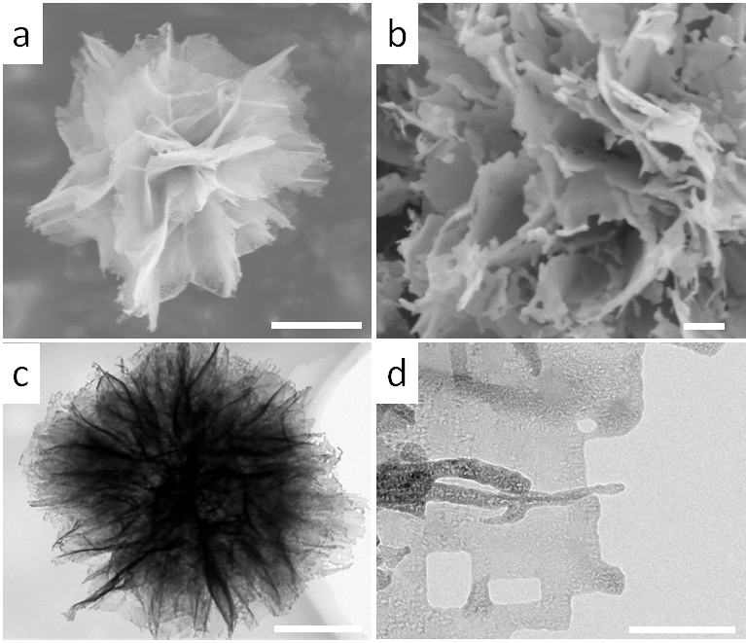
Supplementary Figure 1. Characterization of Nb₄N₅-Nb₂O₅ heterostructure. (a, b) SEM images and (c, d) TEM images of the as-synthesized holey Nb₄N₅-Nb₂O₅ heterostructure. Scale bars: (a, c) 1 μm, (b) 200 nm, and (d) 100 nm
Supplementary Figure 2. Characterization of bare Nb₄N₅. (a, b) SEM images and (c, d) TEM images of the as-synthesized bare Nb₄N₅. Scale bars: (a) 2 μm, (b, c) 1 μm, and (d) 10 nm
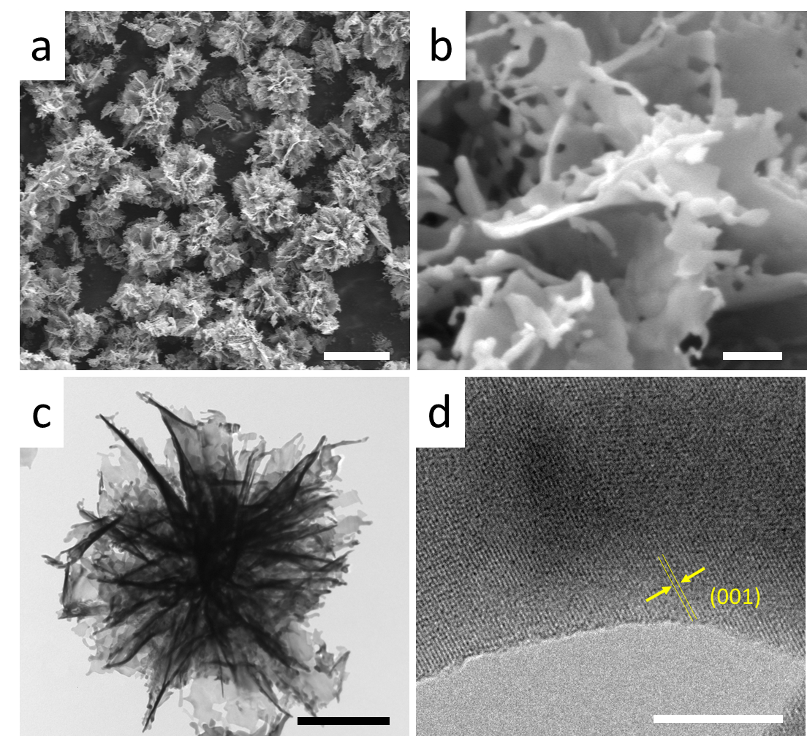
Supplementary Figure 3. Characterization of bare Nb₂O₅. (a, b) SEM images and (c, d) TEM images of the as-synthesized bare Nb₂O₅. Scale bars: (a) 5 μm, (b) 200 nm, (c) 500 nm, and (d) 10 nm

Supplementary Figure 4. Nitrogen adsorption-desorption isotherm of (a) Nb₄N₅ and (b) Nb₂O₅. Inset is its pore size distribution.

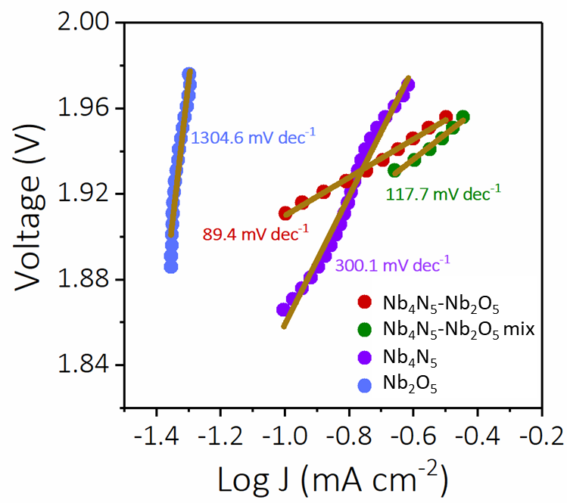
Supplementary Figure 5. Tafel plots for Nb₄N₅-Nb₂O₅ heterostructure, Nb₄N₅-Nb₂O₅ mix, Nb₄N₅, and Nb₂O₅ electrodes in Li₂S₄ catholyte.

Supplementary Figure 6. CV curves of Nb₄N₅-Nb₂O₅ heterostructure for Li-S battery for 6 cycles.

Supplementary Figure 7. Galvanostatic charge and discharge profiles of Li-S batteries. (a) Nb₄N₅-Nb₂O₅ mix, (b) Nb₄N₅ and (c) Nb₂O₅ cathode obtained at 0.5 C.

Supplementary Figure 8. Galvanostatic charge and discharge proﬁles of Li-S batteries with Nb₄N₅-Nb₂O₅ heterostructure, Nb₄N₅-Nb₂O₅ mix, Nb₄N₅, and Nb₂O₅ based cathodes.

Supplementary Figure 9. Cycling performances of Li-S batteries with Nb₄N₅-Nb₂O₅ heterostructure based cathode measured at 0.5 C.

Supplementary Figure 10. Galvanostatic charge and discharge proﬁles of the (a) Nb₄N₅-Nb₂O₅ heterostructure, (b) Nb₄N₅-Nb₂O₅ mix, (c) Nb₂O₅, and (d) Nb₄N₅ based sulfur cathodes measured at different rates.

Supplementary Figure 11. Ragone plot based on the electrochemical data in Figure 3e with respect to the mass of the whole Nb₄N₅-Nb₂O₅ cathode in comparison with the state-of-the-art cathodes: TiO₂/G: ref. 5; G: ref. 6; C: ref. 7; Co-N/C: ref. 8; VN: ref.9; TiO₂: ref. 10; TiS₂: ref. 11; MoO₂-Mo₃N₂: ref. 12; ZnS: ref. 13; and Co/G: ref.14.

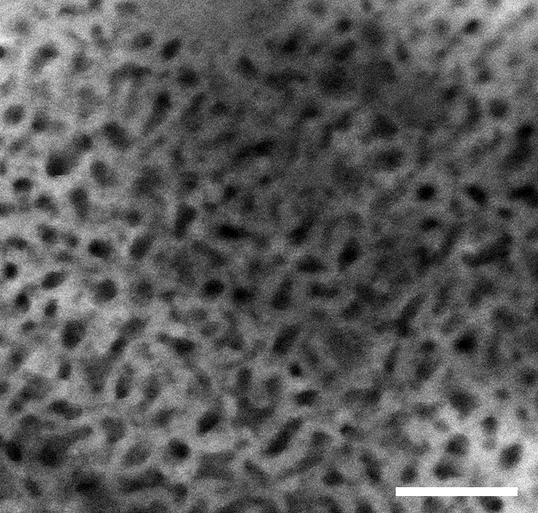
Supplementary Figure 12. Enlarged HAADF-STEM image of Nb₄N₅-Nb₂O₅ heterostructure, showing the uniform pore size of 1.7-3.5 nm. Scale bars: 20 nm

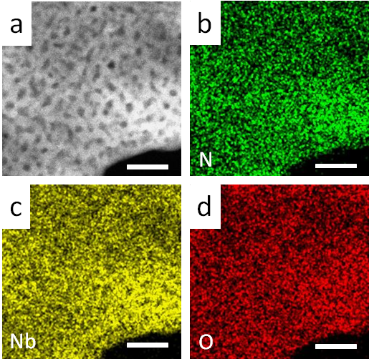
Supplementary Figure 13. HAADF-STEM image of mesoporous Nb₄N₅-Nb₂O₅ and corresponding element mapping of N, Nb, and O element. Scale bars: 20 nm

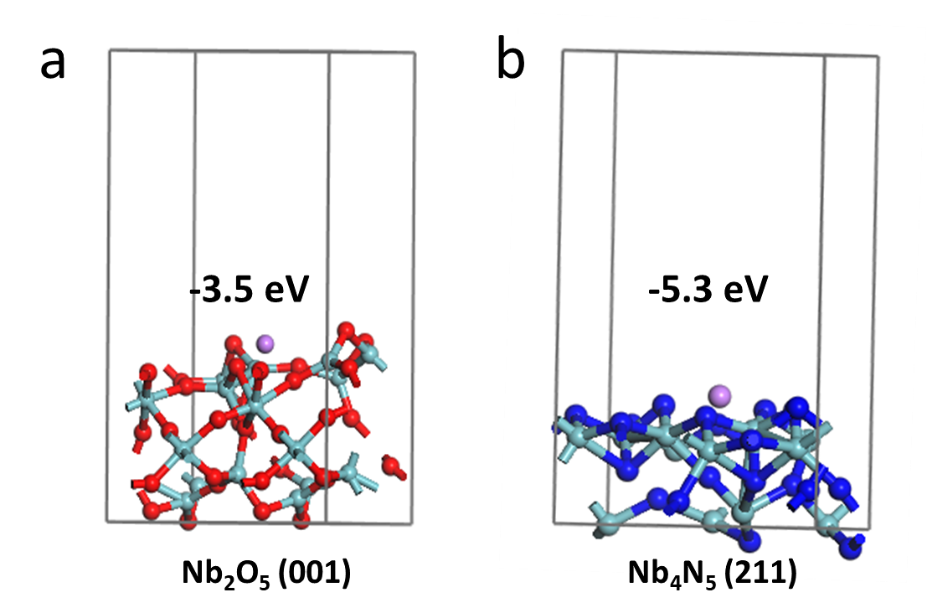
Supplementary Figure 14. Binding energy of a Li atom with (a) Nb₂O₅ and (b) Nb₄N₅.

Supplementary Figure 15. Typical voltage profiles of Nb₄N₅-Nb₂O₅ electrode obtained at the initial 4 cycles. The first 4 cycles at 0.01-1 V was set to realize Li intercalation and stabilize the SEI film.

Supplementary Figure 16. Voltage profiles of Nb₄N₅-Nb₂O₅ heterostructure electrodes tested at different cycles. Planting 0.5 mAh cm⁻² of Li at a current density of 0.5 mA cm⁻² at (a) 1st cycle, (b) 100th cycle, (c) 200th cycle, and (d) 300th cycle.

Supplementary Figure 14. Coulombic efficiencies of Nb₄N₅-Nb₂O₅ heterostructure electrodes at current density of 0.5 mA cm⁻² with areal capacity of 0.5 mAh cm⁻².

Supplementary Figure 18. Detailed voltage profiles of Nb₄N₅-Nb₂O₅/Li symmetric cells measured at current density of 3 mA cm⁻² under stripping/plating capacity of 3 mAh cm⁻².

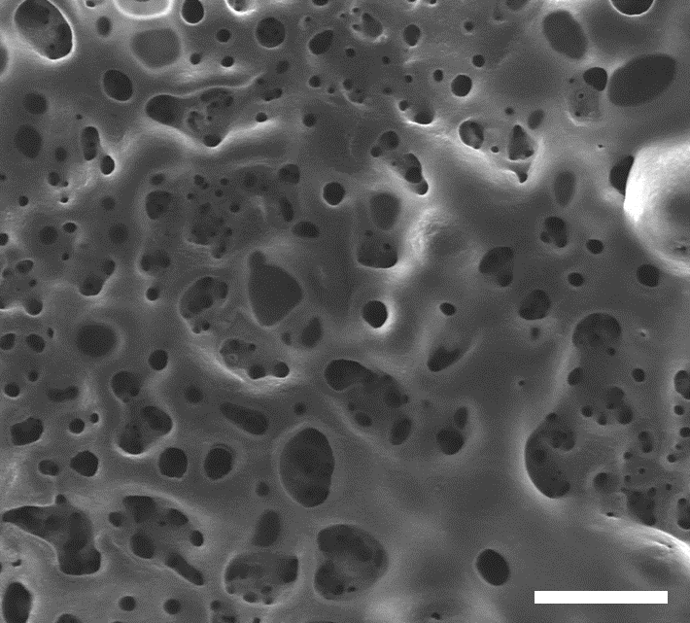
Supplementary Figure 19. Enlarged SEM image of Cu/Li electrode after cycling at current density of 1 mA cm⁻². Scale bars:20 μm

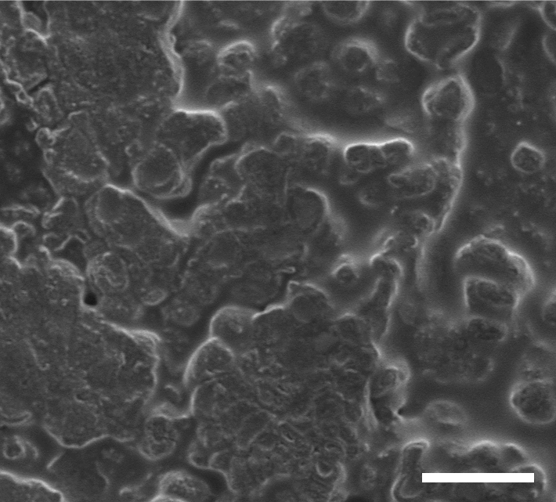
Supplementary Figure 20. SEM image of Nb₄N₅-Nb₂O₅/Li electrode after cycling at current density of 1 mA cm⁻². Scale bars:20 μm

Supplementary Figure 21. Cycling performance of Nb₄N₅-Nb₂O₅/Li||Nb₄N₅-Nb₂O₅/S battery obtained at 0.3 C with high sulfur loading 5.4 mg cm⁻².

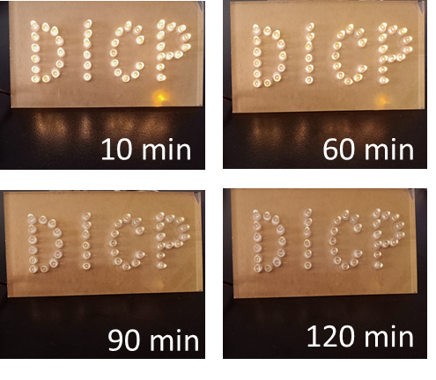
Supplementary Figure 22. Photograph of LED lit by Nb₄N₅-Nb₂O₅/Li||Nb₄N₅-Nb₂O₅/S batteries after different time intervals.

Supplementary Figure 23. Galvanostatic charge and discharge profiles of Nb₄N₅-Nb₂O₅/Li||Nb₄N₅-Nb₂O₅/S full batteries obtained from the different cycles at 2 C.
Supplementary Table 1. The content of element of Nb₄N₅-Nb₂O₅ heterostructures from the X-ray energy spectrometer results.
Element | Weight% | Atomic%
N | 16 | 37
O | 20 | 42
Nb | 64 | 21

Supplementary Table 2. Performance comparison of Nb₄N₅-Nb₂O₅ heterostructures as sulfur host with the reported heterostructure materials for Li-S batteries.
Materials | Rate  (mAh g⁻¹) | Capacity  (mAh g⁻¹) | Decay rate (%) | Refs.
Nb₄N₅-Nb₂O₅ | 10 C (844) | 1136 (0.5 C) | 0.03 (500 cycles) | This work
MoN-VN | 2 C (636) | 766 (1 C) | 0.06 (500 cycles) | 15
VO₂-VN | 5 C (587) | 1010 (2 C) | 0.06 (800 cycles) | 16
MoS₂/Graphene | 2 C (613) | 900 (1 C) | 0.08 (500 cycles) | 17
C/TiN | 5 C (411) | - | - | 18
MoO₂-Mo₃N₂ | 4 C (340) | 750 (1 C) | 0.032 (1000 cycles) | 19
TiO₂-Ni₃S₂ | 5 C (534) | 980 (0.5 C) | 0.04 (900 cycles) | 20
TiO₂-TiN | 2 C (682) | 927 (0.3 C) | 0.03 (300 cycles) | 21
TiN‐VN | 5 C (650) | 576 (2 C) | 0.051 (600 cycles) | 22
WS₂-WO₃ | 3 C (864) | 669 (1 C) | 0.04 (500 cycles) | 23
VTe₂@MgO | 3 C (705) | 927 (1 C) | 0.055 (1000 cycles) | 24
Co₉S₈/CoO | 5 C (534) | 925 (1 C) | 0.049 (1000 cycles) | 25
TiO₂-MXene | 2 C (663) | 800 (2 C) | 0.03 (1000 cycles) | 26
TiO-TiO₂ | 1 C (726) | 1050 (0.5 C) | 0.09 (500 cycles) | 27
MoS₂/Graphene | 3 C (490) | 597 (2 C) | 0.05 (1000 cycles) | 28
NiO‐NiCo₂O₄ | 2 C (698) | 717 (0.5 C) | 0.06 (500 cycles) | 29
SnS₂/SnO₂ | 4 C (600) | 800 (2 C) | 0.033 (500 cycles) | 30
MoSe₂/MoO₂ | 2 C (874) | 1100 (0.5 C) | 0.05 (500 cycles) | 31

Supplementary Table 3. Performance comparison of Nb₄N₅-Nb₂O₅/Li||Nb₄N₅-Nb₂O₅/S batteries with the reported Li-S full batteries.
Materials | Mass loading  (mg cm⁻²) | Rate  (mAh g⁻¹) | Decay rate (%) | Refs.
Nb₄N₅-Nb₂O₅ | 6.9 | 3 C (1163) | 0.025 (1000 cycles) | This work
Mesoporous carbon | 2.0 | 1 C (607) | 0.125 (100 cycles) | 32
TiN-VN | 5.6 | 5 C (650) | 0.051 (600 cycle) | 22
Graphite foam | 2.6 | 3 C (950) | 0.057 (400 cycles) | 33
MoS₂ | 4.0 | 3 C (766) | 0.029 (2000 cycles) | 34
VN | 4.0 | 4 C (910) | 0.03 (850 cycles) | 9
Carbon fabric | 4.0 | 4 C (625) | 0.113 (200 cycles) | 8
Co/N‐PCNSs | 1.0 | 4 C (549) | 0.036 (400 cycles) | 35
VS₂ | 9.2 | 2 C (630) | 0.072 (300 cycles) | 36
Nafion/PVDF | - | 2 C (~590) | - | 37
Co/N‐PCNSs: cobalt‐embedded nitrogen‐doped porous carbon nanosheets

References
1. Shi, H. et al. Dual-functional atomic zinc decorated hollow carbon nanoreactors for kineticallaccelerated polysulfides conversion and dendrite free lithium sulfur batteries. Adv. Energy Mater. 10, 2002271 (2020).
2. Blöchl, P. E. Projector augmented-wave method. Phys. Rev. B 50, 17953-17979 (1994).
3. Perdew, J. P., Burke, K. & Ernzerhof, M. Generalized gradient approximation made simple. Phys. Rev. Lett. 77, 3865-3868 (1996).
4. Monkhorst, H. J. & Pack, J. D. Special points for brillouin-zone integrations. Phys. Rev. B 13, 5188-5192 (1976).
5. Xiao, Z. et al. A lightweight TiO₂/graphene interlayer, applied as a highly effective polysulfide absorbent for fast, long-life lithium-sulfur batteries. Adv. Mater. 27, 2891-2898 (2015).
6. Shao, Y., Xiao, Z., Bi, C., Yuan, Y. & Huang, J. Origin and elimination of photocurrent hysteresis by fullerene passivation in CH₃NH₃PbI₃ planar heterojunction solar cells. Nat. Commun. 5, 1-7 (2014).
7. Jin, S. et al. Covalently connected carbon nanostructures for current collectors in both the cathode and anode of Li-S batteries. Adv. Mater. 28, 9094-9102 (2016).
8. Cai, W. et al. The dual-play of 3D conductive scaffold embedded with Co, N codoped hollow polyhedra toward high-performance Li-S full cell. Adv. Energy Mater. 8, 1802561 (2018).
9. He, J. & Manthiram, A. Long‐life, high-rate lithium-sulfur cells with a carbon-free VN host as an efficient polysulfide adsorbent and lithium dendrite inhibitor. Adv. Energy Mater. 10, 1903241 (2020).
10. Wang, Y. et al. Enhancing catalytic activity of titanium oxide in lithium-sulfur batteries by band engineering. Adv. Energy Mater. 9, 1900953 (2019).
11. Huang, X. et al. Sandwich-like ultrathin TiS₂ nanosheets confined within N, S codoped porous carbon as an effective polysulfide promoter in lithium-sulfur batteries. Adv. Energy Mater. 9, 1901872 (2019).
12. Li, R., Zhou, X., Shen, H., Yang, M., & Li, C. Conductive holey MoO₂-Mo₃N₂ heterojunctions as job-synergistic cathode host with low surface area for high-loading Li-S batteries. ACS Nano 13, 10049-10061 (2019).
13. Xu, J. et al. Promoting lithium polysulfide/sulfide redox kinetics by the catalyzing of zinc sulfide for high performance lithium-sulfur battery. Nano Energy 51, 73-82 (2018).
14. Du, Z. et al. Cobalt in nitrogen-doped graphene as single-atom catalyst for high-sulfur content lithium-sulfur batteries. J. Am. Chem. Soc. 141, 3977-3985 (2019).
15. Ye, C. et al. 2D MoN‐VN heterostructure to regulate polysulfides for highly efficient lithium-sulfur batteries. Angew. Chem. Int. Ed. 57, 16703-16707 (2018).
16. Song, Y. et al. Synchronous immobilization and conversion of polysulfides on a VO₂-VN binary host targeting high sulfur load Li-S batteries. Energy Environ. Sci. 11, 2620-2630 (2018).
17. He, J. et al. Freestanding 1T MoS₂/graphene heterostructures as a highly efficient electrocatalyst for lithium polysulfides in Li-S batteries. Energy Environ. Sci. 12, 344-350 (2019).
18. Chen, X. et al. An analogous periodic law for strong anchoring of polysulfides on polar hosts in lithium sulfur batteries: S- or Li-binding on first-row transition-metal sulfides? ACS Energy Lett. 2, 795-801 (2017).
19. Li, R., Zhou, X., Shen, H., Yang, M. & Li, C. Conductive holey MoO₂-Mo₃N₂ heterojunctions as job-synergistic cathode host with low surface area for high-loading Li-S batteries. ACS Nano 13, 10049-10061 (2019).
20. Wang, R. et al. Bidirectional catalysts for liquid-solid redox conversion in lithium-sulfur batteries. Adv. Mater. 32, e2000315 (2020).
21. Zhou, T. et al. Twinborn TiO₂-TiN heterostructures enabling smooth trapping-diffusion-conversion of polysulfides towards ultralong life lithium-sulfur batteries. Energy Environ. Sci. 10, 1694-1703 (2017).
22. Yao, Y. et al. A dual-functional conductive framework embedded with TiN-VN heterostructures for highly efficient polysulfide and lithium regulation toward stable Li-S full batteries. Adv. Mater. 1905658 (2019).
23. Zhang, B. et al. Optimized catalytic WS₂-WO₃ heterostructure design for accelerated polysulfide conversion in lithium-sulfur batteries. Adv. Energy Mater. 10, 2000091 (2020).
24. Wang, M. et al. Conductive and catalytic VTe₂@MgO hterostructure as effective polysulfide promotor for lithium-sulfur batteries. ACS Nano 13, 13235-13243 (2019).
25. Wang, N. et al. Rational design of Co₉S₈/CoO heterostructures with well-defined interfaces for lithium sulfur batteries: A study of synergistic adsorption-electrocatalysis function. Nano Energy 60, 332-339 (2019).
26. Jiao, L. et al. Capture and catalytic conversion of polysulfides by in situ built TiO₂-MXene heterostructures for lithium-sulfur batteries. Adv. Energy Mater. 9, 1900219 (2019).
27. Chen, G. et al. Rational design of TiO-TiO₂ heterostructure/polypyrrole as a multifunctional sulfur host for advanced lithium-sulfur batteries. ACS Appl. Mater. Interfaces 11, 5055-5063 (2019).
28. Dong, Y. et al. 2D hierarchical yolk-shell heterostructures as advanced host-interlayer integrated electrode for enhanced Li-S batteries. J. Energy Chem. 36, 64-73 (2019).
29. Hu, L. et al. Double-shelled NiO-NiCo₂O₄ heterostructure@carbon hollow nanocages as an efficient sulfur host for advanced lithium-sulfur batteries. Adv. Energy Mater. 8, 1800709 (2018).
30. Wang, M. et al. SnS₂/SnO₂ heterostructures towards enhanced electrochemical performance of lithium-sulfur batteries. Chem. - Eur. J. 25, 5416-5421 (2019).
31. Hao, Q., Cui, G., Zhang, Y., Li, J., & Zhang, Z. Novel MoSe₂/MoO₂ heterostructure as an effective sulfur host for high-performance lithium/sulfur batteries. Chem. Eng. J. 381, 122672 (2020).
32. Cao, D. et al. Stable lithium-sulfur full cells enabled by dual functional and interconnected mesocarbon arrays. J. Mater. Chem. A 7, 3289-3297 (2019).
33. Jin, S. et al. Covalently connected carbon nanostructures for current collectors in both the cathode and anode of Li-S batteries. Adv. Mater. 28, 9094-9102 (2016).
34. Wu, J. et al. Ultralight layer-by-layer self-assembled MoS₂-polymer modified separator for simultaneously trapping polysulfides and suppressing lithium dendrites. Adv. Energy Mater. 8, 1802430 (2018).
35. Liu, S. et al. Superhierarchical cobalt-embedded nitrogen-doped porous carbon nanosheets as two-in-one hosts for high-performance lithium-sulfur batteries. Adv. Mater. 30, 1706895 (2018).
36. Wang, J. et al. Suppressing the shuttle effect and dendrite growth in lithium-sulfur batteries. ACS Nano 14, 9819-9831 (2020).
36. Wang, J. et al. Suppressing the shuttle effect and dendrite growth in lithium-sulfur batteries. ACS Nano 14, 9819-9831 (2020).
37. Luo, J. et al. A dual-functional polymer coating on a lithium anode for suppressing dendrite growth and polysulfide shuttling in Li-S batteries. Chem. Commun. 53, 963-966 (2017).

