Supporting Information

New Series of Ternary Metal Chloride Superionic Conductors for High Performance All-Solid-State Lithium Batteries

Jianwen Liang¹⁺, Eveline van der Maas²⁺, Jing Luo¹⁺, Xiaona Li¹⁺, Ning Chen³, Keegan R. Adair¹, Weihan Li¹, Junjie Li¹, Yongfeng Hu³, Li Zhang⁴, Shangqian Zhao⁴, Shigang Lu⁴, Jiantao Wang⁴, Huan Huang⁵, Steven Parnell², Ronald Smith⁶, Swapna Ganapathy², Marnix Wagemaker^{2,}* and Xueliang Sun ^{1,}*

Experimental Procedures
Preparation of the Li_{3-3x}M_{1+x}Cl₆ SSEs: All preparations and sample treatments were carried out under argon atmosphere (O₂ < 1 ppm, H₂O < 1 ppm). The Li_{3-3x}M_{1+x}Cl₆ (M = Tb, Dy, Ho, Y, Er, Tm) SSEs were synthesized using the following procedure: the starting materials of lithium chloride (LiCl, Alfa Aesar, 99.9%) and trivalent rare earth chloride (MCl₃, Alfa Aesar, > 99.9%) were weighted in the appropriate stoichiometric ratio and directly put into quartz tubes. The quartz tubes were sealed and heated to 650 °C (4 h heating), annealed for 24 h, and then cooled to room temperature (24 h cooling).
Characterizations: Powder X-ray diffraction (XRD) measurements of Li_{3-3x}M_{1+x}Cl₆ (M = Tb, Dy, Ho, Y, Er, Tm) SSEs were carried out on a Bruker AXS D8 Advance with a Cu Kα radiation (λ = 1.54178 Å). All samples were placed into a special holder to avoid possible air exposure during the test. Rietveld refinement was performed for the XRD data collected by scanning 5 s per step with one step of 0.02° in the 2θ range of 10-120°. Scanning electron microscopy (SEM) images were carried out on a FE-SEM (S-4800, Hitachi high-technologies) equipped with an energy-dispersive X-ray spectroscopy system. Air stable performance were performance in a lithium battery dry room with a supply dew point around -50 °C and humidity around 1%. High-energy X-ray photoelectron spectroscopy of NMC811-Li_{2.73}Ho_{1.09}Cl₆ cathode at different charge/discharge states was carried on the soft X-ray microcharacterization beamline (SXRMB) at Canadian Light Source (CLS) under different energies. Holmium (Ho) L₃-edge X-ray absorption ﬁne structure (XAFS) data were measured at Hard X-ray MicroAnalysis (HXMA) beamline in CLS.
Neutron Diffraction: The time of flight (TOF) powder neutron diffraction pattern was data were collected on the high-flux medium resolution diffractometer Polaris at ISIS¹, Rutherford Appleton Laboratory, United Kingdom. 1.575g of Li_{2.72}Ho_{1.09}Cl₆ (x = 0.09) powder was loaded into a 6 mm diameter thin-walled cylindrical vanadium can and sealed with an indium wire inside the glovebox. The sample was mounted in the diffractometer and data were collected at room for a duration of 400 Ah integrated proton beam current to the ISIS neutron target (corresponding to ~2 hour total exposure). Data reduction and generation of files suitable for profile refinement used the Mantid open source software². The data was analysed with the Rietveld refinement program GSAS-2 software³. As initial guess, the structure file of the Pnma phase of Li₃YCl₆ was used, and Y was replaced by Ho. The lattice parameter and atomic positions were refined first, followed by sample broadening effects due to crystallite size. Instrument parameters were refined for small corrections in the time of flight due to sample placement and wavelength dependent average penetration depth. The Chlorine occupancies were fixed to 1, the holmium and the lithium occupancies are refined, where the lithium occupancy of the 8d1 site (see Table S1) was fixed to 1, while the Li 8d2 and the Ho 4c site occupancies were refined but constrained to charge compensation. Both ⁶Li and ¹⁶⁵Ho are strong neutron absorbers. This lead to differences in the peak intensity for the same peaks measured on different banks. As the absorbtion affects peaks at longer time of flight (larger d-spacing) more strongly, not the full measured range of each bank was used for the profile refinement. Instead, the peaks of thus d-spacing range was taken into account for using the data of the next bank, which has somewhat lower resolution, but the longer d-spacing occur at shorter time of flight, avoiding the absorption problem at the cost of somewhat lower resolution. It was made sure that there was sufficient (almost complete) overlap between the banks, to ensure intensities were not fit solely because of the histogram scale parameter. Even with this strategy, due to the size of the unit cell, only bank 5, 4 and 3 were needed for the structure refinement. The background was modelled by a Chebyschev function with 8 components.
Conductivity measurements: Temperature-dependent electrochemical impedance spectroscopy (EIS) was conducted to obtain the ionic conductivities and activation energies of the as-prepared samples. Cold-pressed pellets (diameter of 10 mm, ~380 MPa) were attached with carbon on both sides and then sealed in custom-built Model Cells for EIS tests. Ionic conductivity measurements were carried out in the temperature range from 258 to 338 using a versatile multichannel potentiostat 3/Z (VMP3) impedance analyzer in the range of 7 MHz to 1 Hz with an amplitude of 10 mV. All the EIS fittings were performed using the EC-Lab software package. The activation energies of the Li_{3-3x}M_{1+x}Cl₆, Li_{3-3x}Y_{1+x}Cl₆, and Li_{3-3x}Er_{1+x}Cl₆ samples were determined according to the Arrhenius equation of σT = σ₀ exp(−E_{a}/k_{B}T), where σ, T, σ₀, E_{a}, and k_{B} is the ionic conductivity, the temperature in K, the pre-exponential factor, the activation energy, and the Boltzmann constant, respectively. The electronic conductivity of the samples were calculated by the Ohm's law of σ_{e} = I_{e}×L/(V×A), where σ_{e}, I_{e}, L, V, and A is the electronic conductivity, the equilibrium current, the thickness of the SSE, the applied voltage, and the area of the SSE pellet, respectively.
Molecular Dynamics (MD) simulations: Density functional theory (DFT) calculations were performed in VASP^{4–6} using the GGA approximation⁷ and the PAW-PBE basis set^{8,9}. A 1 x 1 x 2 supercell was used, which results in a size of 80 atoms [12.89 x 11.21 x 12.45 ] for the Pnma phase and 60 atoms [11.33 x 9.76 x 12.45] and for P-3m1. For both structures, a cut-off energy of 450 eV and a k-point mesh of 2 x 2 x 2 was used for the relaxation as well as the molecular dynamics simulation. The values were chosen based on convergence test of the total energy. For the P-3m1 phase, the cif file published in Bohnsack et al.¹⁰ was used as a starting structure. The Ho partial occupancies was changed to 80% (from 97%) and 20% (from 3%), due to computational limitations concerning the size of the supercell. The partial occupancies of both Li and Ho lead to very many possible configurations in the supercell. Therefore, 10 structures with the lowest Ewald-sum were generated as implemented in Pymatgen¹¹. After minimization without symmetry restrictions, the lowest energy configuration of the ten structures was selected for the MD simulations. For the Pnma phase, the cif file for Li₃YCl₆¹⁰ was used as a starting structure. The Lithium was distributed across both sites maximizing the Li-Li distances. 10 structures were then relaxed without symmetry restrictions and the lowest energy configuration was used as starting point for the MDs. The MDs were performed in the NVT ensemble, with a time step of 2fs and an equilibration time of 2.5 ps for all simulations. The simulations were ran for a different length depending on the phase and temperature, to reach a certain amount of jumps also at lower temperatures and for the less conducting phase. The output of the MD simulations was analyzed using the code published elsewhere¹².
Figure S1. The XRD pattern of Li_{3-3x}Ho_{1+x}Cl₆ (x = 0.017 and 0.043) SSEs.

Figure S2. Fitted XRD pattern of Li_{3-3x}Ho_{1+x}Cl₆ (x = 0.09) SSEs following Rietveld profile refinement. The refinement converged to the final stoichiometry of Li_{2.42}Ho_{1.15}Cl₆, with a weighted residual of Rwp = 2.9% and Rp = 1.66%.
Figure S3. Fitted time-of-flight PND data of Li_{3-3x}Ho_{1+x}Cl₆ (x = 0.09) SSEs Time of flight powder neutron diffraction patterns of the high resolution detector banks with d-spacing ranges of 0.5-40 Å.

Figure S4. Ho L₃-edge XAFS spectra of different Li-Ho-Cl compositions.

Figure S5. The magnitude of FT for k³χ(k) of the experimental data and experimentally resolved EXAFS feature “A” of Li_{2.73}Ho_{1.09}Cl₆.

Figure S6. Magnitude and imaginary part of FT between the experimental (red solid and red dash traces) and the Feff modeling (blue solid and blue dash traces) of Li_{2.73}Ho_{1.09}Cl₆.

Figure S7. The magnitude of FT for k³χ(k) of the experimental data and the Feff modeling of Li_{2.73}Ho_{1.09}Cl₆.

Figure S8. The XANES Modeling and experimental data in k space for kχ(k) of Li_{2.73}Ho_{1.09}Cl₆ (x = 0.09).

Figure S9. Conductivity isotherms σ(ν) of the as-prepared Li₃HoCl₆ (x = 0, P-3m1) SSE recorded at different temperatures.

Figure S10. Chronoamperometry result for the In/Li_{2.73}Ho_{1.09}Cl₆/In cell with different voltages step from 0.1 to 0.4 V.

Figure S11. The TGA and DSC curves of the Li_{2.73}Ho_{1.09}Cl₆ (x = 0.09) sample in dry air for 12 h at room temperature. The bar indicates the scale of 0.2 W g⁻¹.

Figure S12. Comparison of the XRD patterns of the pristine Li_{2.73}Ho_{1.09}Cl₆ (x = 0.09) sample and after exposure in lithium battery dry room for 24 h.

Figure S13. Comparison of the XRD patterns of the pristine Li_{2.87}Ho_{1.043}Cl₆ (x = 0.043) sample and after exposure in lithium battery dry room for 24 h.

Figure S14. (a) XRD patterns of the Li_{3-3x}Y_{1+x}Cl₆ system with different x value based on different Li to Y ratios. (b) Magnified XRD patterns of the Li_{3-3x}Y_{1+x}Cl₆ samples at 2θ = 15~27° (the highlighted region in figure a). (c) Orthorhombic Pnma structure of Li₃YCl₆ unit cell. (d) Trigonal P-3m1 structure of Li₃YCl₆ unit cell.
Figure S15. (a) Arrhenius-plots of the Li_{3-3x}Y_{1+x}Cl₆ (0 ≤ x ≤ 0.2) SSEs. (b) The RT ionic conductivities and (c) corresponding activation energies of the Li_{3-3x}Y_{1+x}Cl₆ (0 ≤ x ≤ 0.2) SSEs.

Figure S16. (a) XRD patterns of the as-prepared Li_{2.73}Er_{1.09}Cl₆ (x = 0.09, Pnma phase) and Li₃ErCl₆ (x = 0, P-3m1 phase) SSEs. (b) Magnified XRD patterns at 2θ = 15~27° (the highlighted region in figure a). (c) Representative Nyquist-plots and (d) Arrhenius-plots for the as-prepared Li_{2.73}Er_{1.09}Cl₆ (x = 0.09, Pnma phase) and Li₃ErCl₆ (x = 0, P-3m1 phase) SSEs.

Figure S17. (a) XRD patterns of the as-prepared Li_{2.4}Dy_{1.2}Cl₆ (x = 0.20, Pnma phase), Li_{2.73}Dy_{1.09}Cl₆ (x = 0.09, Pnma phase) and Li₃DyCl₆ (x = 0, P-3m1 phase) SSEs. (b) Magnified XRD patterns at 2θ = 15~31° (the highlighted region in figure a). (c) Representative Nyquist-plots and (d) Arrhenius-plots for the as-prepared Li_{2.4}Dy_{1.2}Cl₆ (x = 0.20, Pnma phase), Li_{2.73}Dy_{1.09}Cl₆ (x = 0.09, Pnma phase) and Li₃DyCl₆ (x = 0, P-3m1 phase) SSEs.

Figure S18. (a) XRD patterns of the as-prepared Li_{2.73}Tm_{1.09}Cl₆ (x = 0.09, Pnma phase) and Li₃TmCl₆ (x = 0, P-3m1 phase) SSEs. (b) Magnified XRD patterns at 2θ = 14~30° (the highlighted region in figure a). (c) Representative Nyquist-plots and (d) Arrhenius-plots for the as-prepared Li_{2.73}Tm_{1.09}Cl₆ (x = 0.09, Pnma phase) and Li₃TmCl₆ (x = 0, P-3m1 phase) SSEs.

Figure S19. (a) XRD patterns of the as-prepared Li_{2.4}Tb_{1.2}Cl₆ (x = 0.20, unknown phase), Li_{2.73}Tb_{1.09}Cl₆ (x = 0.09, unknown phase) and Li₃TbCl₆ (x = 0, P-3m1 phase) SSEs. (b) Magnified XRD patterns at 2θ = 15~31° (the highlighted region in figure a). (c) Representative Nyquist-plots of Li₃TbCl₆ (x = 0, P-3m1 phase) at room temperature. Inserted, Representative Nyquist-plots of Li_{2.73}Tb_{1.09}Cl₆ (x = 0.09, unknown phase) and Li₃TbCl₆ ( x = 0.2, unknown phase) SSEs at 75 °C. (d) Arrhenius-plots for the as-prepared Li₃TbCl₆ (x = 0, P-3m1 phase), Li_{2.73}Tb_{1.09}Cl₆ (x = 0.09, unknown phase) and Li₃TbCl₆ (x = 0.2, unknown phase) SSEs.

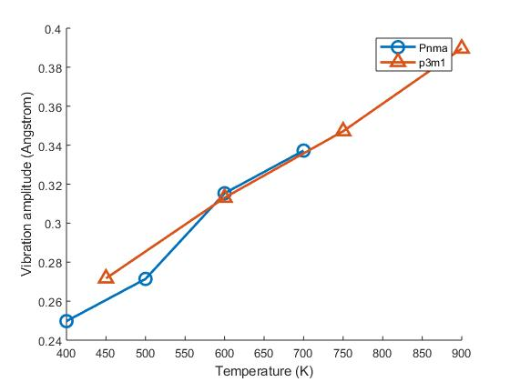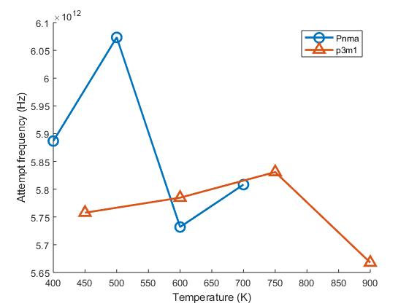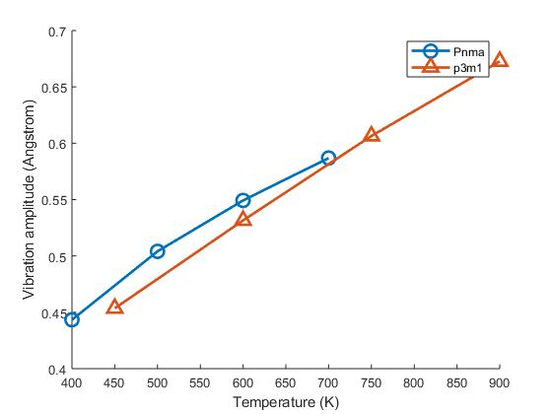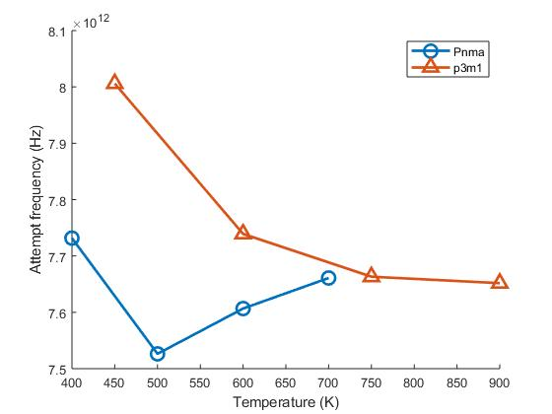
Figure S20: Cl (top row) and Li (bottom row) vibrational amplitudes and frequencies from the MD simulations for Pnma and p-3m1 phases at different temperatures

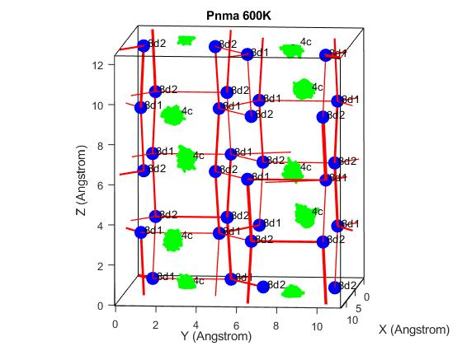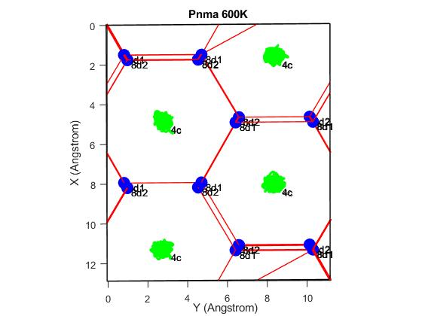
Figure S21. Pnma phase of Li-Ho-Cl at 600K. The Li-sites (blue), Ho-trajectories (green), and Li-ion jumps that occurred during the simulation (red). The size of the Li-sites, as well as the thickness of the Lines, represents the occupancy of the site during the simulation and the jump frequency, respectively.
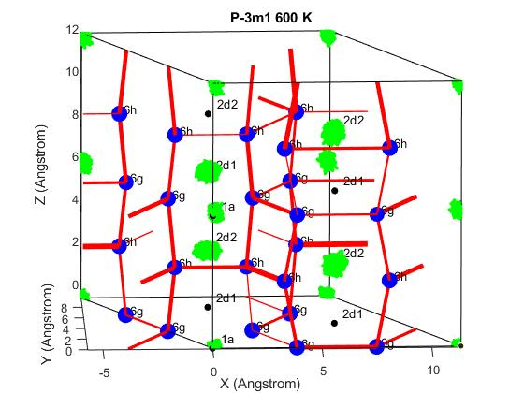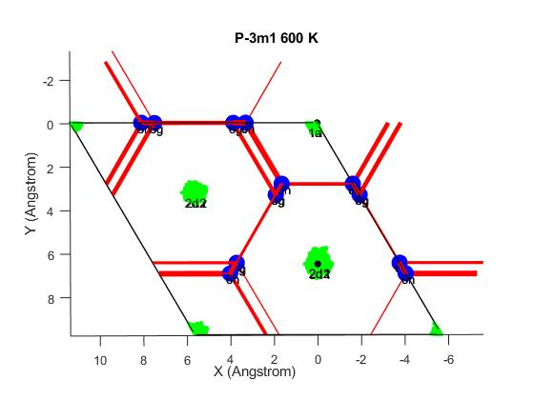
Figure S22. P-3m1 phase of Li-Ho-Cl at 600K. The Li-sites (blue), Ho-trajectories (green), and Li-ion jumps that occurred during the simulation (red). The size of the Li-sites, as well as the thickness of the Lines, represents the occupancy of the site during the simulation and the jump frequency, respectively.

Figure S23. EIS evolution of NMC811/Li_{2.73}Ho_{1.09}Cl₆/In cell at steady state for 24 hrs.

Figure S24. The cycling performance of NMC811/Li_{2.73}Ho_{1.09}Cl₆/In ASSLBs at low temperature (-10 °C).

Figure S25. The charge/discharge curve of NMC811/Li_{2.73}Ho_{1.09}Cl₆/In cell cycled at 0.05 C for 20 hrs with a 2 hrs rest.

Figure S26. HEXPS of Ho 4d and Cl 1s spectra of NMC811-Li_{2.73}Ho_{1.09}Cl₆ cathode at photon energy of 6000 eV recorded at different charge/discharge states, i.e., (a1, b1) pristine, (a2, b2) after first charge, (a3, b3) after first discharge, and (a4, b4) fully discharged after 50 cycles.

Table S1. Atomic parameters of Li_{3-3x}Ho_{1+x}Cl₆ (x = 0.09) sample from the refinement of the XRD data (Rwp = 2.9%, Rp = 1.66%) and Neutron diffraction data (final wR is 3.075).
Component | Li_{2.42}Ho_{1.13}Cl₆
Space group | Pnma (62)
Cell parameters | a = 1.295, b = 1.1793, c = 0.604 nm, α = 90, β = 90, γ = 90°
Cell parameters | V = 0.8738 nm³, a/b = 1.098, b/c = 1.952, c/a = 0.466
Atom coordinates from prototype entry | Site | Elements | Wyck. | Sym. | x | y | z | Occ.
Atom coordinates from prototype entry | Li1 | Li | 8d1 | 1 | 0.1187 | 0.07093 | 0.06723 | 1
Atom coordinates from prototype entry | Li2 | Li | 8d2 | 1 | 0.0563 | 0.1437 | 0.5676 | 0.2026
Atom coordinates from prototype entry | Cl1 | Cl | 8d | 1 | 0.2063 | 0.5806 | 0.27361 | 1
Atom coordinates from prototype entry | Cl2 | Cl | 8d | 1 | 0.4614 | 0.08167 | 0.25322 | 1
Atom coordinates from prototype entry | Cl3 | Cl | 4c | .m. | 0.04688 | 0.25 | 0.73924 | 1
Atom coordinates from prototype entry | Cl4 | Cl | 4c | .m. | 0.20642 | 0.25 | 0.24563 | 1
Atom coordinates from prototype entry | Ho1 | Ho | 4c | .m. | 0.37872 | 0.25 | 0.01184 | 0.9470
Atom coordinates from prototype entry | Ho2 | Ho | 8d2 | 1 | 0.0563 | 0.1437 | 0.5676 | 0.0932

Table S2. Theoretical Pnma structure vs. R space curve fitting.
No. | ID | Theoretical Pnma structure |  | R space fitting |  |  | Adjusting  factor
No. | ID | CN | R(ave) | CN | R | DW | Adjusting  factor
1 | Ho-Cl | 6 | 2.61 | 6.2 | 2.64 | 0.0063 | 0.01335
2 | Ho-Li | 6 | 3.84 | 6.2 | 4.01 | 0.0063 | 0.04330
3 | Ho-Cl | 6 | 4.57 | 5.8 | 4.58 | 0.0100 | 0.00215
4 | Ho-Li | 12 | 4.73 | 12.2 | 4.79 | 0.0063 | 0.01300
5 | Ho-Cl | 6 | 5.10 | 5.8 | 5.21 | 0.0100 | 0.02150
E0=2.5eV
k data range: 2.9-10.8 Å⁻¹;
FT: Gaussian window, window parameter 30 %;
R space fitting range: 1.3-5.5 Å

References
(1) Smith, R. I.; Hull, S.; Tucker, M. G.; Playford, H. Y.; McPhail, D. J.; Waller, S. P.; Norberg, S. T. The Upgraded Polaris Powder Diffractometer at the ISIS Neutron Source. Rev. Sci. Instrum. 2019, 90 (11), 115101.
(2) Arnold, O.; Bilheux, J.C.; Borreguero, J.M.; Buts, A.; Campbell, S.I.; Chapon, L.; Doucet, M.; Draper, N.; Leal, R.F.; Gigg, M.A.; Lynch, V. E. Mantid-Data analysis and visualization package for neutron scattering and μSR experiments. Nucl. Inst. Meth. Phys. Res. 2014, A764, 156-166.
(3) Toby, B. H., Von Dreele, R. B. GSAS-II: the genesis of a modern open-source all purpose crystallography software package. J. Appl. Cryst. 2013, 46(2), 544-549.
(4) Kresse, G.; Hafner, J. Ab Initio Molecular Dynamics for Liquid Metals. Phys. Rev. B 1993, 47 (1), 558–561.
(5) Kresse, G.; Furthmüller, J. Efficiency of Ab-Initio Total Energy Calculations for Metals and Semiconductors Using a Plane-Wave Basis Set. Comput. Mater. Sci. 1996, 6 (1), 15–50.
(6) Kresse, G.; Furthmüller, J. Efficient Iterative Schemes for Ab Initio Total-Energy Calculations Using a Plane-Wave Basis Set. Phys. Rev. B 1996, 54 (16), 11169–11186.
(7) Perdew, J. P.; Burke, K.; Ernzerhof, M. Generalized Gradient Approximation Made Simple. Phys. Rev. Lett. 1996, 77 (18), 3865–3868.
(8) Kresse, G.; Hafner, J. Norm-Conserving and Ultrasoft Pseudopotentials for First-Row and Transition Elements. J. Phys. Condens. Matter 1994, 6 (40), 8245–8257.
(9) Kresse, G.; Joubert, D. From Ultrasoft Pseudopotentials to the Projector Augmented-Wave Method. Phys. Rev. B 1999, 59 (3), 1758–1775.
(10) Bohnsack, A.; Stenzel, F.; Zajonc, A.; Balzer, G.; Wickleder, M. S.; Meyer, G. Ternäre Halogenide vom Typ A3MX6. VI [1]. Ternäre Chloride der Selten-Erd-Elemente mit Lithium, Li3MCl6 (M ? Tb?Lu, Y, Sc): Synthese, Kristallstrukturen und Ionenbewegung. Z. Für Anorg. Allg. Chem. 1997, 623 (7), 1067–1073.
(11) Ong, S. P.; Richards, W. D.; Jain, A.; Hautier, G.; Kocher, M.; Cholia, S.; Gunter, D.; Chevrier, V. L.; Persson, K. A.; Ceder, G. Python Materials Genomics (Pymatgen): A Robust, Open-Source Python Library for Materials Analysis. Comput. Mater. Sci. 2013, 68, 314–319.
(12) de Klerk, N. J. J.; van der Maas, E.; Wagemaker, M. Analysis of Diffusion in Solid-State Electrolytes through MD Simulations, Improvement of the Li-Ion Conductivity in β-Li3PS4 as an Example. ACS Appl. Energy Mater. 2018, 1 (7), 3230–3242.

